Brucellosis Incidence Rate

2023-12-05

## Descriptive Statistics

*The results reported in this file were coded in the* **county_models.R** *file*

Among Camels, the majority of cases (91.30%) are clinically confirmed, with a smaller proportion (8.70%) being lab confirmed; no cases were post-mortem. In the case of Cattle, clinical confirmation dominates (55.34%), followed by lab confirmation (41.26%), and a minor portion through post-mortem (3.40%). Goats show a significant reliance on clinical confirmation (82.16%), while lab confirmation accounts for 17.84%, and no post-mortem cases were reported. Humans exhibit a considerable reliance on lab confirmation (77.98%), with clinical confirmation comprising 22.02%, and no post-mortem cases. Sheep cases are predominantly clinically confirmed (79.27%), with lab-confirmed cases making up 20.73%, and no instances of post-mortem diagnosis.

Number of cases according to the type of Diagnosis

| Species | Diagnosis | Cases | Percent(%) |
| --- | --- | --- | --- |
| Camels | Clinically confirmed | 21.0 | 91.30 |
| Camels | Lab confirmed | 2.0 | 8.70 |
| Camels | Post Mortem | 0.0 | 0.00 |
| Cattle | Clinically confirmed | 228.0 | 55.34 |
| Cattle | Lab confirmed | 170.0 | 41.26 |
| Cattle | Post Mortem | 14.0 | 3.40 |
| Goats | Clinically confirmed | 815.0 | 82.16 |
| Goats | Lab confirmed | 177.0 | 17.84 |
| Goats | Post Mortem | 0.0 | 0.00 |
| Humans | Clinically confirmed | 904217.3 | 22.02 |
| Humans | Lab confirmed | 3202945.0 | 77.98 |
| Humans | Post Mortem | 0.0 | 0.00 |
| Sheep | Clinically confirmed | 65.0 | 79.27 |
| Sheep | Lab confirmed | 17.0 | 20.73 |
| Sheep | Post Mortem | 0.0 | 0.00 |

The descriptive statistics for the incidence rate of Brucellosis among Camels, Cattle, Goats, Humans, and Sheep are presented in the table 2

Descriptive Statistics for Incidence Rate

| Species | Mean Incidence Rate | Minimum | Median | Maximum | Standard Deviation |
| --- | --- | --- | --- | --- | --- |
| Human | 1.0890892 | 0.0007 | 0.71 | 12 | 1.14 |
| Goat | 0.2116064 | 0.0000 | 0.00 | 235 | 4.37 |
| Cattle | 0.1983081 | 0.0000 | 0.00 | 690 | 10.64 |
| Camel | 0.0303408 | 0.0000 | 0.00 | 122 | 1.88 |
| Sheep | 0.0162596 | 0.0000 | 0.00 | 45 | 0.71 |

## Trend

The trend for all animal incidence rate combined was as shown below

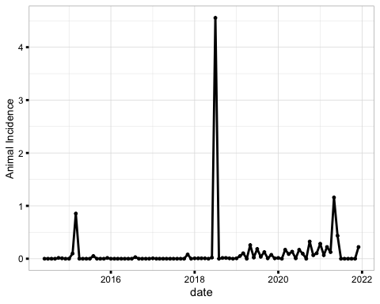

The trend for humans as well as individual species was as shown below

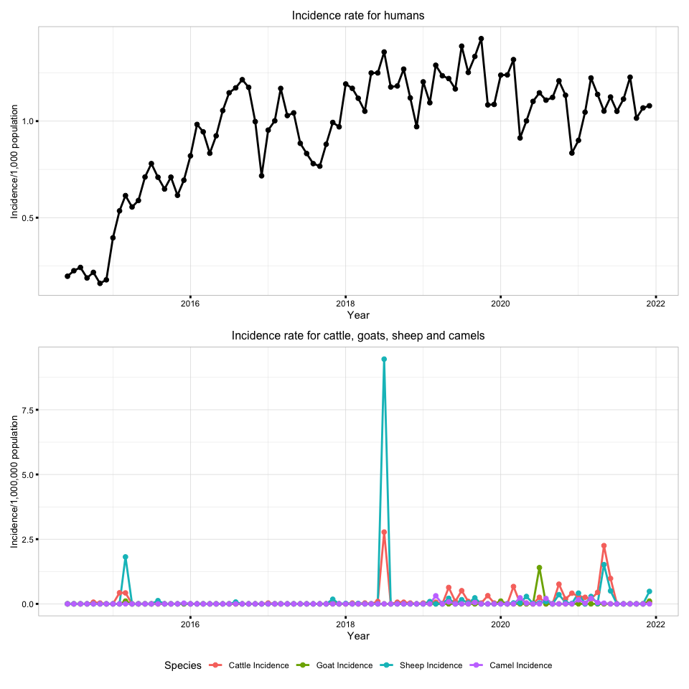

## Spatial

The spatial distribution of the incidence rate of Brucellosis in animals combined was as shown below

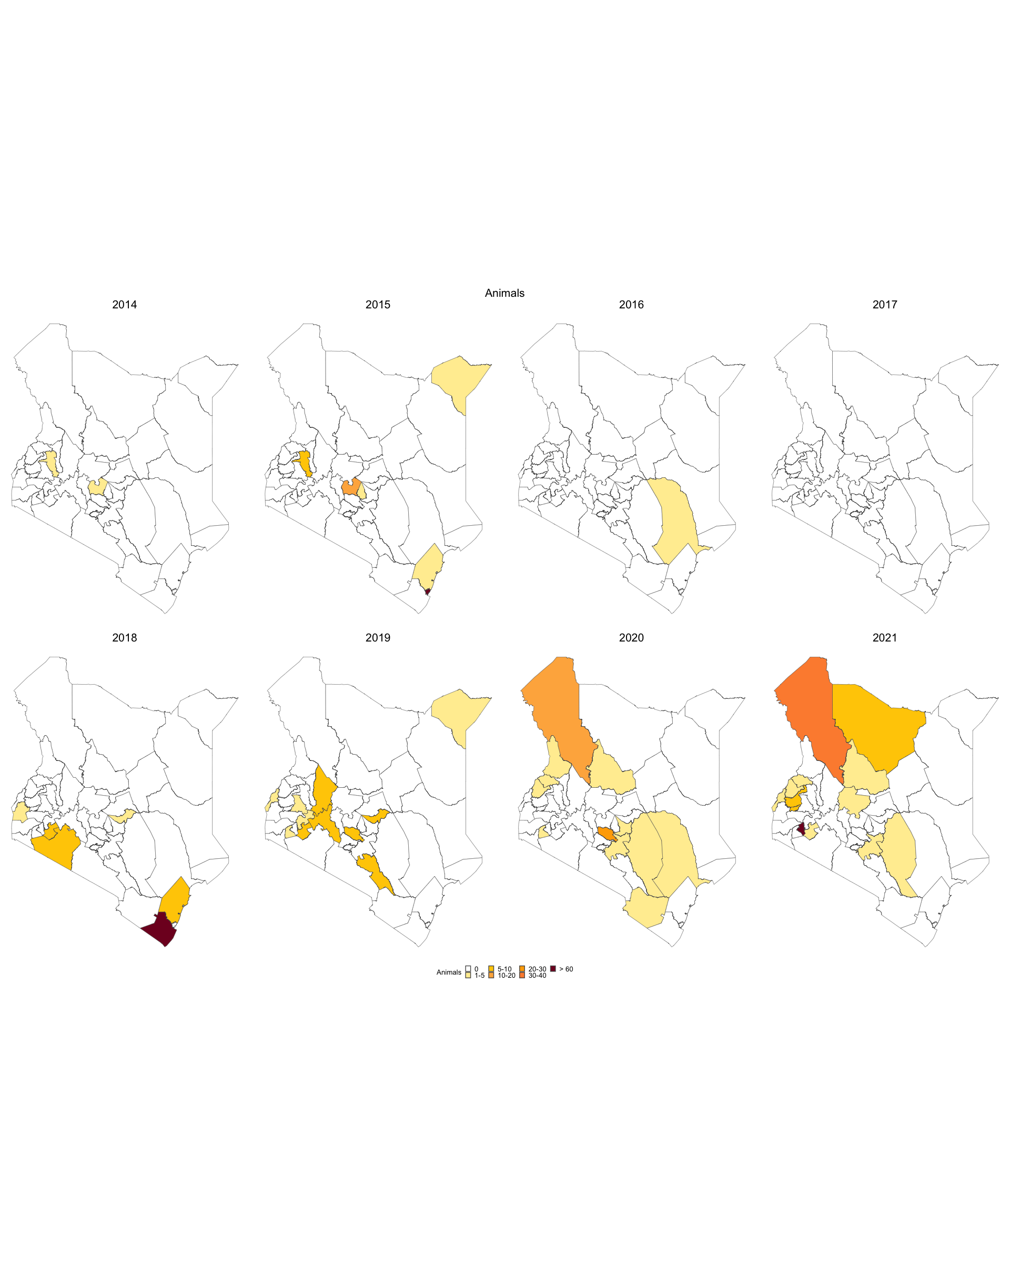

The spatial distribution of the incidence rate of Brucellosis among Camels, Cattle, Goats, Humans, and Sheep are presented in the below,

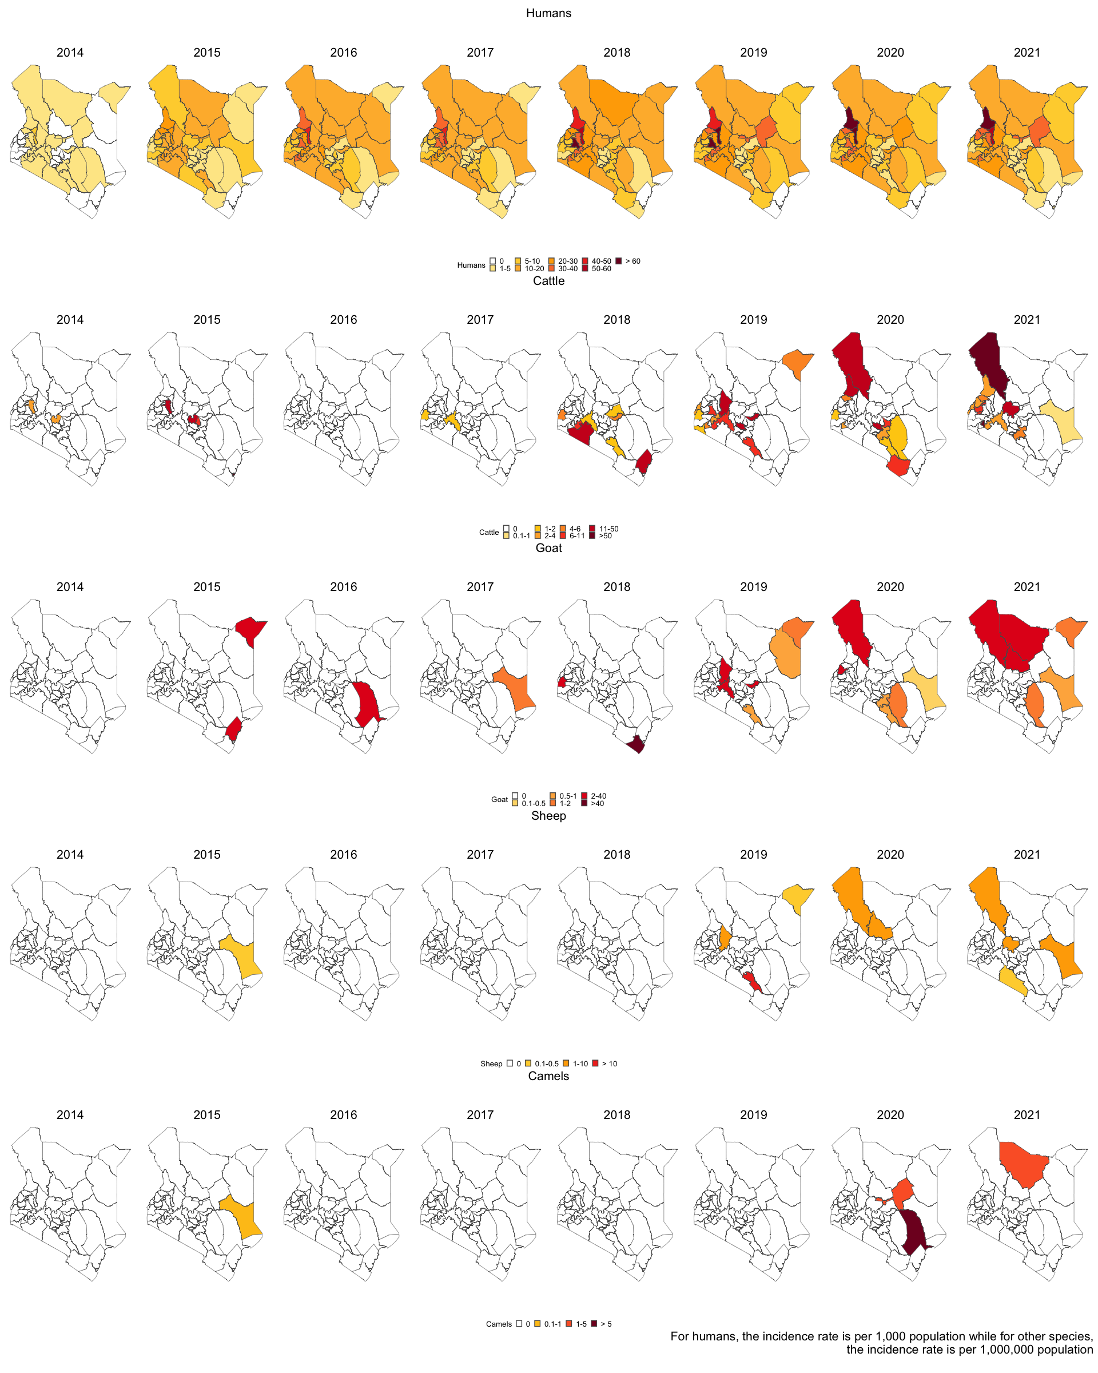

## Correlation

The correlation between the incidence rate of Brucellosis among Camels, Cattle, Goats, Humans, and Sheep were calculated in different lags. There was a high correlation between cattle and goat incidence across all lags. This correlation plot was used to determine the best lag to test for association between the human incidence and animal incidences. The incidence rates for this plot were not differenced.

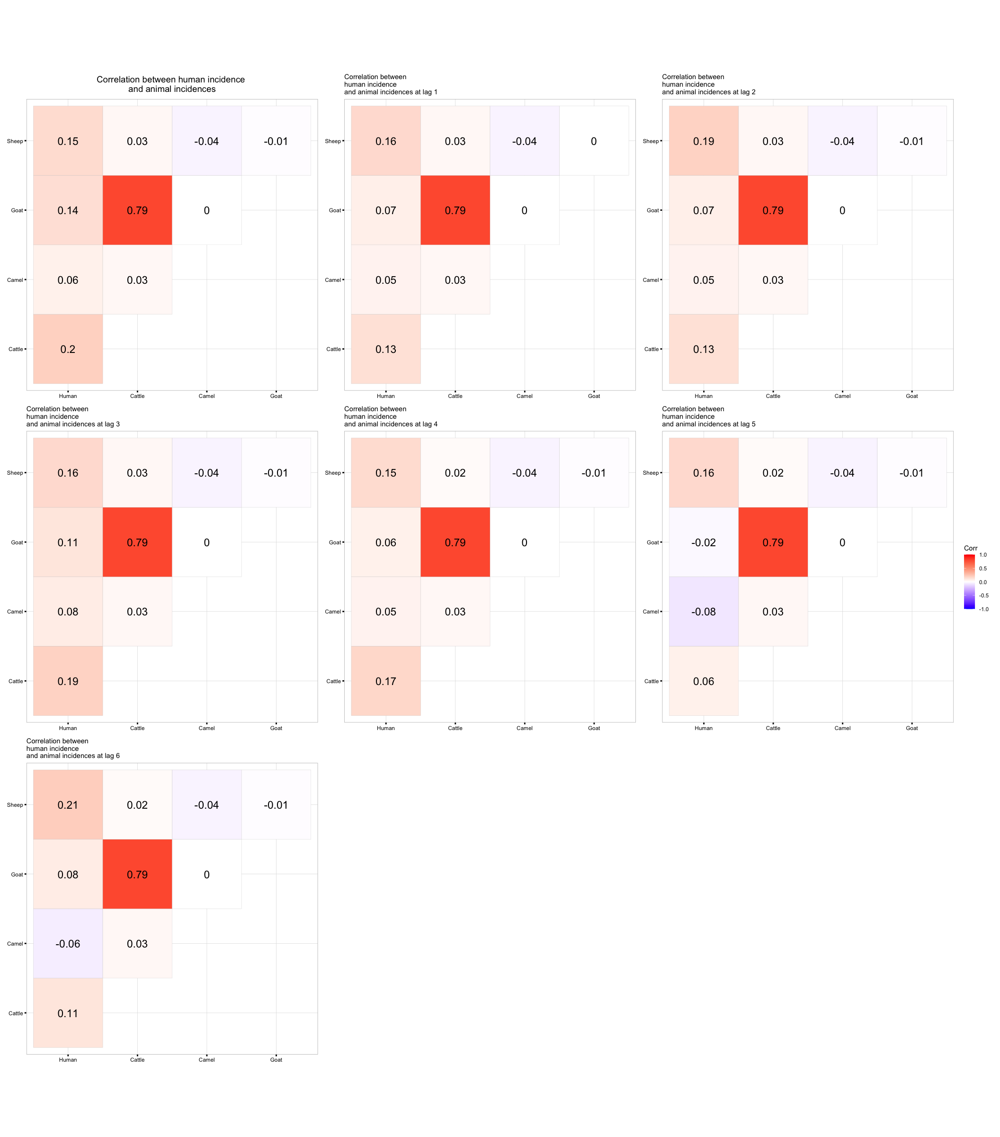

## Models

### 1. Non Differenced Case

We first fit a time series linear model to the original data (original data implying non-differenced) at different lags. Lag 1 to Lag 6. The results of the models were as tabulated in the tables below. Note that the significance was calculated at **10% level of significance**.

In the folder,you can find the full data frames as follows;

1. *non_diff_individual.csv* - Results for non-differenced individual species model.
2. *non_diff_full.csv* - Results for non-differenced all species combined species model.
3. *diff_individual.csv* - Results for differenced individual species model.
4. *diff_full.csv* - Results for differenced all species combined model.

Time Series Linear Model results for no lag (lag = 0)

| variable | estimate | std.error | statistic | p.value | conf_low | conf_high | significance |
| --- | --- | --- | --- | --- | --- | --- | --- |
| (Intercept) | 0.924 | 0.035 | 26.223 | 0.000 | 0.866 | 0.982 | Significant |
| Camel incidence | 0.129 | 0.216 | 0.598 | 0.551 | -0.226 | 0.484 | Not Significant |
| Sheep incidence | 0.808 | 0.600 | 1.346 | 0.182 | -0.180 | 1.796 | Not Significant |
| Cattle incidence | 0.182 | 0.129 | 1.415 | 0.161 | -0.030 | 0.394 | Not Significant |
| Goat Incidence | -0.016 | 0.051 | -0.320 | 0.750 | -0.101 | 0.068 | Not Significant |

Time Series Linear Model results at lag 1

| variable | estimate | std.error | statistic | p.value | conf_low | conf_high | significance |
| --- | --- | --- | --- | --- | --- | --- | --- |
| (Intercept) | 0.941 | 0.035 | 27.029 | 0.000 | 0.884 | 0.998 | Significant |
| Camel incidence | 0.090 | 0.212 | 0.422 | 0.674 | -0.260 | 0.439 | Not Significant |
| Sheep incidence | 0.849 | 0.590 | 1.441 | 0.153 | -0.121 | 1.819 | Not Significant |
| Cattle incidence | 0.129 | 0.127 | 1.013 | 0.314 | -0.080 | 0.337 | Not Significant |
| Goat Incidence | -0.020 | 0.050 | -0.400 | 0.690 | -0.103 | 0.063 | Not Significant |

Time Series Linear Model results at lag 2

| variable | estimate | std.error | statistic | p.value | conf_low | conf_high | significance |
| --- | --- | --- | --- | --- | --- | --- | --- |
| (Intercept) | 0.947 | 0.034 | 28.062 | 0.000 | 0.892 | 1.003 | Significant |
| Camel incidence | 0.102 | 0.204 | 0.499 | 0.619 | -0.234 | 0.439 | Not Significant |
| Sheep incidence | 1.009 | 0.568 | 1.777 | 0.079 | 0.075 | 1.943 | Significant |
| Cattle incidence | 0.123 | 0.122 | 1.008 | 0.316 | -0.078 | 0.324 | Not Significant |
| Goat Incidence | -0.019 | 0.049 | -0.400 | 0.690 | -0.099 | 0.060 | Not Significant |

Time Series Linear Model results at lag 3

| variable | estimate | std.error | statistic | p.value | conf_low | conf_high | significance |
| --- | --- | --- | --- | --- | --- | --- | --- |
| (Intercept) | 0.951 | 0.033 | 29.145 | 0.000 | 0.898 | 1.005 | Significant |
| Camel incidence | 0.135 | 0.196 | 0.685 | 0.495 | -0.189 | 0.458 | Not Significant |
| Sheep incidence | 0.812 | 0.545 | 1.488 | 0.141 | -0.086 | 1.709 | Not Significant |
| Cattle incidence | 0.172 | 0.117 | 1.465 | 0.147 | -0.021 | 0.365 | Not Significant |
| Goat Incidence | -0.024 | 0.047 | -0.513 | 0.610 | -0.101 | 0.053 | Not Significant |

Time Series Linear Model results at lag 4

| variable | estimate | std.error | statistic | p.value | conf_low | conf_high | significance |
| --- | --- | --- | --- | --- | --- | --- | --- |
| (Intercept) | 0.963 | 0.032 | 30.555 | 0.000 | 0.912 | 1.015 | Significant |
| Camel incidence | 0.078 | 0.188 | 0.415 | 0.679 | -0.232 | 0.388 | Not Significant |
| Sheep incidence | 0.708 | 0.523 | 1.352 | 0.180 | -0.153 | 1.569 | Not Significant |
| Cattle incidence | 0.197 | 0.113 | 1.745 | 0.085 | 0.011 | 0.382 | Significant |
| Goat Incidence | -0.047 | 0.045 | -1.046 | 0.299 | -0.120 | 0.027 | Not Significant |

Time Series Linear Model results at lag 5

| variable | estimate | std.error | statistic | p.value | conf_low | conf_high | significance |
| --- | --- | --- | --- | --- | --- | --- | --- |
| (Intercept) | 0.986 | 0.031 | 32.262 | 0.000 | 0.936 | 1.037 | Significant |
| Camel incidence | -0.136 | 0.181 | -0.750 | 0.456 | -0.434 | 0.162 | Not Significant |
| Sheep incidence | 0.687 | 0.504 | 1.363 | 0.177 | -0.142 | 1.516 | Not Significant |
| Cattle incidence | 0.126 | 0.109 | 1.164 | 0.248 | -0.052 | 0.305 | Not Significant |
| Goat Incidence | -0.044 | 0.043 | -1.020 | 0.311 | -0.115 | 0.027 | Not Significant |

Time Series Linear Model results at lag 6

| variable | estimate | std.error | statistic | p.value | conf_low | conf_high | significance |
| --- | --- | --- | --- | --- | --- | --- | --- |
| (Intercept) | 0.992 | 0.029 | 34.634 | 0.000 | 0.945 | 1.040 | Significant |
| Camel incidence | -0.090 | 0.169 | -0.534 | 0.595 | -0.368 | 0.188 | Not Significant |
| Sheep incidence | 0.885 | 0.469 | 1.885 | 0.063 | 0.113 | 1.657 | Significant |
| Cattle incidence | 0.076 | 0.101 | 0.754 | 0.453 | -0.090 | 0.242 | Not Significant |
| Goat Incidence | -0.007 | 0.040 | -0.167 | 0.868 | -0.073 | 0.059 | Not Significant |

**A model was also fit for all the animal incidences combined, and at different lags (lag 1 to lag 6), as shown in the tables below;**

Time Series Linear Model results for no lag (lag = 0)

| variable | estimate | std.error | statistic | p.value | conf_low | conf_high | significance |
| --- | --- | --- | --- | --- | --- | --- | --- |
| (Intercept) | 0.951 | 0.033 | 29.148 | 0.000 | 0.897 | 1.005 | Significant |
| Animal Incidence | 0.097 | 0.064 | 1.520 | 0.132 | -0.008 | 0.203 | Not Significant |

Time Series Linear Model results at lag 1

| variable | estimate | std.error | statistic | p.value | conf_low | conf_high | significance |
| --- | --- | --- | --- | --- | --- | --- | --- |
| (Intercept) | 0.965 | 0.032 | 30.084 | 0.000 | 0.912 | 1.018 | Significant |
| Animal Incidence | 0.052 | 0.063 | 0.832 | 0.407 | -0.051 | 0.155 | Not Significant |

Time Series Linear Model results at lag 2

| variable | estimate | std.error | statistic | p.value | conf_low | conf_high | significance |
| --- | --- | --- | --- | --- | --- | --- | --- |
| (Intercept) | 0.973 | 0.031 | 31.141 | 0.000 | 0.922 | 1.025 | Significant |
| Animal Incidence | 0.050 | 0.061 | 0.830 | 0.409 | -0.050 | 0.150 | Not Significant |

Time Series Linear Model results at lag 3

| variable | estimate | std.error | statistic | p.value | conf_low | conf_high | significance |
| --- | --- | --- | --- | --- | --- | --- | --- |
| (Intercept) | 0.979 | 0.030 | 32.372 | 0.000 | 0.929 | 1.028 | Significant |
| Animal Incidence | 0.075 | 0.058 | 1.281 | 0.204 | -0.021 | 0.171 | Not Significant |

Time Series Linear Model results at lag 4

| variable | estimate | std.error | statistic | p.value | conf_low | conf_high | significance |
| --- | --- | --- | --- | --- | --- | --- | --- |
| (Intercept) | 0.991 | 0.029 | 33.894 | 0.000 | 0.943 | 1.039 | Significant |
| Animal Incidence | 0.045 | 0.056 | 0.797 | 0.427 | -0.048 | 0.137 | Not Significant |

Time Series Linear Model results at lag 5

| variable | estimate | std.error | statistic | p.value | conf_low | conf_high | significance |
| --- | --- | --- | --- | --- | --- | --- | --- |
| (Intercept) | 1.006 | 0.028 | 35.708 | 0.000 | 0.959 | 1.052 | Significant |
| Animal Incidence | 0.000 | 0.054 | 0.002 | 0.999 | -0.088 | 0.089 | Not Significant |

Time Series Linear Model results at lag 6

| variable | estimate | std.error | statistic | p.value | conf_low | conf_high | significance |
| --- | --- | --- | --- | --- | --- | --- | --- |
| (Intercept) | 1.011 | 0.026 | 38.232 | 0.000 | 0.967 | 1.054 | Significant |
| Animal Incidence | 0.042 | 0.050 | 0.827 | 0.411 | -0.041 | 0.124 | Not Significant |

### 2. Differenced Case

Time series models were also fit for the differenced data, and at different lags (lag 1 to lag 6), as shown in the tables below;

Time Series Linear Model results for no lag (lag = 0) (differenced)

| variable | estimate | std.error | statistic | p.value | conf_low | conf_high | significance |
| --- | --- | --- | --- | --- | --- | --- | --- |
| (Intercept) | 0.010 | 0.014 | 0.717 | 0.475 | -0.013 | 0.032 | Not Significant |
| Camel incidence | 0.031 | 0.066 | 0.466 | 0.643 | -0.078 | 0.140 | Not Significant |
| Sheep incidence | 0.003 | 0.187 | 0.016 | 0.987 | -0.305 | 0.311 | Not Significant |
| Cattle incidence | 0.028 | 0.049 | 0.570 | 0.570 | -0.053 | 0.109 | Not Significant |
| Goat Incidence | 0.007 | 0.018 | 0.400 | 0.690 | -0.022 | 0.036 | Not Significant |

Time Series Linear Model results at lag 1 (differenced)

| variable | estimate | std.error | statistic | p.value | conf_low | conf_high | significance |
| --- | --- | --- | --- | --- | --- | --- | --- |
| (Intercept) | 0.010 | 0.014 | 0.695 | 0.489 | -0.013 | 0.032 | Not Significant |
| Camel incidence | -0.021 | 0.067 | -0.317 | 0.752 | -0.132 | 0.089 | Not Significant |
| Sheep incidence | -0.093 | 0.190 | -0.487 | 0.627 | -0.405 | 0.220 | Not Significant |
| Cattle incidence | -0.047 | 0.050 | -0.933 | 0.354 | -0.129 | 0.036 | Not Significant |
| Goat Incidence | 0.005 | 0.018 | 0.278 | 0.782 | -0.024 | 0.034 | Not Significant |

Time Series Linear Model results at lag 2 (differenced)

| variable | estimate | std.error | statistic | p.value | conf_low | conf_high | significance |
| --- | --- | --- | --- | --- | --- | --- | --- |
| (Intercept) | 0.010 | 0.014 | 0.680 | 0.498 | -0.013 | 0.033 | Not Significant |
| Camel incidence | 0.004 | 0.068 | 0.063 | 0.950 | -0.107 | 0.115 | Not Significant |
| Sheep incidence | 0.165 | 0.191 | 0.864 | 0.390 | -0.150 | 0.480 | Not Significant |
| Cattle incidence | -0.037 | 0.050 | -0.739 | 0.462 | -0.120 | 0.046 | Not Significant |
| Goat Incidence | 0.005 | 0.018 | 0.291 | 0.772 | -0.024 | 0.035 | Not Significant |

Time Series Linear Model results at lag 3 (differenced)

| variable | estimate | std.error | statistic | p.value | conf_low | conf_high | significance |
| --- | --- | --- | --- | --- | --- | --- | --- |
| (Intercept) | 0.010 | 0.014 | 0.728 | 0.469 | -0.013 | 0.033 | Not Significant |
| Camel incidence | 0.038 | 0.068 | 0.568 | 0.571 | -0.073 | 0.150 | Not Significant |
| Sheep incidence | -0.027 | 0.192 | -0.139 | 0.890 | -0.342 | 0.289 | Not Significant |
| Cattle incidence | 0.020 | 0.051 | 0.390 | 0.697 | -0.063 | 0.103 | Not Significant |
| Goat Incidence | 0.007 | 0.018 | 0.369 | 0.713 | -0.023 | 0.036 | Not Significant |

Time Series Linear Model results at lag 4 (differenced)

| variable | estimate | std.error | statistic | p.value | conf_low | conf_high | significance |
| --- | --- | --- | --- | --- | --- | --- | --- |
| (Intercept) | 0.010 | 0.014 | 0.710 | 0.480 | -0.013 | 0.033 | Not Significant |
| Camel incidence | 0.073 | 0.068 | 1.079 | 0.284 | -0.038 | 0.184 | Not Significant |
| Sheep incidence | 0.036 | 0.191 | 0.186 | 0.853 | -0.279 | 0.350 | Not Significant |
| Cattle incidence | 0.073 | 0.050 | 1.455 | 0.150 | -0.010 | 0.156 | Not Significant |
| Goat Incidence | -0.020 | 0.018 | -1.132 | 0.261 | -0.050 | 0.009 | Not Significant |

Time Series Linear Model results at lag 5 (differenced)

| variable | estimate | std.error | statistic | p.value | conf_low | conf_high | significance |
| --- | --- | --- | --- | --- | --- | --- | --- |
| (Intercept) | 0.011 | 0.014 | 0.784 | 0.435 | -0.012 | 0.034 | Not Significant |
| Camel incidence | -0.135 | 0.066 | -2.056 | 0.043 | -0.243 | -0.027 | Significant |
| Sheep incidence | -0.182 | 0.186 | -0.982 | 0.329 | -0.487 | 0.123 | Not Significant |
| Cattle incidence | -0.026 | 0.049 | -0.525 | 0.601 | -0.106 | 0.055 | Not Significant |
| Goat Incidence | -0.012 | 0.017 | -0.670 | 0.505 | -0.040 | 0.017 | Not Significant |

Time Series Linear Model results at lag 6 (differenced)

| variable | estimate | std.error | statistic | p.value | conf_low | conf_high | significance |
| --- | --- | --- | --- | --- | --- | --- | --- |
| (Intercept) | 0.011 | 0.014 | 0.767 | 0.445 | -0.013 | 0.035 | Not Significant |
| Camel incidence | -0.017 | 0.068 | -0.251 | 0.802 | -0.129 | 0.095 | Not Significant |
| Sheep incidence | 0.094 | 0.193 | 0.489 | 0.626 | -0.223 | 0.411 | Not Significant |
| Cattle incidence | -0.042 | 0.054 | -0.791 | 0.431 | -0.131 | 0.046 | Not Significant |
| Goat Incidence | 0.030 | 0.019 | 1.584 | 0.117 | -0.001 | 0.061 | Not Significant |

**A model was also fit for all the animal incidences combined, differenced and at different lags (lag 1 to lag 6), as shown in the tables below;**

Time Series Linear Model results for no lag (lag = 0) (differenced)

| variable | estimate | std.error | statistic | p.value | conf_low | conf_high | significance |
| --- | --- | --- | --- | --- | --- | --- | --- |
| (Intercept) | 0.010 | 0.013 | 0.729 | 0.468 | -0.012 | 0.032 | Not Significant |
| Animal Incidence | 0.033 | 0.019 | 1.762 | 0.082 | 0.002 | 0.064 | Significant |

Time Series Linear Model results at lag 1 (differenced)

| variable | estimate | std.error | statistic | p.value | conf_low | conf_high | significance |
| --- | --- | --- | --- | --- | --- | --- | --- |
| (Intercept) | 0.010 | 0.014 | 0.704 | 0.483 | -0.013 | 0.032 | Not Significant |
| Animal Incidence | -0.021 | 0.019 | -1.097 | 0.276 | -0.053 | 0.011 | Not Significant |

Time Series Linear Model results at lag 2 (differenced)

| variable | estimate | std.error | statistic | p.value | conf_low | conf_high | significance |
| --- | --- | --- | --- | --- | --- | --- | --- |
| (Intercept) | 0.010 | 0.014 | 0.687 | 0.494 | -0.013 | 0.032 | Not Significant |
| Animal Incidence | -0.013 | 0.019 | -0.672 | 0.503 | -0.045 | 0.019 | Not Significant |

Time Series Linear Model results at lag 3 (differenced)

| variable | estimate | std.error | statistic | p.value | conf_low | conf_high | significance |
| --- | --- | --- | --- | --- | --- | --- | --- |
| (Intercept) | 0.010 | 0.014 | 0.739 | 0.462 | -0.013 | 0.033 | Not Significant |
| Animal Incidence | 0.027 | 0.019 | 1.394 | 0.167 | -0.005 | 0.059 | Not Significant |

Time Series Linear Model results at lag 4 (differenced)

| variable | estimate | std.error | statistic | p.value | conf_low | conf_high | significance |
| --- | --- | --- | --- | --- | --- | --- | --- |
| (Intercept) | 0.010 | 0.014 | 0.707 | 0.481 | -0.013 | 0.033 | Not Significant |
| Animal Incidence | 0.007 | 0.020 | 0.373 | 0.710 | -0.025 | 0.040 | Not Significant |

Time Series Linear Model results at lag 5 (differenced)

| variable | estimate | std.error | statistic | p.value | conf_low | conf_high | significance |
| --- | --- | --- | --- | --- | --- | --- | --- |
| (Intercept) | 0.011 | 0.014 | 0.777 | 0.439 | -0.012 | 0.034 | Not Significant |
| Animal Incidence | -0.043 | 0.019 | -2.247 | 0.027 | -0.074 | -0.012 | Significant |

Time Series Linear Model results at lag 6 (differenced)

| variable | estimate | std.error | statistic | p.value | conf_low | conf_high | significance |
| --- | --- | --- | --- | --- | --- | --- | --- |
| (Intercept) | 0.011 | 0.014 | 0.740 | 0.461 | -0.013 | 0.034 | Not Significant |
| Animal Incidence | 0.034 | 0.020 | 1.721 | 0.089 | 0.001 | 0.066 | Significant |

## Model for Each specific County

### For individuL Species

Time series linear regression model was fit for all the counties giving the following results. Some counties didn’t have results because they contained zero incidences in all the predictors (cattle, goat, sheep, and camel incidence). Also, the models have also been tested only at **lag 3**. The NA in the dataframe, indicates that the variable had zero incidence.

In the folder, you will find the results of the models as follows;

1. *individual_animal_incidence_per_county.csv* - Results for individual animal incidences per county (at lag 3).
2. *all_animal_incidence_per_county.csv* - Results for all animal incidences per county (at lag 3).

Time Series Linear Model results at lag 3, for each county

| county | variable | estimate | std.error | statistic | p.value | conf_low | conf_high | significant |
| --- | --- | --- | --- | --- | --- | --- | --- | --- |
| Baringo | (Intercept) | 1.664 | 0.085 | 19.609 | 0.000 | 1.524 | 1.803 | Significant |
| Baringo | Cattle incidence | 0.451 | 0.456 | 0.989 | 0.326 | -0.299 | 1.201 | Not Significant |
| Baringo | Goat Incidence | 0.342 | 0.243 | 1.403 | 0.164 | -0.059 | 0.742 | Not Significant |
| Baringo | Sheep incidence | -1.443 | 1.536 | -0.940 | 0.350 | -3.969 | 1.083 | Not Significant |
| Baringo | Camel incidence | NA | NA | NA | NA | NA | NA | NA |
| Bomet | (Intercept) | 0.924 | 0.043 | 21.610 | 0.000 | 0.854 | 0.995 | Significant |
| Bomet | Cattle incidence | 0.075 | 0.049 | 1.536 | 0.128 | -0.005 | 0.156 | Not Significant |
| Bomet | Goat Incidence | NA | NA | NA | NA | NA | NA | NA |
| Bomet | Sheep incidence | NA | NA | NA | NA | NA | NA | NA |
| Bomet | Camel incidence | NA | NA | NA | NA | NA | NA | NA |
| Bungoma | (Intercept) | 1.707 | 0.082 | 20.822 | 0.000 | 1.572 | 1.842 | Significant |
| Bungoma | Cattle incidence | 0.996 | 0.546 | 1.824 | 0.072 | 0.098 | 1.895 | Significant |
| Bungoma | Goat Incidence | 0.040 | 0.085 | 0.474 | 0.637 | -0.100 | 0.181 | Not Significant |
| Bungoma | Sheep incidence | NA | NA | NA | NA | NA | NA | NA |
| Bungoma | Camel incidence | NA | NA | NA | NA | NA | NA | NA |
| Busia | (Intercept) | 0.630 | 0.080 | 7.855 | 0.000 | 0.498 | 0.762 | Significant |
| Busia | Cattle incidence | -0.047 | 0.207 | -0.226 | 0.822 | -0.386 | 0.293 | Not Significant |
| Busia | Goat Incidence | NA | NA | NA | NA | NA | NA | NA |
| Busia | Sheep incidence | NA | NA | NA | NA | NA | NA | NA |
| Busia | Camel incidence | NA | NA | NA | NA | NA | NA | NA |
| Embu | (Intercept) | 0.471 | 0.038 | 12.364 | 0.000 | 0.408 | 0.534 | Significant |
| Embu | Cattle incidence | 0.164 | 0.071 | 2.306 | 0.023 | 0.047 | 0.281 | Significant |
| Embu | Goat Incidence | NA | NA | NA | NA | NA | NA | NA |
| Embu | Sheep incidence | NA | NA | NA | NA | NA | NA | NA |
| Embu | Camel incidence | NA | NA | NA | NA | NA | NA | NA |
| Garissa | (Intercept) | 1.078 | 0.055 | 19.747 | 0.000 | 0.989 | 1.168 | Significant |
| Garissa | Cattle incidence | -0.824 | 5.849 | -0.141 | 0.888 | -10.446 | 8.798 | Not Significant |
| Garissa | Goat Incidence | 0.450 | 0.388 | 1.161 | 0.249 | -0.188 | 1.087 | Not Significant |
| Garissa | Sheep incidence | 0.047 | 2.818 | 0.017 | 0.987 | -4.589 | 4.683 | Not Significant |
| Garissa | Camel incidence | -1.156 | 0.834 | -1.386 | 0.169 | -2.529 | 0.216 | Not Significant |
| Isiolo | (Intercept) | 1.644 | 0.133 | 12.407 | 0.000 | 1.426 | 1.862 | Significant |
| Isiolo | Cattle incidence | NA | NA | NA | NA | NA | NA | NA |
| Isiolo | Goat Incidence | NA | NA | NA | NA | NA | NA | NA |
| Isiolo | Sheep incidence | NA | NA | NA | NA | NA | NA | NA |
| Isiolo | Camel incidence | 0.233 | 0.376 | 0.620 | 0.537 | -0.386 | 0.853 | Not Significant |
| Kajiado | (Intercept) | 1.138 | 0.050 | 22.821 | 0.000 | 1.056 | 1.220 | Significant |
| Kajiado | Cattle incidence | NA | NA | NA | NA | NA | NA | NA |
| Kajiado | Goat Incidence | NA | NA | NA | NA | NA | NA | NA |
| Kajiado | Sheep incidence | -0.597 | 1.066 | -0.560 | 0.577 | -2.351 | 1.157 | Not Significant |
| Kajiado | Camel incidence | NA | NA | NA | NA | NA | NA | NA |
| Kakamega | (Intercept) | 0.492 | 0.018 | 27.885 | 0.000 | 0.463 | 0.521 | Significant |
| Kakamega | Cattle incidence | 0.000 | 0.036 | -0.003 | 0.998 | -0.060 | 0.060 | Not Significant |
| Kakamega | Goat Incidence | NA | NA | NA | NA | NA | NA | NA |
| Kakamega | Sheep incidence | NA | NA | NA | NA | NA | NA | NA |
| Kakamega | Camel incidence | NA | NA | NA | NA | NA | NA | NA |
| Kericho | (Intercept) | 2.144 | 0.100 | 21.427 | 0.000 | 1.980 | 2.309 | Significant |
| Kericho | Cattle incidence | 0.586 | 0.461 | 1.270 | 0.207 | -0.173 | 1.345 | Not Significant |
| Kericho | Goat Incidence | NA | NA | NA | NA | NA | NA | NA |
| Kericho | Sheep incidence | NA | NA | NA | NA | NA | NA | NA |
| Kericho | Camel incidence | NA | NA | NA | NA | NA | NA | NA |
| Kilifi | (Intercept) | 0.033 | 0.004 | 7.751 | 0.000 | 0.026 | 0.040 | Significant |
| Kilifi | Cattle incidence | -0.001 | 0.001 | -0.395 | 0.694 | -0.003 | 0.002 | Not Significant |
| Kilifi | Goat Incidence | -0.004 | 0.006 | -0.722 | 0.472 | -0.015 | 0.006 | Not Significant |
| Kilifi | Sheep incidence | NA | NA | NA | NA | NA | NA | NA |
| Kilifi | Camel incidence | NA | NA | NA | NA | NA | NA | NA |
| Kirinyaga | (Intercept) | 0.269 | 0.026 | 10.170 | 0.000 | 0.226 | 0.313 | Significant |
| Kirinyaga | Cattle incidence | -0.020 | 0.029 | -0.686 | 0.495 | -0.067 | 0.028 | Not Significant |
| Kirinyaga | Goat Incidence | NA | NA | NA | NA | NA | NA | NA |
| Kirinyaga | Sheep incidence | NA | NA | NA | NA | NA | NA | NA |
| Kirinyaga | Camel incidence | NA | NA | NA | NA | NA | NA | NA |
| Kisii | (Intercept) | 2.309 | 0.096 | 24.129 | 0.000 | 2.151 | 2.466 | Significant |
| Kisii | Cattle incidence | 0.137 | 0.229 | 0.598 | 0.551 | -0.239 | 0.513 | Not Significant |
| Kisii | Goat Incidence | NA | NA | NA | NA | NA | NA | NA |
| Kisii | Sheep incidence | NA | NA | NA | NA | NA | NA | NA |
| Kisii | Camel incidence | NA | NA | NA | NA | NA | NA | NA |
| Kitui | (Intercept) | 0.716 | 0.041 | 17.520 | 0.000 | 0.649 | 0.783 | Significant |
| Kitui | Cattle incidence | -0.063 | 0.289 | -0.216 | 0.829 | -0.538 | 0.413 | Not Significant |
| Kitui | Goat Incidence | 0.115 | 0.475 | 0.241 | 0.810 | -0.667 | 0.896 | Not Significant |
| Kitui | Sheep incidence | NA | NA | NA | NA | NA | NA | NA |
| Kitui | Camel incidence | NA | NA | NA | NA | NA | NA | NA |
| Kwale | (Intercept) | 0.093 | 0.024 | 3.816 | 0.000 | 0.053 | 0.133 | Significant |
| Kwale | Cattle incidence | NA | NA | NA | NA | NA | NA | NA |
| Kwale | Goat Incidence | 0.000 | 0.000 | 0.345 | 0.731 | 0.000 | 0.001 | Not Significant |
| Kwale | Sheep incidence | NA | NA | NA | NA | NA | NA | NA |
| Kwale | Camel incidence | NA | NA | NA | NA | NA | NA | NA |
| Laikipia | (Intercept) | 0.935 | 0.058 | 16.152 | 0.000 | 0.840 | 1.030 | Significant |
| Laikipia | Cattle incidence | -0.023 | 0.037 | -0.625 | 0.534 | -0.085 | 0.038 | Not Significant |
| Laikipia | Goat Incidence | NA | NA | NA | NA | NA | NA | NA |
| Laikipia | Sheep incidence | NA | NA | NA | NA | NA | NA | NA |
| Laikipia | Camel incidence | NA | NA | NA | NA | NA | NA | NA |
| Machakos | (Intercept) | 0.455 | 0.024 | 19.184 | 0.000 | 0.416 | 0.494 | Significant |
| Machakos | Cattle incidence | -0.084 | 0.082 | -1.025 | 0.308 | -0.218 | 0.051 | Not Significant |
| Machakos | Goat Incidence | 0.212 | 0.308 | 0.690 | 0.492 | -0.294 | 0.718 | Not Significant |
| Machakos | Sheep incidence | NA | NA | NA | NA | NA | NA | NA |
| Machakos | Camel incidence | NA | NA | NA | NA | NA | NA | NA |
| Makueni | (Intercept) | 0.687 | 0.044 | 15.638 | 0.000 | 0.614 | 0.759 | Significant |
| Makueni | Cattle incidence | -0.157 | 0.114 | -1.372 | 0.174 | -0.345 | 0.031 | Not Significant |
| Makueni | Goat Incidence | -0.320 | 0.475 | -0.674 | 0.502 | -1.102 | 0.461 | Not Significant |
| Makueni | Sheep incidence | -0.008 | 0.009 | -0.924 | 0.358 | -0.023 | 0.006 | Not Significant |
| Makueni | Camel incidence | NA | NA | NA | NA | NA | NA | NA |
| Mandera | (Intercept) | 0.527 | 0.034 | 15.483 | 0.000 | 0.471 | 0.583 | Significant |
| Mandera | Cattle incidence | 0.136 | 0.063 | 2.157 | 0.034 | 0.032 | 0.240 | Significant |
| Mandera | Goat Incidence | -0.031 | 0.031 | -0.979 | 0.330 | -0.082 | 0.021 | Not Significant |
| Mandera | Sheep incidence | 0.531 | 0.718 | 0.739 | 0.462 | -0.650 | 1.712 | Not Significant |
| Mandera | Camel incidence | NA | NA | NA | NA | NA | NA | NA |
| Meru | (Intercept) | 0.346 | 0.021 | 16.748 | 0.000 | 0.312 | 0.380 | Significant |
| Meru | Cattle incidence | 0.056 | 0.122 | 0.455 | 0.650 | -0.145 | 0.257 | Not Significant |
| Meru | Goat Incidence | -0.019 | 0.012 | -1.547 | 0.125 | -0.039 | 0.001 | Not Significant |
| Meru | Sheep incidence | NA | NA | NA | NA | NA | NA | NA |
| Meru | Camel incidence | NA | NA | NA | NA | NA | NA | NA |
| Migori | (Intercept) | 1.197 | 0.062 | 19.343 | 0.000 | 1.095 | 1.299 | Significant |
| Migori | Cattle incidence | 0.096 | 0.382 | 0.253 | 0.801 | -0.531 | 0.724 | Not Significant |
| Migori | Goat Incidence | NA | NA | NA | NA | NA | NA | NA |
| Migori | Sheep incidence | NA | NA | NA | NA | NA | NA | NA |
| Migori | Camel incidence | NA | NA | NA | NA | NA | NA | NA |
| Mombasa | (Intercept) | 0.055 | 0.007 | 7.853 | 0.000 | 0.043 | 0.066 | Significant |
| Mombasa | Cattle incidence | 0.000 | 0.000 | -0.669 | 0.505 | -0.001 | 0.000 | Not Significant |
| Mombasa | Goat Incidence | NA | NA | NA | NA | NA | NA | NA |
| Mombasa | Sheep incidence | NA | NA | NA | NA | NA | NA | NA |
| Mombasa | Camel incidence | NA | NA | NA | NA | NA | NA | NA |
| Murang’a | (Intercept) | 0.128 | 0.008 | 16.154 | 0.000 | 0.115 | 0.141 | Significant |
| Murang’a | Cattle incidence | -0.001 | 0.001 | -0.497 | 0.621 | -0.003 | 0.002 | Not Significant |
| Murang’a | Goat Incidence | NA | NA | NA | NA | NA | NA | NA |
| Murang’a | Sheep incidence | NA | NA | NA | NA | NA | NA | NA |
| Murang’a | Camel incidence | NA | NA | NA | NA | NA | NA | NA |
| Nakuru | (Intercept) | 1.596 | 0.052 | 30.490 | 0.000 | 1.510 | 1.682 | Significant |
| Nakuru | Cattle incidence | 0.048 | 0.149 | 0.322 | 0.748 | -0.197 | 0.293 | Not Significant |
| Nakuru | Goat Incidence | 0.000 | 0.050 | -0.007 | 0.995 | -0.083 | 0.082 | Not Significant |
| Nakuru | Sheep incidence | NA | NA | NA | NA | NA | NA | NA |
| Nakuru | Camel incidence | NA | NA | NA | NA | NA | NA | NA |
| Nandi | (Intercept) | 2.940 | 0.191 | 15.429 | 0.000 | 2.626 | 3.253 | Significant |
| Nandi | Cattle incidence | 0.956 | 0.511 | 1.872 | 0.064 | 0.116 | 1.797 | Significant |
| Nandi | Goat Incidence | NA | NA | NA | NA | NA | NA | NA |
| Nandi | Sheep incidence | NA | NA | NA | NA | NA | NA | NA |
| Nandi | Camel incidence | NA | NA | NA | NA | NA | NA | NA |
| Narok | (Intercept) | 1.600 | 0.075 | 21.206 | 0.000 | 1.476 | 1.724 | Significant |
| Narok | Cattle incidence | 0.043 | 0.031 | 1.405 | 0.164 | -0.007 | 0.093 | Not Significant |
| Narok | Goat Incidence | NA | NA | NA | NA | NA | NA | NA |
| Narok | Sheep incidence | NA | NA | NA | NA | NA | NA | NA |
| Narok | Camel incidence | NA | NA | NA | NA | NA | NA | NA |
| Nyamira | (Intercept) | 1.735 | 0.074 | 23.414 | 0.000 | 1.613 | 1.857 | Significant |
| Nyamira | Cattle incidence | -0.006 | 0.009 | -0.679 | 0.499 | -0.021 | 0.009 | Not Significant |
| Nyamira | Goat Incidence | NA | NA | NA | NA | NA | NA | NA |
| Nyamira | Sheep incidence | NA | NA | NA | NA | NA | NA | NA |
| Nyamira | Camel incidence | NA | NA | NA | NA | NA | NA | NA |
| Nyandarua | (Intercept) | 1.429 | 0.059 | 24.116 | 0.000 | 1.332 | 1.527 | Significant |
| Nyandarua | Cattle incidence | -0.275 | 0.135 | -2.031 | 0.045 | -0.497 | -0.052 | Significant |
| Nyandarua | Goat Incidence | NA | NA | NA | NA | NA | NA | NA |
| Nyandarua | Sheep incidence | NA | NA | NA | NA | NA | NA | NA |
| Nyandarua | Camel incidence | NA | NA | NA | NA | NA | NA | NA |
| Nyeri | (Intercept) | 0.188 | 0.008 | 22.519 | 0.000 | 0.174 | 0.202 | Significant |
| Nyeri | Cattle incidence | 0.004 | 0.002 | 1.691 | 0.094 | 0.000 | 0.008 | Significant |
| Nyeri | Goat Incidence | NA | NA | NA | NA | NA | NA | NA |
| Nyeri | Sheep incidence | NA | NA | NA | NA | NA | NA | NA |
| Nyeri | Camel incidence | NA | NA | NA | NA | NA | NA | NA |
| Samburu | (Intercept) | 1.272 | 0.067 | 19.024 | 0.000 | 1.162 | 1.382 | Significant |
| Samburu | Cattle incidence | NA | NA | NA | NA | NA | NA | NA |
| Samburu | Goat Incidence | 0.020 | 0.091 | 0.221 | 0.826 | -0.130 | 0.170 | Not Significant |
| Samburu | Sheep incidence | 0.015 | 0.090 | 0.167 | 0.868 | -0.133 | 0.163 | Not Significant |
| Samburu | Camel incidence | NA | NA | NA | NA | NA | NA | NA |
| Siaya | (Intercept) | 0.425 | 0.024 | 17.940 | 0.000 | 0.386 | 0.464 | Significant |
| Siaya | Cattle incidence | 0.018 | 0.060 | 0.310 | 0.757 | -0.080 | 0.116 | Not Significant |
| Siaya | Goat Incidence | 0.078 | 0.050 | 1.554 | 0.124 | -0.005 | 0.161 | Not Significant |
| Siaya | Sheep incidence | NA | NA | NA | NA | NA | NA | NA |
| Siaya | Camel incidence | NA | NA | NA | NA | NA | NA | NA |
| Taita Taveta | (Intercept) | 0.343 | 0.026 | 12.965 | 0.000 | 0.299 | 0.386 | Significant |
| Taita Taveta | Cattle incidence | -0.001 | 0.041 | -0.018 | 0.986 | -0.068 | 0.067 | Not Significant |
| Taita Taveta | Goat Incidence | NA | NA | NA | NA | NA | NA | NA |
| Taita Taveta | Sheep incidence | NA | NA | NA | NA | NA | NA | NA |
| Taita Taveta | Camel incidence | NA | NA | NA | NA | NA | NA | NA |
| Tana River | (Intercept) | 0.355 | 0.043 | 8.251 | 0.000 | 0.284 | 0.426 | Significant |
| Tana River | Cattle incidence | NA | NA | NA | NA | NA | NA | NA |
| Tana River | Goat Incidence | 0.044 | 0.120 | 0.365 | 0.716 | -0.154 | 0.241 | Not Significant |
| Tana River | Sheep incidence | NA | NA | NA | NA | NA | NA | NA |
| Tana River | Camel incidence | 0.002 | 0.003 | 0.705 | 0.483 | -0.003 | 0.008 | Not Significant |
| Tharaka Nithi | (Intercept) | 1.490 | 0.102 | 14.544 | 0.000 | 1.321 | 1.658 | Significant |
| Tharaka Nithi | Cattle incidence | 0.010 | 0.089 | 0.113 | 0.910 | -0.137 | 0.157 | Not Significant |
| Tharaka Nithi | Goat Incidence | 0.009 | 0.171 | 0.054 | 0.957 | -0.272 | 0.290 | Not Significant |
| Tharaka Nithi | Sheep incidence | NA | NA | NA | NA | NA | NA | NA |
| Tharaka Nithi | Camel incidence | NA | NA | NA | NA | NA | NA | NA |
| Trans Nzoia | (Intercept) | 2.216 | 0.084 | 26.460 | 0.000 | 2.078 | 2.354 | Significant |
| Trans Nzoia | Cattle incidence | 0.164 | 0.147 | 1.120 | 0.266 | -0.077 | 0.405 | Not Significant |
| Trans Nzoia | Goat Incidence | NA | NA | NA | NA | NA | NA | NA |
| Trans Nzoia | Sheep incidence | NA | NA | NA | NA | NA | NA | NA |
| Trans Nzoia | Camel incidence | NA | NA | NA | NA | NA | NA | NA |
| Turkana | (Intercept) | 1.004 | 0.040 | 25.248 | 0.000 | 0.939 | 1.070 | Significant |
| Turkana | Cattle incidence | -0.001 | 0.013 | -0.104 | 0.917 | -0.022 | 0.019 | Not Significant |
| Turkana | Goat Incidence | 0.021 | 0.061 | 0.343 | 0.733 | -0.080 | 0.122 | Not Significant |
| Turkana | Sheep incidence | 0.024 | 0.073 | 0.324 | 0.747 | -0.097 | 0.145 | Not Significant |
| Turkana | Camel incidence | NA | NA | NA | NA | NA | NA | NA |
| Uasin Gishu | (Intercept) | 2.221 | 0.116 | 19.178 | 0.000 | 2.030 | 2.411 | Significant |
| Uasin Gishu | Cattle incidence | -0.083 | 0.075 | -1.111 | 0.270 | -0.206 | 0.040 | Not Significant |
| Uasin Gishu | Goat Incidence | NA | NA | NA | NA | NA | NA | NA |
| Uasin Gishu | Sheep incidence | NA | NA | NA | NA | NA | NA | NA |
| Uasin Gishu | Camel incidence | NA | NA | NA | NA | NA | NA | NA |
| Vihiga | (Intercept) | 0.716 | 0.041 | 17.443 | 0.000 | 0.648 | 0.783 | Significant |
| Vihiga | Cattle incidence | 0.026 | 0.070 | 0.378 | 0.706 | -0.089 | 0.142 | Not Significant |
| Vihiga | Goat Incidence | NA | NA | NA | NA | NA | NA | NA |
| Vihiga | Sheep incidence | NA | NA | NA | NA | NA | NA | NA |
| Vihiga | Camel incidence | NA | NA | NA | NA | NA | NA | NA |
| Wajir | (Intercept) | 0.756 | 0.043 | 17.673 | 0.000 | 0.686 | 0.827 | Significant |
| Wajir | Cattle incidence | NA | NA | NA | NA | NA | NA | NA |
| Wajir | Goat Incidence | -0.294 | 0.653 | -0.451 | 0.653 | -1.368 | 0.780 | Not Significant |
| Wajir | Sheep incidence | NA | NA | NA | NA | NA | NA | NA |
| Wajir | Camel incidence | NA | NA | NA | NA | NA | NA | NA |
| West Pokot | (Intercept) | 3.520 | 0.187 | 18.811 | 0.000 | 3.212 | 3.828 | Significant |
| West Pokot | Cattle incidence | 0.167 | 0.130 | 1.290 | 0.200 | -0.046 | 0.380 | Not Significant |
| West Pokot | Goat Incidence | NA | NA | NA | NA | NA | NA | NA |
| West Pokot | Sheep incidence | NA | NA | NA | NA | NA | NA | NA |
| West Pokot | Camel incidence | NA | NA | NA | NA | NA | NA | NA |

### For all the species combined

The model (at lag 3) for all the animal incidences combined were as follows;

Time Series Linear Model results at lag 3, for each county for all the animal incidences combined

| county | variable | estimate | std.error | statistic | p.value | conf_low | conf_high | significant |
| --- | --- | --- | --- | --- | --- | --- | --- | --- |
| Bomet | (Intercept) | 0.932 | 0.041 | 22.493 | 0.000 | 0.864 | 1.000 | Significant |
| Bomet | Animal Incidence | 0.142 | 0.084 | 1.693 | 0.094 | 0.004 | 0.281 | Significant |
| Bungoma | (Intercept) | 1.685 | 0.084 | 20.037 | 0.000 | 1.547 | 1.824 | Significant |
| Bungoma | Animal Incidence | 0.255 | 0.144 | 1.767 | 0.081 | 0.018 | 0.492 | Significant |
| Busia | (Intercept) | 0.627 | 0.080 | 7.816 | 0.000 | 0.495 | 0.759 | Significant |
| Busia | Animal Incidence | 0.009 | 0.337 | 0.027 | 0.978 | -0.545 | 0.563 | Not Significant |
| Elgeyo Marakwet | (Intercept) | 3.882 | 0.196 | 19.775 | 0.000 | 3.559 | 4.205 | Significant |
| Elgeyo Marakwet | Animal Incidence | 0.418 | 0.823 | 0.508 | 0.613 | -0.935 | 1.772 | Not Significant |
| Garissa | (Intercept) | 1.066 | 0.054 | 19.923 | 0.000 | 0.978 | 1.154 | Significant |
| Garissa | Animal Incidence | 0.427 | 0.327 | 1.305 | 0.195 | -0.111 | 0.965 | Not Significant |
| Homa Bay | (Intercept) | 0.651 | 0.039 | 16.623 | 0.000 | 0.586 | 0.715 | Significant |
| Homa Bay | Animal Incidence | 0.072 | 0.361 | 0.199 | 0.843 | -0.522 | 0.666 | Not Significant |
| Kajiado | (Intercept) | 1.140 | 0.050 | 22.911 | 0.000 | 1.058 | 1.222 | Significant |
| Kajiado | Animal Incidence | -1.911 | 2.188 | -0.874 | 0.385 | -5.510 | 1.688 | Not Significant |
| Kakamega | (Intercept) | 0.492 | 0.017 | 28.128 | 0.000 | 0.463 | 0.520 | Significant |
| Kakamega | Animal Incidence | 0.030 | 0.860 | 0.035 | 0.972 | -1.385 | 1.445 | Not Significant |
| Kericho | (Intercept) | 2.159 | 0.102 | 21.201 | 0.000 | 1.992 | 2.327 | Significant |
| Kericho | Animal Incidence | -0.032 | 0.280 | -0.116 | 0.908 | -0.492 | 0.428 | Not Significant |
| Kiambu | (Intercept) | 0.336 | 0.013 | 26.463 | 0.000 | 0.315 | 0.357 | Significant |
| Kiambu | Animal Incidence | -0.021 | 0.090 | -0.230 | 0.819 | -0.168 | 0.127 | Not Significant |
| Kisii | (Intercept) | 2.329 | 0.094 | 24.692 | 0.000 | 2.173 | 2.484 | Significant |
| Kisii | Animal Incidence | -0.217 | 0.225 | -0.967 | 0.336 | -0.587 | 0.153 | Not Significant |
| Kisumu | (Intercept) | 0.566 | 0.026 | 22.081 | 0.000 | 0.524 | 0.608 | Significant |
| Kisumu | Animal Incidence | -0.011 | 0.080 | -0.137 | 0.891 | -0.143 | 0.121 | Not Significant |
| Kwale | (Intercept) | 0.097 | 0.025 | 3.899 | 0.000 | 0.056 | 0.137 | Significant |
| Kwale | Animal Incidence | -0.094 | 0.192 | -0.491 | 0.624 | -0.410 | 0.221 | Not Significant |
| Laikipia | (Intercept) | 0.929 | 0.058 | 16.022 | 0.000 | 0.833 | 1.024 | Significant |
| Laikipia | Animal Incidence | 0.001 | 0.002 | 0.455 | 0.650 | -0.002 | 0.003 | Not Significant |
| Makueni | (Intercept) | 0.679 | 0.043 | 15.841 | 0.000 | 0.608 | 0.749 | Significant |
| Makueni | Animal Incidence | -0.580 | 0.335 | -1.730 | 0.087 | -1.132 | -0.028 | Significant |
| Mandera | (Intercept) | 0.533 | 0.035 | 15.382 | 0.000 | 0.476 | 0.590 | Significant |
| Mandera | Animal Incidence | 0.011 | 0.067 | 0.164 | 0.870 | -0.099 | 0.121 | Not Significant |
| Marsabit | (Intercept) | 1.293 | 0.049 | 26.142 | 0.000 | 1.211 | 1.374 | Significant |
| Marsabit | Animal Incidence | -0.098 | 0.093 | -1.052 | 0.296 | -0.251 | 0.055 | Not Significant |
| Meru | (Intercept) | 0.346 | 0.021 | 16.841 | 0.000 | 0.312 | 0.380 | Significant |
| Meru | Animal Incidence | -0.035 | 0.029 | -1.215 | 0.227 | -0.082 | 0.012 | Not Significant |
| Migori | (Intercept) | 1.190 | 0.061 | 19.419 | 0.000 | 1.089 | 1.291 | Significant |
| Migori | Animal Incidence | 1.265 | 0.934 | 1.354 | 0.179 | -0.271 | 2.801 | Not Significant |
| Mombasa | (Intercept) | 0.054 | 0.007 | 7.747 | 0.000 | 0.043 | 0.066 | Significant |
| Mombasa | Animal Incidence | 0.011 | 0.071 | 0.155 | 0.877 | -0.106 | 0.128 | Not Significant |
| Murang’a | (Intercept) | 0.128 | 0.008 | 16.244 | 0.000 | 0.115 | 0.141 | Significant |
| Murang’a | Animal Incidence | -0.001 | 0.001 | -0.771 | 0.443 | -0.003 | 0.001 | Not Significant |
| Nairobi | (Intercept) | 0.209 | 0.010 | 20.376 | 0.000 | 0.192 | 0.226 | Significant |
| Nairobi | Animal Incidence | 0.004 | 0.004 | 1.090 | 0.279 | -0.002 | 0.011 | Not Significant |
| Nandi | (Intercept) | 2.945 | 0.187 | 15.740 | 0.000 | 2.637 | 3.253 | Significant |
| Nandi | Animal Incidence | 0.586 | 0.250 | 2.347 | 0.021 | 0.175 | 0.997 | Significant |
| Narok | (Intercept) | 1.585 | 0.076 | 20.963 | 0.000 | 1.461 | 1.710 | Significant |
| Narok | Animal Incidence | 0.600 | 0.313 | 1.915 | 0.059 | 0.085 | 1.115 | Significant |
| Nyamira | (Intercept) | 1.739 | 0.074 | 23.649 | 0.000 | 1.618 | 1.860 | Significant |
| Nyamira | Animal Incidence | -0.128 | 0.102 | -1.250 | 0.215 | -0.296 | 0.040 | Not Significant |
| Nyandarua | (Intercept) | 1.421 | 0.061 | 23.439 | 0.000 | 1.322 | 1.521 | Significant |
| Nyandarua | Animal Incidence | -0.006 | 0.010 | -0.622 | 0.536 | -0.023 | 0.011 | Not Significant |
| Samburu | (Intercept) | 1.285 | 0.066 | 19.623 | 0.000 | 1.178 | 1.393 | Significant |
| Samburu | Animal Incidence | -0.068 | 0.048 | -1.402 | 0.164 | -0.147 | 0.012 | Not Significant |
| Siaya | (Intercept) | 0.434 | 0.023 | 18.819 | 0.000 | 0.396 | 0.472 | Significant |
| Siaya | Animal Incidence | -0.024 | 0.056 | -0.428 | 0.670 | -0.115 | 0.068 | Not Significant |
| Taita Taveta | (Intercept) | 0.329 | 0.027 | 12.213 | 0.000 | 0.284 | 0.373 | Significant |
| Taita Taveta | Animal Incidence | 0.197 | 0.113 | 1.739 | 0.085 | 0.011 | 0.382 | Significant |
| Tana River | (Intercept) | 0.361 | 0.043 | 8.409 | 0.000 | 0.290 | 0.431 | Significant |
| Tana River | Animal Incidence | -0.037 | 0.211 | -0.177 | 0.860 | -0.384 | 0.309 | Not Significant |
| Tharaka Nithi | (Intercept) | 1.491 | 0.100 | 14.974 | 0.000 | 1.327 | 1.654 | Significant |
| Tharaka Nithi | Animal Incidence | 0.040 | 0.190 | 0.207 | 0.836 | -0.274 | 0.353 | Not Significant |
| Trans Nzoia | (Intercept) | 2.188 | 0.082 | 26.563 | 0.000 | 2.052 | 2.323 | Significant |
| Trans Nzoia | Animal Incidence | 0.391 | 0.163 | 2.403 | 0.018 | 0.123 | 0.659 | Significant |
| Turkana | (Intercept) | 0.999 | 0.039 | 25.915 | 0.000 | 0.935 | 1.062 | Significant |
| Turkana | Animal Incidence | 0.232 | 0.128 | 1.816 | 0.073 | 0.022 | 0.443 | Significant |
| Uasin Gishu | (Intercept) | 2.218 | 0.118 | 18.878 | 0.000 | 2.025 | 2.411 | Significant |
| Uasin Gishu | Animal Incidence | -0.030 | 0.049 | -0.623 | 0.535 | -0.111 | 0.050 | Not Significant |
| Vihiga | (Intercept) | 0.724 | 0.041 | 17.830 | 0.000 | 0.657 | 0.791 | Significant |
| Vihiga | Animal Incidence | -0.061 | 0.051 | -1.198 | 0.234 | -0.145 | 0.023 | Not Significant |
| Wajir | (Intercept) | 0.754 | 0.043 | 17.500 | 0.000 | 0.683 | 0.825 | Significant |
| Wajir | Animal Incidence | 0.005 | 0.095 | 0.049 | 0.961 | -0.152 | 0.161 | Not Significant |
| West Pokot | (Intercept) | 3.564 | 0.188 | 18.989 | 0.000 | 3.255 | 3.873 | Significant |
| West Pokot | Animal Incidence | -2.921 | 6.654 | -0.439 | 0.662 | -13.866 | 8.025 | Not Significant |
| Baringo | (Intercept) | 1.658 | 0.086 | 19.383 | 0.000 | 1.517 | 1.799 | Significant |
| Baringo | Animal Incidence | 0.033 | 0.220 | 0.148 | 0.883 | -0.330 | 0.395 | Not Significant |
| Kirinyaga | (Intercept) | 0.271 | 0.027 | 10.220 | 0.000 | 0.228 | 0.315 | Significant |
| Kirinyaga | Animal Incidence | -0.026 | 0.026 | -0.985 | 0.328 | -0.070 | 0.017 | Not Significant |
| Lamu | (Intercept) | 0.096 | 0.018 | 5.438 | 0.000 | 0.067 | 0.125 | Significant |
| Lamu | Animal Incidence | -0.023 | 0.037 | -0.635 | 0.528 | -0.083 | 0.037 | Not Significant |