Article
Integrated surveillance for human and animal brucellosis in Kenya: A predictive analysis

Samuel Kahariri^{1,2,3,4*}, Thomas Lian F.^{2,5}, Bernard Bett², Marianne Mureithi⁴, Anita Makori³, Brian Njuguna³,Samuel Kadivane⁷, Dennis N. Makau⁸, Nyamai Mutono^{3,6}, SM Thumbi^{3,6}
Academic Editor: Firstname Lastname
Received: date
Revised: date
Accepted: date
Published: date
Citation: To be added by editorial staff during production.
Copyright: © 2025 by the authors. Submitted for possible open access publication under the terms and conditions of the Creative Commons Attribution (CC BY) license (https://creativecommons.org/licenses/by/4.0/).
1Directorate of Livestock Policy, Research and Regulations, Ministry of Agriculture and Livestock Development, Kenya (drkahariri@gmail.com)
2International Livestock Research Institute, Old Naivasha Road, PO BOX 30709, 00100-Nairobi, Kenya (B.BETT@cgiar.org, lian.thomas@ed.ac.uk, drkahariri@gmail.com)
3Centre for Epidemiological Modelling and Analysis, University of Nairobi, P.O Box 19676-00202, Nairobi, Kenya (mutono.nyamai@uonbi.ac.ke, thumbi.mwangi@wsu.edu, drkahariri@gmail.com, anitamakori99@gmail.com)
4 Department of Medical Microbiology & Immunology, Faculty of Health Sciences, University of Nairobi, Kenya (marianne@uonbi.ac.ke, drkahariri@gmail.com)
5Royal (Dick) School of Veterinary Studies, University of Edinburgh, Easter Bush Campus, Midlothian, EH25 9RG, UK (lian.thomas@ed.ac.uk)
6Paul G. Allen School for Global Health, Washington State University, Pullman, WA, USA (thumbi.mwangi@wsu.edu)
7 Division of Disease Surveillance and Response, Ministry of Health, Kenya (kadivane75@gmail.com)
8 Department of Biomedical and Diagnostic Sciences, College of Veterinary Medicine, University of Tennessee, Knoxville, USA (dmakau@utk.edu; dennmak003@gmail.com)

* Correspondence: samuel.kahariri@cema.africa
drkahariri@gmail.com
Abstract
Brucellosis is a bacterial zoonotic disease which poses significant public health challenge globally. In Kenya, it is a priority zoonoses, causing morbidity and losses in humans and animals. Here, we use monthly surveillance data from 2014 to 2022 from the official human and animal health surveillance databases. We conducted spatio-temporal analysis, tested associations between human and animal brucellosis using Time Series Linear Models, and forecasted the incidence of human brucellosis for twelve months using Seasonal Autoregressive Integrated Moving Average models (SARIMA).
Our analysis revealed a significant disparity in brucellosis cases, with a much higher number of human cases (4,688,806) compared to animal cases (1,054). Human incidence depicted relatively stable trend, with occasional fluctuations. However, cattle and camel incidences displayed sporadic peaks and troughs. Only cattle brucellosis was significantly associated (estimate: 0.355, 95% CI: 0.004 to 0.707) with human brucellosis. SARIMA models demonstrated reasonable predictive accuracy for human incidence, but incorporating animal data did not significantly improve model performance.
Our study highlights the weaknesses in the existing surveillance systems and the need for comprehensive evaluation of the systems and implementation of an integrated surveillance to address gaps in surveillance, improve the accuracy of predictive analysis, and enhance early detection for zoonotic diseases.
Keywords: Brucellosis, surveillance, zoonotic, time series, and forecast.

1. Introduction
Brucellosis is a globally widespread zoonotic disease with an estimated annual incidence of 1.6-2.1 million cases, majority of which are in Africa and Asia (1). In livestock, brucellosis causes large economic losses due to abortions, reduced fertility, and subsequent reduced milk production over an animal’s life span (2). Transmission of brucellosis from animals to humans is primarily through contact with materials from infected animals, and consumption of unpasteurised dairy products (3–5).
In Kenya, brucellosis is listed as one of the top five priority zoonotic disease due to its high prevalence, public health importance, and impact on livestock production (6). Kenya has developed a Brucellosis National Prevention and Control Strategy that focuses on strengthening integrated surveillance, enhancing coordination mechanisms, harmonizing one health policy and institutional frameworks, awareness creation, targeted livestock vaccinations, standardization of human and animal brucellosis testing, and enforcement of biosecurity and biosafety testing towards progressively controlling brucellosis in animals and human by the year 2040 (7).
Several studies in Kenya have provided important epidemiological information about brucellosis. These studies have included estimates of incidence in humans in a pastoralist setting (6), variation in the prevalence of human and animal brucellosis across the country (8–11), associations between animal and human brucellosis from linked household studies (8,9,12) and identification of the circulating Brucella species in different livestock hosts (13,14). The majority (85%) of the research studies on zoonotic diseases in East Africa between 1920 and 2017, primarily focused on endemic diseases and were mainly conducted as cross-sectional studies. This highlights the need to expand the scope and improve the quality of these studies to fully understand and address the potential impacts of zoonoses (15). There has been little focus on studies on early warning systems for brucellosis using animal and human health data. We found no studies that have evaluated data from the routine human and animal surveillance information systems testing the association of reported human and animal brucellosis, and whether animal cases can be used to forecast human cases in Kenya. This study will also provide empirical evidence on the status of the existing human and animal health surveillance systems and provide important insights in the potential initiatives to improving the early warning system for zoonotic diseases.
Analysis of surveillance data can provide insights for critical planning, detection of cases and case surges, and in managing disease outbreaks effectively. An effective disease surveillance system is essential in enhancing rapid detection of disease outbreaks or health events before transmission within or across species which can cause loss of lives (16,17). The key objective of surveillance is to provide data to guide interventions (18). Establishment of a fully Integrated One Health Surveillance System will result in improved prevention, detection and response to disease threats and prevent spillover of most infections to human (17). One Health surveillance should track multiple indicators of health challenges, combined with this traditional disease-based surveillance, and must include surveillance of disease drivers to improve prevention and mitigation of spill-over (17). Scientific analysis and prediction of incidence of human brucellosis cases in humans can benefit of animal and climatic data and assist in decision making for prevention and control measures (19).
In Kenya, public health facilities across the country are equipped with varying capacities for diagnostic tests, ranging from basic to complex, ensuring comprehensive diagnostic services at different healthcare levels. On the other hand, the animal health surveillance system primarily depends on few regional veterinary laboratories sparsely distributed across the country for disease confirmation (20). These laboratories are sparsely distributed, and veterinary practitioners may incur expenses when submitting samples, which can discourage sample collection and testing.
In this manuscript, we determined the spatial-temporal patterns of the reported cases of brucellosis in the national human and animal surveillance systems, the association between animal and human brucellosis cases, and performed short-term forecasts of human brucellosis across the country. These analyses improve our understanding of the burden of brucellosis in animals and humans over time across the country, and the utility of geographically linked animal and human national surveillance systems as early warning system for zoonotic infections such as brucellosis. This work is focused on examining the existing surveillance system’s capabilities and limitations to inform strategies for integrated One Health surveillance.

2. Materials and Methods
Data sources. The analyses in this study draw on routinely collected data reported to Kenya’s national human and animal health surveillance systems between 2014 and 2022. The surveillance data reflect the real-world operation of Kenya’s reporting infrastructure. We obtained data on the human cases of brucellosis from the Kenya Health Information System (KHIS) as monthly aggregates of cases reported from health facilities (21). The data is collected manually into registers by the records officer at the facility level and tallied into aggregates which are submitted on weekly basis to the subcounty for entry into the KHIS system.
Data on brucellosis cases in animals (cattle, sheep, goats, and camels) were obtained from the Kenya Animal Bio-surveillance System (KABS) (22) and the Directorate of Veterinary Services repositories for data collected from other platforms. Briefly, animal syndromic data have been collected through KABS since 2017, and all the counties are expected to report through the mobile application on near real-time basis. Brucellosis cases reported through KABS are based on both clinical and laboratory diagnosis for all animal species under surveillance. The data collected from both human and animal health surveillance systems spanned from January 2014 to December 2022. Clinical diagnoses were made by qualified health and veterinary professionals in all 47 counties of Kenya, without the use of laboratory facilities. In contrast, laboratory diagnoses involved the use of laboratory tests or postmortem examinations to identify cases of brucellosis.
Additionally, we used the 2019 census data obtained from the Kenya National Bureau of Statistics (KNBS) to estimate human and animal populations (23). The annual human population estimates for each county were projected using annual population growth rate estimates from KNBS (23).
Data analysis
Estimating incidence
We computed the monthly incidence rate of human brucellosis for each county using the cases reported during the month and the estimated human population in the county during the same month (assumed to be equivalent to the annual population estimate for the county). To estimate brucellosis incidence for each of the selected animal species, we used reported cases for the animal species during the month and estimated their respective population as per the 2019 animal census data since this provides the most credible and recent estimates. Brucellosis incidence for both humans and animals was expressed as cases per 1,000,000 population.
Temporal trends and spatial patterns of brucellosis incidence in humans and the livestock species were visualized using time series graphs and choropleth maps.
Test of association between animal and human brucellosis cases
We tested the associations between reported human cases of brucellosis and brucellosis cases for each animal species (cattle, camel, sheep and goats), and with the combined animal cases from all species. We tested these associations at national and county level. To assess these associations between brucellosis incidence in humans with incidence in all the animal species and with specific animal species, we fitted Time Series Linear Models (TSLMs) at lags ranging from 0 to 6 months, while controlling for trends and seasonality. The lags were set in consideration of brucellosis incubation period, potential delays in reporting and possible exposure dynamics. This approach aimed to investigate the association between human brucellosis incidence and animal brucellosis incidence.
We calculated the Root Mean Square Error (RMSE), Mean Absolute Error (MAE), and Mean Absolute Percentage Error (MAPE) for all the lag models determine which model best fits the data. Finally we confirmed this by checking residual plots and autocorrelation to make the final selection of the lag.

Forecasting of human brucellosis cases
Let $Y_{t}=1,2,3,…i$ be the incidence of human brucellosis at time $t$. To model and predict $Y_{t}$we analyzed its temporal patterns, which may include trends, seasonality, and randomness, using time series methods. We first tested for stationarity using the Augmented Dickey–Fuller (ADF) unit root test, which indicated that $Y_{t}$ was non-stationary, suggesting a long-term trend. Stationarity, where the mean and variance of the series remain constant over time, is a prerequisite for many time series models.
A widely used method for modeling time series data is the Auto-Regressive Integrated Moving Average model, denoted as $ARIMA(p, d, q),$where p represents the number of lagged observations in the autoregressive component, d is the degree of differencing required to achieve stationarity, and q is the order of the moving average component.
If $Y_{t }∼ARIMA(p,d,q)$ then, $Δ^{d}Y_{t }∼ ARMA(p, q)$. The general equation for $ARMA(p,q)$ is;
$$ϕ(B)Δ^{d}Y_{t}=θ(B)ϵ_{t}$$
where $ϕ(B) = (1-ϕ_{1 }B - ϕ_{2}B^{2}- ⋯ - ϕ_{p}B^{p})$ is the autoregressive (AR) polynomial, and $θ\left(B\right)= \left(1+ θ_{1 }B+ θ_{2}B^{2}+⋯+θ_{q}B^{q}\right)$ is the moving average (MA ) polynomial, $B$ is the backshift operator, $Δ^{d}$ is the differencing operator and $ϵ_{t}$ is a white noise error term with zero mean and constant variance.
To address possible seasonal patterns in brucellosis incidence, we employed a Seasonal ARIMA (SARIMA) model, which extends ARIMA to capture both trends and seasonal fluctuations, making it suitable for high-accuracy, short-term predictions of diseases like brucellosis. The SARIMA model, denoted as $ARIMA(p,d,q) × {\left(P,D,Q\right)}_{s}$ includes additional seasonal parameters $P, D, Q$ and $s,$ where P is the order of the seasonal AR component, D is the degree of seasonal differencing, Q the order of the seasonal moving average component and $s$ the seasonal period. The SARIMA model is expressed as;
$$Φ(B^{s})ϕ(B){Δ_{s}}^{D }Δ^{d}Y_{t }= Θ(B^{s})θ(B)ϵ_{t}$$
Where $Φ(.) and Θ(.)$ are the polynomials of order $P$ and $Q$ respectively.
The initial SARIMA model solely incorporated human incidence, excluding the covariate, whereas the subsequent SARIMA model integrated animal incidence as the exogenous variable. The stepwise method was employed to identify the optimal model, with selection guided by the Akaike Information Criterion (AIC). The model characterized by the lowest AIC value was selected as the most suitable model for forecasting the human incidence.
A three-month lag for combined animal incidence was used because it best fit the data and was therefore was considered most suitable for predicting the human incidence as an exogenous variable.
To forecast cases of human brucellosis over a 12-month period, we utilized SARIMA models. We used data where cases were aggregated per month at national level. We divided our data into two sets: training data from 2014 to 2021 and testing data from January to December 2022 (with an 80% to 20% split). We calculated the Root Mean Square Error (RMSE), Mean Absolute Error (MAE), and Mean Absolute Percentage Error (MAPE) to determine which model performed the best in forecasting human incidence in 2022. After testing the models, we retrained the best model using the complete dataset from 2014 to 2022 and then made forecasts for 2023. Methodological summary of this study is presented in Figure 1 below. All analyses were conducted using the R statistical programming software (24).

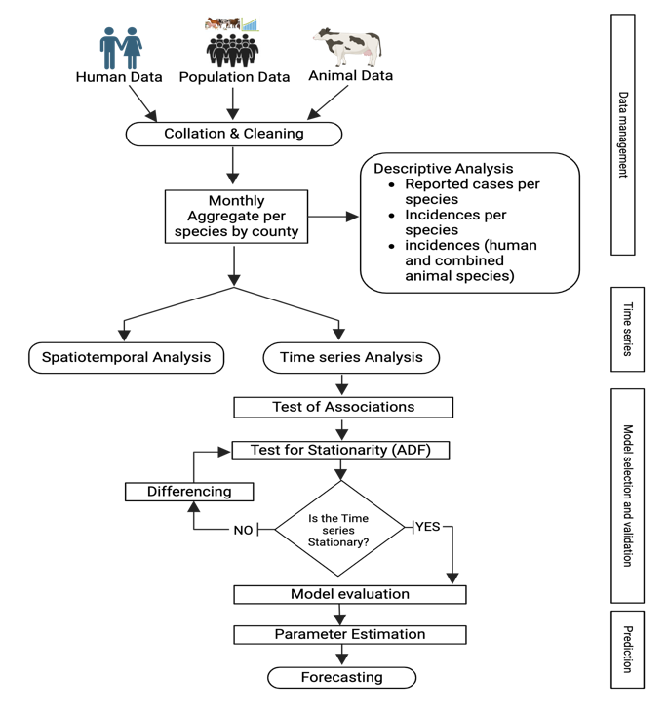

Figure 1: summary of methodology and approach used to undertake the spatiotemporal analysis and forecast for human brucellosis incidence 2014-2022.( Created in BioRender. Manyu, R. (2025) https://BioRender.com/nbmw39m)

3. Results
Over the entire period 2014 – 2022, the number of reported human cases was significantly higher than the number of reported animal cases, with human cases totalling 4,688,787 compared to 1,214 animal cases over the same period. Most of the animal cases were from goats 54.1% (656/1214), and the rest of the species-specific distribution was cattle 35.2% (427/1214), sheep 8.2% (99/1214), and camels 2.6% (32/1214). The average annual number of reported cases was highest in humans 99.97% (520,976/521,111), with markedly lower averages observed in animals, including goats 0.014% (73/521,111), cattle 0.009% (47/521,111), sheep 0.002% (11/521,111), and camels 0.0008% (4/521,111). The estimated incidence of human brucellosis varied between counties and ranged between 3 cases per 1000 people in Kilifi County to 399 cases per 1000 people in Elgeyo Marakwet County. Other counties with high incidence rates included West Pokot (375) and Nandi (304). On the lower end, counties such as Kilifi (4), Lamu (7), and Mombasa (6) reported significantly lower incidences.
The incidence of cattle brucellosis showed notable regional differences, ranging from 0 cases per 1,000,000 cattle in several counties to 235 cases per 1,000,000 cattle in Mombasa County. Eight counties had zero reported cases of brucellosis. Camel brucellosis incidence was relatively rare, with higher rates in specific regions. The incidence ranged from 0 cases per 1,000,000 camels in 38 counties to 122 cases per 1,000,000 camels in Tana River County. Goat brucellosis incidence varied significantly, ranging from 0 cases per 1,000,000 goats in 38 counties to 28 cases per 1,000,000 goats in Kwale County. Sheep brucellosis incidence was generally low, ranging from 0 cases per 1,000,000 sheep in 26 counties to 46 cases per 1,000,000 sheep in Makueni County. The highest recorded incidence in cattle 235 cases per 1,000,000 cattle is much higher than peaks in other species. That range for camels is narrower with maximum 122 cases per 1,000,000 camels in Tana River. Sheep and goat shows high heterogeneity with generally lower maximum incidence rate compared to cattle and camels.
Over the period, human incidence exhibited a relatively stable trend over time, with occasional fluctuations observed. Conversely, cattle and camel populations displayed sporadic peaks and troughs in incidence. Goat incidence exhibited a gradual increase over the study period, indicating a possible emerging health concern within this species. Sheep incidence, on the other hand, remained consistently low throughout the observation period.
The mean incidence rate in humans stood at 10,993 cases per a million people while for the animals, it was 1 case per million sheep, 3 cases per million goats, 3 cases per million cattle, and 1 case per million camels as shown in Table 1.
Overall, 3,630,512 (77.43%) 3,630,551 (77.43%) of the reported human cases of brucellosis underwent laboratory diagnosis. Out of all reported animal cases 24.8% (301/1214) were laboratory diagnosed, only 0.01% (17/1214) were diagnosed through postmortem with most 73.8% (896/1214) of them being clinically diagnosed as shown in Table 1 below.
The maximum incidence rate in humans was 14,764 cases per million people. Among animal species, goats had the highest maximum incidence rate of 10 cases per million goats followed by cattle, camels, and sheep with maximum incidence rates of 10, 3, and 2 cases per million population, respectively.
Table 1: Summary of estimates of brucellosis incidence and by the method of brucellosis diagnosis used for cases reported in the national human and animal surveillance systems in Kenya for the period 2014-2022.

Species | Total cases | Average annual cases | Clinically confirmed | Lab confirmed | Postmortem | Mean incidence rate | Minimum incidence rate | Median incidence rate | Maximum incidence rate | SD of incidence rate
Human | 4,688,787 | 520,976.3 | 1,058,236 (22.57%) | 3,630,551 (77.43%) | 0 (0%) | 10,992.68 | 2292.39 | 11968.15 | 14764.17 | 3918.56
Cattle | 427 | 47.4 | 270 (63.23%) | 140 (32.79%) | 17 (3.98%) | 3.01 | 0 | 1.97 | 6.47 | 2.74
Camel | 32 | 3.6 | 30 (93.75%) | 2 (6.25%) | 0 (0%) | 0.77 | 0 | 0 | 3.02 | 1.15
Goat | 656 | 72.9 | 514 (78.35%) | 142 (21.65%) | 0 (0%) | 2.6 | 0 | 1.11 | 10.32 | 3.47
Sheep | 99 | 11 | 82 (82.83%) | 17 (17.17%) | 0 (0%) | 0.57 | 0 | 0.05 | 1.86 | 0.72

The average brucellosis incidence in human maintained a gradual increase from around October 2014 and peaked in July 2017. From there the average incidence reported had uneven surges and the greatest peak was experienced in August 2019 as shown in figure 2. In animals, brucellosis incidence in cattle and goat was seen to follow a fairly similar pattern with the highest incidence being reported in cattle. Cases of brucellosis in camel appear to have been reported sporadically around 2015, 2019 and 2020. From the trends in the figure below, the trend in the animal brucellosis is distinctly different from the trend of the human brucellosis incidence.
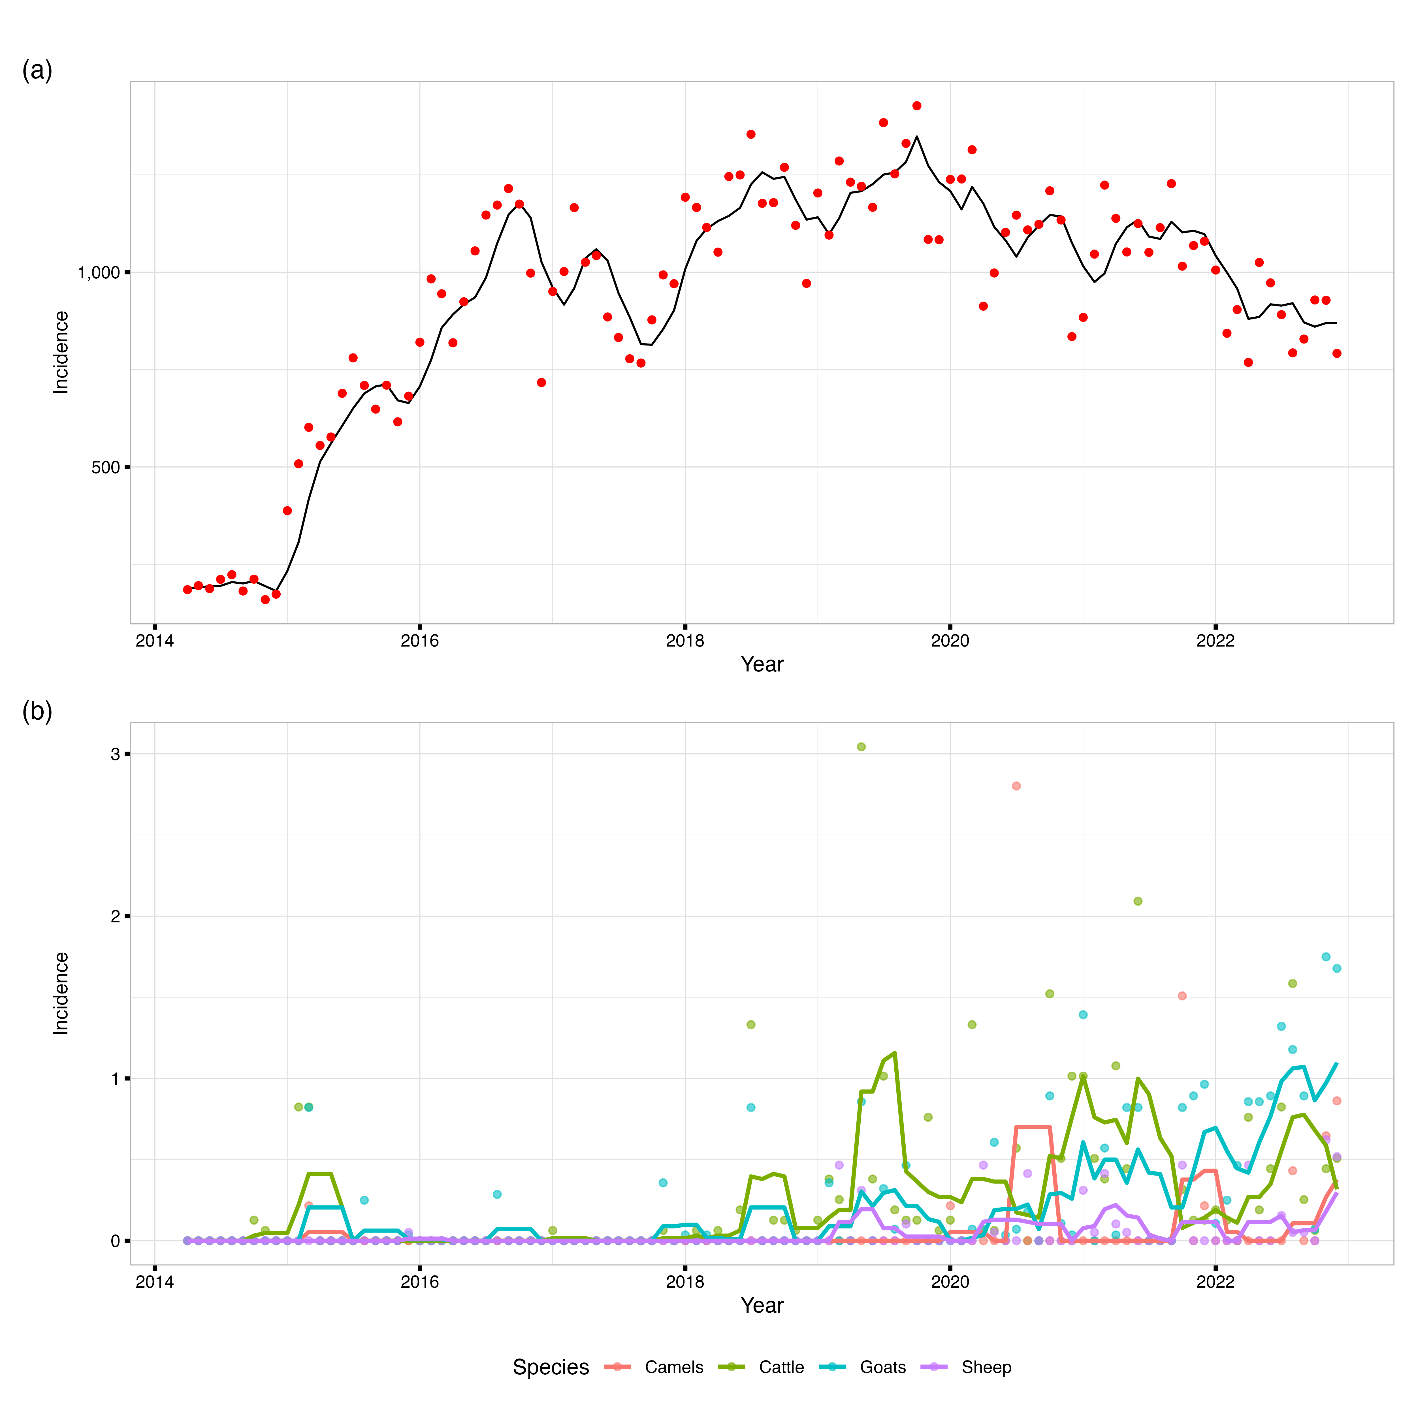
Figure 2: A line graph depicting monthly distribution of (a) humans and (b) animal brucellosis average incidences in Kenya, 2014-2022. (Applied temporal smoothing using a 4-months-period moving average to reduce noise in the monthly incidence time series and facilitate trend identification).
Human incidence was higher than the animal incidences with cases distributed across all the counties as shown in the Figure 3 below. The Coastal counties have consistently reported the lowest incidences of human and animal brucellosis. On the contrary, some cases were reported in 2015 in goats in Kilifi and 2018 in cattle. A big number of counties had no reported cases in animals despite having significant human incidence.

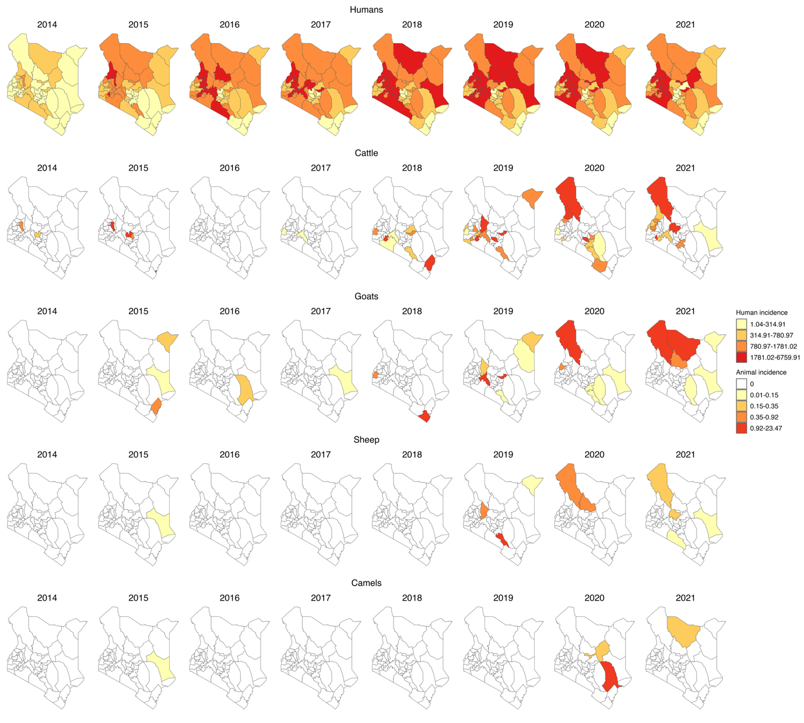
Figure 3: yearly incidence of human and animal Brucellosis at the county level in Kenya, 2014–2022. (For humans the incidence rate is per 1,000 population while for animal species it is per 1,000,000 population, and the colour is per the percentiles. Shapefiles sourced from GADM - https://gadm.org/download_country.html.

Test of association at national level: As shown on the Figure 4 below for individual animal species, At lag 0, sheep incidence was significantly associated with human incidence (estimate = -156.511, p = 0.045), while all other species, including total animal incidence, were not significant. At lag 1, cattle incidence showed a significant negative association with human incidence (estimate = -55.345, p = 0.012), and total animal incidence was also significant though marginally (estimate = -17.817, p = 0.090). For subsequent lags (2 to 6), most species-level and total animal incidence variables were not significantly associated with human incidence. However, at lag 4, goat incidence was statistically significant (estimate = -67.529, p = 0.087), and at lag 6, goat incidence became positively and significantly associated with human incidence (estimate = 65.600, p = 0.099). Across all models, the adjusted R² values remained low (ranging from -0.021 to 0.027), suggesting limited explanatory power. Additionally, model fit metrics such as AIC generally decreased with increasing lag, indicating a better model fit at higher lags, although the associations were not consistently significant.
The association between human brucellosis incidence and the log-transformed combined animal brucellosis incidence at a lag of 0-6 months was also analysed as shown in the Figure 4 below. At lag 0, the association was not statistically significant (estimate = 5.061, p = 0.631), with a very low adjusted R² of 0.018. At lag 1, total animal incidence showed a marginally significant negative association with human incidence (estimate = -17.817, p = 0.090), with a modest increase in model fit (adjusted R² = 0.018, AIC = 1024.73). For lags 2 to 6, the associations remained statistically non-significant (p > 0.05) as detailed in the Appendix B. Based on model fit statistics and evaluation of the diagnostic plots shown in Appendix A, lag 1 was selected for further analysis, as it demonstrated the strongest statistical association with human incidence (p = 0.090), had a lower AIC compared to lag 0, and showed the highest adjusted R² among all lags evaluated. Adjusted R² values for these models were consistently low (ranging from -0.009 to 0.007), indicating limited explanatory power.
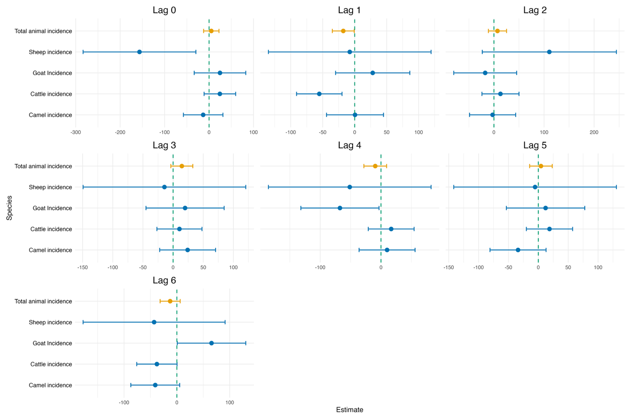
Figure 4: Forest plot for test of association between human brucellosis and animal (Individual and combined)species brucellosis at lag 0-6 using TSLM model

Test of association at combined animal species and county level: We proceeded further, to test the association between combined animal brucellosis incidence and human brucellosis incidence at 0-6 months lag for each individual county. Significant associations between animal and human brucellosis incidence were observed in several counties, with the strongest and most consistent effects occurring at lags 4 to 6 months. Notably, Kajiado, Kilifi, Siaya, and Tharaka Nithi showed strong statistical significance and higher model fit (R²).
At lag 0, only weak associations were observed, with marginal significance in Kericho (p = 0.052), Nakuru (p = 0.062), and Trans Nzoia (p = 0.053). Stronger and more statistically significant associations emerged at lag 1, particularly in Nakuru (estimate = -3.47, p = 0.009), Narok (estimate = -349, p = 0.008), and Tharaka Nithi (estimate = 41.05, p = 0.016). At lag 2, significant positive associations were found in Nakuru (estimate = 3.79, p = 0.004) and Narok (estimate = 288.8, p = 0.031). At lag 3, counties such as Nyeri (estimate = 2.14, p = 0.003) and Tharaka Nithi (estimate = -48.7, p = 0.004) exhibited strong associations. The trend intensified at lag 4, where several counties demonstrated highly significant associations, including Kajiado (estimate = -810, p < 0.001), Siaya (estimate = 20.32, p = 0.002), and Tharaka Nithi (estimate = 76.05, p < 0.001). The strongest effects were observed at lag 5, particularly in Kajiado (estimate = 1376, p < 0.001, R² = 0.36) and Kilifi (estimate = -1.05, p = 0.035). At lag 6, Kajiado again showed a significant negative association (estimate = -794, p < 0.001), while Kilifi had a strong positive association (estimate = 2.04, p < 0.001, R² = 0.165).
SARIMA prediction analysis: Here we used the combined animal incidence data at lag of 1 month. Two SARIMA models were evaluated for forecasting human brucellosis incidence in 2023: SARIMA(1,1,1)(2,0,0)[12] (without a covariate) and SARIMA(2,1,2)(1,0,0)[12] (with a covariate). The model without the covariate consistently outperformed the model with the covariate, showing lower RMSE, MAE, and MAPE values. Thus, the simpler SARIMA(1,1,1)(2,0,0)[12] model provided a more accurate forecast for human brucellosis in 2023 as shown in the Table 2 below.
Table 2: Error metrics used to select the best fit model

Model | MAE | RMSE | MAPE
Model with no exogenus variable | 108.88 | 123.44 | 11.63
Model with exogenus variable | 110.16 | 127.63 | 11.90

A graphical visualization of the models training and forecasts shown in Figure 5Error! Reference source not found. below depicts that our predicted values were within the 80% and 95% prediction interval and the forecast without exogenous variable was closer to the actual human incidence. The first plot on the top shows the training and testing forecasting of human incidence based on the first SARIMA model without the exogenous variable. The second plot in the bottom shows the training and testing forecasting of human incidence based on the second SARIMA model with the exogenous variable.

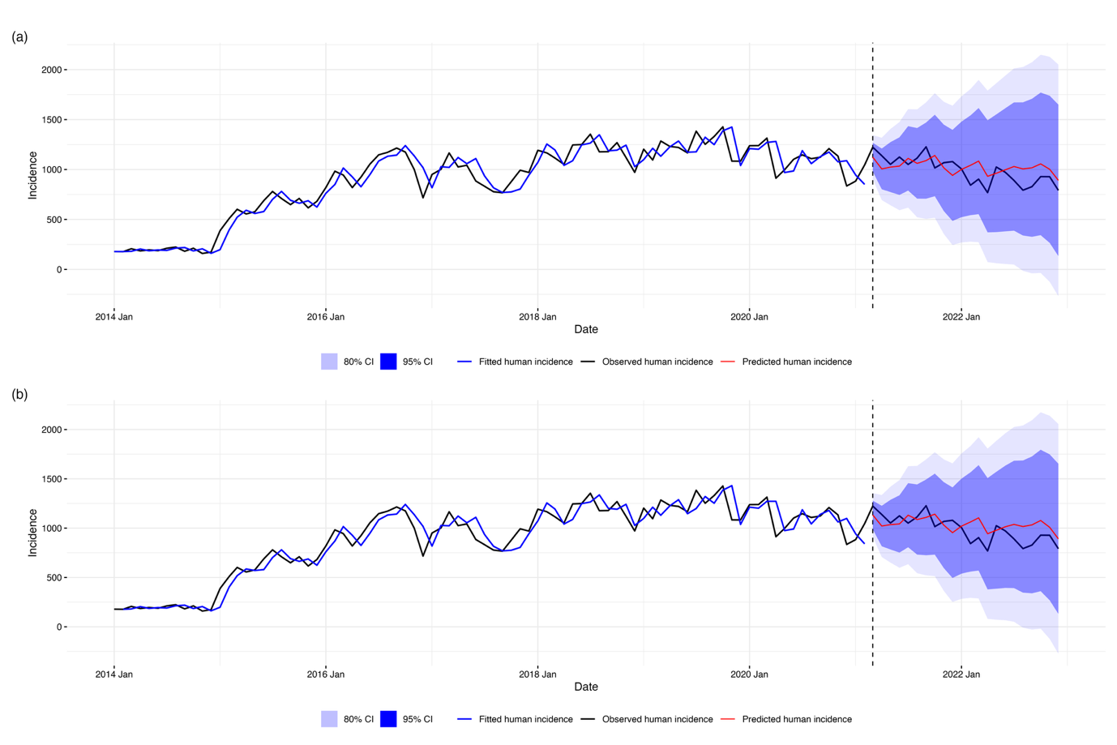
Figure 5: comparison of SARIMA forecasting models for human disease incidence. (a) Univariate SARIMA model using only historical human incidence data. (b) SARIMA model with one-month lagged animal incidence exogenous variable. Both panels show observed human incidence (black line) from 2014-2021, model-fitted values during the training period (blue line), and out-of-sample forecasts for 2021-2022 (red line) with 80% (dark blue) and 95% (light blue) prediction intervals. The vertical dashed line indicates the start of the forecasting period (March 2021)

After establishing that the forecasting model without animal incidence fitted our data better than with the exogenous variable, we retrained the best model with complete data set 2014 to 2022 and then forecasted for 2023 as shown in the Error! Reference source not found.Error! Reference source not found. below.

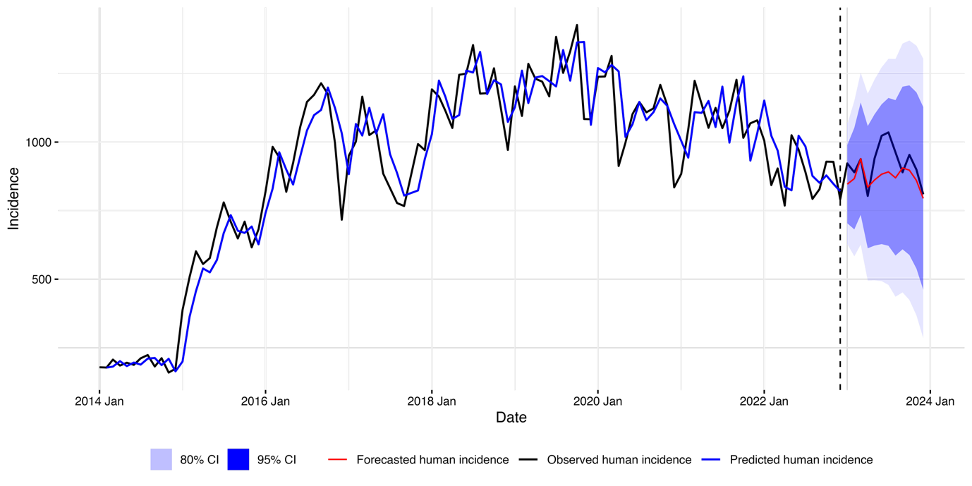
Figure 6: Final SARIMA model for human disease incidence forecasting. Following model comparison, the univariate SARIMA model was retrained on full 2014-2022 data and used to generate 2023 forecasts. Lines show observed incidence (black), fitted values (blue), and forecasts (red) with 80% and 95% prediction intervals. Vertical line marks forecast period start.

4. Discussion
This study uncovers important epidemiological findings that emphasize the need for integrated One Health (OH) surveillance. The number of reported cases of human brucellosis far exceeds the number of animal cases, showing notable regional disparities and variations over time. The spatial distribution suggests that animal cases are being underreported, despite high incidences in humans. Apart from cattle incidences which showed negative association, there is a lack of significant association between brucellosis incidences in most animal species and humans, highlighting potential gaps and underreporting in the animal health sector. Additionally, our SARIMA forecasting models demonstrate that although human brucellosis incidence can be reasonably predicted, the inclusion of animal incidence data surprisingly does not significantly improve the predictive power. These findings provide insights into the gaps and potential data quality issues in passive surveillance systems and make a compelling case for policymakers to invest in comprehensive One Health surveillance systems to effectively combat zoonoses.

The clinical picture of brucellosis can be confusing because unusual cases with uncharacteristic lesions continue to be reported. For this reason, diagnosis ought to be supported by laboratory tests (25). The quality of the data in animal health surveillance system is therefore, greatly affected by the conspicuously high level of underreporting and minimal utilization of the laboratory diagnostic services as evidenced by the study. This could compromise the utility of animal incidences of brucellosis to predict human brucellosis.
Brucellosis diagnosis has been identified as one of the major hindrances to the control of the disease (26) since it can be clinically confused with various other conditions in both humans and animals. In our surveillance systems, there was a considerable number of reports that were not confirmed in the laboratory but were diagnosed clinically, especially in animal health surveillance. In Kenya, studies have confirmed lack of reliable diagnostic support, use of highly sensitive and non-specific tests and routine disease underreporting greatly affect the surveillance systems and potentially cause false alerts (5). However, there is a likelihood of overdiagnosis of brucellosis cases in human due to use of rapid tests in most health facilities without confirmatory testing which leads to possible overestimation of human cases (27). It therefore immediate priority to improve brucellosis surveillance in Kenya and East Africa is the implementation of robust quality control systems and clear guidance on the selection and use of frontline diagnostic tests(7). Effective integrated surveillance requires harmonized diagnostic testing across human and animal health sectors, as inconsistent test selection undermines data comparability and outbreak detection. Brucellosis serves as a critical model for demonstrating how standardized laboratory confirmation in both populations coupled with data linkage mechanisms enhances early warning capabilities (28,29).
Brucella organisms localize and multiply in reticuloendothelial tissues like lymph nodes, liver, and bone marrow, which can be sampled postmortem. While postmortem examination is not a primary diagnostic approach, it may enhance bacterial recovery when combined with culture techniques for diagnosing brucellosis(26,30). From this study, the analysis reveals that the official human health surveillance system does not capture any cases that may be passively picked during the pathological examination at the postmortem. This could lead to the loss of some important information and underreporting of human health events. It is therefore important to consider mortality surveillance focussing on the mortuaries to address this gap.
The observed distinct temporal patterns of brucellosis underscore the complex interplay of factors influencing disease dynamics within each species, highlighting the importance of targeted surveillance and intervention strategies tailored to the specific needs of individual animal populations. We also observed potential correlations in trends between some animal species like goats and human incidence peaks suggesting possible zoonotic transmission patterns confirming the fact that brucellosis is an obligate zoonoses. The weak correlations between human and animal case data in most other animal species likely result from incomplete surveillance, diagnostic variability, and complex transmission involving multiple hosts and environmental factors. These challenges, common in pastoralist regions of Kenya, highlight the need for continuous, integrated One Health surveillance to improve understanding of transmission and support effective control (31,32).
Generally, the spatial distribution and the numbers of cases (reports) captured in the human health surveillance system are comparatively much more than those captured in the animal health surveillance system. Additionally, the distribution of the animal cases does not follow the same spatial pattern as the cases of human probably due to poor data quality. This is contrary to previous studies that proved existence of similar distribution pattern and trends in human and animal brucellosis (33–35) and this is probably due to underreporting, misdiagnosis, and other factors weakening the surveillance systems. This may be attributed to the wide distribution and accessibility of numerous health facilities which are the aggregation points for data in human health sector unlike the case in animal health sector where the reports are collected at the herd/farm level from villages, laboratories, clinics, crushes, and abattoirs and aggregated at the sub-county level. Additionally, the observed widespread occurrence of human cases across nearly all regions of the country could also be attributed to the fact that people move around further and wide while infected animal products could also be traded far and wide thus spreading infection to many humans.
Cattle and goat incidences follow a fairly similar distribution patterns and as reported in previous studies, cattle cases were higher than the sheep and goat cases(33). Isiolo County, previously identified as brucellosis endemic by earlier studies (35), did not record any animal cases during the study period. This absence of recorded cases highlights significant weaknesses in the surveillance system (36). However, the spatial coverage of animal health reports seems to be improving from around 2018 onwards, an improvement that can be attributed to the national roll out of electronic reporting tools (20).
The bulk of the cases in the animal health surveillance system were in cattle since cattle are the most widely distributed animal species in Kenya (KNBS, 2019) and it is the species which most health care is provided due to its high value. The distribution of brucellosis cases in the country as manifested by the study is affected by reporting bias across counties and thus the need to ensure that both surveillance systems have a clear process where they report even absence of priority diseases cases or events, called "zero reporting" to remove uncertainty and distinguish absence of disease (37) from lack of reporting.
Previous studies established that in developing countries, B. abortus, B. melitensis, and B. suis are leading causes of animal and human brucellosis (8,25) and that there is a high correlation between human brucellosis and brucella seroprevalence in animals (6,38,39). However, this study found discrepancies in the association that may be explained by inadequacy and weaknesses in the Kenyan surveillance system and data. In human health surveillance system, some counties still use manual data collection contributing to delayed reporting and therefore, affect the data quality which could contribute to the observed discrepancies. Contrary to our expectations and previous studies, forecast models fitted the data better when brucellosis incidences are forecasted without the animal brucellosis incidences as exogenous variable, suggesting that the exogenous variable introduced noise in the model reducing its accuracy and predictive ability which further underscores the need to address the weaknesses in our surveillance systems. Poor quality data could arise from challenges affecting the surveillance systems. Some of the key challenges affecting the surveillance systems identified in the previous studies include; vastness and remoteness of some areas characterized by poor infrastructure and communications, the need to conduct adequate surveillance with limited financial resources (40), inadequate numbers of trained personnel (41), lack of supplies, materials, transport facilities, diagnostic facilities (42–44), competition among stakeholders driven by financial needs “Commercial interest” (45), unharmonized reporting structures, inadequate response to disease outbreaks, lack of incentives and motivation for surveillance and political interference (46) among others.
Among the practical steps towards addressing the identified challenges in brucellosis surveillance is investing in integrated community based and One Health surveillance systems that leverage mobile and digital technologies, strengthening workforce capacity through targeted training and promoting multisectoral coordination. Improving infrastructure, standardizing diagnostic protocols, and implementing zero-reporting mechanisms are essential to ensure data quality and harmonization across human and animal health sectors. Sustained stakeholder engagement further supports resilient and effective surveillance systems capable of early warning and control of zoonotic diseases like brucellosis (47–49).
In consideration of the principles of One Health and the existence of human-animal and environmental interactions in Kenya's epidemiological triad, our study agrees with previous research on the importance of addressing priority zoonotic diseases. This includes focusing on disease control in animal reservoirs and strengthening surveillance and management efforts in animals. By doing so, we aim to reduce the incidence of these diseases in human populations through the implementation of a One Health framework (26). Effective control measure would benefit from a targeted intervention policy and strengthened cooperation between human health and veterinary services (34,50) and would be bolstered by better quality data.
This study had several limitations. Firstly, the quality surveillance data may be affected by limited diagnostic capacity including reliance on clinical diagnosis and inconsistent laboatory testing for brucellosis, which increases risk of false positive and false negative case reporting and thus affect the results. The use of retrospective data extracted from routine surveillance systems could be affected by reporting bias, incomplete records and potential underreporting, which may diminish the representativeness of findings and influence geographic or temporal patterns. The study also assumes that patients generally seeks healthcare services in their respective counties however, patient movement across counties is possible, which could influence estimates of disease clustering and spatial distribution.
It is important to note that the primary aim of this study was not to validate clinical or laboratory diagnoses, but rather to evaluate the strengths and shortcomings of the official surveillance systems as they currently function in Kenya. Therefore, all data were extracted, cleaned, and analyzed in their original form as reported to the national authorities, providing insights into surveillance system performance under real-world operational conditions. These limitations reinforce the importance of strengthening diagnostic capacities, harmonizing case definitions to enhance the accuracy and effectiveness of integrated zoonotic disease surveillance.

5. Conclusions
This study is the first prediction of human brucellosis in Kenya for the period 2022 to 2023. From our study we characterize the spatial distribution, test the association of human and animal brucellosis and note that prediction of zoonotic disease such as brucellosis is possible. Moreover, we observed that that SARIMA is effective in forecasting the human incidence of brucellosis. SARIMA outperforms ETS and ARIMA in the forecasting accuracy. Using the established $SARIMA \left(2,1,2\right)\left(1,0,0\right)\left[12\right]$ model, we tested accuracy of human brucellosis incidence prediction in Kenya from 2022 to 2023. Our study method and prediction results can contribute to policy makers for improvement of human and animal diseases surveillance system and utility of the surveillance data to strengthen Early Warning System.
Animal health surveillance data is important in informing the human health surveillance system and therefore can be useful in forecasting public health events. However, the current surveillance systems as revealed by this analysis, may not be reflecting the accurate disease situation due to underreporting, possible misdiagnosis of cases arising from identified structural and operational issues. These challenges and identified gaps should be addressed to improve the quality of information collected and consequently their potential to inform the Early Warning systems for zoonoses in Kenya.
These findings reinforce the need for improving the diagnosis, reporting of zoonoses, and potential adoption of integrated One Health (OH) surveillance approach enhance synergy across sectors and improve the accuracy of disease reporting and forecasting, ultimately leading to more effective interventions and reduced zoonotic disease burdens in Kenya.

6. Patents
Not applicable
Supplementary Materials: The following supporting information can be downloaded at: https://www.mdpi.com/article/doi/s1, Figure S1: title; Table S1: title; Video S1: title.
Author Contributions: SK, LFT, BB, MM & SMT conceptualized the work. SK, AM, BN, MN carried out the analysis. SK developed the first draft manuscript. All authors wrote the manuscript, read and approved the final draft of the manuscript.
Funding: This research was funded by One Health Research, Education and Outreach Centre in Africa OHRECA and the Gates Foundation through the Centre for Epidemiological Modelling and Analysis (INV-044079)
Institutional Review Board Statement: The ethical approval for the study was sought from the University of Nairobi Ethical Approval Committee (KNH/UON ERC). For the use of human and animal data, the authority sought from the Ministry of Health and Directorate of Veterinary Services respectively.
Data Availability Statement: The data used in this study and the analysis code is available on GitHub on https://github.com/wagathu/brucellosis.
Acknowledgments: SK, BB & LFT are supported by the BMZ funded ‘One Health Centre for Research, Education & Outreach (OHRECA). LFT is also supported by the Welcome Trust-University of Liverpool Institutional Strategic Support Fund and is a Soulsby Foundation One Health Travelling Fellow. The funders had no role in the decision to publish or the preparation of this manuscript.
Conflicts of Interest: The authors declare no conflict of interest.

Abbreviations
The following abbreviations are used in this manuscript:
SARIMA Seasonal Autoregressive Integrated Moving Average models
KHIS Kenya Health Information System
KABS Kenya Animal Bio-surveillance System
KNBS Kenya National Bureau of Statistics
TSLM Time Series Linear Models
ADF Augmented Dickey–Fuller

Appendix A

Appendix A: TSLM models diagnostics Plot lag 0-6 months (left panel-Time series plot, Middel panel – ACF Plot, Right Panel-Histogram)
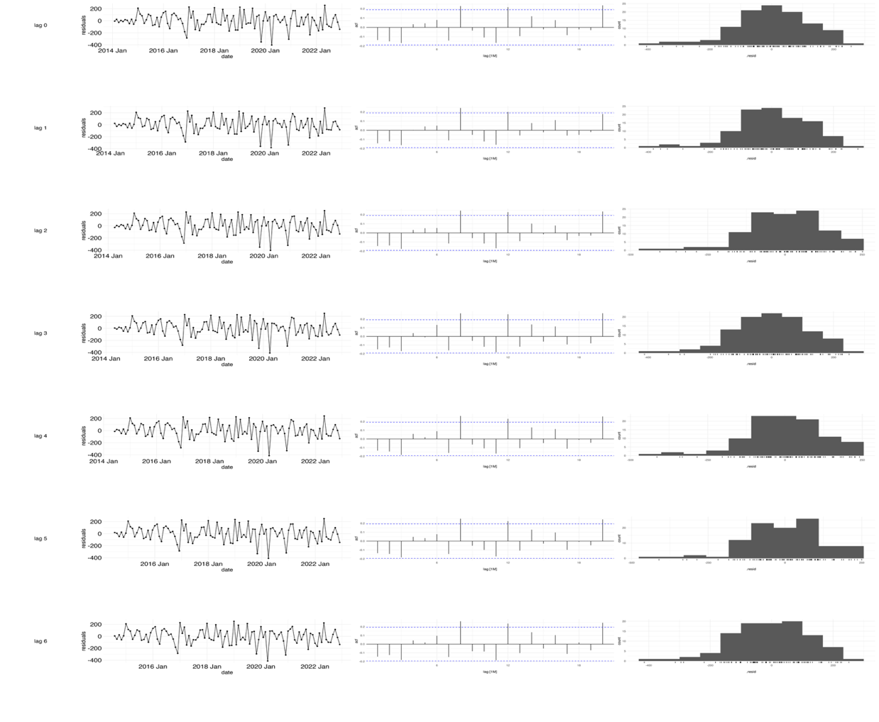
TSLM models diagnostics Plot lag 0-6 months (left panel-Time series plot, Middel panel – ACF Plot, Right Panel-Histogram)

Appendix B

Appendix B: Tabulation of the error metrices (MAE, RMSE and MAPE) for the TSLM from 1-6 lags
lag | MAE | RMSE | MAPE
Lag 0 | 107.340785 | 121.775861 | 11.412123
Lag 1 | 110.164144 | 127.631526 | 11.9027991
Lag 2 | 110.096513 | 124.752796 | 11.7661673
Lag 3 | 106.71078 | 121.684391 | 11.3373693
Lag 4 | 110.259697 | 122.84345 | 11.4226258
Lag 5 | 113.204553 | 131.292121 | 12.2466865
Lag 6 | 99.0380344 | 118.30954 | 10.2856198

References

1. Laine CG, Johnson VE, Scott HM, Arenas-Gamboa AM. Global Estimate of Human Brucellosis Incidence - Volume 29, Number 9—September 2023 - Emerging Infectious Diseases journal - CDC. Emerg Infect Dis [Internet]. 2023 Sep 1 [cited 2024 Feb 26];29(9):1789–97. Available from: https://wwwnc.cdc.gov/eid/article/29/9/23-0052_article
2. McDermott J, Grace D, Zinsstag J. Economics of brucellosis impact and control in low-income countries. Rev Sci Tech [Internet]. 2013 [cited 2024 Feb 26];32(1):249–61. Available from: https://pubmed.ncbi.nlm.nih.gov/23837382/
3. Nasinyama G, Ssekawojwa E, Opuda J, Grimaud P, Etter E, Bellinguez A. Brucella sero-prevalence and modifiable risk factors among predisposed cattle keepers and consumers of un-pasteurized milk in Mbarara and Kampala districts, Uganda. Afr Health Sci. 2014;14(4):790–6.
4. Nejad RB, Krecek RC, Khalaf OH, Hailat N, Arenas-Gamboa AM. Brucellosis in the middle east: Current situation and a pathway forward. Vol. 14, PLoS Neglected Tropical Diseases. 2020.
5. Njeru J, Wareth G, Melzer F, Henning K, Pletz MW, Heller R, et al. Systematic review of brucellosis in Kenya: Disease frequency in humans and animals and risk factors for human infection. Vol. 16, BMC Public Health. BioMed Central Ltd.; 2016.
6. Munyua P, Osoro E, Hunsperger E, Ngere I, Muturi M, Mwatondo A, et al. High incidence of human brucellosis in a rural pastoralist community in Kenya, 2015. PLoS Negl Trop Dis. 2021 Feb 1;15(2).
7. Zoonotic Disease Unit K. Kenya brucellosis control strategy. Government of Kenya; 2022.
8. Osoro EM, Munyua P, Omulo S, Ogola E, Ade F, Mbatha P, et al. Strong association between human and animal brucella seropositivity in a linked study in Kenya, 2012-2013. American Journal of Tropical Medicine and Hygiene. 2015 Aug 1;93(2):224–31.
9. Muema J, Oboge H, Mutono N, Makori A, Oyugi J, Bukania Z, et al. Sero – epidemiology of brucellosis in people and their livestock: A linked human – animal cross-sectional study in a pastoralist community in Kenya. Front Vet Sci. 2022;9.
10. Akoko JM, Mwatondo A, Muturi M, Wambua L, Abkallo HM, Nyamota R, et al. Mapping brucellosis risk in Kenya and its implications for control strategies in sub-Saharan Africa. Scientific Reports | [Internet]. 123AD;13:20192. Available from: https://doi.org/10.1038/s41598-023-47628-1
11. Lokamar PN, Kutwah MA, Munde EO, Oloo D, Atieli H, Gumo S, et al. Prevalence of brucellosis in livestock keepers and domestic ruminants in Baringo County, Kenya. PLOS global public health [Internet]. 2022 Aug 15 [cited 2024 Feb 26];2(8):e0000682. Available from: https://pubmed.ncbi.nlm.nih.gov/36962768/
12. Mwatondo A, Muturi M, Akoko J, Nyamota R, Nthiwa D, Maina J, et al. Seroprevalence and related risk factors of Brucella spp. in livestock and humans in Garbatula subcounty, Isiolo county, Kenya. PLoS Negl Trop Dis [Internet]. 2023 Oct 1 [cited 2024 Feb 26];17(10). Available from: https://pubmed.ncbi.nlm.nih.gov/37844102/
13. Akoko JM, Pelle R, Lukambagire AHS, Machuka EM, Nthiwa D, Mathew C, et al. Molecular epidemiology of Brucella species in mixed livestock-human ecosystems in Kenya. Sci Rep. 2021 Dec 1;11(1).
14. Akoko J, Pelle R, Kivali V, Schelling E, Shirima G, MacHuka EM, et al. Serological and molecular evidence of Brucella species in the rapidly growing pig sector in Kenya. BMC Vet Res [Internet]. 2020 May 11 [cited 2024 Feb 26];16(1). Available from: https://pubmed.ncbi.nlm.nih.gov/32393374/
15. Kemunto N, Mogoa E, Osoro E, Bitek A, Kariuki Njenga M, Thumbi SM. Zoonotic disease research in East Africa. BMC Infect Dis [Internet]. 2018 Nov 3 [cited 2024 Jun 9];18(1):1–9. Available from: https://bmcinfectdis.biomedcentral.com/articles/10.1186/s12879-018-3443-8
16. WHO. Surveillance in emergencies [Internet]. 2022 [cited 2024 Feb 27]. Available from: https://www.who.int/emergencies/surveillance
17. Hayman DTS, Adisasmito WB, Almuhairi S, Behravesh CB, Bilivogui P, Bukachi SA, et al. Developing One Health surveillance systems. One Health. 2023 Dec 1;17:100617.
18. Nsubuga P, White ME, Thacker SB, Anderson MA, Blount SB, Broome C V., et al. Public Health Surveillance: A Tool for Targeting and Monitoring Interventions. Disease Control Priorities in Developing Countries [Internet]. 2006 [cited 2024 Feb 27]; Available from: https://www.ncbi.nlm.nih.gov/books/NBK11770/
19. Huppert A, Katriel G. Mathematical modelling and prediction in infectious disease epidemiology. Vol. 19, Clinical Microbiology and Infection. Blackwell Publishing Ltd; 2013. p. 999–1005.
20. Kahariri S, Thumbi SM, Bett B, Mureithi MW, Nyaga N, Ogendo A, et al. The evolution of Kenya’s animal health surveillance system and its potential for efficient detection of zoonoses. Front Vet Sci [Internet]. 2024 Jun 20 [cited 2024 Jul 1];11:1379907. Available from: https://www.frontiersin.org/articles/10.3389/fvets.2024.1379907/full
21. Cunningham Paul, Cunningham Miriam. IST-Africa 2012 conference proceedings and exhibition 9-12 May 2012, Dar es Salaam, Tanzania. IIMC; 2012.
22. Njenga K, Kemunto N, Kahariri S, Holmstrom L, Oyas H, Biggers K, et al. High Real-time Reporting of Domestic and Wild Animal Diseases Following Rollout of Mobile Phone Reporting System in Kenya. 2020;
23. KNBS. 2019 Kenya Population and Housing Census. 2019.
24. Team RC. R: A language and environment for statistical computing. R Foundation for Statistical Computing, Vienna, Austria. http://wwwR-project.org/ [Internet]. 2016 [cited 2023 May 27]; Available from: https://cir.nii.ac.jp/crid/1574231874043578752.bib?lang=en
25. Corbel M. Brucellosis: an Overview. Emerg Infect Dis [Internet]. 1997 Jun;3(2):213–21. Available from: http://www.cdc.gov/ncidod/eid/vol3no2/corbel.htm
26. Hull NC, Schumaker BA. Comparisons of brucellosis between human and veterinary medicine. Vol. 8, Infection Ecology and Epidemiology. Taylor and Francis Ltd.; 2018.
27. de Glanville WA, Conde-Álvarez R, Moriyón I, Njeru J, Díaz R, Cook EAJ, et al. Poor performance of the rapid test for human brucellosis in health facilities in Kenya. PLoS Negl Trop Dis [Internet]. 2017 Apr 7 [cited 2024 Jul 6];11(4):e0005508. Available from: https://journals.plos.org/plosntds/article?id=10.1371/journal.pntd.0005508
28. Pappas G, Akritidis N, Bosilkovski M, Tsianos E. Brucellosis. New England Journal of Medicine [Internet]. 2005 Jun 2 [cited 2025 Jun 6];352(22). Available from: https://www.nejm.org/doi/full/10.1056/NEJMra050570
29. Lyimo B, Hugho E, Mathew C, Mayenga C, Lukambagire AH, Lyimo S, et al. Seroprevalence and risk factors for brucellosis amongst livestock and humans in a multi-herd ranch system in Kagera, Tanzania. Front Public Health [Internet]. 2024 [cited 2025 Jun 6];12:1478494. Available from: https://pubmed.ncbi.nlm.nih.gov/39555043/
30. Yagupsky P, Morat P, Colmenero JD. Laboratory diagnosis of human brucellosis. Clin Microbiol Rev [Internet]. 2020 Jan 1 [cited 2025 Jun 7];33(1). Available from: https://journals.asm.org/doi/10.1128/cmr.00073-19
31. Akoko JM, Pelle R, Lukambagire AHS, Machuka EM, Nthiwa D, Mathew C, et al. Molecular epidemiology of Brucella species in mixed livestock-human ecosystems in Kenya. Sci Rep [Internet]. 2021 Apr 23 [cited 2025 Jun 7];11(1). Available from: https://hdl.handle.net/10568/113566
32. Lokamar PN, Kutwah MA, Munde EO, Oloo D, Atieli H, Gumo S, et al. Prevalence of brucellosis in livestock keepers and domestic ruminants in Baringo County, Kenya. PLOS Global Public Health [Internet]. 2022 Aug 1 [cited 2025 Jun 7];2(8):e0000682. Available from: https://pmc.ncbi.nlm.nih.gov/articles/PMC10021631/
33. Zhou K, Wu B, Pan H, Paudyal N, Jiang J, Zhang L, et al. ONE Health Approach to Address Zoonotic Brucellosis: A Spatiotemporal Associations Study Between Animals and Humans. Front Vet Sci [Internet]. 2020 Sep 2 [cited 2024 Feb 9];7:521. Available from: /pmc/articles/PMC7492289/
34. De Massis F, Di Girolamo A, Petrini A, Pizzigallo E, Giovannini A. Correlation between animal and human brucellosis in Italy during the period 1997–2002. Clinical Microbiology and Infection. 2005 Aug 1;11(8):632–6.
35. Njeru J, Nthiwa D, Akoko J, Oyas H, Bett B. Incidence of Brucella infection in various livestock species raised under the pastoral production system in Isiolo County, Kenya. BMC Vet Res [Internet]. 2021 Dec 1 [cited 2024 Feb 9];17(1):1–12. Available from: https://bmcvetres.biomedcentral.com/articles/10.1186/s12917-021-03036-z
36. Armstrong G, Birkhead GS, Horan JM, Herrera G, Lee LM, Milstein RL, et al. Updated Guidelines for Evaluating Public Health Surveillance Systems Recommendations from the Guidelines Working Group The following CDC staff members prepared this report. 2001.
37. Chow A, Leo YS. Surveillance of Disease: Overview. International Encyclopedia of Public Health [Internet]. 2017 Oct 6 [cited 2024 Feb 12];124. Available from: /pmc/articles/PMC7149774/
38. Reif JS. Animal sentinels for environmental and public health. Public Health Rep [Internet]. 2011;126 Suppl 1(SUPPL. 1):50–7. Available from: http://www.ncbi.nlm.nih.gov/pubmed/21563712
39. Pearce N, Douwes J. Research at the interface between human and veterinary health. Prev Vet Med [Internet]. 2013 Sep 1;111(3–4):187–93. Available from: http://www.ncbi.nlm.nih.gov/pubmed/23791125
40. Allport R, Mosha R, Bahari M, Swai E, Catley A. The use of community-based animal health workers to strengthen disease surveillance systems in Tanzania. 2005;24(3):921–32.
41. Halliday J, Daborn C, Auty H, Mtema Z, Lembo T, Bronsvoort BM deC., et al. Bringing together emerging and endemic zoonoses surveillance: shared challenges and a common solution. Philosophical Transactions of the Royal Society B: Biological Sciences [Internet]. 2012 Oct 19;367(1604):2872–80. Available from: https://royalsocietypublishing.org/doi/10.1098/rstb.2011.0362
42. Robertson C, Sawford K, Daniel SLA, Nelson TA, Stephen C. Mobile phone-based infectious disease surveillance system, Sri Lanka. Emerg Infect Dis [Internet]. 2010 Oct;16(10):1524–31. Available from: http://www.ncbi.nlm.nih.gov/pubmed/20875276
43. Omondi M, Ngere I, Ndeta C. Report on the Evaluation of Surveillance Systems Relevant to Zoonotic Diseases in Kenya-2015: A Basis for Design of an Integrated Human Livestock Surveillance System Evaluation Report [Internet]. 2016. Available from: www.zoonotic-diseases.org
44. Don Bamunusinghage Nihal P, Dangolla A, Hettiarachchi R, Abeynayake P, Stephen C. CHALLENGES AND OPPORTUNITIES FOR WILDLIFE DISEASE SURVEILLANCE IN SRI LANKA. J Wildl Dis [Internet]. 2020 Jul 2;56(3):538. Available from: https://bioone.org/journals/journal-of-wildlife-diseases/volume-56/issue-3/2019-07-181/CHALLENGES-AND-OPPORTUNITIES-FOR-WILDLIFE-DISEASE-SURVEILLANCE-IN-SRI-LANKA/10.7589/2019-07-181.full
45. Johnson I, Hansen A, Bi P. The challenges of implementing an integrated One Health surveillance system in Australia. Zoonoses Public Health [Internet]. 2018 Feb;65(1):e229–36. Available from: http://doi.wiley.com/10.1111/zph.12433
46. Omondi M, Ngere I, Ndeta C. Report on the Evaluation of Surveillance Systems Relevant to Zoonotic Diseases in Kenya-2015: A Basis for Design of an Integrated Human Livestock Surveillance System Evaluation Report [Internet]. 2016. Available from: www.zoonotic-diseases.org
47. Worsley-Tonks KEL, Bender JB, Deem SL, Ferguson AW, Fèvre EM, Martins DJ, et al. Strengthening global health security by improving disease surveillance in remote rural areas of low-income and middle-income countries. Lancet Glob Health [Internet]. 2022 Apr 1 [cited 2025 Jun 7];10(4):e579–84. Available from: https://www.thelancet.com/action/showFullText?pii=S2214109X22000316
48. Lisa Were AM, Otieno JA, Nyanchoka M, Karanja PW, Omia D, Ngere P, et al. Advance Warning and Response Systems in Kenya: A Scoping Review. medRxiv [Internet]. 2025 Apr 23 [cited 2025 Jun 7];2025.04.23.25326250. Available from: https://www.medrxiv.org/content/10.1101/2025.04.23.25326250v1
49. MOH. DIVISION OF DISEASE SURVEILLANCE & RESPONSE.
50. Zheng Y, Zhang L, Wang C, Wang K, Guo G, Zhang X, et al. Predictive analysis of the number of human brucellosis cases in Xinjiang, China. Sci Rep. 2021 Dec 1;11(1).

