Notes:

I. Only the Metsense board is used in all the graphs.
II. The Metsense board has several sensors on it, a bunch of which measure temperature, two of which measure humidity and one pressure (see figure below).
III. Below is the arrangement of sensors on the Metsense board. In the image way below, you can see that
the CPU (has ATMEL written on it) is closest to TSYS and PRJ sensors. The PRJ Sensor is lifted from the board by 2 mm. The rest of the sensors are mounted on the board).

IV. Graphs and Axis:
1. In graphs with temperature, the Y axis unit is Centigrade and the X axis unit is Seconds.
2. In graphs with humidity, the Y axis unit is %RH and the X axis unit is Seconds.
3. In graphs with Atmospheric Pressure, the Y axis unit is Pa and the X axis unit is Seconds.

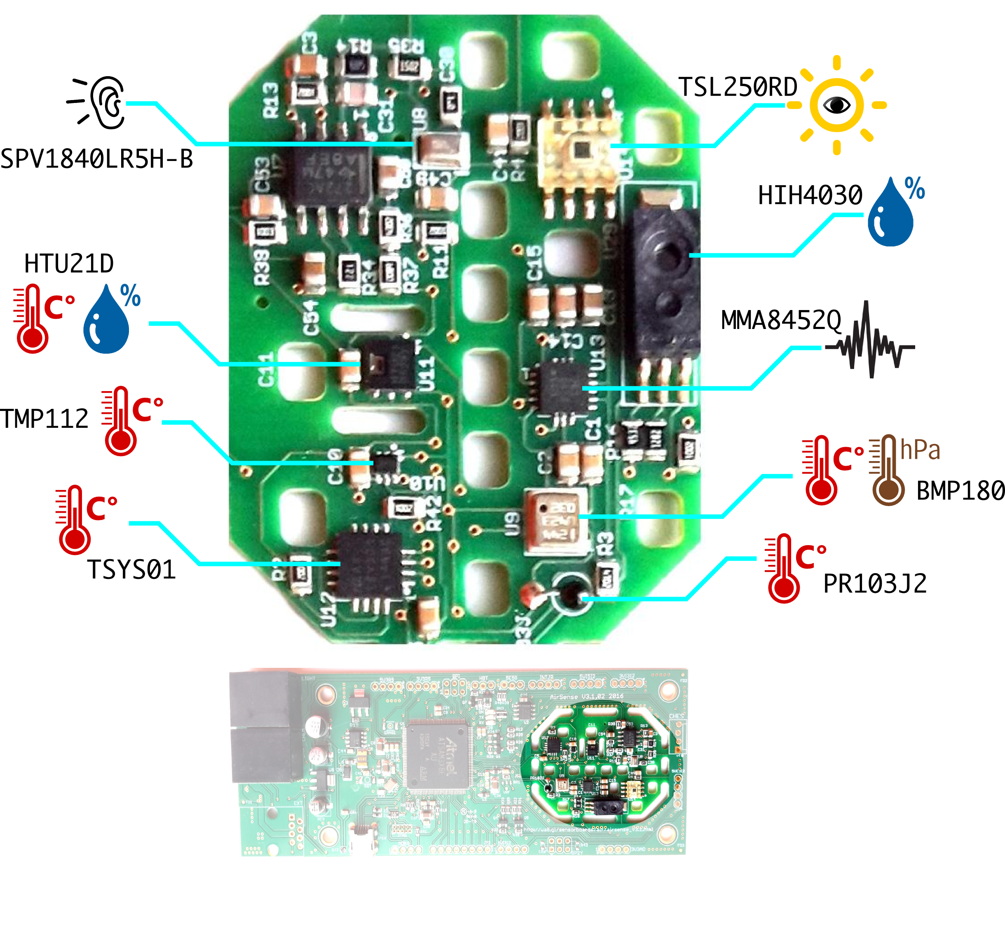

Board Test : Cold Boot Short Test

* Only Metsense board, left out in open in a room.
* No external environment changes.

Board Test : Freeze Test

* Only Metsense board, left overnight in home freezer.

Board Test : Heater Test

* Only Metsense board, left overnight by heater. The test was concluded by suddenly raising the
heater output and moving the board closer to it.

Combined Test: Pod With Goretex

* Test performed with a pod and bare Metsense board. The two systems were left about 20 CM apart,
and positioned such that the location of the Metsense board in both the cases was roughly the same.

* The devices were placed in a room where the vents were closed, but the cyclic nature of the heater
coming on can be seen.

* The door to the room was left open, and brought in warm air from other rooms.

* The experiment was finished by running the shower at the end, to change RH.

* This test was performed first with the pair.

Combined Test: Pod Without Goretex

* This test was performed the second day, with the same pair as the goretex test, after removing the
layer.

* Test performed with a pod and bare Metsense board. The two systems were left about 20 CM apart,
and positioned such that the location of the Metsense board in both the cases was roughly the same.

* The devices were placed in a room where the vents were closed, but the cyclic nature of the heater
coming on can be seen.

* The door to the room was left open, and brought in warm air from other rooms.

* The experiment was finished by running the shower at the end, to change RH.

Pod Test: Longterm Cold-Boot Test

* Test performed with a pod, with goretex layers. The Pod was left overnight at TCS.

