Experiment 1: Design of Star Schema and Snowflake Schema
Name: Atharva Waghmode | Roll No: 59 | Div: D15A | Course: DMBI Lab
Experiment 1
Design of Star Schema and Snowflake Schema

Aim
To design Star Schema and Snowflake Schema for a given system using a suitable fact table and dimension tables.

Objective
- To understand the concept of Data Warehouse Schema.
- To design Star Schemas for two different subject areas of a college database.
- To design a Snowflake Schema by normalizing one of the star schemas.

Problem Statement
Consider a College Database System that maintains records related to student academic results and library book
issues. The college wants to build a small data warehouse to analyze:
- How students are performing in different subjects and exams (Result Analysis).
- How books are being issued to students from the library (Library Management).
Since both areas need to be analyzed by Date, Student and other descriptive details, two separate Star Schemas are
designed for these two subject areas. In addition, the Result Analysis star schema is further normalized into a

Snowflake Schema by splitting the Student and Subject dimensions into smaller related tables (Department and
Course).

Theory
1. Star Schema
2. Snowflake Schema
A Star Schema centers on a fact table containing measurable data. The fact table connects directly to dimension tables
that supply descriptive details about each record. These dimensions are usually denormalized, which keeps the structure
simple and gives the diagram its familiar star-like shape.
A Snowflake Schema extends the star design by normalizing selected dimension tables into related sub-tables. This
separates repeated descriptive details, reduces redundancy, and creates more branches from the main dimensions. For
example, student or subject details may be split into department or course tables, producing a snowflake-like structure.

Star Schema 1 — Student Result Analysis System
This schema is used to analyze the marks obtained by students in various subjects and exams over time.

Fact and Dimension Tables
Fact Table: Result_Fact
Column Description

Result_ID Primary Key
Student_ID Foreign Key
Subject_ID Foreign Key
Exam_ID Foreign Key
Date_ID Foreign Key
Marks_Obtained Marks scored by the student
Max_Marks Maximum marks for the exam
Student_Dimension
Column Description
Student_ID Primary Key
Student_Name Name of the student
Class Class of the student
Section Section of the student
Subject_Dimension
Column Description
Subject_ID Primary Key
Subject_Name Name of the subject
Subject_Type Theory / Practical
Exam_Dimension
Column Description
Exam_ID Primary Key
Exam_Name Name of the exam
Exam_Type Internal / External
Semester Semester in which exam is held
Date_Dimension
Column Description
Date_ID Primary Key
Date Date of the exam
Month Month
Quarter Quarter
Year Year
Diagram
Fig 1.1: Star Schema for Student Result Analysis System
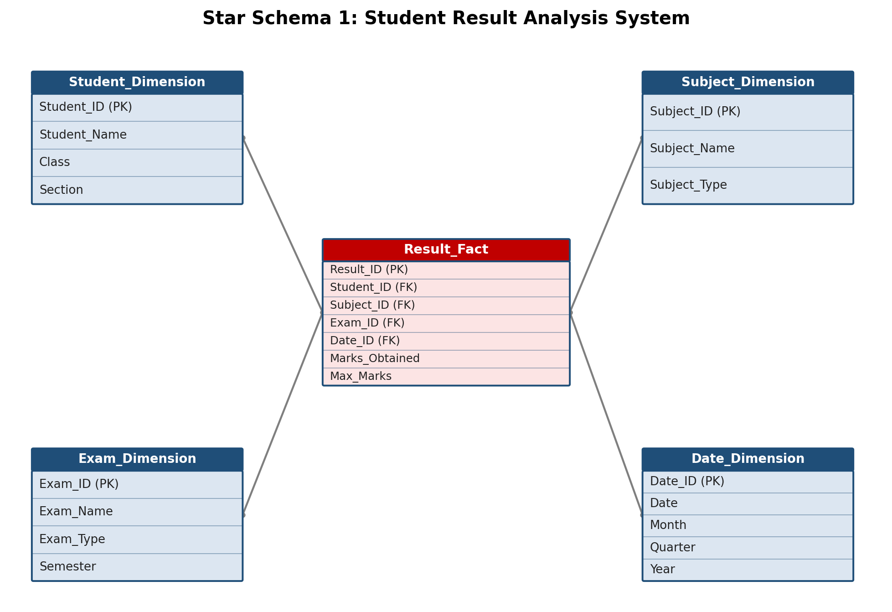

Star Schema 2 — Library Book Issue System
This schema is used to analyze how books are issued to students, by whom, and when.

Fact and Dimension Tables
Fact Table: Issue_Fact
Column Description
Issue_ID Primary Key
Book_ID Foreign Key
Student_ID Foreign Key
Staff_ID Foreign Key
Date_ID Foreign Key
Days_Issued Number of days the book is issued for
Fine_Amount Fine charged, if any
Book_Dimension
Column Description
Book_ID Primary Key
Book_Title Title of the book
Author Author of the book
Category Category / Genre of the book
Student_Dimension
Column Description
Student_ID Primary Key
Student_Name Name of the student
Class Class of the student
Section Section of the student
Staff_Dimension
Column Description
Staff_ID Primary Key
Staff_Name Name of the library staff
Designation Designation of staff
Date_Dimension
Column Description
Date_ID Primary Key
Date Date of issue
Month Month
Quarter Quarter
Year Year
Diagram
Fig 1.2: Star Schema for Library Book Issue System
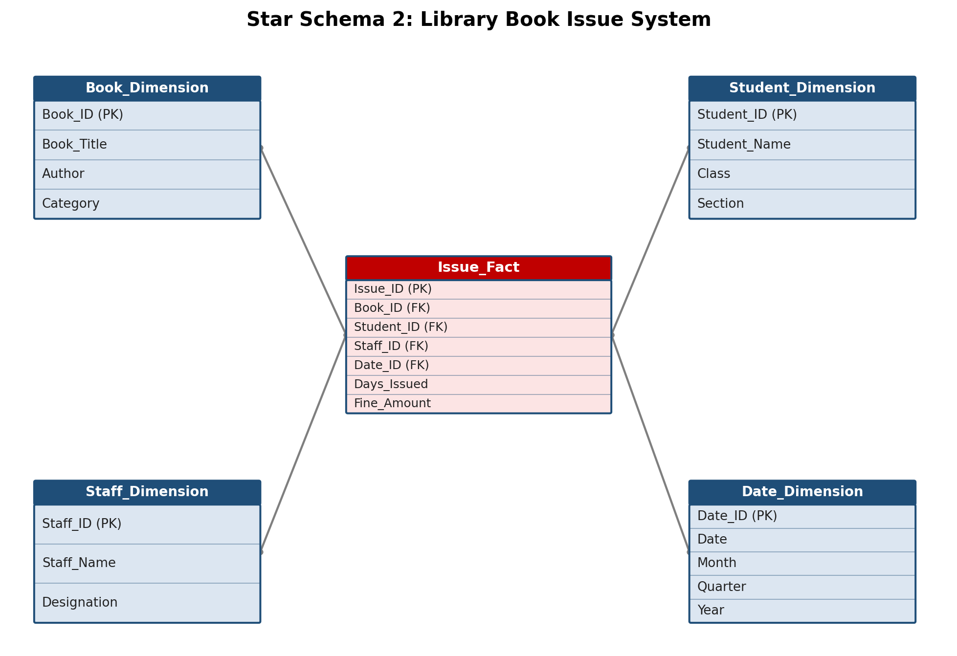

Snowflake Schema — Student Result Analysis System (Normalized)
The Student Result Analysis star schema (Star Schema 1) is now normalized to form a Snowflake Schema. The
Student_Dimension is split so that Department details move into a separate Department table, and the
Subject_Dimension is split so that Course details move into a separate Course table. This removes repeated data and
reduces redundancy.

Fact and Dimension Tables (Normalized)
Fact Table: Result_Fact
Column Description

Result_ID Primary Key
Student_ID Foreign Key
Subject_ID Foreign Key
Exam_ID Foreign Key
Date_ID Foreign Key
Marks_Obtained Marks scored by the student
Max_Marks Maximum marks for the exam
Student_Dimension
Column Description
Student_ID Primary Key
Student_Name Name of the student
Dept_ID Foreign Key to Department
Department (Sub-Dimension)
Column Description
Dept_ID Primary Key
Dept_Name Name of the department
HOD_Name Head of department
Subject_Dimension
Column Description
Subject_ID Primary Key
Subject_Name Name of the subject
Course_ID Foreign Key to Course
Course (Sub-Dimension)
Column Description
Course_ID Primary Key
Course_Name Name of the course
Duration Duration of the course
Exam_Dimension
Column Description
Exam_ID Primary Key
Exam_Name Name of the exam
Exam_Type Internal / External
Semester Semester in which exam is held
Date_Dimension
Column Description
Date_ID Primary Key
Date Date of the exam
Month Month
Quarter Quarter
Year Year
Diagram
Fig 1.3: Snowflake Schema for Student Result Analysis System
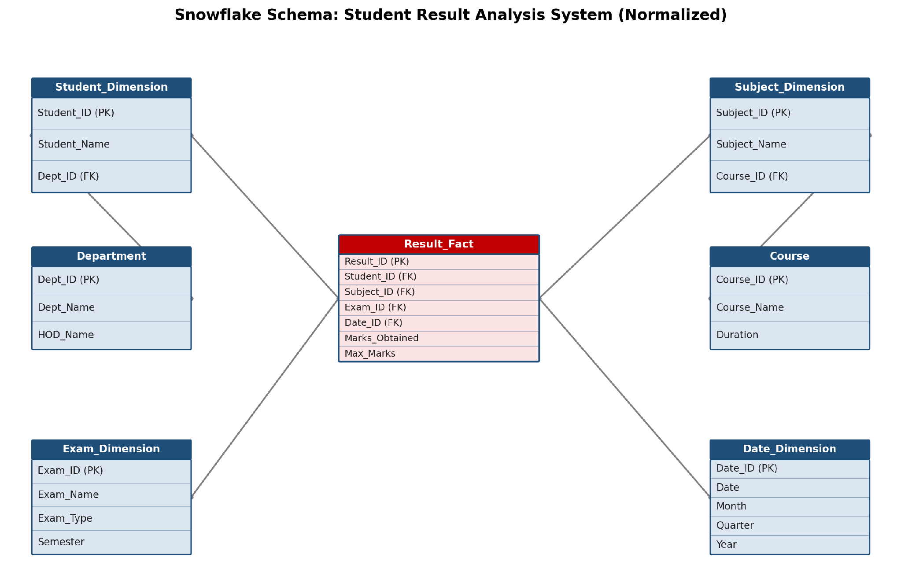
Main Difference Between Star and Snowflake Schema

Star Schema Snowflake Schema
Dimensions are generally denormalized Dimensions are normalized
Fewer tables More tables
Simple structure More complex structure
Faster querying in many analytical cases May require more joins
Requires more storage Can reduce data redundancy

Result
Thus, two Star Schemas (Student Result Analysis and Library Book Issue) and one Snowflake Schema (normalized
Student Result Analysis) were successfully designed by identifying suitable fact tables and dimension tables for the
college database system.

GitHub Repository & Submission Verification
Student Name | Atharva Waghmode
Roll Number / Division | 59 / D15A
Course / Experiment | DMBI Lab — Experiment 1
Individual GitHub Link (Exp 1) | https://github.com/wagha-builds/dmbi_exps_59/tree/main/Experiment_1
Master GitHub Repository | https://github.com/wagha-builds/dmbi_exps_59

