Experiment 2: Data Preprocessing Using Python
Name: Atharva Waghmode | Roll No: 59 | Div: D15A | Course: DMBI Lab
Experiment 2 – To Perform Data Preprocessing Using Python

Aim
To perform data preprocessing on a synthetic Student Result dataset using Python by handling missing values,
removing duplicate records, encoding categorical data, and scaling numerical features.

Objectives
- Load the student result dataset using Python.
- Identify and handle missing values.
- Remove duplicate records.
- Convert categorical data into numerical form.
- Normalize/standardize numerical data.
- Prepare clean data for further analysis or machine learning.
Software/Tools Required
- Python 3.x
- Jupyter Notebook / Google Colab
- Pandas
- NumPy
- Scikit-learn

Theory
- Data Cleaning – Handling missing and incorrect values.
- Removing Duplicates – Eliminating repeated records.
- Encoding – Converting categorical values into numerical values.
- Feature Scaling – Bringing numerical features to a similar scale.
- Data Transformation – Converting data into a suitable format.
Dataset
A synthetic dataset of 500 records was generated to represent student academic activity in the College Database
System, mirroring the Result_Fact schema designed in Experiment 1. The dataset was intentionally seeded with
missing values and duplicate records to give every preprocessing step meaningful data to act on.
Columns: student_id, age, class, section, study_hours_per_week, attendance_pct, subject, city, marks_obtained
Data preprocessing prepares raw data for analysis by correcting incomplete, inaccurate, or inconsistent values and
arranging the information in a usable format for analytics and machine learning.
The main stages generally include:

Output
1. Loading the Dataset
Dataset loaded successfully – Shape: (512, 9). The head shows missing values (NaN) already present in Age and
Attendance_pct.
2. Checking Duplicates and Missing Values
12 duplicate rows found; missing values present in age (32), study_hours_per_week (26), attendance_pct (30), and
city (27).
3. Removing Duplicate Records
Shape after removing duplicates: (500, 9).
4. Handling Missing Values
Numerical columns (age, study_hours_per_week, attendance_pct) were imputed using the column mean, and the
categorical column (city) was imputed using the mode. No missing values remain in any column.
5. Encoding Categorical Data
class, section, subject, and city were encoded into numeric labels using LabelEncoder.
6. Feature Scaling
age, study_hours_per_week, attendance_pct, and marks_obtained were standardized to mean = 0, std = 1 across all
500 rows.
7. Final Preprocessed Dataset Info
Final shape: (500, 9) with no missing values across all columns.
8. Final Preprocessed Dataset (Head)
First 5 rows of the cleaned, encoded, and scaled dataset.

Result
Thus, the Student Result dataset was successfully preprocessed using Python by removing 12 duplicate records,
imputing missing values (mean for age, study_hours_per_week, and attendance_pct; mode for city), label-encoding
categorical features (class, section, subject, city), and standardizing continuous numerical attributes via z-score
scaling. The resulting dataset (500 rows × 9 columns) is clean, consistent, and structurally validated for analytical
modeling.
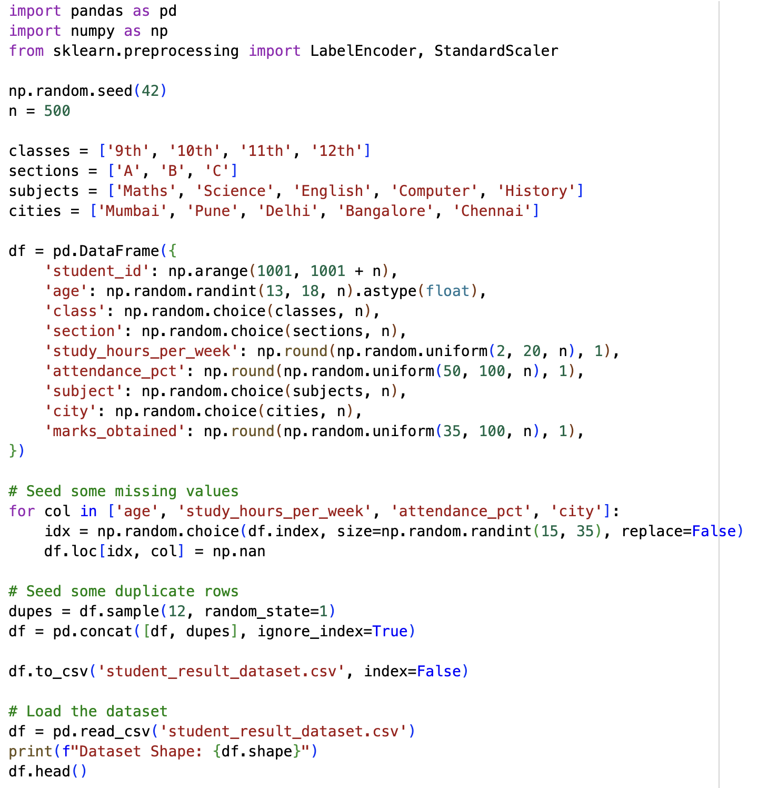
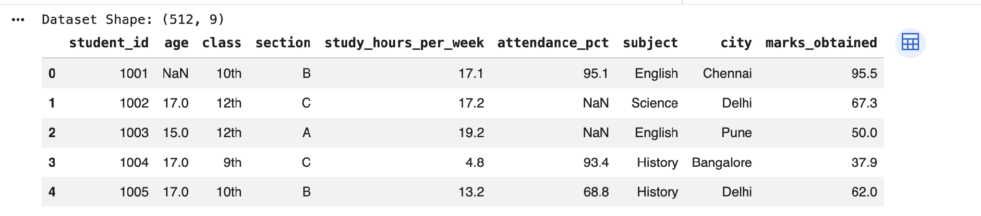
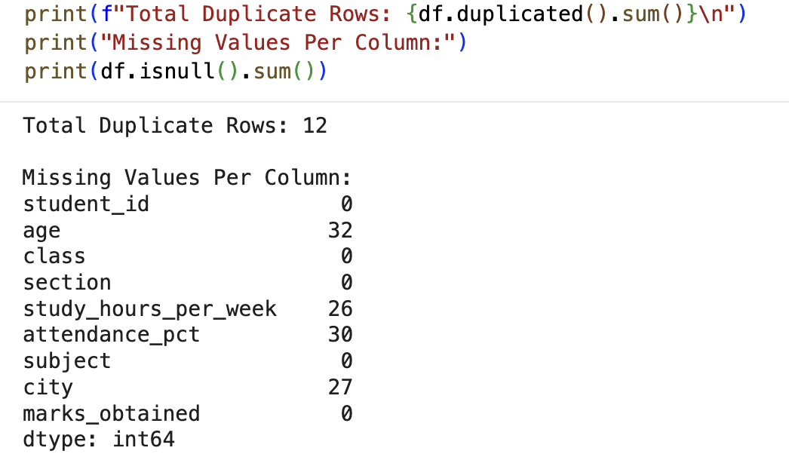
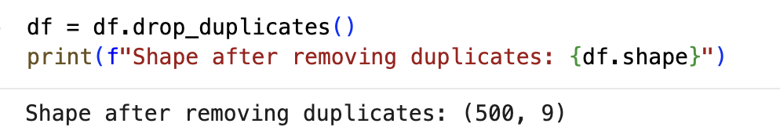
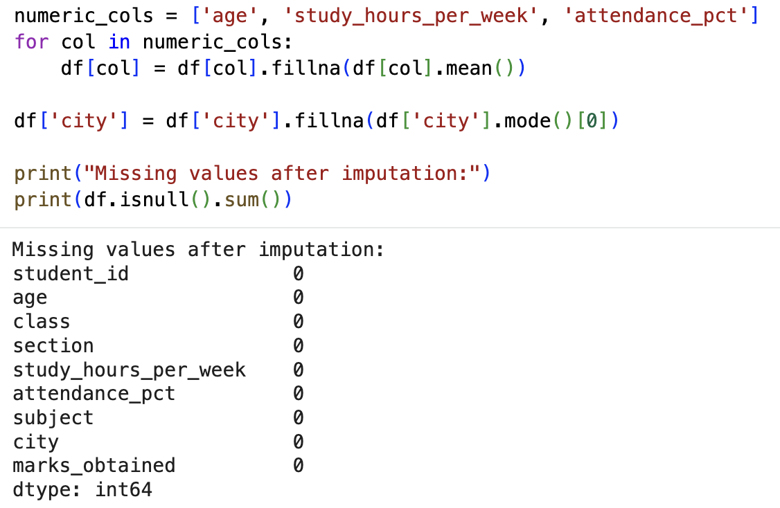
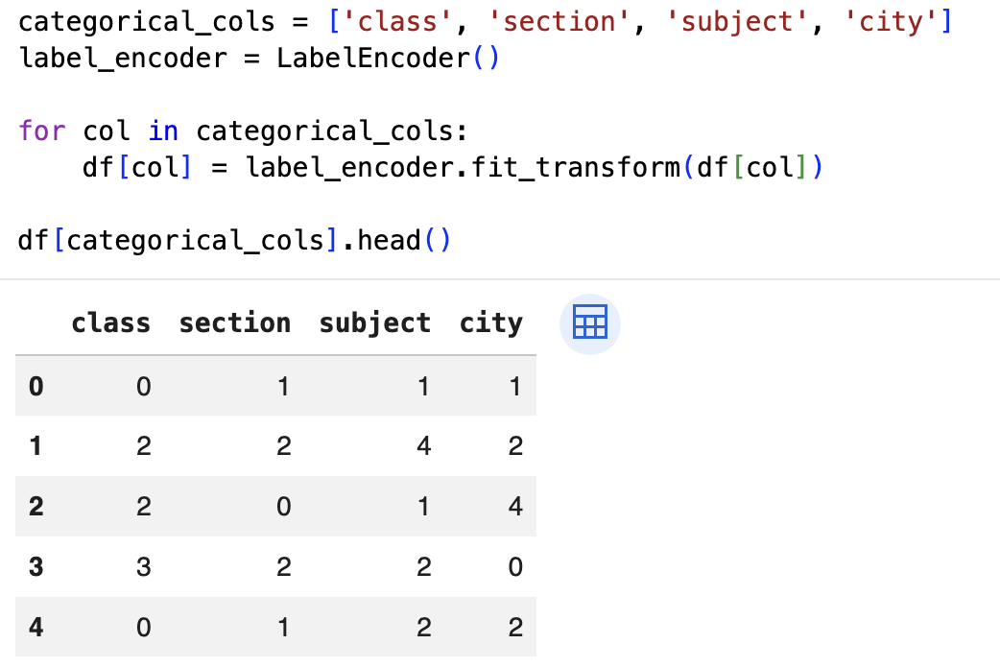
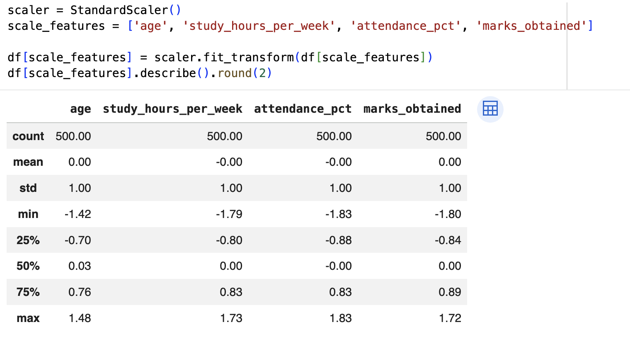
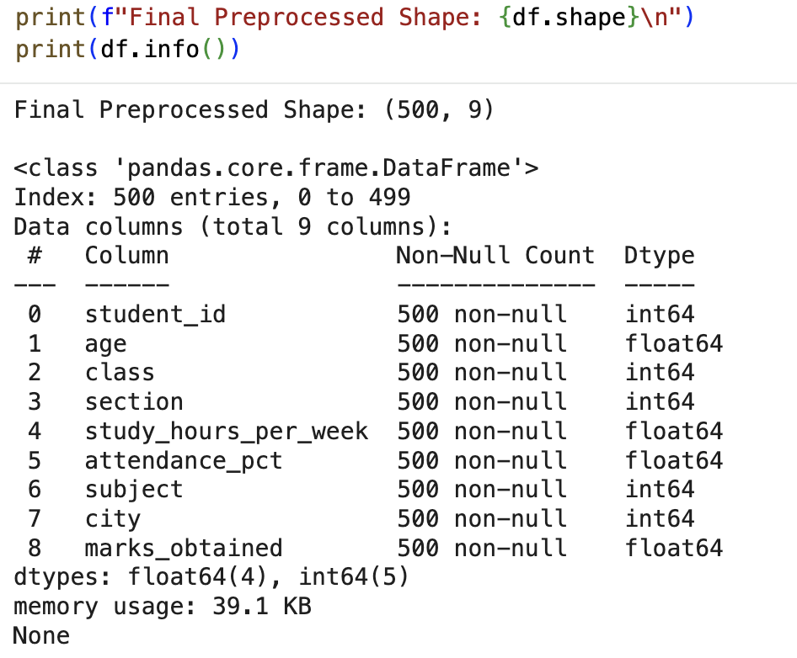
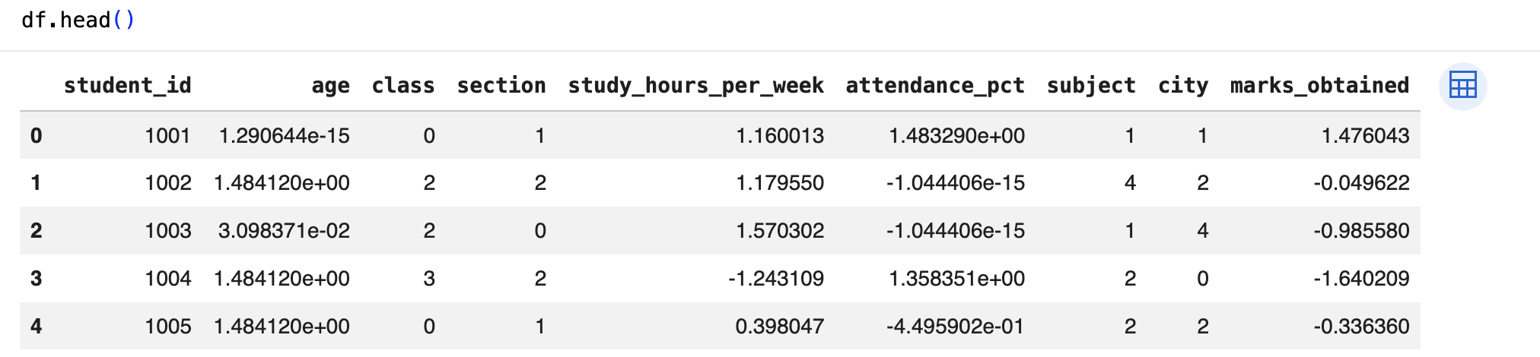

GitHub Repository & Submission Verification
Student Name | Atharva Waghmode
Roll Number / Division | 59 / D15A
Course / Experiment | DMBI Lab — Experiment 2
Individual GitHub Link (Exp 2) | https://github.com/wagha-builds/dmbi_exps_59/tree/main/Experiment_2
Master GitHub Repository | https://github.com/wagha-builds/dmbi_exps_59

