Experiment 3: Exploratory Data Analysis and Visualization
Name: Atharva Waghmode | Roll No: 59 | Div: D15A | Course: DMBI Lab
Experiment 3 – Exploratory Data Analysis and Visualization

Aim
To perform exploratory data analysis (EDA) and data visualization on the Student Result dataset using Python.

Theory

Dataset Overview:
Significance of EDA for Student Result Analytics:
- Data Cleaning & Quality Check: Identifies missing values, inconsistencies, and outliers (e.g., extreme
study_hours_per_week values).
- Understanding Data Distribution: Visualizes distributions (e.g., skewness in study_hours_per_week) to
guide preprocessing steps.
- Identifying Key Features: Determines which features (e.g., attendance_pct) influence marks_obtained.
Helps eliminate redundant variables.
- Detecting Relationships & Patterns: Correlation analysis reveals dependencies (e.g., between
attendance_pct and marks_obtained). Useful for feature selection in machine learning.
- Improving Model Interpretability: Helps choose appropriate preprocessing techniques (e.g.,
normalization for skewed data). Assists in selecting models based on feature relationships.
1. Descriptive Analysis – Statistical Measures of Central Tendency
Central tendency measures indicate the "center" of the data distribution.
Includes:
- Mean: Represents the average value (e.g., typical study_hours_per_week).
- Median: The middle value, robust to outliers (e.g., for marks_obtained).
- Mode: The most frequent value, useful for categorical data (e.g., class).
Relevance:
- The average study_hours_per_week highlights typical study behavior.
- The median marks_obtained avoids skew from outliers.
- The mode of class shows the most common class among students.
2. Descriptive Analysis – Statistical Measures of Dispersion
Dispersion measures the spread of data.
This dataset contains 512 student records and nine attributes covering demographic details, class information, and
academic results. It follows the Result_Fact design from Experiment 1 and includes deliberately introduced missing
entries, duplicate rows, unusually high study-hour values, and inconsistent class labels. These examples allow EDA to
reveal common data-quality issues before model building. Including these irregularities also shows how quality checks
can uncover problems that may affect later statistical analysis and predictive modeling.
EDA is an important stage in data analysis and model development because it helps to:
Includes:
- Standard Deviation: Shows deviation from the mean.
- Variance: Quantifies spread (squared standard deviation).
- Range: Difference between maximum and minimum values.
- Interquartile Range (IQR): Range of the middle 50%, useful for outlier detection.
Relevance:
- High variance in study_hours_per_week indicates diverse study habits, and hints at data-entry outliers.
- IQR of marks_obtained helps identify typical performance and flags outliers.
- Standard deviation of attendance_pct shows consistency in how regularly students attend class.
3. Correlation Between Attributes
Correlation measures the strength of relationships between variables. The Pearson correlation coefficient (-1 to +1)
helps determine:
- If attendance_pct and marks_obtained are correlated, students who attend more might score higher.
- If age correlates with marks_obtained, it could indicate a maturity-related performance pattern.
Relevance:
- Identifies key predictors for academic performance.
- Detects multicollinearity to remove redundant features.
- Guides feature selection for modeling.
4. Different Visualization Techniques & Their Uses
Visualizations help interpret patterns, detect anomalies, and support inferences. Suitable methods include:
- Histogram: Shows distributions (e.g., study_hours_per_week).
- Boxplot: Highlights outliers and comparisons (e.g., marks_obtained by class).
- Heatmap: Visualizes correlations.
- Scatter Plot: Analyzes relationships (e.g., attendance_pct vs. marks_obtained).

Output

Step 1: Loading the Dataset and Initial Exploration
Dataset loaded — 512 entries, 9 columns; 32 missing in age, 26 in study_hours_per_week, 30 in attendance_pct, 27
in city.

Step 2: Task 1 – Descriptive Analysis – Statistical Measures of Central Tendency
Mean, Median, and Mode of the numeric and categorical columns.
Inferences:
- The mean study_hours_per_week (15.21) is noticeably higher than the median (11.50), indicating a
right-skewed distribution driven by extreme outlier values (data-entry errors of 999 hours).
- The mean marks_obtained (68.32) sits very close to the median (68.45), suggesting a roughly symmetric
distribution with no major skew.
- The mode shows the most common student is in Class 9th, Section B, studies Computer, and is based in
Bangalore.
Insight: The typical student is around 15 years old, studies roughly 11.5 hours a week, attends about 76% of classes,
and scores around 68 marks.

Step 3: Task 2 – Descriptive Analysis – Statistical Measures of Dispersion
Standard Deviation, Variance, Range, and IQR for age, study_hours_per_week, attendance_pct, and
marks_obtained.
Inferences:
- study_hours_per_week has an extremely high standard deviation (63.5) and range (1004.0), far larger than
its IQR (9.175) — a clear sign of a small number of severe outliers (the -5 and 999 data-entry errors).
- marks_obtained shows a moderate, well-behaved spread (std 18.47, range 65.0, IQR 32.1), consistent with
natural variation in student performance.
- age has the most stable spread (std 1.42, IQR 2.0), suggesting a fairly evenly distributed student base across
age groups.
Insight: The extreme range vs. IQR gap in study_hours_per_week confirms outlier handling is essential before this
feature can be used reliably in modeling.

Step 4: Task 3 – Correlation Between Attributes
Pearson correlation matrix across age, study_hours_per_week, attendance_pct, and marks_obtained.
Inferences:
- All pairwise correlations are extremely weak (|r| < 0.08), indicating age, study_hours_per_week,
attendance_pct, and marks_obtained behave largely independently of one another in this dataset.
- The near-zero correlation between study_hours_per_week and marks_obtained (-0.044) is partly explained
by the outlier-inflated study_hours_per_week values distorting the linear relationship.
- Low correlation overall reduces the risk of multicollinearity, which is favourable for downstream modeling.
Insight: Once outliers in study_hours_per_week are treated, a clearer relationship with marks_obtained and
attendance_pct could emerge, since consistent study habits and attendance typically support better performance.

Step 5: Task 4 – Visualization Techniques
5a. Histogram of Study Hours per Week
Sharp right-skewed distribution — nearly all students study under 30 hours per week, with a long thin tail out to
~1,000 caused by the injected outliers.
5b. Boxplot of Marks Obtained by Class (before cleanup)
FutureWarning raised for passing palette without hue; 16 separate boxes appear because the class column still has
inconsistent casing (10th / 12Th / 9TH / 10TH / etc.).
5c. Boxplot of Marks Obtained by Class (after cleanup)
After standardizing text casing, the 16 fragmented boxes collapse into the correct 4 classes — 9th, 10th, 11th, and
12th — each with a sensible, well-formed spread.
5d. Feature Correlation Heatmap
Heatmap confirms all pairwise correlations among age, study_hours_per_week, attendance_pct, and marks_obtained
are close to zero.
5e. Scatter Plot: Attendance % vs Marks Obtained
Points are spread evenly across the full attendance range (50–100%) and marks range (35–100) for every subject,
with no visible upward or downward trend.
Inferences:
- Histogram: study_hours_per_week is heavily right-skewed, with the vast majority of sessions under 30
hours and a small number of extreme outliers stretching the axis to 1,000 — this single-handedly explains
the earlier gap between mean and median.
- Boxplot (before cleanup): inconsistent text casing in class silently created 16 categories instead of 4, which
would have broken any groupby or model trained on this column.
- Boxplot (after cleanup): once standardized, marks cleanly separate by class, with all four classes showing a
comparable median and no visible outliers within each group.
- Heatmap: confirms numerically what the scatter plot shows visually — no meaningful linear relationship
exists between any pair of numeric features while outliers remain in the data.
- Scatter Plot: no visible trend between attendance_pct and marks_obtained for the bulk of students,
regardless of subject — attendance alone does not appear to predict performance in this synthetic dataset.
Insight: Outlier treatment for study_hours_per_week and categorical text cleaning for class are the two most urgent
preprocessing needs surfaced by this EDA, in addition to the missing-value and duplicate-record handling already
carried out in Experiment 2.

Conclusion
The exploratory data analysis (EDA) on the Student Result dataset provided valuable insights into the characteristics
and relationships of student demographic and performance features. Measures of central tendency and dispersion
revealed that study_hours_per_week is heavily distorted by a small number of extreme outliers, while
marks_obtained, attendance_pct, and age show reasonably well-behaved distributions.
Correlation analysis found only weak relationships (|r| < 0.08) among all numeric features, largely because the
unresolved outliers in study_hours_per_week mask any genuine association with marks_obtained or attendance_pct.
These findings enhance the dataset's quality for machine learning by identifying critical features
(study_hours_per_week, attendance_pct, class) and highlighting the exact preprocessing steps — outlier treatment
and categorical text standardization — needed before the data can be reliably used for predictive modeling.
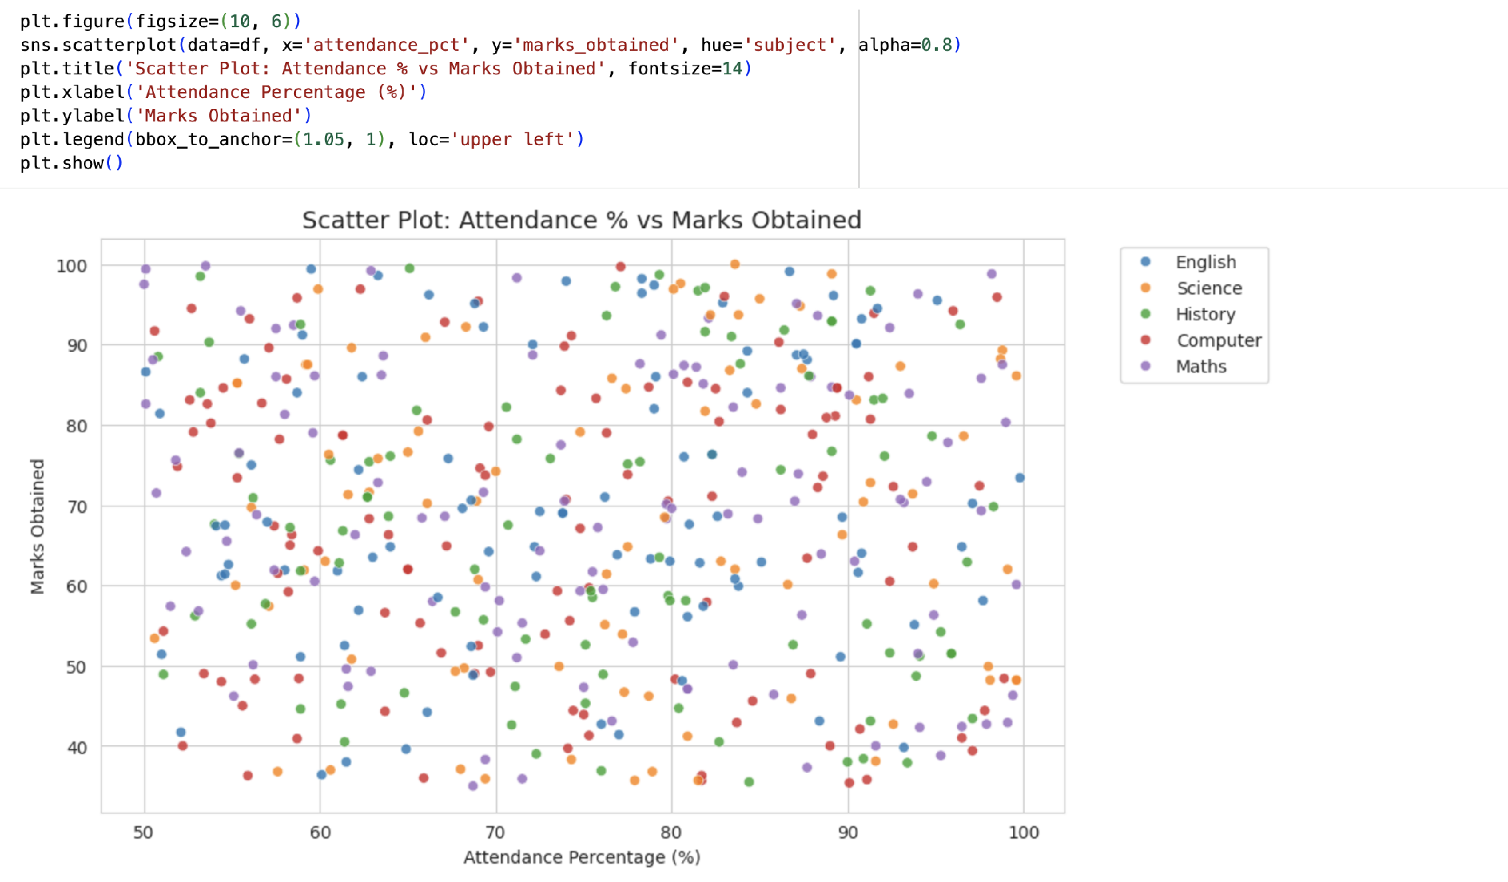
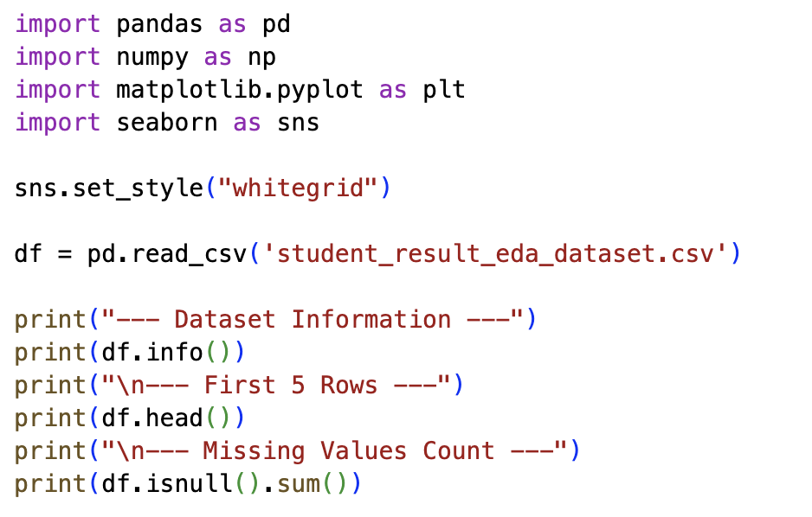
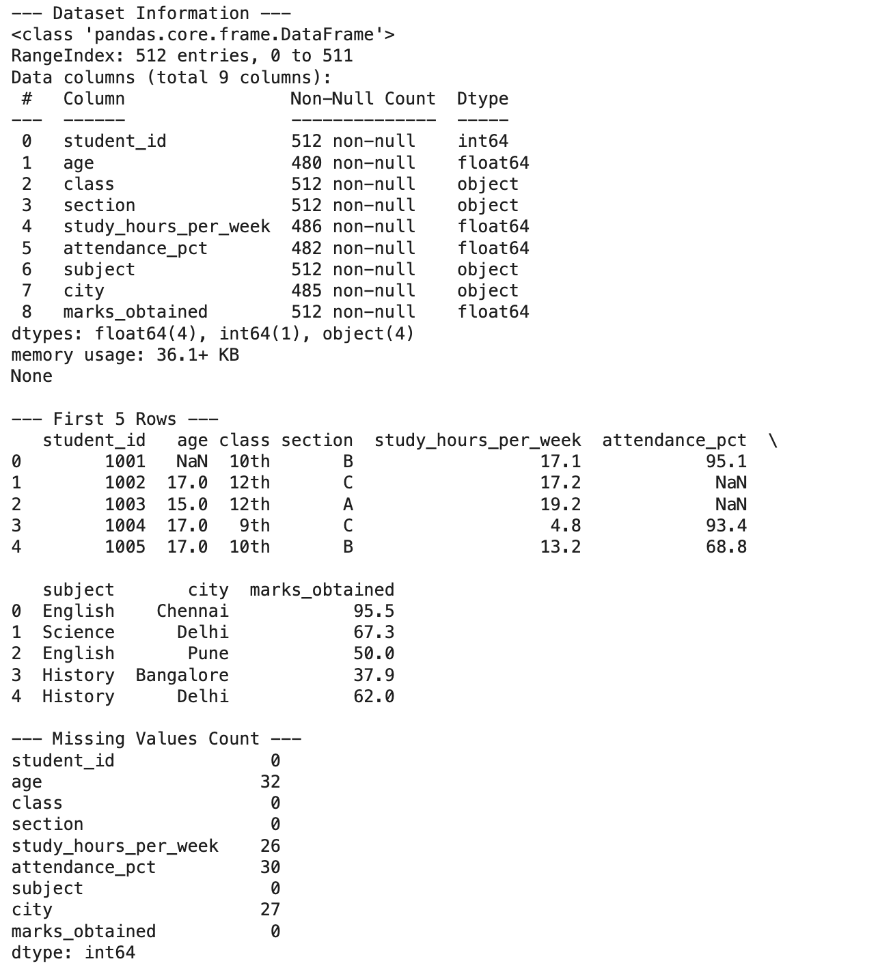
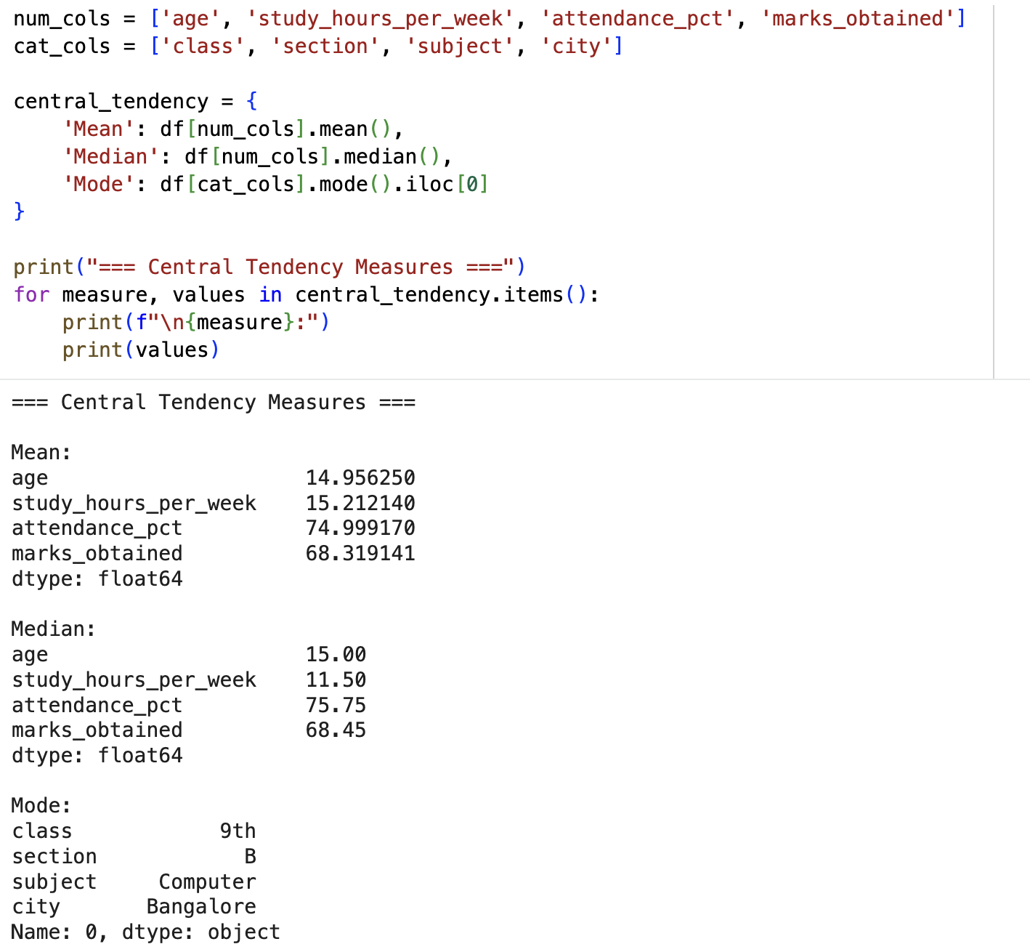
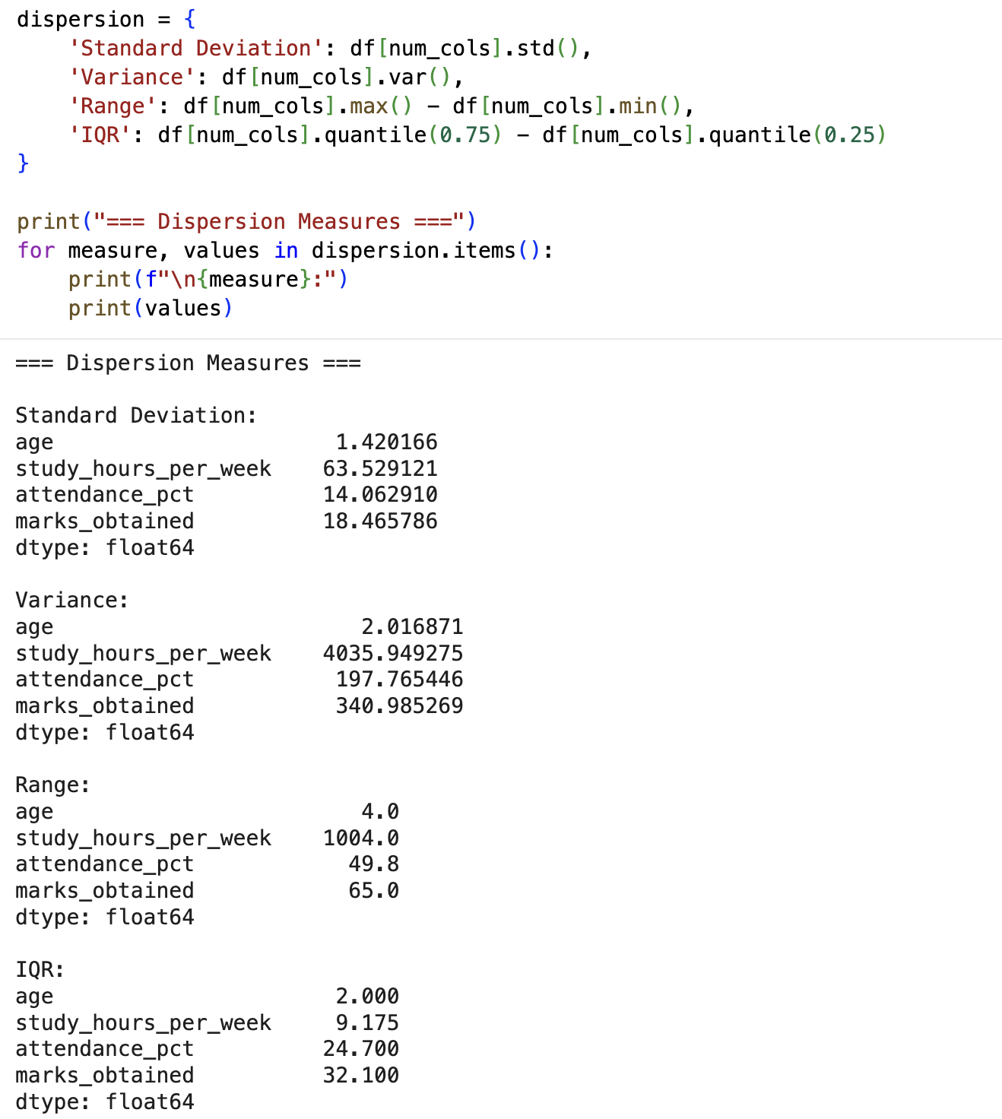
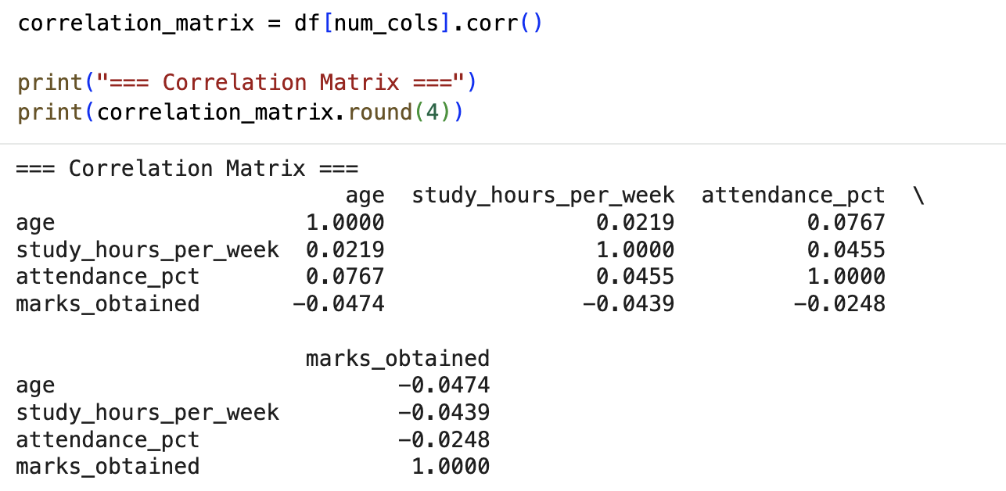
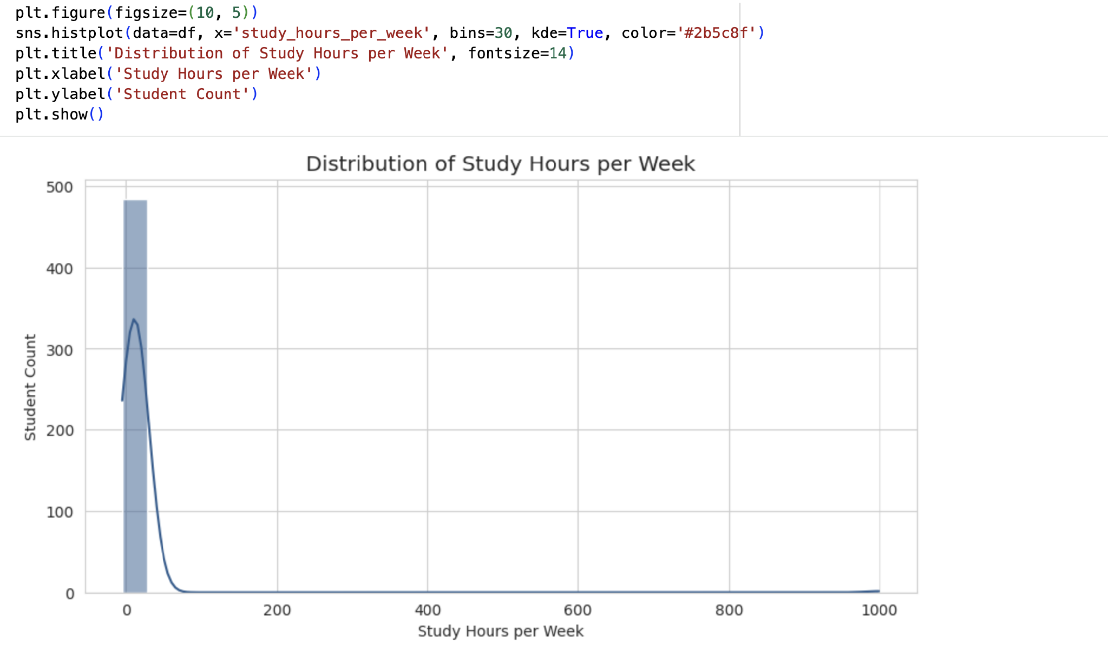
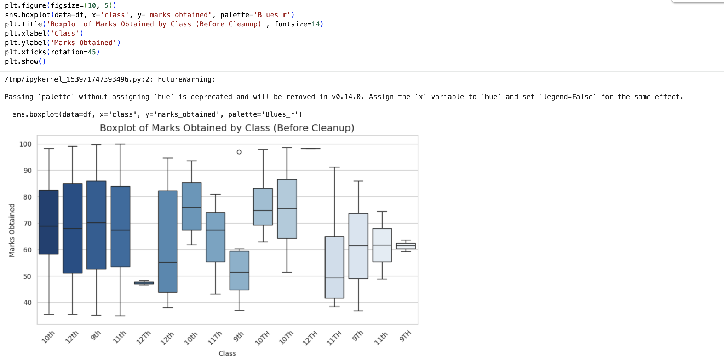
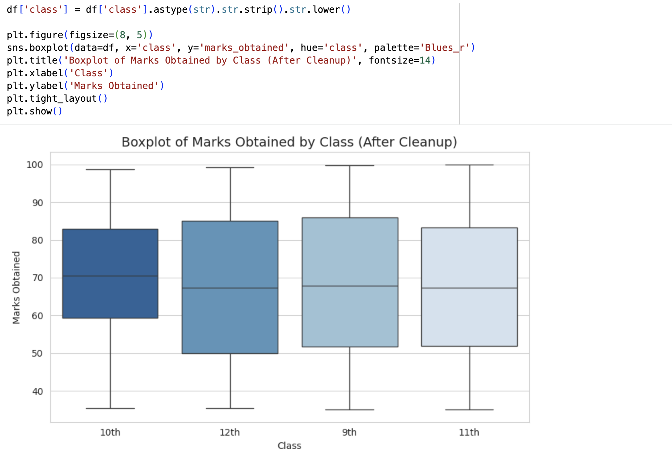
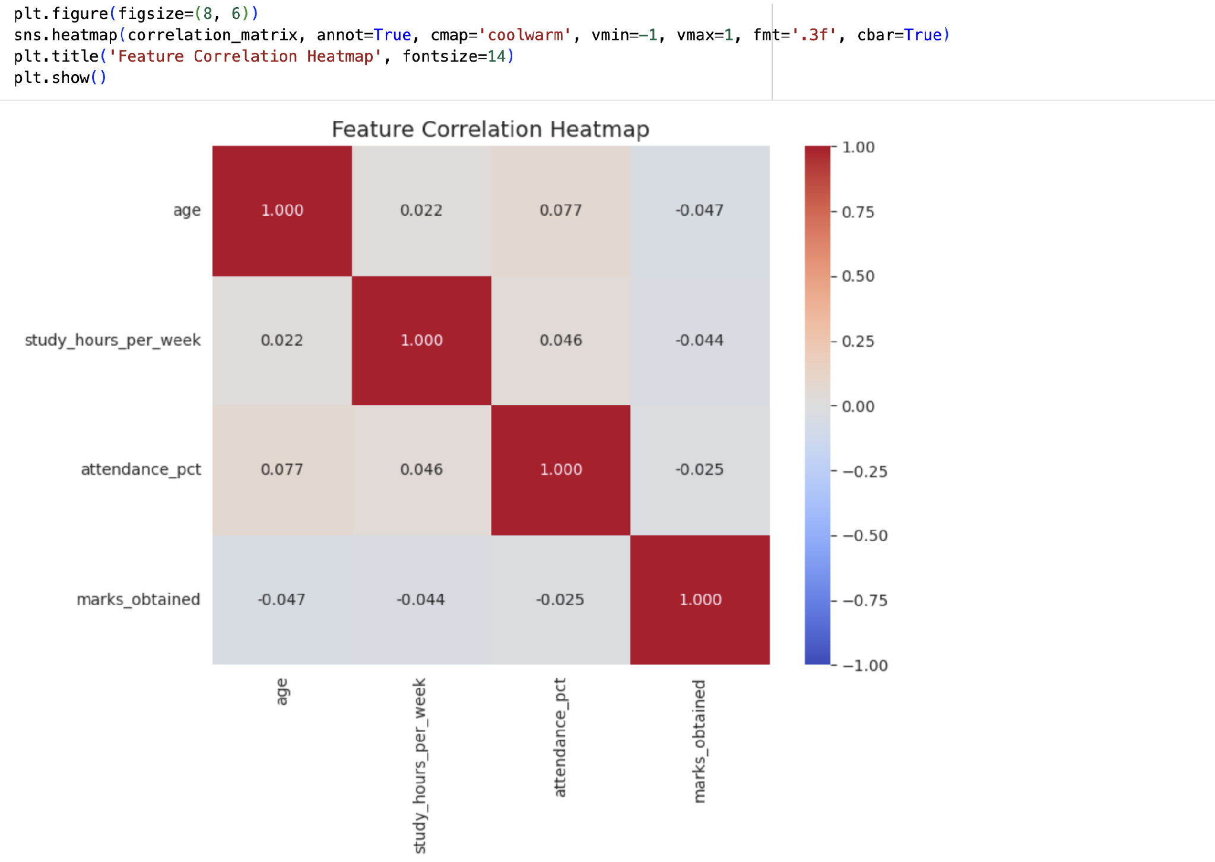

GitHub Repository & Submission Verification
Student Name | Atharva Waghmode
Roll Number / Division | 59 / D15A
Course / Experiment | DMBI Lab — Experiment 3
Individual GitHub Link (Exp 3) | https://github.com/wagha-builds/dmbi_exps_59/tree/main/Experiment_3
Master GitHub Repository | https://github.com/wagha-builds/dmbi_exps_59

