Experiment 6: Clustering using Python (K-Means Clustering)
Name: Atharva Waghmode | Roll No: 59 | Div: D15A | Course: DMBI Lab
Experiment 6

Aim: Experiment to implement any one of the clustering algorithms using Rapid Miner and
Python.

Theory :
- Discover the natural grouping or structure in unlabelled data without predefined
categories.
- Data points are assigned to clusters based on similarity or distance measures.
- Uses Euclidean distance, cosine similarity or other metrics depending on data type and
clustering method.
Types of Clustering
1. Hard Clustering
Hard clustering assigns each data point to exactly one cluster. A data point cannot belong to
multiple clusters, making the grouping clear and easy to interpret.
- Each data point belongs to only one cluster
- No overlap between clusters
- Simple and easy to interpret
2. Soft Clustering
Soft clustering allows a data point to belong to multiple clusters with different probabilities. Instead
of assigning a strict cluster, it gives a degree of membership to each cluster.
Example
A data point may belong 70% to Cluster 1 and 30% to Cluster 2, indicating that it shares
characteristics with both groups.
Clustering groups observations that share similar features without relying on pre-assigned labels. As
an unsupervised learning method, it helps reveal structure in a dataset. K-Means divides records into
k groups, DBSCAN finds dense regions and treats isolated points as noise, and hierarchical clustering
builds nested groups. These methods are used in customer segmentation, anomaly detection, image
analysis, and bioinformatics. The best choice depends on the data shape, noise level, and intended
analysis. Clustering is useful when the goal is to explore a dataset rather than predict a known class.
The groups can then be studied to understand shared patterns within the records.
Clustering can also be viewed as a way to discover natural groups when no target categories are
supplied. Records with similar characteristics are placed together, while dissimilar records are
assigned to other groups.
Use Cases
- Overlapping class boundaries: Useful when data points cannot be clearly separated into
distinct groups.
- Customer personas: Helps represent customers who share traits with multiple
behavioral groups.
- Medical diagnosis: Patients may show symptoms related to multiple conditions.
Benefits
- Captures ambiguity: Represents uncertainty when cluster boundaries are not clear.
- Models gradual transitions: Allows smooth transitions between clusters instead of strict
separation.
K-Means Clustering:
K-Means Clustering groups similar data points into clusters without needing labeled data. It is
used to uncover hidden patterns when the goal is to organize data based on similarity.
- Helps identify natural groupings in unlabeled datasets
- Works by grouping points based on distance to cluster centers
- Commonly used in customer segmentation, image compression and pattern discovery
- Useful when you need structure from raw, unorganized data.
Uses of K-Means Clustering
K-Means is popular in a wide variety of applications due to its simplicity, efficiency and
effectiveness. Here’s why it is widely used:
1. Data Segmentation: One of the most common uses of K-Means is segmenting data into
distinct groups. For example, businesses use K-Means to group customers based on
behavior, such as purchasing patterns or website interaction.
2. Image Compression: K-Means can be used to reduce the complexity of images by
grouping similar pixels into clusters, effectively compressing the image. This is useful for
image storage and processing.
3. Anomaly Detection: K-Means can be applied to detect anomalies or outliers by
identifying data points that do not belong to any of the clusters.
4. Document Clustering: In natural language processing (NLP), K-Means is used to group
similar documents or articles together. It’s often used in applications like
recommendation systems or news categorization.
5. Organizing Large Datasets: When dealing with large datasets, K-Means can help in
organizing the data into smaller, more manageable chunks based on similarities,
improving the efficiency of data analysis.

Implementation :
A. Python
Inference: The JioHotstar dataset was successfully loaded into Python using the pandas library.
The dataset contains information about episode characteristics and viewer behaviour. Checking
the number of rows and columns helps us understand the size and structure of the data before
applying clustering.
Inference: Relevant features such as average watch percentage, episode duration, hook
strength, pacing score, pause count, rewind count, and cognitive load were selected for
clustering. The features help identify similarities in viewing behaviour. The target-related
columns drop_off and drop_off_probability were excluded because this experiment uses
unsupervised learning.
Inference: The selected features were standardized using StandardScaler. This converts the
features to a comparable scale, generally with a mean of approximately zero and a standard
deviation of approximately one. Standardization is important because K-Means uses distance
calculations, and features with larger numerical values could otherwise dominate the clustering
process.
Inference: The Elbow Method was used to compare the inertia values for different numbers of
clusters (K). Inertia measures the sum of squared distances between data points and their
assigned cluster centroids. The elbow plot helps identify a suitable number of clusters. In this
experiment, K = 4 was selected for clustering.
Inference: The K-Means algorithm was applied with four clusters using n_clusters=4,
random_state=42, and n_init=10. The algorithm grouped records based on similarities in their
selected features. Each record was assigned a cluster label from 0 to 3, allowing different
viewer-behaviour patterns to be studied.
Inference: Clustering evaluation measures were used to assess the quality of the clusters.
Inertia indicates how closely records are grouped around their centroids. The Silhouette Score
evaluates how well-separated the clusters are, while the Davies–Bouldin Score measures
similarity between clusters. These measures help assess the clustering result; the actual scores
should be reported only if they are visible in the output.
Inference: A scatter plot was created using average watch percentage on the X-axis and
cognitive load on the Y-axis. Different colours represent the four clusters formed by K-Means.
The visualization helps compare viewer-engagement patterns and observe how records are
distributed among the clusters.
Inference: Cluster-wise averages were calculated to understand the characteristics of each
group. Cluster 0 showed good engagement, Cluster 1 showed moderate engagement with intro
skipping, Cluster 2 showed lower watch percentage and higher cognitive load, and Cluster 3
showed the highest average watch percentage with high pacing and lower cognitive load. These

results demonstrate that K-Means can identify different viewing-behaviour patterns in the
JioHotstar dataset.

Conclusion:
In this experiment, K-Means clustering was successfully performed on the JioHotstar dataset
using Python. The Elbow Method was used to select four clusters, and the clusters were
evaluated using different performance measures. The results helped identify different
viewer-behaviour patterns based on watch percentage, cognitive load, pacing score, and hook
strength. Thus, the experiment demonstrated how unsupervised machine learning can be used
to analyze viewer engagement and understand content-viewing patterns.
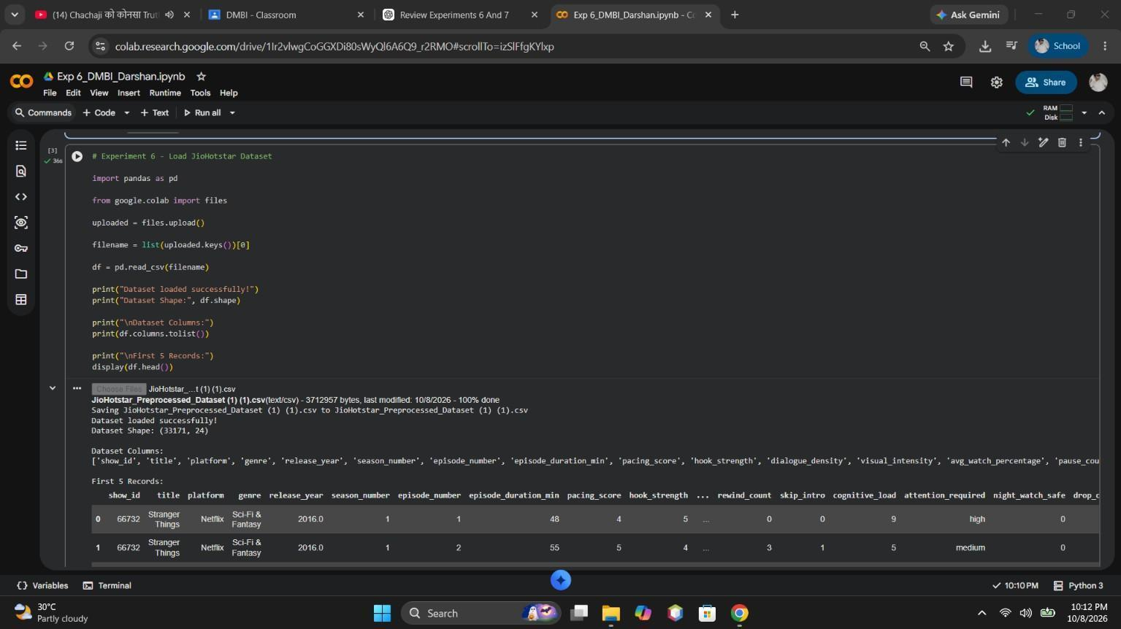
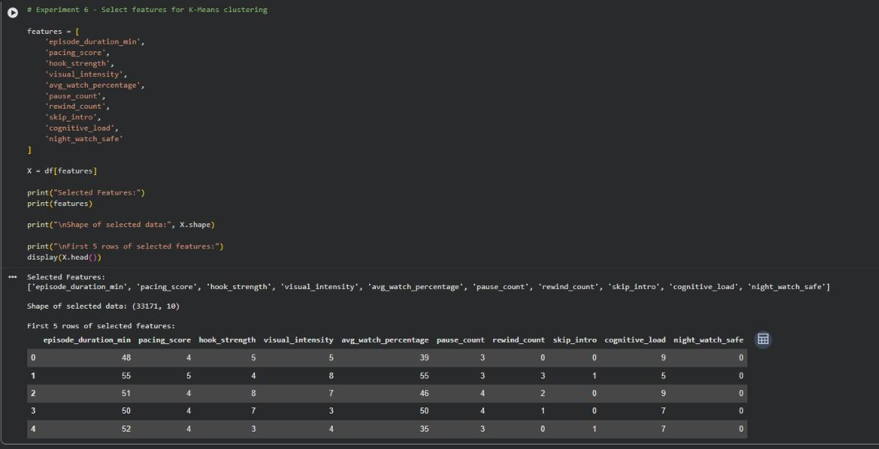
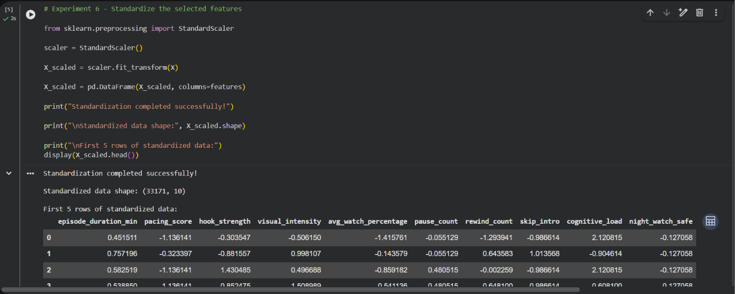
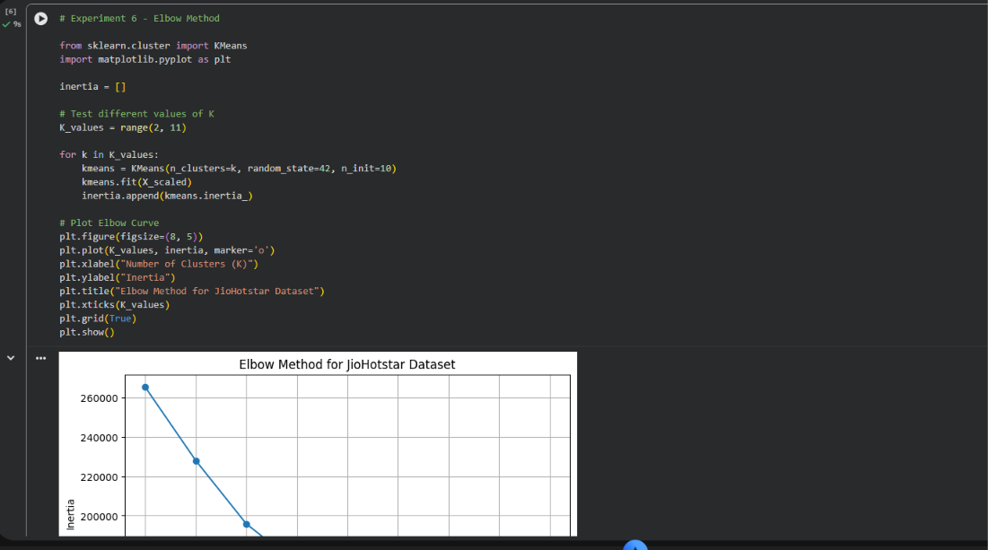
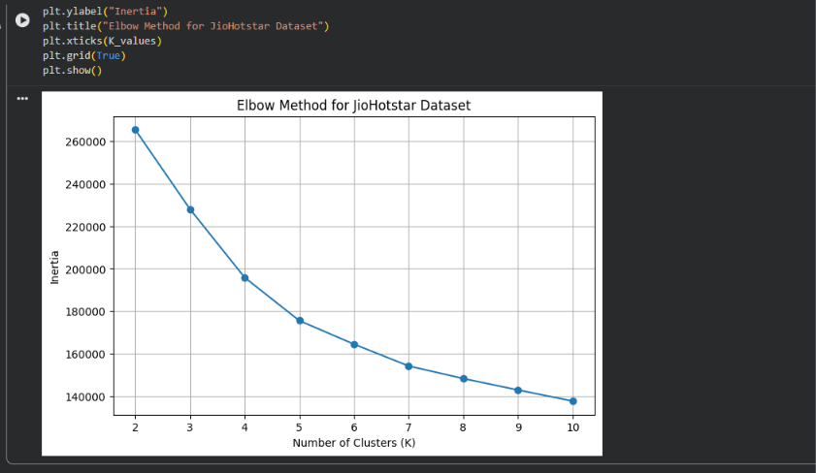
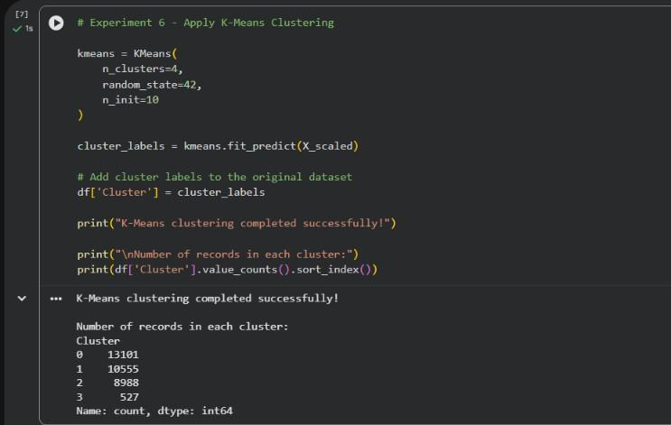
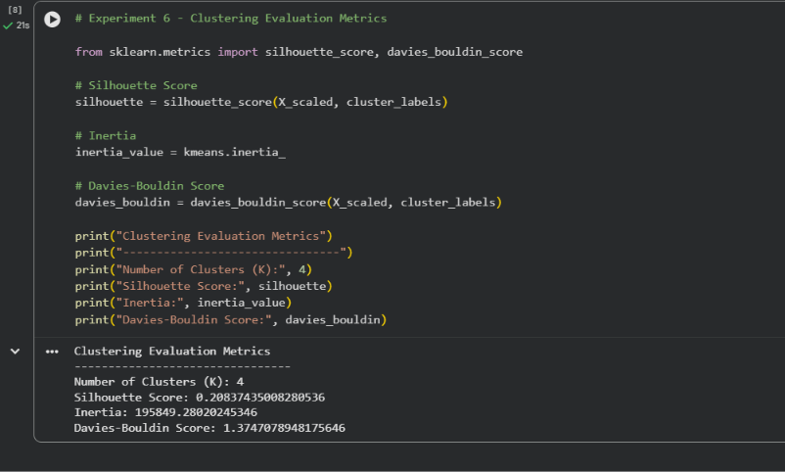
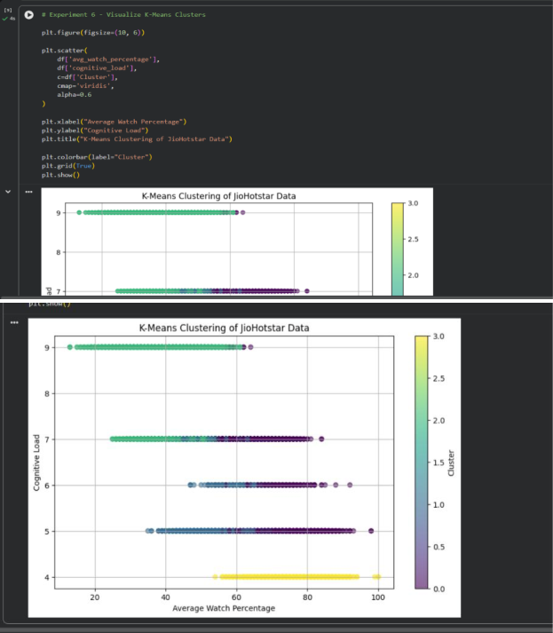
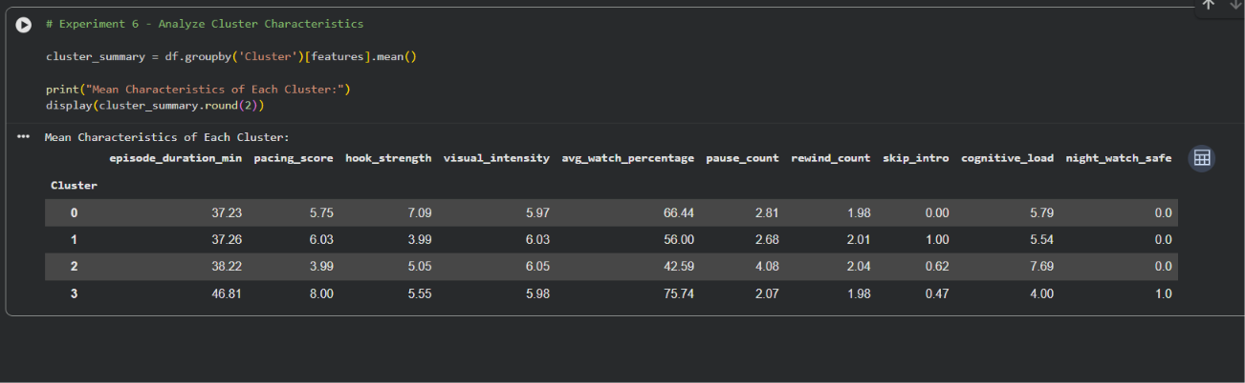

GitHub Repository & Submission Verification
Student Name | Atharva Waghmode
Roll Number / Division | 59 / D15A
Course / Experiment | DMBI Lab — Experiment 6
Individual GitHub Link (Exp 6) | https://github.com/wagha-builds/dmbi_exps_59/tree/main/Experiment_6
Master GitHub Repository | https://github.com/wagha-builds/dmbi_exps_59

