Experiment 7: Clustering using RapidMiner / Altair AI Studio (K-Means Clustering)
Name: Atharva Waghmode | Roll No: 59 | Div: D15A | Course: DMBI Lab
Experiment 7

Aim: Experiment to implement any one of the clustering algorithms using Rapid Miner and
Python.

Theory :
- Discover the natural grouping or structure in unlabelled data without
predefined categories.
- Data points are assigned to clusters based on similarity or distance measures.
- Uses Euclidean distance, cosine similarity or other metrics depending on data type
and clustering method.
Types of Clustering
1. Hard Clustering
Hard clustering assigns each data point to exactly one cluster. A data point cannot belong to
multiple clusters, making the grouping clear and easy to interpret.
- Each data point belongs to only one cluster
- No overlap between clusters
- Simple and easy to interpret
2. Soft Clustering
Soft clustering allows a data point to belong to multiple clusters with different probabilities.
Instead of assigning a strict cluster, it gives a degree of membership to each cluster.
Example
A data point may belong 70% to Cluster 1 and 30% to Cluster 2, indicating that it shares
characteristics with both groups.
Clustering groups observations that share similar features without relying on pre-assigned labels. As
an unsupervised learning method, it helps reveal structure in a dataset. K-Means divides records into
k groups, DBSCAN finds dense regions and treats isolated points as noise, and hierarchical clustering
builds nested groups. These methods are used in customer segmentation, anomaly detection, image
analysis, and bioinformatics. The best choice depends on the data shape, noise level, and intended
analysis. Clustering is useful when the goal is to explore a dataset rather than predict a known class.
The groups can then be studied to understand shared patterns within the records.
Clustering can also be viewed as a way to discover natural groups when no target categories are
supplied. Records with similar characteristics are placed together, while dissimilar records are
assigned to other groups.
Use Cases
- Overlapping class boundaries: Useful when data points cannot be clearly separated into
distinct groups.
- Customer personas: Helps represent customers who share traits with multiple behavioral
groups.
- Medical diagnosis: Patients may show symptoms related to multiple conditions.
Benefits
- Captures ambiguity: Represents uncertainty when cluster boundaries are not clear.
- Models gradual transitions: Allows smooth transitions between clusters instead of strict
separation.
K-Means Clustering:
K-Means Clustering groups similar data points into clusters without needing labeled data. It is
used to uncover hidden patterns when the goal is to organize data based on similarity.
- Helps identify natural groupings in unlabeled datasets
- Works by grouping points based on distance to cluster centers
- Commonly used in customer segmentation, image compression and pattern discovery
- Useful when you need structure from raw, unorganized data.
Uses of K-Means Clustering
K-Means is popular in a wide variety of applications due to its simplicity, efficiency and
effectiveness. Here’s why it is widely used:
1. Data Segmentation: One of the most common uses of K -Means is segmenting data into
distinct groups. For example, businesses use K -Means to group customers based on
behavior, such as purchasing patterns or website interaction.
2. Image Compression : K -Means can be used to reduce the complexity of images by
grouping similar pixels into clusters, effectively compressing the image. This is useful for
image storage and processing.
3. Anomaly Detection: K-Means can be applied to detect anomalies or outliers by identifying
data points that do not belong to any of the clusters.
4. Document Clustering: In natural language processing (NLP), K -Means is used to group
similar documents or articles together. It’s often used in applications like recommendation
systems or news categorization.
5. Organizing Large Datasets: When dealing with large datasets, K -Means can help in
organizing the data into smaller, more manageable chunks based on similarities,
improving the efficiency of data analysis.

Implementation :
B. Rapid Miner
Inference: The Retrieve operator was added to the process to access the JioHotstar dataset stored
in the repository. This operator loads the saved dataset into Altair AI Studio so that it can be
processed and analyzed using subsequent operators.
Inference: The dataset was successfully retrieved and displayed in the Results view. The Free
license restricted processing to 10,000 examples, and the displayed dataset contains 10,000 rows
and 23 regular attributes. The data includes show details and numerical viewing-related features
required for further analysis.
Inference: The Replace Missing Values operator was added after Select Attributes. It is used to
handle missing data by replacing missing numerical values with the average of the respective
attributes. This improves data completeness before normalization and clustering.
Inference: The Normalize operator was connected after Replace Missing Values to standardize
the selected numerical features using Z -transformation. This makes the features comparable in
scale and prevents attributes with larger numerical ranges from dominating the d istance
calculations performed by K-Means.
Inference: The K-Means clustering operator was added to the workflow after data preparation.
The process connects Retrieve, Select Attributes, Replace Missing Values, Normalize, and
Clustering in sequence. The prepared dataset is passed to K-Means to group similar records into
four clusters and analyze different viewing-behaviour patterns.
After executing the process, Altair AI Studio displays the resulting ExampleSet containing the
assigned cluster for each record. The cluster column indicates which cluster each record belongs
to, such as cluster_0 or cluster_2. The numerical attribute values are standardized values because
the Normalize operator uses Z -transformation. The results show that the records have been
grouped according to similarities in their selected attributes.
This screenshot shows another portion of the ExampleSet results table. Each row represents a
record from the dataset, and the cluster column shows its assigned group. Viewing multiple rows
helps verify that the clustering operator has assigned cluster labe ls throughout the processed
dataset. The displayed values are normalized values rather than the original measurements.
The Cluster Model displays the number of records assigned to each cluster. The output shows
that Cluster 0 contains 4,931 records, Cluster 1 contains 1 record, Cluster 2 contains 4,738 records,
and Cluster 3 contains 330 records. The total number of processed records is 10,000. The results
indicate that most records belong to Clusters 0 and 2, while Cluster 1 contains only one record,
which may represent an unusual observation or outlier.
The visualization displays the clustering results using different colours to represent the clusters.
Each plotted point represents a record, and the colours distinguish the cluster assignments. This
visualization helps observe how records are distributed a mong the identified groups. The
displayed graph uses pacing_score as the value column and cluster for colour. Since the X-axis is
not assigned to a specific dataset attribute, this graph is mainly useful for viewing the distribution
of cluster labels against the selected values.
The Statistics view displays information about the attributes in the clustered dataset, such as their
data types, missing -value counts, minimum values, maximum values, averages, and deviations.
The screenshot shows the distribution of the cluster attribute and statistics for numerical
attributes such as episode duration, pacing score, and hook strength. This helps verify the
processed data and understand its distribution. The normalized numerical attributes have
averages close to zero and standard deviations close to one, as expected from Z-transformation.
The Result History displays the outputs generated after executing the process. It confirms that
the original dataset was retrieved with 33,171 records and that the clustering output contains
10,000 records. The Cluster Model output also displays the number of records assigned to each
cluster. The reduction to 10,000 records was due to the example limit in the free version of Altair
AI Studio. This screenshot provides an overall confirmation of the execution and the generated

results.

Conclusion:
Thus, K-Means clustering was successfully performed on the JioHotstar dataset using Altair AI
Studio. The dataset was preprocessed by handling missing values and applying Z-transformation
normalization before grouping the records into four clusters. Out of 10,000 processed records,
most belonged to Clusters 0 and 2. The experiment helped me understand how clustering can
group similar episodes based on viewing and engagement characteristics. One limitation was the
free-version restriction of 10,000 records.
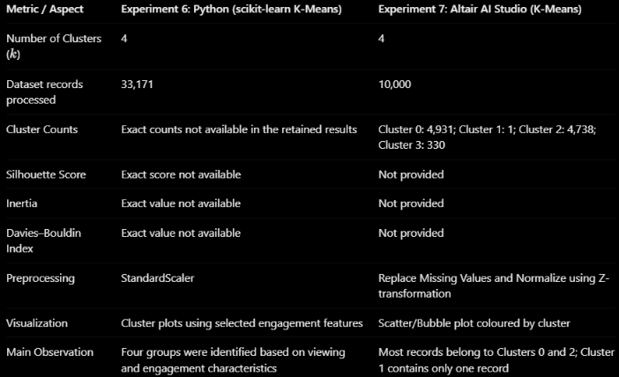
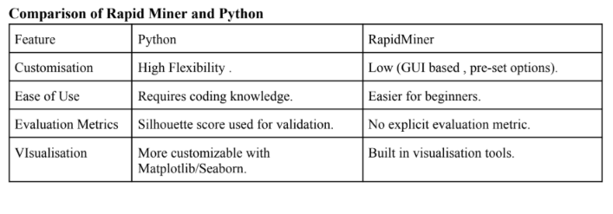
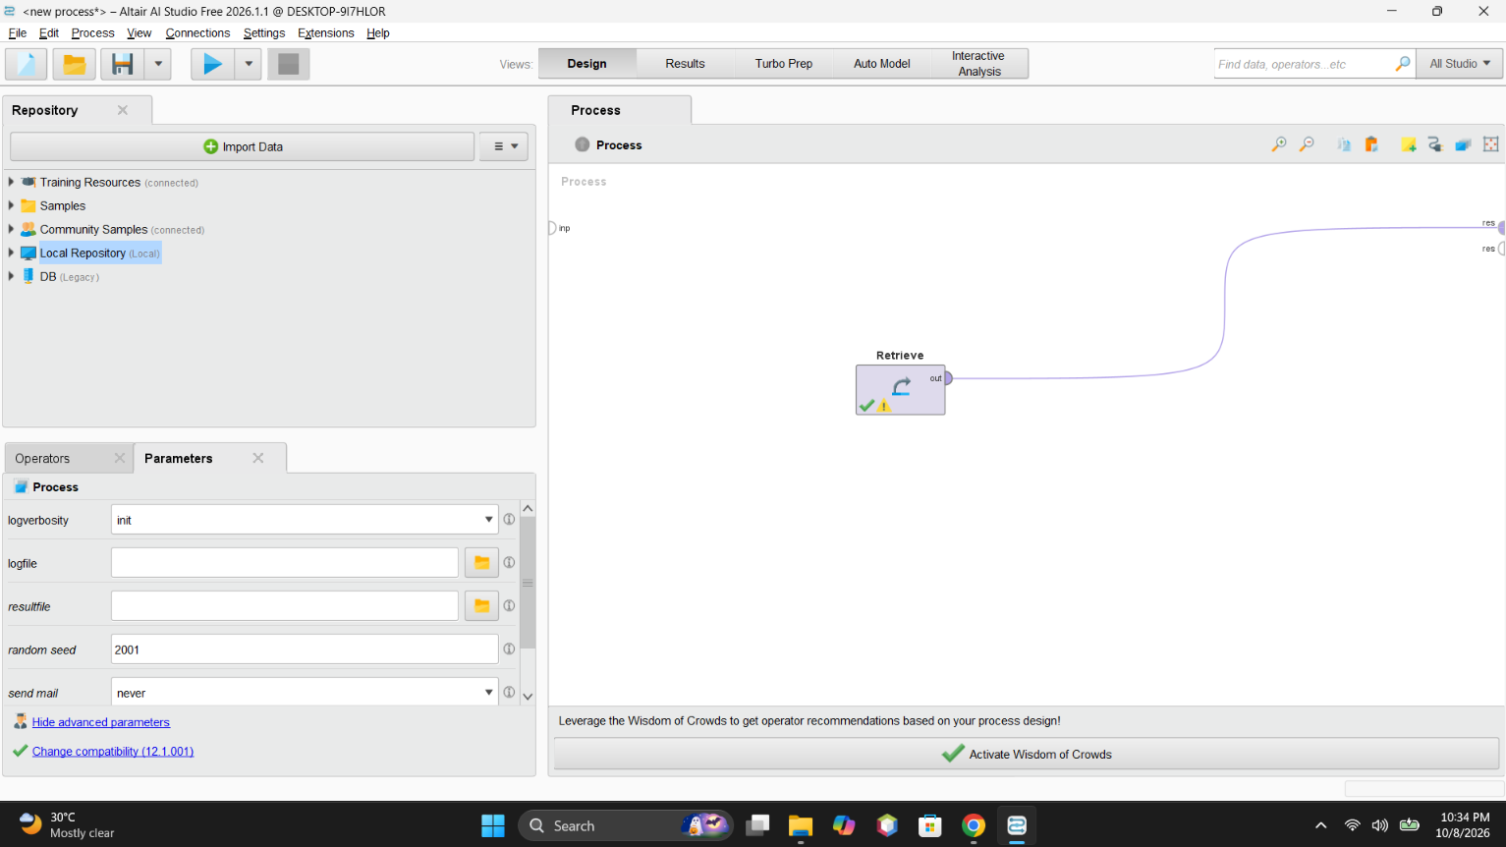
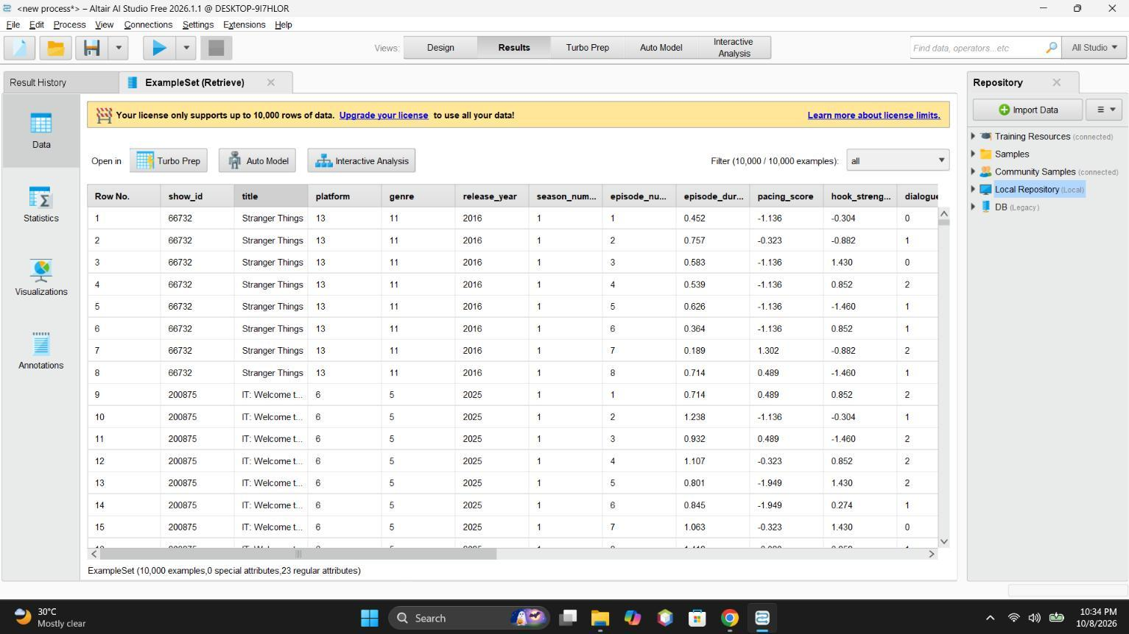
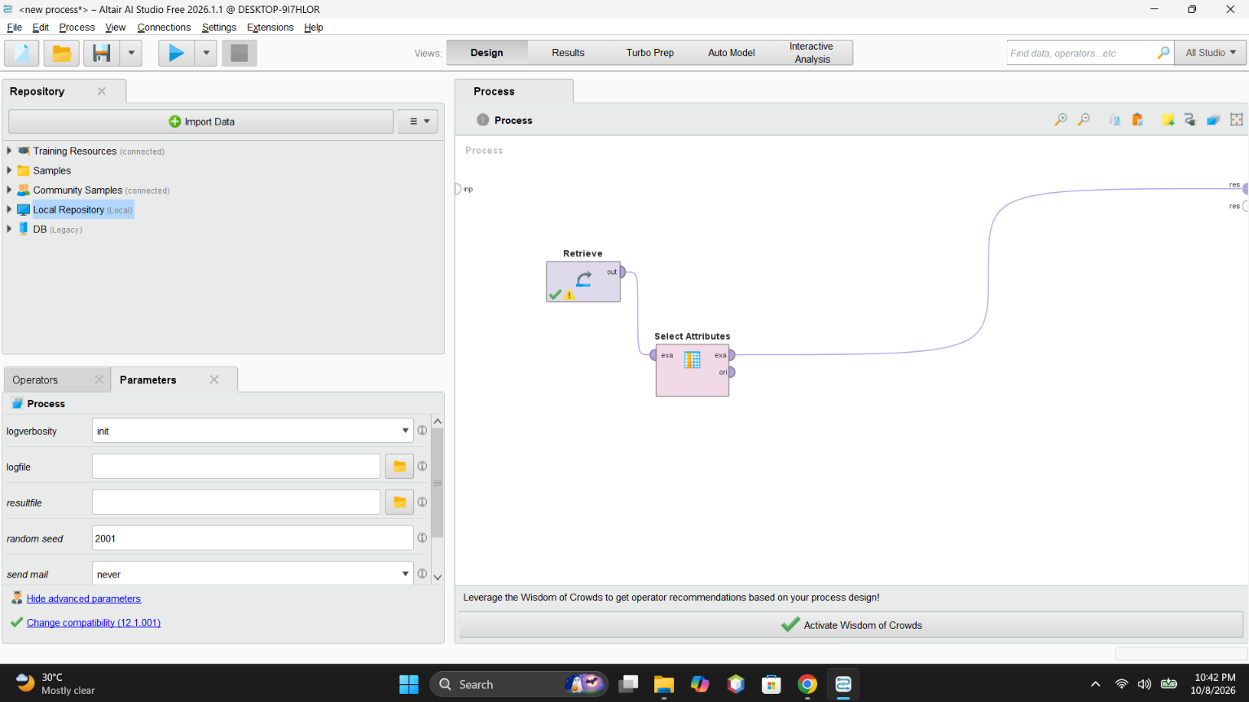
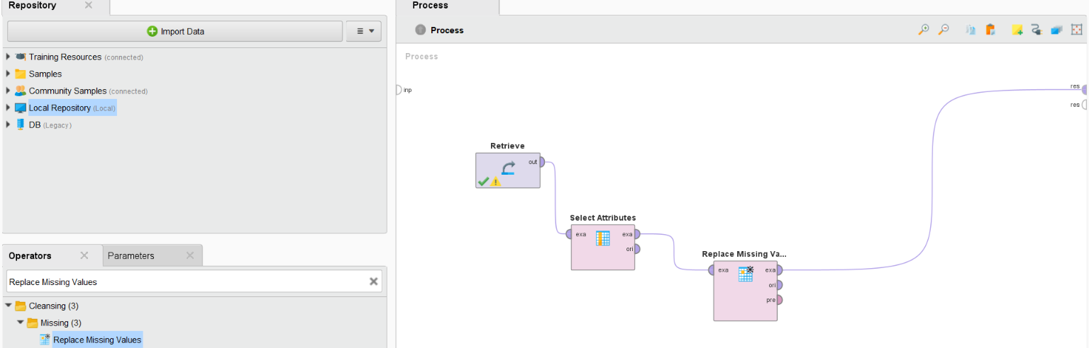
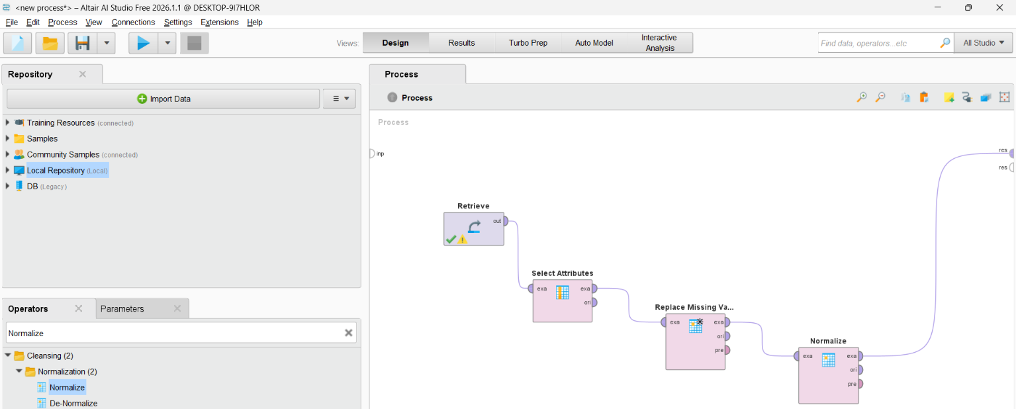
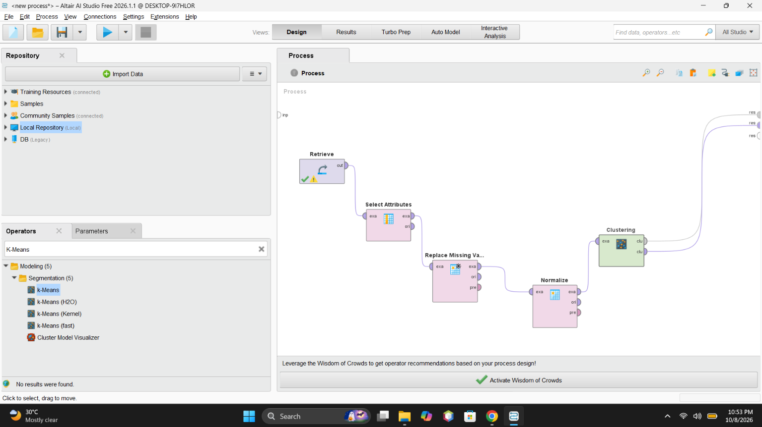
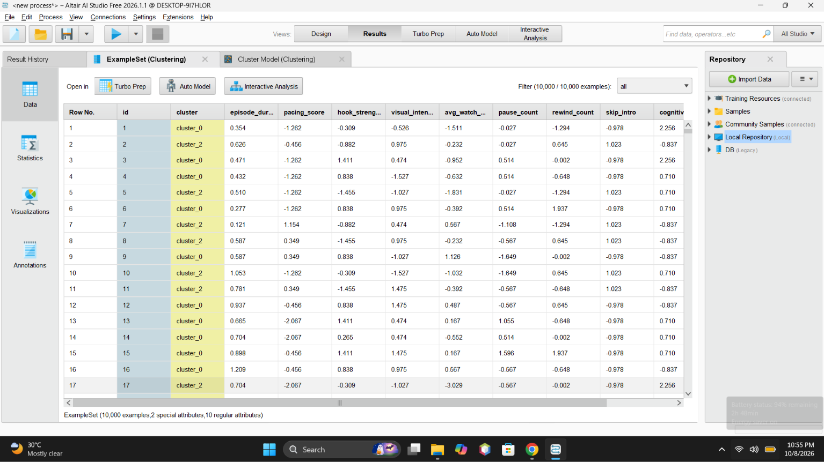
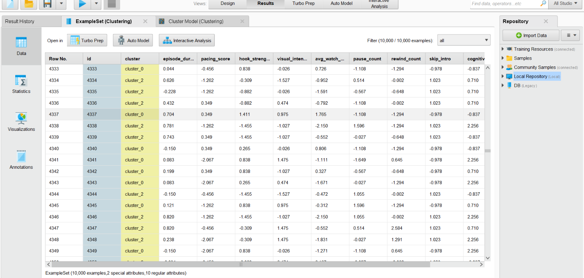
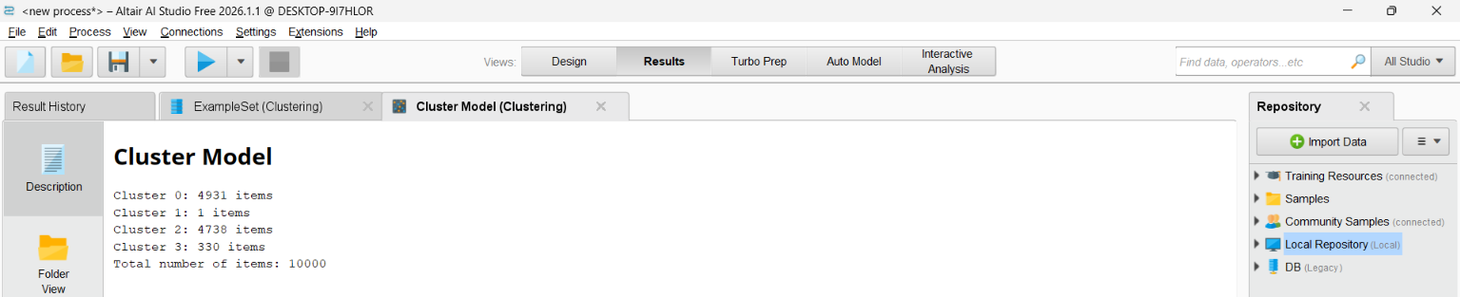
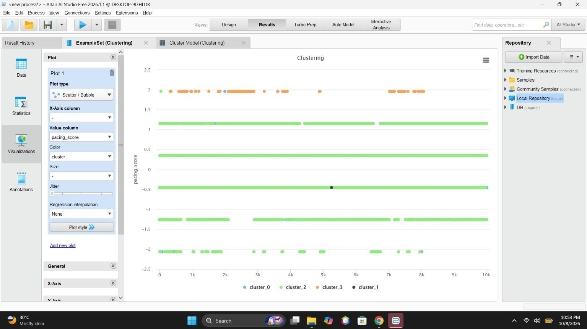
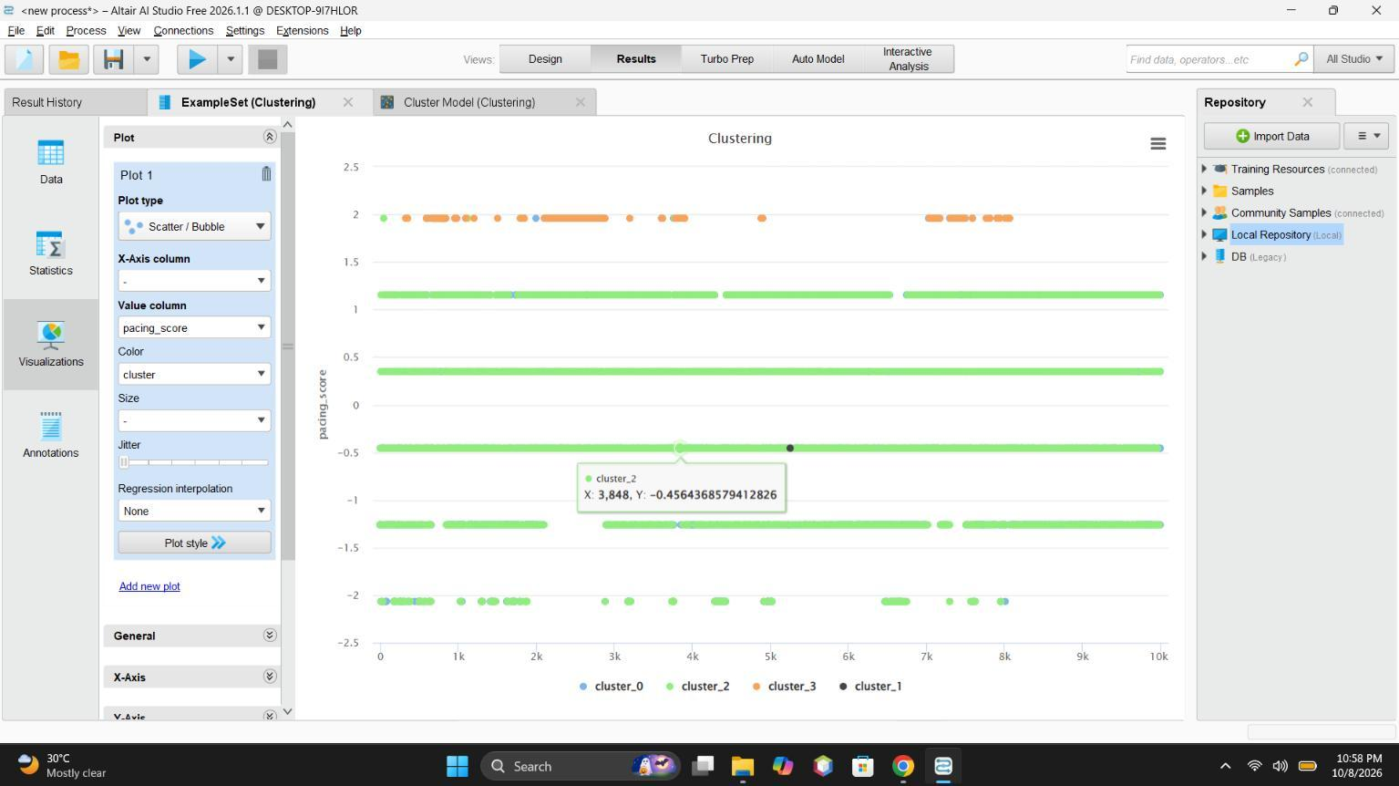
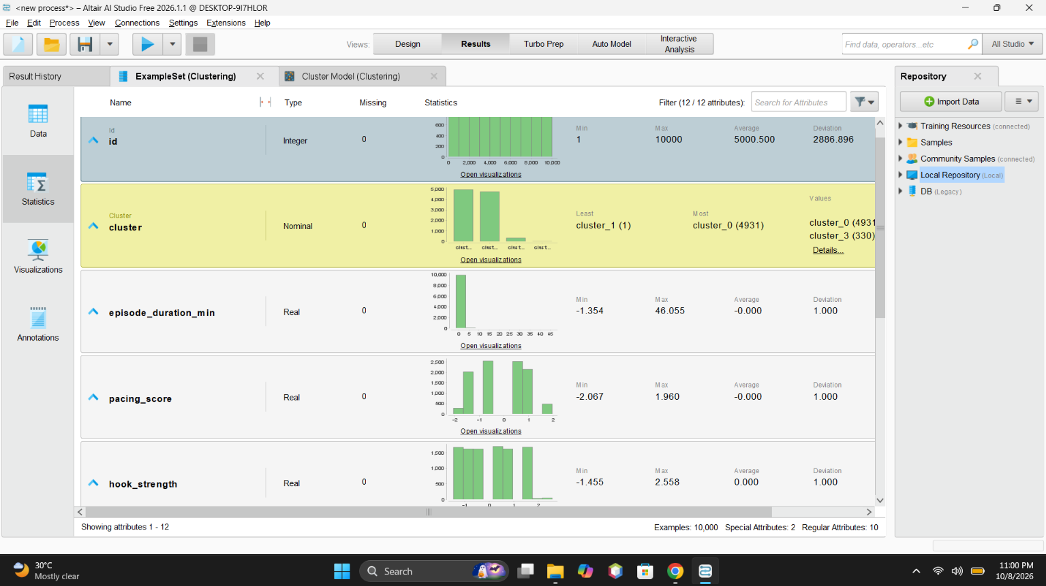
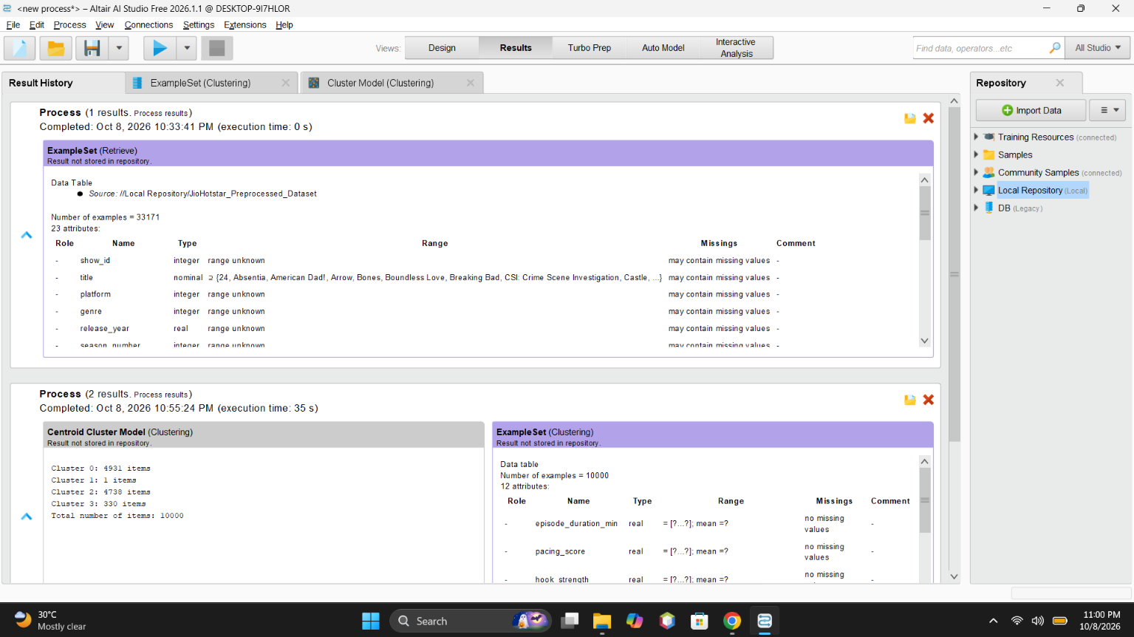
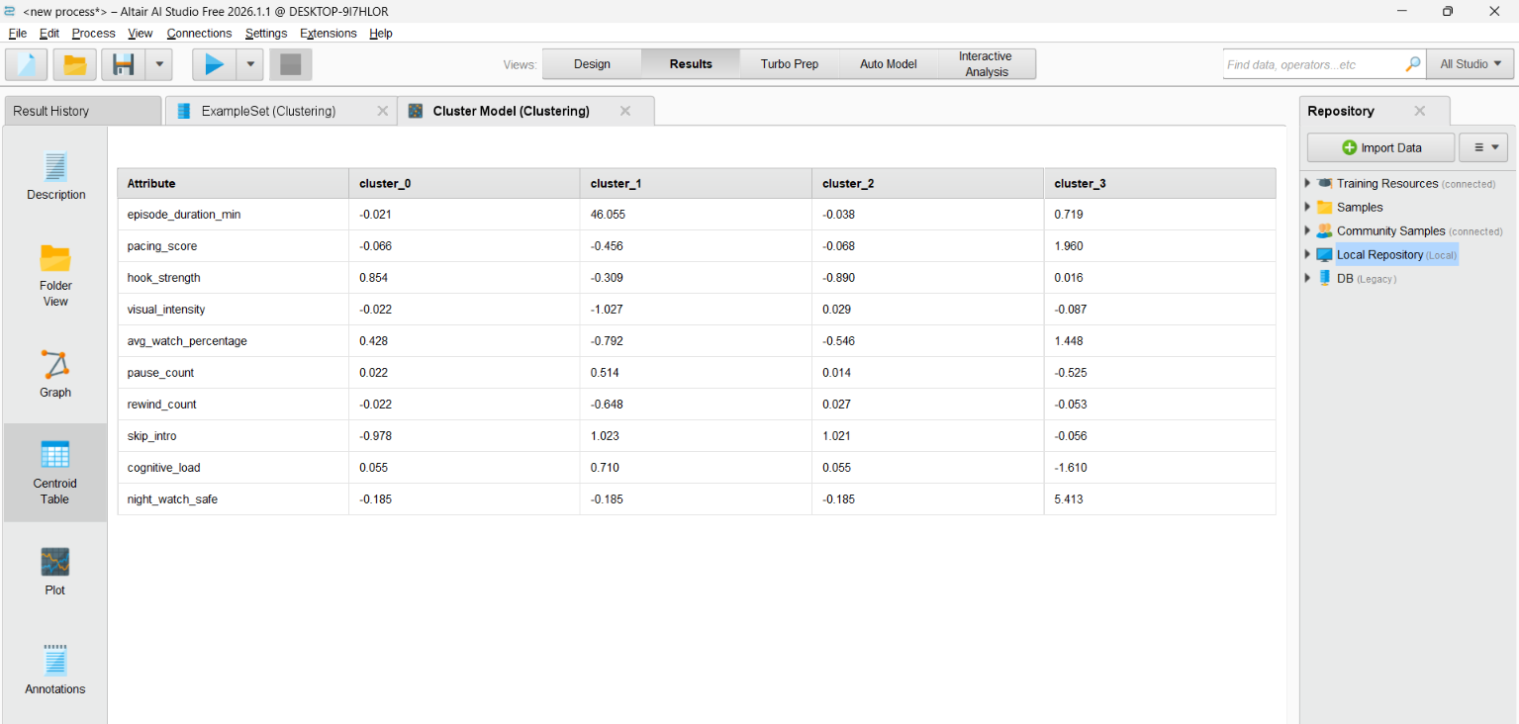

GitHub Repository & Submission Verification
Student Name | Atharva Waghmode
Roll Number / Division | 59 / D15A
Course / Experiment | DMBI Lab — Experiment 7
Individual GitHub Link (Exp 7) | https://github.com/wagha-builds/dmbi_exps_59/tree/main/Experiment_7
Master GitHub Repository | https://github.com/wagha-builds/dmbi_exps_59

