Experiment 8: Association Mining Algorithm (Apriori) using Python
Name: Atharva Waghmode | Roll No: 59 | Div: D15A | Course: DMBI Lab
EXPERIMENT 8

Aim: Experiment to implement Association mining algorithm(Apriori) using Rapid Miner and
Python.

Theory:
1. Association Rule Mining
2. Apriori Algorithm
The main steps are:
- Find frequent itemsets using a minimum support value.
- Generate association rules from the frequent itemsets using a minimum confidence value.
3. Important Terms
1. Itemset: A group of one or more items.
2. Frequent Itemset: A combination of items that appears frequently and satisfies the
minimum support threshold.
3. Association Rule: A rule written as A ⇒ B, which shows that when A occurs, B may also
occur.
4. Support: The percentage or proportion of transactions that contain a particular item or
itemset.
5. Confidence: The probability that B occurs in a transaction when A is already present.
6. Lift: A measure used to check how strongly two itemsets are associated compared with
what would be expected if they were independent.
4. For
mulas
Support:
Support(A) = Number of transactions containing A / Total number of transactions
It tells us how frequently an item or itemset appears in the dataset.
Confidence:
Confidence(A ⇒ B) = Support(A ∪ B) / Support(A)
It tells us how often B appears when A is present.
Association Rule Mining examines a collection of transactions or events to find items that commonly
occur together. The relationships it discovers can highlight repeated patterns; for example, a retailer
may identify products that shoppers often purchase in one basket. Such patterns show
co-occurrence, but they do not by themselves prove cause and effect.
Apriori searches for combinations of items that meet a chosen support threshold and then derives
association rules from those frequent sets. It uses the downward-closure property: if an itemset is
frequent, all of its subsets must also be frequent.
Lift:
Lift(A ⇒ B) = Confidence(A ⇒ B) / Support(B)
- Lift greater than 1: A and B have a positive association.
- Lift equal to 1: A and B are independent.
- Lift less than 1: A and B have a negative association.
5. Dataset Description
The Groceries dataset is obtained from Kaggle and contains grocery purchase records. Each
record represents an item purchased by a customer on a particular date. The dataset can be
used to study customer purchasing behaviour and discover products that are frequently bought
together. The main columns are:
- Member_number: Identifies the customer or member who made the purchase.
- Date: Specifies the date of the purchase.
- itemDescription: Contains the name of the purchased grocery item, such as whole milk
or tropical fruit.
The dataset does not contain product prices, quantities, or detailed customer information.
According to the reference description, it contains 14,963 unique transactions and 167 unique
items.
6. Use of the Apriori Algorithm
To apply Apriori to the grocery dataset, transactions are grouped using the member number
and date. A transaction matrix is then created, where rows represent transactions and columns
represent grocery items. A value of 1 indicates that an item is present in a transaction, while 0
indicates that it is absent.
The Apriori algorithm is applied to identify frequent itemsets and generate association rules.
These rules help discover purchasing patterns, such as when customers who buy one product
also tend to buy another product.
This dataset contains transactional data from a grocery store, capturing customer purchases of
various grocery items. The data is likely collected from a retail environment (specific details
about the store or location are not provided in the source). Each record represents a single item
purchased as part of a customer’s transaction, identified by a member number and date. The
dataset is suitable for market basket analysis and association mining, such as applying the
Apriori algorithm to discover patterns in customer buying behavior.

Output:
The JioHotstar dataset was selected and uploaded for analysis. This dataset contains episode
characteristics and viewer-behaviour information that will be used to discover frequent patterns
and associations.
The dataset was loaded into Python for processing. Loading the data makes it available for
inspection, transformation, and association rule mining.
The dataset was inspected to understand its structure, column names, data types, and sample
records. This step helps verify that the data is loaded correctly and identify relevant attributes
for further analysis.
Relevant viewing behaviours were converted into transaction items, such as high watch
percentage, strong hook, high pacing, high visual intensity, intro skipping, high cognitive load,
and night-watch safety. These items represent the presence of specific characteristics in a
record.
A transaction matrix was prepared in which rows represent records and columns represent
behavioural items. Binary values indicate whether an item is present or absent. This matrix
provides the required input format for frequent itemset mining.
The frequency and support of individual behavioural items were calculated. Support represents
the proportion of records containing an item. This analysis helps identify common viewing
behaviours in the dataset.
The Apriori algorithm and its required Python library functions were imported or prepared for
execution. Apriori identifies frequent itemsets by checking whether their support meets a
specified minimum threshold.
The Apriori algorithm was applied to identify frequent combinations of behavioural items. The

resulting itemsets represent individual items or groups of items that occur frequently in the
dataset.
The displayed output provides additional frequent itemsets and their support values. These
values help determine how commonly different combinations of viewer behaviours occur
together.
Association rules were generated from the frequent itemsets. Each rule contains an antecedent
(the starting condition) and a consequent (the associated item). These rules help identify
relationships between viewing behaviours.
The additional association rules were examined to compare different relationships among
behavioural items. Measures such as support, confidence, and lift can help assess the frequency
and usefulness of each rule.
The association rules were ranked or filtered to identify the most relevant patterns. This reduces
the number of rules that need to be examined and helps focus on relationships that may
provide useful insights into viewer engagement.
The remaining top rules provide further examples of relationships between behavioural
characteristics. Comparing their support, confidence, and lift helps evaluate how frequently and
strongly the items are associated.
The association rules were represented graphically to make the relationships easier to interpret.
Visualization helps compare rule strength and identify potentially interesting patterns in viewer
behaviour.
The additional visualization provides another view of the association rules. It supports

comparison of different item combinations and helps interpret the discovered patterns more
clearly.
The strongest or most relevant association rule was identified from the generated results using
the selected evaluation measure. The rule describes a relationship between behavioural items;
however, association does not prove that one behaviour causes another.
The final Python output summarizes the results of association rule mining, including the
frequent itemsets and the generated rules. These results demonstrate how data mining can
reveal recurring combinations of viewing behaviours in the JioHotstar dataset.

Result:
The final output summarizes the experiment and its findings. Association rule mining helps
identify frequent behavioural patterns and relationships that can support the analysis of viewer
engagement and episode characteristics.

Conclusion:
In this experiment, I learned how to use the Apriori algorithm for association rule mining. I
understood how to identify frequent itemsets and generate association rules using support,
confidence, and lift. This experiment helped me understand the relationships between different
items in a dataset and how these patterns can be useful for decision-making. Initially,
understanding the algorithm and interpreting the rules was a little difficult, but performing the
experiment helped me understand the process better.
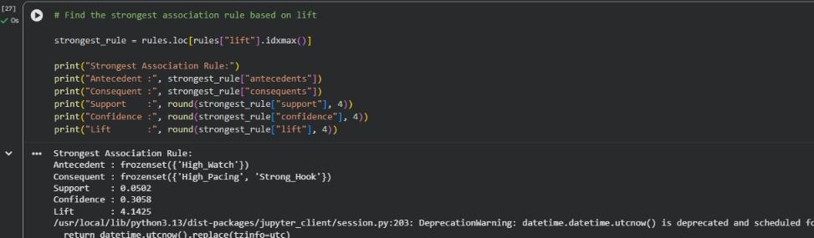
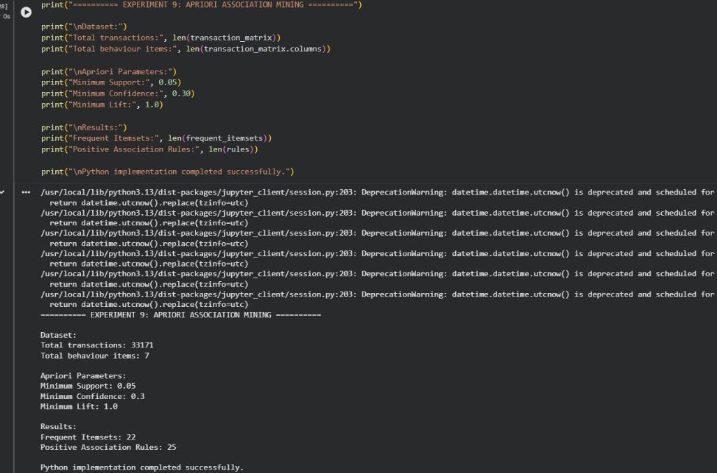
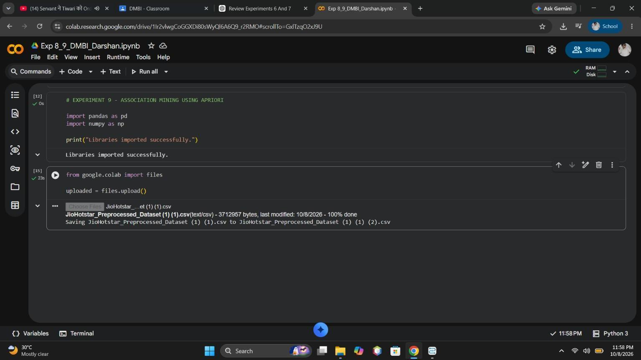
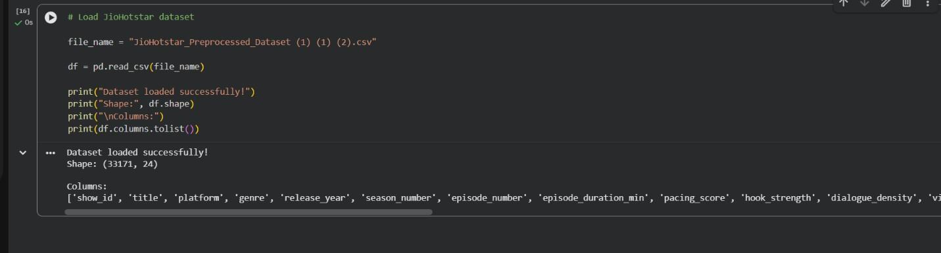
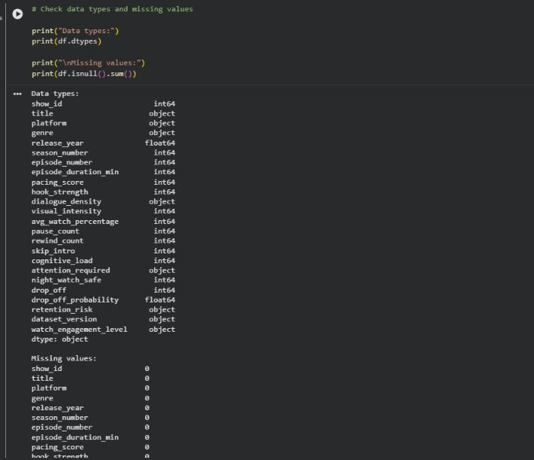
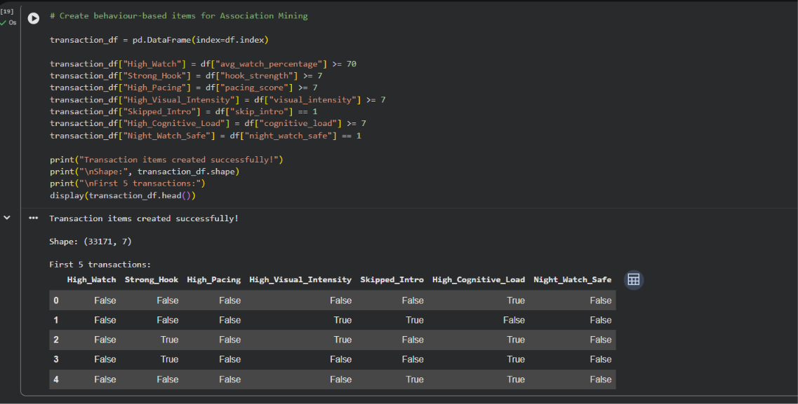
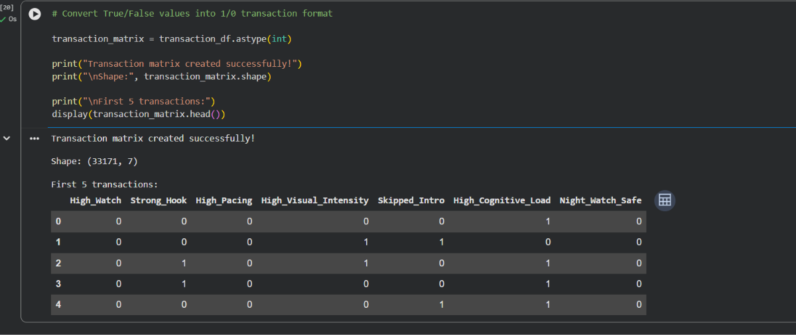
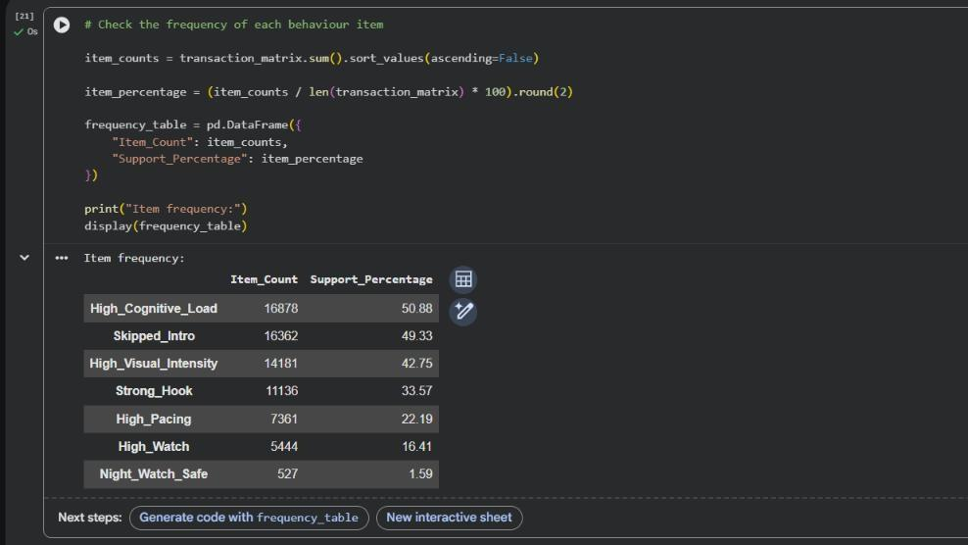
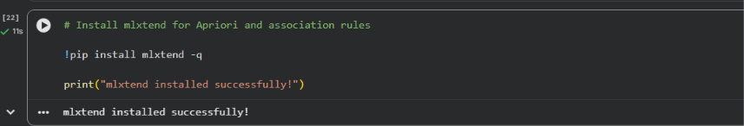
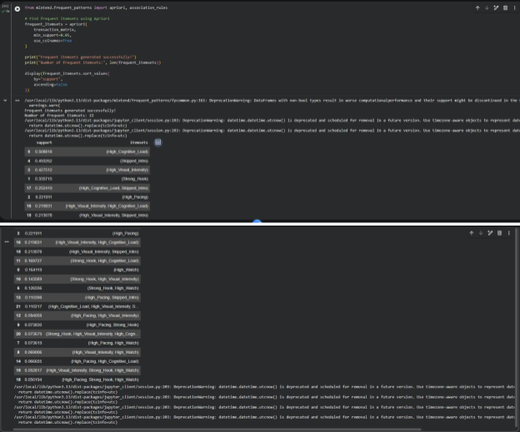
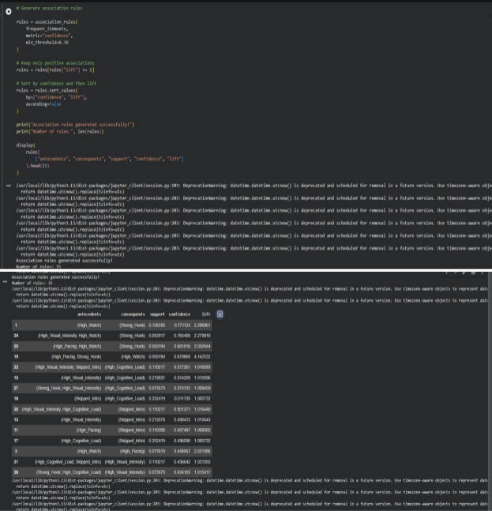
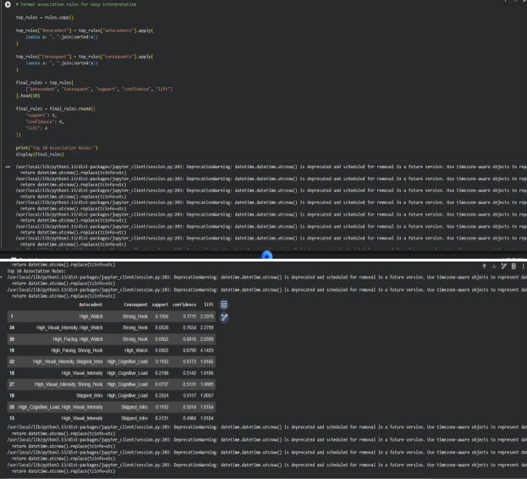
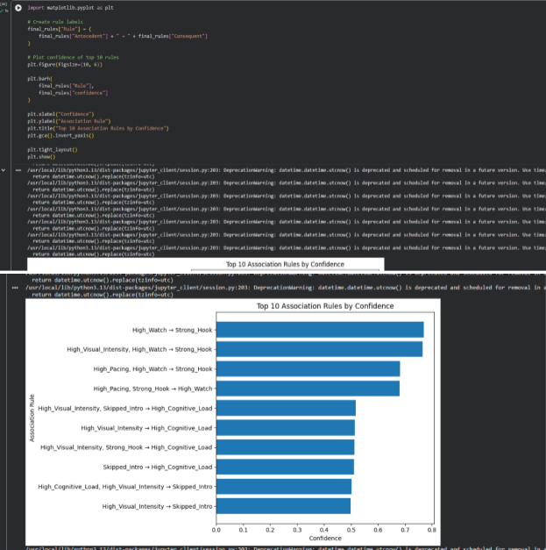

GitHub Repository & Submission Verification
Student Name | Atharva Waghmode
Roll Number / Division | 59 / D15A
Course / Experiment | DMBI Lab — Experiment 8
Individual GitHub Link (Exp 8) | https://github.com/wagha-builds/dmbi_exps_59/tree/main/Experiment_8
Master GitHub Repository | https://github.com/wagha-builds/dmbi_exps_59

