Experiment 9: Association Mining Algorithm (FP-Growth / Apriori) using RapidMiner
Name: Atharva Waghmode | Roll No: 59 | Div: D15A | Course: DMBI Lab
EXPERIMENT 9

Aim: Experiment to implement Association mining algorithm(Apriori) using Rapid Miner and
Python.

Theory:
1. Association Rule Mining
2. Apriori Algorithm
The main steps are:
- Find frequent itemsets using a minimum support value.
- Generate association rules from the frequent itemsets using a minimum confidence value.
3. Important Terms
1. Itemset: A group of one or more items.
2. Frequent Itemset: A combination of items that appears frequently and satisfies the
minimum support threshold.
3. Association Rule: A rule written as A ⇒ B, which shows that when A occurs, B may also
occur.
4. Support: The percentage or proportion of transactions that contain a particular item or
itemset.
5. Confidence: The probability that B occurs in a transaction when A is already present.
6. Lift: A measure used to check how strongly two itemsets are associated compared with
what would be expected if they were independent.
4. Formulas
Support:
Support(A) = Number of transactions containing A / Total number of transactions
It tells us how frequently an item or itemset appears in the dataset.
Confidence:
Confidence(A ⇒ B) = Support(A ∪ B) / Support(A)
It tells us how often B appears when A is present.
Association Rule Mining examines a collection of transactions or events to find items that commonly
occur together. The relationships it discovers can highlight repeated patterns; for example, a retailer
may identify products that shoppers often purchase in one basket. Such patterns show
co-occurrence, but they do not by themselves prove cause and effect.
Apriori searches for combinations of items that meet a chosen support threshold and then derives
association rules from those frequent sets. It uses the downward-closure property: if an itemset is
frequent, all of its subsets must also be frequent.
Lift:
Lift(A ⇒ B) = Confidence(A ⇒ B) / Support(B)
- Lift greater than 1: A and B have a positive association.
- Lift equal to 1: A and B are independent.
- Lift less than 1: A and B have a negative association.
5. Dataset Description
The Groceries dataset is obtained from Kaggle and contains grocery purchase records. Each record
represents an item purchased by a customer on a particular date. The dataset can be used to
study customer purchasing behaviour and discover products that are frequently bought together.
The main columns are:
- Member_number: Identifies the customer or member who made the purchase.
- Date: Specifies the date of the purchase.
- itemDescription: Contains the name of the purchased grocery item, such as whole milk or
tropical fruit.
The dataset does not contain product prices, quantities, or detailed customer information.
According to the reference description, it contains 14,963 unique transactions and 167 unique
items.
6. Use of the Apriori Algorithm
To apply Apriori to the grocery dataset, transactions are grouped using the member number and
date. A transaction matrix is then created, where rows represent transactions and columns
represent grocery items. A value of 1 indicates that an item is present in a transaction , while 0
indicates that it is absent.
The Apriori algorithm is applied to identify frequent itemsets and generate association rules.
These rules help discover purchasing patterns, such as when customers who buy one product also
tend to buy another product.
This dataset contains transactional data from a grocery store, capturing customer purchases of
various grocery items. The data is likely collected from a retail environment (specific details about
the store or location are not provided in the source). Each record represents a single item
purchased as part of a customer’s transaction, identified by a member number and date. The
dataset is suitable for market basket analysis and association mining, such as applying the Apriori
algorithm to discover patterns in customer buying behavior.

Output:
The JioHotstar association dataset was imported into RapidMiner. This step makes the dataset
available for further processing and association rule mining.
The imported dataset was checked to confirm that it was loaded correctly and that the required
attributes were available.
The Retrieve operator was connected to the Numerical to Binominal operator. This converts
numerical values into binary values so that the data can be processed by the FP -Growth
algorithm.
The FP-Growth operator was used to identify frequent itemsets in the dataset. The minimum
support was set to 0.05, meaning itemsets occurring in at least 5% of transactions could be
considered frequent.
The complete workflow was checked to ensure that the operators were connected correctly and
that the output was directed to the results section.
The generated rules were examined using measures such as support and confidence to
understand how frequently the patterns occurred and how reliable the relationships were.
The association rules generated by RapidMiner were displayed. These rules show relationships
between different viewing behaviours in the JioHotstar dataset.
The top association rules were examined to identify useful relationships between viewing
behaviours, such as strong hooks, high watch percentage, high pacing, and visual intensity.

Result:
The final result demonstrates that FP -Growth and association rule mining can identify frequent
patterns and relationships in the JioHotstar dataset. These patterns can help in understanding
viewer behaviour and engagement.

Conclusion:
In this experiment, I learned how to perform association rule mining using RapidMiner and the
FP-Growth algorithm. I learned how to import the dataset, convert numerical attributes into
binominal values, find frequent itemsets, and generate association rul es using support and
confidence. The experiment helped me understand the relationships between different viewing
behaviours in the JioHotstar dataset. These patterns can be useful for analysing viewer
engagement and improving content recommendations.
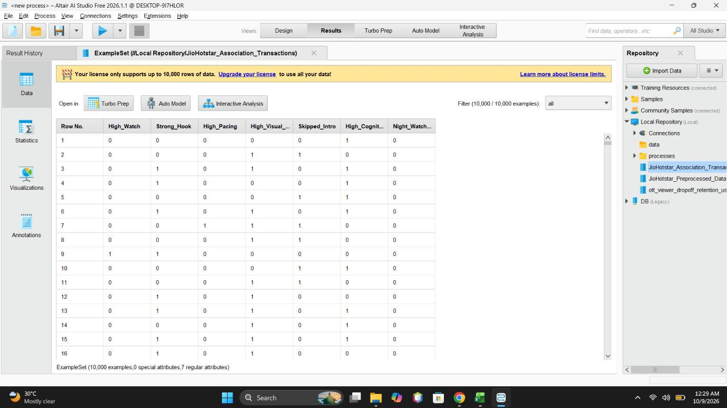
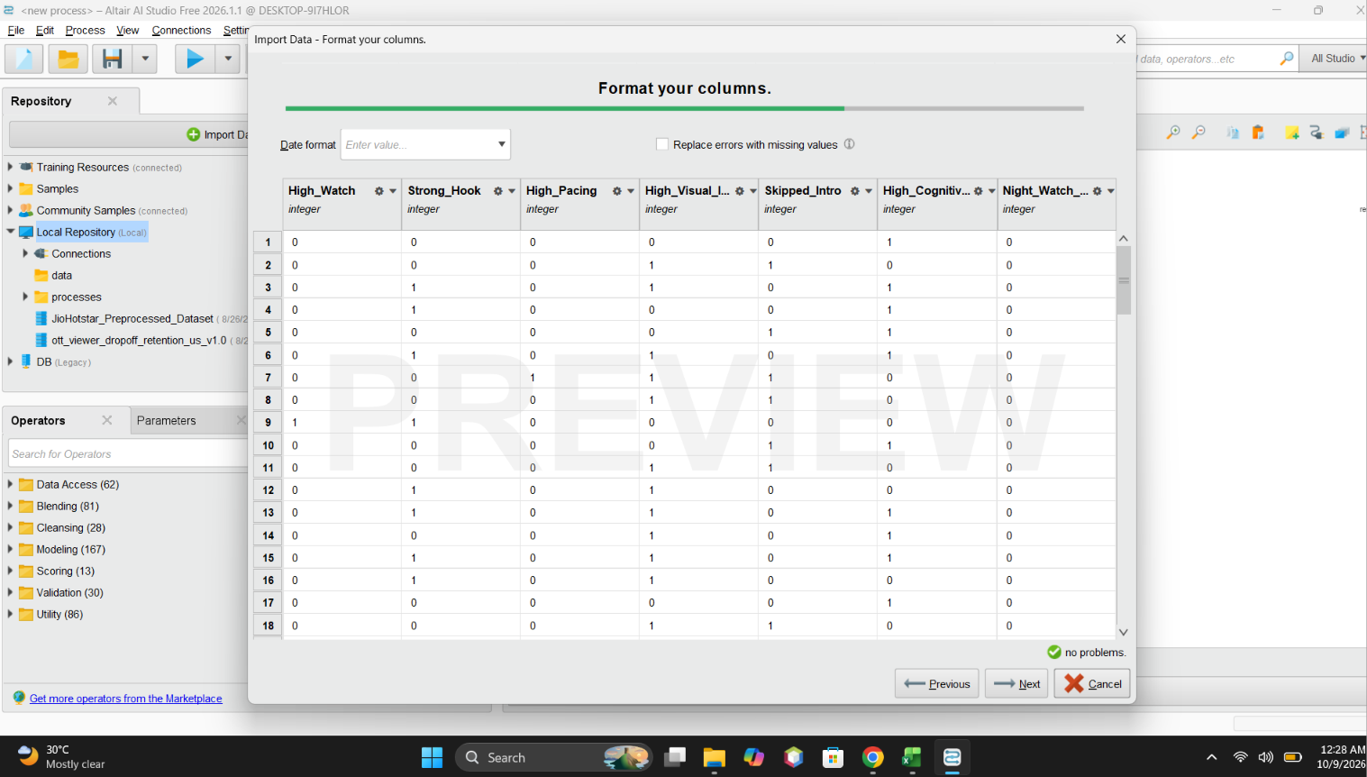
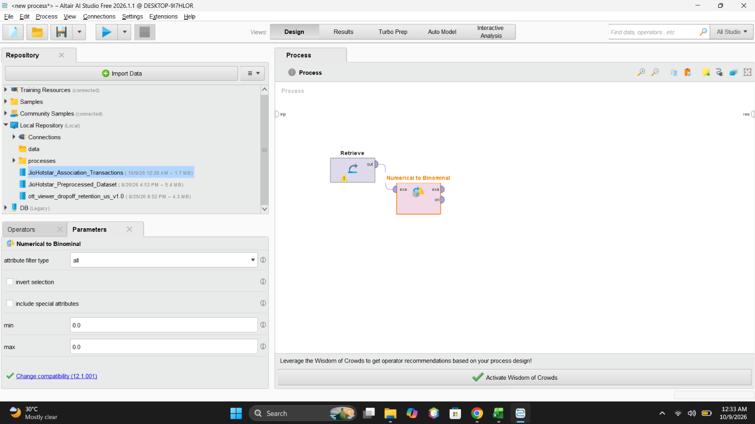
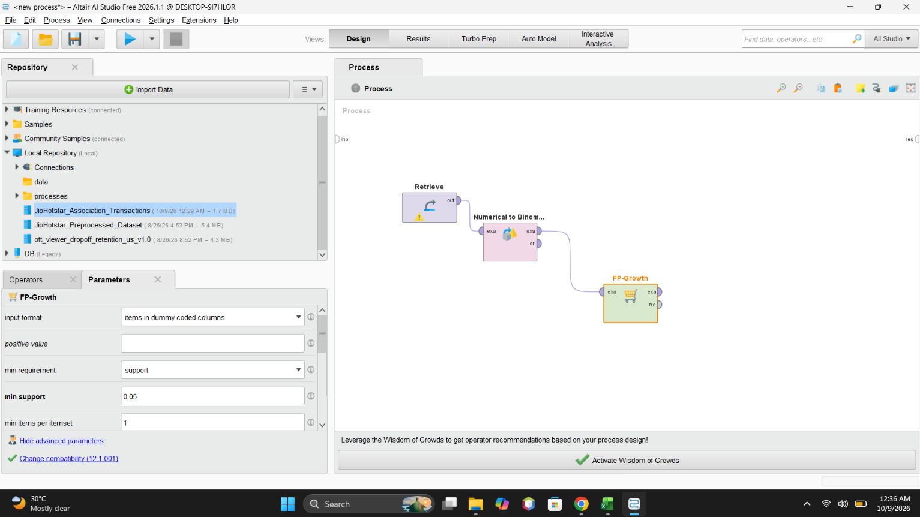
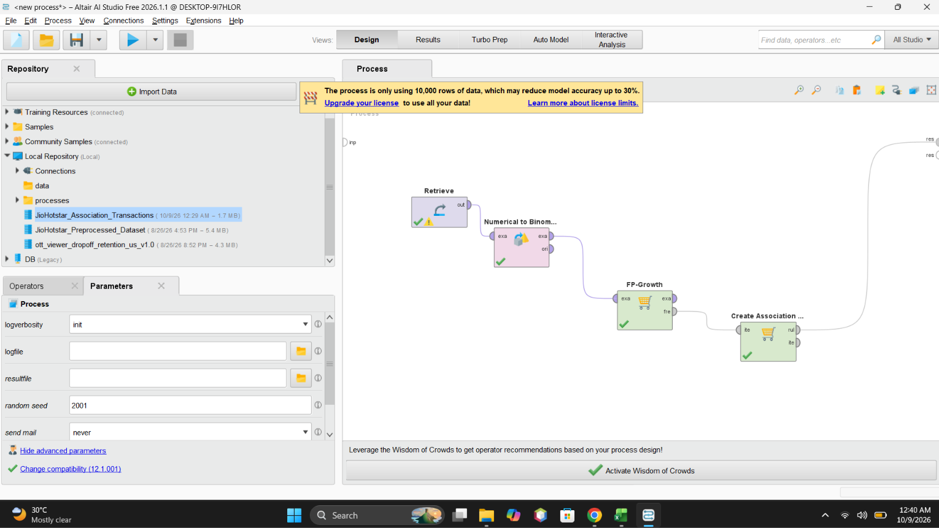
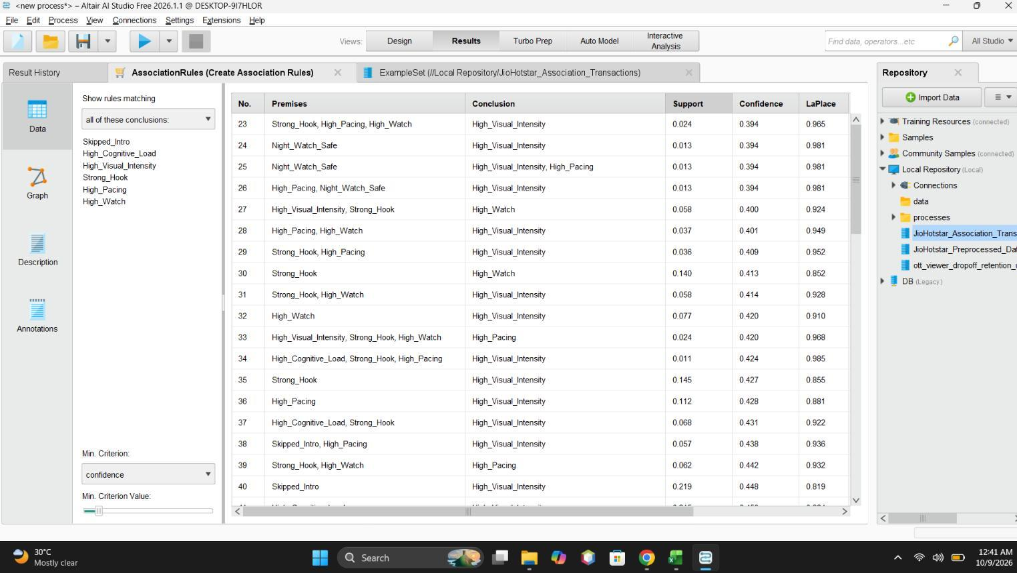
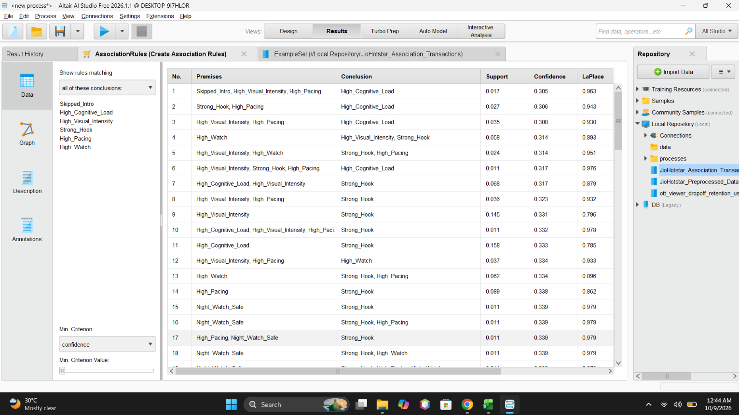

GitHub Repository & Submission Verification
Student Name | Atharva Waghmode
Roll Number / Division | 59 / D15A
Course / Experiment | DMBI Lab — Experiment 9
Individual GitHub Link (Exp 9) | https://github.com/wagha-builds/dmbi_exps_59/tree/main/Experiment_9
Master GitHub Repository | https://github.com/wagha-builds/dmbi_exps_59

