Jira

Intro
Jira is a project management and issue-tracking tool used by teams to plan, track, assign, and manage work throughout the software development lifecycle.
It helps teams organize work into items such as Epics, Stories, Tasks, and Bugs, assign them to team members, track progress using workflows (To do, in progress, done) and ensure timely delivery.
Jira is widely used by Product, Development, QA, and DevOps teams to collaborate efficiently, maintain transparency, and improve project visibility.

JIRA PROCESS

Step 1: Create a team. Open JIRA and click on teams
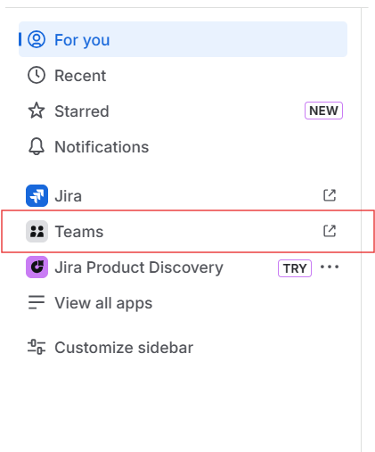

Step 2: Click on create and select Teams
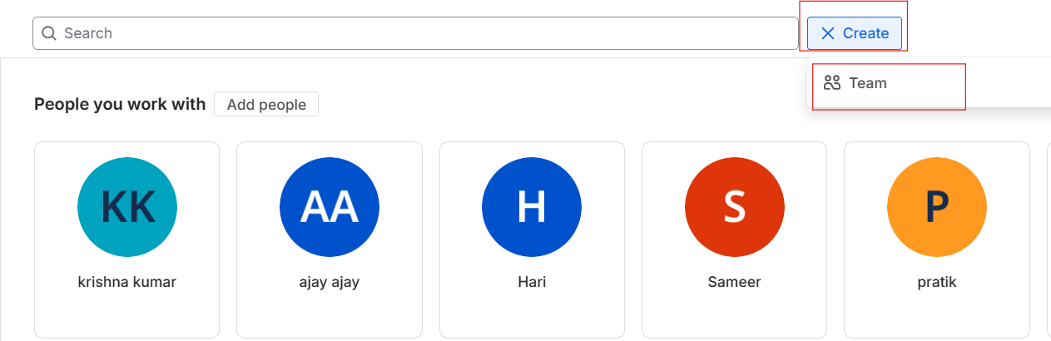
Step 3 : Add the name of the team and add team member and go to create
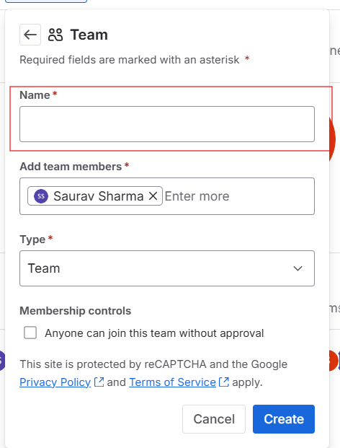
Step 4: click on the create
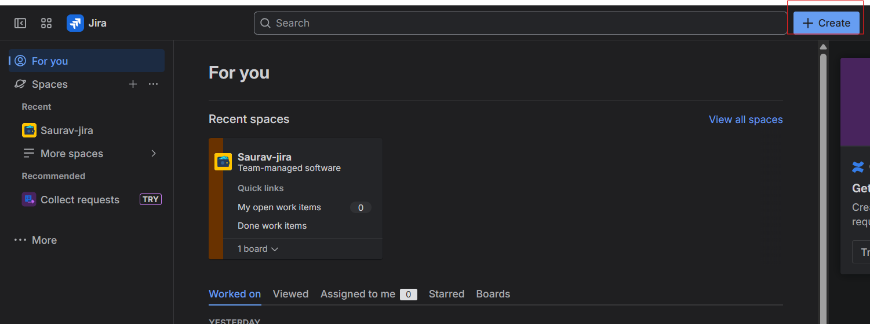
Step 5: Give the work type according to the team.. status To Do . In summary write the tilte of the work and add description according to problem.
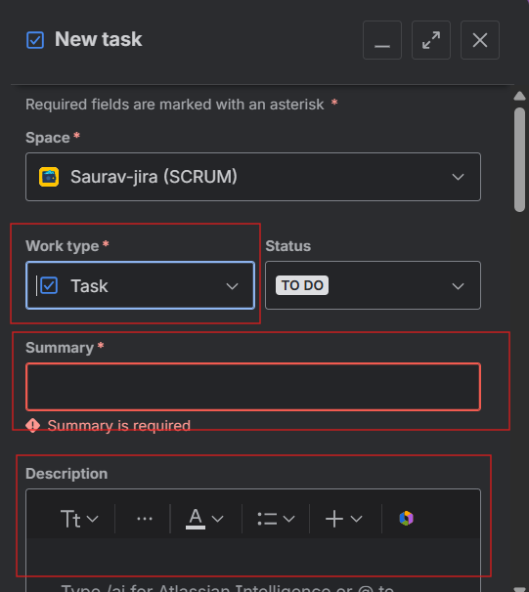

Step 6: Assign the work to the people and add due date.
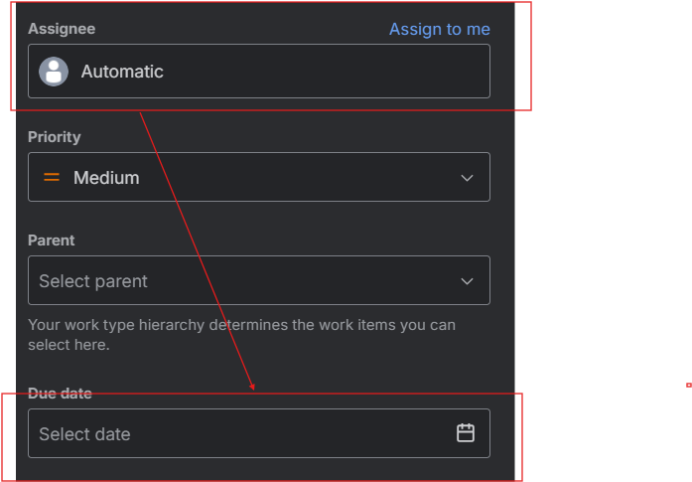

Step 6 : choose the team according to problem and add start date and click on create team.
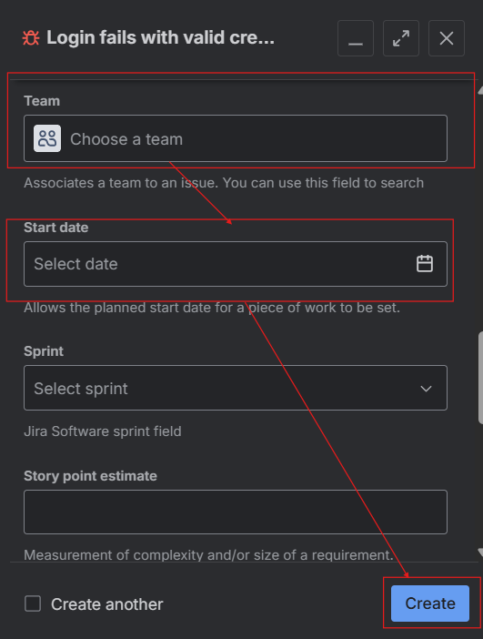
Step 7: Repeat the same step up to 6 to create team like
QA Team, Dev Team, Staging Team, Product Team
Step 8: After completion ticket raise it will show like this .
