Linux Commands

touch : it is use to create a file
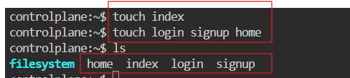

ls : it is use to get the list of the file

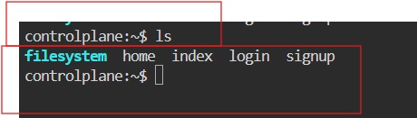

vi : it is use to create and open a file
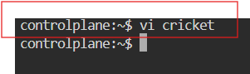

i : it is a insert mode in vi.

For saving the file
esc
:wq

cat: it is used to read file content without opening a file.
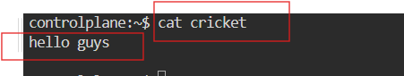

mkdir: it is used to make a directory (folder)
folder name is written in blue color.
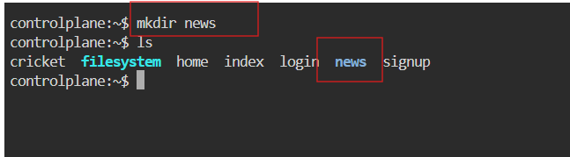

cd filename: it is used to change the directory
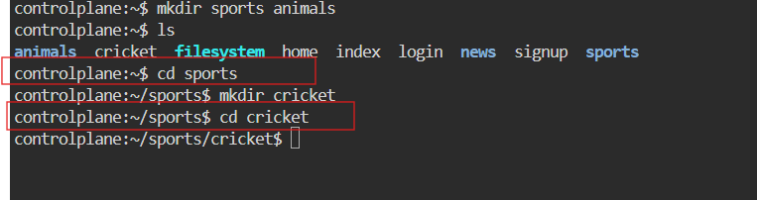

cd: used to go to root directory
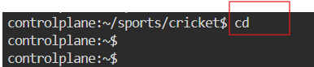

cd .. : used to go onefolder back
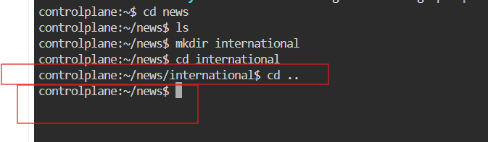

mv : it is used to move the file ( it is also known renaming)
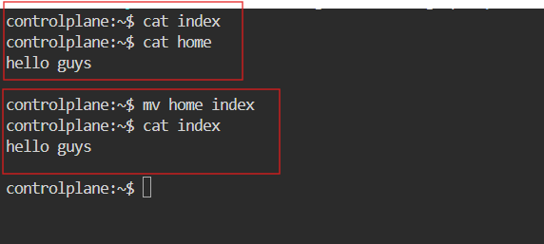

cp: it is used to copy files and directories
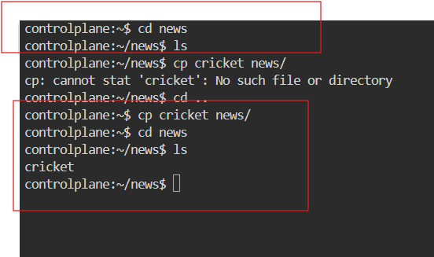

rmdir: it is used to remove empty directory
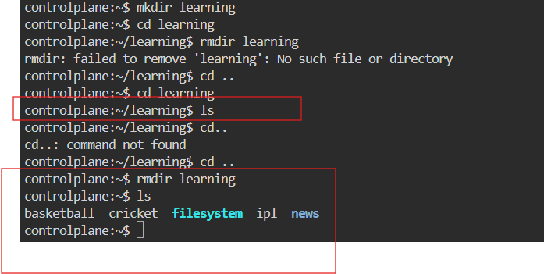

pwd: it is used to display the current working directory
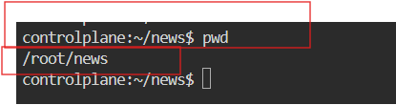

ping: it is used to check network connectivity between your computer and another host
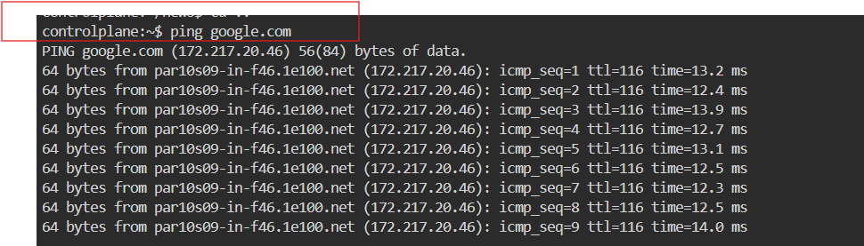
History : it is used to display previous executed command in terminals
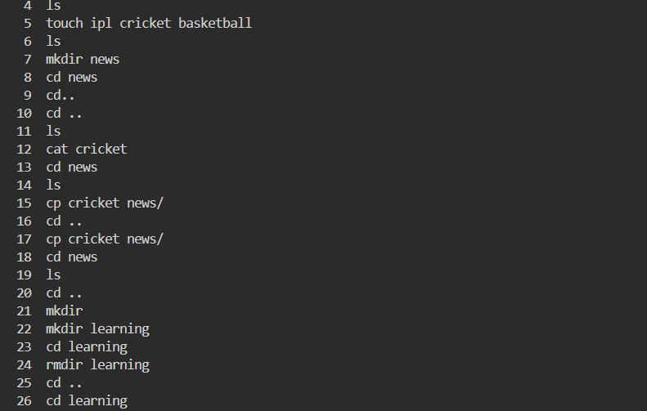

How to add Users

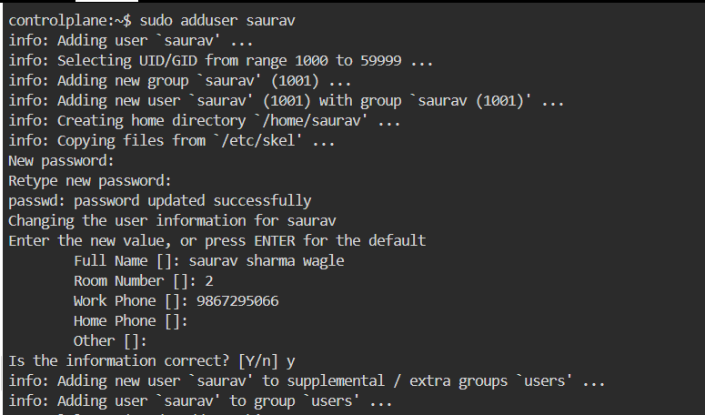

To Show the list of user
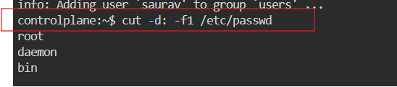
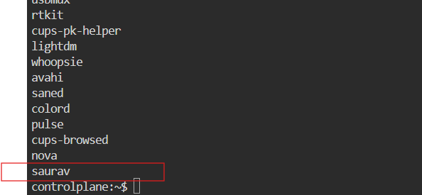

For Deleting user :
Sudo userdel usename

Permission Types

- User R= Read =4
- Group W= Write =2
- Other X=Executable =1

Change file permission

There are 2 types:
chmod: change modification on permission
chown: change ownership

There are two ways to change the file name using chmod.

- Symbolic
Syntax: chmod who operator permission filename

chmod= command
who= user,group,other(u,g,o)
Operator=(+,-)
Permission : r,w,x

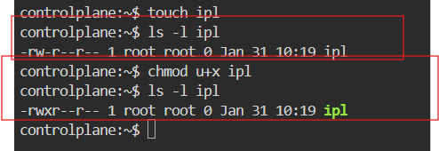

- Numeric Mode
Syntax : chmod rwx file name
The value of r w x is in top of this page.

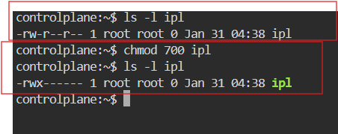

System Command

uname : used to get type of os
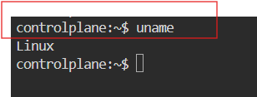

uname -r : used to get kernel version of our os
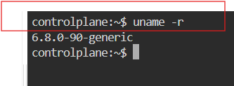

uname -a : used to get full info about os
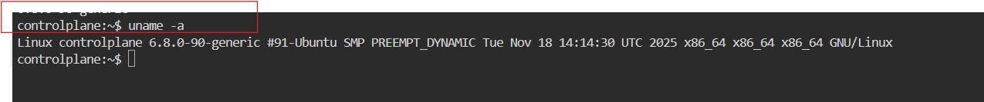

clear : used to clear

uptime: used to get since how long the system is in running state
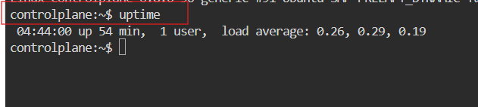

uptime -p : this will give time only
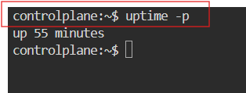

hostname : used to get private dns name of our system
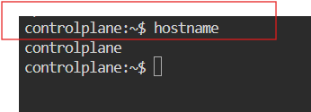

hostname -i : used to get private ip of our system
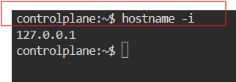

For changing hostname : hostnamectl set-hostname “saurav”
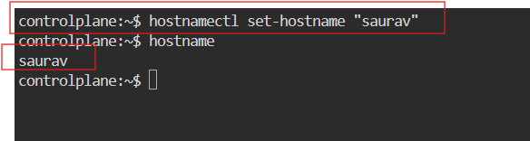
ip addr: used to get private Ip
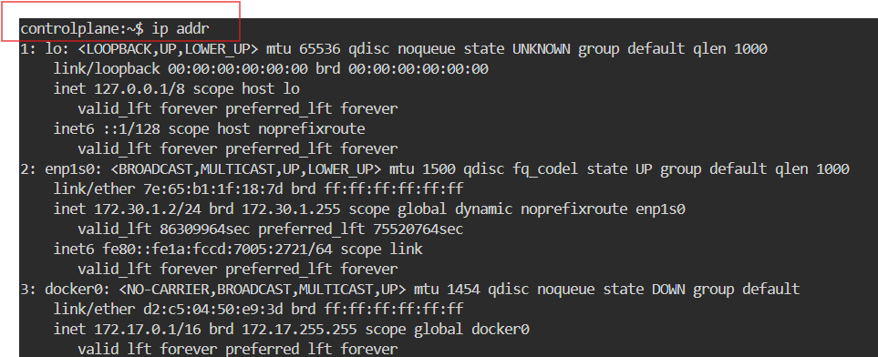
ip route : used to get private IP
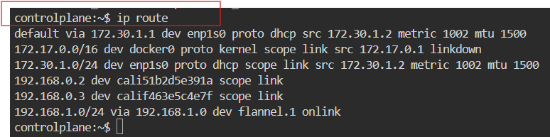
Ifconfig: used to get private IP
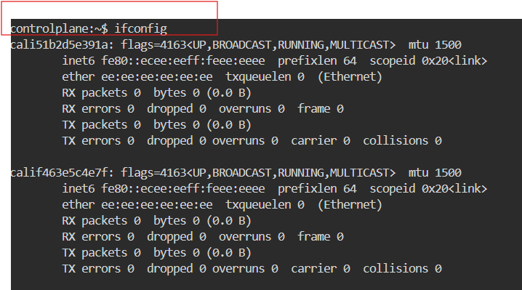
date: to get todays date
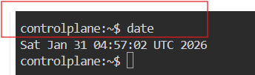

timedatectl: used to get timezones
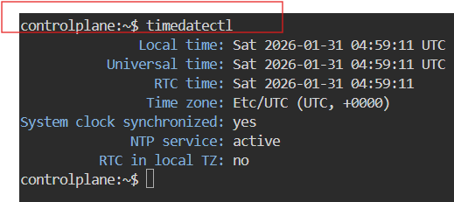

For changing timezones
Syntax: timedatectl set-timezone Asia/Kathmandu
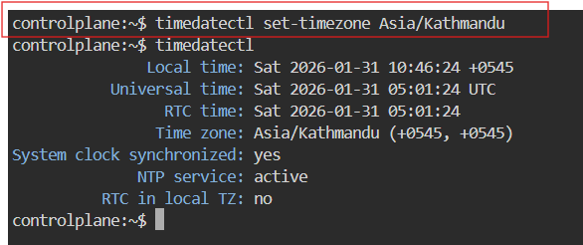

who : used to see how many users have been loggin into your system

whoami : used to see the current user.

ps : used to see the running processors in system

kill -9 PID : used to kill a processor

date +”%d”: prints the day of the months(01-31)
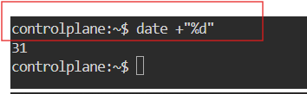

date +”%m” : Prints the month of the year 01-12
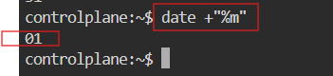

date +”%y” : Prints only the last two digits of Year
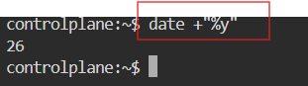

date +”%H” : Prints the hour 00-23
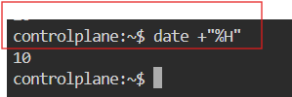

date +”%M” : Prints the Minute of the hour 00-59
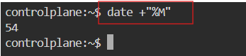

date +”%S” : Prints the current seconds count in the minute (00-60)
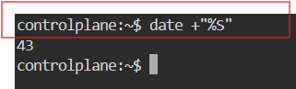

date +"%D" : Prints Date in MM/DD/YY
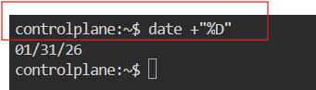

date +”%F” : Prints only the Full date as YYYY-MM-DD
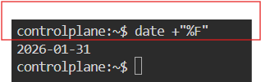

date +”%A” : Prints the Day of the Week Saturday-Sunday
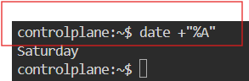

date +”%B” : Prints the month between January-December
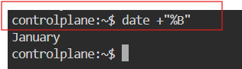

Hardware Commands

lscpu (or) cat /proc/cpuinfo : Displays information about the CPU architecture
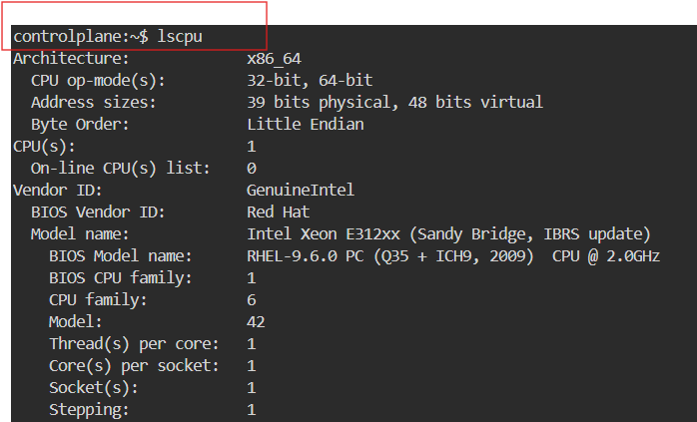

lsblk -a : Lists the information about all the block devices attached to the system
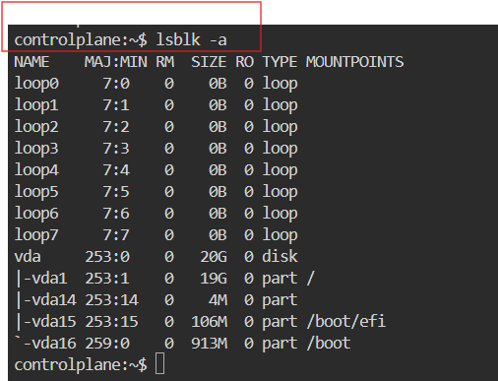

free (or) cat /proc/meminfo: Displays system memory(RAM) details in KB
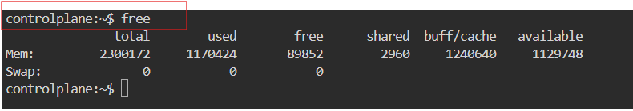

free -m : Displays system memory(RAM) details in MB
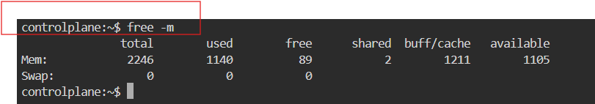

df -h : Report file system disk space usage in human readable languages
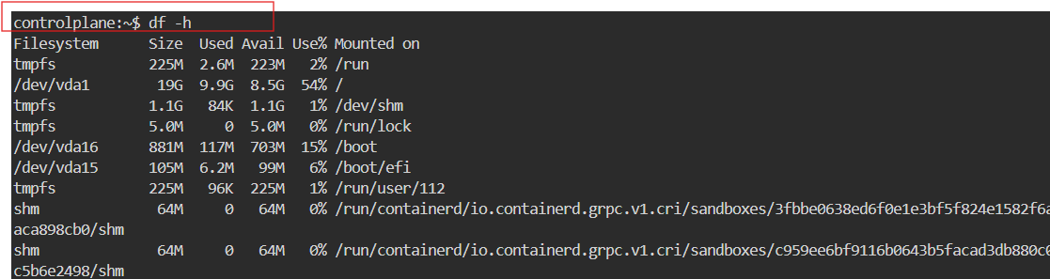

GREP (Global Regular Expression Print):
It is used to search for a word in a file

SYNTAX: grep “word” filename

grep “word” filename : used to search for a word in a file
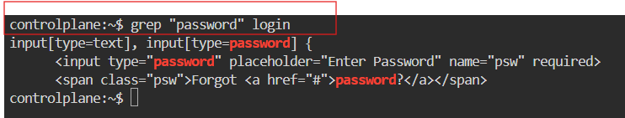

grep -n “word” filename : it prints the data along with line numbers
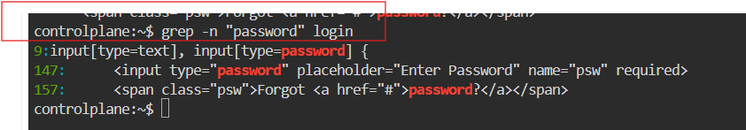

grep -c “word” filename : it prints no of occurances of a word
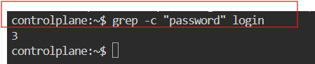

grep -i “word” filename : used to search for a case-sensitive
