Linux

What is Linux?

Linux is a free and open-source operating system based on the Linux kernel. It acts as an interface between computer hardware and the user, managing system resources and allowing applications to run efficiently.
Linux was created by Linus Torvalds in 1991 and is widely used in servers, desktops, mobile devices (Android), and embedded systems.

Why Linux ?
Linux is preferred for many reasons:

- Open Source — Source code is freely available
- Secure — Strong permissions and fewer viruses
- Stable & Reliable — Can run for years without rebooting
- Cost-Effective — Free to use and distribute
- Customizable — Can be modified for specific needs
- High Performance — Efficient use of system resources
- Community Support — Large global developer community

Operating System
An Operating System (OS) is system software that:

• Manages hardware (CPU, memory, disk, devices)
• Provides a platform for applications
• Acts as an interface between user and hardware

Examples: Linux, Windows, macOS
Linux is a multi-user, multitasking operating system.

KERNEL
The kernel is the core of the Linux operating system.
Functions of the Kernel:

- Process management
- Memory management
- Device management
- File system management
- System call handling

Linux uses a monolithic kernel, meaning most services run in kernel space for better performance.

DAEMONS

Daemons are background processes that run without direct user interaction.
Examples:
• sshd — Secure Shell service
• httpd — Web server daemon
• cron — Scheduled task daemon

Characteristics:
• Start at system boot
• Run continuously in the background
• Provide system services

SHELL
The shell is a command-line interpreter that allow users to interact with the linux system.

Functions:
• Accepts user commands
• Interprets commands
• Communicates with the kernel

Common Linus Shells:
• Bash
• Zsh
• Sh
• Ksh

Command
A command is an instruction given by the user to the Linux system to perform a specific task.

Terminal
The terminal is a text-based interface used to interact with Linux shell

Features:
• Executes shell commands
• Displays command output
• Allows system administration tasks

The terminal is also called:
• Command Line Interface (CLI)
• Console

Linux Architecture

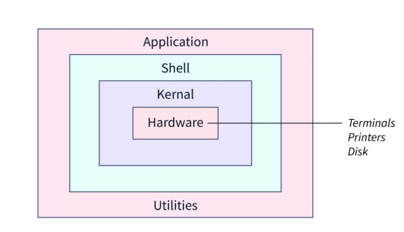

Architecture Layers:
- Hardware — CPU, RAM, disks, devices
- Kernel — Core system management
- Shell — User interaction layer
- Applications — User programs (editors, browsers, tools)

In Linux we have different type of Command

System Command:
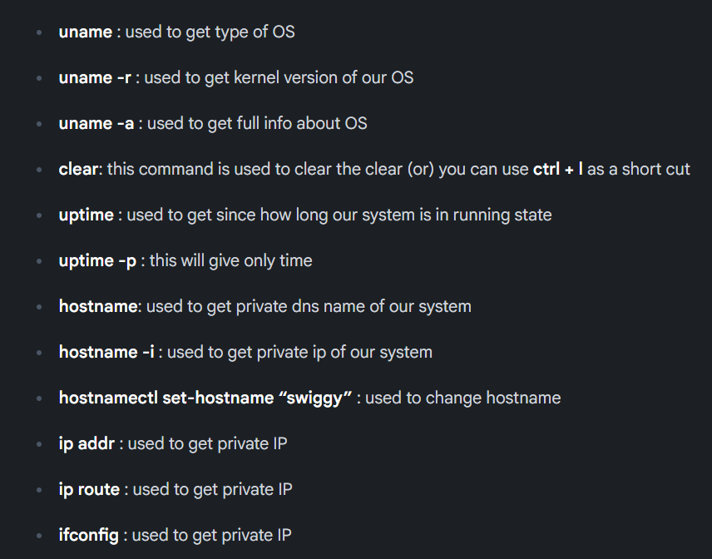
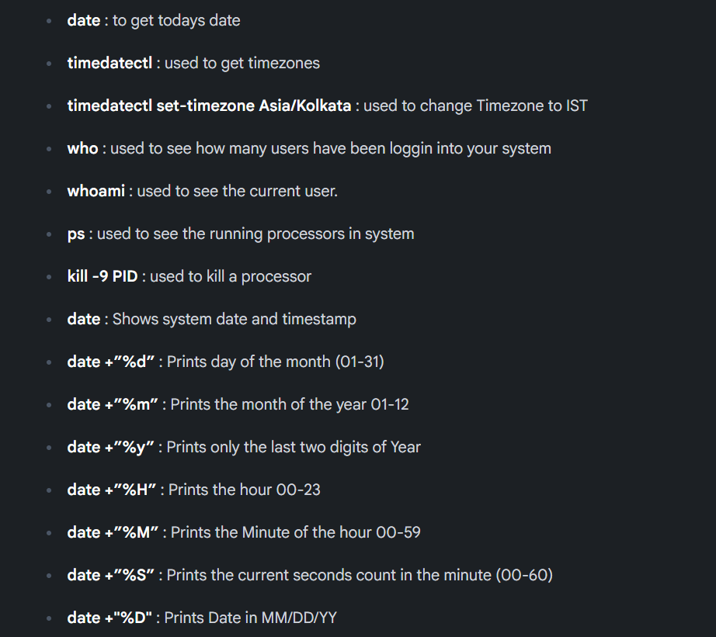

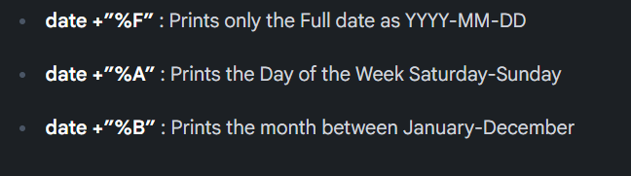

HardWare Commands:
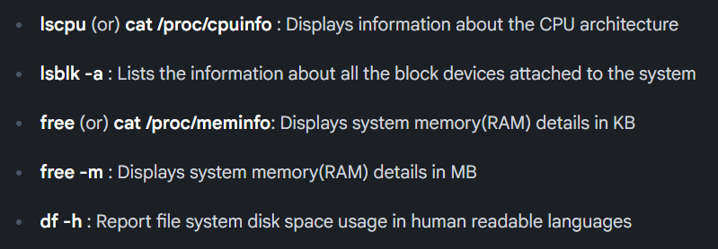

Files Command
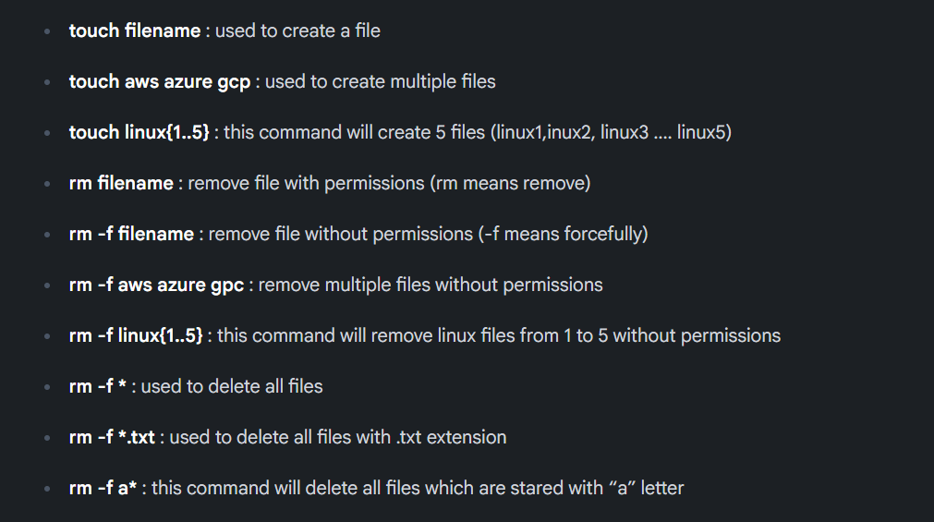

Folder Commands:
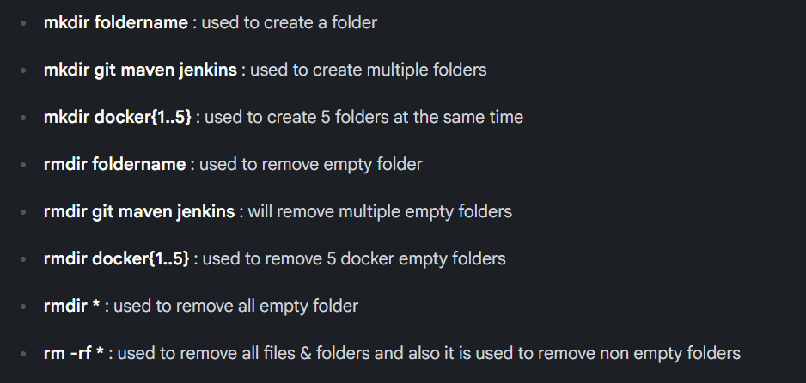

List the files:

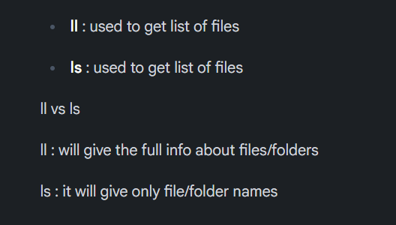

Change Directory:
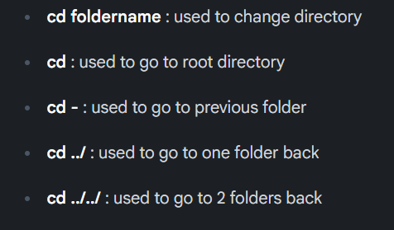

Directory Commands:
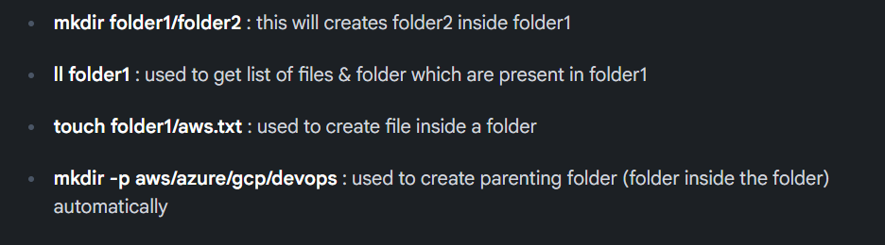

Copy Commands:
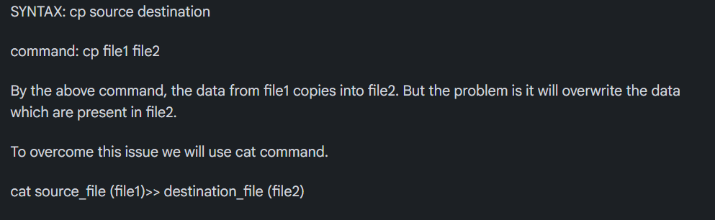

Move Commands:
