Deployment Rolloing Update Commands

Step 1: writing the deployment.yaml file
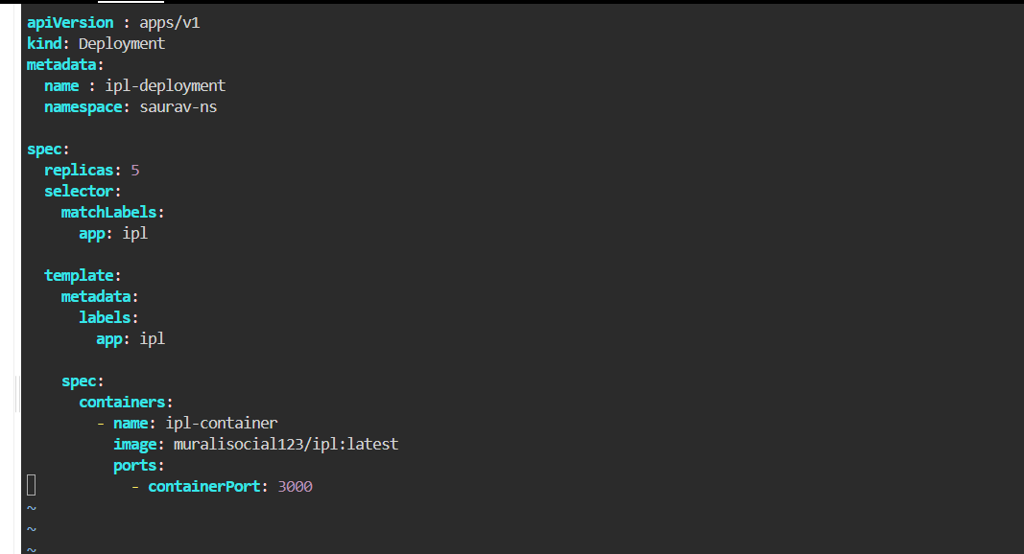

Step2: creating a namespace using the namespace provided in deployment.yaml file

Command: kubectl create ns saurav-ns
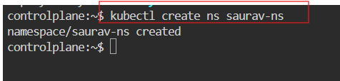

Step3: Running the deployment.yaml file
Command : kubectl apply -f deployment.yaml

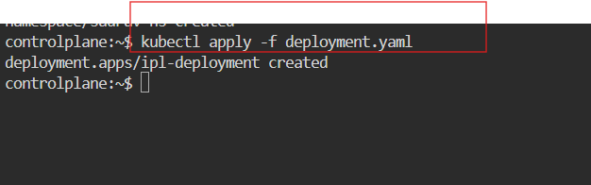

Step4: checking whether it is created or not
Command : kubectl get all -n saurav-ns
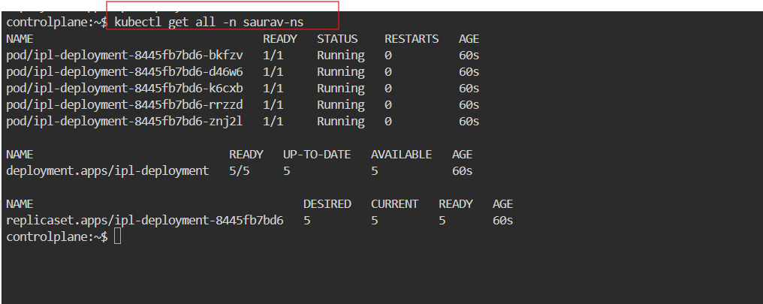

Step5: using describe command for the detailed information
Command : kubectl describe deployment ipl-deployment -n saurav-ns

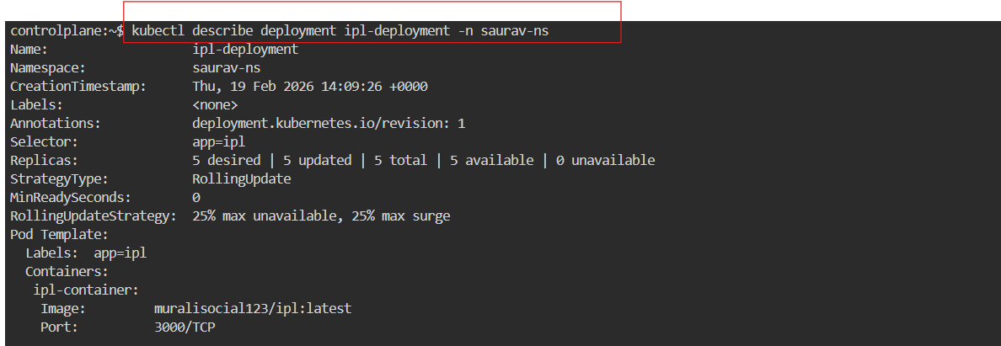

Step6: using describe command for individual pod
Command: kubectl describe pod ipl-deployment-8445fb7bd6-bkfzv -n saurav-ns

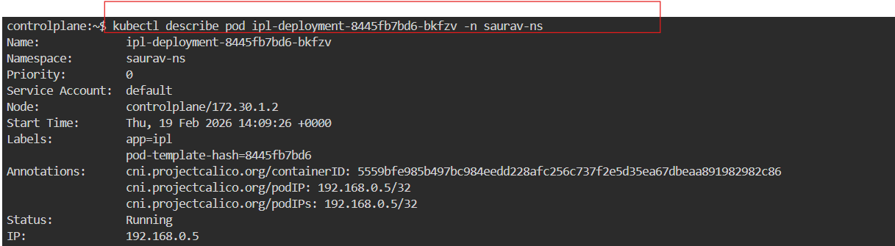

Step7: changing the image container of the previous deployment yaml file and running the updated deployment .

Previous it was : ipl:latest

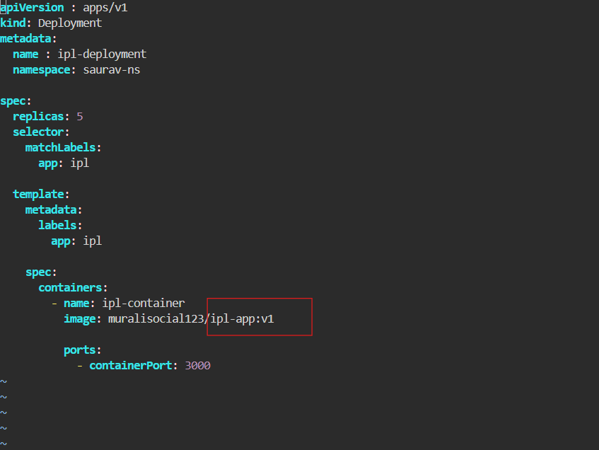

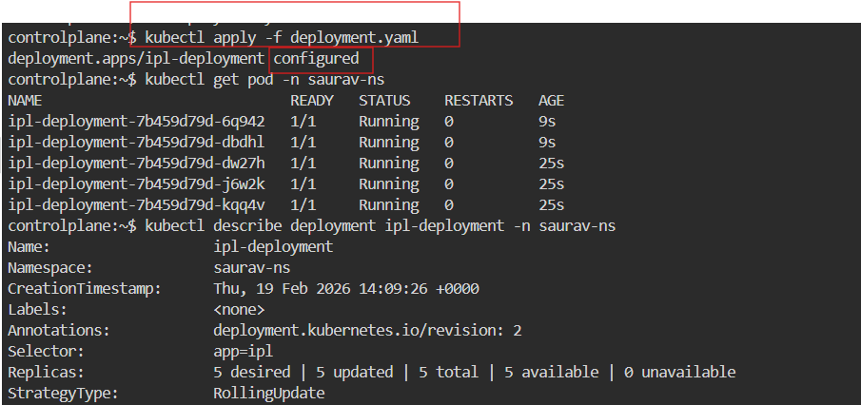
Step 8: using the describe command to check whether it is changed or not
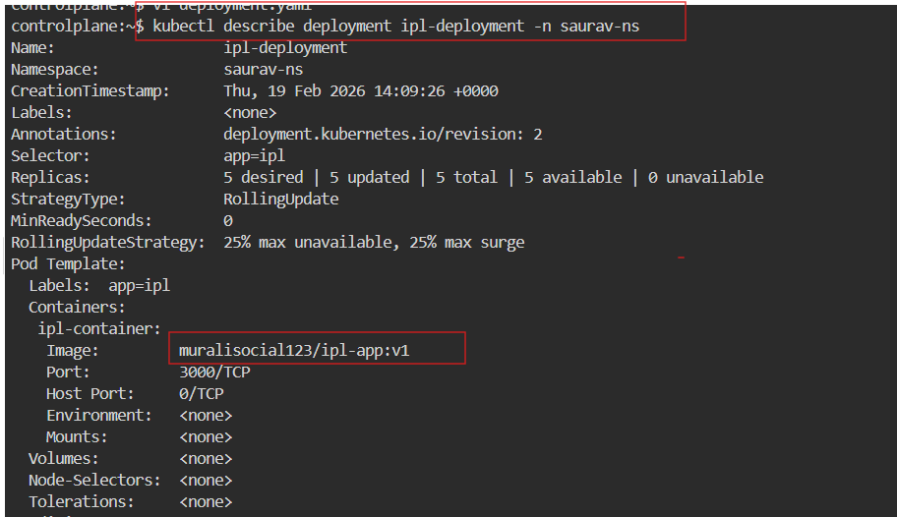

Step 9: using the rollout command to rollback to previous version
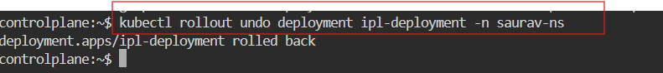

Step10: using rollout history command to see the history

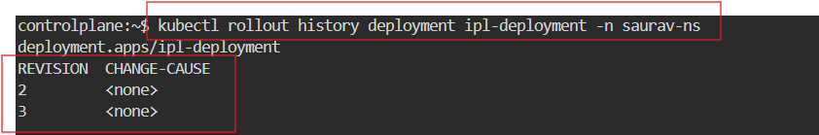

Step 11: using rollout status command to verify whether it is rolled out or not

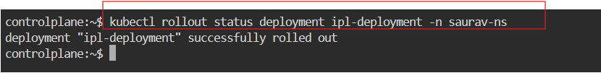

Step12: usingdecribe command to check that if it is roll back to the previous version or not

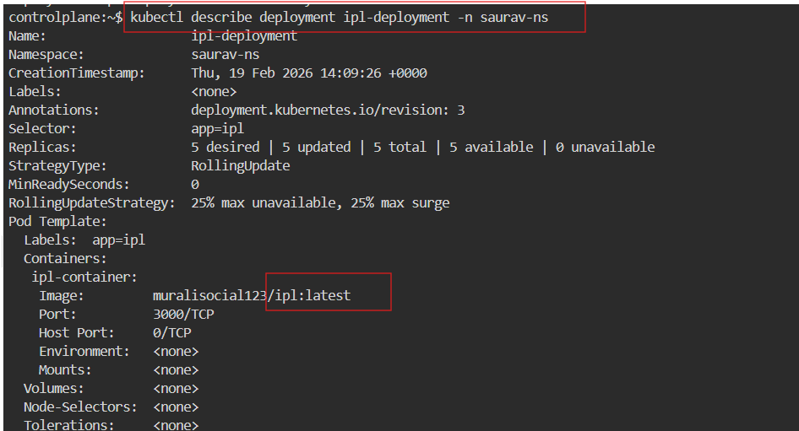

Step13: using cat command to see the content from the deployment.yaml file and checking the images on it .

