**ABSTRACT**

Beta thalassemia major is a fatal genetic blood disorder that gets transferred from parents to their next generation while the parents being only carriers doesn’t face any clinical complications. But the thalassemia major patients remain blood transfusion dependent throughout their life and that becomes a reason of oxidative stress in their body leading towards more complications. These clinical complications need to be monitored regularly in order to refrain from further problems and early death of patient. Blood samples of patients were collected for DNA isolation and biochemical profiling. Primers were designed using Primer3plus and verified by in-silico PCR. The secondary structures of proteins were obtained via Psipred by using obtained sequences of samples. TrRosetta software was used to predict the 3D structure of amplified protein and AutoDockvina was used to predict the interactions between protein and ligands i.e. Folic acid and vitamin D3. A total of 91 beta thalassemia major patients were included in this study. Basic demographic details along their biochemical profiles were collected from patients and Fatimid Foundation. Statistical analysis showed that there is statistically non-significant correlation between the levels of ALT, AST, ALP and Hb i.e. p= 0.149, p= -0.161 and p= 0.062 respectively. The primer for 3rd exon of beta globin gene was used to amplify the selected exonic regions. The predicted secondary structures obtained by Psipred were used to compare the helix and coils of mutant protein with wild and it showed significant differences. The predicted secondary 3D structures obtained by trRosetta were used to check molecular interaction between beta globin and ligands. The molecular interaction between folic acid and beta globin gene showed the affinity of -4.4 kcal/mol and the interaction of vitamin D3 and beta globin showed the affinity of -4.6 kcal/mol. These interactions show very weak binding between the ligand and protein which confirms that the health complications faced by beta thalassemia major patients aren’t sufficiently dealt by using these supplements. This study is an attempt to understand the health complications faced by beta thalassemia patients and the results can be used for designing personalized drugs for the patients.

**Keywords:** Beta thalassemia, β-globin, biochemical profiling, molecular characterization

# Introduction

Beta thalassemia is known for chronic hemolytic anemia occurring as a result of defect in beta globin chain. It is a recessive autosomal blood disorder inherited from parents to children. Beta thalassemia is caused by quantitative defect in hemoglobin resulting in reduction of production of beta chain or in complete absence of beta globin chain. The deficiency or absence of beta chains result in severe anemia and the patient becomes completely dependent upon blood transfusions and management therapies. Regular blood transfusions and therapeutic management can result in more complications and infections, adding more to the suffering of a patient (Maheri, Sadeghi et al. 2018). Beta thalassemia is caused due to several mutations affecting the transcriptional control, splicing and translation of HBB gene. The disease severity depends upon the inheritance of beta globin gene, one on each chromosome 11, that’s why its categorized under heterogeneous pool of genetic diseases (Needs, Gonzalez-Mosquera et al. 2020).

It is characterized by severe anemia and body’s inability to produce appropriate Hemoglobin. It is linked to 200-point mutations in the beta chains of globin. There are three further classifications of beta thalassemia based upon clinical severity and genetics i.e. Beta thalassemia major, beta thalassemia minor and intermedia. Beta thalassemia major is a homozygous condition which is clinically affected and the person suffering from beta thalassemia major needs periodic blood transfusions throughout their life (Fibach and Rachmilewitz 2017). Beta thalassemia minor is a heterozygous condition where the patient doesn’t need blood transfusions or clinical management but they be a carrier for the upcoming generation if married to another thalassemia minor. If both male and female of the couple is having autosomal recessive condition, they have one in four chances of having an affected child with beta thalassemia major who will need continuous blood transfusions for life. While if only one member of the couple is having recessive condition, none of their offspring will have beta thalassemia major condition but they can carry the recessive condition as one of their parents. While thalassemia intermedia is a condition in which the patient may or may not need blood transfusions or the duration of blood transfusions can be longer than even a year, so consequently the chances of occurrence of more complications in thalassemia intermedia are lesser than thalassemia major. (Needs, Gonzalez-Mosquera et al. 2020).

The patients of beta thalassemia major usually doesn’t have access to safe and healthy blood transfusions. In most countries there are no such policies or medical regulations for blood donors which lead to unsafe blood donation and putting the life of donor and recipient at risk. Mostly the patients are transfused un-screened blood that becomes the reason of viral infections in them. Consequently, patients face cardiac failure, kidney and liver disorders. Better and improved services can increase the life expectancy of patients (Shah, Sayani et al. 2019). Patients of beta thalassemia major have shown significantly lower life quality (Ismail, El-Tagui et al. 2018).

Continuous blood transfusions make the patient vulnerable towards iron overload, cardiac disorders, oxidative stress and viral infections. Despite of great improvement in medical equipment and methods, the life of patient remains dependent upon multiple factors that are not directly linked to thalassemia (Koohi, Kazemi et al. 2019). Iron intoxication can damage vital organs which ultimately leads to organ failure. Excessive iron is also stored in tissues. These unbound molecules of iron leads to the release of free radicals of iron. Supplements and iron chelation therapies can help improving the life of thalassemia major patients (Yu, Chen et al. 2019).

All these related health issues cause more problems for the patients and their clinical management. At a time, they need to take multiple treatments which can cause more complications. Iron overload is a very commonly faced issue by thalassemia major patients which itself need iron chelation therapies but it also increases the amount of free radicals in the bloodstream and ultimately erythrocytes face oxidative damage. The imbalance of oxidative in the bloodstream cause damage to other trace minerals in the body which are a reason of osteoporosis and other endocrinal issues in children and adults both. It is needed to maintain a balance of these trace minerals to have a healthy life (Al-Ghanimi, AL-Essawi et al. 2019).

Thalassemia major patients need regular iron chelation from the age of 2 and a half years and this tiring process just adds more to the already existing disease. Patients who are deprived of proper medical facilities are often suffering more than the rest. Because their iron levels keep increasing and that leads in increase of oxidative stress on the blood cells. It is highly recommended to get ALT and AST tests done on a regular basis, so that the medical practitioners can keep a healthy balance of chemicals in the body of the patient. It’s important to understand that oxidative stress isn’t the main etiology of thalassemia but it is definitely significant for its pathophysiology (Fibach and Dana 2019).

Renal and liver issues aren’t directly caused by any genetic mutation but these are indirect results of regular blood transfusion in beta thalassemia major patients. Tissue damage occurs due to oxidative stress, and accumulation of iron in the body. Liver is the primary organ of iron storage has a large capacity to produce proteins. It is the only tissue for synthesis of transferrin and ferritin. Free ferrous iron is highly toxic and normally is protein-bound within the liver. With continued transfusions, iron eventually accumulates in parenchymal cells (hepatocytes). Moreover, iron catalyzes the production of free radicals which have been implicated in the lipid peroxidation, hepatotoxicity and increasing the risk of liver injury with hepatocytes, synthetic dysfunction, fibrosis, and eventually cirrhosis. In most β-TM patients, remarkable increase in renal tissue iron content and oxidative stress which contribute to lipid peroxidation and functional abnormalities in tubular cells may lead to tissue injury and kidney dysfunction (Shanaki, 2016).

While hormonal inadequacy, medullary development, high bone turnover, press gathering, irregular calcium phosphorus, and hypoxia are the diverse variables that add to skeletal illnesses. The most debilitating life-restricting complexity caused by over-burden in beta-thalassemia patients is heart malady caused by myocardial siderosis and 71% beta thalassemia patients reportedly suffer from these issues (Sharif, 2021).

Endocrine glands are susceptible to excess iron causing endocrine dysfunction (significantly Hypogonadotropic hypogonadism HH) which is a common complication in beta thalassemia major that requires recognition and treatment. Patients with the beta thalassemia major present with a delay in growth and puberty and reduction of the average height. Growth failure pathogenesis is multifactorial: including iron overload, chronic anemia and hypoxia, zinc and folic acid deficiency, chronic liver disease, intensive use of chelating agents, endocrinopathies and growth hormone-insulin like growth factor-1(GH-IGF-1) axis dysregulation. Folic acid deficiency results in complications such as anorexia, growth failure and GIT disorders besides megaloblastic anemia. Folic acid deficiency is more severe among beta thalassemia major patients; however, microcytosis of thalassemia may mask the hematological characteristics of folic acid deficiency (Shawkat and Jwaid 2019). Deficiency of trace elements and oxidative stress cause damage to normal growth of adults and cause delayed puberty (Prakash and Aggarwal 2012). Endocrinopathies have shown a great impact on the lifestyle of growing patients with beta thalassemia major which makes their disease a syndrome carrying multiple clinical complications. Thalassemia is a chronic disorder and the suffering of patients never end until death. Children who face health issues are more likely to get into psychological diseases as well. They are posed with a risk of getting mental health issues 1.3 to 3 times more than normal children who are healthy. Patients are more likely to suffer from anxiety disorders, OCD and disruptive behavior disorders. Most of the patients suffer from behavioral disorders, academic problems, sleep difficulty, eating and appetite disorders etc. Most of the time when patient has to go to hospital twice in a month and in severe cases more than twice, they are then unable to stay synchronized with their school and academic activities. Usually they suffer from fatigue and bone issues, so they cannot participate in any other extracurricular activities as well. Psychotic and sexual issues are more common in patients ranging in age from 18 to 25 (Altincik and Akin 2016).

Beta thalassemia is more prevalent in Mediterranean region, Africa, Middle east and Asia. Many regions of the world have eradicated thalassemia by spreading awareness and improved medical practices. While it still remains a fatal blood disorder in many other regions of the world (Ansari-Moghaddam, Adineh et al. 2018). Beta thalassemia major has a birthrate of 7000-9000 per year in Pakistan while the carrier rate is 5-7% of whole population, making a total of 9.8 million carriers ready to contribute in the already existing pool of millions of patients. Among Asian countries, Pakistan has the larger birthrate of genetic disease due to multiple factors which include larger population size, inter-caste marriages, bigger birthrate and lack of awareness (Ehsan, Wahab et al. 2020). Pakistan being a struggling country constitute of most of the labor class, who also unfortunately happen to suffer more from genetic and viral diseases and beta thalassemia is one of those. Patients and their families due to lack of awareness are usually unable to access the right medical help and that is why the average life expectancy of patients in Pakistan still lies between 17-20 years of age, while it has been improved in other regions of the world (Kantharaj and Chandrashekar 2018). Other than these factors, there is an important issue being faced by beta thalassemia patients is that their growth patterns are disturbed and they face many issues in this regard i.e. delayed puberty, hormonal imbalance, bone deformities and disturbed biochemistry profiles. Their lifestyle can be improved by adding supplements and important vitamins, it also increases their life expectancy (Yassin, Soliman et al. 2018).

The normal levels of AST, ALT and ALP help the body maintaining its enzymes and consequently the vital systems are run normally. While in the case of beta thalassemia patients due to multiple factors these levels aren’t normal and the patient suffers. These enzymes help in reducing the levels of free radicals, these free radicals if left unattended in the body. They may cause harm for vital organs such as liver and heart (Guzelcicek, Cakirca et al. 2019).

# MATERIALS AND METHODS

## 3.1 Samples and Data Collection

This study was conducted using fresh blood samples of beta thalassemia major patients from Fatimid Foundation, Lahore. Ethical clearance was obtained from Ethical Board Fatimid Foundation. The survey and sample collection was conducted after obtaining verbal consent was from the participants of study. The patients selected for this study were all transfusion dependent and were diagnosed with beta thalassemia early in their life. A total of 91 blood samples were obtained in EDTA (Ethylenediaminetetraacetic Acid) tubes. 3 ml blood was taken in EDTA tube via intravenous injection. These blood samples were later used to extract DNA and to perform biochemistry tests i.e. ALT, ALP and AST.

## 3.2 DNA Extraction

A total of 200 µl blood was taken in an Eppendorf and it was mixed using vortex for at least 1-2 minutes. Then 1000 µl lysis buffer (TE) was added and it was again mixed with vortex and centrifuged for 5 minutes at 3000 rpm. After centrifugation the supernatant was discarded and 1000 µl lysis buffer was added again. This process of washing was repeated 3-4 times until the clear pellet was left in the Eppendorf. After washing 20 µls Proteinase K, 60 µl of 10% SDS and 100 µl and the Eppendorf were left in shaking incubator at 37 °C. On the next day, 24:1 of chloroform and isoamyl alcohol were added in equal volume Eppendorf and centrifuge it for 15 min at 3000 rpm. Three layers were formed after centrifugation and the upper layer was transferred into a new Eppendorf where equal amount of isopropanol was added and the Eppendorf was centrifuged for 10 minutes at 3000 rpm. The supernatant was discarded and 70% chilled ethanol was added and centrifuge for 5 minutes at 3000 rpm. After discarding the supernatant, the Eppendorf was left to air dry for 10 minutes. In the final step, 30 µl of TE buffer was added and the DNA was stored at -20 degree Celsius. Later on the presence of DNA was verified by performing gel electrophoresis.

## 3.3 Gel Electrophoresis

1% agarose gel was prepared to verify the presence of DNA in the extracted samples. The DNA samples after mixing with dye were loaded in the gel and run for 45 minutes at constant voltage and then visualized in gel doc system.

**Ingredients of Gel Electrophoresis**

* TAE Buffer with 50x Concentration
* 1% Agarose gel

### 3.3.1 Preparation of TAE Buffer with 50X Concentration

Table 3.1: Ingredients of TAE Buffer with 50X Concentration

|  |  |  |
| --- | --- | --- |
| Sr. | Ingredient Name | Concentration gm/liter |
| 1 | Tris Base | 242 gm |
| 2 | Glacial Acetic Acid | 57.1 ml |
| 3 | 0.5M EDTA | 100 ml |

All the above mentioned components were dissolved in 800ml of distilled water mixed to make a homogenous solution and then the volume of solution was made to 1 liter by adding distilled water in it. Then the pH was maintained to 8.0. TAE 50X was prepared as stock solution.

### 3.3.2 Preparation of Working Solution

Table 3.2: Ingredients and Composition of 1X TAE Buffer

|  |  |  |
| --- | --- | --- |
| Sr. | Ingredient Name | Concentration in ml |
| 1 | Distilled Water | 980 |
| 2 | Stock Solution of 50X Buffer | 20 |

All the mentioned ingredients were mixed to make a homogenous solution and volume was made till 1000 ml by adding distilled water. This working solution was used in the lab.

### 3.3.3 Preparation of 1% Agarose Gel

Table 3.3: Ingredients and Composition of 1% Agarose gel

|  |  |  |
| --- | --- | --- |
| Sr. | Ingredient Name | Quantity of Components |
| 1 | Agarose (Powder) | 1 gm |
| 2 | 1X TAE Buffer | 100 ml |
| 3 | Ethidium Bromide Solution | 2 µl |

1 gram of agarose powder was taken in a 100 ml conical flask, transfer the 100 ml of 1X TAE Buffer into it and mixed it properly, covered the conical flask with aluminum foil in order to avoid contamination. Put the flask into oven for 1.5 minutes, with intervals of 30 second each until the agarose is dissolved. Then cool down the solution at room temperature. After cooling till 40% add 2 µl of ethidium bromide in it and mixed thoroughly. Ethidium bromide is used to illuminate DNA. Pour the solution in the cast tray. In order to create wells in the tray, combs were inserted in the solution. Then left the casting tray to cool down and solidify into the gel form.

### 3.3.4 Gel Electrophoresis Protocol

The combs were removed carefully for loading the samples. Now, the gel was transferred into the electrophoresis chamber which already contains TAE buffer. 3 µl of the sample of DNA was mixed into 2 µl of thermos scientific loading dye making the final volume 5 µl, was loaded into the wells of gel. Thermo scientific DNA Ladder of 1000 bp was added in the first well and all other wells were loaded with extracted DNA. After that electrophoresis chamber was covered with the lid. The gel was run for 45 minutes at 80 volts. The gel was then carefully taken to gel doc system to visualize the extracted DNA.

## 3.4 Primer Design and Synthesis

To design the primer, sequence of complete gene *HBB* was taken from Ensembl Genome (<http://asia.ensembl.org/index.html>) and its 3rd exon was selected. *In silico* Primer was designed through primer3 plus (<https://www.bioinformatics.nl/cgi-bin/primer3plus/primer3plus.cgi>) and then it was verified via UCSC *in silico* PCR (<https://genome.ucsc.edu/cgi-bin/hgPcr>).

Table 3.4: Details of primer used in the study

|  |  |  |  |
| --- | --- | --- | --- |
| HBB Gene Exon 3 | Forward Primer | Reverse Primer | Length |
| (CGGCTGTCA-TGGGCAG) | ACTCCTAAGCCAGTGCCAGA | GTCTCCACATGCCCAGTTTC | 20BP |

## 3.5 PCR Amplification

PCR is a thermos cycler technique of laboratory used to make several copies of a gene, we used it to amplify our gene with primer *HBB.*

### 3.5.1 Profile for PCR Process

*Table 3.5: Ingredients and Concentration for PCR reaction*

|  |  |  |
| --- | --- | --- |
| Sr. | Ingredient Name | Amount of Ingredient in |
| 1 | Double Distilled Water | 8 |
| 2 | Master Mix | 12.5 |
| 3 | Primer (reverse) | 1 |
| 4 | Primer (forward) | 1 |
| 5 | DNA Template | 2 |
| 6 | Total Volume | 25 |

For scanning 3rd Exon of *HBB* gene by conventional PCR with primer, each reaction included a total volume of 25 µls. The reaction volume was composed of 2 µl of the DNA template, 12.5 µl of master mix, 1 µl of each forward and reverse primer and 8.5 µls of double distilled water was added to make the final solution of 25 µls. After a 10 min hold at 95 °C, 26 cycles of PCR were performed as follows: denaturation for 15s at 95 °C, annealing for 15s at 57 °C and the final elongation 15s at 72 °C.

## 3.6 Sequencing of 3rd Exon of HBB gene

Sequencing is a molecular technique to identify the sequence of unknown DNA sample. The samples were labelled properly and after labelling the samples were covered with paraffin properly in order to avoid contamination or leakage and sent for sequencing.

## 3.7 Use of Bioinformatics

Nucleotide Sequence (obtain from our DNA)

ExPasy Translate

Secondary structure by Psipred

3D Structure prediction by trRosetta

PyMOL: To visualize 3D Protein

Comparison of wild with Mutatnt

RESULT

Figure 3.1: Figure shows the tools used in the bioinformatics analysis.

## 3.7.1 Analysis of Sequence via BioEdit and BLAST

The sequence obtained was visualized and edited by using the tool BioEdit and its similarity was checked by BLAST in NCBI.

## 3.7.2 Physiochemical Properties of Protein

Physiochemical properties like isoelectric point, charge, molecular weight and number of residues were calculated by using online tool ExPasy Protparam.

## 3.7.3 Analysis of Secondary Structure of Protein

PSIPRED, online server predicted the secondary structure, showed the presence of α-helix, β-sheets and coils of protein.

## 3.7.4 3D Structure Prediction of Protein

3 dimensional structure of protein was created by online server trRosetta with prominent residues, while it was visualized by using PyMol.

## 3.7.5 Molecular Docking

Docking analysis of protein and ligands (Vitamin D3 and Folic Acid) was carried out by AutoDockvina software. The structures of ligands were obtained by PubChem. PDBQT files were produced by AutoDockvina software and results were visualized by PyMol.

## 3.8 Biochemistry Tests

All the biochemistry tests were performed under the supervision of lab technologist at Fatimid foundation, using the biochemistry analyzer.

## 3.9 Statistical Analysis

Data were analyzed using the statistical package for social science (SPSS). Computer software package SPSS 22.0 was used in the analysis. For quantitative variables, mean, standard deviation, minimum, and maximum (as measures of variability) were presented. Frequency and percentages were presented for qualitative variable.

# RESULTS

# 4.1 Sample Collection

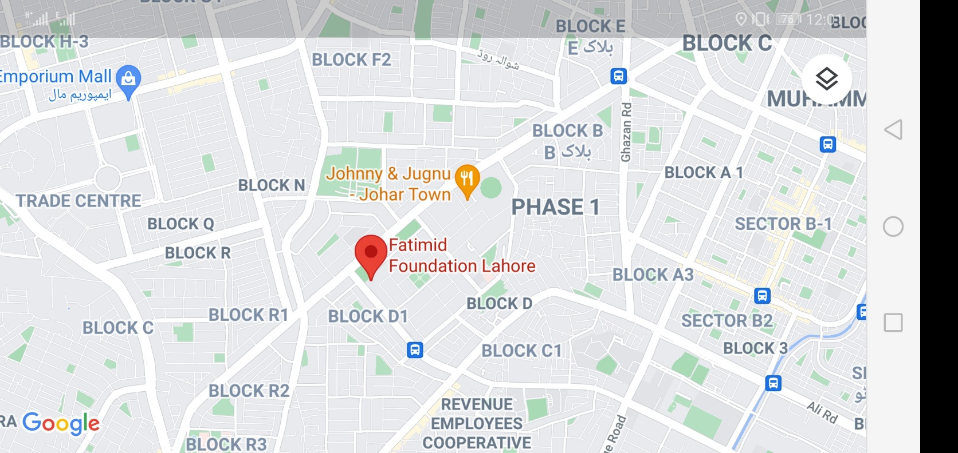A total of 91 Samples are collected from Fatimid Foundation, Lahore. These samples included blood samples and biochemical reports of the subjects of beta thalassemia major.

Figure 4.1: Geographial Location of Fatimid Foundation, Lahore.

## 4.2 Statistical Analysis of Biochemical Profiles of Patients

The reports of ALT, AST, ALP and CBC were collected and are analyzd with statistical tools to check their correlation.

### Table 4.1: Descriptive Statistics of Hb, MCV and MCH levels

Descriptive statistics was run for the collected samples of 91 patients for Hb, MCV and MCH.

|  |  |  |  |  |  |  |  |  |  |
| --- | --- | --- | --- | --- | --- | --- | --- | --- | --- |
| Tests Performed | N | Range | Minimum | Maximum | Sum | Mean | | Std. Deviation | Variance |
| Statistic | Statistic | Statistic | Statistic | Statistic | Statistic | Std. Error | Statistic | Statistic |
| Hb | 91 | 5.9 | 5.5 | 11.4 | 772.9 | 8.493 | .1337 | 1.2750 | 1.626 |
| MCV | 91 | 63.5 | 25.4 | 88.9 | 6985.0 | 76.759 | .8799 | 8.3934 | 70.449 |
| MCH | 91 | 8.3 | 21.7 | 30.0 | 2409.6 | 26.479 | .1627 | 1.5522 | 2.409 |

## 4.2 Correlation of ALT, AST and ALP with Hb

### 4.2.1 Correlation of ALT with Hb

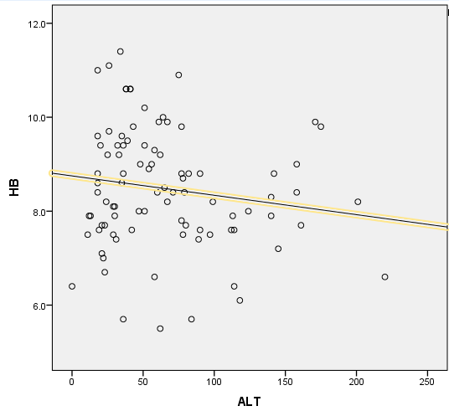

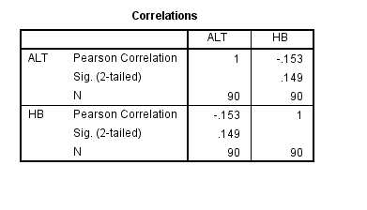**Alanine Aminotransferase (Units/Liter) and HB (gram/deciliter)**

Figure 4.2: Correlation between ALT and Hb levels

A Pearson product moment correlation was run to determine the relationship between ALT and Hb level. There is a slightly, negative correlation between ALT and Hb levels which statically non-significant (r= -0.153, p= 0.149, N=90).

### 4.2.2 Correlation between AST and Hb Levels

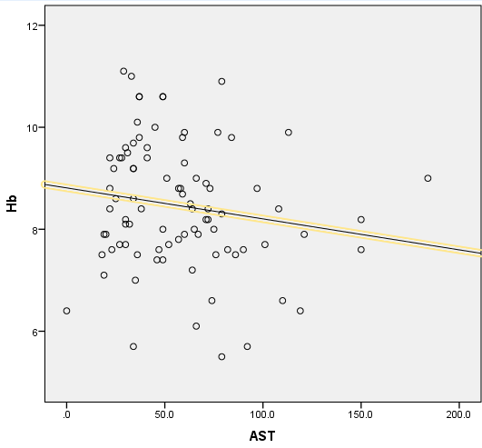

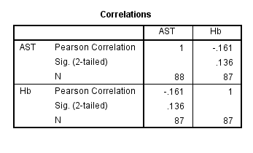**Aspartate Aminotransferase (Units/Liter) and HB (gram/deciliter)**

Figure 4.3: Correlation between AST and Hb levels

A Pearson product moment correlation was run to determine the relationship between AST and Hb level. There is a slightly, negative correlation between AST and Hb levels which statically non-significant (r= -0.161, p= 0.136, N=87).

## 4.2.3 Correlation between ALP and Hb Levels

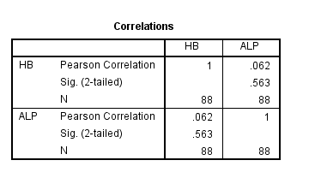**Alkaline Phosphatase (Units/Liter) and HB (gram/deciliter**

Figure 4.4: Correlation between ALP and Hb levels

A Pearson product moment correlation was run to determine the relationship between ALP and Hb level. There is a weak, positive correlation between ALP and Hb levels which statically non-significant (r= 0.062, p= 0.563, N=88).

## 4.3 Molecular Analysis of Samples

### 4.3.1 DNA Extraction from Blood Samples

DNA was extracted from ten samples i.e. TM-1 to TM-10 by using manual DNA extraction method. 1Kb molecular marker was used and the DNA bands were visualized in gel documentation system.

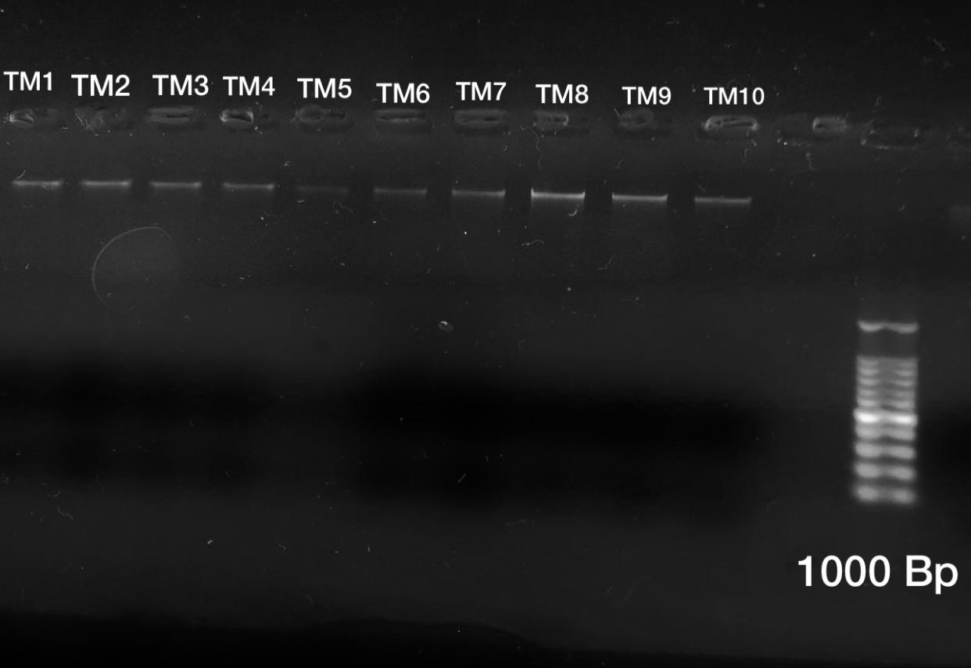

Figure 5: Extracted DNA Samples in 1% Agarose gel

### 4.3.2 PCR Amplification and Amplification

The extracted DNA samples were then analyzed by using thermocycler PCR, the sample was amplified by using HBB primer. After amplification the PCR products were run on gel electrophoresis using 2% agarose and then visualized under gel documentation system. 1Kb molecular marker was used and the product size is 366 bp shown in the figure below.

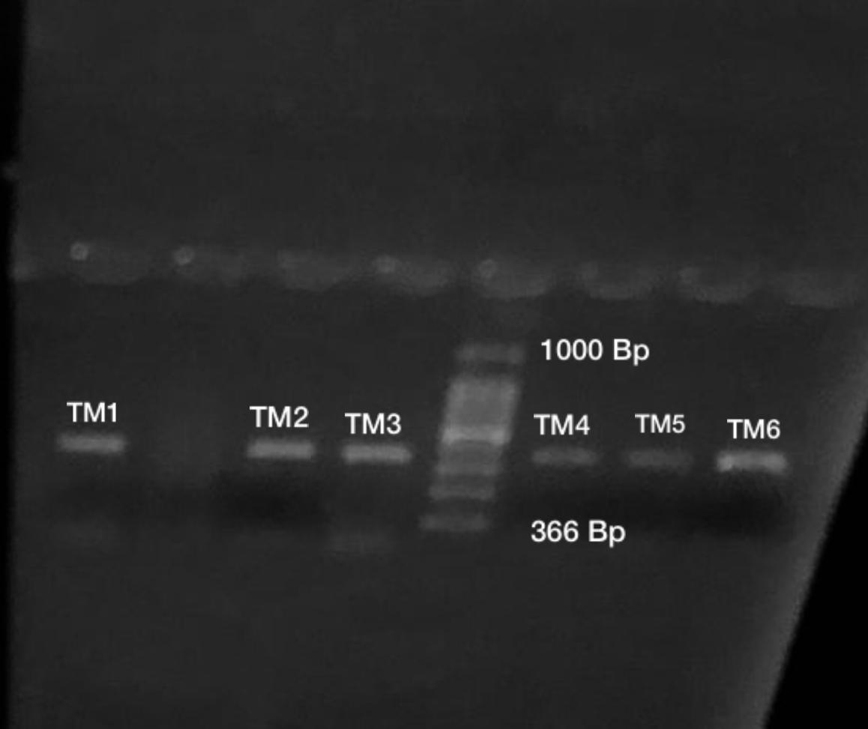

Figure 4.6: Bands of HBB gene Amplified Samples, Product size 366bp and 1000bp Ladder

## 4.4 Sequencing and BLAST

The sequence of TM 2 and TM 3 were used to find similarity between our query and already present *HBB* gene.

Table 4.1: BLAST results with Highly Similar Sequences

|  |  |  |  |  |  |  |  |  |  |  |
| --- | --- | --- | --- | --- | --- | --- | --- | --- | --- | --- |
| Sample ID | Sample Name/Genus | | | Source of Isolation | Location of Isolation | No. of Nucleotide  (bp) | GenBank Accession Number | Closely related taxa identification by using BLASTn  (https://blast.ncbi.nlm.nih.gov/Blast.cgi) | Sequence identification (%) of HBB gene with closely related taxa | Sequence query coverage (%) |
| TM 2 | | *Homo* | Human Blood | | Lahore | 311 | AH001475.2 | Homo sapiens beta-globin gene, complete cds | 99.36 | 100 |
| TM 3 | | *Homo* | Human Blood | | Lahore | 324 | AH001475.2 | Homo sapiens beta-globin gene, complete cds | 99.39 | 100 |

## 4.5 Bioinformatics Analysis

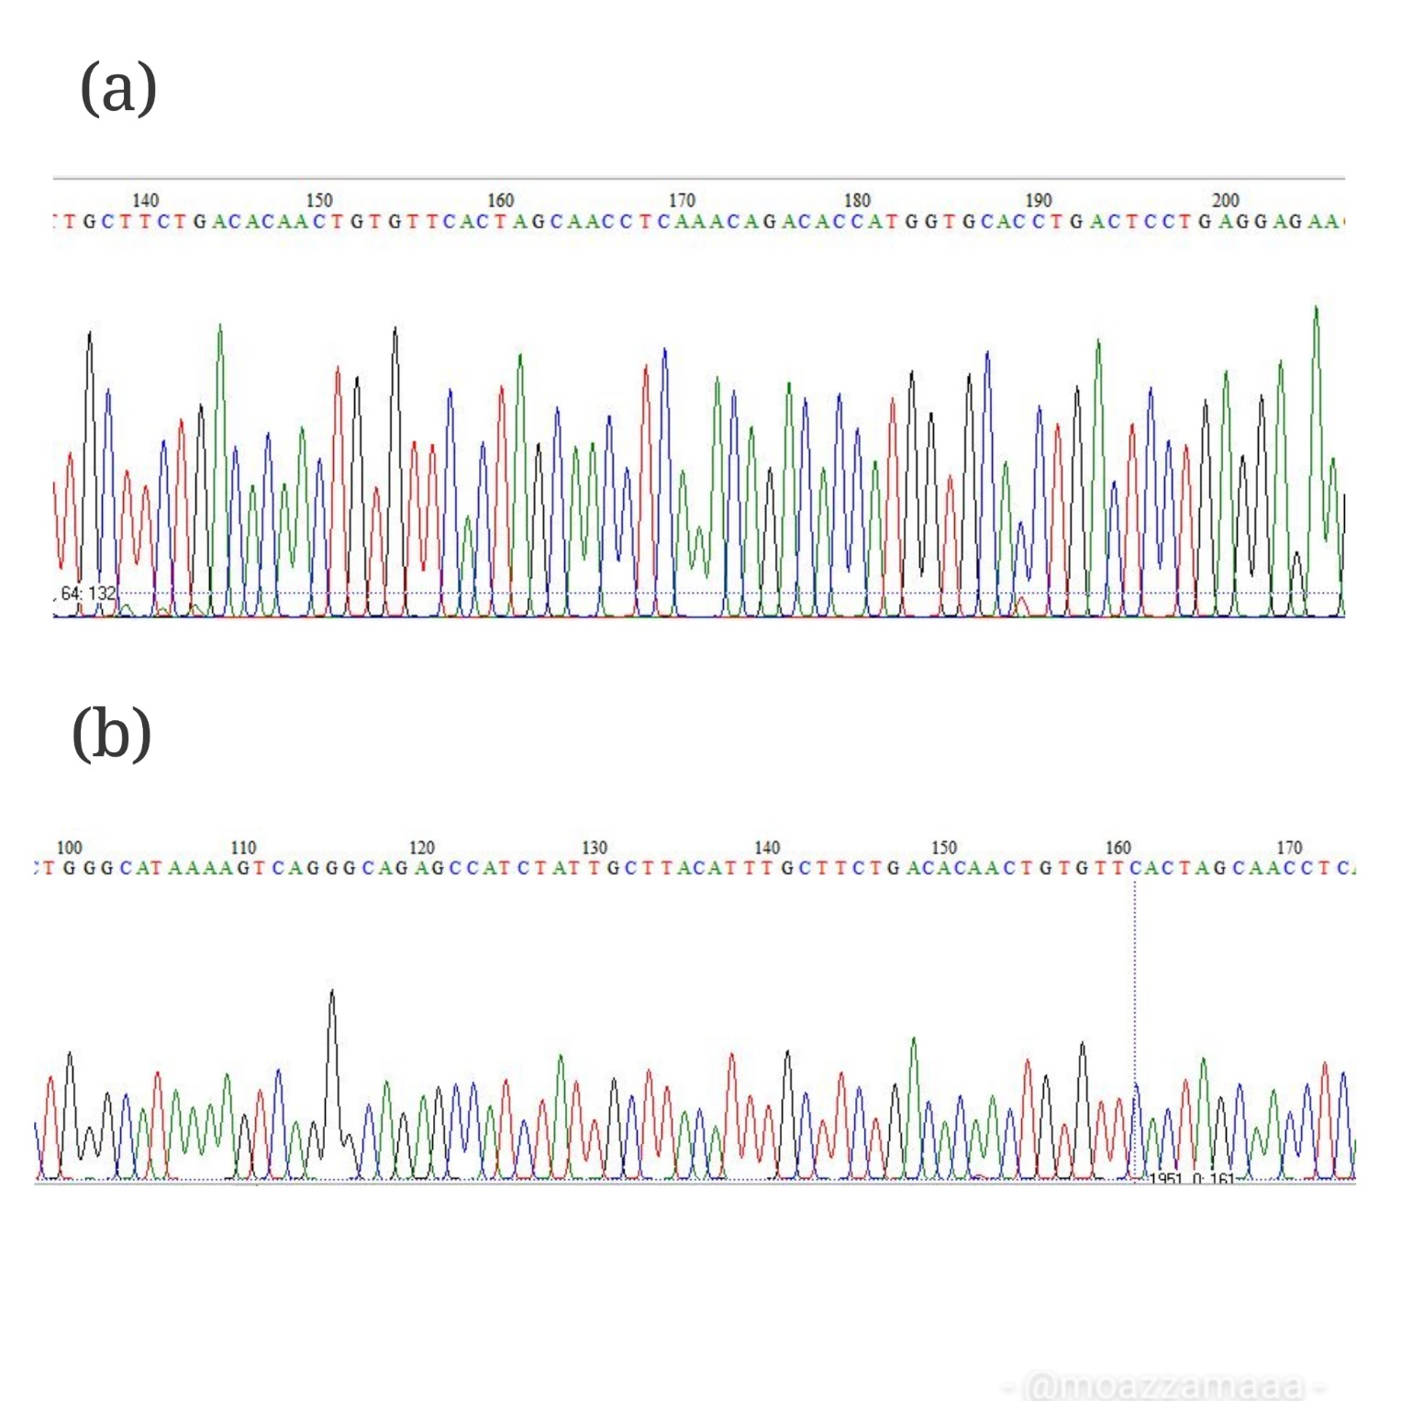The chromatographs obtained by BioEdit are shown in Figure 4.7 below.

Figure 4.7: Chromatograph of sample TM 2 (a) and sample TM 3 (b).

## 4.6 Characteristics of Proteins

Physiochemical properties of protein were obtained through ExPasy Protparam.

Table 4.2: Physiochemical Properties of Protein

|  |  |  |  |  |  |  |
| --- | --- | --- | --- | --- | --- | --- |
| Sample no. | Molecular weight  (Da) | Theoretical pI | Formula | Extinction coefficients | Estimated half-life | Instability index |
| HBB  Exon 3  (wild) | 3137.56 | 4.57 | C138H222N36O45S1 | 5500  Abs 0.1% (=1 g/l) 1.753 | 30 hours (mammalian reticulocytes, in vitro).  >20 hours (yeast, in vivo).  >10 hours (Escherichia coli, in vivo). | The instability index (II) is computed to be 16.03  This classifies the protein as stable. |
| TM 2  (Mutant) | 3200.76 | 10.43 | C148H227N43O35S1 | 13980  Abs 0.1% (=1 g/l) 4.368 | 30 hours (mammalian reticulocytes, in vitro).  >20 hours (yeast, in vivo).  >10 hours (Escherichia coli, in vivo). | The instability index (II) is computed to be 53.88.  This classifies the protein as unstable. |
| TM 3  (Mutant) | 3429.01 | 9.99 | C158H243N45O39S1 | 13980  Abs 0.1% (=1 g/l) 4.077. | 30 hours (mammalian reticulocytes, in vitro).  >20 hours (yeast, in vivo).  >10 hours (Escherichia coli, in vivo). | The instability index (II) is computed to be 50.85  This classifies the protein as unstable. |

## 4.7 Secondary Structure of Protein

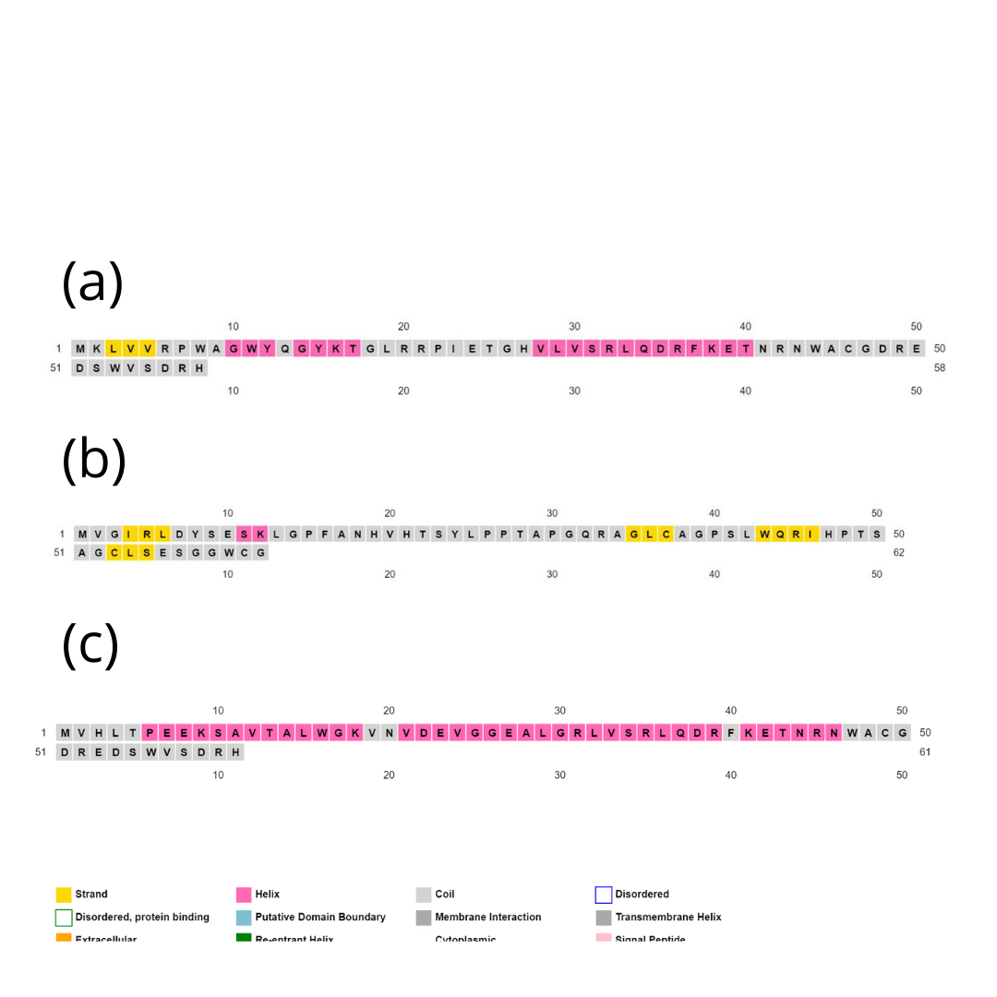The secondary structures of protein were analyzed by Psipred, the pink color show helixes, grey color show coils and yellow color shows strands.

Figure 4.8: Secondary structure of proteins of thalassemia major patients.

Secondary structures of sample protein were predicted by Psipred workbench shown in figure as (a) represdents TM 2, (b) represents TM 3 while (c) represents the wild protein.

## 4.8 Analysis of Gene Ontology

The table 4.3 shows the molecular and biological functions of protein under study.

|  |  |  |  |  |  |  |
| --- | --- | --- | --- | --- | --- | --- |
| Protein name | Cellular Function | | Biological Function | | Molecular Function | |
| Exon 1 of Beta Globin | **GO Term** | **Function** | **GO Term** | **Function** | **GO**  **Term** | **Function** |
| Go:0034673 | Inhibin-betaglycan-actrii complex | Go:0048519 | Down regulation of biological process | Go:0004857 | Enzyme inhibitor activity |
| Go:0098577 | Inactive sex chromosome | Go:0051051 | Negative regulation of transport | GO:0045340 | mercury ion binding |
|  |  | GO:0060457 | Negative regulation of digestive system process | GO:0090722 | receptor-receptor interaction |
|  |  | GO:0048585 | Negative regulation of response to stimulus |  |  |
|  |  |  | GO:0009892 | Negative regulation of metabolic process |  |  |

## 4.9 Molecular Docking

AutoDock vina was used for the process of molecular docking. The molecular docking was used to analyze the interactions of calcium and Vitamin D3 with *HBB* gene. The structures were obtained via trRosetta and the results of docking were visualized via PyMol.

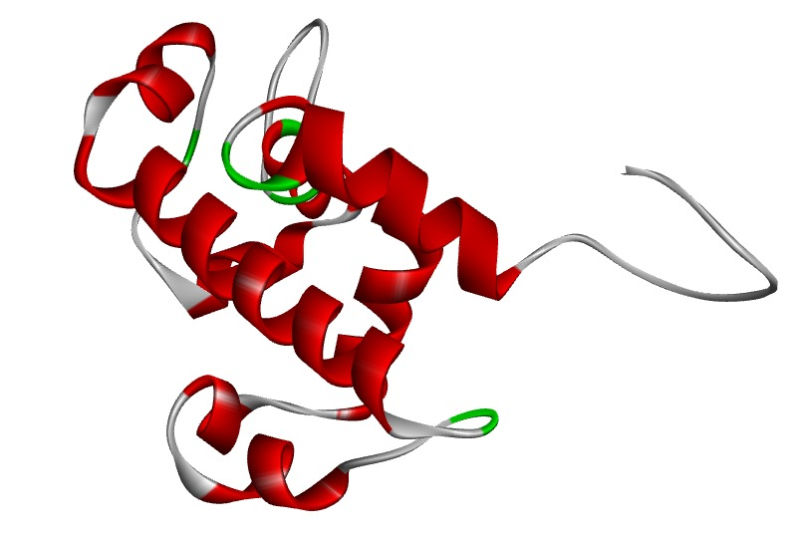

Figure 4.9: 3D structure of sample TM 2. The model was built by trRosetta with restraints from De novo folding with T-score 0.631.

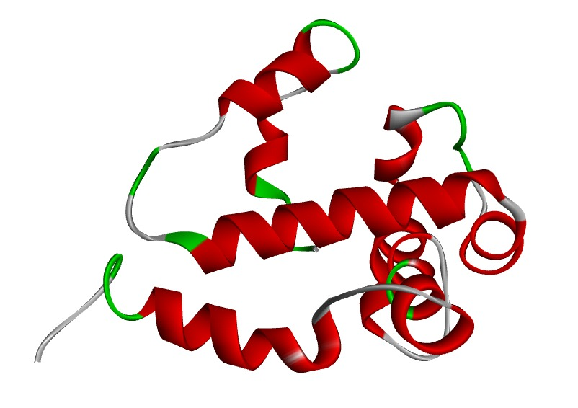

Figure 4.10: 3D structure of sample TM 3. The model was built by trRosetta with restraints from De novo folding with T-score 0.617.

## 

Figure 4.11: 3D structure of studied ligand i.e. Folic Acid obtained by PubChem

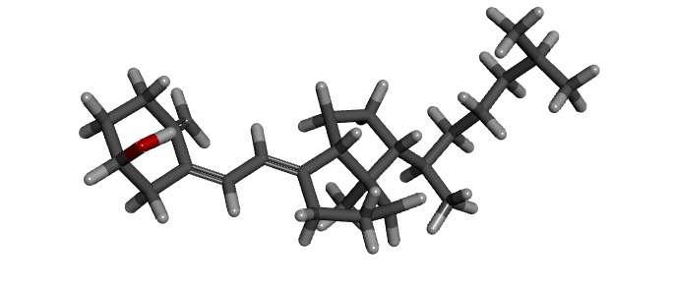

Figure 4.11: 3D structure of studied ligand i.e. vitamin D3 obtained by PubChem

## 4.9 Docking Analysis

AutoDockvina software was used to carry out the process of molecular docking. The interactions done through docking were used to analyze the reaction of folic acid and vitamin D3 with our protein under study i.e. Beta globin*.* In AutoDock tool, our studied beta globin was added with polar hydrogen. Dimension of Grid box was set to locate the active site of beta globin and noted the values in conf,txt file then saved in vina folder in C drive. After that PDBQT file of our protein and both ligand i.e. folic acid and vitamin D3 was prepared. The binding energies of both ligand and protein were analyzed. The binding energy of beta globin (protein) energy with folic acid (ligand) was –4.6 kcal/mol (shown on table 4.4) while docking of wild beta globin and vitamin D3 have -4.4 binding energy (shown on table 4.5).

Due to this, in this study we have concluded that, patients of beta thalassemia major who are completely dependent clinical management have shown weak affinity for bonding with the supplements they are taking for improvement in their health. The mutated structure’s weak binding shows that these supplements aren’t of great help for thalassemia major patients. And consequently, their health keeps on going down.

Table 4.4: Docking energies of Folic Acid with Beta globin

|  |  |  |  |
| --- | --- | --- | --- |
| Name of Sample | Affinity | Distance from best mode | |
| TM 2 | Kcal/mol | rmsdl.b. | Rmsdu.b. |
| -4.6 | 0.000 | 0.000 |

Table 4.5: Docking energies of Vitamin D3 with Beta globin

|  |  |  |  |
| --- | --- | --- | --- |
| Name of Sample | Affinity | Distance from best mode | |
| TM 2 | Kcal/mol | rmsdl.b. | Rmsdu.b. |
| -4.4 | 0.000 | 0.000 |

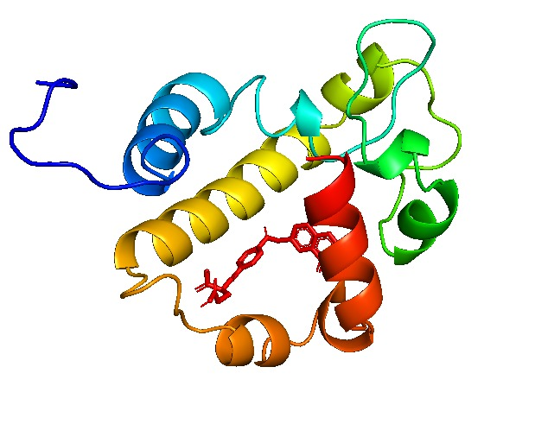

Figure 4.12: Docking results of beta globin (sample TM 2) and Folic Acid, visualized via PyMol

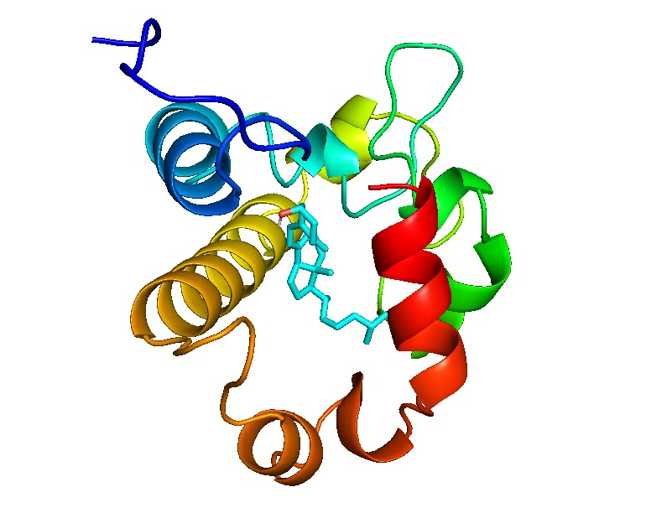

Figure 4.12: Docking results of beta globin (sample TM 2) and Folic Acid, visualized via PyMol

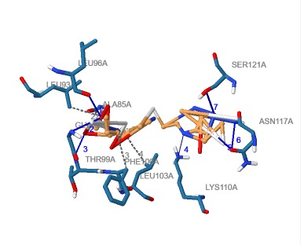

Figure 4.13: Hydrogen bonding between TM 2 and Folic Acid visualized through PLIP. Table 4.5 shows the complete description of interactions between TM 2 and Folic Acid.

Table 4.5: Description of interactions between TM 2 and Folic Acid.

**Hydrogen Bonds**

|  |  |  |  |  |
| --- | --- | --- | --- | --- |
| Sr. | Residue | AA | Distance H-A | Distance D-A |
| 1 | 96A | LEU | 2.09 | 3.03 |
| 2 | 98A | GLY | 2.67 | 3.06 |
| 3 | 99A | THR | 2.14 | 2.91 |
| 4 | 110A | LYS | 3.03 | 3.47 |
| 5 | 117A | ASN | 2.96 | 3.41 |
| 6 | 117A | ASN | 2.84 | 3.84 |
| 7 | 121A | SER | 3.37 | 3.83 |

|  |  |  |  |
| --- | --- | --- | --- |
| Sr. | Residue | AA | Distance |
| 1 | 85A | ALA | 3.79 |
| 2 | 93A | LEU | 3.74 |
| 3 | 100A | PHE | 3.96 |
| 4 | 103A | LEU | 3.80 |

**Hydrophobic Interactions**

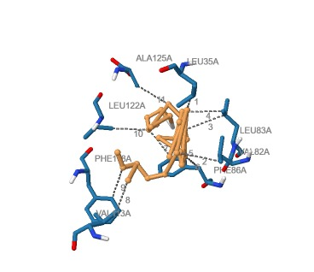

Figure 4.14: Hydrogen bonding between TM 2 and Vitamin D3 visualized through PLIP. Table 4.6 shows the complete description of interactions between TM 2 and Vitamin D3.

Table 4.6: Description of interactions between TM 2 and Vitamin D3.

**Hydrophobic Interactions**

|  |  |  |  |
| --- | --- | --- | --- |
| Sr | Residue | AA | Distance |
| 1 | 35A | LEU | 3.70 |
| 2 | 82A | VAL | 3.82 |
| 3 | 83A | LEU | 3.92 |
| 4 | 83A | LEU | 3.63 |
| 5 | 86A | PHE | 3.75 |
| 6 | 86A | PHE | 3.32 |
| 7 | 86A | PHE | 3.49 |
| 8 | 113A | VAL | 3.82 |
| 9 | 118A | PHE | 3.71 |
| 10 | 122A | LEU | 3.47 |
| 11 | 125A | ALA | 3.82 |
|  |  |  |  |

# DISCUSSION

Beta Thalassemia major am autosomal recessive blood disorder linked to many other health complications and often referred to as a syndrome. It is linked with reduced or absent beta globin in patients that makes them dependent upon regular blood transfusions, chelation therapies and management therapies for biochemical balance in their body. This research was aimed to analyze the link between disturbed lifestyle of thalassemia patients who are dependent on blood transfusion and their clinical management therapies (Origa 2018).

DNA was isolated from whole blood which was taken by intravenous injection from patients and the DNA bands for these samples were obtained by the method of gel electrophoresis by using 1% agarose gel. (Charoenkwan, Sirichotiyakul et al. 2017). In this study the primers were designed by Primer3plus and PCR conditions were optimized for amplification of targeted gene. The amplified gene product’s band were obtained by gel electrophoresis in 2% agarose gel and visualized in gel documentation

For molecular and structural analysis bioinformatics tools play an integral role and are very useful to predict 2D, 3D structures and their interactions with suitable ligands. BLASTn was used to compare the obtained sequence with the reported database on NCBI. The BLAST results are comprised of query coverage and similarity. BioEdit software was used to edit the sequence for further processing. Furthermore, to predict the physiochemical properties of protein ExPasy Protparam was used. Then the nucleotide sequence of the gene under study was translated by using ExPasy translate tool and its secondary structures were predicted through Psipred and 3D structure by trRosetta. The 3D structures of ligand under study were obtained by PubChem. AutoDockvina software was used to run the interaction of ligand and protein under study and the results were visualized by PyMol.

The results of this research demonstrates that there is a link between the burden of iron overload and its free radicals with other health complications faced by thalassemia major patients. Table 4.1 shows that the mean Hb level of the patients under study is 8.49 g/dl while the normal levels are 12-14 g/dl. The mean MCV and MCH levels of patients under study are 76.7 fl and 26.4 pg while the normal ranges are 80-100 fl and 33 pg respectively. Figure 4.2 shows statistically non-significant (*p=*0.149) correlation of Hb with ALT levels. Figure 4.3 shows statistically non-significant (*p*=0.136) correlation of Hb with AST levels. Figure 4.4 shows statistically non-significant (*p*=0.563) correlation of Hb with ALP levels.

The results of *in-silico* molecular interactions showed that, the binding energies of beta globin protein with folic acid is -4.6 kcal/mol and the binding energies of beta globin protein with vitamin D3 is -4.4 kcal/mol. This weak binding results concludes that the supplements taken by patients are not sufficient enough to help them with their ongoing health issues.

# CONCLUSION

In this study, we found the link between increasing health complications of thalassemia major patients to be in link with increased oxidative stress due to regular blood transfusions. The mutant proteins show structural and functional changes when compared to wild protein and these conformational changes are contributing in the mal-functioning of protein. The decreased binding capacity of beta globin with the supplements taken by thalassemia major patients clearly shows the reason behind their growth delay, mortality and other health concerns.