Assignment – 01

Name: Muhammad Wahaj

Course: Web Application Development

Roll: L1F17BSCS0324

Sec: A

1.

GitHub registration:

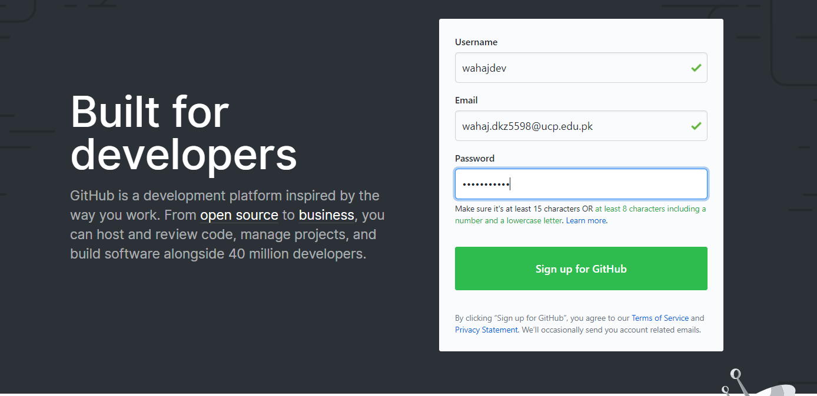

2.

Creating new Git repository:

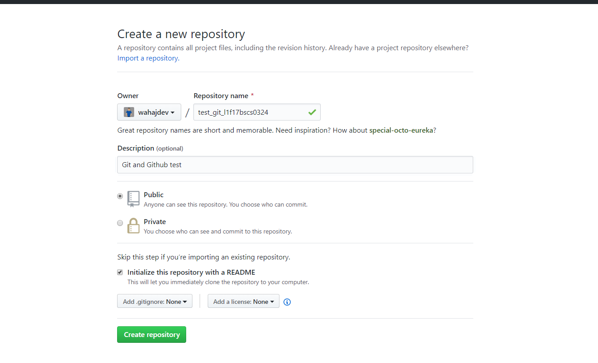

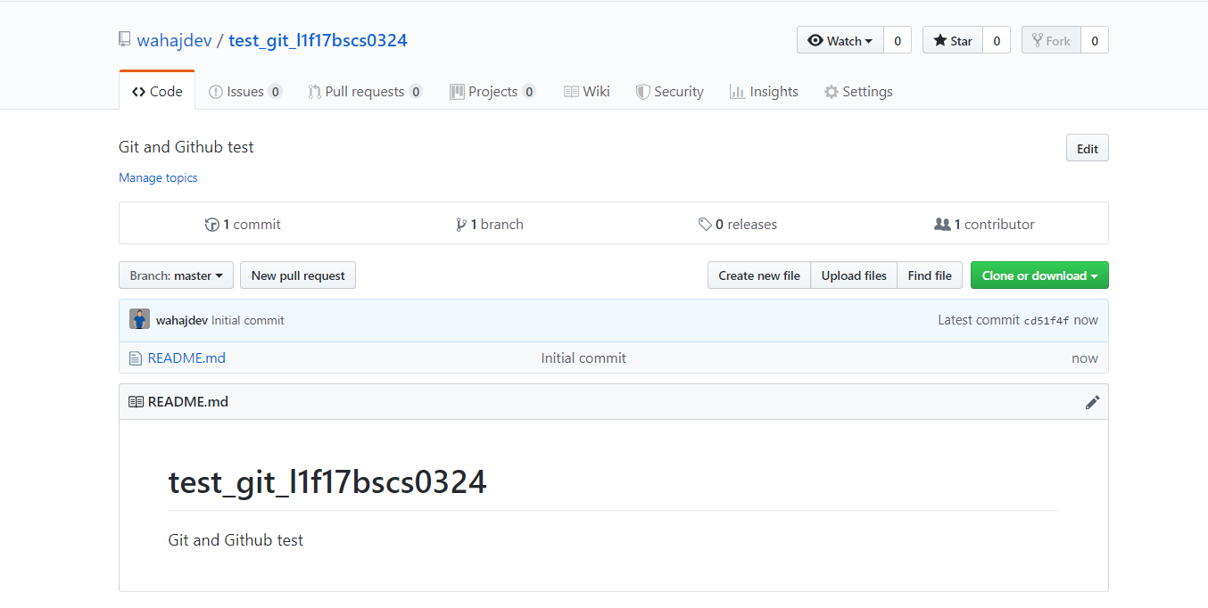

3.

Installing Git

Since I’ve already installed Git and worked on it before, I don’t think there’s any need to re-install it.

4.

Configuring:

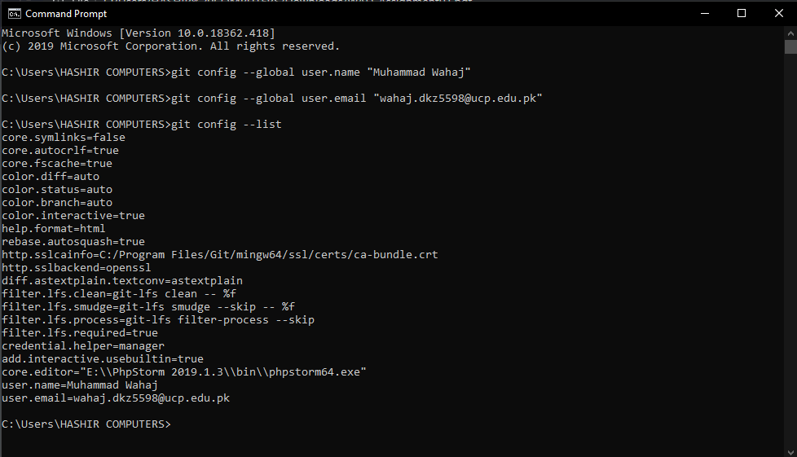

5.

Cloning the repository:

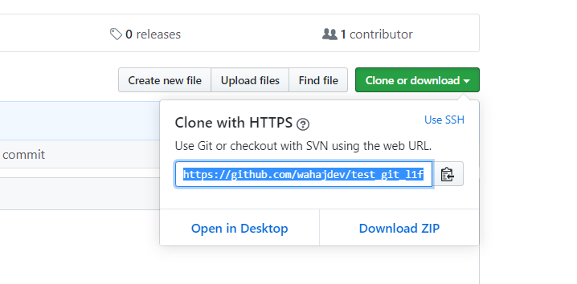

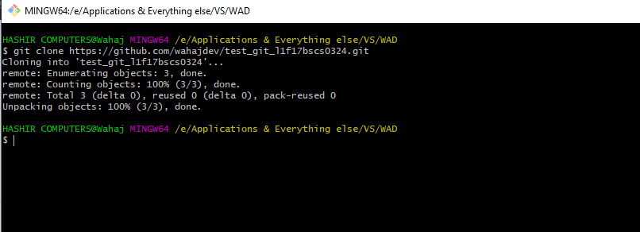

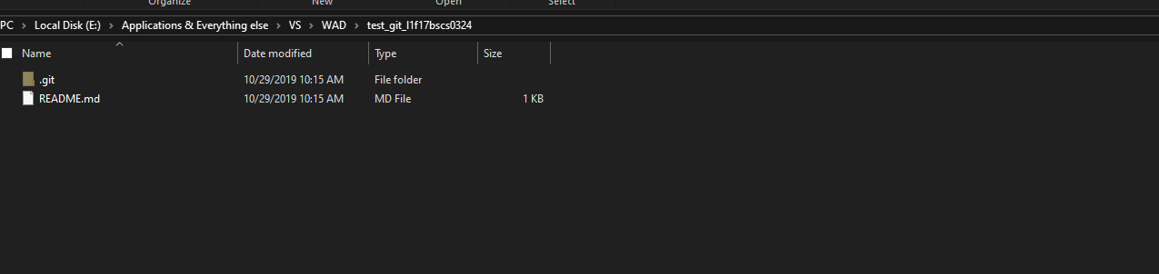

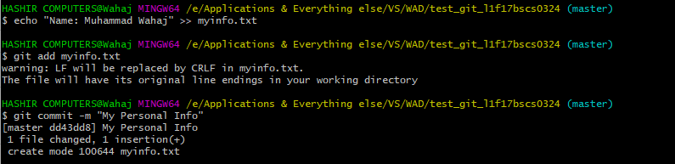

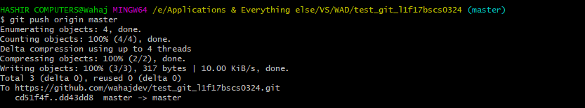

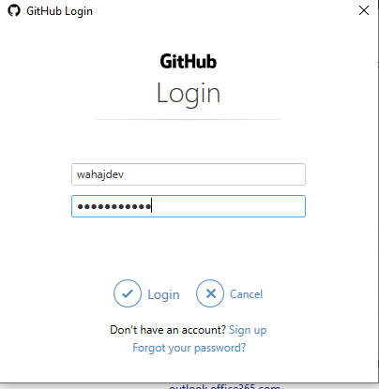

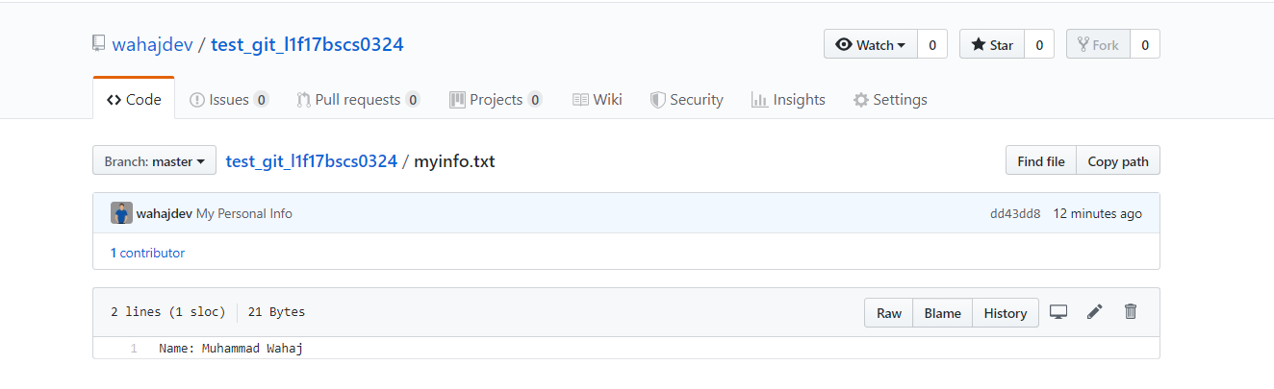

6:

Editing the file:

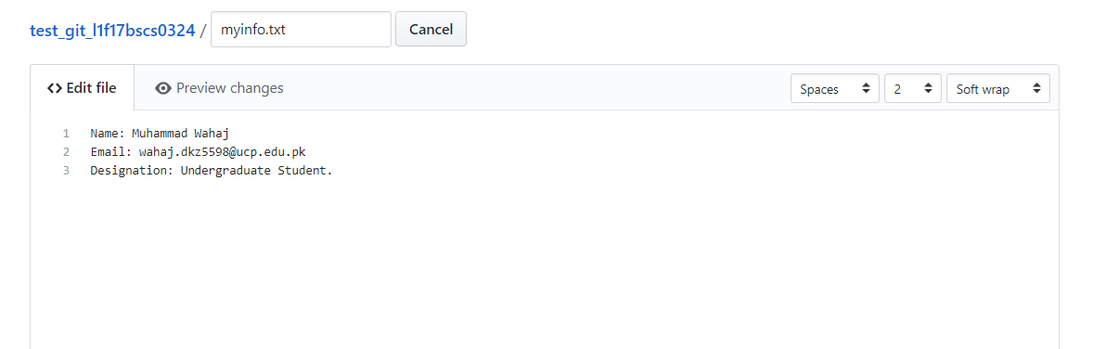

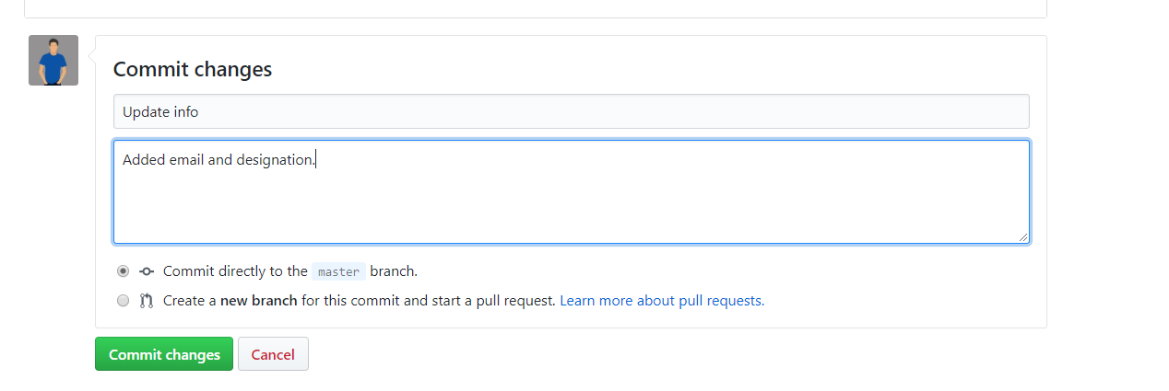

7.

Pulling the changes:

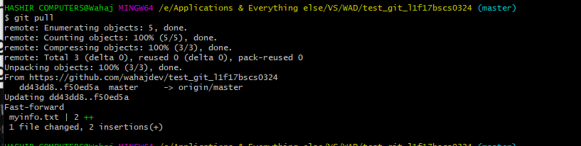



8.

The conflicts during pulling/merging:

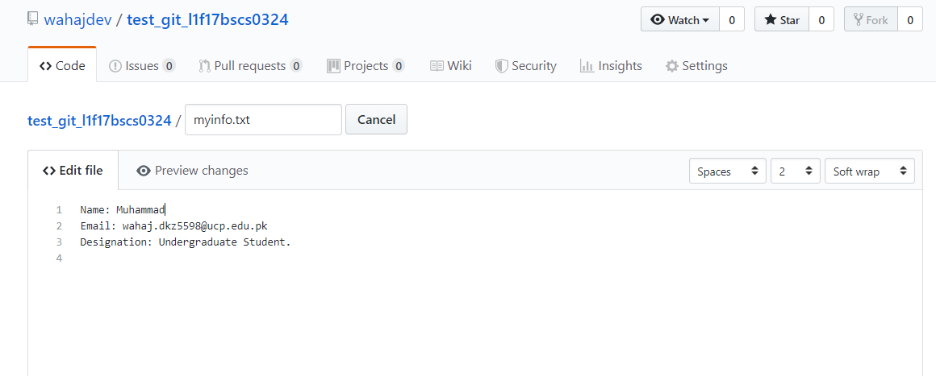

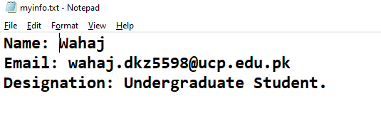

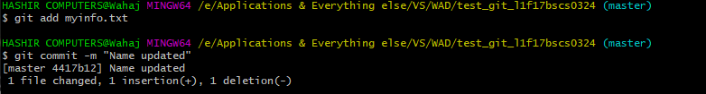

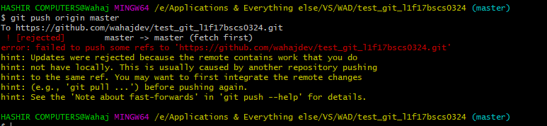

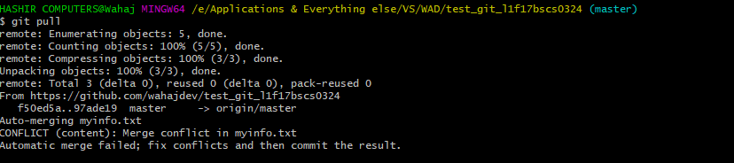

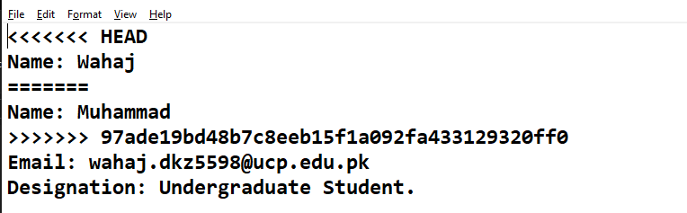

Changed to:

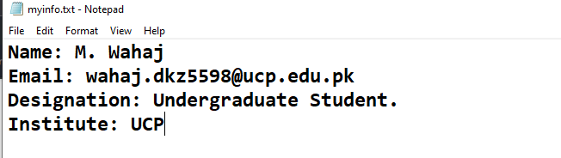

Git status:

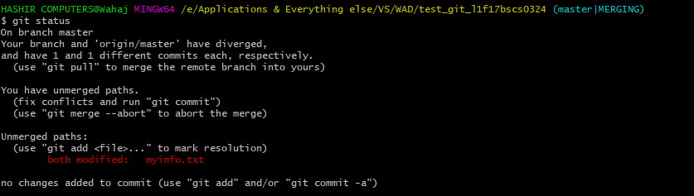

Now, pushing yet again:

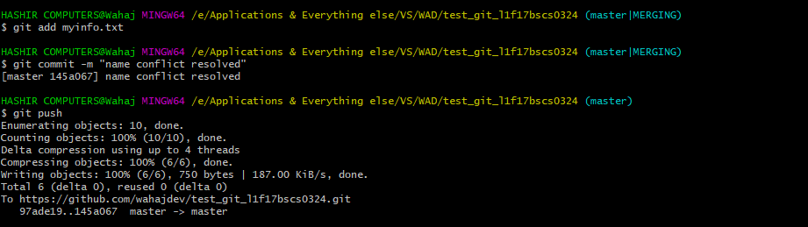

9:

Creating branches:

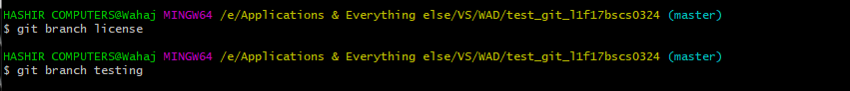

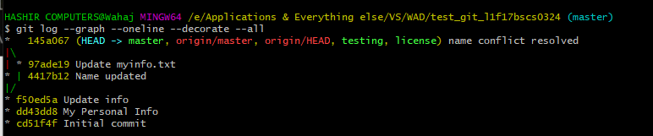

Switched to other branch:

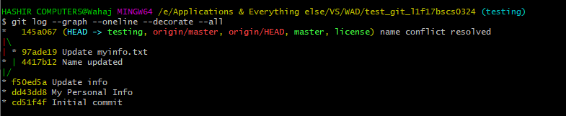

9:

Creating a text file in testing branch:



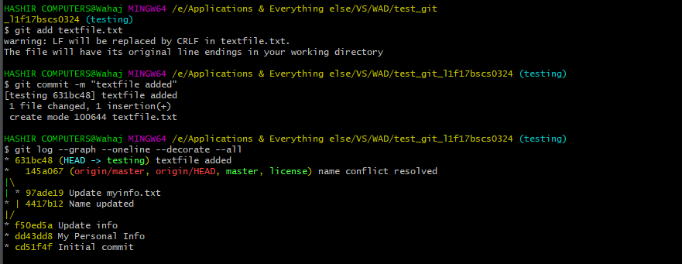

Switched to LICENSE branch:

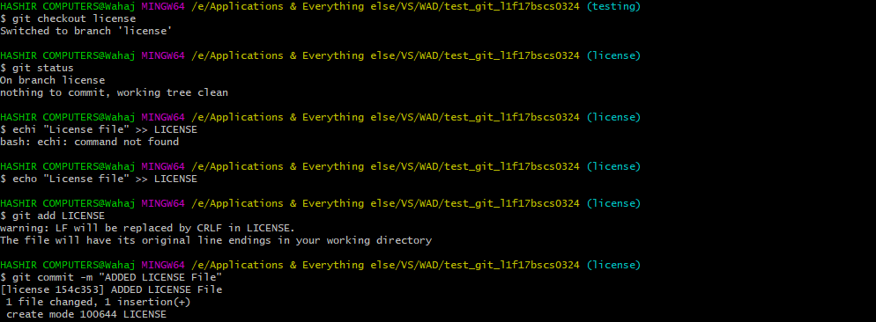

Adding the license file to its respective branch:

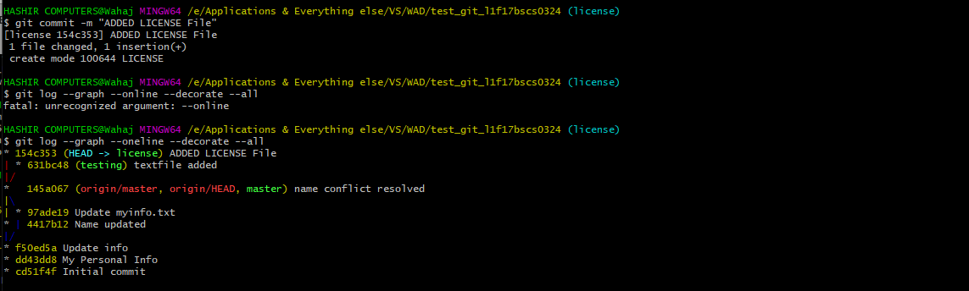

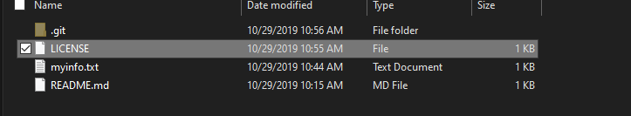

Switching to Master & Merging:

