Control Center

Overview
The following chapter will give a quick description of the functions of the Control Center & Flexikey® applications.
Control Center

Supported Features
Note that the
LED Keyboard
,
overclocking, anti-dust fan
and
Flexikey
menus will only be available for models supporting
these features.
The Control Center provides quick access to Power Modes, Fan settings, Preferences, Blue light filter and LED Keyboard configuration etc.

Flexikey®
The Flexikey® application is a quick hotkey configuration application, which allows you to assign a single key to launch multiple key combinations, to create text macros and to disable certain keys. The application can also be used to configure the mouse buttons to create hotkeys for gaming etc. Click Flexikey in the Control Center to launch the application.

Overview - 1
Run the Control Center (fn hotkeys and OSD) from the Windows Start menu (click All apps if you don’t see
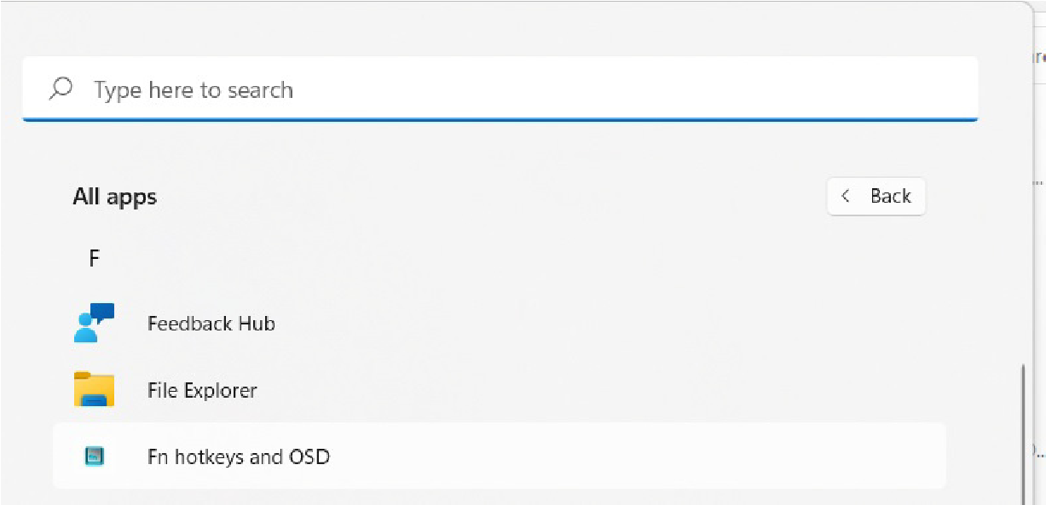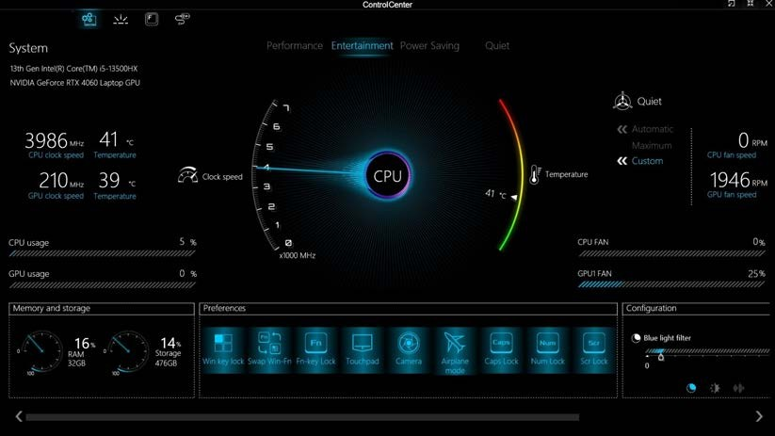
the icon) or use the
Fn + Esc
in the notification area of the taskbar.
key combination, or double-click the icon
Figure B - 1 - Control Center Home

2 - Overview

Fan Speed Setting
You can set the fan speed to Maximum (full power), Automatic or Custom from this menu item. The fan speed will adjust itself automatically to control the heat of the CPU. However you can adjust the setting to maximum if you prefer. You can use the Offset slider in Automatic (click the arrows) to adjust the settings to your preference, however these settings can be overridden by the system as a safety precaution, if it requires heavier use of the fan.
The Custom setting allows you to click and drag on any of the 2 midrange nodes on the graph in order to adjust the temperature parameters of the CPU Fan or GPU Fan (click on the CPU Fan or GPU Fan icon for either on to select it, then click and drag either of the midrange nodes), then click 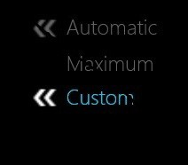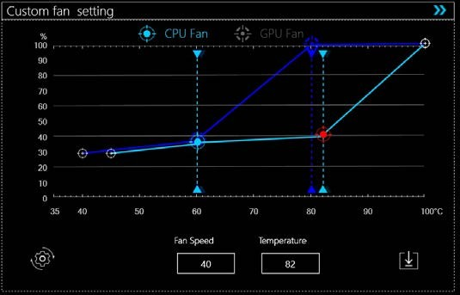Save to retain the setting changes.
Figure B - 2 - CPU/GPU Fan Custom Settings
Overview - 3

Power Modes
Power Modes allows you to adjust the power mode by clicking the appropriate icon.
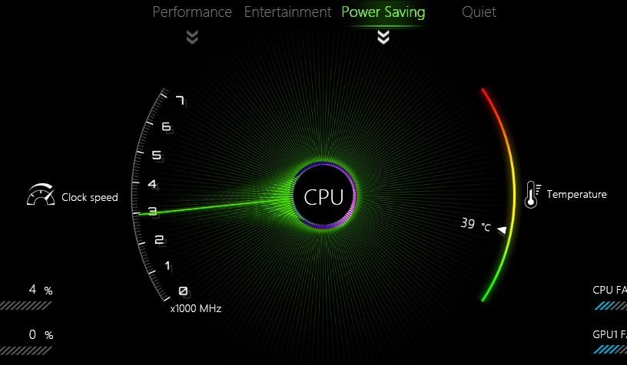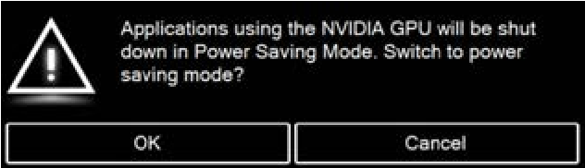
Figure B - 3
- Power Modes

Power Saving Warning
If you select
Power Saving,
a warning will
pop-up to remind you that the NVIDIA dis-
crete GPU will be shut down (do not use
this mode if you are playing games or any
apps which need to use the discrete
GPU).
- Power Saving mode saves battery life (CPU Turbo Boost will be on and dGPU Turbo will be off). Click the arrows to enable/disable panel refresh rate exchange)
- Quiet mode focuses on reducing fan noise and will decrease both CPU power and GPU power.
- Entertainment balances CPU and GPU power and is ideal for watching videos etc.
- Performance mode is ideal for gaming with higher CPU and GPU performance (click the arrows to enable/ disable Turbo fan).
4 - Power Modes

Flexicharger
The FlexiCharger may be set to automatically start charging your battery when the battery reaches a certain capacity level (e.g. you could start the battery charge level at 40%). You can then set the level to stop charging (e.g. 100%), and of course this stop charge level must be higher than the start charge level.
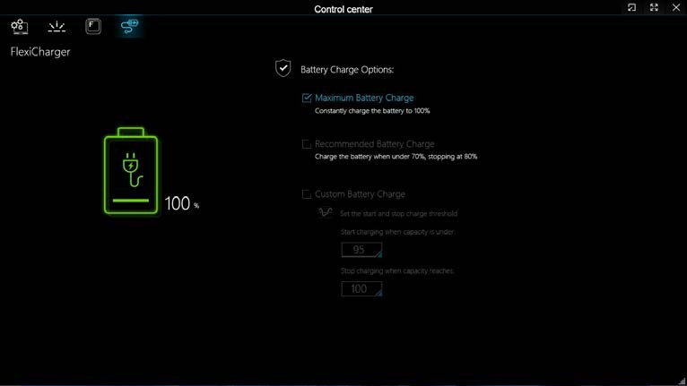
Figure B - 4
- Flexicharger

FlexiCharger Warning
If you leave the FlexiCh-
arger continuously "
En-
abled
” for a period of
three months or more, the
battery meter's reading
accuracy will deteriorate.
To reset this, set the Flex-
iCharger to "
Disabled
",
and then allow the battery
to completely discharge
before enabling the func-
tion again.
Power Modes - 5

Preferences
Click on the icons to enable any of the functions.

Windows Key Lock & Swap Windows and Fn Key
The functionality of the Fn and Windows keys can be swapped using the control here if preferred. You can disable the Windows key altogether if preferred.

Fn Key Lock
Click to lock the Fn key for the function keys F1 ~ F12. When locked you will not need to hold the Fn Key when using the function keys.
Click on the icons to enable/disable the Touchpad, Camera, Airplane Mode, Caps Lock, Number Lock and Scroll Lock.
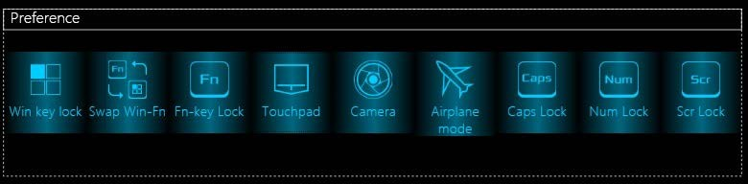
Figure B - 5 - Preferences Keys

6 - Power Modes

Configuration
Click one of the icons at the bottom of the Configuration panel and use the slider to adjust the Blue light filter, Brightness and Volume to your preferences.
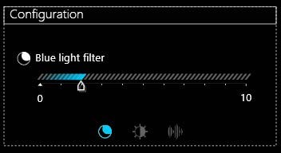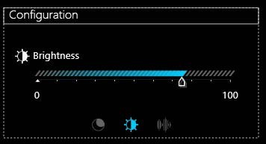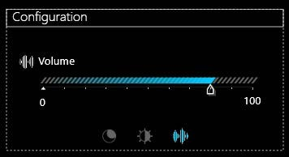
Figure B - 6 - Configuration

GPU Switch
Select the preferred GPU mode by ticking the appropriate check box (the options available will depend on your video adapter).
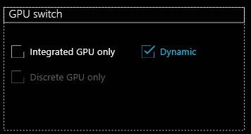
Figure B - 7 - GPU Switch
Power Modes - 7

LED Keyboard

(Note the LED Keyboard menu will only appear for models featuring an LED Keyboard)
The LED Keyboard menu will allow to configure the backlight LED. There are 3 types of menu available depending on which type of keyboard your system supports (either the white illuminated LED keyboard, the illuminated colored LED keyboard or illuminated colored “Per Key” LED keyboard.
- You can change the brightness for the white illuminated LED keyboard.
- You can change the colors for the whole keyboard illuminated colored LED keyboard.
- You can change the colors for individual keys on the illuminated colored “Per Key” LED Keyboard.
The LED Keyboard application can be accessed by pressing the Fn plus  key (or by clicking LED Keyboard in the Control Center).

Override Boot Effect
On boot the colored keyboard will momentarily flash. You can click in the
Override Boot Effect
check box to disable the
keyboard flashing effect as the system boots.
8 - LED Keyboard

White Illuminated LED Keyboard
The LED Keyboard menu will allow to change the Brightness and Keyboard Sleep Timer. The LED Key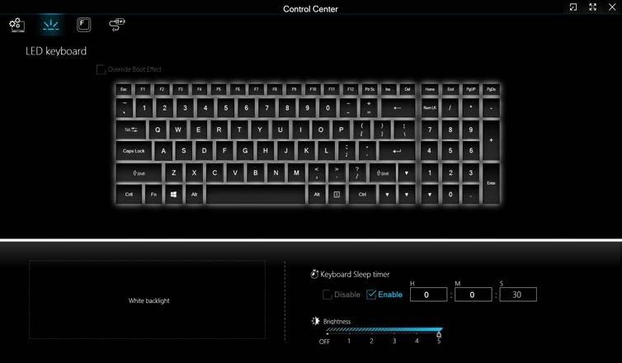board application can be accessed by pressing the Fn plus
key (or by clicking
LED Keyboard
in the Control
Center).
Figure B - 8
- White Illuminated LED Keyboard Setting

Override Boot Effect
On boot the colored key-
board
will
momentarily
flash. You can click in the
Override
Boot
Effect
check box to disable the
keyboard flashing effect
as the system boots.
White Illuminated LED Keyboard - 9

LED Keyboard - Illuminated Colored LED Keyboards
The LED Keyboard menu will allow to change the Brightness and Keyboard Sleep Timer. The LED Key-
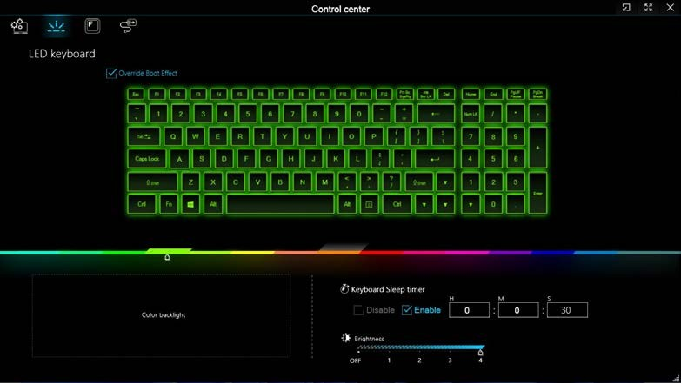
board
application can be accessed by pressing the
Fn
plus
key (or by clicking
LED Keyboard
in the Control
Center).
Help Button
Keyboard Sections
Color Swatches
Effects Buttons

Override Boot Effect
On boot the colored key-
board will momentarily
flash. You can click in
the
Override Boot Ef-
fect
check box to dis-
able
keyboard
the
flashing effect as the
system boots.
Figure B - 9 - LED Mode for Illuminated Colored LED Keyboards

10 - LED Keyboard - Illuminated Colored LED Keyboards
Color Slider
Click the color bar to select a colors for your keyboard backlight.

Keyboard Sleep Timer
Enable and then select the amount of time the system for which the system is idle before the keyboard LED enters sleep mode (i.e. the LED keyboard illumination will turn off to save power).

Brightness
Click on any of the numbers (1 - 4) on the Brightness bar to set the brightness level of the LED Device. You can also turn the keyboard backlight LED Device off by clicking the OFF button, or by using the Fn plus key.
LED Keyboard - Illuminated Colored LED Keyboards - 11

LED Device Menu - Illuminated Colored “Per Key” LED Keyboards
Click Keyboard, on the left under LED Mode, to set individual color settings for any keyboard keys you may wish to highlight.
Simply click to highlight any keys to which you wish to apply the color, and then click a color from the bar to apply the color. To highlight further keys first click to deselect any previously selected keys, then repeat the above procedure.
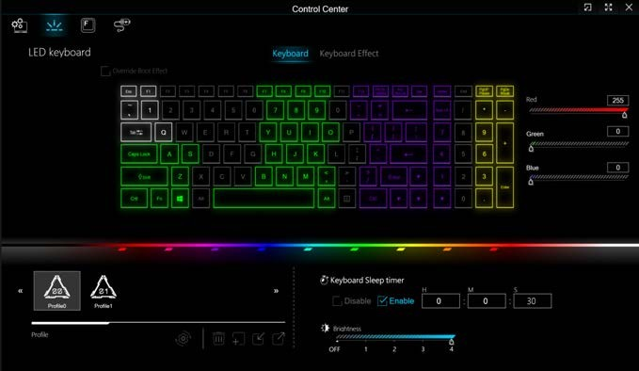
Figure B - 10 - LED Mode - Illuminated Colored “Per Key” LED Keyboards

12 - LED Keyboard - Illuminated Colored LED Keyboards

Keyboard Effects (for Illuminated Colored “Per Key” LED Keyboards)
Click on Keyboard Effect and then click any of the Effect buttons (Wave, Breath, Scan, Blink, Random, Ripple or Snake) to view the effects on the keyboard. You can also adjust the LED Speed for the effects from the buttons on the right. Some effect colors can set to Random or Custom.
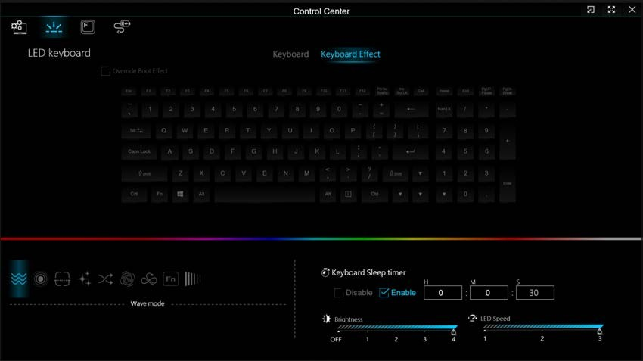
Figure B - 11 - Keyboard Effects - Illuminated Colored “Per Key” LED Keyboards
LED Keyboard - Illuminated Colored LED Keyboards - 13

Overclocking
You can access CPU overclocking by clicking the item in the Control Center.
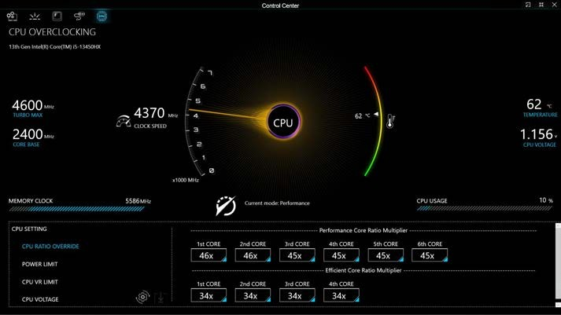
Figure B - 12
- Control Center with Overclocking

CPU Overclocking
Note that CPU overclocking is
only supported by certain specif-
ic processors. CPU overclocking
needs to be enabled in the BIOS
before it can be configured in the
Control Center.
If CPU overclocking does not ap-
pear in the Control Center then
your system’s processor does
not support it. Contact your sup-
plier or distributor for details

14 - Overclocking
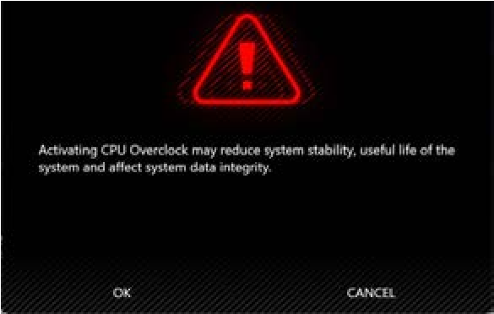

Overclocking Issues
Note
overclocking
the system by making alterations to clock frequency and/or voltage may cause hardware damage, re-
duce system stability, the useful life of the system and affect system data integrity. Therefore
overclocking
the system
is
enabled at the user’s own risk
, and is
not covered in the warranty terms
.
Overclocking should only be enabled when powered by a plugged-in adapter, and not on battery power.
A warning message will appear when you have activated CPU overclocking, click
OK
to activate the changes or click
Can-
cel
to return to the previous settings.

Figure B - 13
-
CPU Overclocking Warning
Resetting the System In Case of Errors
If you get any system errors, to reset

the computer you can press and hold the power button to force the system to shut-
down. To restart
press and hold the power button while holding down the Fn + D key combination (for the CPU re-
set)
. The overclocking settings will be
OFF
after restart.

Overclocking - 15

CPU Overclocking
You can adjust the CPU setting by adjusting the sliders for the CPU Ratio Override, Power Limit, CPU VR Limit, and CPU Voltage.
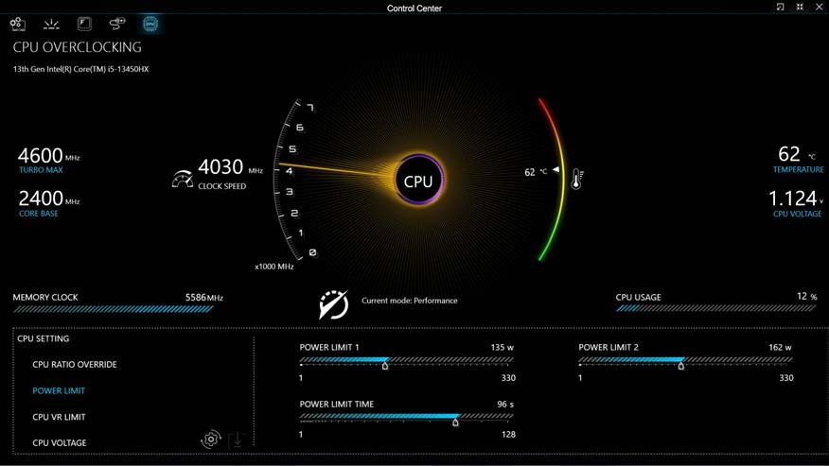
Figure B - 14 - CPU Overclocking
16 - Overclocking

Flexikey® Application
Click Flexikey in the Control Center to launch the application.

Profiles
The controls at the top right side of the application relate to Profiles. You can Add/Delete Profiles (you can maintain 12 active Profiles), Export and Import profiles by clicking on the appropriate icon. If you doubleclick on a Profile you can change the Profile Name, and import an Image file (images created using PNG files).
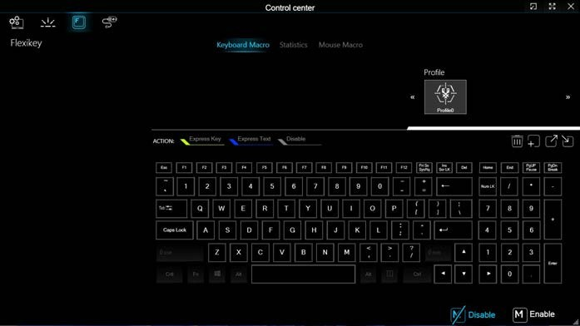
Figure B - 15
- Flexikey® - Profiles (Keyboard Macro)

Windows Key

Fn & P Keys
Note that you can
actions
to
assign
any keyboard key
except
the
Win-
dows key
Fn
and P key
.

Flexikey® Application - 17
- EXPRESS KEY - This feature allows you to configure a single key to send multiple key combinations or to create more useful shortcut keys. This is useful in gaming or when using applications which have a complex set of keyboard shortcuts.
- EXPRESS TEXT - With this you can assign single keys to send commonly used strings of text.
- DISABLE - Use this function to disable any keyboard keys.
- STATISTICS - Use this to quickly record keys in use in any application, and to disable unused keys.

Keyboard Macro and Mouse Macro Settings
Click Enable  (at the bottom right of the screen) to create settings for the keyboard and/or mouse by clicking the tab at the bottom of the screen. Clicking on Keyboard Macro or Mouse Macro allows you to access the settings page for the either the keyboard or mouse.

Enabling or Disabling Flexikey®
You can enable or disable Flexikey® (and therefore any hotkeys or mouse profile functions currently in use) by using the Fn + Backspace key combination. Pressing this key combination will toggle you between the currently selected keyboard or mouse profile to the standard keyboard and/or mouse settings, and back again. An on screen icon will also pop-up to display the status of the application as it is toggled on/off.

Figure B - 16 - FlexiKey On Screen Icons
18 - Flexikey® Application

Keyboard Macro
The keyboard macro settings allow you to configure actions for any single key (or a combination of keys). Click the key and then select the action type (Express Key, Express Text or Disable) from the menu at the top of the page.
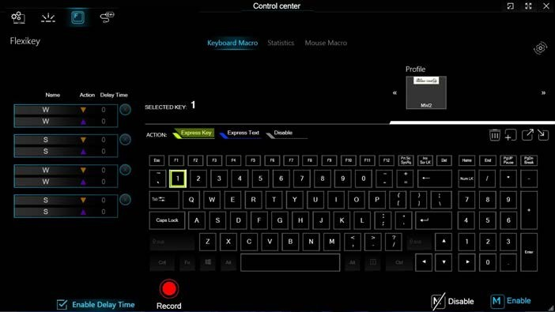
Figure B - 17
- Keyboard Macro

Unused Keys
Note that you can assign actions
to any keyboard key except
those that appear blacked out
e.g. the
Windows key
Fn,
Alt
and
Ctrl keys etc
.
Disable Keys
To disable any key macro simply
select the key and click
Disable
.
Flexikey® Application - 19

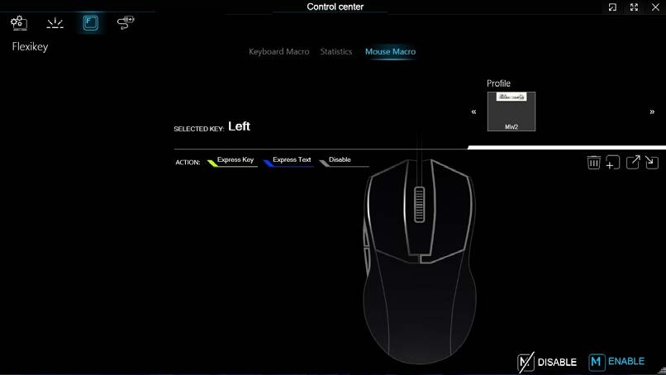
Mouse Macro
,
When an external mouse is attached, the mouse macro settings allow you to configure actions for the left
buttons
buttons of the attached mouse, and also for any backward
and forward
and middle
right
if applicable (on a gaming type mouse). Click the button number and then select the action type (
Express Key
,
Express Text
or
Disable
from the menu.
)
Figure B - 18
- Mouse Macro Configuration
1
2
3
4
5
1
2
3
4
5
20 - Flexikey® Application

Keyboard Macro - Express Key
To configure a single key to send multiple key combinations, or to create more useful shortcut keys, use Express Key.
1. Enable and select the Keyboard Macro, click on the chosen key to select it, and then click to select Express Key.
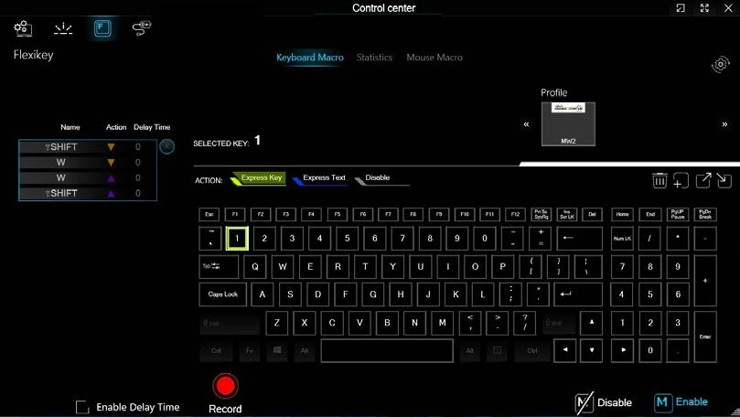
Figure B - 19 - Keyboard Macro - Record Express Key

Keyboard Macro - Express Key - 21
- In the following example we want to change an existing game key configuration which uses the left shift key for sprinting, and the W key for moving forwards, to use the 1 key to combine this movement to sprint forward.
- Click the Record button  and then press the key or keys (in this case we will press Left Shift and W) required (make sure you press the key(s) required and do not click on them).
- Click the Record button  again to complete the process and stop recording.
- If you want to remove any individual key, click to select it, and then click the restore icon .
- Any assigned Express Keys will be highlighted in green.

22 - Keyboard Macro - Express Key

Enabling Delay Time
If you want to create a delay between key presses within the key combination, then you can use Enable Delay Time function to do so.
- Enable and select the keyboard under your chosen profile, click on the chosen key to select it, and then click to select Express Key.
- Click the Record button  and then press the key or keys required in the sequence and time delay between key presses required (make sure you press the key(s) required and do not click on them).
- Click the Record button  again to complete the process and stop recording.
- Click to select a key in the sequence and click Enable Delay Time , then click a key to view the time delay.
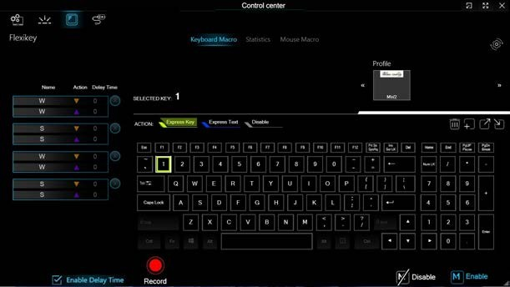
Figure B - 20 - Enable Delay Time

Keyboard Macro - Express Key - 23
- You can edit the delay between key presses by clicking in the Delay Time (MS) field and typing a new number for the delay between the key presses.
- If you want to remove any recorded key stroke then click the delete  icon.
- If you want to remove any individual key, click to select it, and then click the restore icon .
24 - Keyboard Macro - Express Key

Keyboard Macro - Express Text
A single key can be set to send a string of text within any application using Express Text.
- Enable and select the keyboard, click to select a key, and then click to select Express Text.
- Click the Record button in Start key and press the keys to use (the Start key is the key used to in your target program to open a text message).
- Click in the Text Context field and type in your message and click Save.
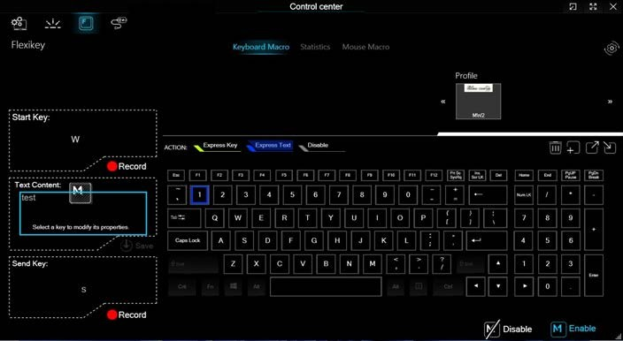
Figure B - 21 - Keyboard Macro - Express Text

Keyboard Macro - Express Text - 25
- Click the Record button in Send and press the keys to use if required (the Send key is the key used to in your target program to send a text message e.g. the Enter key would be the most commonly used).
- The key will now be configured to send the text message in the target program under your chosen Profile, and the key will appear in blue.
If you want to remove any Express Text key, click to select it, and then click the restore icon
6.
.

Copy & Paste Text
Note that some applications and games do not support copy and pasted text. Where this is the case, any text you may have
copy and pasted in to the “Type to Text” field may not be displayed within the application. In this case you will need to type
the text into the field instead.
26 - Keyboard Macro - Express Text

Keyboard Macro - Disable
You can use the program to disable any keys not required.
- Enable and select the keyboard, click to select a key to disable, and then click to select Disable.
- The key will now be disabled.
- If you want to enable the key again, select it and then click Disable.
- The key will be disabled, and the key will appear in Gray.
Keyboard Macro - Disable - 27

Mouse Macro - Express Key
To assign a mouse button click to send multiple key combinations (an external mouse must be attached), or to create more useful shortcut keys, use Express Key.
- Enable and select the mouse, click on a mouse button to select it, and then click to select Express Key.
- In the following example we will configure the central mouse wheel to combine the actions of left shift key for sprinting, and the W key for moving forwards in a game program.
- Click on the central mouse wheel for the shortcut action.
- Click the Record button  and then press the key or keys (in this case we will press Left Shift and W) required (make sure you press the key(s) required and do not click on them).
- Click the Record button  again to complete the process and stop recording.
- If you want to remove any mouse setting, click to select it, and then click the restore icon .
- The mouse button for any assigned Express Keys will appear in green.

Enabling Time Record for Mouse Settings
If you want to create a delay between key presses within the mouse click combination, then you can use Time Record function to do so in the same manner as that used for keyboard settings (see “Enabling Delay Time” on page B - 23).
28 - Mouse Macro - Express Key

Mouse Macro - Express Text
A mouse button click can be set to send a string of text within any application using Express Text.
- Enable and select the mouse, click on a mouse button to select it, and then click to select Express Text.
- Click the Record button in Start key and press the keys to use (the Start key is the key used to in your target program to open a text message). Click the Record button again to stop the process.
- Click in the Text Context field and type in your message and click Save.
- Click the Record button in Send and press the keys to use (the Send key is the key used to in your target program to send a text message e.g. the Enter key would be the most commonly used). Click the Record button again to stop the process.
- The key will now be configured to send the text message in the target program under your chosen Profile, and the key will appear in blue.
If you want to remove any Express Text key, click to select it ,and then click the restore icon
6.
.

Copy & Paste Text
Note that some applications and games do not support copy and pasted text. Where this is the case, any text you may have
copy and pasted in to the “Type to Text” field may not be displayed within the application. In this case you will need to type
the text into the field instead.
Mouse Macro - Express Text - 29

Mouse Macro - Disable
You can use the program to disable any mouse button clicks if not required.
- Enable and select the mouse, click on a mouse button to select it, and then click to select Disable.
- The button click will now be disabled.
- If you want to enable the button again, select it and then click Disable.
- The button click will be disabled under your chosen Profile, and the key will appear in Gray.
30 - Mouse Macro - Disable

Statistics
The Statistics tab allows you to record keys used in any application, and to disable any infrequently, or unused, keys to save any accidental incorrect key presses.
- Click the Statistics Tab, and press the Record button to start recording the frequency of key presses for keys used.
- You can then go to the application for which you wish to use the profile, and use the application as per normal so that a standard set of keys used may be recorded.
- Return to the Flexikey® application and press Record button again to stop recording.
- At the end of the recording process colors will represent the frequency of key presses, with the darker keys as the most frequent through to lighter the less frequent (the color dial on the left of the screen displays the color code against the number of key presses).
- You can move the mouse over any key to see the number of times it has been pressed.
- If you want to disable a key click Quick Disable and click the keys you wish to disable (the key will become grayed out) and then click Save to retain the settings.
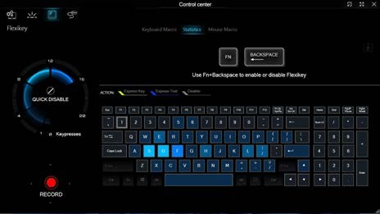
Figure B - 22 - Statistics
Statistics - 31

32

