DeepFace Duchenne Rater – Technical Specification & Business Impact
Version: 1.0
Date: 2025-11-03
Owner: OOREDOO

1. Project Overview
This project delivers a complete system to estimate smile authenticity (Duchenne vs. posed) using DeepFace (emotion recognition) and MediaPipe FaceMesh (eye-aperture proxy for AU6). It provides two interfaces: (a) a Streamlit app for camera or image uploads and (b) a FastAPI service for programmatic access. Each analysis generates a JSON record and saves the original image. A persistent baseline of neutral eye-aperture is maintained to personalize the authenticity score.

2. Objectives
- Provide an accessible UI to rate smiles from webcam or uploaded images.
- Expose a stable API to integrate the analysis into other apps or pipelines.
- Store image + JSON results consistently with persistent user baseline.
- Be reproducible and portable across Windows/macOS/Linux with pinned dependencies.

3. System Architecture
High-level components:
- Streamlit App (`app/app.py`) – interactive UI, camera & upload, animated result, autosave.
- FastAPI Service (`api/api.py`) – REST endpoints for baseline management and analysis.
- Core Engine (`smile/core.py`) – DeepFace + MediaPipe logic, scoring, file persistence.
- Models (`smile/models.py`) – shared dataclass and Pydantic response models.
- Outputs Folder – baseline, images, JSON results.

Directory layout:
Path | Description
app/app.py | Streamlit UI for camera/upload analysis, baseline capture, autosave.
api/api.py | FastAPI endpoints: /health, /baseline, /baseline/add, /analyze, /list, /results/{basename}, /images/{basename}.
smile/core.py | SmileAnalyzer: face landmarks, DeepFace analysis, scoring, saving.
smile/models.py | AnalysisResult dataclass and AnalyzeResponse Pydantic model.
outputs/images/ | Saved original images (.jpg).
outputs/json/ | Saved JSON analysis files.
outputs/baseline.json | Persistent neutral eye-aperture samples (median → baseline).
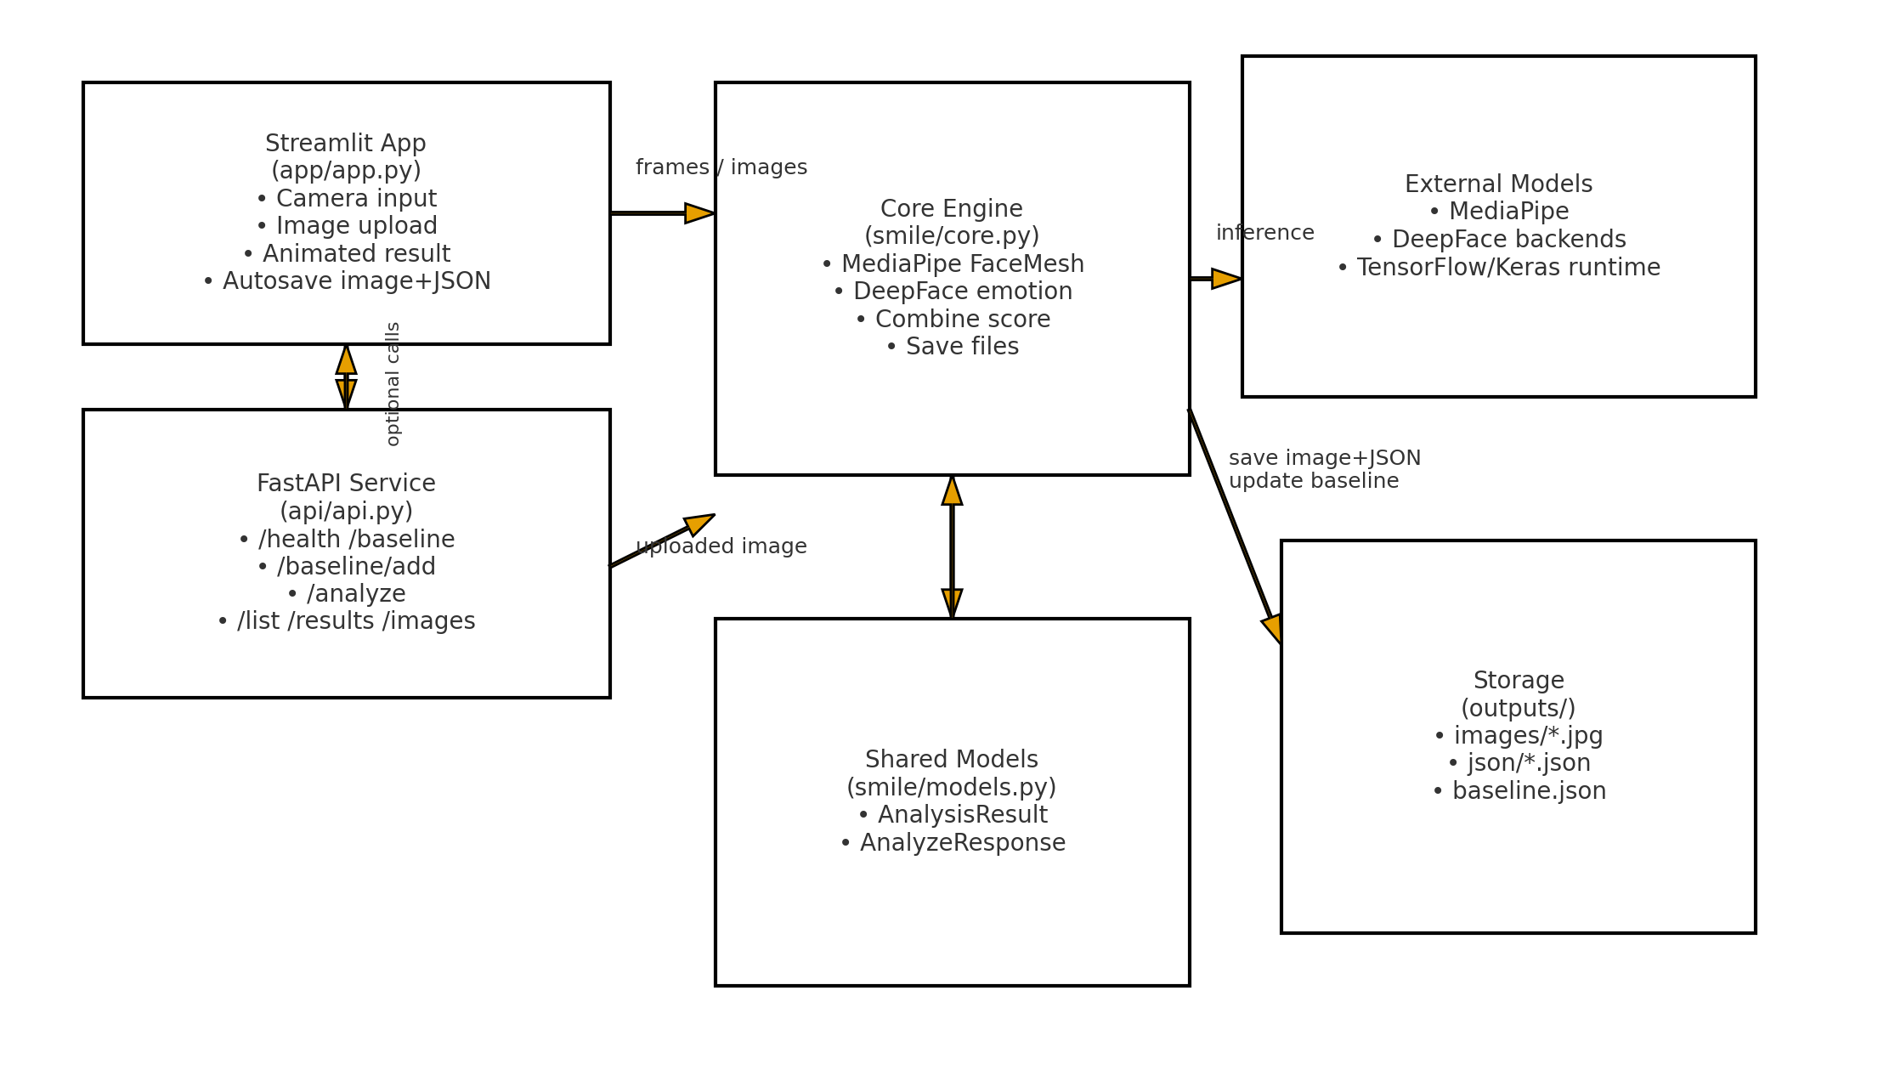

4. Technical Specification

4.1 Data Flow
1) Capture frame (camera or upload) → 2) MediaPipe FaceMesh computes normalized eyelid aperture → 3) DeepFace estimates happy probability → 4) Combine into 0–100 score using eye-narrowing vs. baseline → 5) Save original image (*.jpg) and JSON (*.json) with matched basename.

4.2 Core Algorithms
- Eye-Aperture (AU6 proxy): Measures vertical eyelid opening normalized by eye width for both eyes; averages them.
- Happy Probability: DeepFace emotion analyzer returns `happy` ∈ [0,1] (or % scaled to [0,1]).
- Score: 0.6 * happy + 0.4 * max((baseline - aperture)/0.25, 0).

4.3 Baseline Persistence
Neutral samples (no smile) are appended to `outputs/baseline.json`. The baseline is the median of at least two samples. Both app and API hydrate the baseline into memory on startup and update it when new samples are captured.

4.4 Storage & File Formats
Item | Format
Image | JPEG (.jpg), 95 quality, original content.
Result JSON | {"timestamp_utc","source","image_filename","deepface_happy_prob","eye_aperture","neutral_eye_baseline","score","label","emoji"}
Baseline JSON | {"neutral_samples":[float,...]} (median used as baseline if len≥2).

4.5 API Endpoints
Method | Path | Description
GET | /health | Server status and configuration.
GET | /baseline | Return count + neutral samples.
DELETE | /baseline | Clear baseline (disk + memory).
POST | /baseline/add | Upload neutral image; adds one sample.
POST | /analyze | Upload image; saves image+JSON; returns analysis payload.
GET | /list | List saved images and JSONs.
GET | /results/{basename} | Download a specific result JSON.
GET | /images/{basename} | Download a specific image.

4.6 Configuration (.env)
- OUTPUT_DIR=outputs # Base path for images, JSON, baseline
- DETECTOR_BACKEND=retinaface # or opencv, mtcnn, ssd

4.7 Dependencies
- Python 3.10 or 3.11 (Windows recommended for MediaPipe stability).
- streamlit, fastapi, uvicorn[standard], deepface, mediapipe==0.10.14, opencv-python<4.10, numpy<2.0, pillow.
- Optional: tensorflow CPU (pulled transitively by DeepFace); logs can be silenced via TF_CPP_MIN_LOG_LEVEL=3.

4.8 Security & Privacy
- All processing can run locally; no images leave the machine unless you choose to upload.
- Stored images/JSON are in `outputs/`; control access via OS permissions.
- Avoid storing PII without consent; purge `outputs/` as needed.

4.9 Performance & Reliability
- Prefer Python 3.10/3.11 + pinned wheels to avoid MediaPipe DLL issues on Windows.
- Use the `opencv` backend if retinaface is too heavy on older CPUs.
- Batching: API accepts one image per request to simplify resource usage and latency.

5. Testing Strategy
- Unit tests for core scorer (combine_score) with synthetic inputs.
- Golden-image tests where outputs are stable given fixed frames.
- API smoke tests: /health, /baseline, /baseline/add, /analyze, /list, /results.
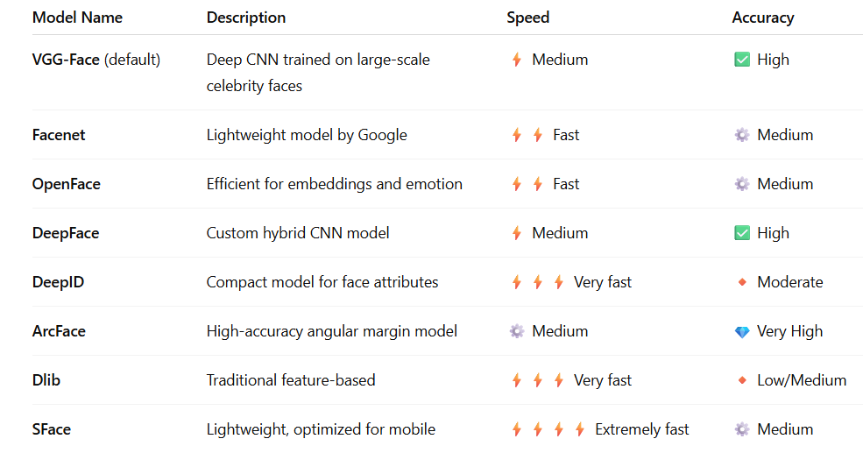

6. Deployment
- Streamlit app: `streamlit run app/app.py`.
- API service: `uvicorn api.api:app --reload` (or systemd/Docker for prod).
- Env vars via `.env` or process manager (e.g., systemd EnvironmentFile).

7. Roadmap
- Video support (live scoring over time, stability filtering).
- Face box overlay + eye landmarks visualization.
- Multi-user baselines with separate stores.
- On-device model caching and warmup routines.

8. Business Impact – Challenge & Reward
Embedding smile-authenticity challenges and rewards into an app drives engagement and data collection. Users complete weekly challenges (e.g., “Duchenne of the Week”) and earn points, badges, or streaks for genuine smiles. Organizations can leverage anonymized aggregates to study user sentiment, wellness initiatives, or campaign impact.

8.1 Example Gamification Mechanics
- Daily Challenge: submit one genuine smile over 70 score – earn 10 points.
- Streaks: 5 genuine smiles in 7 days – award a “Spark Joy” badge.
- Leaderboards: team-based competitions with opt-in privacy.
- Seasonal Events: special themes (e.g., “Grin-tober”) with bonus multipliers.

8.2 KPIs
- DAU/WAU uplift from challenge participation.
- Submission completion rate and average smile score.
- Retention: streak continuation across weeks.
- Conversion: % of users who redeem rewards or badges.

8.3 Risks & Mitigations
- Privacy & Consent: require consent and provide a “do not store images” mode; default to local-only.
- Bias & Fairness: disclose model limits; include calibration tools for diverse populations.
- Over-Optimization: encourage healthy usage; cap daily challenges; avoid negative feedback loops.

9. Appendix
Sample result JSON:
{
"timestamp_utc": "2025-11-03T08:45:00Z",
"source": "upload",
"image_filename": "smile_001.jpg",
"deepface_happy_prob": 0.83,
"eye_aperture": 0.19,
"neutral_eye_baseline": 0.22,
"score": 78,
"label": "Genuine smile likely",
"emoji": "😁"
}

