Student Name: Md Karim  
Email: mkarim10@aus.edu  
Submission Date: 05/26/2024  
Class Name and Term: CSE548 Summer 2024

Packet Filter Firewall (iptables) Project

# Project Overview

This project focuses on setting up and configuring a packet filter firewall using iptables on a Linux-based system. The project involves implementing security policies to manage network traffic, ensuring proper network connectivity, and configuring necessary software services like a web server. Through this project, I gained practical experience in firewall management, troubleshooting network issues, and applying security policies in a simulated environment.

# Network Setup

# Software

I have use following tool/command to achieve goal for this project

* iptables – set routing rules
* ping – check network reachability
* ifconfig – check network configuration
* chmod – change file read write or execute permissions
* ls -l – view file permissions
* cat – view file content
* echo – update file content
* sudo – execute command as root user

# Project Description

I have set Server and Client Virtual machine using Hands-on Lab Description (file lab-cs-sys-00101-update-5_15_23.pdf) document provided as part of project 1.

Server side:

Server can ping 8.8.8.8 before Reset firewall to whitelist

Server can ping 10.0.2.5 before Reset firewall to whitelist

Reset firewall to whitelist:

Server cannot ping 8.8.8.8 after Reset firewall to whitelist

Server cannot ping 8.8.8.8 after Reset firewall to whitelist

Server cannot ping localhost after Reset firewall to whitelist

Client side:

Client can ping 8.8.8.8 before Reset firewall to whitelist

Client can ping 10.0.2.6 before Reset firewall to whitelist

Client can ping 10.0.2.6 after Reset firewall to whitelist

Client cannot ping 8.8.4.4 after Reset firewall to whitelist

**Enable 8.8.8.8 only from client:**

Update following changes in rc.firewall file in server and execute it





Client can ping 8.8.8.8 after updating rc.firewall file and execute it on server side

sudo nmap -sU -p- 10.0.2.6 after applying firewall rules

Install Apache web server

Execute “Sudo apt-get install apache2” to install apache2 server

Check apache2 server status

Check web page port configuration for apache2 server

Update index.html file context

Before applying firewall, rules client can view demo:

After applying firewall without whitelisting client, the client rules can view demo:

The following change was made in rc.firewall file in the server side and execute it to allow client to access web page



Response back:

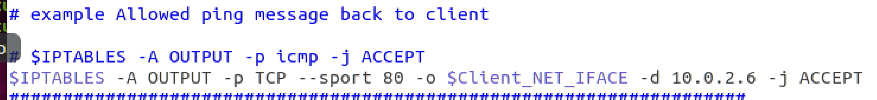

Server Ip address 10.0.2.6 map with www.test-and-demo.com

[www.test-and-demo.com](http://www.test-and-demo.com) is accessible from client after mapping ip with url:

# Conclusion

In this project, I learned how iptables controls packet flow under various use cases. The best way to debug and correctly set up iptables was to use the following command in another terminal tab: *sudo watch -d iptables -L -n -v*

Using this command, I could see the counter changes for each table, which helped me determine if the filter rules were correct.

I invested a significant amount of time setting up the virtual machine. Initially, I tried running the VMs on my OSX-based machine, but I encountered many performance issues that caused the virtual machine to crash and not work properly. Despite following various fixes and different blogs, none of them helped.

Finally, I decided to run the virtual machine on a native Ubuntu machine. This attempt also had its challenges. Fortunately, the guides and explanations I found online helped me fix the issues and start working on the project.

# APPENDIX B: ATTACHED FILE

# References

# Linux Nat Tutorial: https://www.karlrupp.net/en/computer/nat_tutorial

# Ubuntu :https://help.ubuntu.com/community/IptablesHowTo

# Firewall rules: https://phoenixnap.com/kb/iptables-tutorial-linux-firewall