**I z h a n Y a m e e n**

# O B J E C T I V E :

To work in a larger capacity in order to utilize my analytical potential, knowledge and experience of planning & marketing resulting in the establishment and progress of business and my career on strong footings.

# E X P E R I E N C E :

**JOB TITLE COMPANY NAME DURATION WORKING TOOLS**

# C O N T A C T

+92-332-8831270

+92-213-4921258

[izhan.yameen25@gmail.com](mailto:izhan.yameen25@gmail.com)

House 8, Street 12th Block B1,

Queno

Internship Queno from Aug 2018 to Nov 2018

Angular, Ionic

Liaquatabad, Karachi

Graphic Designer

Graphic Designer

The Carpentor from Sep 2015

to Current

Hi Life Interior from Jun 2014

to May 2015

AutoCad, Vray SketchUp, MS office

AutoCad, Vray SketchUp, MS office

# E D U C A T I O N

## BACHELOR DEGREE

BScs, from

Federal Urdu University, Karachi

### (In Progress)

**S K I L L S :**

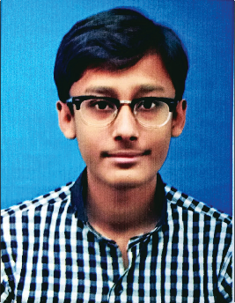

**BASIC :**

Ms Office

English Language (Intermediate)

### PROGRAMMING :

C language HTML5

CSS

Javascript PHP

### GRAPHICS :

Adobe Photoshop Adobe Illustrator AutoCad (civil) SketchUp

Vray (Rendering Engine)

# P R O F I L E :

GitHub https://github.com/izhan25

## INTERMEDIATE

Pre-Engineering, from

Govt. Degree Science College, Ranked : 2nd Division

## MATRIC

Computer Science, from Liaquat Public Sec. School, Ranked : 1st Division

# A B O U T M E

BirthDate : 25th April 1996 Father’s Name : Yameen Baig Marital Status : Single

City : Karachi Reference : Will be Furnished

on demand