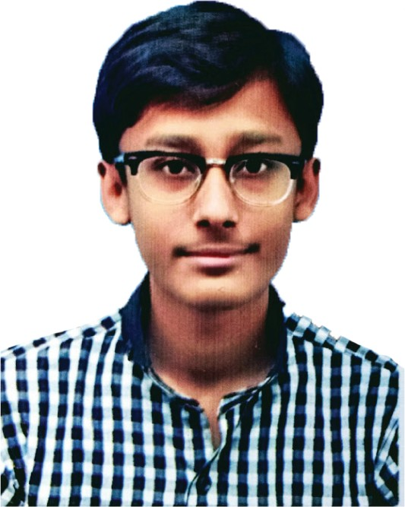Sufiyan Waheed

 03408682605

 [sufyanwhaeed4415@gmail.com](mailto:sufyanwhaeed4415@gmail.com)

House 8/3, Street 5th Sector 7E, Orangi Town Karachi



 https://github.com/Waheed-sf

# M Y O B J E C T I V E :



I want to work in a larger capacity in order to utilize my analytical potential, knowledge and experience of planning and marketing resulting in the establishment and progress of business and my career on strong footings.

# E X P E R I E N C E :

**JOB TITLE COMPANY NAME DURATION**

|  |  |  |  |  |  |  |  |
| --- | --- | --- | --- | --- | --- | --- | --- |
| |  |  |  | | --- | --- | --- | | Sale Associate | Outfitters | from 23rd Sep 2016 to Jan 2017 | | Head Casher | Outfitters | from Jan 2011 to Current | | |
| **S K I L L S :** |  |
| **PROGRAMMING LANGUAGES: BASIC :**  Javascript HTML5 Ms Office  PHP CSS English Language  **FRAMEWORKS / LIBRARIES : GRAPHICS :**  React JS, Redux Adobe Photoshop  Angular Adobe Illustrator  Laravel AutoCad (civil)  JQuery SketchUp + Rendering | |

# E D U C A T I O N :



**BACHELOR DEGREE**

BScs, from

Federal Urdu University, Khi

**(In Progress)**

# A B O U T M E

**INTERMEDIATE**

Pre-Engineering, from Govt. Degree Science Collg.

Ranked : 2nd Division

**MATRIC**

Computer Science, from Liaquat Public Sec. School, Ranked : 1st Division

BirthDate : 25th April 1996 Father’s Name : Yameen Baig Marital Status : Single



City : Karachi

Reference : Will be Furnished on demand