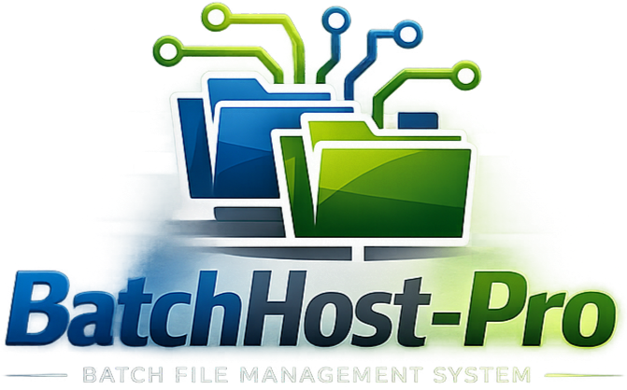 BatchHost-Pro
Comprehensive System Overview & Technical Documentation
Version 1.0 | Created: May 2026
Audience: Team Members, Onboarding Users
____________________________________________________________________________________________________________________________________

Table of Contents
1. What is BatchHost-Pro? ____________________________________________________________________________ 02
2. How the System Works — The Big Picture ________________________________________________________ 03
3. User Roles & Permissions ___________________________________________________________________________ 04
4. Logging In & Out ______________________________________________________________________________________ 05
5. The Dashboard Page _________________________________________________________________________________ 06
6. Agents — Your Connected Machines ________________________________________________________________ 07
7. Scripts — Batch Jobs Being Monitored ______________________________________________________________ 08
8. Script Management — Super Admin Control ______________________________________________________ 09
9. Alerts — Automatic Problem Detection _____________________________________________________________ 10
10. Logs — Full Activity Trail ____________________________________________________________________________ 11
11. Admin Audit Logs __________________________________________________________________________________ 12
12. Users — Account Management ____________________________________________________________________ 13
13. Organizations — Multi-Tenant Groups ___________________________________________________________ 14
14. Backups — Data Protection _______________________________________________________________________ 15
15. Settings — Email & Notifications _________________________________________________________________ 16
16. User Profile Page __________________________________________________________________________________ 17
17. Session Management & Security _________________________________________________________________ 18
18. How Agents Communicate with the Server? ____________________________________________________19
19. Data Storage________________________________________________________________________________________ 20
20. System Infrastructure_____________________________________________________________________________ 21
21. Technical Architecture & Execution Lifecycle_________________________________________________ 23

1. What is BatchHost-Pro?
BatchHost-Pro is a web-based monitoring and management platform designed to watch over batch scripts and automated jobs running on one or many computers ("machines") across an organization or multiple organizations.
Think of it like a control room — all your computers running background tasks (like database backups, scheduled reports, data transfers, or cleanup routines) "call home" to BatchHost-Pro to report what they are doing, whether they succeeded, and whether they are still alive. If something goes wrong, the system immediately raises an alert and can even send you an email.

What problems does it solve?
- Visibility: Instead of logging into each machine individually to check if scripts ran, everything is visible in one place.
- Reliability: If a machine goes offline or a script fails, an alert is raised automatically — no manual checking required.
- Multi-organization support: Multiple separate organizations or teams can each have their own isolated view of their machines and scripts; all managed from one system.
- Audit trail: Every action taken by administrators is recorded, so there is always a clear record of who did what and when.

2. How the System Works — The Big Picture

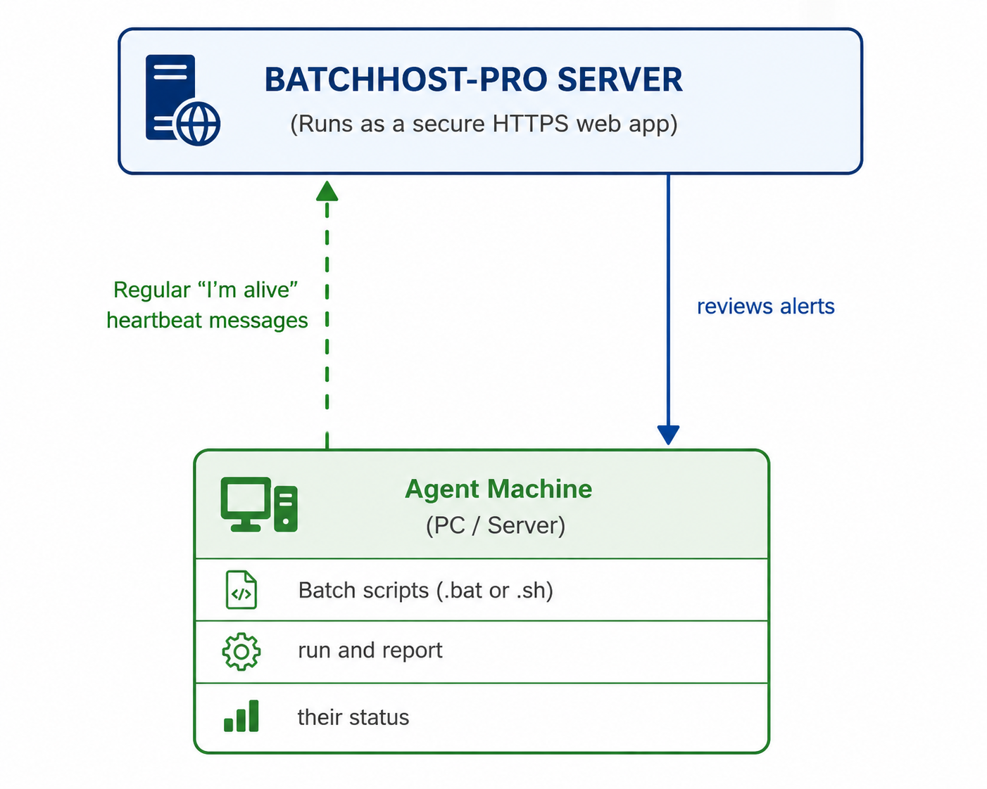

There are two main parts to the system:
1. The Server (BatchHost-Pro) — A secure web application that stores all data, shows the dashboard, and handles user logins. It runs 24/7 and is accessed through any web browser.
2. Agents — Small programs running on remote machines that periodically "check in" with the server to say "I'm still here and here's what's running." They don't need a browser — they communicate in the background automatically.

3. User Roles & Permissions
There are mainly three types of user accounts in BatchHost-Pro:

Super Admin
The super admin is the most powerful account in the system. A super admin can:
- See everything across all organizations
- Create, edit, and delete users, organizations, agents, and scripts
- Access admin-only pages: Script Management, Backups, Settings, Logs, Admin Audit Logs, and Organizations
- Clear admin logs
- Trigger and download backups

Organization Admin
The organization admin manages resources only within their assigned organization. An organization admin can:
- View all dashboards, agents, scripts, alerts, and logs belonging to their organization
- View their organization’s agents and scripts, logs
- Access organization admin-only pages: Backups, Logs, Users, Profile.
- View their own profile
- View other users in the same organization
- Trigger and download backups of their organization only.

Organization Viewer
A viewer is a regular user tied to a specific organization. A viewer can:
- See the dashboard, agents, scripts, and alerts — Only for their own organization
- View other users in the same organization
- View their own profile
- Cannot add, edit, or delete anything
- Cannot copy or download logs
Viewers cannot access: Script Management, Backups, System Logs, Admin Logs, Settings, or Organizations.

4.Logging In & Out
Page: `/login`
Access: All registered users in system

Splash Screen Page (`/login`)
The BatchHost-Pro splash screen works as an animated startup overlay that appears immediately when the website is opened, before the main login interface becomes accessible. The splash overlay remains visible for approximately 3 seconds and then smoothly fades out using scale and opacity transition effects, revealing the main login page underneath.
Additionally, the splash screen is optimized to appear only once per browser session, enhancing user experience while preserving application performance and branding consistency throughout the BatchHost-Pro monitoring platform.

Login Page (`/login`)
When you first open BatchHost-Pro in your browser, you are taken to the login screen. You enter your email address and password to log in. If your credentials are wrong, or if your account is inactive, or if your organization has been disabled, you will see an appropriate error message. For that you've to contact super admin for assistance.
On successful login:
- The system records your login time (so your previous login time can be shown later).
- A session is started, giving you access for up to 30 minutes at a time & A ‘Stay in Session’ pop-up appears after 25 minutes that extends the session for another 30 minutes.
- Admins have their login/logout recorded in the Admin Audit Log.
New users cannot create their own account. Self-registration of accounts is disabled & Account creation is only handled by the super admins. And when a new user is added it automatically assigned the Viewer role. An admin can later change their organization or promote their role.

Logout
You can log out using the button in the top-right profile dropdown menu. The system records the logout event for admins. Once logged out, you must log in again to access the system.

5. The Dashboard Page
Page: `/dashboard`
Access: All logged-in users (Organization Admins & organization viewers see only their organization's dashboard)
The dashboard is the home screen of BatchHost-Pro. It gives you a real-time overview of what is happening in the system. The data on this page refreshes automatically every 10 seconds — no need to manually reload the page.

Welcome Banner (First Visit Only)
The first time you open the dashboard in a browser session, you see a personalized welcome card showing:
- A time-based greeting: (Based on the current time.)
- Organization's logo and name
- User’s Name & organization role
- User’s last login
- Three quick statistics: total agents, running scripts, and total alerts
This welcome card disappears if you navigate to any page in the system — it only shows once per browser session.

System Overview (Subsequent Visits)
After the welcome card, or when you revisit the dashboard, you see:
8 live statistics cards:
Card | What it shows
Total Agents | How many machines are registered
Online | Machines that have recently checked in
Offline | Machines that haven't been heard from in over 30 seconds
Total Scripts | How many batch scripts are being tracked
Running | Scripts currently executing on a machine
Completed | Scripts that finished successfully
Failed | Scripts that ended with an error
Terminated | Scripts that were manually stopped before completion
Timeout | Scripts that exceeded the allowed/expected execution time
Unknown | Scripts whose current status could not be determined
Alerts | Total number of alerts raised

Running Jobs panel — A live table showing scripts that are currently executing, which machine they are on, and when they started.
Recent Alerts panel — The last 5 alerts in the system, color-coded by severity (red for critical/error, yellow for warning)

6. Agents — Your Connected Machines
Page: `/agents`
Access: All logged-in users (Organization Admins & organization viewers see only their organization's agents)
An agent represents a computer or server that is sending information to BatchHost-Pro. Each agent runs a lightweight background runtime service responsible for:

Process tracking

Script execution monitoring

Heartbeat telemetry

Lifecycle event delivery

Automatic reconnection and recovery

What information is shown per agent?
Field | Description
Hostname | The name of the machine
OS Type | Windows or Linux
Status | Online (recently active) or Offline
CPU Usage | Percentage of processor being used
Memory Usage | Percentage of RAM being used
Last Heartbeat | When the agent last checked in
Organization | Which organization the agent belongs to
Scripts | How many scripts are registered on this agent
Running | How many scripts are currently executing
Failed | How many scripts have failed

How does an agent go "Offline"?
If an agent does not check in for more than 30 seconds, the server automatically marks it as offline and raises a CRITICAL alert.

Agent Actions (Super Admin Only)
- Reassign: Move an agent to a different organization
- Delete: Remove an agent from the system (also removes all its associated scripts)

7. Scripts — Batch Jobs Being Monitored
Page: `/scripts`
Access: All logged-in users (Organization Admins & organization viewers see only their organization's scripts)
A script is a batch file (`.bat` on Windows) or shell script (`.sh` on Linux) running on an agent machine. BatchHost-Pro tracks their status in real time.

Script Status Values
Status | Meaning
RUNNING | The script is currently executing
COMPLETED | The script finished without errors (exit code 0)
FAILED | The script stopped with an error (non-zero exit code)
PENDING | The script is registered but not yet started
TERMINATED | Script was manually stopped or process was killed
TIMEOUT | Script exceeded maximum allowed execution duration
UNKNOWN | Server lost execution visibility before terminal confirmation

Script Details Shown
- Name and file path on the agent machine
- Which agent it runs on
- Type (BAT for Windows, SH for Linux)
- Current status
- Last execution timestamps
- Organization it belongs to

How Script Status Updates
The agent reports back when:
- A script starts running
- A script completes successfully
- A script fails with an error
If the server stops receiving execution updates for a running script, the execution may transition to TIMEOUT or UNKNOWN depending on the last known execution state and timeout policies.
Execution state changes are driven only by explicit lifecycle events sent by the agent runtime.

8. Script Management — Super Admin Control
Page: `/script-management`
Access: Super Admins only
This is the super admin's control panel for managing all scripts. Unlike the scripts view page (which is read-only for viewers), this page allows full management.

Features
1] Search & Filter
- Search by script name or file path
- Filter by: All, Enabled, Disabled, BAT, SH
- Filter by a specific agent
2] Adding a Script
Click "+ Add Script" to register a new script. You provide:
- Script Name — A friendly label (e.g., "Daily Backup")
- Script Path — the full file path on the agent machine (e.g., `C:\scripts\backup.bat`)
- Agent — which machine this script runs on/belongs to.
- Auto Start Script If Crashed — A toggle that tells the agent's batch program to restart the script automatically if it unexpectedly stops
- Auto Scheduler — optionally set the script to run on a schedule (see Scheduling below in dropdown)
3] Editing a Script - You can change a script's name, path, assigned agent, or schedule at any time.
4] Enabling / Disabling a Script - A toggle switch on each script row lets you turn it on or off without deleting it.
5] Deleting a Script - Permanently removes the script record from the system.

Auto Scheduler
When you enable the scheduler for a script, you choose a schedule type:
Schedule Type | Description
Minutes | Run every X minute
Hours | Run every X hour
Daily | Run once per day at a specific time
Weekly | Run once per week on a specific day/time
Monthly | Run once per month
Date Range | Run only between two specific dates
Repeat Days | Run every X Day
Auto Schedule | System picks a smart default based on the script name (e.g., "backup" scripts run at midnight daily)

The scheduler shows a "Next Run Preview" so you can confirm the schedule is configured correctly before saving.

9. Alerts — Automatic Problem Detection
Page: `/alerts`
Access: All logged-in users (Organization Admins & Organization viewers see only their organization's alerts)
Alerts are automatic notifications raised by the system when something goes wrong. They require no manual action to create — the server generates them in the background.

Alert Severity Levels
Level | Color | Meaning
CRITICAL | Red | A serious problem requiring immediate attention (e.g., machine went offline)
ERROR | Red | A script failed with an error code
WARNING | Yellow | A resource threshold was exceeded (CPU, memory)
INFO | Blue | Informational notice (e.g., a machine came back online)

What Triggers Alerts?
Alert Type | Trigger
AGENT_OFFLINE | A machine hasn't sent a heartbeat in over 30 seconds
AGENT_ONLINE | A previously offline machine reconnects
SCRIPT_FAILED | A script exits with a non-zero code or stops unexpectedly
SCRIPT_COMPLETED | Optional notice when a script finishes successfully
HIGH_CPU | Agent CPU usage exceeds 90% for more than 60 seconds
HIGH_MEMORY | Agent memory usage exceeds 90%

Alert Information Shown
- Severity level and type
- When it occurred
- Which agent it relates to
- A description of what happened
- Whether an email notification was sent

Managing Alerts
Admins can delete individual alerts once they have been reviewed. Non-admin users can view alerts but cannot delete them.

10. Logs — Full Activity Trail
Page: `/logs`
Access: Super Admins & Organization Admin only
The Logs page gives admins a unified view of all system activity, bringing together:
- Server logs — internal server events (logins, errors, configuration changes)
- Agent logs — messages sent by agent machines
- Script execution logs — output and results from batch scripts
- Alert records — all alerts that have been raised

Log Export
Admins can export logs in two formats:
- PDF — a nicely formatted report with a table of all log entries, suitable for printing or sharing
- XML — a structured data file for importing into other tools
Export Range Options:
- All logs — everything in the system
- Previous X hours — last 1–24 hours of activity
- Custom date range — pick a specific start and end date
- Organization Logs — pick a specific organization and get end to end logs of specific organization.

11. Admin Audit Logs
Page: `/admin_logs`
Access: Super Admins only
Every action taken by an admin through the web interface is recorded in the Admin Audit Log. This creates a permanent, tamper-evident trail of who did what and when.

What is logged in the Admin Logs Page?
Action | Example
Login | Admin logged in from IP address
Logout | Admin logged out
Auto-Logout | Session ended because browser was closed
Add | New user/agent/script/organization created
Update | Any record was modified
Delete | A record was removed
Backup Trigger | A backup was manually created
Settings Update | Email settings were changed

Log Entry Details
Each entry includes:
- Timestamp — exact date and time
- Who — the admin username
- Action type — what kind of action was taken
- Module — which part of the system (Users, Scripts, Agents, etc.)
- Record affected — the specific item that was changed
- Previous value — what the data was before the change
- New value — what the data changed to
- IP address — the network address of the user who performed the action
- Status — whether the action succeeded

Clearing the Log
Only an admin can clear all audit logs. This action itself is recorded in the log before clearing.

Filtering & Export
Logs can be filtered by action type, module, date range, or searched by keyword. They can also be exported as a PDF for archiving.

12. Users — Account Management
Page: `/users`
Access: All logged-in users (viewers see only users in their own organization; admins see everyone)
The Users page lets admins manage all user accounts in the system.

User Information Shown
Field | Description
Username | The display name / login identifier
Email | Used to log in and receive notifications
Role | Admin or Viewer
Organization | Which group the user belongs to
Status | Active or Inactive
Web Status | Whether the user currently has the dashboard open
Last Login | When the user last signed in
Total Logins | Cumulative count of all logins
Account Created | When the account was first created

Admin Actions on Users
Creating a New User
Admins can create accounts by providing: username, email, password, and organization. New users created this way start as Viewers.
Editing a User
Admins can change:
- Username
- Email
- Password (sets a new one)
- Role (promote to admin or demote to viewer)
- Organization (move them to a different group)
- Status (activate or deactivate the account)
If an account is set to Inactive, that user will be immediately blocked from logging in and kicked out if they are already logged in.
Deleting a User
Permanently removes the account. Admins cannot delete their own account.

13. Organizations — Multi-Tenant Groups
Page: `/organizations`
Access: Super Admins only
Organizations allow BatchHost-Pro to serve multiple separate groups (teams, clients, departments) from a single installation. Each organization has its own isolated set of:
- Users
- Agents
- Scripts
- Alerts

Organization Information
Field | Description
Name | The organization's display name
Status | Active or disabled
Users | How many user accounts belong to this org
Agents | How many machines belong to this org
Is Default | Whether this is the system's default organization
Created | When the organization was set up

Admin Actions
Creating an Organization
Provide a unique name. The new organization starts as active.
Editing an Organization
- Rename it
- Enable or disable it
- Assign agents: You can select which machines belong to this organization. The system also automatically moves all scripts and alerts associated with those agents.
Disabling an Organization
When an organization is disabled, all its users are immediately blocked from logging in. This is useful when a client's contract ends or access needs to be suspended.
Deleting an Organization
Permanently removes the organization and all associated users and agents. The default organization cannot be deleted.
Admins themselves are not tied to any organization — they have a global view of everything

14. Backups — Data Protection
Page: `/backups`
Access: Super Admins only
The Backups page lets admins create snapshots of all system data that can be saved and downloaded for safekeeping.

What's in a Backup?
Each backup is a single text file (`.txt`) that contains all of the following:
Section | Contents
Organization details | Name, status, configuration
Agents | All registered machines and their settings
Scripts | All scripts, their paths, statuses, and history
Alerts | All alerts that have been raised
Users | All user accounts (passwords are excluded for security)
Log files | All daily execution logs

Creating a Backup
Click "Download Backup" and choose the backup type from the dropdown. Fill in any date fields that appear, then click Run. The system creates the backup immediately and begins downloading the file to your computer.

Backup Types
Full Backup
Captures everything — all data and all log files with no date restrictions. This is the most comprehensive backup.
1-Day Backup
You select a specific date. The backup includes all data, but log files and alerts are filtered to only that day.
Date-Range Backup
You select a start and end date. The backup includes all data, but logs and alerts are filtered to that range only.

Backup List
The page shows a table of all previously created backups:
- File name
- Date created
- File size
- Backup type (Full / 1-Day / Date Range)
- Download button

15. Settings — Email & Notifications
Page: `/settings`
Access: Super Admins only
The Settings page lets admins configure how the system sends email notifications when problems are detected.

Email Configuration
To enable email alerts, fill in the following:
Field | Description
Enable Email Alerts | Master switch to turn email alerts on or off
SMTP Host | The email server address (e.g., `smtp.gmail.com`)
SMTP Port | The connection port (usually `587` for TLS)
SMTP Username | The email account used to send alerts (e.g., `alerts@yourcompany.com`)
SMTP Password | The password or app password for that email account
Alert Recipients | Comma-separated list of email addresses that receive alerts

Per-Agent Email Alerts
You can configure a specific email address for each individual agent/machine. When that machine goes offline or a script on it fails, that specific email is notified in addition to the global recipients list.

Alert Rules Reference
The settings page also displays a read-only summary of all built-in alert rules, showing what triggers each type of alert:
Rule | Trigger
AGENT_OFFLINE (Critical) | No heartbeat for 30 seconds
SCRIPT_FAILED (Error) | Script exits with a non-zero code
HIGH_CPU (Warning) | CPU exceeds 90% for 60+ seconds
HIGH_MEMORY (Warning) | Memory exceeds 90%
AGENT_ONLINE (Info) | Offline agent reconnects
SCRIPT_COMPLETED (OK) | Script finishes successfully

16. User Profile Page
Page: `/profile`
Access: All logged-in users
Every user has a personal profile page showing their account details.

Information Displayed
- Username and email
- Role (Admin or Viewer)
- Organization name
- Account creation date
- Last login date and time
- Total number of times logged in (running count across all sessions)
The profile page is accessible from the top-right dropdown menu & from sidebar also. (click your initials or avatar in the top-right corner of any page).

17. Session Management & Security
BatchHost-Pro includes several layers of security to protect accounts and data.

Session Timeout
Each login session is valid for 30 minutes. After 25 minutes of elapsed session time, the system will warn you that your session is about to expire. You can extend your session without logging out again when prompted. If you don't respond, you will be automatically logged out at the 30-minute mark.

Presence Detection
The system tracks whether you have the browser window open. Every few seconds, the browser quietly signals to the server that you are still active. If you close the browser or tab:
- After about 45 seconds of no signal, the server marks your session as ended
- After a 20-second grace period (to account for page navigation), the session is formally logged as an Auto-Logout in the admin audit trail
- Your session is invalidated, so if you reopen the browser, you must log in again

Secure Connection (HTTPS)
All communication between your browser and BatchHost-Pro is encrypted using SSL/TLS. The server automatically generates a security certificate if one isn't already present.

Password Security
Passwords are never stored in plain text. The system uses SHA-256 hashing, which transforms password into a scrambled code that cannot be reversed. Even if someone accessed the data files directly, they could not read the password. Plain-text passwords are never stored anywhere in the system.

Account Status Checks
Every time you make a request to the server, it checks:
- Is your session still valid? (not expired)
- Is your account still active? (not deactivated)
- Is your organization still active? (not disabled)
- Has your session been invalidated (e.g., by an auto-logout)?
If any of these checks fail, you are immediately redirected to the login page.

18. How Agents Communicate with the Server
Agents are the "messengers" installed on remote machines. They communicate with the BatchHost-Pro server using a series of background calls. No browser is needed — this all happens automatically.

Step 1: Registration
When an agent starts up for the first time on a machine, it registers itself with the server by sending:
- Its unique Agent ID
- The machine's hostname
- The operating system type (Windows or Linux)
- A device fingerprint key
The server responds with a secret token — a unique code the agent uses for all future communication (like a password for the agent).
If the same agent restarts (e.g., after a reboot), it re-registers and gets the same token back. The system recognizes the machine by its device key and hostname to avoid creating duplicate records.

Step 2: Heartbeat (Every ~ 05 seconds)
The agent regularly sends a "heartbeat" to the server with:
- Its authentication token
- Current CPU usage percentage
- Current memory usage percentage
- A list of scripts currently running on the machine
The server uses this to:
- Confirm the agent is still alive
- Update CPU and memory readings
- Compare the running scripts list against what it expects — if a script was running last heartbeat but isn't now, it flags it as Failed

Step 3: Script Status Updates
When a script starts, finishes, or fails, the agent immediately reports the exact status and exit code. The server updates the script record and raises alerts if needed.

Agent Token Security
Every API request from an agent must include a secret token in the request header. Without a valid token, the request is rejected. This prevents unauthorized machines from reporting false data.

19. Data Storage
BatchHost-Pro stores all data in JSON files are located in the `data/` directory on the server's local file system.
The default deployment stores data in JSON files on the local filesystem for lightweight setups and easy portability.
For production-scale deployments, BatchHost-Pro also supports migration to MySQL-compatible relational storage using the schema provided in `db/script.sql`.
File | What it contains
agents.json | All registered agent machines and their current status
scripts.json | All tracked batch scripts and their execution state
alerts.json | All system alerts that have been raised
users.json | All user accounts (with hashed passwords)
organizations.json | All organization groups and their settings
admin_logs.json | The admin audit trail
settings.json | Email/SMTP configuration
backup_state.json | Backup scheduling state

Log files are stored in the `logs/` directory:
- `server.log` — internal server activity
- `<agent_id>_<date>.log` — per-agent logs by date
- `<date>.log` — consolidated daily script execution logs
Backup files are stored in the `backup/` directory as `.txt` files named with the date, time, backup type, and organization name.

20. System Infrastructure

Web Server
BatchHost-Pro runs using Waitress, a production-grade Python web server. It uses the Flask framework and serves all pages over HTTPS.

Default Server Address
https://172.100.31.40:5000

Background Processes
The server runs two continuous background tasks, in addition to handling web requests:
1. Heartbeat Monitor — Checks every 10 seconds if any agents have gone silent, If no heartbeat for 30+ seconds then marks them offline and raises a CRITICAL alert if so.
2. Web Presence Monitor — Checks every 10 seconds if any logged-in browser sessions have gone quiet (browser closed or navigated away). After a grace period, records the auto-logout in the audit trail and invalidates the session.
3. Agent Runtime —

SSL/TLS Certificates
The server uses `cert.pem` and `key.pem` for HTTPS. If these files don't exist, the server automatically generates a self-signed certificate valid for 365 days.
For production deployments, a properly signed certificate from a trusted authority is recommended.

Dependencies
The system requires Python with the following libraries:
- Flask — web framework
- Flask-SocketIO —
- Flask-Limiter —
- Waitress — production server
- WebSocket —
- ReportLab — PDF generation for log exports
- Cryptography — SSL certificate generation

Appendix A: Navigation Guide
The sidebar on the left side of every page contains the navigation menu. The items shown depend on your role:
Menu Item | Admin Access | Viewer Access | Description
Dashboard | Yes | Yes | System overview and live stats
Agents | Yes | Yes | View connected machines
Scripts | Yes | Yes | View monitored batch jobs
Script Management | Yes | No | Add/edit/delete scripts (admin only)
Alerts | Yes | Yes | View system alerts
Logs | Yes | No | View all system and agent logs
Admin Logs | Yes | No | View admin audit trail
Users | Yes | Yes* | Manage or view user accounts
Organizations | Yes | No | Manage organization groups
Backups | Yes | No | Create and download backups
Settings | Yes | No | Configure email notifications
Profile | Yes | Yes | View your personal account details

*Viewers see only users within their own organization.

Appendix B: Color Coding Reference
BatchHost-Pro uses a consistent color system throughout the interface:

Color | Meaning
Green | Online / Completed / Active / Success
Red | Offline / Failed / Critical Error
Yellow | Running / Warning
Blue | Informational / Accent / Agent Name
Purple | Alerts / Alert Count
Gray | Pending / Unknown / Disabled

________________________________________
End of BatchHost-Pro System Description Document

21.Rate Limiting Architecture & Execution Lifecycle
BatchHost-Pro Execution Tracking Architecture
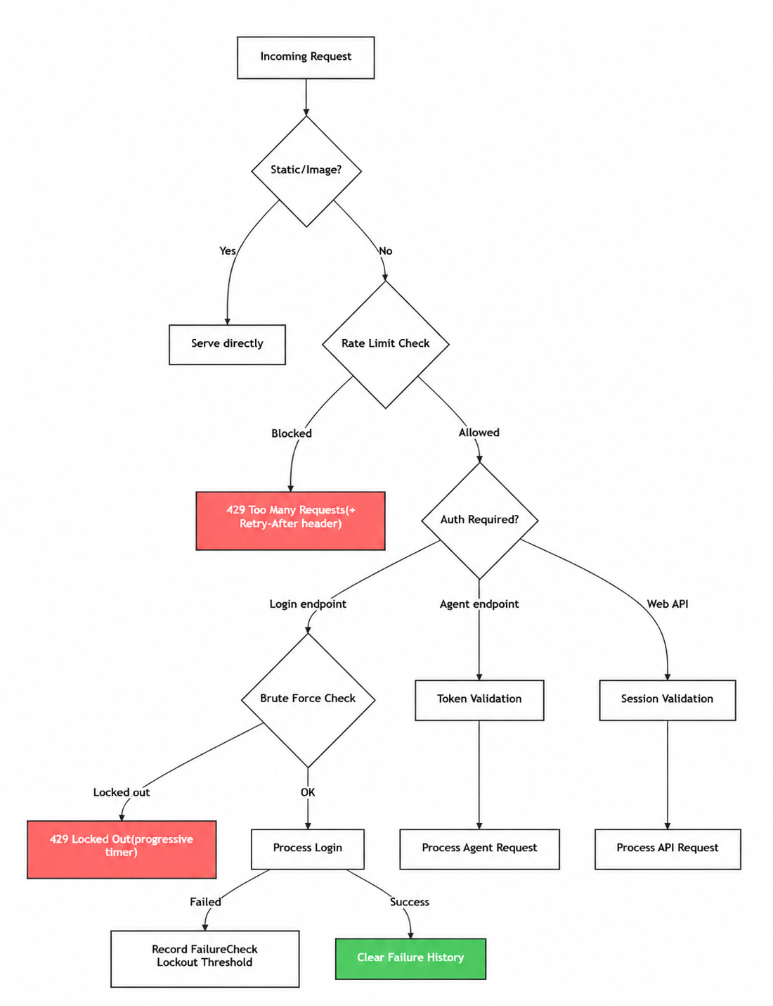

21. Technical Architecture & Execution Lifecycle
BatchHost-Pro Execution Tracking Architecture
BatchHost-Pro uses an event-driven execution lifecycle instead of deriving script state from heartbeat disappearance.

Modules
- Agent Runtime: `agents/agent_runtime.py` registers the device, starts scripts, tracks PIDs, persists local executions, sends lifecycle events, sends heartbeat telemetry, and reconnects automatically.

- Process Tracker: the agent owns PID observation and emits `SCRIPT_TERMINATED` when a tracked PID disappears unexpectedly.

- Execution Manager: `backend/tracking.py` owns execution sessions, state transitions, event sequencing, and read-model synchronization.

- Event Queue: current deployment stores accepted/rejected events in `data/execution_events.json`; production deployments should replace this with Redis Streams or Kafka.

- WebSocket Broadcaster: `server.py` emits `execution_update` for every accepted execution mutation and keeps legacy `script_status` broadcasts for older pages.

- State Machine Validator: `backend/tracking.py` rejects invalid transitions and terminal-state rewrites.

- Dashboard Sync Engine: `/api/dashboard/stats`, `/api/executions`, and Socket.IO `execution_update` deliver active and historical execution sessions.

- Persistence Layer: current JSON files are preserved for compatibility; `db/script.sql` contains the SQL schema for MySQL-compatible deployments.

- Recovery/Reconnection Engine: the agent persists local executions and retries registration/events. Server timeout handling moves stale active executions to `TIMEOUT` or `UNKNOWN`, never `FAILED`.

Critical Rule
Heartbeat is presence and telemetry only. It may update `last_seen`, `cpu`, `memory`, and `runtime` through explicit `SCRIPT_HEARTBEAT` events. It must never mark a script `FAILED`, `COMPLETED`, or `TERMINATED` because a path disappeared.

Runtime Defaults
- Heartbeat interval: 5 seconds.
- Timeout threshold: 30 seconds.
- Active states: `PENDING`, `STARTING`, `RUNNING`.
- Terminal states: `COMPLETED`, `FAILED`, `TERMINATED`, `TIMEOUT`, `UNKNOWN`.

