Empathy Map Canvas – Online Payments Fraud Detection System
Date | 21 April 2026
Project Name | Project - Online Payments Fraud Detection using ML
Project Owner | Wahid R. Jamadar
Maximum Marks | 4 Marks

Problem Statement (5W’s)
- Who: David (E-commerce business owner), fraud analysts, customers
- What: Increasing online payment fraud causing financial loss and trust issues
- Where: E-commerce platform during online transactions
- When: During real-time payment processing
- Why: Due to weak security, stolen cards, fake accounts, and cyber attacks

Empathy Map
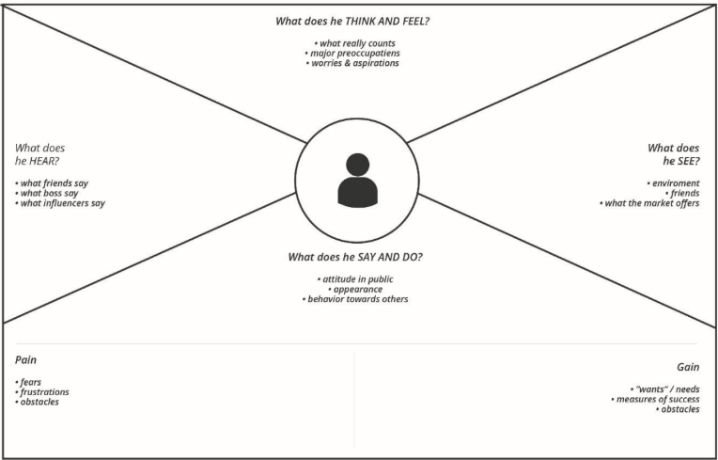
Gain
• Reduced fraud
• Customer trust
• Automation
• Business growth
Say & Do
• Invests in ML systems
• Hires experts
• Monitors transactions
• Implements security upgrades
Hear
• Customers demand security
• Team discussions on fraud
• Industry warnings
• Analyst feedback
Think & Feel
• Worried about fraud losses
• Wants secure system
• Concerned about reputation
• Needs accurate detection
See
• Increasing fraud cases
• Customer complaints
• Chargeback reports
• Competitors improving security
Pain
• Financial losses
• Loss of trust
• Manual workload
• False positives

