PROJECT PROPOSAL: Design of Campus Network with DHCP and DNS Services

Table of Contents
Abstract
1. Introduction
2. Objectives
3. Scope of the Project
4. Literature Review
5. System Architecture
6. Network Design
7. IP Addressing Scheme
8. Hardware and Software Requirements
9. Methodology
10. Implementation Plan
11. Expected Outcomes
11.1 Screenshots of the Implementation
11.2 Testing (Screenshots)
12. Conclusion
13. References

Abstract
This project presents the design and implementation of a small-scale network system using Cisco Packet Tracer to simulate real-world networking concepts. The network consists of multiple departments connected through switches and a router, enabling communication between different subnets. Dynamic Host Configuration Protocol (DHCP) is implemented to automatically assign IP addresses to client devices, reducing manual configuration and improving efficiency.
Additionally, a centralized server is configured to provide essential services such as Domain Name System (DNS) and Hypertext Transfer Protocol (HTTP). The DNS service resolves domain names into IP addresses, allowing users to access network resources using user-friendly URLs instead of numerical addresses. The HTTP service hosts a web page that can be accessed by all connected clients, demonstrating successful end-to-end communication across the network.
The project also highlights key networking concepts including IP addressing, subnetting, routing between networks, and service configuration. Through testing and verification, it ensures that all devices can dynamically obtain IP addresses, resolve domain names, and access the hosted website. This implementation provides a practical understanding of how modern enterprise networks operate and how multiple services integrate to deliver seamless connectivity.
Overall, the project demonstrates the effective integration of DHCP, DNS, and web services within a structured network, making it a valuable learning model for network design and management.
- Introduction
In modern educational institutions, efficient and reliable network communication is essential for academic and administrative operations. A campus network connects multiple departments and buildings, enabling data sharing, internet access, and centralized services.
This project focuses on designing a campuses using Cisco Packet Tracer. The network integrates DHCP (Dynamic Host Configuration Protocol) for automatic IP address assignment and DNS (Domain Name System) for resolving domain names into IP addresses. This design ensures scalability, efficiency, and ease of management.

2. Objectives
The main objectives of this project are:
- To design a network connecting four campuses
- To implement DHCP for automatic IP configuration
- To assign static IP addresses to router.
- To implement DNS for domain name resolution
- To ensure communication between all campuses
- To simulate the network using Cisco Packet Tracer
- Scope of the Project
This project covers:
- Designing a logical network for four campuses
- Configuring routers, switches, and end devices
- Implementing DHCP and DNS services
- Testing connectivity between all devices
Limitations:
- The network is simulated (not physically implemented)
- Security features (like firewalls) are not deeply covered

4. Literature Review
A campus network is a type of LAN (Local Area Network) that connects multiple buildings within a limited geographical area. Modern campus networks rely on automated services such as DHCP and DNS.
- DHCP (Dynamic Host Configuration Protocol) automatically assigns IP addresses to devices, reducing manual configuration errors.
- DNS (Domain Name System) translates human-readable domain names into IP addresses, making network communication user-friendly.
These technologies are widely used in universities, companies, and organizations to simplify network management.

5. System Architecture
The proposed system consists of:
- Three Departments (Department A, B and C)
- Each campus contains:
  - One switch.
  - Multiple PCs or Servers.
  - A router.
- A centralized server system providing:
  - DHCP services
  - DNS services
- Overall five Networks A B and C and a connection between A and C and a coonection between A and B so on.
All campuses are interconnected through routers forming a Wide Area Network (LAN).

6. Network Design
The network is designed using a hierarchical approach:
- Access Layer: PCs connected to switches
- Distribution Layer: Switches connected to routers
- Core Layer: Routers interconnected for campus communication
Each campus operates in its own subnet, ensuring organized traffic flow and easy troubleshooting.
- IP Addressing Scheme

Network 1 (Left LAN)
Device | IP Address | Subnet Mask | Default Gateway
PC0 | 10.10.10.2 | 255.0.0.0 | 10.10.10.1
PC1 | 10.10.10.3 | 255.0.0.0 | 10.10.10.1
Router0 (g0/0) | 10.10.10.1 | 255.0.0.0 | —

Network 1 (Left LAN)
Device | IP Address | Subnet Mask | Default Gateway
PC0 | 10.10.10.2 | 255.0.0.0 | 10.10.10.1
PC1 | 10.10.10.3 | 255.0.0.0 | 10.10.10.1
Router0 (g0/0) | 10.10.10.1 | 255.0.0.0 | —

Network 3 (Middle LAN)
Device | IP Address | Subnet Mask | Default Gateway
PC2 | 30.30.30.2 | 255.0.0.0 | 30.30.30.1
PC3 | 30.30.30.3 | 255.0.0.0 | 30.30.30.1
Router1 (g0/1) | 30.30.30.1 | 255.0.0.0 | —

Network 4 (R1 ↔ R2)
Device | IP Address | Subnet Mask
Router1 (g0/2) | 40.40.40.1 | 255.0.0.0
Router2 (g0/0) | 40.40.40.2 | 255.0.0.0

Network 5 (Right LAN)
Device | IP Address | Subnet Mask | Default Gateway
PC4 | 50.50.50.2 | 255.0.0.0 | 50.50.50.1
PC5 | 50.50.50.3 | 255.0.0.0 | 50.50.50.1
Router2 (g0/1) | 50.50.50.1 | 255.0.0.0 | —

Hardware and Software Requirements

Hardware Requirements
- Computers (PCs)
- Switches
- Routers
- Servers
- Cables

Software Requirements
- Cisco Packet Tracer
- Operating System (Windows)

9. Methodology
The project is implemented in the following steps:
- Design network topology in Cisco Packet Tracer
- Add routers, switches, and PCs
- Configure IP addresses on routers
- Implement DHCP server for automatic IP assignment
- Configure DNS server for domain name resolution
- Connect all campuses using routing
- Test connectivity using ping and web access

Implementation Plan

Phase | Description
Phase 1 | Network design and planning
Phase 2 | Device placement in Packet Tracer
Phase 3 | Configuration of router and switches
Phase 4 | Setup of DHCP and DNS servers
Phase 5 | Testing and troubleshooting

Expected Outcomes

  - Screenshots of the Implementation

Step 1:
Select:
- 3 routers
- 3 Switces
- 3 PCs
- 3 servers
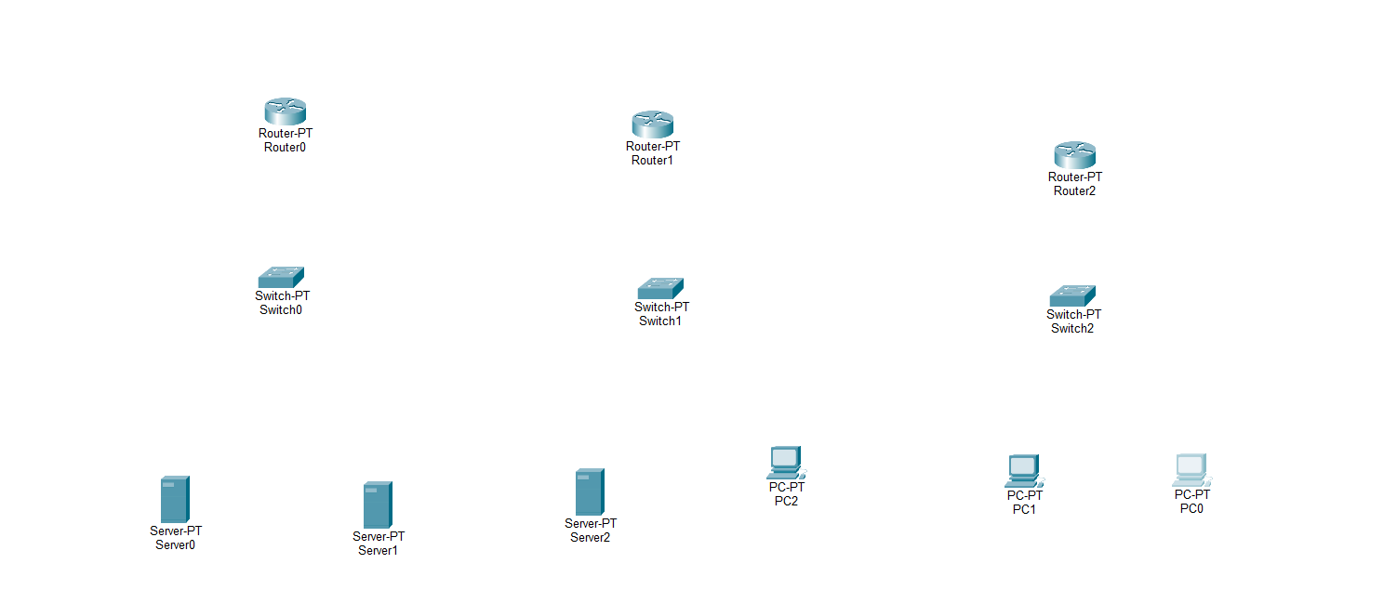
Step 2: Complete Topology

- Connect all devices.
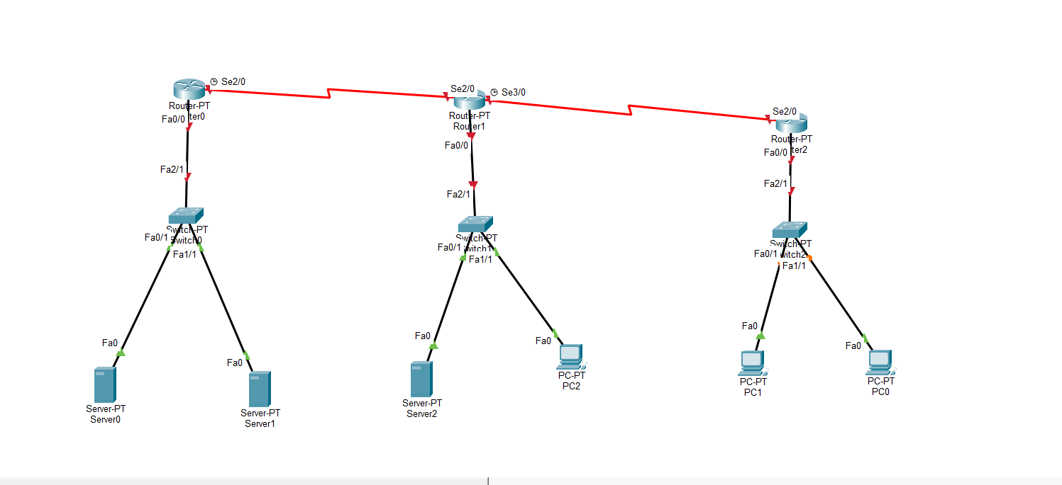

Step 3: Giving names to servers

Renamed the:
- Server0 as Web server
- Server1 as DNS server
- Server2 as DHCP server
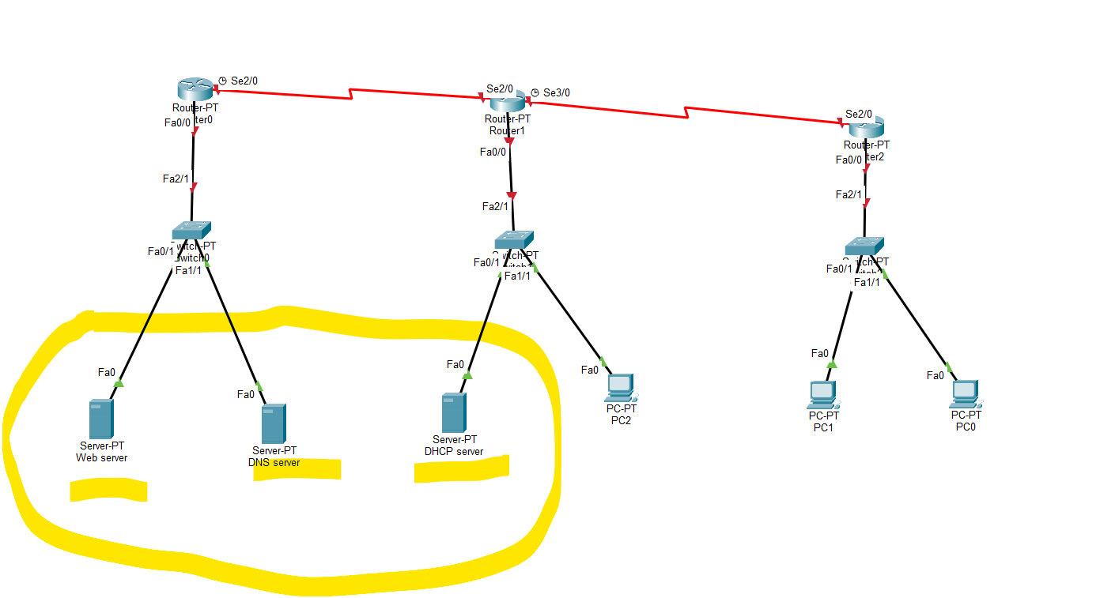

Step 4: Configuration of Web Server

- I am going to configure the Web server:
- Open web server
- Go to desktop
- IP configuration
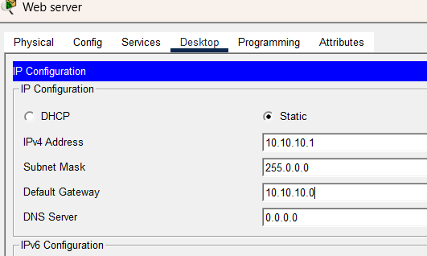

Step 5:

- Go to service tab
- Go to http
- Turn on both HTTP and HTTPS services
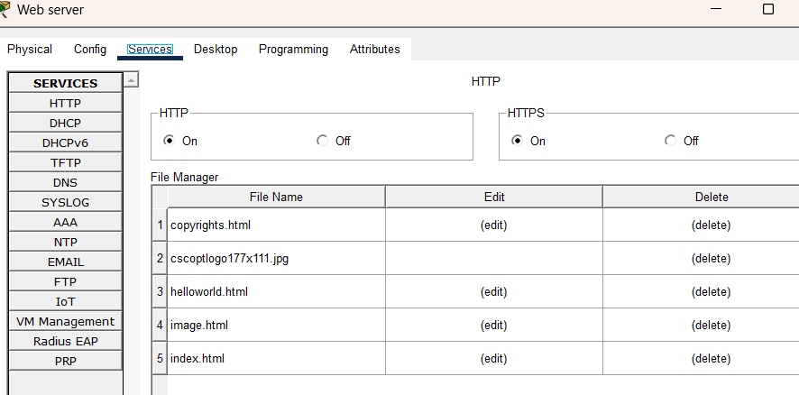

Step 6:

- Edit this index.html
- Change the name as Youtube
- Click on the save.
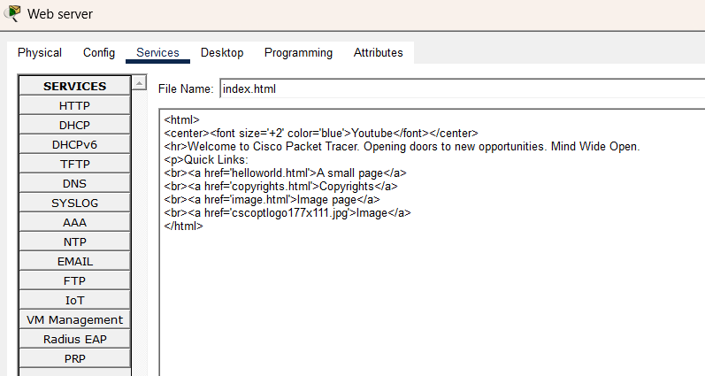
STEP 7 : Configuration of DNS Server
- Open the DNS server
- Click on the desktop
- Ip configuration
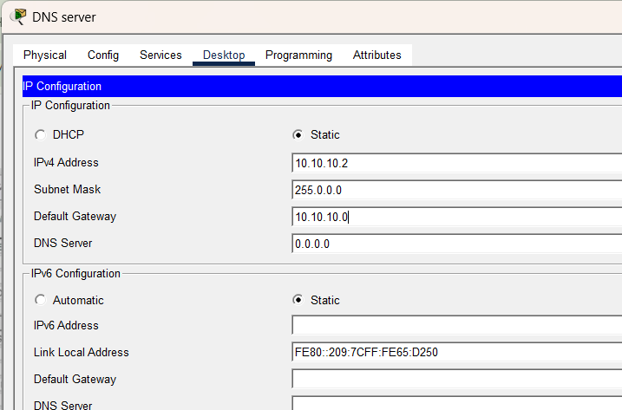

STEP 8:
GO to service tab
- Go to DNS
- Turn on DNS services
- Give the name as www.youtube.com
- Give the address of the web server
- Click on add.
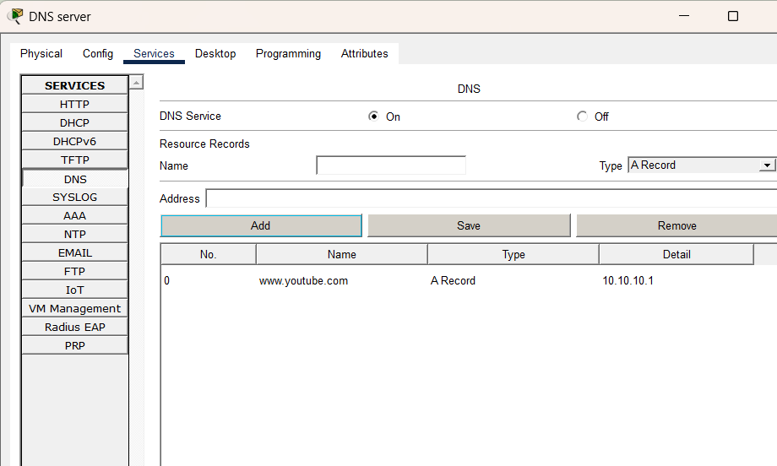
STEP 9: Configuration of DHCP Server
- Open the DHCP server
- Desktop
- Ip configuration
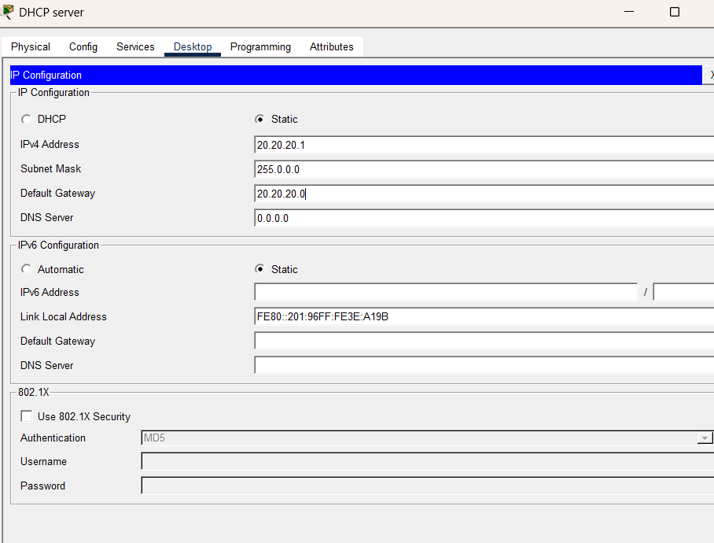
STEP 10:
- Go to service tab
- Go to DHCP
- Turn on the services
- Click on Save
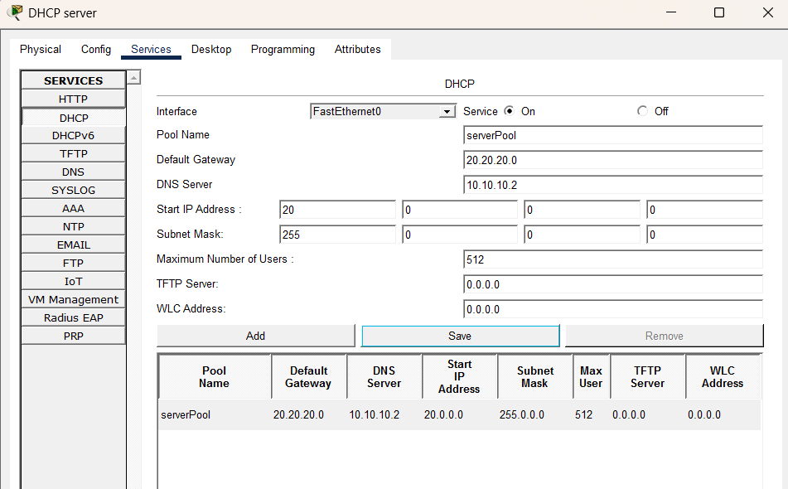
STEP 11: Verification of DHCP-Server on all PCs
Now we are going to verify the dhcp server which is working or not?
PC0:
- Open the PC 0
- Dektop
- Ip configuration
- It’s static
- Now turn on dhcp
- Successful
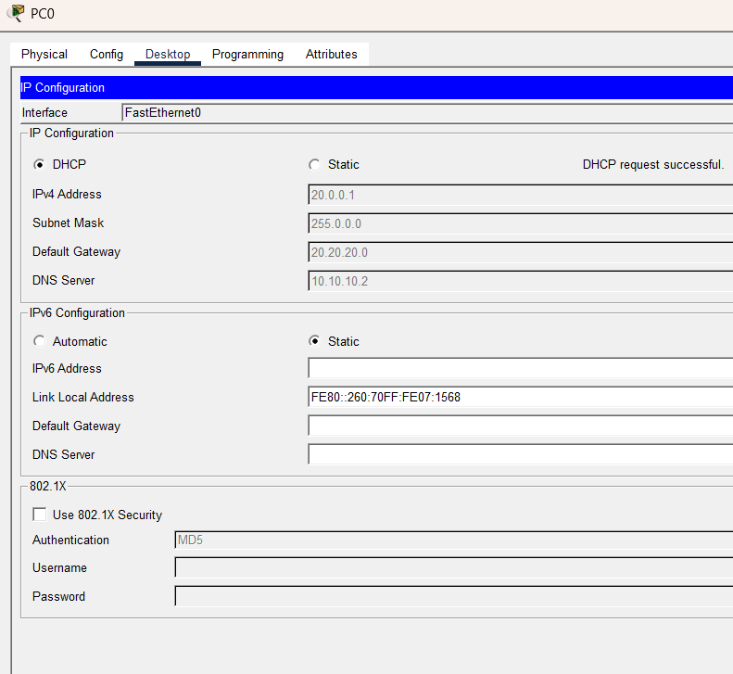
STEP 12: Connecting lane2 DHCP-server to lane 3 PCs by configuration of routers
Now are going to DHCP for third lane which is in different network
- So we need to work on router
- Open the router 2
- Go to config tab
- Turn on the port
- Give default ip address
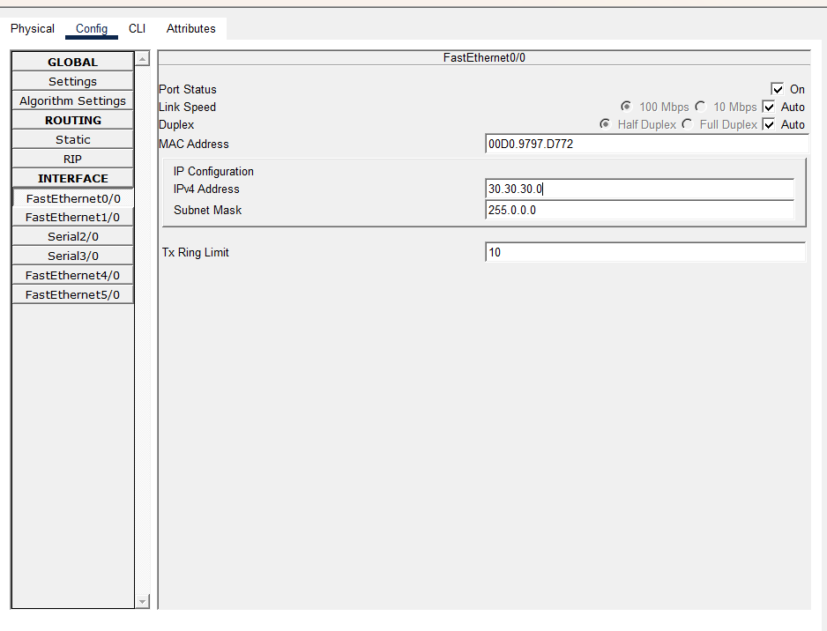

Sir I did this task there and the CLI code automatically generate as you told us. This is the smart method I use in my project:
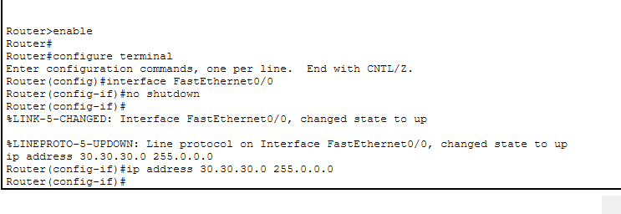
So we need to configure the DHCP for this router where it will assign the ip address to the PCs
- Go to CLI
- We need to give the commands
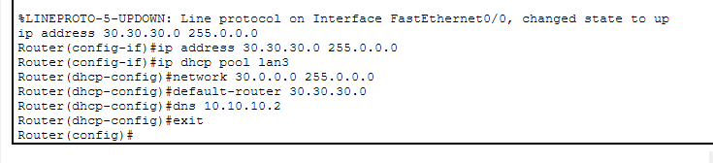
STEP 13: Verification at PC1 (which is in lane 3)
- Now we going to verify the DHCP
- Open the PC 1
- Desktop
- Ip configuration
- It’s in the static
- Turn on DHCP
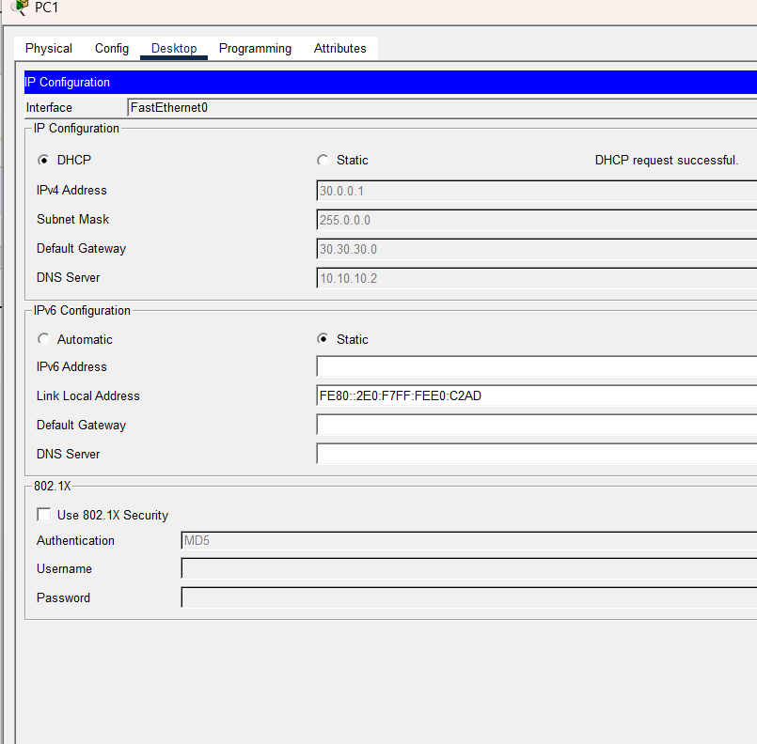
STEP 14: Verification of PC2 (which is in lane 3)
- Open the PC2
- Desktop
- Ip configuration
- It’s static
- Turn on DHCP
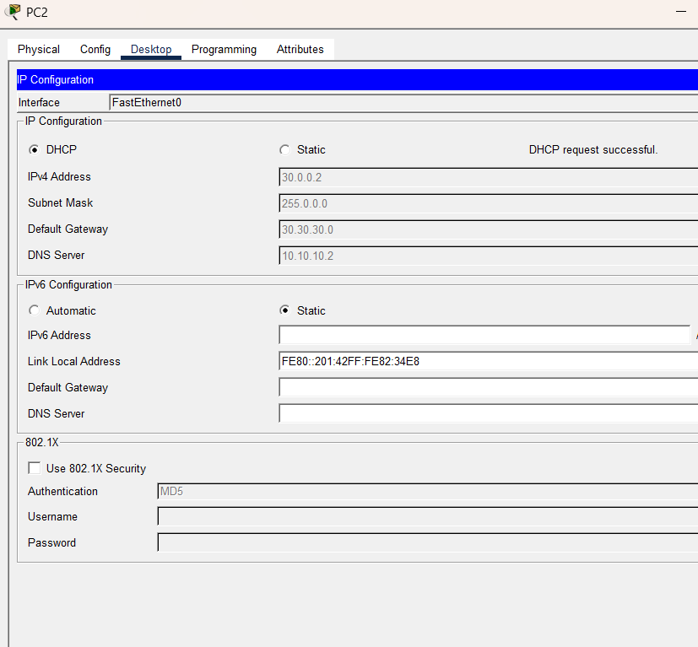
STEP 15: (Configuration of router to connect all networks and making Network 4 and 5) to established connections
Consider that connection between L2 and L3 already established means (Router 1 and Router 2 )
We configure all the dhcp now only thing left are the routers
- Open the router0
- Config tab
- F0/0
- Turn on the port
- Give default address
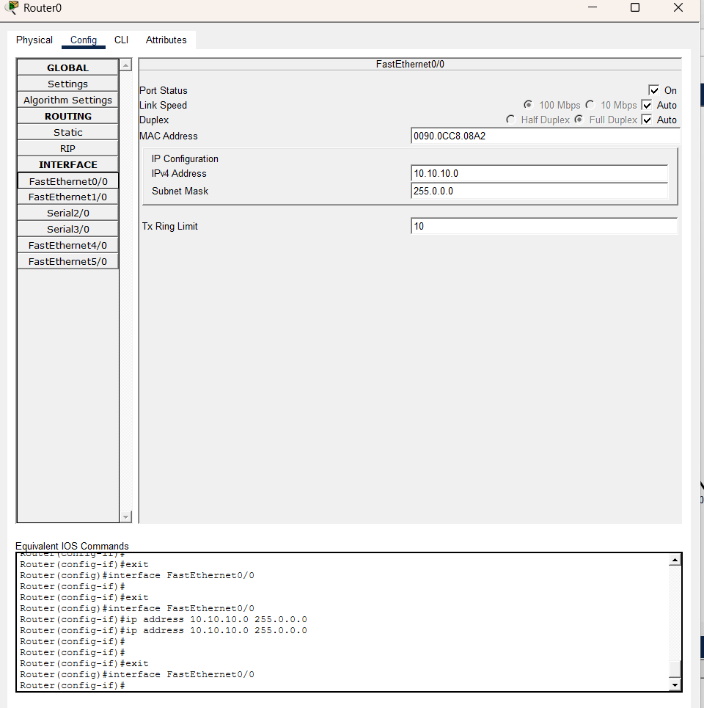
STEP 16: Connecting Router0 and Router1
Now the router 0 is connect to router 1 through serial 2/0
- Click on serial 2/0
- On the port
- Give Ip address
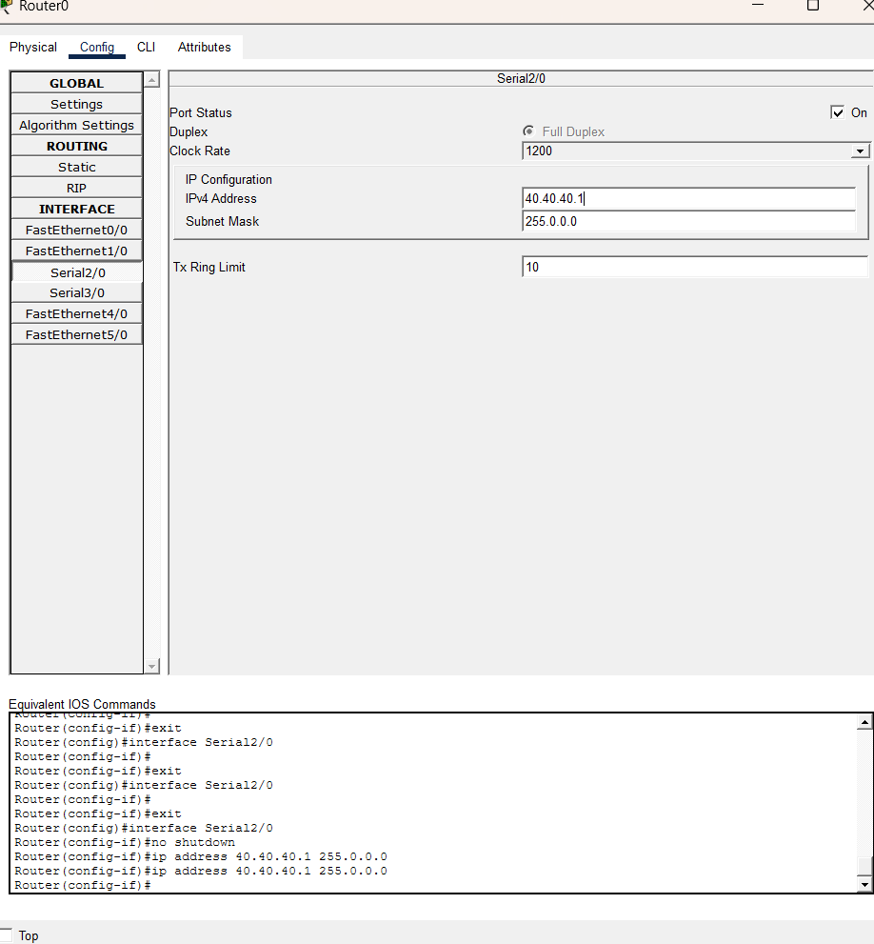
STEP 17:
Router 1
- Open the router 1.
- Go to config tab
- Go to f0/0
- Turn porn on
- Give default ip address
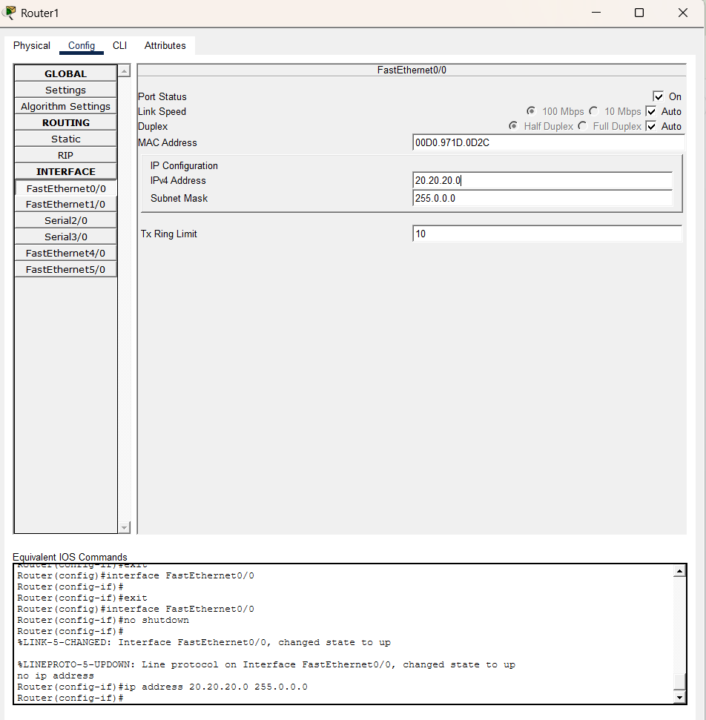
STEP 18:
Now we need to configure serial 2/0
- Click on serial 2/0
- On the port
- Give the address
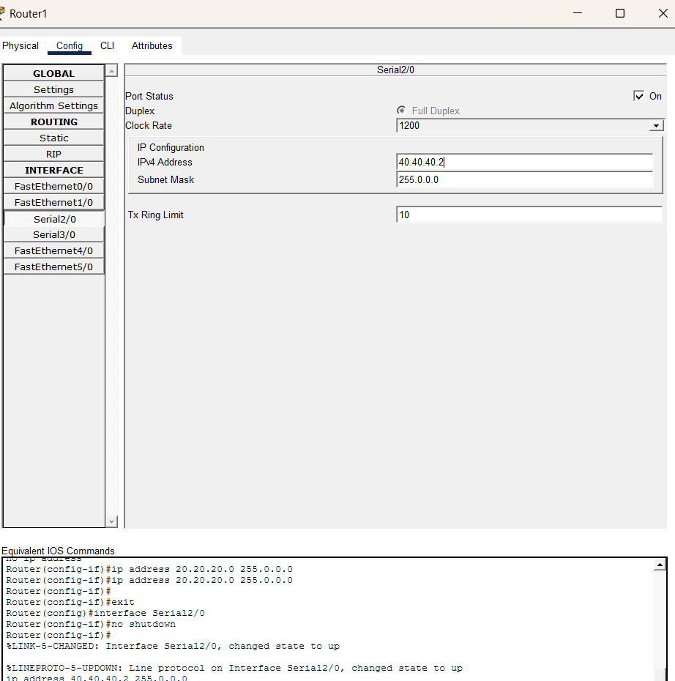
STEP 19:
Also configure serial 3/0
- Turn on the port
- Give the address
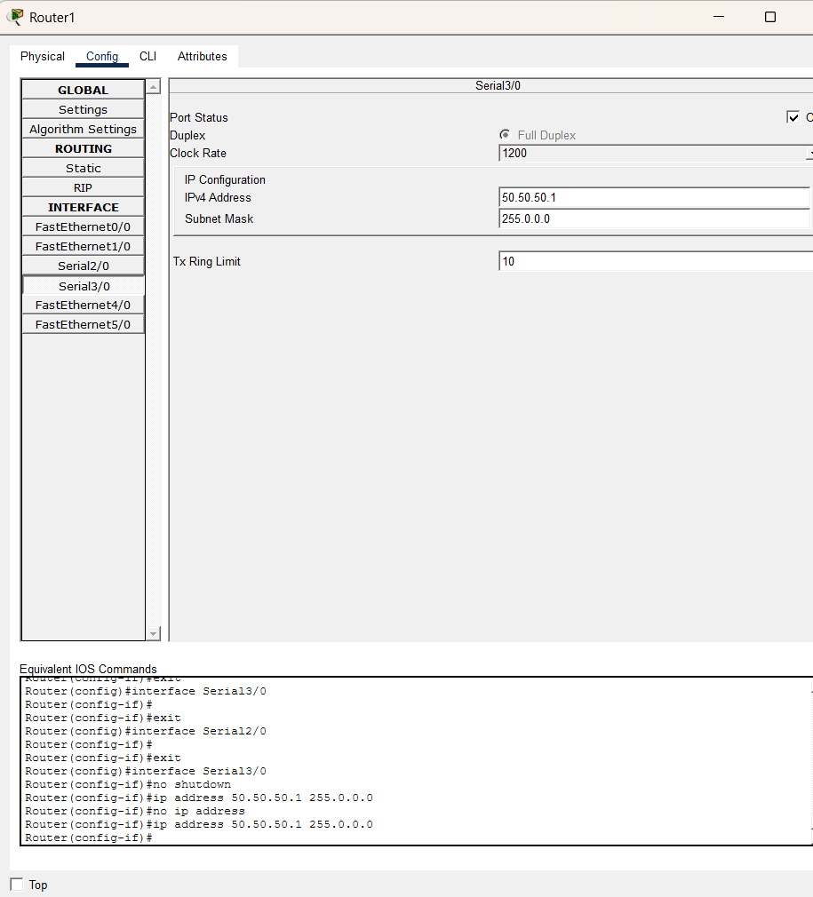
STEP 20:
Router 2
- Open the router 2
- Click on config tab
So we already configure f0/0
STEP 21:
So we need to configure serial 2/0
Click on serial 2/0
- Turn on the port
- Give address
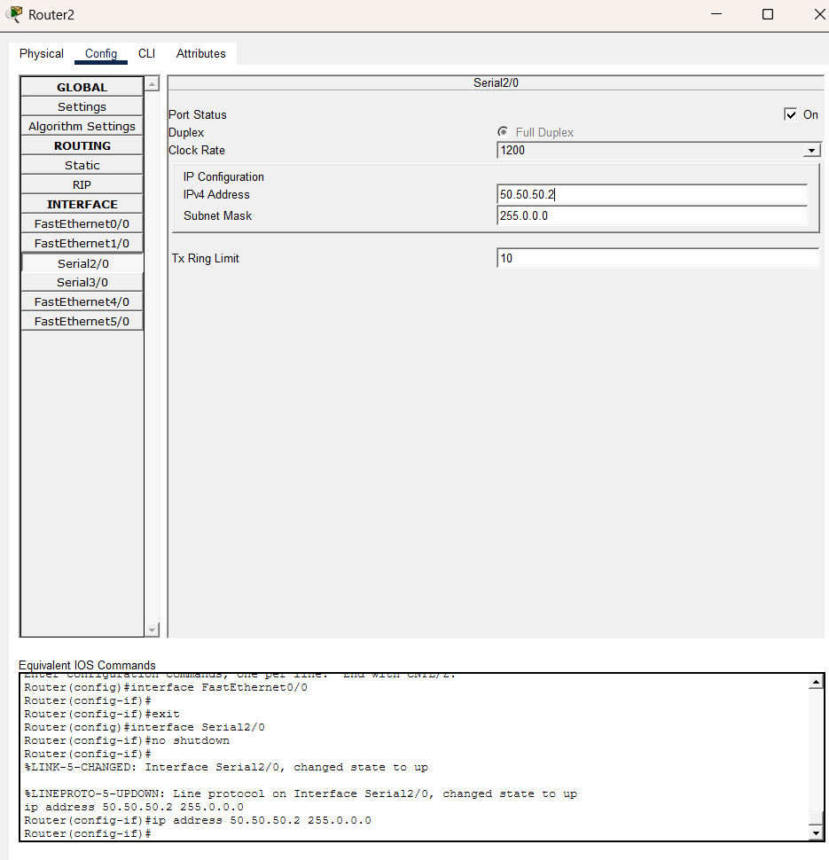
Static Routing:
So we configure the router Pc and the server
The Network 1 can access 2 and 3 after this.
STEP 22: Static Routing for Packet passage
Now static routing for send packets.
- Router 0
The router 1 is 10 series it should access 20 30 series and more
- Open router 0
- Go to static
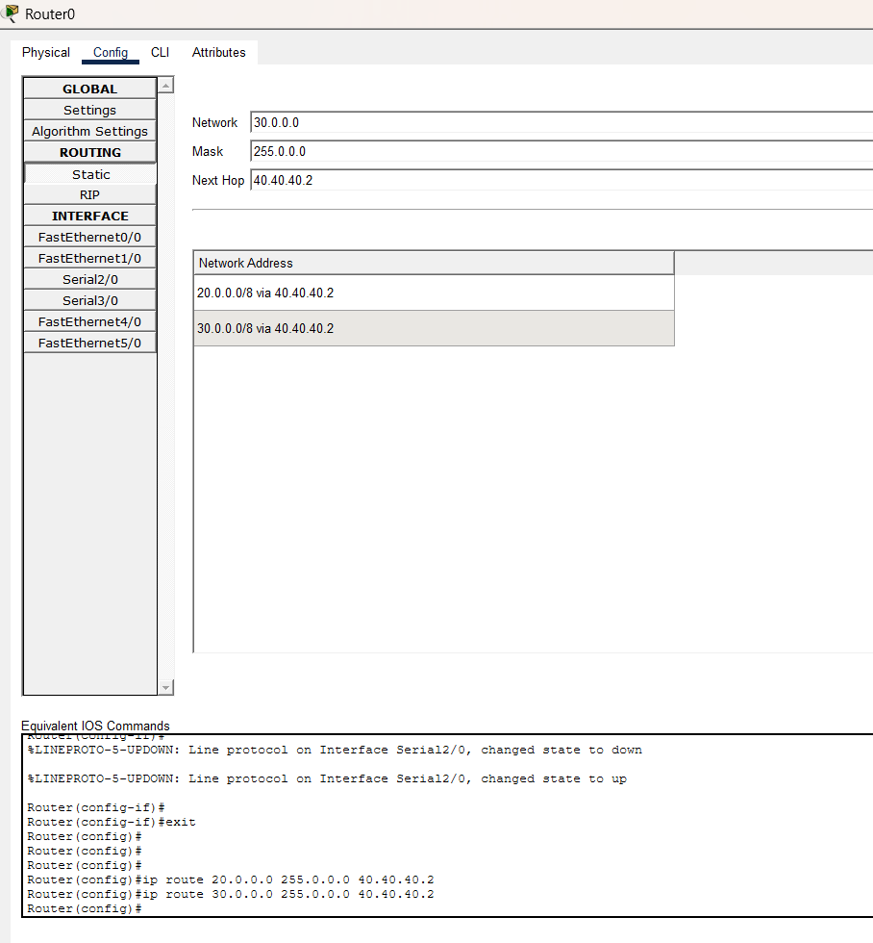
STEP 23:
Router 1
The router 1 can access the 20 series but not access 10 and 30 series
So to access both of them
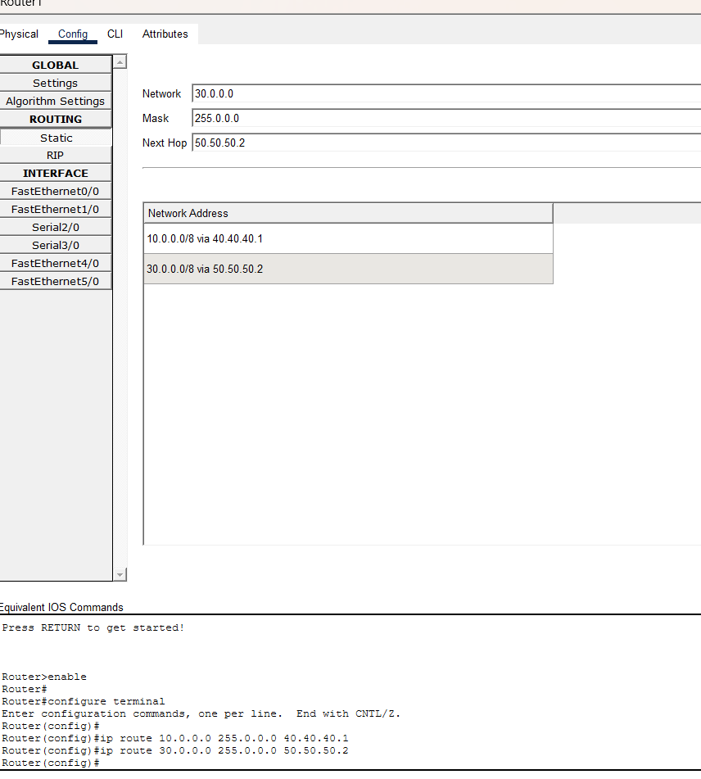
STEP 24:
Router 2: It cannot access the 10 and 20 series
- Go to router 2
- Go to static
- Give address through which can access

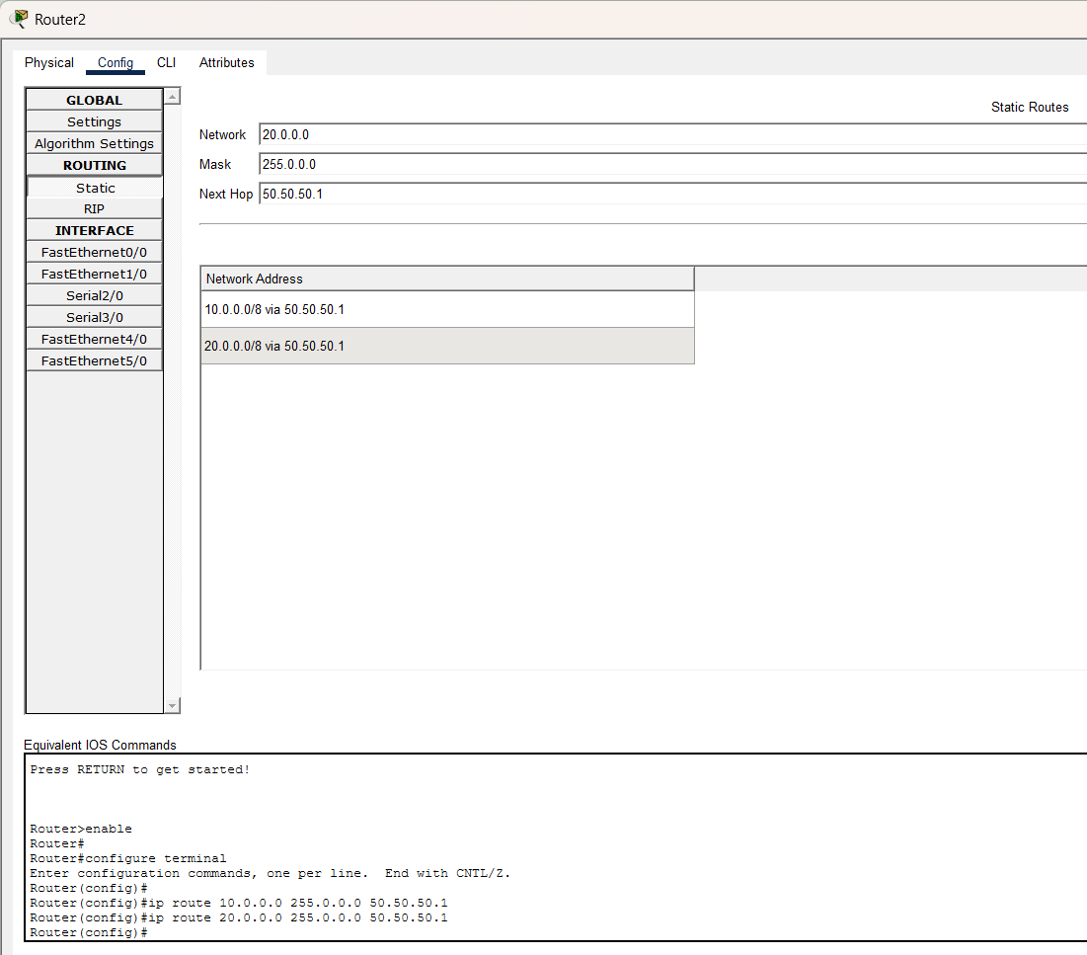

11.2 Testing:
First sending the packets
Same network
Web server to DNS server:
Pass:
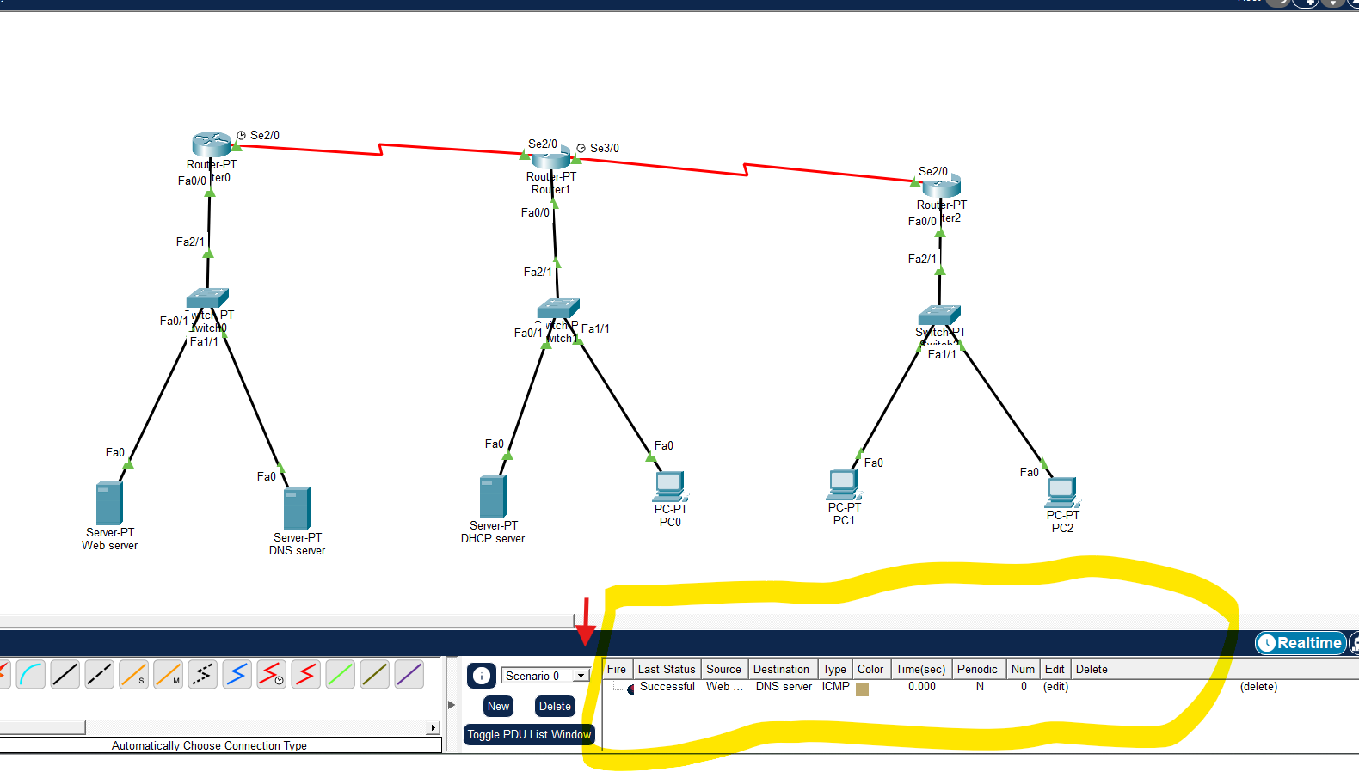
Different Network:
DNS to DHCP:
Pass
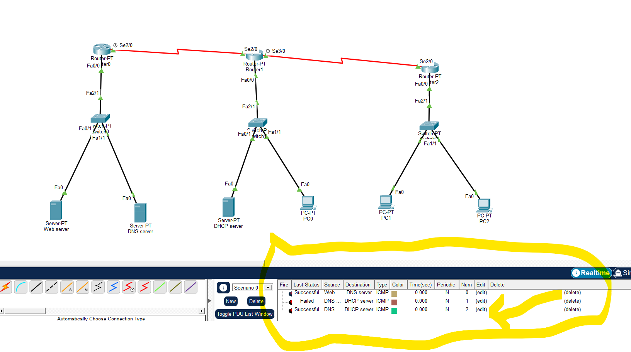
From web server to PC
Pass:
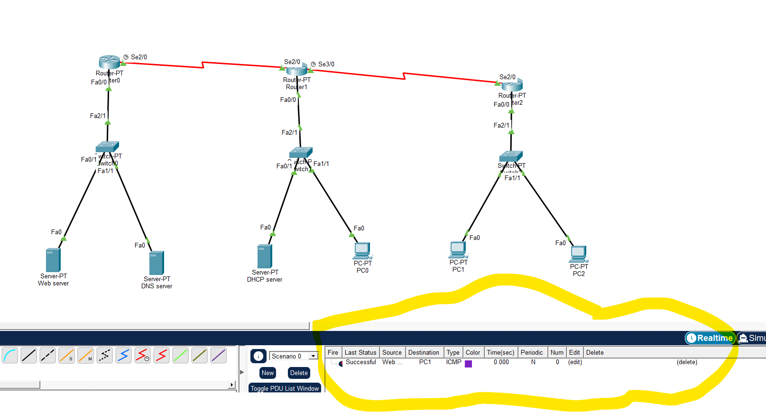
DNS Testing:
- Open up the PC zero
- Click on the web browser
- Give Ip address
Successful:
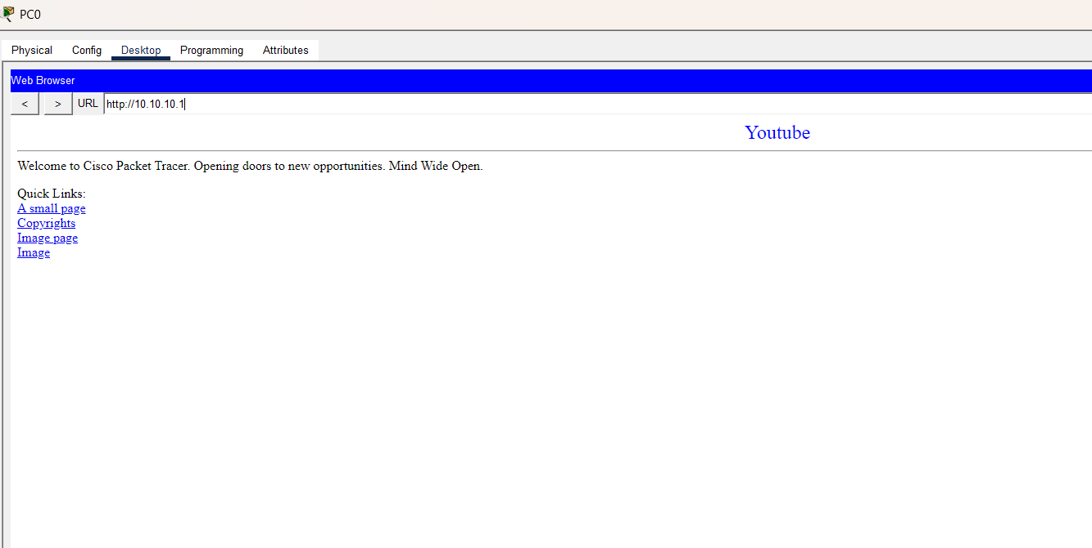
STEP 25:
- Close this
- Open it again
- Access through domain name
Successful:
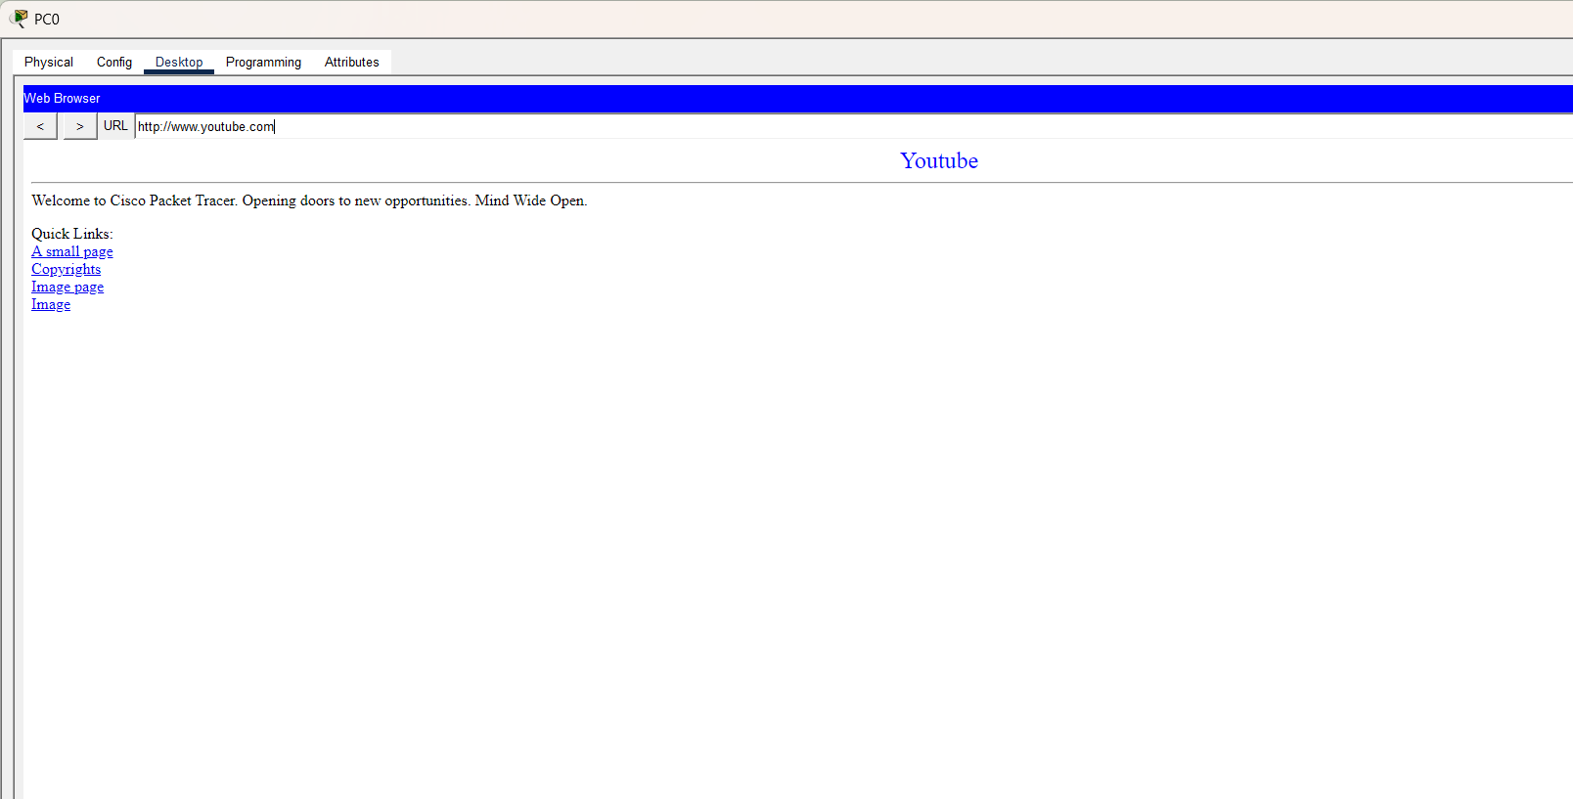

12. Conclusion
This project demonstrates the design and implementation of a campus network using DHCP and DNS services using static routing. The use of automated IP addressing and domain name resolution improves network efficiency and reduces administrative workload. The simulation provides practical knowledge of real-world networking concepts.

References
- Text Book Computer Networking: A Top-Down Approach Featuring the Internet, James F. Kurose and Keith W. Ross , James F. Kurose and Keit, 6th Edition, ,.
- Data and Computer Communications, , William Stallings , 10th Edition, ,.

