Rifah Platform Documentation Screenshots

Rifah Platform Documentation Screenshots - Walkthrough
This document summarizes the screenshots captured for the Rifah User Guide documentation, covering the Tenant Dashboard and Super Admin Panel.

Tenant Dashboard

1. Authentication & Onboarding

**Login Page**
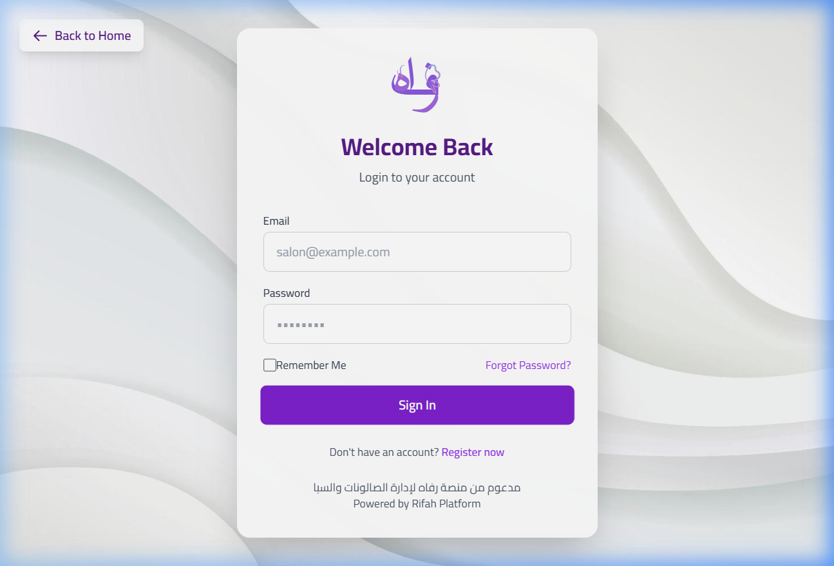

**Main Dashboard (Overview)**
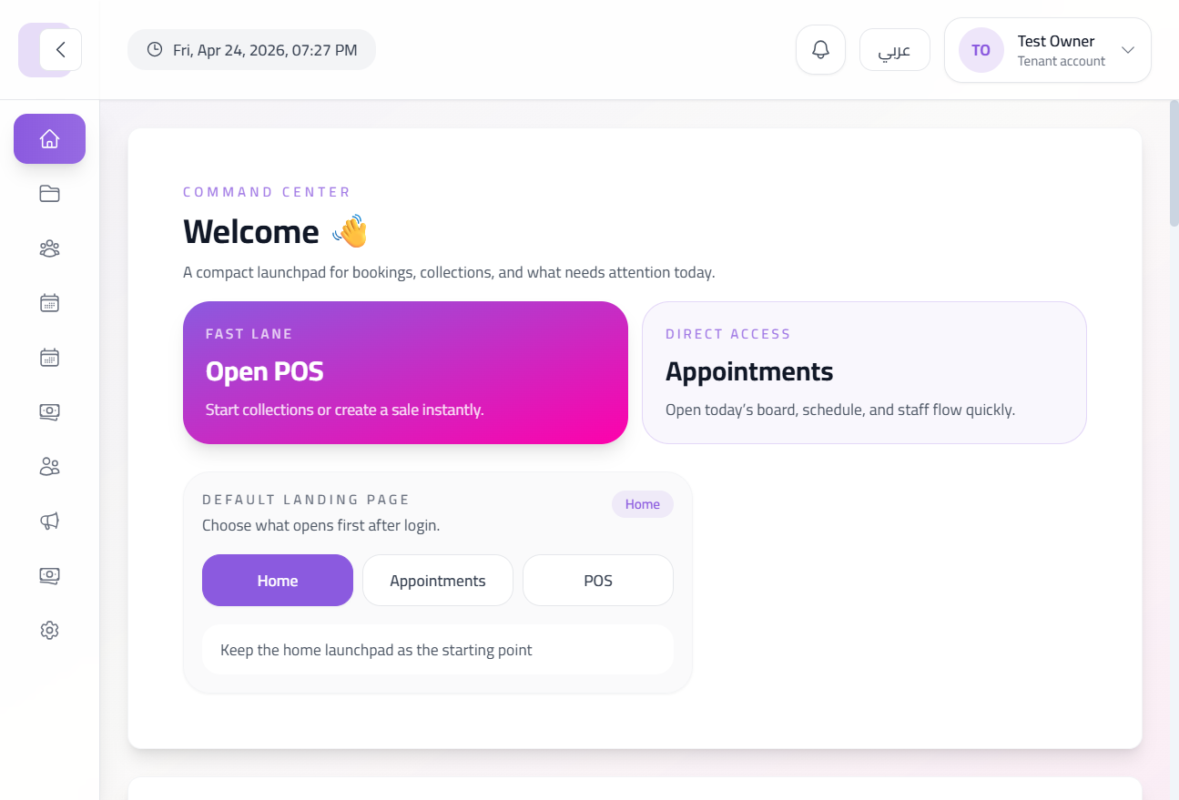

**Navigation Sidebar**
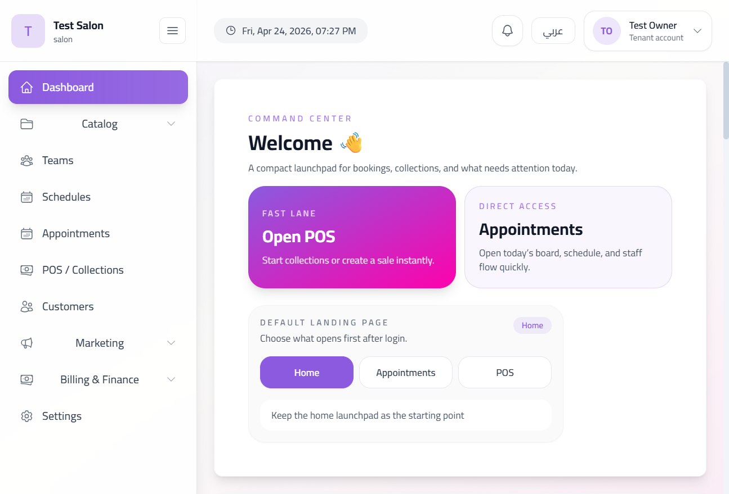

2. Catalog Management

**Services List**
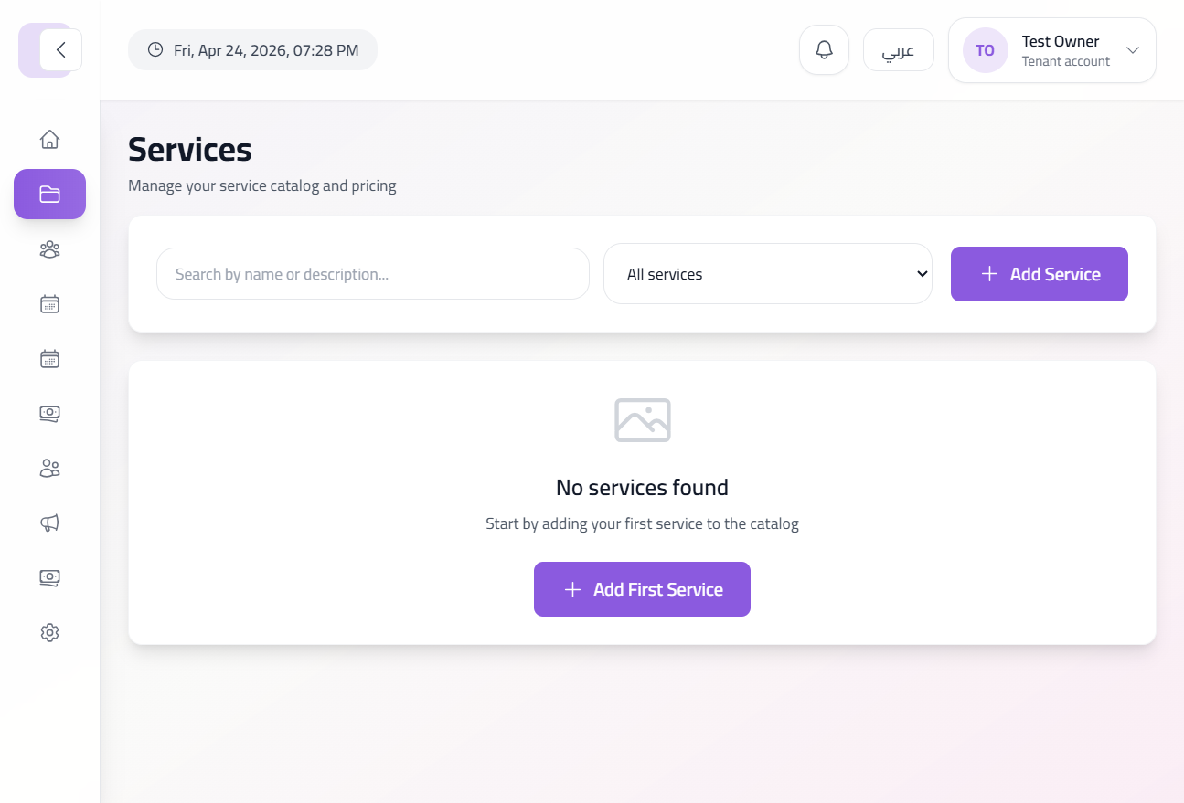

**Add New Service (Upper)**
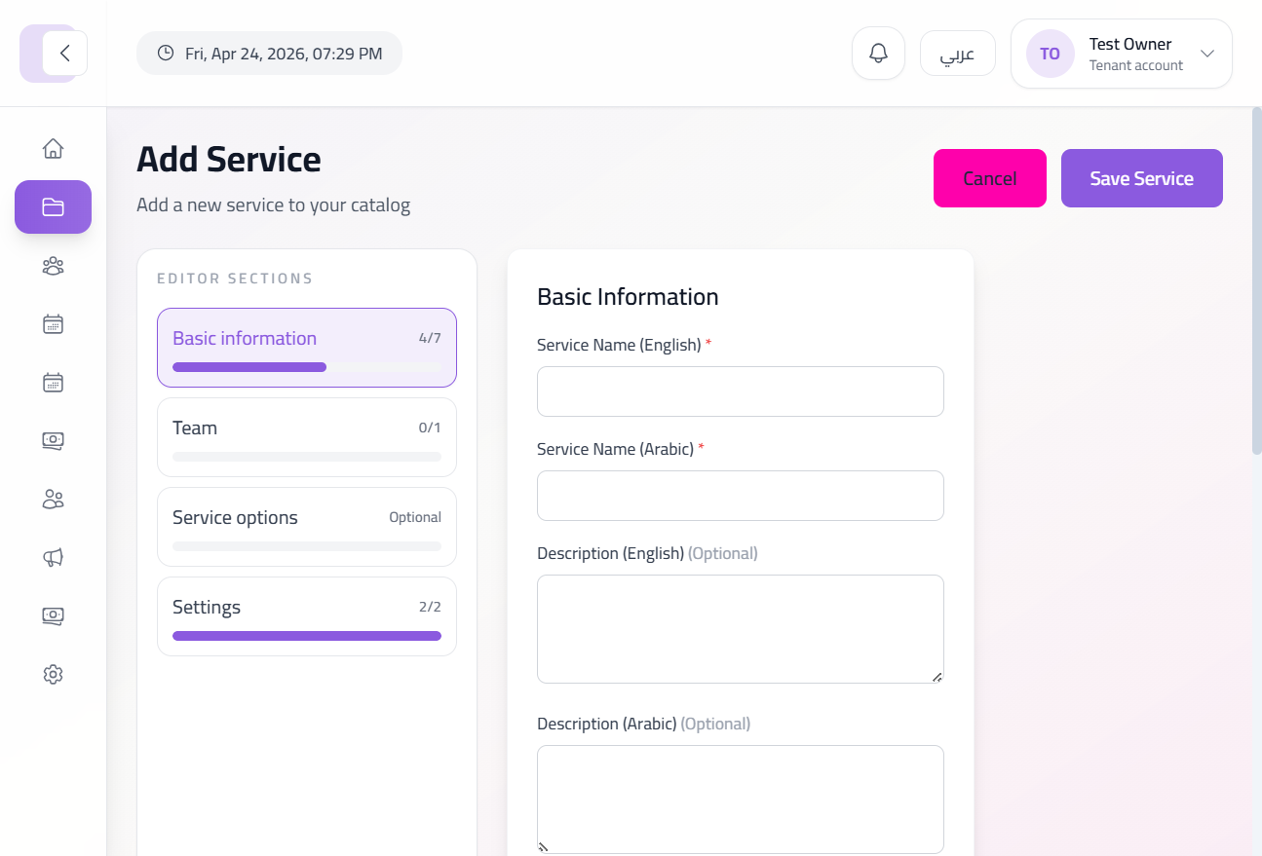

**Add New Service (Lower)**
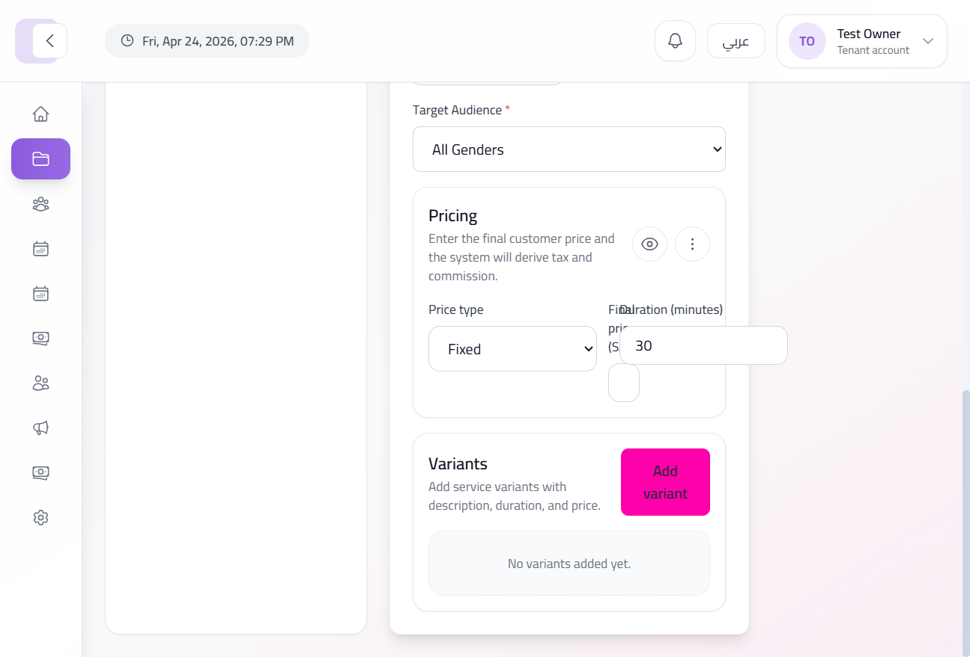

3. Team & Scheduling

**Staff Members List**
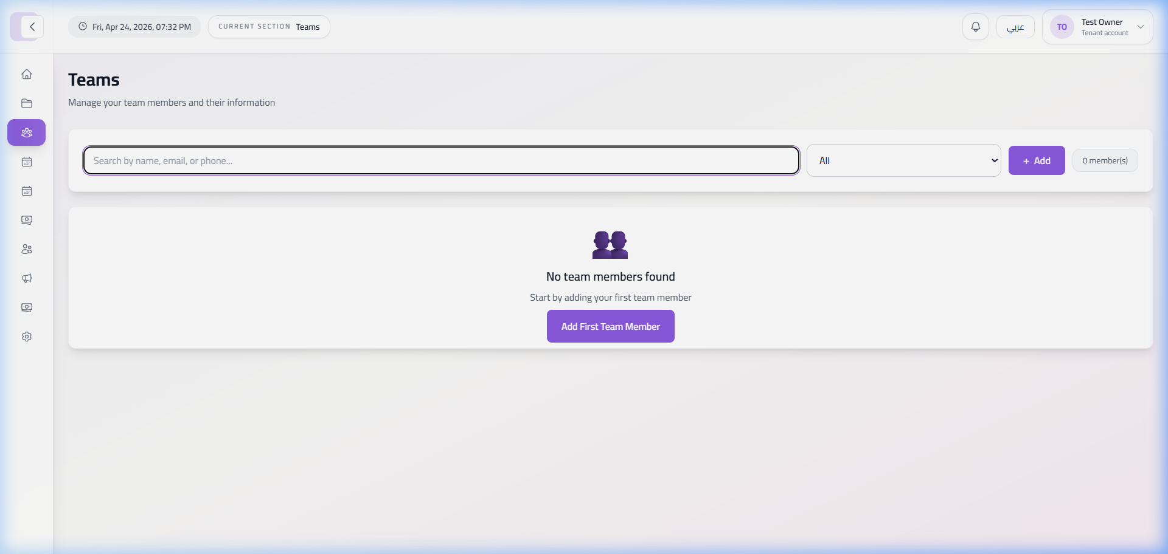

**Add Staff Member Form**
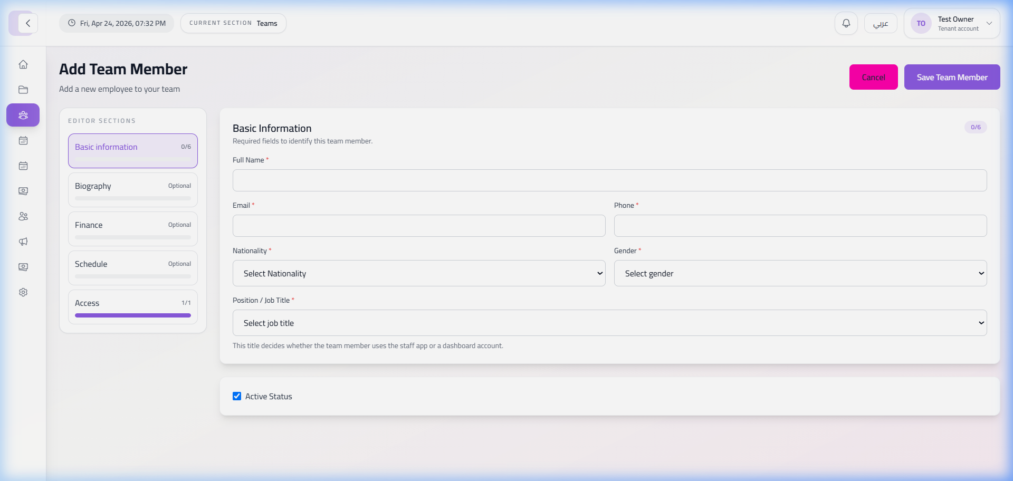

**Staff Schedules (Empty)**
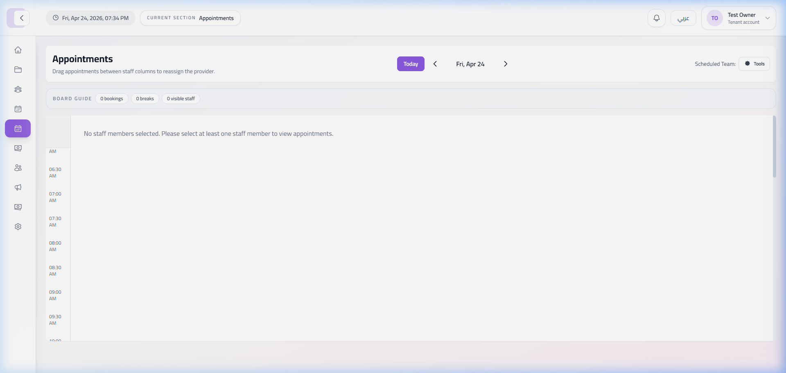

4. Operations & POS

**Appointments Board**
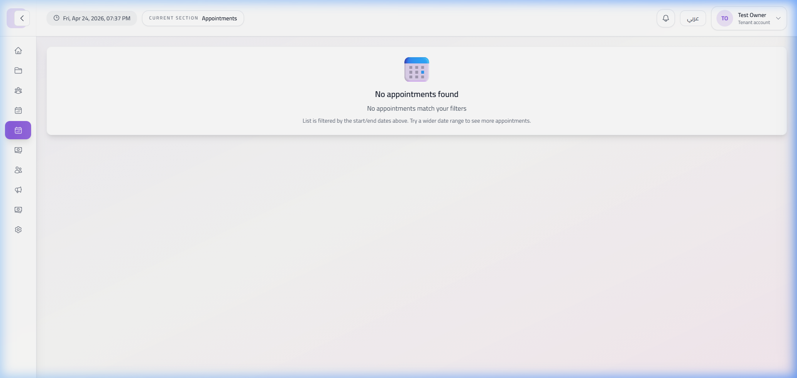

**New Appointment Form**
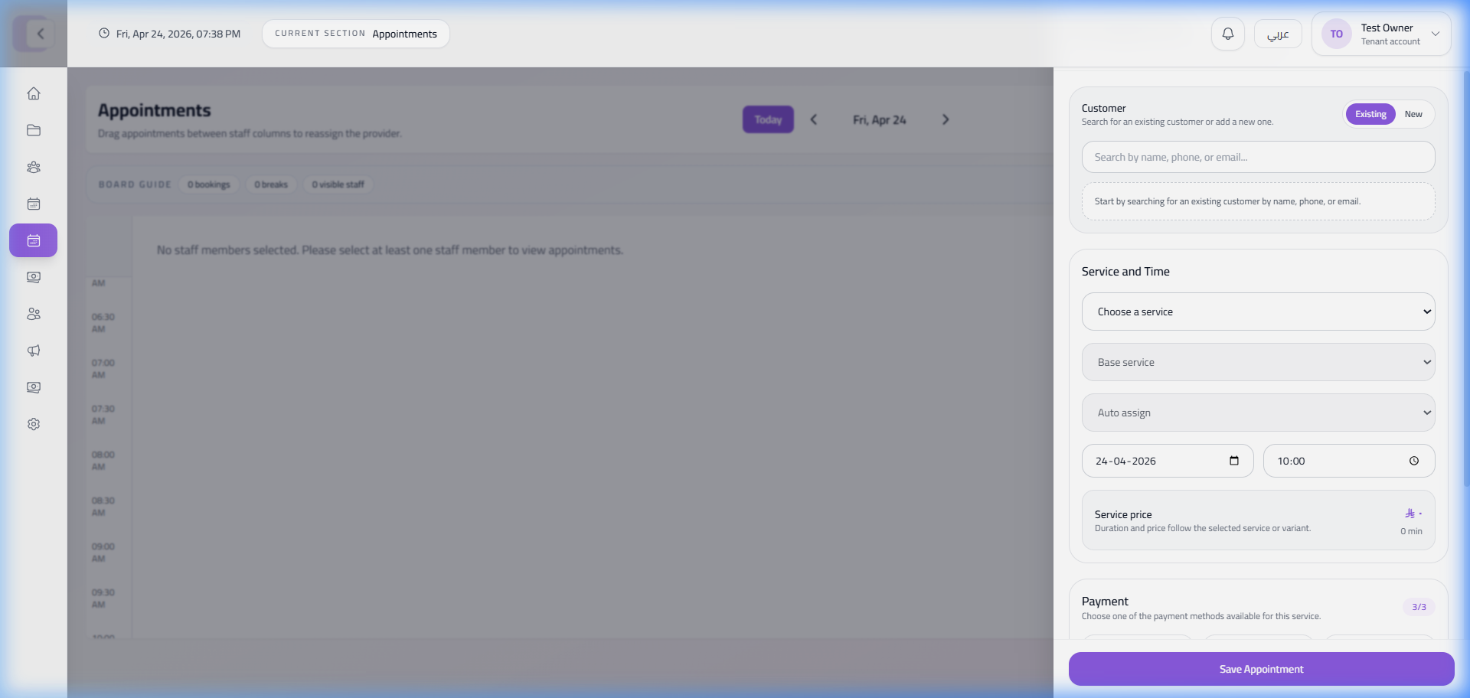

**POS / Collections Interface**
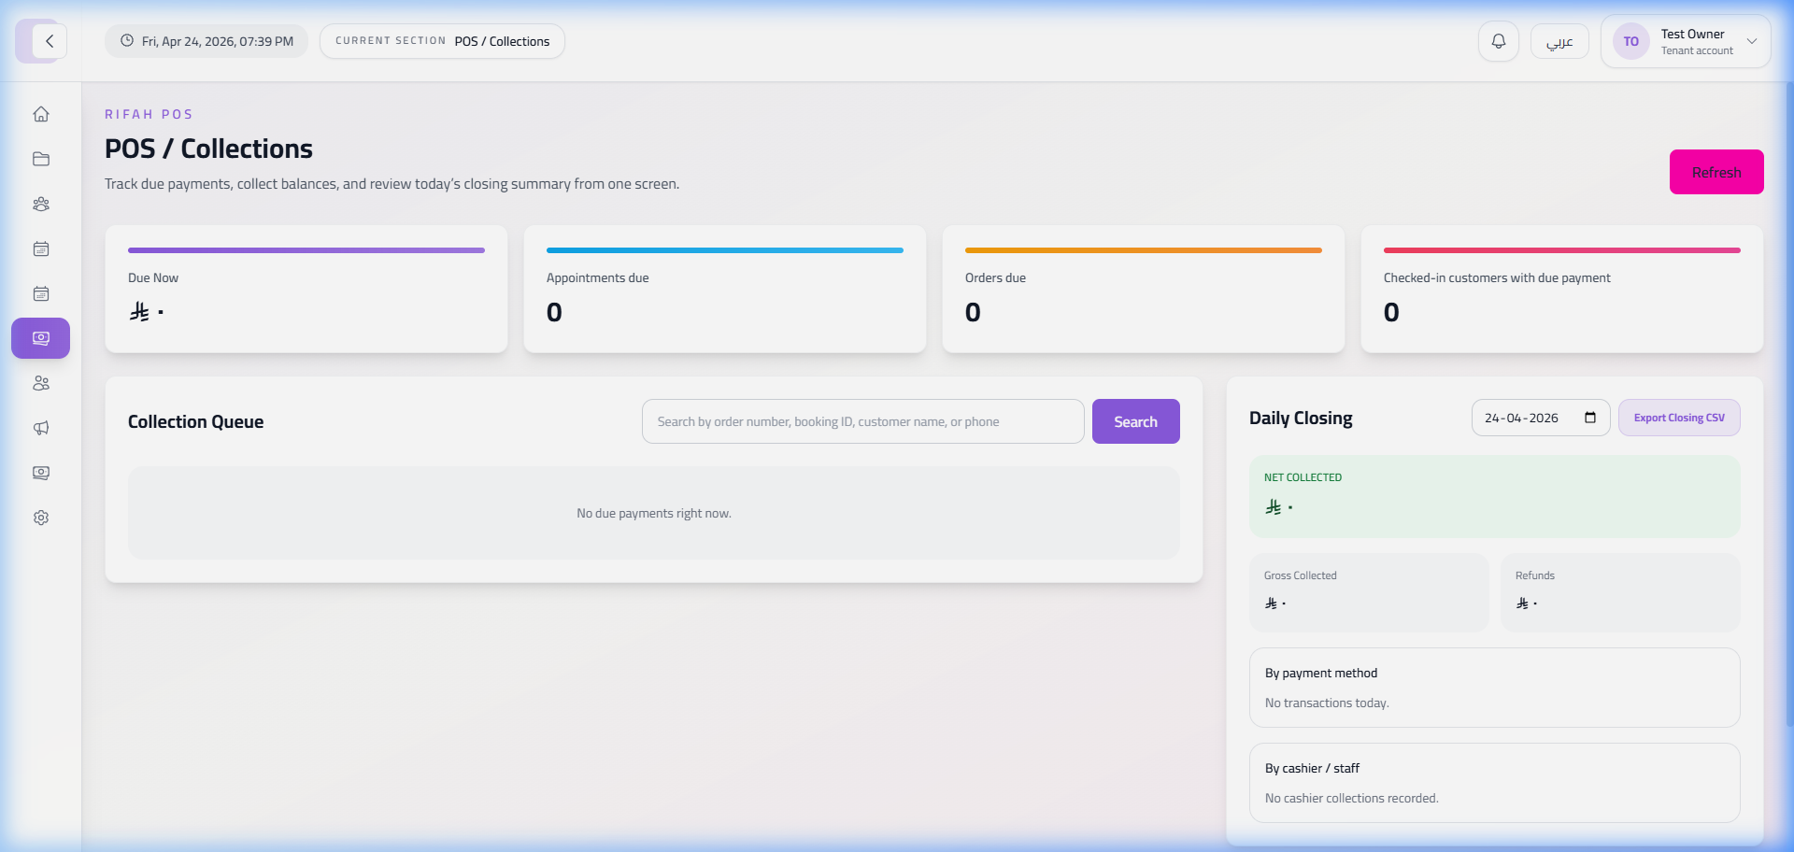

5. Customers & Business Settings

**Customers Database**
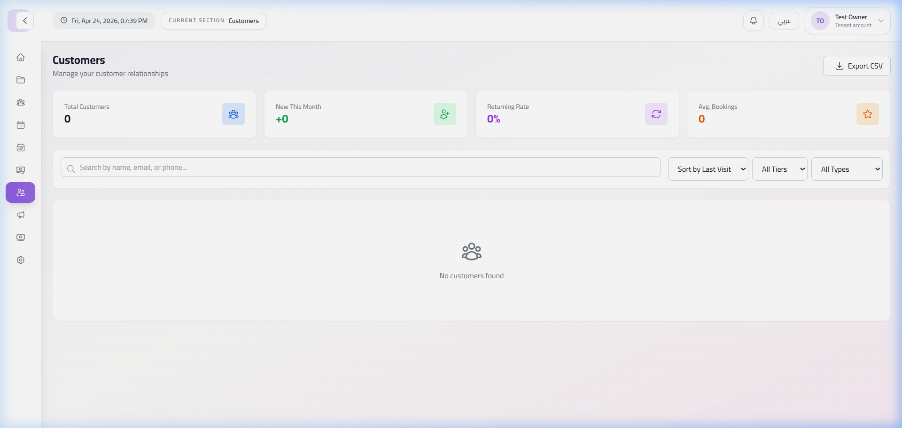

**Business Information Settings**
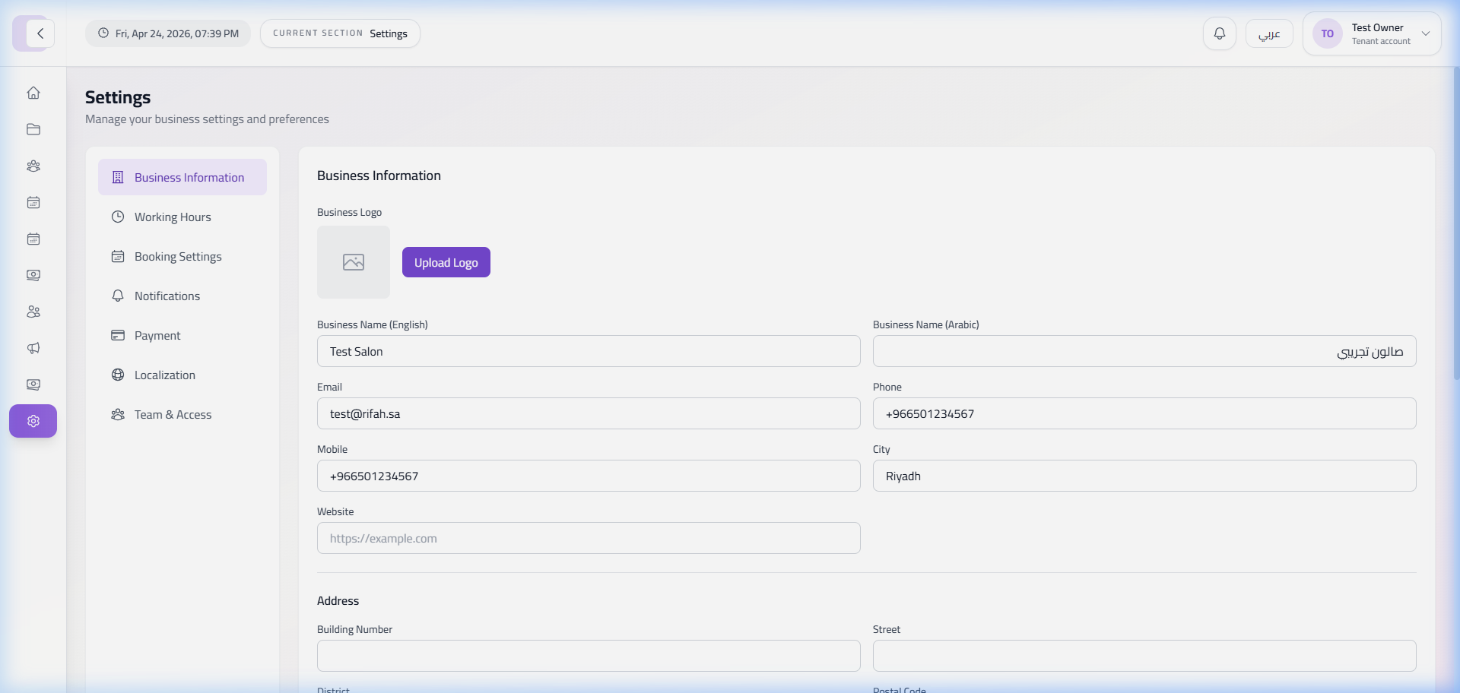

6. Marketing & Billing

**Marketing (Reviews)**
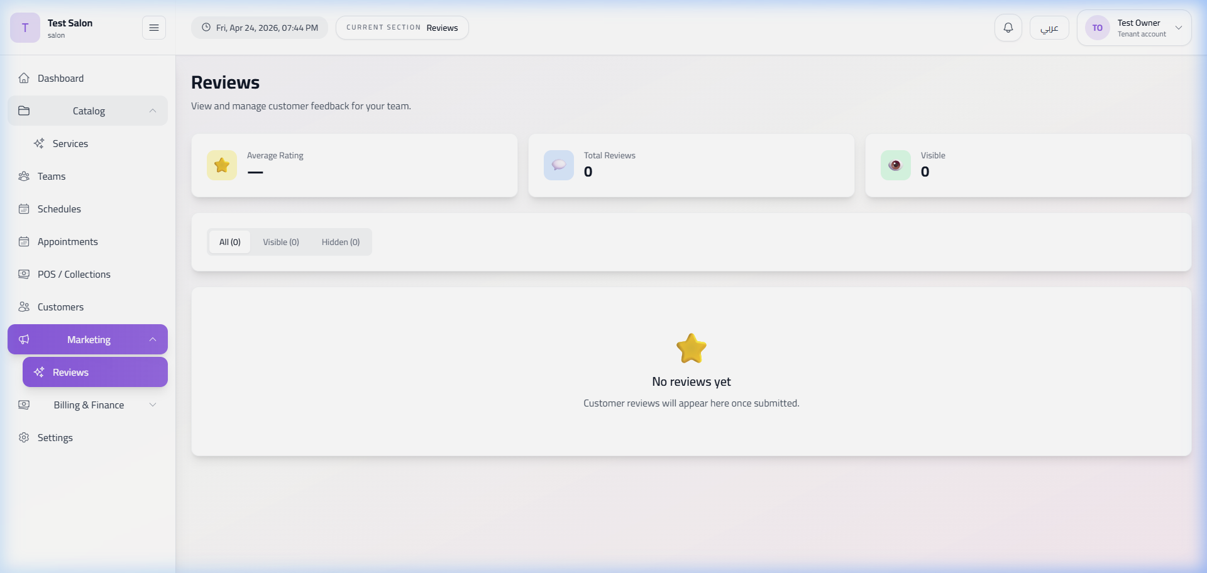

**Financial Balance (Billing)**
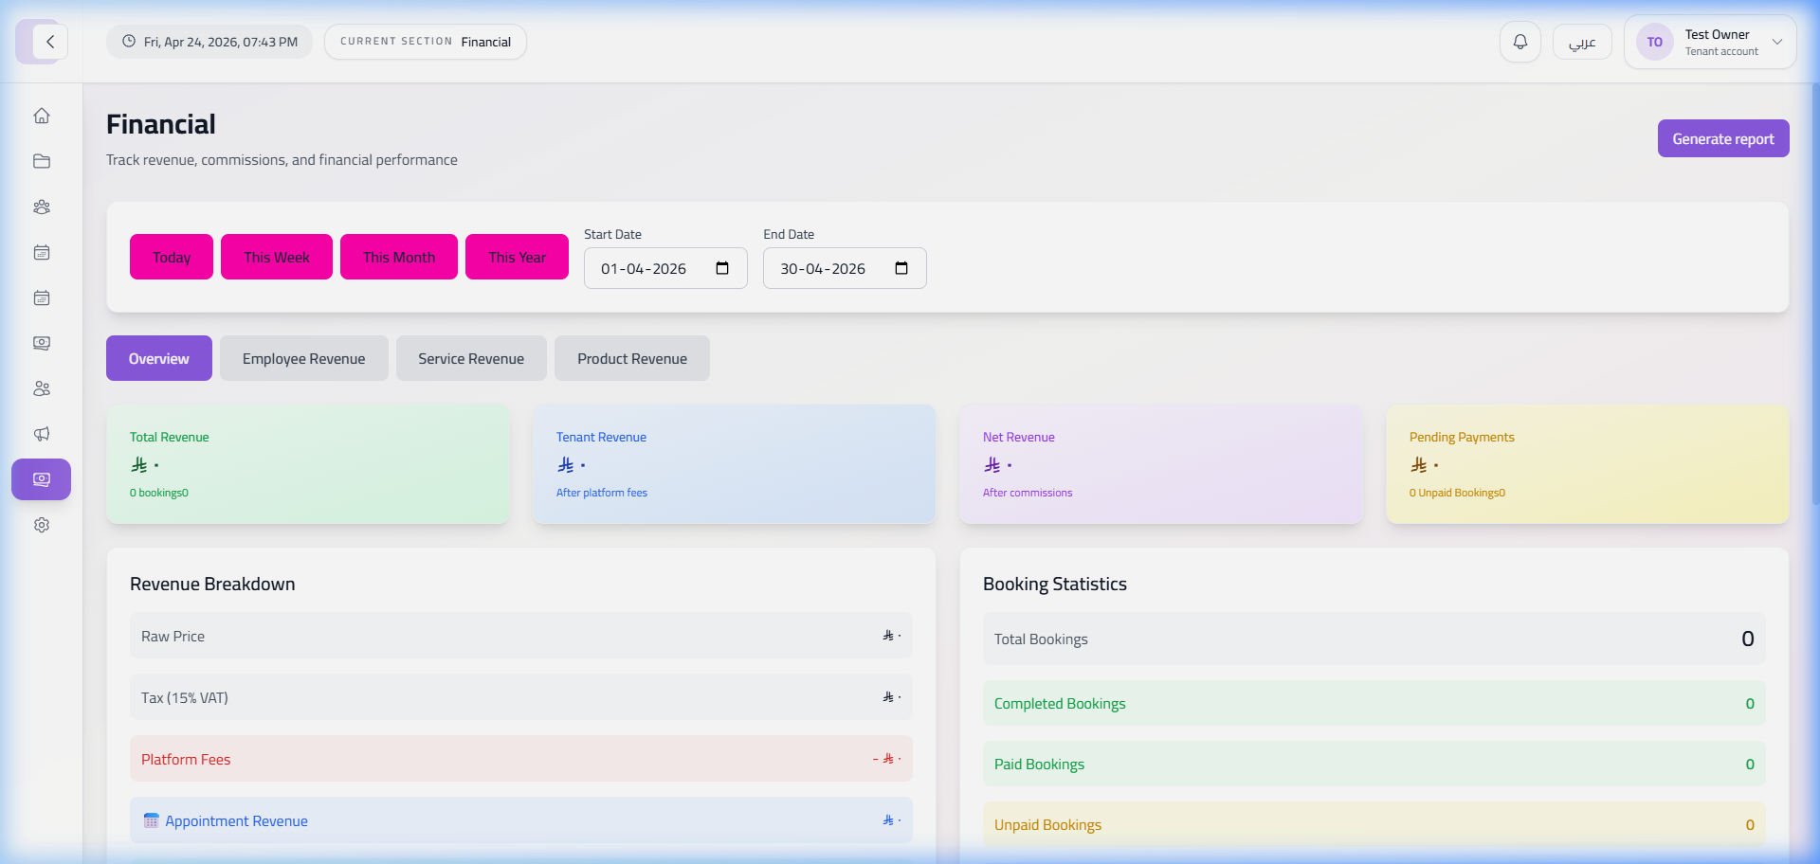

---

Super Admin Dashboard

**Admin Login**
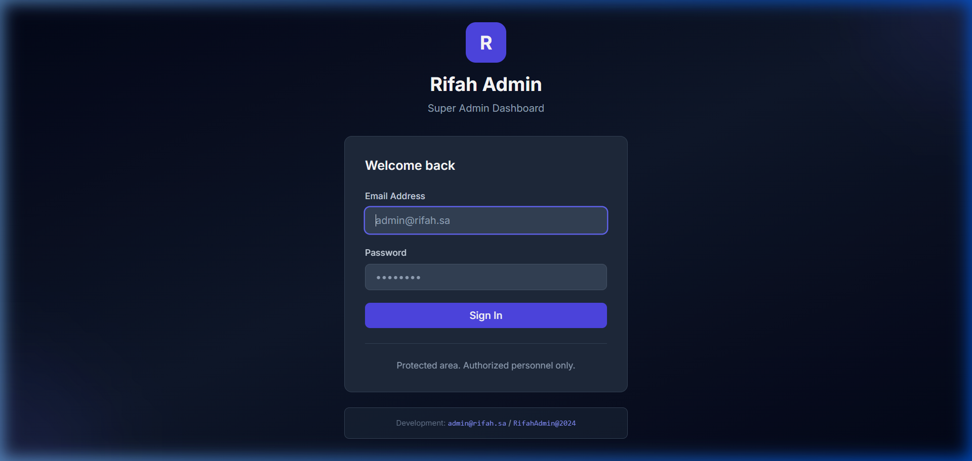

**Platform Overview**
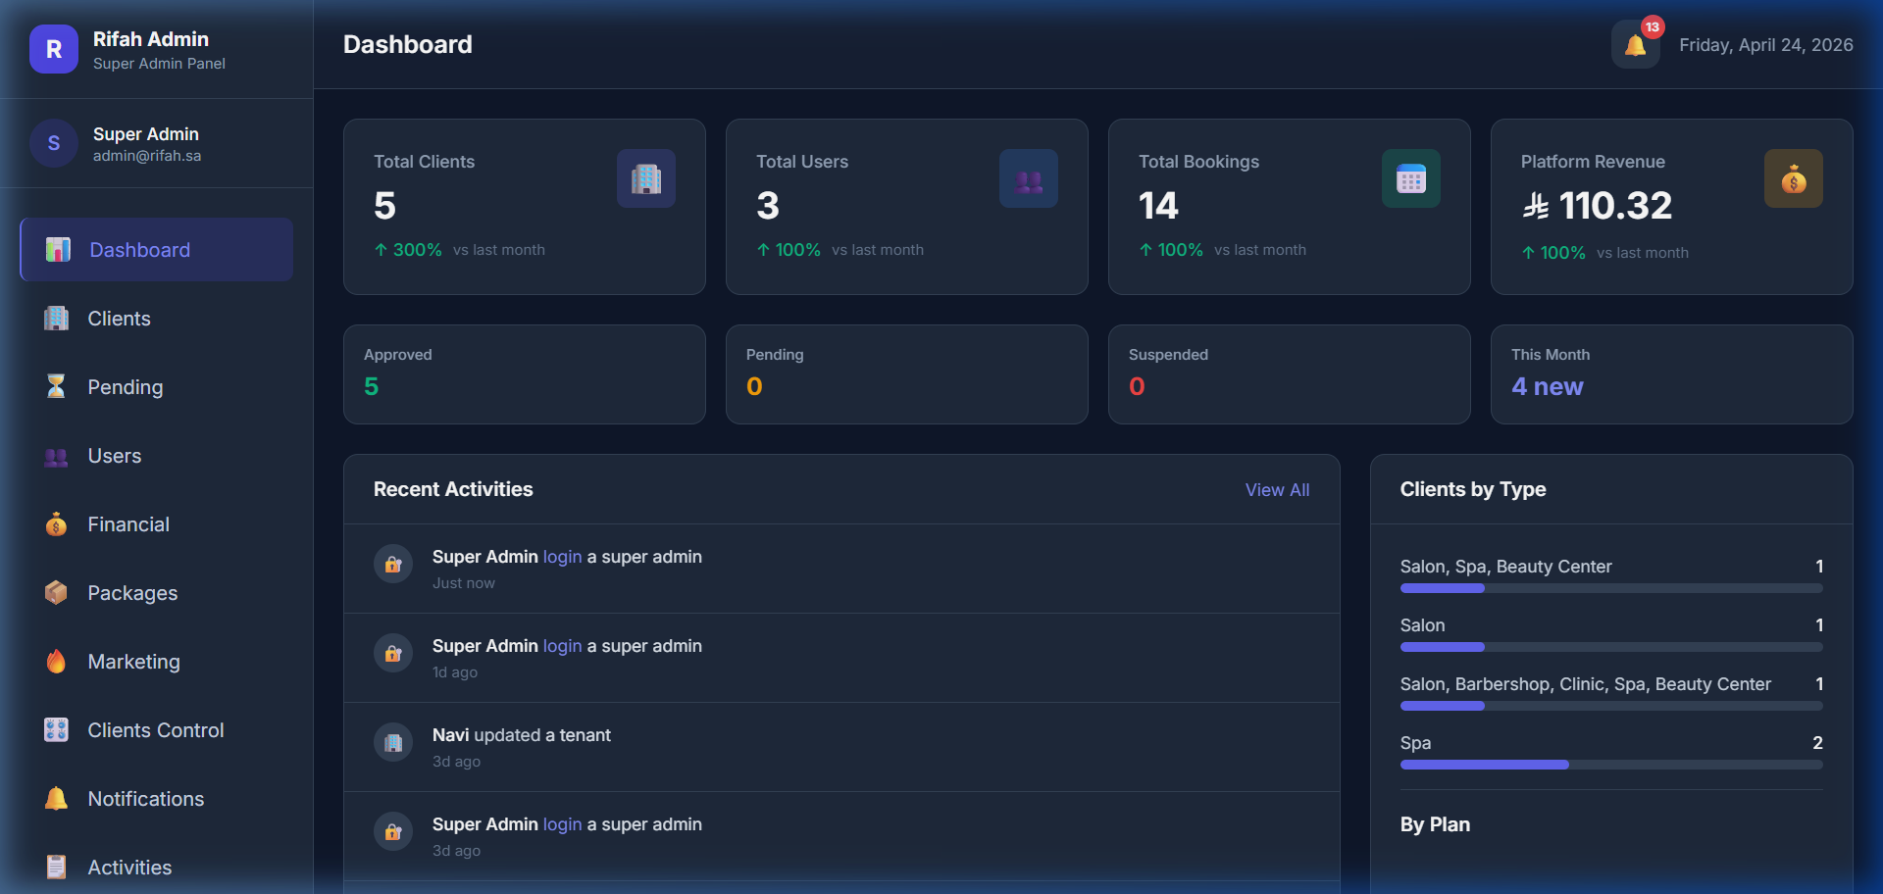

**Clients (Tenants) Management**
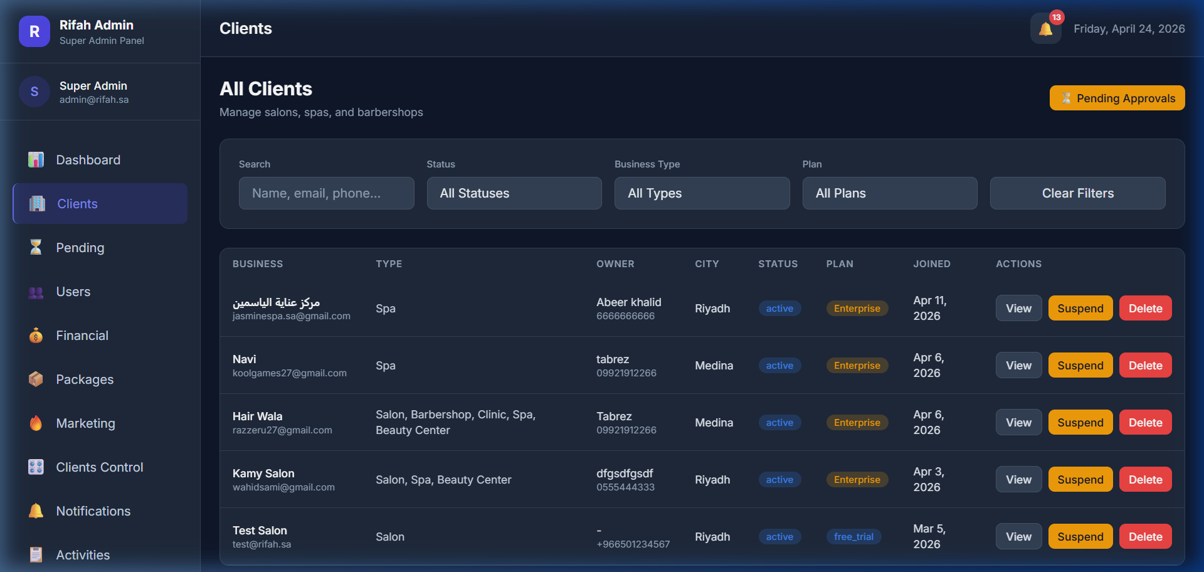

**Tenant Details View**
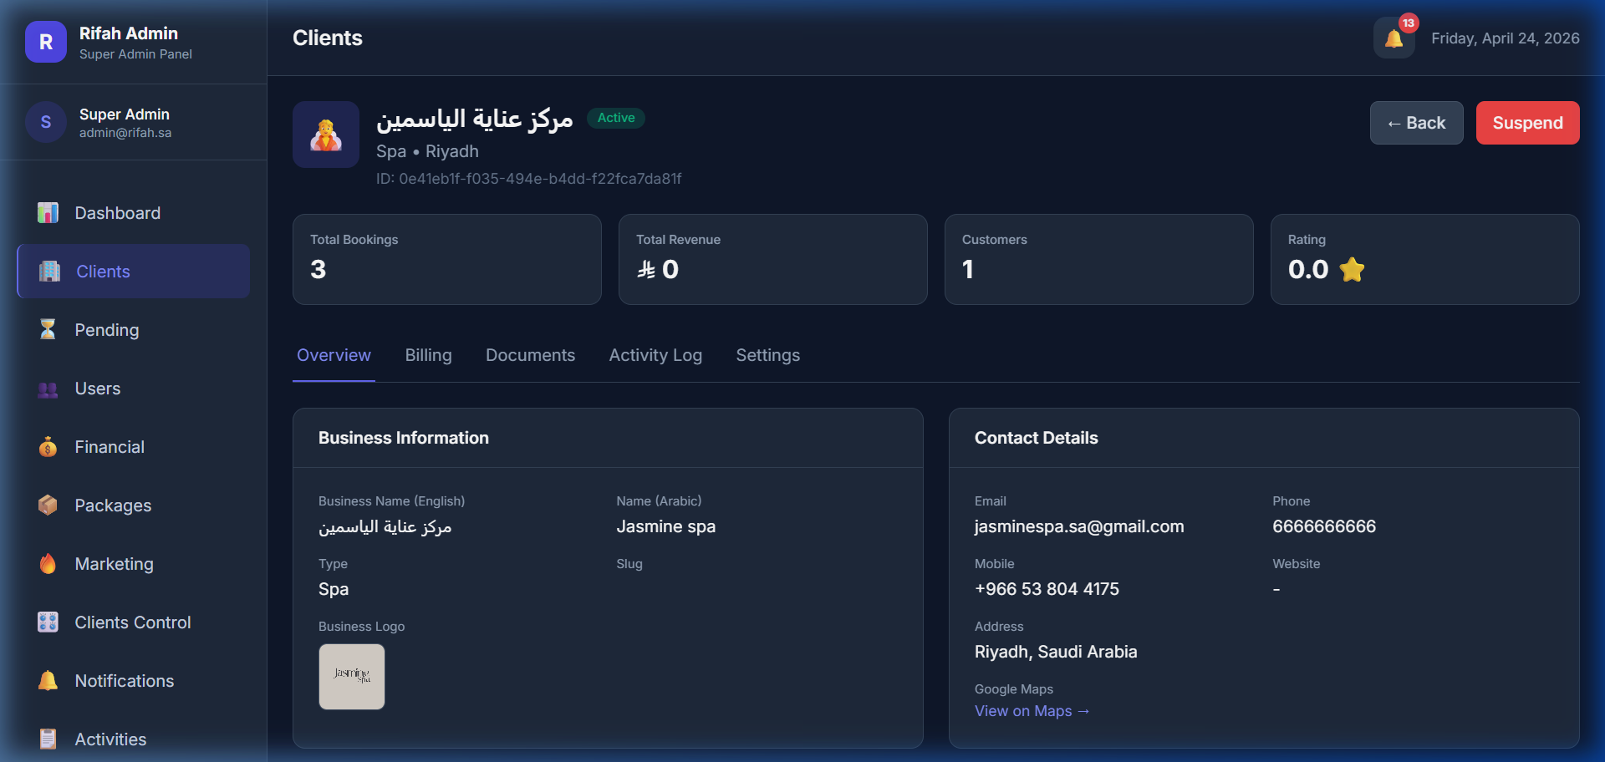

**Platform Users Database**
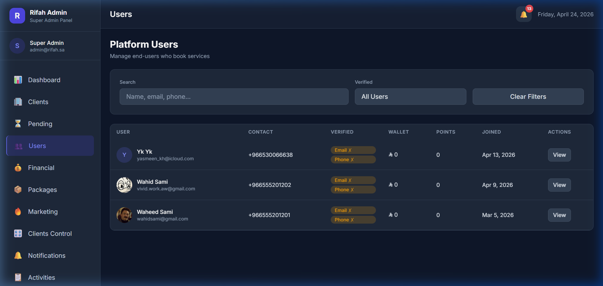

**Financial Overview (Escrow/Comm)**
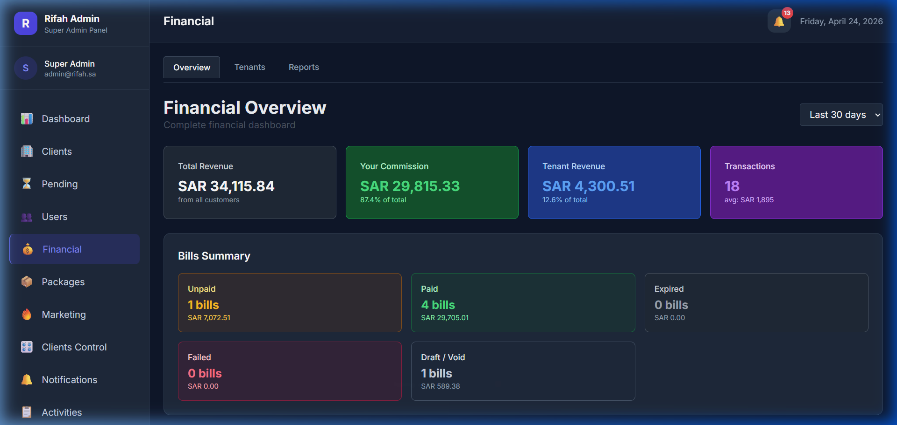

**System Settings**
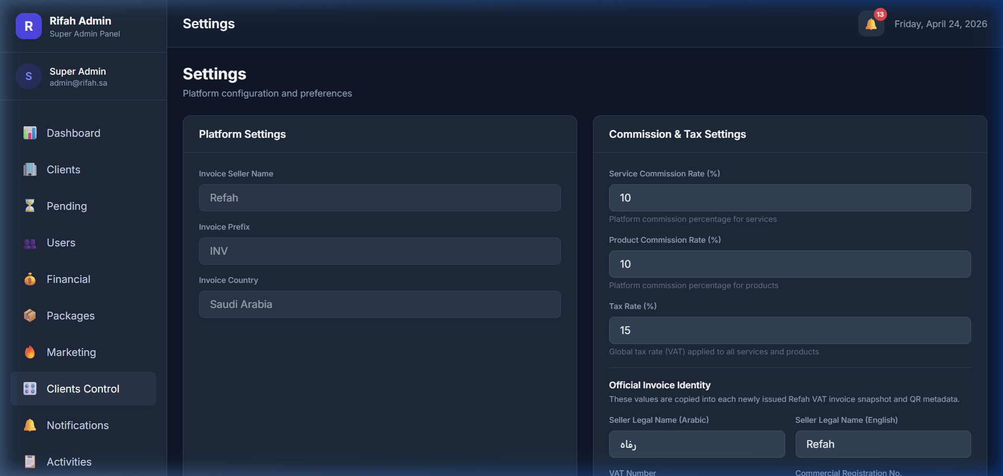

---

Notes & Exceptions
- **Customer App**: Not available as a web application for capture (Mobile native).
- **Staff (Agent) App**: The host `rapp.unifinitylab.com` currently returns a "no available server" error.
- **Service Products**: Currently not enabled/visible for this test tenant.
> [!TIP]
> All screenshots were taken in English mode to match the documentation requirements. Locations and timestamps are embedded in the filenames for tracking.

