**Phase: Prototype 1**

This is a simple application I created using Python, specifically the tkinter library in python.



You can add application you need to be opened all at once. Once you click the Open Applications it will open an explorer pop up.

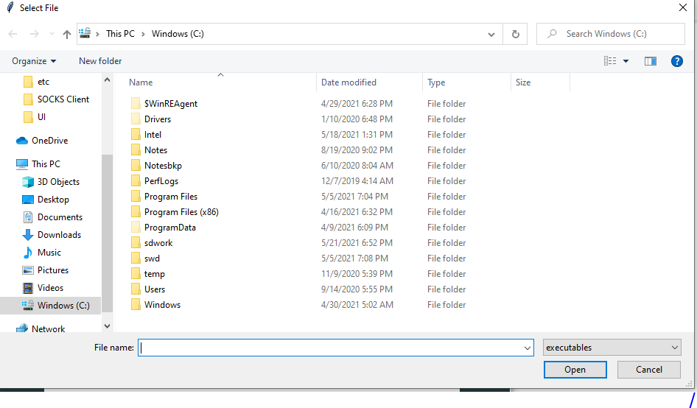

Here we can select the program or documents that we need to open. For example I will choose Internet Explorer and Firefox.exe files located in the Program Files.

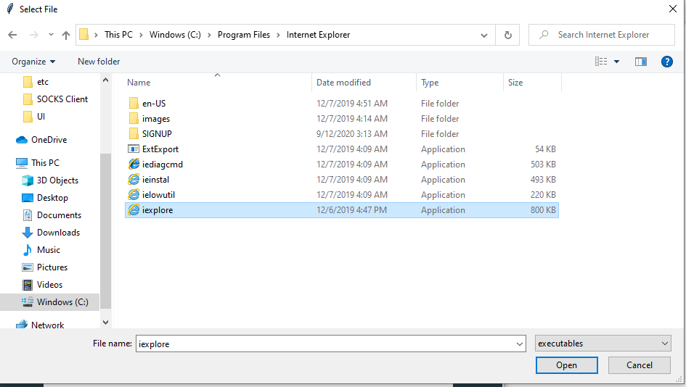

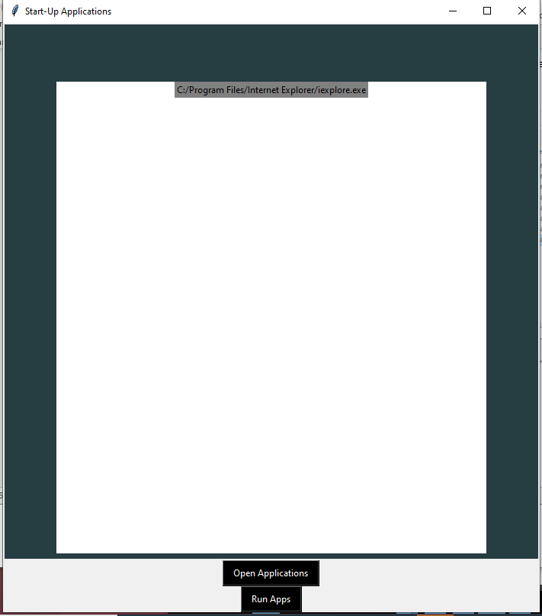

In the bottom picture you can see the two applications added in red. You can then click Run Apps, circled in blue to run all the applications simultaneously. I recommend associates using an Excel Spread Sheet to store passwords, which can be added here along with all the passwords. We can automate this to open once a month, using the Task Scheduler. This is just a prototype; I can do some research on how I can incorporate another method. The application is executable on Windows 10, I can send the .exe file over to you.