Marijuana Database

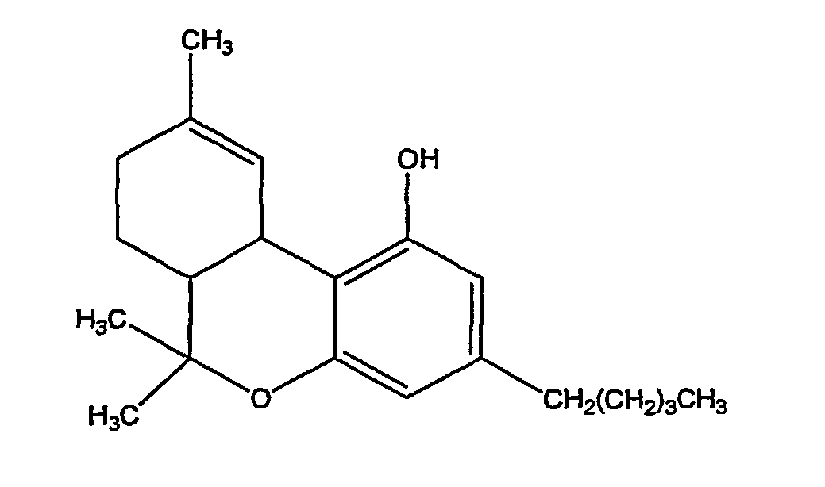

Anthony Santostefano

**Table of Contents**

1…………………………………………………………………………………Title Page

2…………………………………………………………………………Table of Contents

3………………………………………………………………………Executive Summary

4………………………………………………………………………………ER Diagram

5………………………………………………………..………………………Type Table

6………………………………………………………………………………Strains Table

7………………………………………………………….……………………Plants Table

9………………………………………………………………………………Effects Table

10………………………………………………………………………Plant Effects Table

11………………………………………………………………..……………People Table

12……………………………………….………………………………Dispensaries Table

13……………………………………………………………………………Growers Table

14…………………………………………………………..…………Grower Plants Table

15…………………………………………………….……………Dispensary Plants Table

16…………………………………………………….………………………Patients Table

17…………………………………………………….………Dispensary Patients Diagram

18…………………………………………………….………………………Dealers Table

19…………………………………………………………………………Customers Table

20……………………………...…………………………………Dealers Customers Table

21……………………………..…………………………………View – Marijuana Strains

22………………………...…………………………………View – Marijuana Full Details

23………………………………………………………………View - Plant Strain Effects

24………………………………………………………………View – Dispensary Strains

25…………………………………………………..…………View – Dispensary_Patients

26…………………………………………………..…………Triggers/Stored Procedures

28…………………………………………………..………………………………Security

29……………………….……………………………Known Issues/Future Enhancements

**Executive Summary**

This document is a small look inside the complex world of the legal, and illegal, sale, distribution, and growth of marijuana. It is meant to show many things, but primarily the growth cycles of the individual strains, their affects on the human brain, and an average look into their yields. Even though data is relative, it is never fake or meant to be misleading, all data is based upon real numbers whether it be street, dispensary or research level of the industry.

Firstly the Entity Relationship Diagram is shown in order to display the tables of the database, and how closely related the data is in actuality. Next, their SQL scripts written to build on Postgres, these will include the framework of the database, its sample data, views, triggers and stored procedures. Lastly, the security of the data is viewable and explained.

ER Diagram

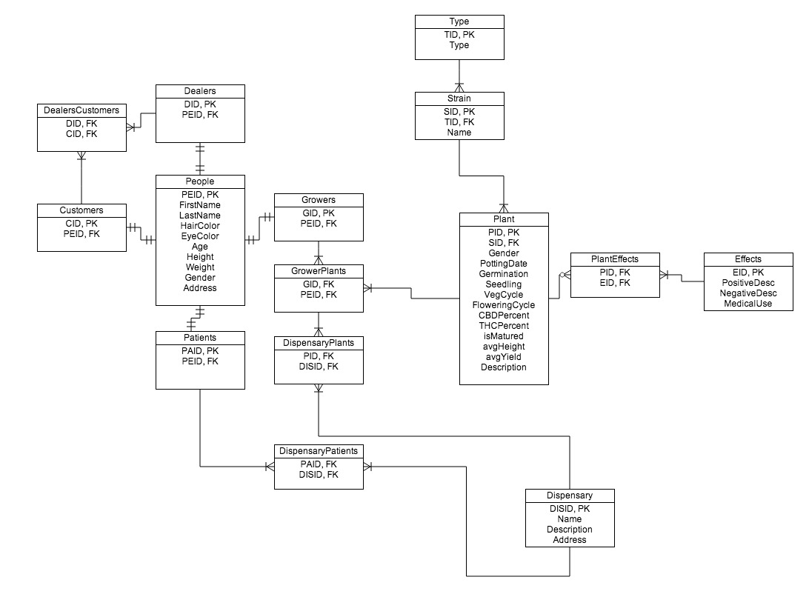

**Type Table**

This table contains the marijuana strain type, which can be Indica, Sativa, or Hybrid.

**Functional Dependency:**

tid => type

**Create Table Statement:**

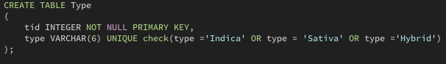

**Sample Data:**

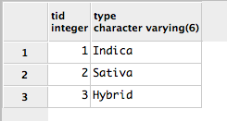

**Strains Table**

This table contains the strains and their names.

**Functional Dependency:**

sid => tid, name

**Create Table Statement:**

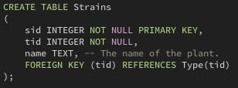

**Sample Data:**

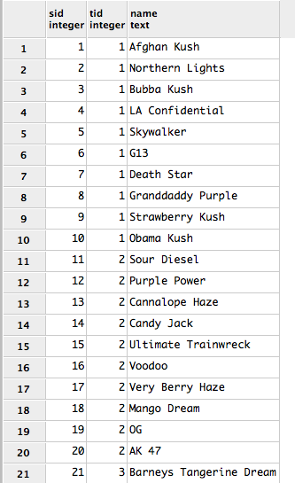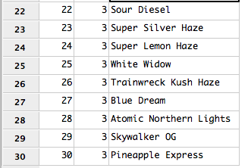

**Plants Table**

The Plants table contains a list of the plants and their characteristics. It contains information about their gender, their potting date (the date they were planted), the amount of time until germination, the time they spend (in days) as a seedling, the time they spend during their vegetative stage where they do most of their initial growing measured in days, their flowering stage where they may double in height and begin their budding process measured in days, their CBD or cannabinoid percentage the chemical is found mostly to have an effect physically, THC or tetrahydrocannabinol percentage the chemical primarily effects the psyche, if they are fully matured or developed, their average height measure in inches, their average yield measured in grams, and a brief description about the plant.

**Functional Dependency:**

pid => sid, gender, pottingdate, germination, seedling, vegcycle, floweringcycle, cbdpercent, thcpercent, ismatured, avgheight, description

**Create Table Statement:**

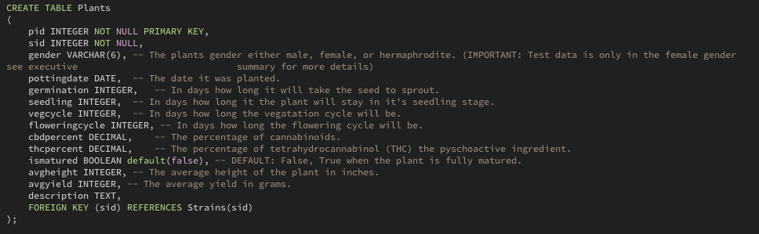

**Sample Data:**

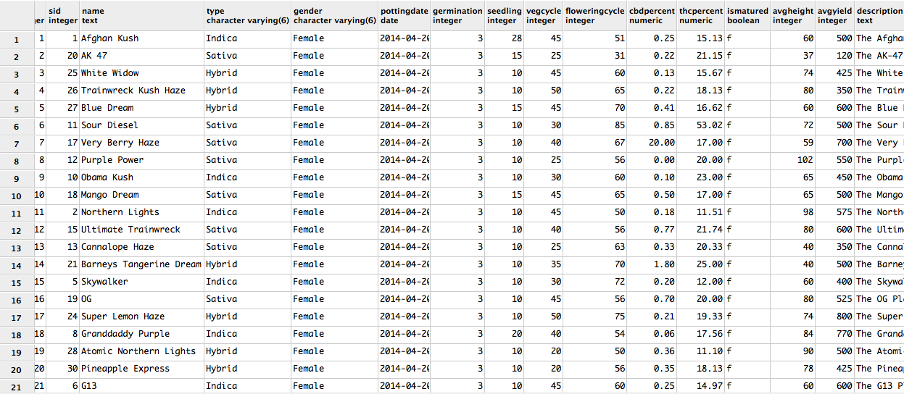

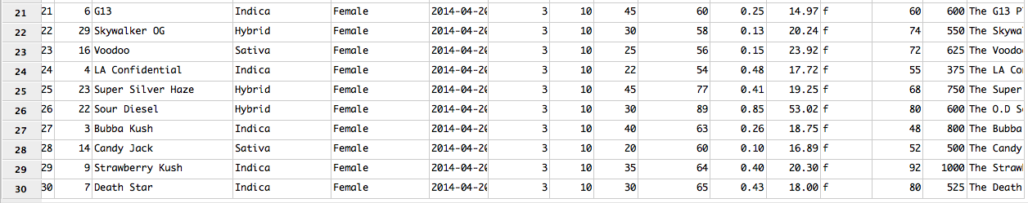

**Effects Table**

The effects table contains the possible effects after user, and the common medical uses.

**Functional Dependency:**

eid => PostiveDesc, NegativeDesc, MedicalUse

**Create Table Statement:**

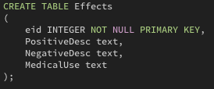

**Sample Data:**

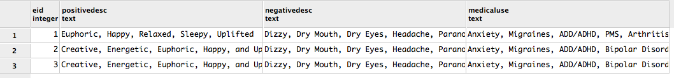

**Plant Effects Table**

The Plant Effects table is the join table between the plants and their effects.

**Functional Dependency:**

pid, eid =>

**Create Table Statement:**

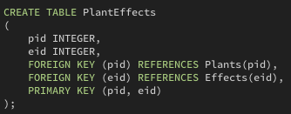

**Sample Data:**

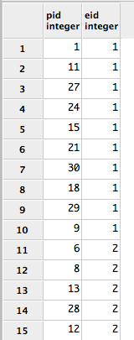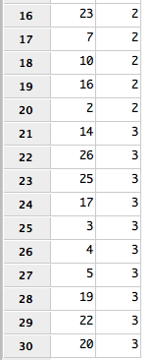

People Table

The people table contains information about the people entered into the database.

**Functional Dependency:**

peid => firstname, lastname, age, haircolor, eyecolor, height, weight, gender, address

**Create Table Statement:**

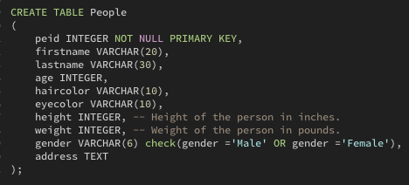

**Example Data:**

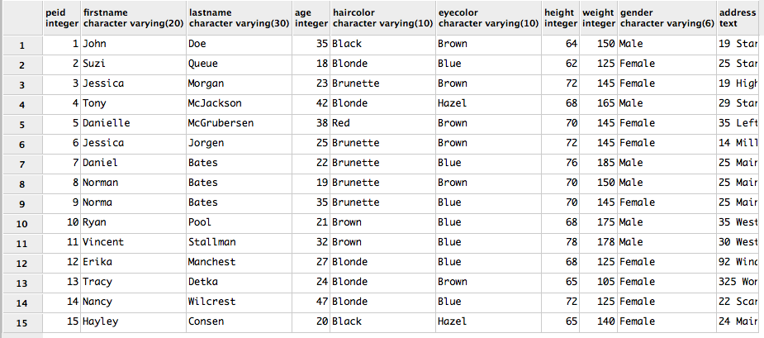

**Dispensaries Table**

The Dispensaries table contains the name, address, and location of the dispensaries.

**Functional Dependency:**

disid => name, description, address

**Create Table Statement:**

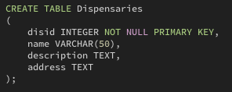

**Example Date:**

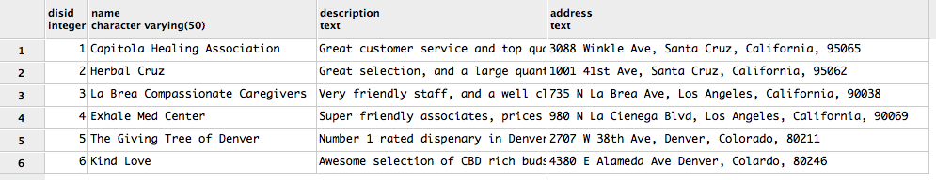

Growers Table

The Growers table inherits the primary key from people in order to display what people are also growers.

**Functional Dependency:**

gid => peid

**Create Table Statement:**

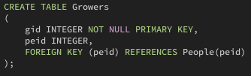

**Sample Data:**

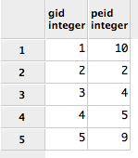

**Grower Plants Table**

The Grower Plants table is the join table between Plants and Growers in order to show what plants are grown by what person.

**Functional Dependency:**

gid, pid =>

**Create Table Statement:**

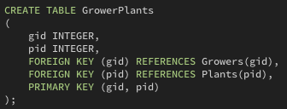

**Example Data:**

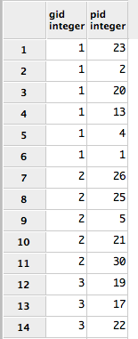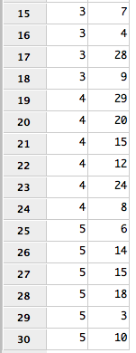

**Dispensary Plants Table**

The Dispensary Plants table is the join table between Dispensaries and Plants to show which Plants are purchased by what dispensaries.

**Function Dependency:**

pid, disid =>

**Create Table Statement:**

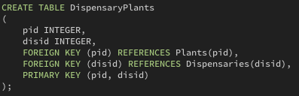

**Sample Data:**

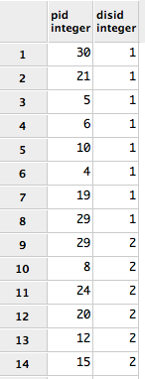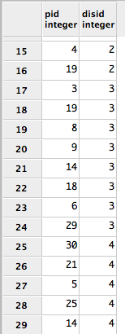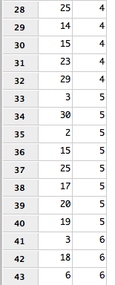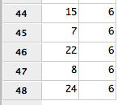

**Patients Table**

The Patients table inherits the primary key from People in order to show what people are patients.

**Functional Dependency:**

paid => peid

**Create Table Statement:**

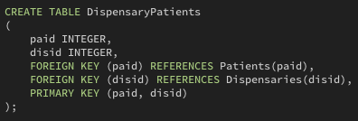

**Example Data:**

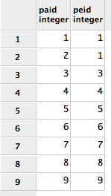

**Dispensary Patients Table**

The Dispensary Patients table is the join table between Dispensaries and Patients to show which Patients belong to which Dispensaries.

**Functional Dependency:**

paid, disid =>

**Create Table Statement:**



**Example Data:**

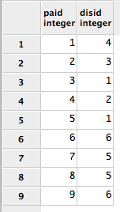

**Dealers Table**

The Dealers table inherits the primary key from People in order to show what people are Dealers.

**Functional Dependency:**

did => peid

**Create Table Statement:**

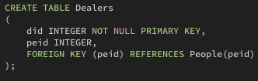

**Example Data:**

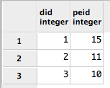

Customers Table

The Customers table inherits the primary key from People in order to show what people are Customers.

**Functional Dependency:**

cid => peid

**Create Table Statement:**

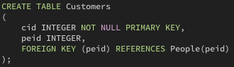

**Sample Data:**

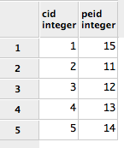

**Dealers Customers Table**

The Dealers Customers table is the join table between Dealers and Customers to show which Customers purchase from what Dealers.

**Functional Dependency:**

**Create Table Statement:**

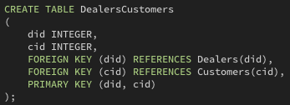

**Example Data:**

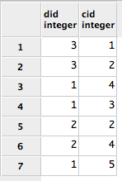

View – Marijuana Strains

The Marijuana Strains view is useful in order to show the strains types.

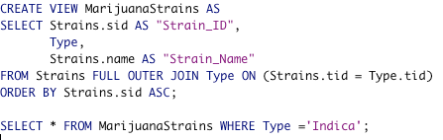

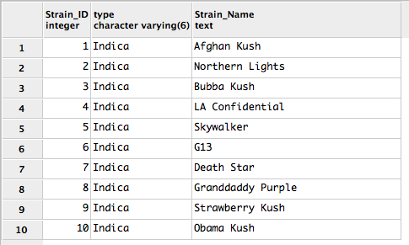

**View – Marijuana Full Details**

A full details view would be useful to a dispensary who wanted to know more about the plant or a grower interested in growing.

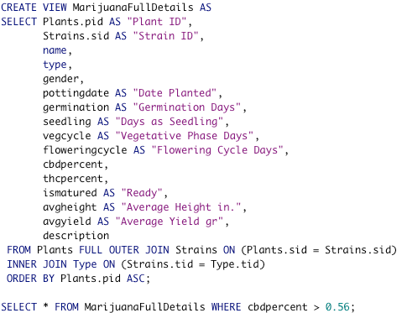

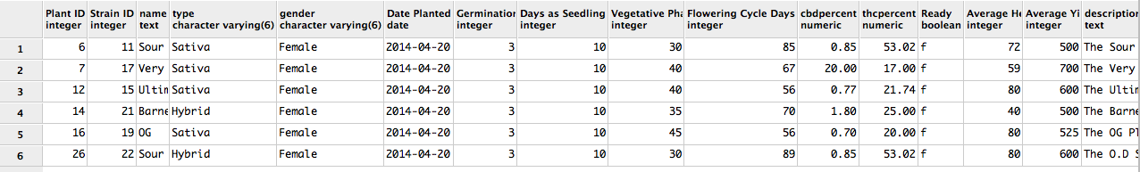

**View – Plant Strain Effects**

The Plant Strain Effects view would be useful for purchaser before purchasing.

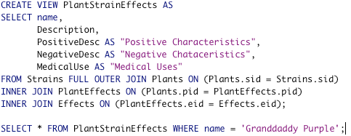



**View – Dispensary Strains**

The Dispensary Strains view would be useful until an actual inventory view is developed. It gives us minimal knowledge of what the dispensaries may carry.

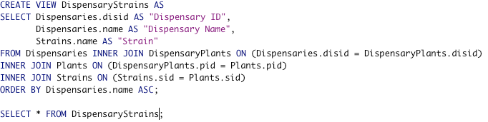

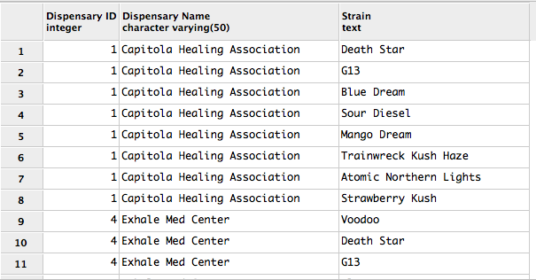

**View - Dispensary_Patients**

The Dispensary_Patients view would be useful in order to see what patient purchase from what dispensenary.

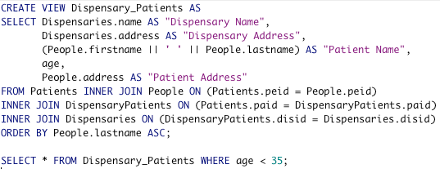

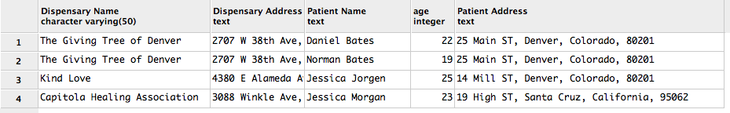

**Triggers/Stored Procedures**

Update Maturity:

This trigger will update the isMatured boolean from false to true in the Plants table when the growth cycle is complete.

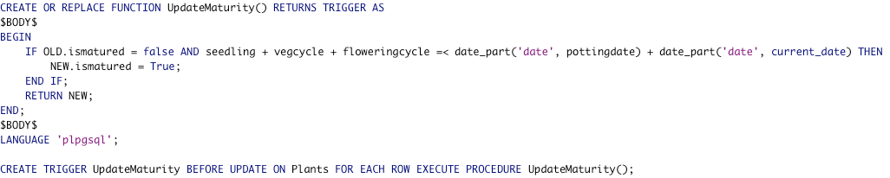

Get Plants By Name:

Allows user to input a Strain name and returns information about the plant.

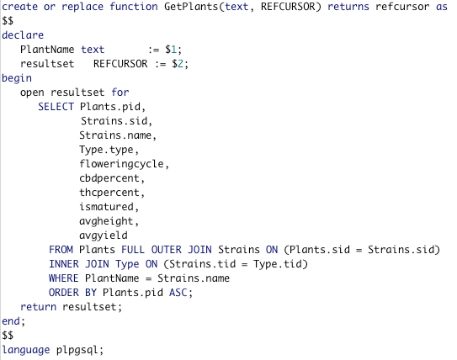



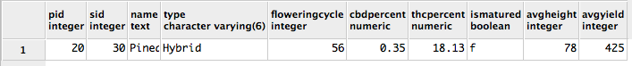

**Security**

Breaking down levels of security to different users is a must. First we start with a password protected Admin user.

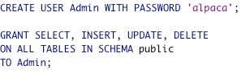

Scientists must be able to alter the Plants table in order to make changes in data to reflect the latest findings.

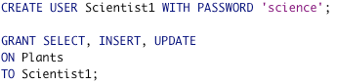

A public user is created with select privileges to view certain public tables, but have no access to other tables.

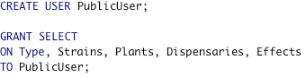

**Known Issues/Future Enhancements**

Known Issues:

* The UpdateMaturity function doesn’t function properly.
* The is no view to show what customers buy from what dealers in Las Vegas.

Future Enhancements:

* A working UpdateMaturity function.
* A function that automatically inserts the plants into the Dispensary Plants table when they are fully matured.
* A prescribers table.
* A price guide table.