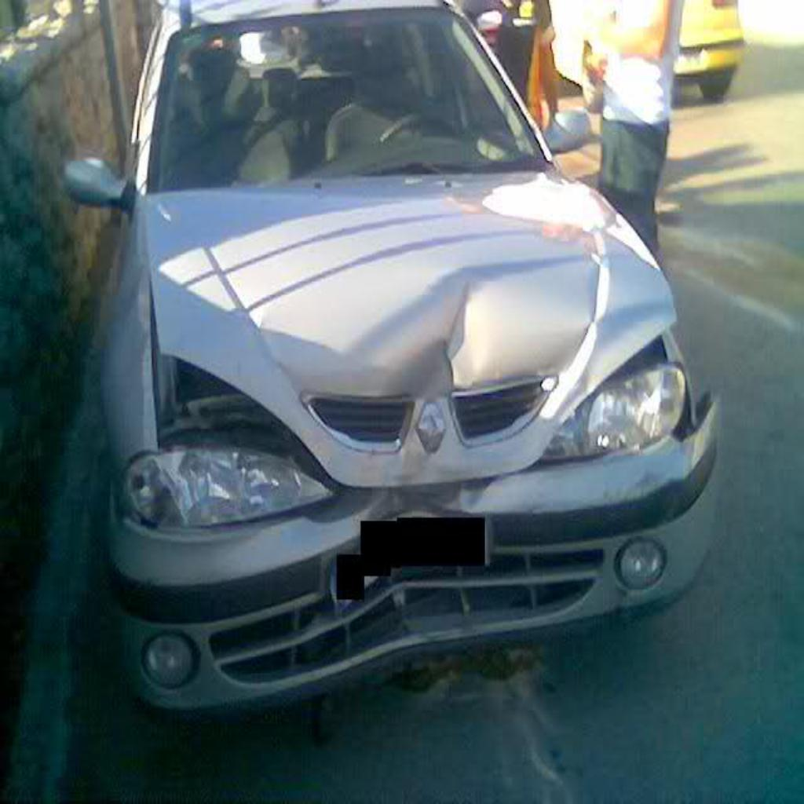

The model identified three damaged car parts: the headlamp , front bumper and the hood. The severity levels were classified as minor and severe, respectively. Using the predefined price mapping, the estimated costs for each part were as follows:

* Headlamp (Severe): KSh 20,000
* Front Bumper (Severe**):** KSh 30,000
* Hood(Severe): Ksh 14,000

The total estimated cost was calculated as KSh 64,000, which matches the aggregated sum of individual part costs.

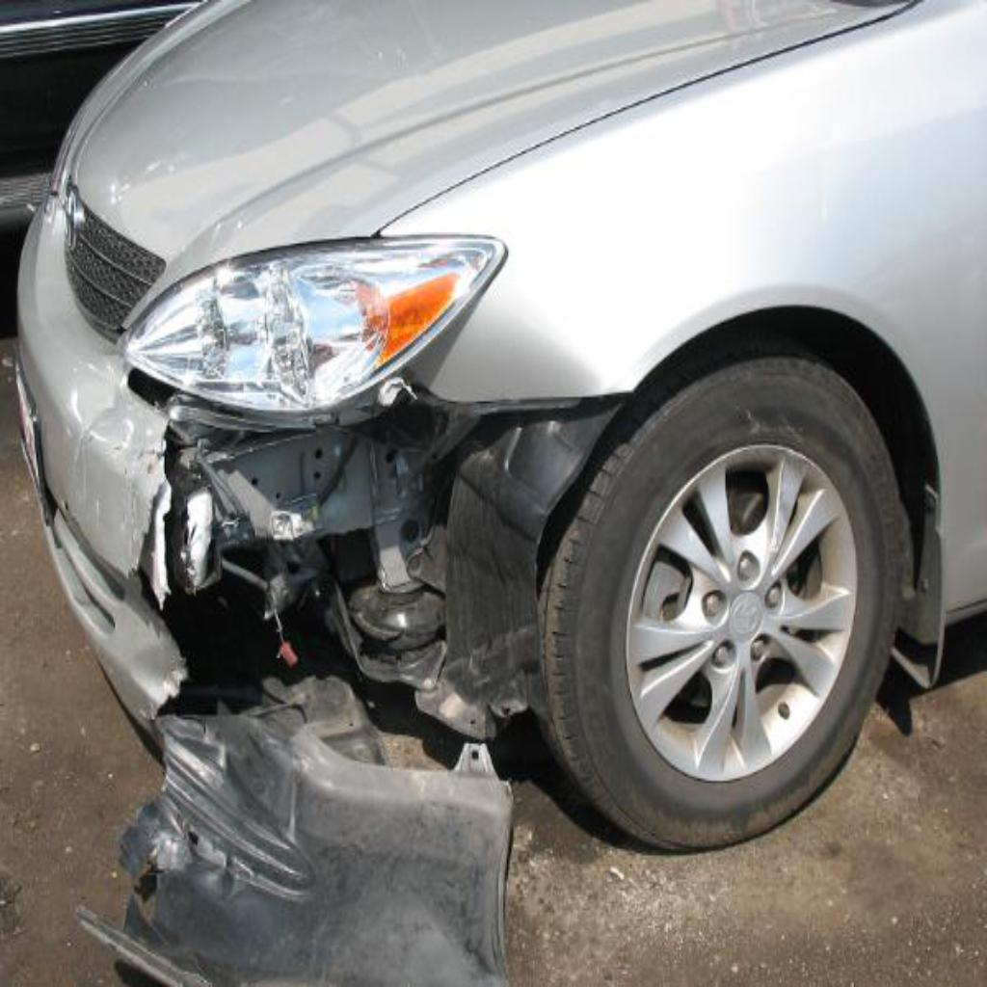



The model identified two damaged car parts: the headlamp and the front bumper. The severity levels were classified as minor and severe, respectively. Using the predefined price mapping, the estimated costs for each part were as follows:

* Headlamp (Minor): KSh 20,000
* Front Bumper (Severe**):** KSh 30,000

The total estimated cost was calculated as KSh 50,000, which matches the aggregated sum of individual part costs.

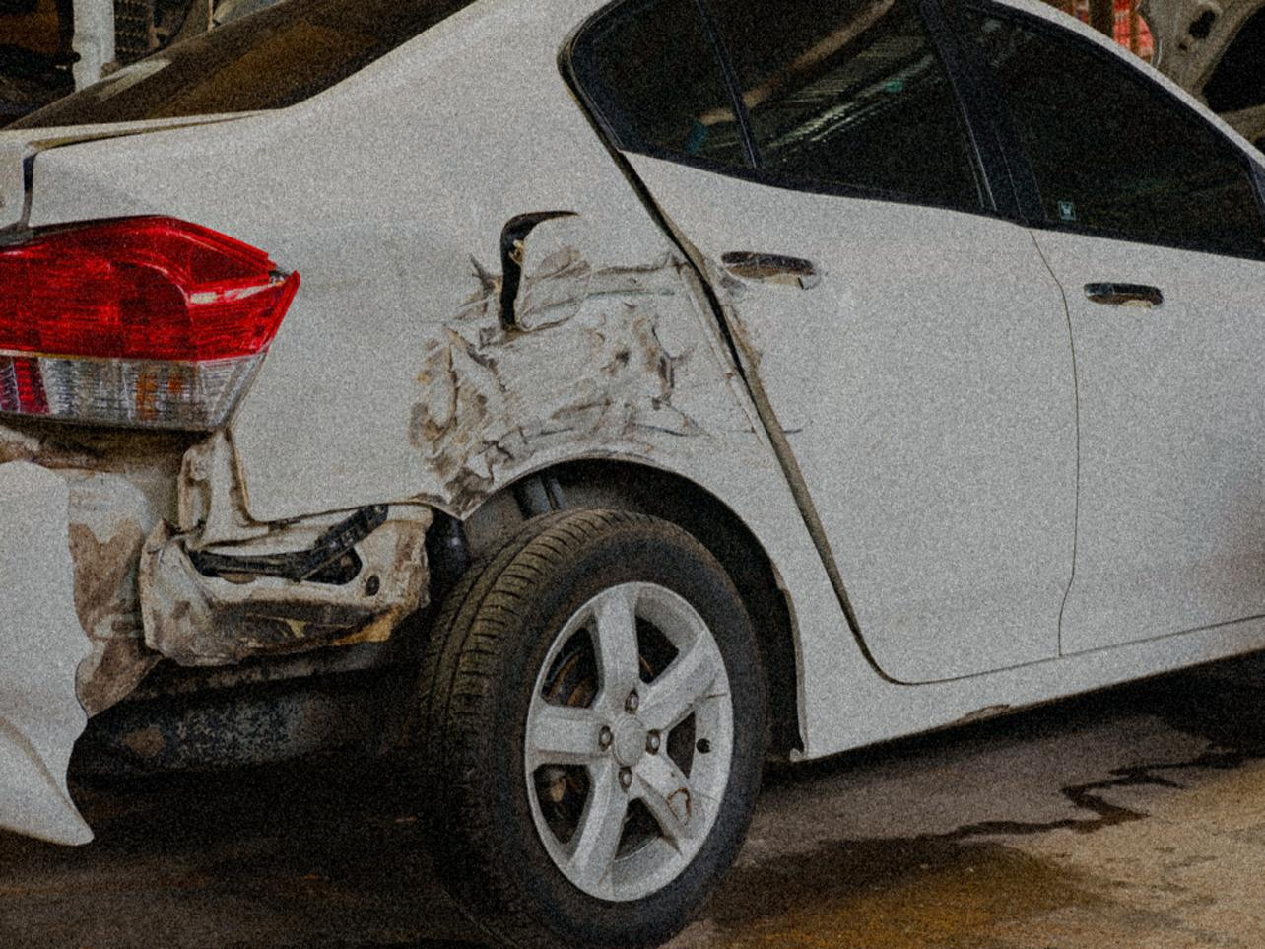



The model identified three damaged car parts: the headlamp , rear bumper and the door.. The severity levels were classified as minor and severe, respectively. Using the predefined price mapping, the estimated costs for each part were as follows:

* Headlamp (Minor): KSh 2,500
* Rear Bumper (Minor**):** KSh 7,500
* Door (Minor) : Ksh 2,200

The total estimated cost was calculated as KSh 12,200, which matches the aggregated sum of individual part costs

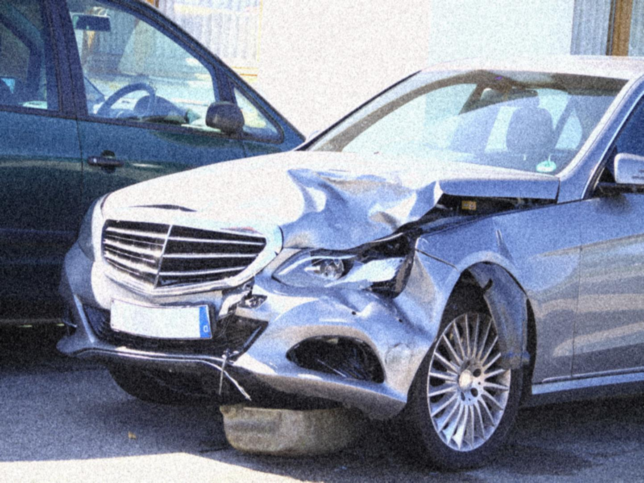



The model identified three damaged car parts: the headlamp ,rear bumper and the hood.. The severity levels were classified as minor and severe, respectively. Using the predefined price mapping, the estimated costs for each part were as follows:

* Headlamp (Severe): KSh 20,000
* Rear Bumper (Severe**):** KSh 30,000
* Hood (Severe) : Ksh 14,000

The total estimated cost was calculated as KSh 64,000, which matches the aggregated sum of individual part costs

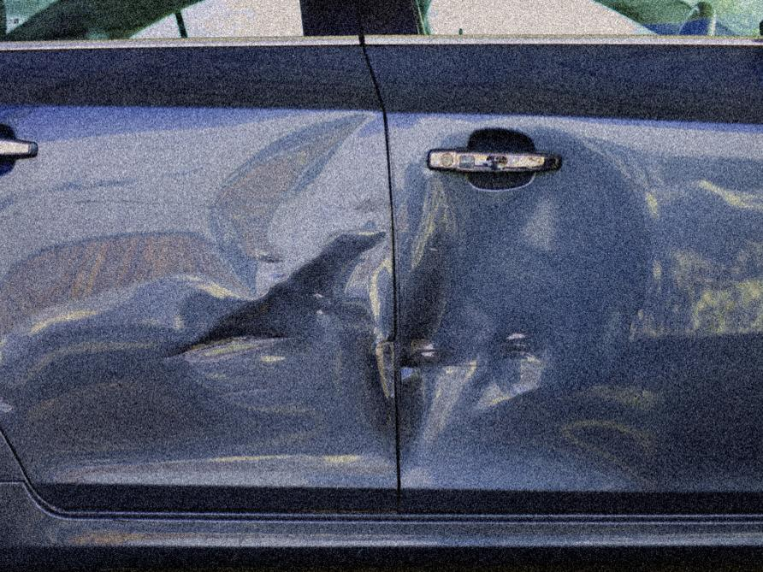



The model identified one damaged car part, the door. The severity level were classified as minor Using the predefined price mapping, the estimated costs for each part were as follows:

* Door (Minor): KSh 3,000

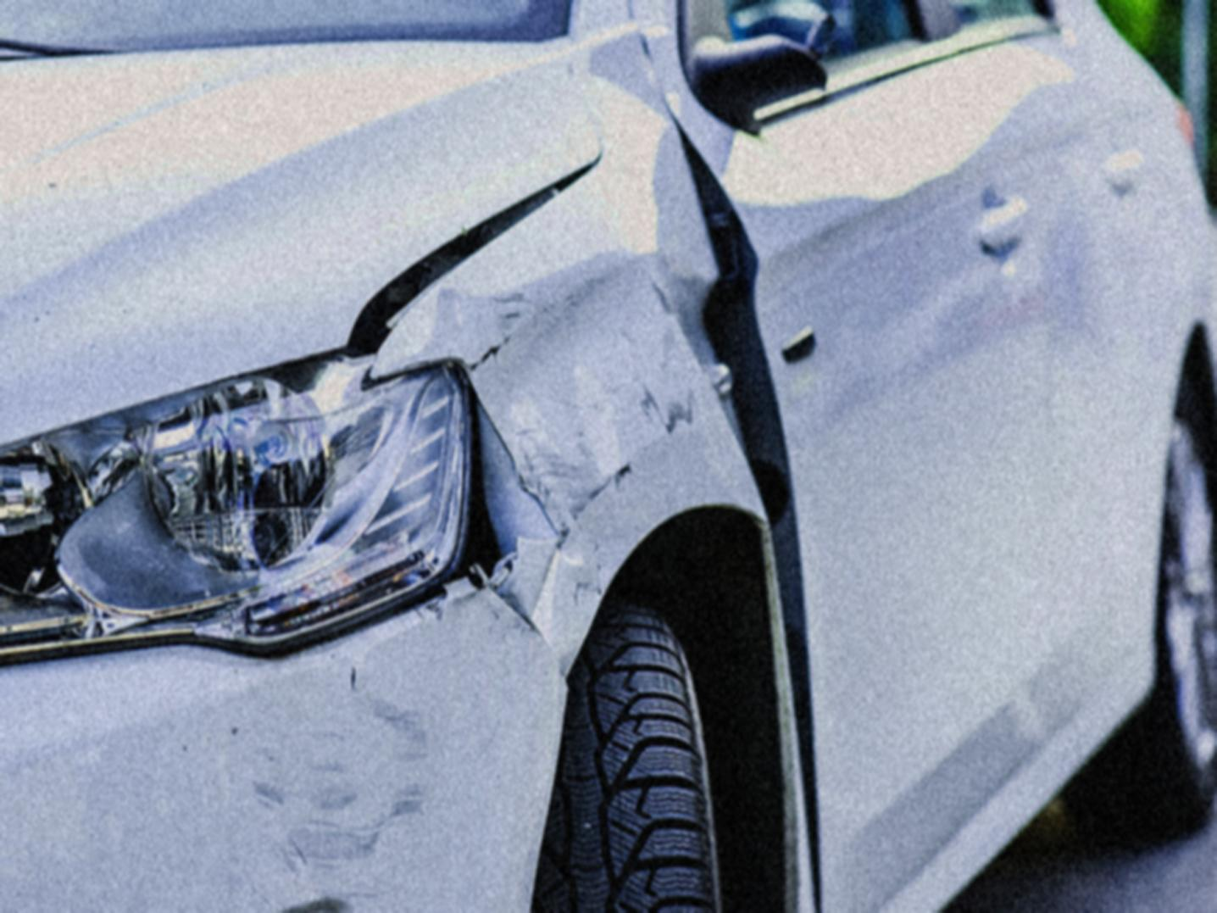



The model identified four damaged car parts: the headlamp ,rear bumper and the hood.. The severity levels were classified as minor and severe, respectively. Using the predefined price mapping, the estimated costs for each part were as follows:

* Headlamp (Minor): KSh 2,500
* Front Bumper (Minor**):** KSh 3,000
* Hood (Moderate) : Ksh ,7,400
* Door(Minor) 2000

The total estimated cost was calculated as KSh 64,000, which matches the aggregated sum of individual part costs

Model Strengths

The model demonstrated high accuracy in detecting car parts and their associated severity levels for this specific input. The bounding boxes accurately localized the damaged areas, and the severity predictions aligned with the expected results. This showcases the robustness of the trained model in processing real-world crash images and providing actionable insights for repair cost estimation.

. Challenges and Observations

The model successfully estimated the repair costs in this case, there were some notable trends during testing:

* + Headlamp Dominance: The model showed higher accuracy (70-80%) in detecting headlamp damages compared to other car parts, likely due to better representation of headlamp features in the training dataset.
  + Rear Bumper Underperformance**:** Rear bumper predictions were less accurate (60% accuracy), which may stem from insufficient training data or overlapping features with similar parts (e.g., front bumper).
  + Severity Distribution Bias: Minor severity levels were less frequently predicted compared to moderate and severe levels. This may indicate a bias in the dataset, where minor damages were underrepresented, causing the model to favour higher severity classifications."