ASG Airlines Analytics Platform

End-to-End Data Engineering & Business Intelligence Solution

Submitted
By
Mohit Ranjan
VIT VELLORE
MCA -2025-2027
mohit09079@gmail.com
Github:

Abstract
The ASG Airlines Analytics Platform is an end-to-end Business Intelligence project developed to transform raw airline operational data into meaningful business insights through modern data engineering and visualization techniques. The project follows a complete analytics lifecycle beginning with data ingestion from Microsoft Excel, followed by data profiling, cleaning, transformation, SQL-based KPI generation, and interactive dashboard development in Power BI.
A Medallion Architecture consisting of Raw, Bronze, Silver, and Gold layers was implemented to ensure systematic data processing and maintain data quality throughout the pipeline. Python was used for exploratory data analysis (EDA), data cleaning, validation, and ETL operations, while SQLite served as the analytical database for writing optimized SQL queries. The final business insights were presented using a five-page Power BI dashboard containing executive KPIs, passenger demographics, flight operations, revenue analysis, and business analytics.
The project demonstrates practical implementation of ETL, Star Schema data modeling, DAX calculations, SQL analytics, Power Query transformations, and interactive business reporting. It provides airline stakeholders with actionable insights regarding revenue trends, passenger behavior, operational efficiency, and airline performance, enabling data-driven decision making.

Keywords: Business Intelligence, Power BI, ETL, SQL, Python, Medallion Architecture, Star Schema, DAX, Data Analytics.

1. INTRODUCTION
1.1 Background
The airline industry generates enormous volumes of operational and transactional data every day. Information related to flight schedules, bookings, passengers, ticket payments, airline performance, and travel routes contains valuable business intelligence that can help organizations improve customer satisfaction and operational efficiency.
However, raw data alone cannot support strategic decisions because it often contains inconsistencies, duplicates, missing values, and multiple disconnected tables. Therefore, organizations require a structured data pipeline that transforms raw information into reliable analytical datasets.
This project addresses that challenge by building an end-to-end analytics solution for ASG Airlines, integrating data engineering, SQL analytics, and Power BI visualization into a single workflow.

1.2 Problem Statement
The airline management team lacked a centralized analytical platform capable of answering critical business questions such as:
- Which airlines generate the highest revenue?
- What are the busiest departure cities?
- How does monthly revenue fluctuate?
- What is the passenger demographic distribution?
- What percentage of flights operate overnight?
- Which payment method contributes the most revenue?
Manual analysis using Excel was time-consuming and inefficient. Hence, an automated analytics platform was required.

1.3 Project Objectives
The primary objectives of this project are:
- Design an end-to-end ETL pipeline.
- Clean and validate airline datasets using Python.
- Build a normalized SQL database.
- Generate business KPIs using SQL and DAX.
- Implement Star Schema data modeling.
- Develop interactive Power BI dashboards.
- Enable slicers, navigation, and drill-down analysis.
- Produce executive-level business reports for decision making.

2. TOOLS & TECHNOLOGIES USED
2.1 Technology Stack
Technology | Purpose
Microsoft Excel | Raw dataset source
Python | Data cleaning, EDA, ETL
Pandas | Data manipulation
NumPy | Numerical operations
SQLite | Relational database
SQL | KPI and analytical queries
Jupyter Notebook | Development environment
Power BI | Dashboard & visualization
DAX | Business measures & KPIs
Power Query | Data transformation

2.2 Python Libraries Used
1. Pandas
Purpose: Data manipulation and ETL
Pandas was used throughout the project for reading Excel files, cleaning datasets, removing duplicates, handling missing values, creating calculated columns, and exporting cleaned tables.
Example operations:
- Reading Excel sheets
- Dropping duplicate records
- Converting dates
- Creating dataframes
- Exporting CSV files

2. NumPy
Purpose: Numerical calculations
NumPy supported statistical computations during exploratory analysis and helped in efficient numerical processing wherever required.
3. SQLite3
Purpose: Database connectivity
The SQLite3 library was used to create a lightweight relational database containing bookings, flights, passengers, and payments tables. SQL queries were executed directly from Python.
4. Pathlib
Purpose: File path management
Pathlib created platform-independent file paths for the ETL pipeline, improving portability across different operating systems.

3. PROJECT FOLDER STRUCTURE
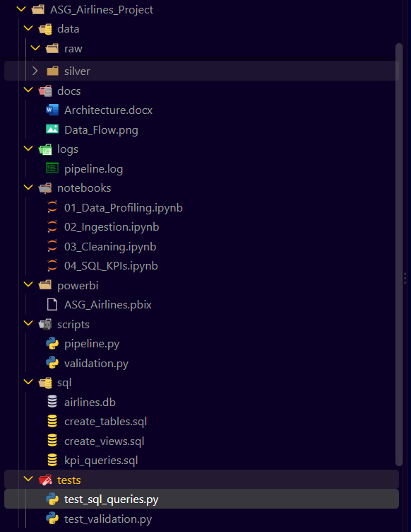

Significance of Each Folder
Folder | Description
raw | Original Excel dataset received from source
bronze | Initial extracted data without modifications
silver | Cleaned and validated datasets
gold | Business-ready analytical datasets
notebooks | Interactive development of ETL pipeline
sql | Database schema and KPI queries
scripts | Automated execution of ETL pipeline
tests | Data quality and SQL validation
powerbi | Final dashboard implementation
docs | Technical documentation
logs | Execution logs of pipeline

4. ARCHITECTURE USED
4.1 Architecture Overview
The project follows Medallion Architecture, a layered data engineering approach widely adopted in modern analytics platforms.
The architecture separates data into four logical layers:
- Raw Layer
- Bronze Layer
- Silver Layer
- Gold Layer
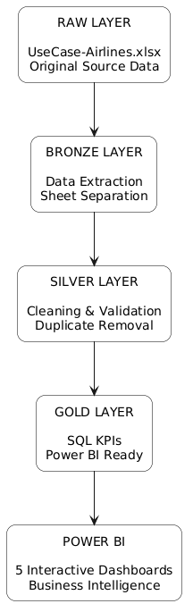
Each layer increases data quality while reducing redundancy and improving analytical usability.

4.3 Why Medallion Architecture?
The Medallion approach was selected because it provides:
- Incremental data refinement
- Data quality isolation
- Reproducible ETL process
- Easy debugging
- Scalable analytical workflow
Instead of modifying raw data directly, each transformation creates a cleaner version in the next layer, preserving data lineage.

5. ASSUMPTIONS MADE
During development, several business assumptions were made because the dataset did not explicitly provide certain operational fields.
Assumption | Reason
Seat capacity is fixed | Required for Load Factor KPI
Cancellation rate derived from status | Dataset lacked explicit cancellation table
Overnight flights identified using Boolean field | Simplified operational KPI
Revenue measured from payment amount | Payment table considered source of truth
Passenger age already calculated | Used for demographic analysis

5.1. WORKFLOW
End-to-End Workflow
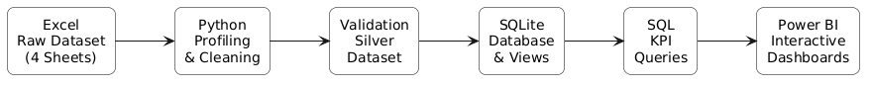
Step-by-Step Workflow
Step 1 – Data Collection
The airline dataset was collected in Excel format containing four sheets:
- Bookings
- Flights
- Passengers
- Payments
Step 2 – Data Profiling
Using Python and Pandas, the dataset was explored to identify:
- Missing values
- Duplicate records
- Data types
- Statistical summary
- Unique categorical values
Step 3 – Data Cleaning
Cleaning operations included:
- Duplicate removal
- Date conversion
- Standardizing text values
- Null value handling
- Creating calculated columns
Step 4 – SQL Database
Cleaned datasets were imported into SQLite, where relational tables and analytical views were created.
Step 5 – KPI Generation
Business KPIs such as revenue, bookings, passengers, airline share, and monthly trends were calculated using SQL and DAX.
Step 6 – Dashboard Development
Five interconnected Power BI dashboards were created with navigation buttons, slicers, KPIs, and interactive visuals.

6. Methodology
6.1 Project Methodology
The ASG Airlines Data Engineering and Business Intelligence project follows a structured ETL (Extract, Transform, Load) methodology combined with dimensional data modeling and interactive dashboard development. The objective is to convert raw operational airline data into meaningful business insights through a scalable analytics pipeline.
The project consists of five major stages:
- Data Extraction – Reading raw Excel sheets into Python.
- Data Transformation – Cleaning, validating, and standardizing data.
- Data Modeling – Creating relational tables and Star Schema in SQLite.
- Business Logic – Writing SQL queries and DAX measures for KPIs.
- Visualization – Building interactive Power BI dashboards for decision making.

6.2 Tools and Technologies Used
The project combines Python for ETL, SQL for relational modeling, SQLite as the analytical database, and Power BI for visualization.
Tool | Purpose
Excel | Raw airline dataset (4 sheets)
Python | ETL pipeline and data cleaning
Pandas | Data manipulation and transformation
NumPy | Numerical operations and missing values
SQLite | Relational database and SQL execution
SQL | KPI generation and business queries
Power BI | Interactive dashboards
DAX | KPI measures and calculations
VS Code | Development environment
Git | Project version control

6.3 Python Libraries Used
Pandas
Pandas is the primary library used throughout the ETL pipeline. It provides DataFrames that allow structured manipulation of tabular airline data.
Why it was used
- Reading Excel sheets
- Removing duplicates
- Handling missing values
- Standardizing column names
- Exporting cleaned CSV files
Example operations performed include read_excel(), drop_duplicates(), fillna(), and to_csv().

NumPy
NumPy supports numerical data preprocessing.
Applications
- Handling NaN values
- Mathematical calculations
- Data type conversions
SQLite3
SQLite stores the cleaned Silver dataset in a lightweight relational database.

Benefits
- No server installation required
- Fast SQL execution
- Easy integration with Power BI
- Suitable for analytical projects

6.4 ETL Concepts Implemented
Extract (E)
The extraction phase imports the original Excel workbook containing four sheets:
- Bookings
- Flights
- Passengers
- Payments
Each sheet is loaded independently using Pandas and stored in the Bronze layer without modification.
Objective: Preserve original source data.
Transform (T)
The transformation stage creates the Silver dataset by improving data quality.
The following operations were performed:

Transformation | Purpose
Remove duplicates | Eliminate repeated records
Handle null values | Improve completeness
Standardize text | Consistent city and airline names
Convert data types | Date, time, numeric formatting
Generate keys | Create surrogate primary keys
Validate records | Ensure referential integrity
This stage ensures the dataset becomes analytics-ready.
Load (L)
The cleaned Silver tables are loaded into SQLite where relationships are established. SQL views and KPI queries are created, producing the Gold layer consumed by Power BI.
6.5 Data Validation Methodology
Data quality is critical for Business Intelligence. Multiple validation checks were performed before loading data into the database.
Validation Rule | Description
Duplicate Check | Removed repeated flight records
Null Validation | Missing values identified and handled
Data Type Validation | Dates, integers and text standardized
Key Validation | Primary and foreign keys verified
Record Count Validation | Ensured row consistency after cleaning
These validations prevent inaccurate KPI calculations and improve dashboard reliability.
7. Data Modeling
7.1 Star Schema
A Star Schema was implemented because it is the most common dimensional model used in Business Intelligence systems. It separates transactional facts from descriptive dimensions, improving query performance and simplifying reporting.
Why Star Schema?
- Faster analytical queries
- Easy dashboard filtering
- Reduced data redundancy
- Better scalability
- Industry standard for Power BI
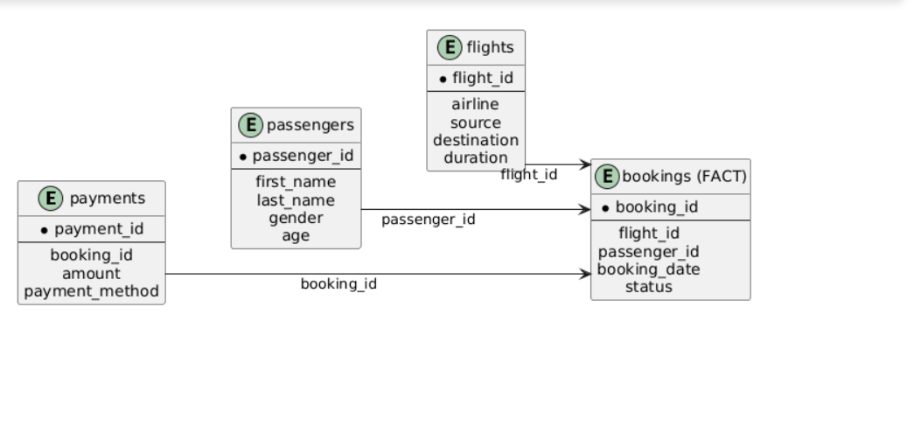

7.2 Fact Table
The Bookings table acts as the central fact table because every business transaction originates from a booking.
Measures stored or derived from this table include:
- Total Bookings
- Active Passengers
- Booking Status
- Monthly Bookings
- Route Analysis

7.3 Dimension Tables
Flights Dimension
Contains descriptive information about flights.
Attribute | Purpose
flight_id | Unique flight identifier
airline | Airline company
source | Departure city
destination | Arrival city
duration | Flight duration
is_overnight | Overnight indicator

Passengers Dimension
Stores customer demographic information.
Attribute | Purpose
passenger_id | Primary key
gender | Gender analysis
age | Age segmentation
date_of_birth | Age calculation

Payments Dimension
Contains financial information.
Attribute | Purpose
payment_id | Unique payment
amount | Revenue
payment_method | UPI/Card/NetBanking

8. SQL Design
8.1 Database Objects Created
The SQLite database contains four primary tables.
Table | Type
bookings | Fact
flights | Dimension
passengers | Dimension
payments | Dimension
Primary keys and foreign keys establish one-to-many relationships.
8.2 SQL Concepts Used
The project implements several analytical SQL concepts.
Concept | Usage
JOIN | Combine related tables
GROUP BY | Aggregate KPIs
SUM | Revenue
COUNT | Total bookings
AVG | Average ticket value
DISTINCTCOUNT | Unique passengers
CASE | Conditional logic
VIEW | Gold layer reporting

Example business KPIs generated through SQL include:
- Monthly Revenue
- Airline Revenue
- Route Performance
- Payment Method Distribution
- Passenger Count by Gender

9. DAX Measures and KPI Design
Power BI uses DAX measures instead of calculated columns for dynamic KPI calculations. Measures respond automatically to slicers and filters.

9.1 Core KPI Measures
Measure | Business Meaning
Total Bookings | Total reservations
Total Flights | Number of unique flights
Total Revenue | Overall airline revenue
Active Passengers | Unique passengers travelling
Average Ticket | Revenue per booking
Revenue Per Flight | Operational efficiency

9.2 Passenger Measures
Measure | Purpose
Average Age | Customer demographics
Male % | Gender distribution
Female % | Gender distribution
Age Group | Passenger segmentation

9.3 Flight Measures
Measure | Purpose
Avg Flight Hours | Operational KPI
Overnight Flights | Night operation analysis
Total Airlines | Fleet diversity

9.4 Revenue Measures
Measure | Purpose
UPI % | Digital payment adoption
Card % | Card usage
Net Banking % | Banking transactions

Dashboard 1 – Executive Overview
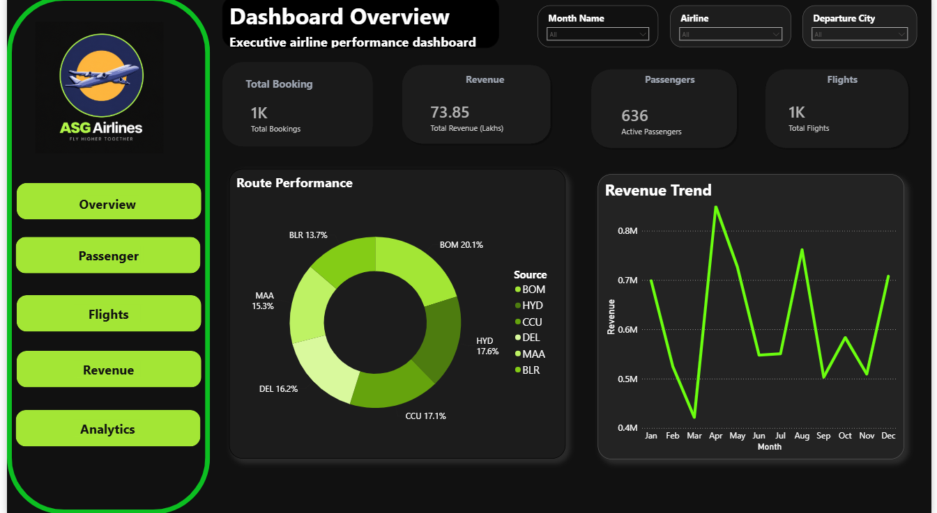
KPIs
- Total Bookings
- Total Revenue
- Active Passengers
- Total Flights
Visuals
- Route Performance (Donut Chart)
- Monthly Revenue Trend (Line Chart)
- Interactive Slicers (Month, Airline, Departure City)
Business Value
Executives can immediately identify revenue trends and busiest routes.

Dashboard 2 – Passenger Analytics
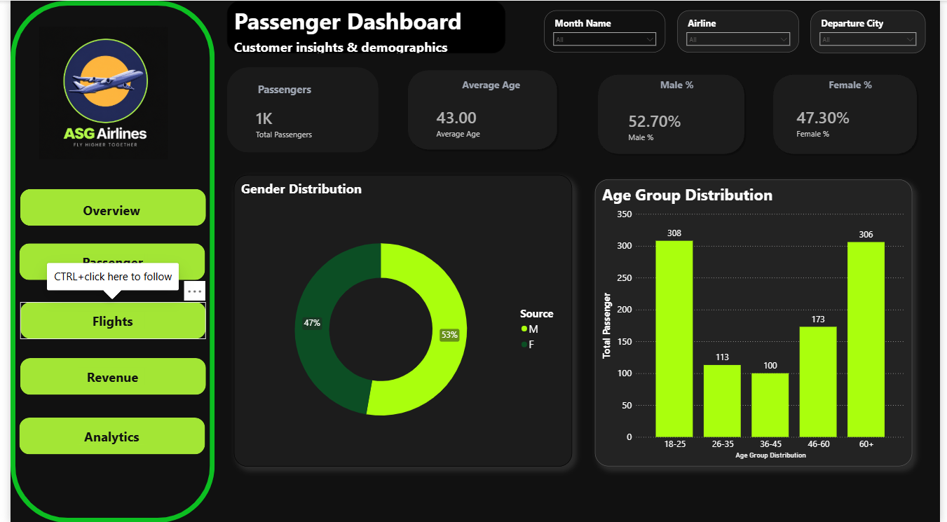

KPIs
- Total Passengers
- Average Age
- Male %
- Female %
Visuals
- Gender Distribution
- Age Group Distribution
Insight
The airline can identify its dominant customer age group and gender ratio for targeted marketing.

Dashboard 3 – Flight Operations
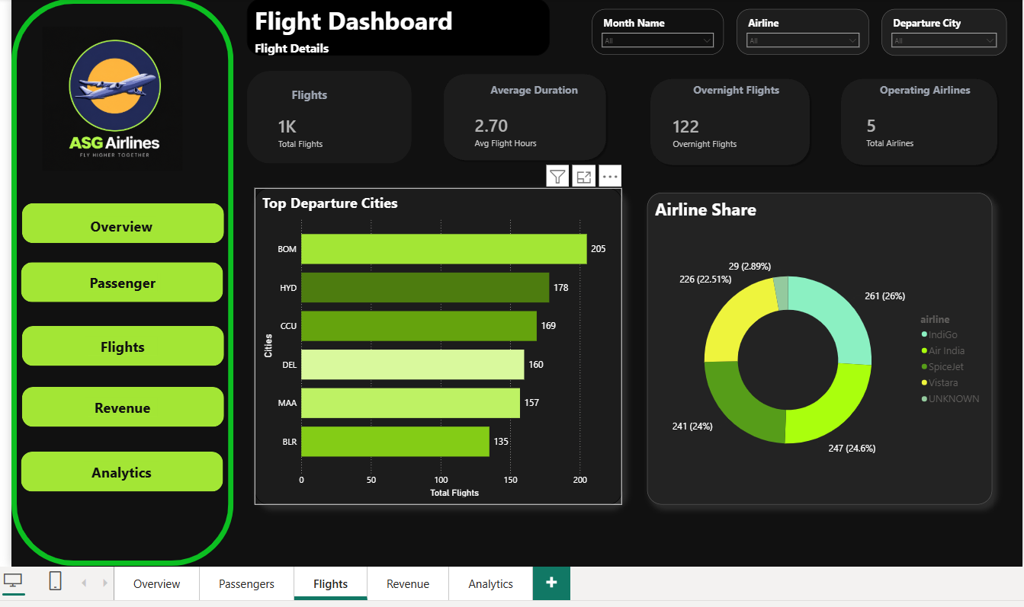
KPIs
- Total Flights
- Average Flight Duration
- Overnight Flights
- Total Airlines
Visuals
- Top Departure Cities
- Airline Market Share
Insight
Operations teams can identify the busiest airports and airline contribution.
Dashboard 4 – Revenue Analysis
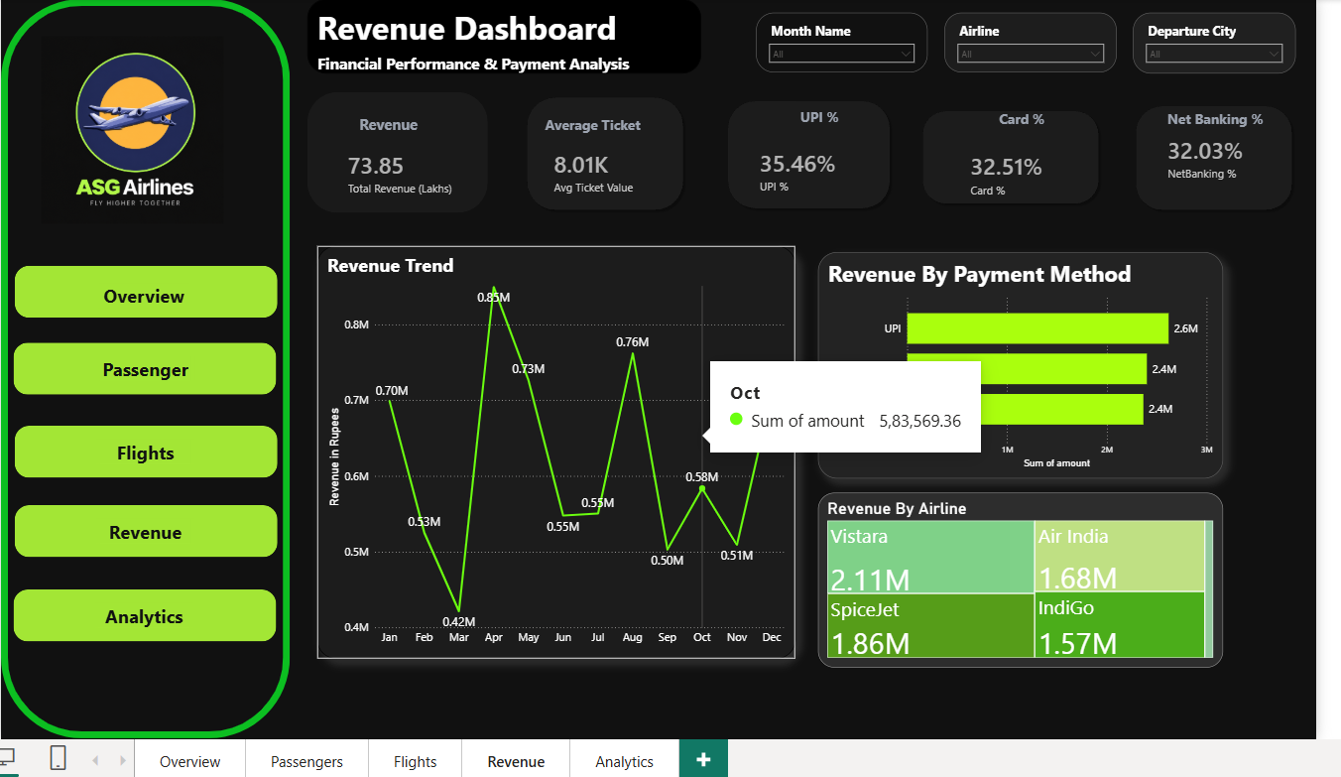

KPIs
- Total Revenue
- Average Ticket Value
- UPI %
- Card %
- Net Banking %
Visuals
- Monthly Revenue Trend
- Revenue by Payment Method
- Revenue by Airline (Treemap)
Insight
Management can compare airline profitability and customer payment preferences.
Dashboard 5 – Business Analytics
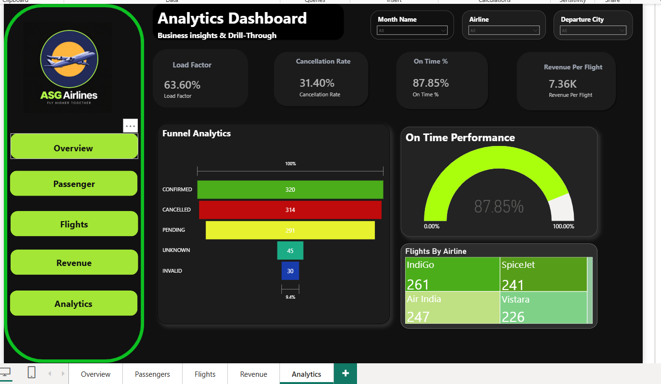

KPIs
- Load Factor
- Cancellation Rate
- On-Time %
- Revenue Per Flight
Visuals
- Funnel Analysis (Booking Status)
- Gauge (On-Time Performance)
- Treemap (Flights by Airline)
Insight
This dashboard helps management monitor service quality and operational performance.

11. Results and Business Insights
The completed BI solution successfully transformed raw airline operational data into an interactive decision-support system. The dashboards enable executives to analyze booking trends, customer demographics, operational efficiency, and revenue performance from a single interface.
Key business insights
- The airline generated 73.85 Lakhs in total revenue.
- 1,000 bookings and 636 active passengers were analyzed.
- Male passengers account for approximately 53% of travellers.
- The 18–25 and 60+ age groups represent the largest customer segments.
- UPI is the most frequently used payment method, indicating strong digital payment adoption.
- BOM is the busiest departure city based on flight volume.
- On-time performance is approximately 88%, indicating good operational reliability.

12. Conclusion
The ASG Airlines project demonstrates a complete end-to-end Data Engineering and Business Intelligence workflow using Python, SQLite, SQL, and Power BI. Starting from raw Excel data, the project implemented a Bronze–Silver–Gold ETL architecture, performed comprehensive data cleaning and validation, designed a Star Schema database, generated analytical KPIs using SQL and DAX, and developed five interactive dashboards.
The solution provides a scalable foundation for airline analytics and illustrates industry-standard practices including dimensional modeling, ETL pipelines, KPI development, and executive dashboard design. The modular folder structure and layered architecture also make the project maintainable and suitable for future enhancements such as real-time data ingestion, cloud deployment, and predictive analytics.
13. Future Scope
Possible improvements for future versions include:
- Integrating real-time flight data through APIs.
- Deploying the pipeline on Azure or AWS cloud services.
- Automating ETL using Apache Airflow.
- Adding machine learning models for demand forecasting.
- Implementing passenger churn and revenue prediction models.
- Publishing dashboards to the Power BI Service with scheduled refresh.

