Nama : Wahyudi

NIM : 181011401636

Kelas : 06TPLE017

Mata Kuliah : Mobile Programming(Tugas aplikasi cuaca)

Markup

<form method="get">

<fieldset>

<ul>

<li>

<label

for="latitude">Latitude</label>

<input type="text" id="latitude" placeholder="e.g. 42.9150747" required>

</li>

<li>

<label for="longitude">Longitude</label>

<input type="text" id="longitude" placeholder="e.g. -77.784323" required>

</li>

</ul>

</fieldset>

<button>Get Weather</button>

</form>

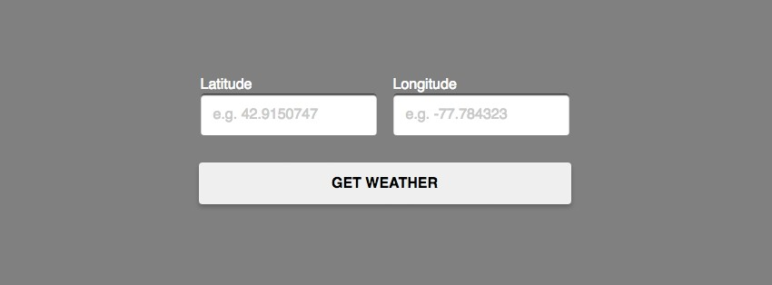

Autofill input

<li>

<label for="city-search">City Name</label>

<input type="text" id="city-search" placeholder="e.g.

Rochester, NY">

</li>

Permintaan API google maps

<script src="https://maps.googleapis.com/maps/api/js?key=[your_ api_key]&libraries=places,geometry"></script> &libraries=places,geometry

Logika

searchBox.addListener('places_changed', function() { var locale = searchBox.getPlaces()[0];

});

https://api.darksky.net/forecast/[key]/[latitude],[long itude]

$.getJSON('https://api.darksky.net/forecast/[key]/[lati tude],[longitude]', function(forecast) {});

$.getJSON([api_url], function(forecast) { console.log(forecast);

});

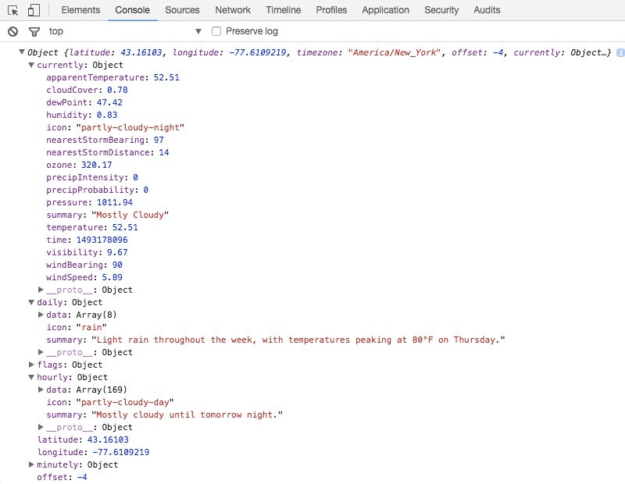

function skycons() { var i,

android hack

icons = new Skycons({ "color" : "#FFFFFF",

"resizeClear": true // nasty

}),

icons

list = [ // listing of all possible

"clear-day", "clear-night",

"partly-cloudy-day", "partly-cloudy-night", "cloudy",

"rain",

"sleet",

"snow",

"wind", "fog"

];

// loop thru icon list array for(i = list.length; i--;) {

var weatherType = list[i], // select each icon from list array

// icons will have the name in the array above attached to the

// canvas element as a class so

let's hook into them.

elements =

document.getElementsByClassName( weatherType );

// loop thru the elements now and set them

up

for (e = elements.length; e--;) { icons.set(elements[e], weatherType);

}

}

// animate the icons