Screenshot folder

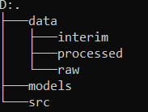

screenshot terminal yang menampilkan command saat Anda membuat venv tersebut



screenshot terminal yang menampilkan command saat Anda mengaktifkan venv tersebut



screenshot terminal yang menampilkan command saat Anda melakukan update PIP



screenshot terminal yang menampilkan command saat Anda melakukan pemasangan packages tersebut

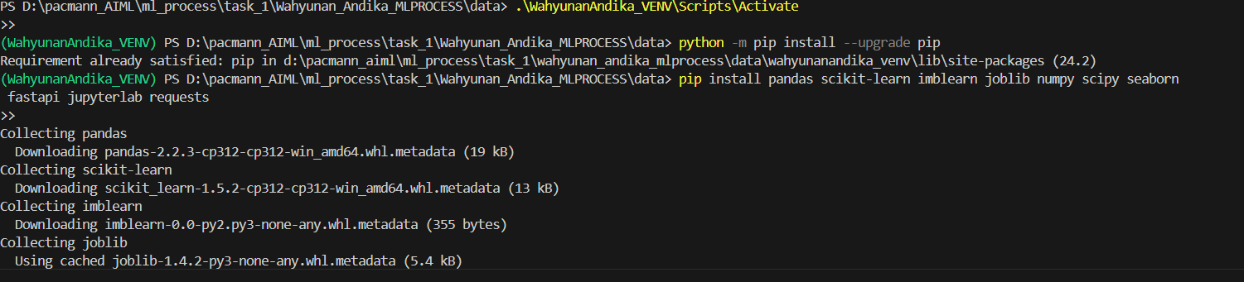

screenshot terminal yang menampilkan command saat Anda menonaktifkan venv

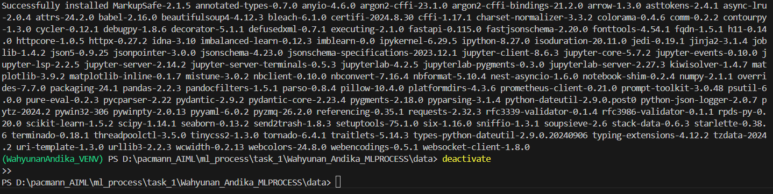

Summarize

Business problem background:

The bank is facing challenges with credit risk and wants to predict customers who might default on their loans.

Business objective:

Reduce Non-Performing Loans (NPL) and detect risky loans early to mitigate potential financial losses.

Business metric to measure success:

Key metrics include reducing the NPL ratio, minimizing defaults, and increasing the accuracy of loan default predictions.

Candidate Machine Learning solution:

A machine learning model that predicts whether a customer will default or not, using historical loan data.

Machine Learning metric to measure success:

Evaluation metrics such as Accuracy, Precision, Recall, and F1-score will be used to assess the model’s performance.

screenshot hasil dari pemindahan file tersebut

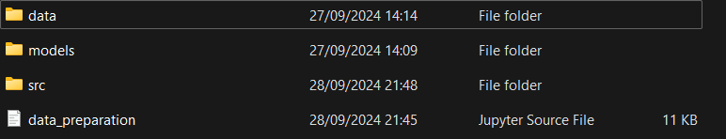

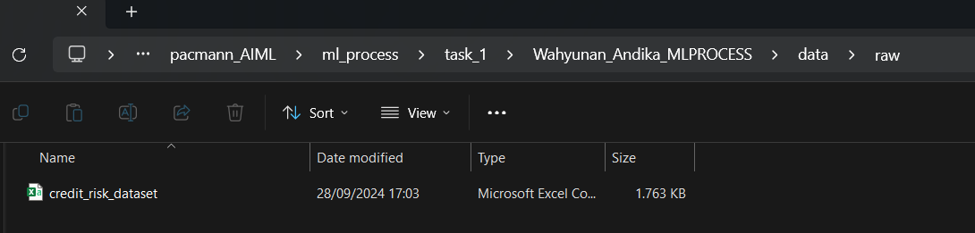

screenshot hasil dari fungsi yang dijalankan

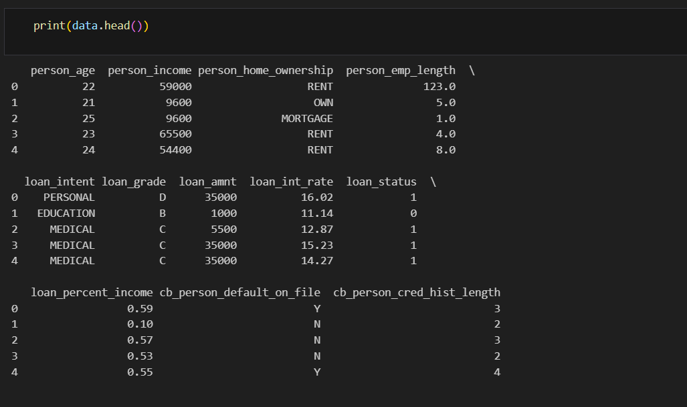

screenshot hasil dari fungsi yang dijalankan

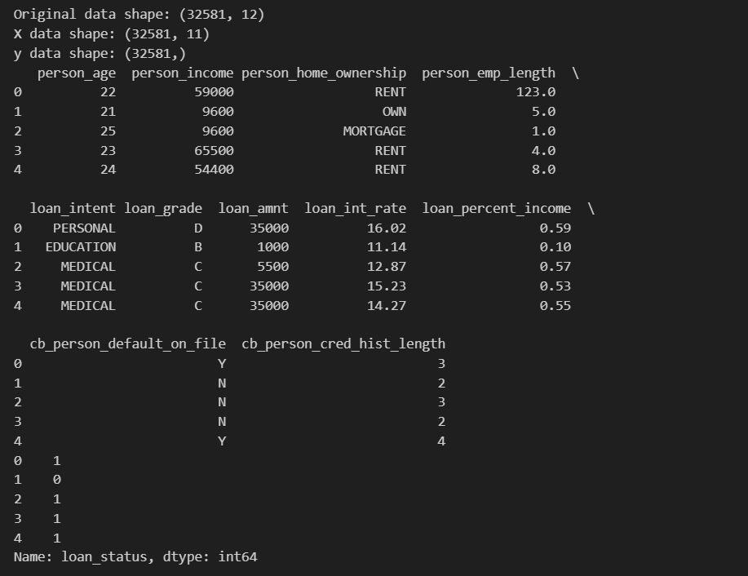

screenshot hasil dari fungsi yang dijalankan

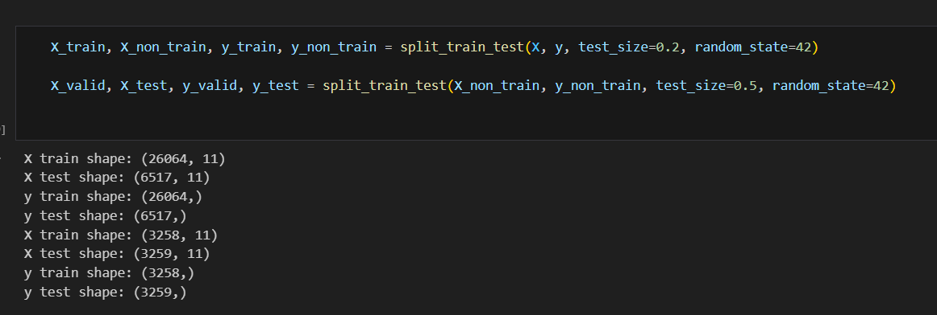

**screenshot hasil dari fungsi yang dijalankan**

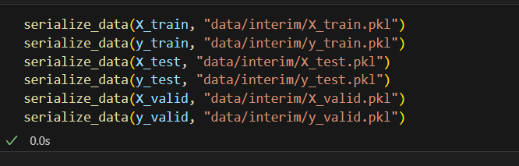

**screenshot hasil dari fungsi yang dijalankan (sertakan screenshot terminal)**

