# Decision Support front-end

Front-end for Decision Support tool.

## Requirements

Use the package manager pip to install flask.

pip install flask

## Usage

$ cd frontend/

$ export FLASK_APP=main.py

$ flask run

* Running on http://127.0.0.1:5000/

Access the test page via <http://127.0.0.1:5000/scenario/test>

## How to use my template with Flask

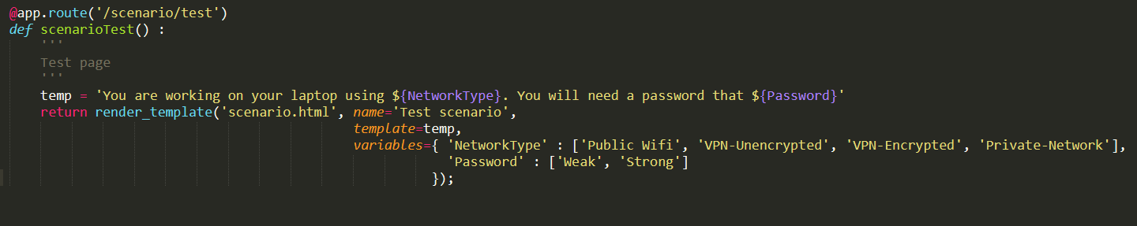

Just simply pass parameters “name”, “template”, and “variables” to the render_template function.

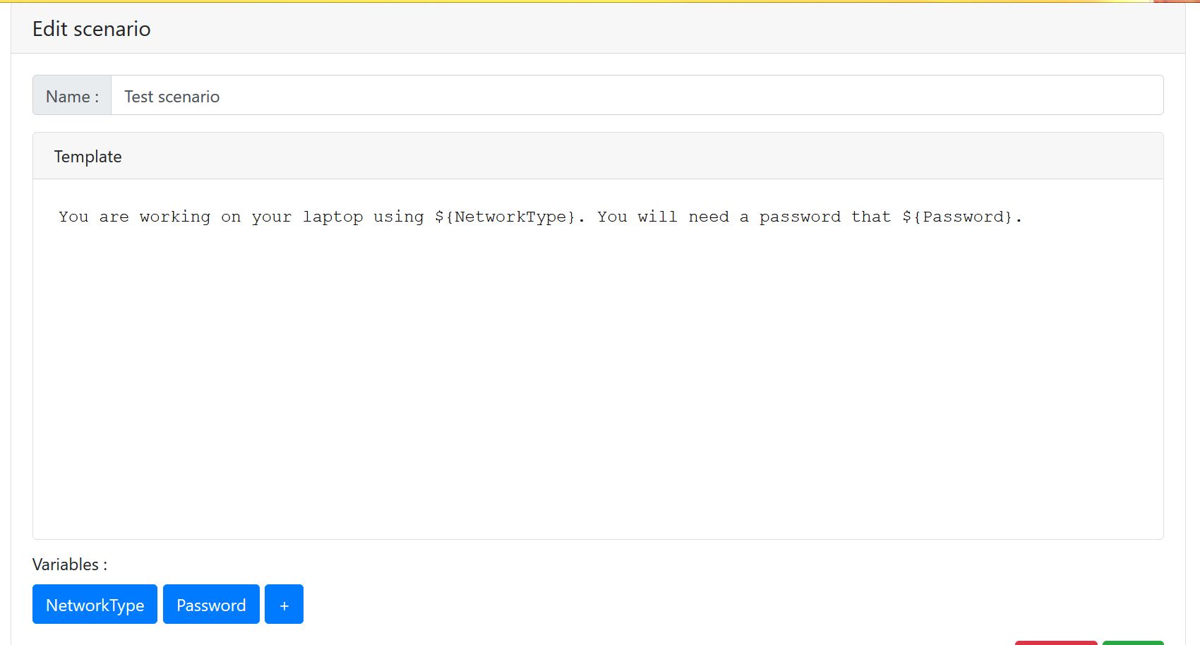

🡨 “variable” will be listed as buttons here

“template” variable will appear as content here.

🡨 “name” variable will be put here

List of level for each variable will be shown when clicked at the variable button.

