THE INSTITUTE OF LANDSCAPE ARCHITECTS VISIT LONGBUSH

On 1 March 2014, two busloads of landscape architects pulled up in front of the Welcome Shelter at Longbush.

The Shelter is still being built, and Sarosh Mulla, its brilliant young designer, was on hand to tell them about the challenges of building a large, sophisticated structure with a zero budget, abundant reserves of enthusiasm and resilience, and an ability to galvanise hundreds of sponsors and volunteers.

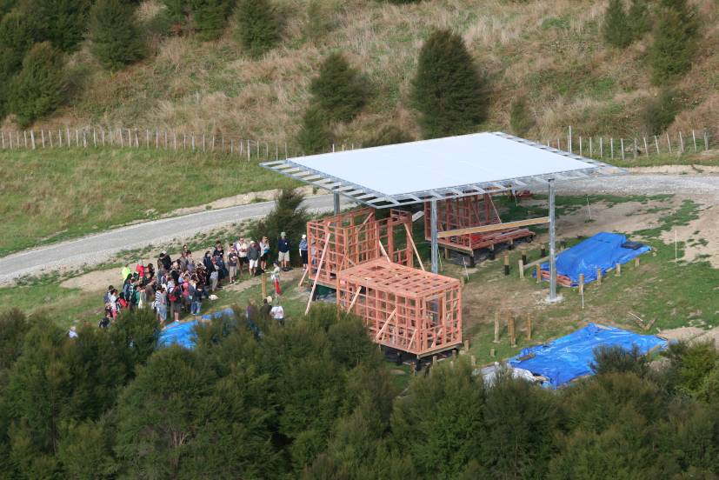

Sarosh Mulla describes the Welcome Shelter project

Afterwards Megan Wraight, the first landscape architect to have been made an Arts Laureate, told them about the 1769 garden that she is designing in front of the Welcome Shelter.

This garden, which will be planted in time for the 250th anniversary of the arrival of Captain James Cook and his Royal Society party of artists and scientists at the mouth of the Waimata river, will include plants descended from seed collected in the bay in 1769 by Joseph Banks and Daniel Solander and later propagated at Kew Gardens in London.

After climbing up Pa Hill, with its superb vistas up and down the Waimata valley, the landscape architects heard Megan talking about her plans for the Ecosanctuary.

From Pa Hill they wandered down past the pond and kumara pits, up the bush track beside the Waikereru stream to the homestead for morning tea, before heading into Longbush Reserve, where Steve Sawyer told them about the restoration of the bush over the past 10 years, the reappearance of many rare and endangered species and the reintroduction of native robins.

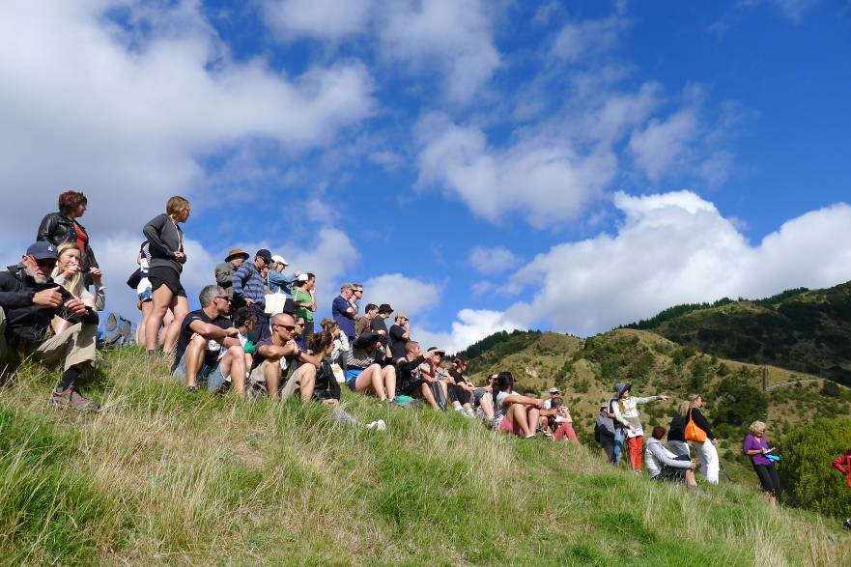

On Pa Hill, Megan Wraight discusses her plans for the Ecosanctuary

At the Pa Harakeke, Janine Te Reo, the kai tiaki (guardian) of the flax collection, described the 60 odd varieties in the Rene Orchiston collection, the care of flax plants and their different uses in weaving.

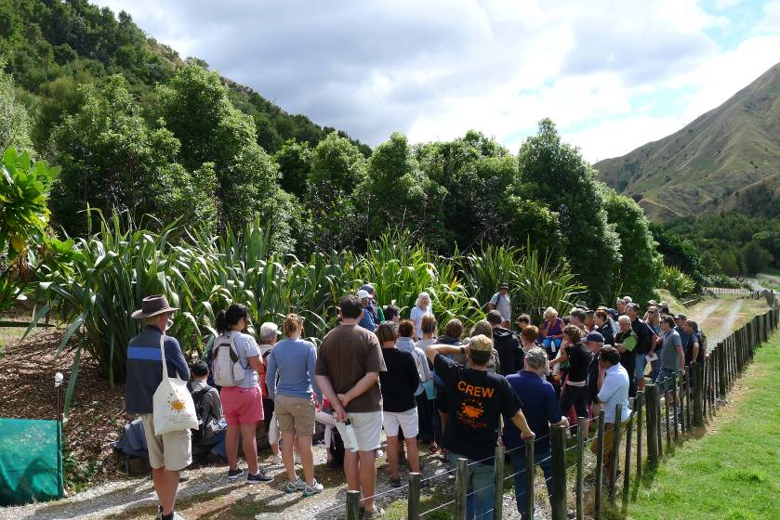

Anne Salmond & Janine Te Reo talk at the Pa Harakeke

Finally, they returned to Longbush Homestead, where Steve Sawyer talked about the restoration of titi (muttonbirds) to this inland site, and Anne Salmond explored the Longbush philosophy of making space for creative ideas and people, and the restoration of the Waimata River.