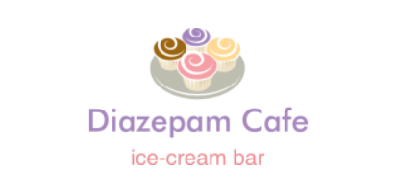

***About Us***

Welcome to Diazepam Café, your favourite ice-cream bar. We’re dedicated to giving you the very best quality in our food as well as service, it aims to provide the highest quality ice-cream. Our café was started as a small local setup and has grown to have 5 outlets in Singapore. Our mission is to make, innovate the finest and best dairy ice-cream with a commitment to incorporate wholesome, natural ingredients for great ice-cream lovers. Our new Diazepam café will be opening in 5th May 2017 on 200, Diazepam Crescent, 100000 Singapore.

So, we hope you enjoy our new café as much as we enjoy offering them to you. If you have any questions or comments, please don’t hesitate to contact us, our phone number is +65-44446677 and you can also email us to [Diazepam@gmail.com](mailto:Diazepam@gmail.com) .

***Products***

Our current products are:

1. Ice-cream – single/double scoop (different flavours)

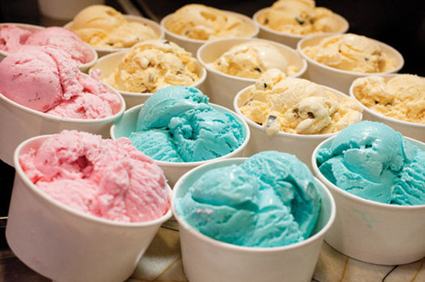

In a single or double scoop, they can be Strawberry, Mints, and Vanilla.

1. Waffle ice-cream

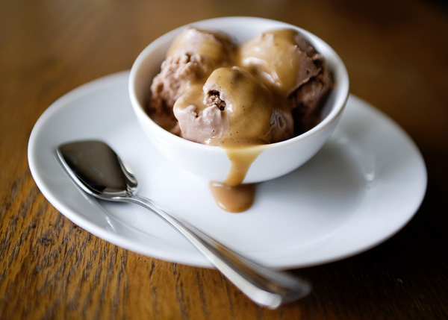

Topped with fresh fruits, a scoop of ice cream, and a dollop of whipped cream, a good waffle is something that you can eat every day. For those of you who prefer something simpler, waffle with maple syrup and butter is equally gratifying.

1. Ice-cream cake

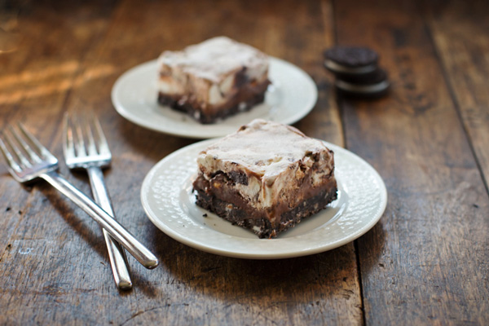

An ice cream cake is a cake that incorporates ice cream. A popular form is a three-layer cake, with a layer of ice cream between two layers of cake, although not all versions contain cake.

1. Fried ice-cream

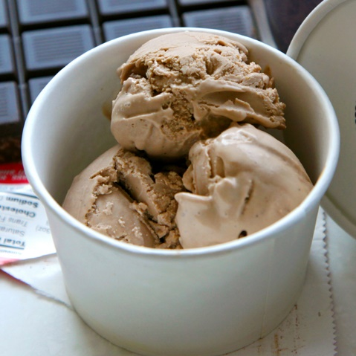

Fried ice cream is a dessert made from a breaded scoop of ice cream that is quickly deep-fried creating a warm, crispy shell around the still-cold ice cream.

1. Ice-cream cookies

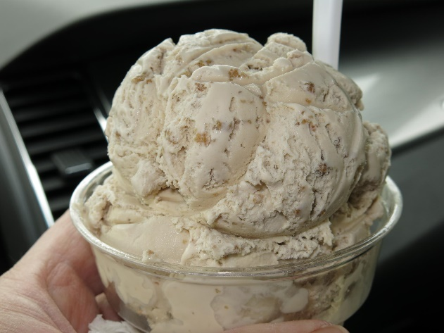

The only thing that makes a warm, chewy chocolate chip cookie better, in my humble opinion, is a scoop of ice cream wedged between it and another cookie. Sure, ice cream is wonderful, and so are cookies, but together they make a Very Important Dessert, one that requires some strategy to assemble flawlessly.

1. Ice-cream sundae – mix & match

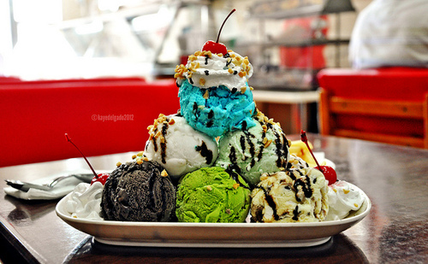

The sundae is a sweet ice cream dessert. It typically consists of one or more scoops of ice cream topped with sauce or syrup, and in some cases other toppings including sprinkles, whipped cream, peanuts, maraschino cherries, or other fruits.

1. Ice-cream float – drink of your choice

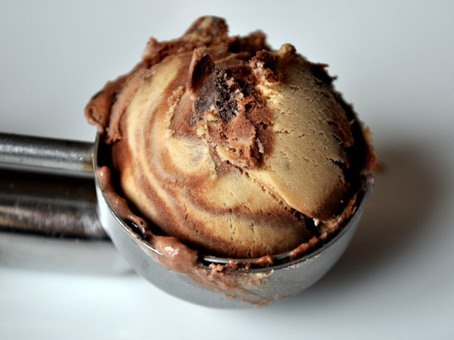

An ice cream float or soda, coke float, root beer float or spider, is a beverage that consists of ice cream in either a soft drink or in a mixture of flavoured syrup and carbonated water.