Supplementary material

Milk allergen quantification in rice flour: An experimental investigation of sampling and testing procedures.
Anders R. Andersenª, Charlotte B. Madsen^{b}, Katrine L. Bøgh^{b}, Ana I. Sancho^{b}.

ªDepartment of Applied Mathematics and Computer Science, Technical University of Denmark, 2800, Kgs. Lyngby, Denmark
^{b}National Food Institute, Technical University of Denmark, 2800, Kgs. Lyngby, Denmark

Materials and methods

Statistical analysis

A Hierarchical Mixed Effects (HME) model was chosen to derive maximum likelihood estimates of the variances on each level in the sampling design (Madsen & Thyregod, 2010). In our HME model, $s ∈S= \{0,0.5,5,...,500\}$ denoted the spiked concentration, $l ∈L= \{100,200\}$ denoted the laboratory sample size, and $t∈T =\{0.5,5\}$ denoted the test portion size. The HME model was used to derive the variances on the laboratory, ${σ(s,l,t)}_{lab}^{2}$, test portion, ${σ(s,l,t)}_{por}^{2}$, and aliquot, ${σ(s,l,t)}_{ali}^{2}$, level, respectively, where the variances are functions of $s$, $l$, and $t$. The total variance of the measured concentration, ${σ(s,l,t)}_{measured}^{2}$, is the sum of the individual variance components as described in equation S1:

${σ(s,l,t)}_{measured}^{2} ={σ(s,l,t)}_{lab}^{2}+{σ(s,l,t)}_{por}^{2}+{σ(s,l,t)}_{ali}^{2}$ (S1)

Our HME model contained the following effects: A deterministic (fixed) intercept, ${c(s,l,t)}_{measured}$, and random intercepts for each laboratory sample, ${τ(s,l,t)}_{i} ̴ N(0,{σ(s,l,t)}_{lab}^{2})$, where $i ∈ \{1,2,...,5\}$, test portion sample, ${ω(s,l,t)}_{j(i)} ̴ N(0,{σ(s,l,t)}_{por}^{2})$, where $j ∈ \{1,2\}$, and a residual error, $ϵ(s,l,t) ̴ N(0,{σ(s,l,t)}_{ali}^{2})$. Thus, the effects ${τ(s,l,t)}_{i}$ and ${ω(s,l,t)}_{j(i)}$ denoted the random effects associated with laboratory and test portion samples, where ${ω(s,l,t)}_{j(i)}$was nested into the $i$’th laboratory sample. The complete model was:

${y(s,l,t)}_{ij} = {c(s,l,t)}_{measured}+{τ(s,l,t)}_{i}+{ω(s,l,t)}_{j(i)}+ϵ(s,l,t)$ (S2)

where ${y(s,l,t)}_{ij}$ denoted the mean measured concentration of a laboratory sample $i$ and test portion sample $j$, where the spiked concentration was $s$, laboratory sample had a size of $l$, and the test portion had a size of $t$.
The parameters of the HME model were fitted using the package ‘nlme’ and function ‘lme’ from the R programming language (Pinheiro et al., 2022; R Development Core Team, 2022). Individual HME models were fitted to obtain estimates of the means and the variances for each combination of the spiked concentrations, $s$, laboratory sample sizes, $l$, and test portion sizes, $t$. This led to 28 estimates of the mean ${c(s,l,t)}_{measured}$, variances ${σ(s,l,t)}_{por}^{2}$ and ${σ(s,l,t)}_{ali}^{2}$. The laboratory sample variances were pooled across the test portion sizes to obtain a single estimate for each combination of a spiked concentration and laboratory sample size, leading to 14 estimates of ${σ(s,l,t)}_{lab}^{2}$.
The assumption of normally distributed residual error was validated by illustrating the residuals in a quantile-quantile (QQ)-plot and a histogram, respectively. Additionally, Pearson’s chi-squared test was conducted to test the hypothesis of normality. In both cases, the residuals were standardised by dividing them by their respective estimates of ${σ(s,l,t)}_{ali}$, hereby accounting for the potential differences in standard deviation. The graphs were created using the functions ‘qqnorm’, ‘qqline’, and ‘hist’, and Pearson’s chi-squared test by using the function ‘person.test’ in the R programming language (R Development Core Team, 2022).
Several permutation tests were conducted to validate the effects of the spiked concentrations above 0 ppm, laboratory sample size and test portion size on the mean measured concentration ${c(s,l,t)}_{measured}$, and the variances ${σ(s,l,t)}_{lab}^{2}$, ${σ(s,l,t)}_{por}^{2}$, and ${σ(s,l,t)}_{ali}^{2}$. The permutation test is a type of resampling method where the reference distribution of the null-hypothesis is created by randomly rearranging the measurements among categories in the data (Good, 2005). In this study, the permutation tests were conducted on standardised measurements, except when validating the effect of the spiked concentrations. First, the mean $μ_{s}$ and standard deviation $σ_{s}$ encompassing all measurements from the lot with a spiked concentration of $s$ were calculated (Table S1). Next, the measurements were standardised with

${x'}_{s} = (x_{s}-μ_{s})/σ_{s}$ (S3)

where ${x'}_{s}$ denotes a standardised measurement and $x_{s}$ a true measurement.
The significance of three main effects, spiked concentration ($s$), laboratory sample size ($l$) and test portion size ($t$) was tested. Additionally, three two-way and one three-way interaction effects were tested, corresponding to all possible interactions:
- Spiked concentration ($s$) - Laboratory sample size ($l$).
- Spiked concentration ($s$) - Test portion size ($t$).
- Laboratory sample size ($l$) - Test portion size ($t$).
- Spiked concentration ($s$) - Laboratory sample size ($l$) - Test portion size ($t$).
The seven effects (three main effects and four interaction effects) led to a total of 28 permutation tests, where each test was based on 10 000 permutations and a significance level of $α=0.05$. The test statistics associated with each effect is described below. The main effects were validated as two-tailed tests and the interaction effects as one-tailed tests, due to the different definitions of test statistics. The insignificantly different parameters were pooled to obtain the final estimates of the mean and variance measured concentration.
Acceptance probabilities were calculated to assess the risks associated with increasing the spiked concentration, sample sizes, and number of samples. Here, $P(x<ρ)$ denoted the acceptance probability of a single new measurement $x$ and a threshold value of $ρ$. Thus, $P(x<ρ) =Φ(z)$, where $Φ(z)$ is the cumulative distribution function of the standard normal distribution (i.e. a normal distribution with a mean of 0 and standard deviation of 1). The standard score, $z$, was calculated with

$z =(ρ-c{\left(s,l,t\right)}_{measured})/σ{\left(s,l,t\right)}_{measured}$ (S4)

For multiple samples, the parameter $κ$ denoted the number of laboratory samples in a setting where a single test portion from each laboratory sample and a single aliquot from each test portion were sampled. If $κ>1$ and $x_{1},x_{2},⋯x_{κ}$ denote the resulting independent measurements, we can obtain an improved acceptance probability by employing the average of the resulting measurements, $\overline{x}=\left(\sum_{i=1}^{κ}{x_{i}}\right)/κ$, into our expression for the acceptance probability. That is, $P\left( \overline{x}<ρ\right) =Φ(z)$, where the standard score, $z$, is calculated with

$z =(ρ-c{\left(s,l,t\right)}_{measured})/({σ(s,l,t)}_{measured}/\sqrt{κ})$ (S5)

Test statistics in the permutation tests
The following test statistics were used for the effects associated with variances:
Main effects:
- Spiked conc. ($s$): $\sum_{\{γ_{2},γ_{2}\}∈Γ}^{ }{\sum_{l∈L}^{ }{\sum_{t∈T}^{ }{log\left(\frac{{σ(γ_{1},l,t)}_{j}^{2}}{{σ(γ_{2},l,t)}_{j}^{2}}\right)}}} ∀j∈J.$
- Lab. sample size ($l$): $\sum_{s∈S\backslash 0}^{ }{\sum_{t∈T}^{ }{log\left(\frac{{σ(s,100,t)}_{j}^{2}}{{σ(s,200,t)}_{j}^{2}}\right)}} ∀j∈J$.
- Test por. size ($t$): $\sum_{s∈S\backslash 0}^{ }{\sum_{l∈L}^{ }{log\left(\frac{{σ(s,l,0.5)}_{j}^{2}}{{σ(s,l,5)}_{j}^{2}}\right)}} ∀j∈J$.
Interaction effects:
- Spiked conc. ($s$) - Lab. sample size ($l$): $\sum_{\{γ_{1},γ_{2}\}∈Γ}{\sum_{t∈T}{SD_{ l∈L}\left\{log\left(\frac{{σ(γ_{1},l,t)}_{j}^{2}}{{σ(γ_{2},l,t)}_{j}^{2}}\right)\right\}}} ∀j∈J.$
- Spiked conc. ($s$) - Test por. size ($t$): $\sum_{\{γ_{1},γ_{2}\}∈Γ}{\sum_{l∈L}{SD_{t∈T}\left\{log\left(\frac{{σ(γ_{1},l,t)}_{j}^{2}}{{σ(γ_{2},l,t)}_{j}^{2}}\right)\right\}}} ∀j∈J.$
- Lab. sample size ($l$) - Test por. size ($t$): $\sum_{s∈S\backslash 0}{SD_{t∈T}\left\{log\left(\frac{{σ(s,100,t)}_{j}^{2}}{{σ(s,200,t)}_{j}^{2}}\right)\right\}} ∀j∈J.$
- Spiked conc. ($s$) - Lab. sample size ($l$) - Test por. size ($t$): $\sum_{\{γ_{1},γ_{2}\}∈Γ}{SD_{t∈T}\left\{SD_{l∈L}\left\{log\left(\frac{{σ(γ_{1},l,t)}_{j}^{2}}{{σ(γ_{2},l,t)}_{j}^{2}}\right)\right\}\right\}} ∀j∈J.$
The following test statistics were used for the effects associated with the mean measured concentration:
Main effects:
- Spiked conc. ($s$): $\sum_{\{γ_{1},γ_{2}\}∈Γ}{\sum_{l∈L}{\sum_{t∈T}{{c(γ_{1},l,t)}_{measured}-{c(γ_{2},l,t)}_{measured}}}}.$
- Lab. sample size ($l$): $\sum_{s∈S\backslash 0}{\sum_{t∈T}{{c(s,100,t)}_{measured}-{c(s,200,t)}_{measured}}}$.
- Test por. size ($t$): $\sum_{s∈S\backslash 0}{\sum_{l∈L}{{c(s,l,0.5)}_{measured}-{c(s,l,5)}_{measured}}}$.
Interaction effects:
- Spiked conc. ($s$) - Lab. sample size ($l$): $\sum_{\{γ_{1},γ_{2}\}∈Γ}{\sum_{t∈T}{SD_{ l∈L}\left\{{c(γ_{1},l,t)}_{measured}-{c(γ_{2},l,t)}_{measured}\right\}}}.$
- Spiked conc. ($s$) - Test por. size ($t$): $\sum_{\{γ_{1},γ_{2}\}∈Γ}{\sum_{l∈L}{SD_{t∈T}\left\{{c(γ_{1},l,t)}_{measured}-{c(γ_{2},l,t)}_{measured}\right\} }}.$
- Lab. sample size ($l$) - Test por. size ($t$): $\sum_{s∈S\backslash 0}{SD_{t∈T}\left\{{c(s,100,t)}_{measured}-{c(s,200,t)}_{measured}\right\} }.$
- Spiked conc. ($s$) - Lab. sample size ($l$) - Test por. size ($t$): $\sum_{\{γ_{1},γ_{2}\}∈Γ}{SD_{t∈T}\left\{SD_{l∈L}\left\{{c(γ_{1},l,t)}_{measured}-{c(γ_{2},l,t)}_{measured}\right\}\right\}}.$
In the above, ${σ(s,l,t)}_{j}^{2}$ denotes the variance on level $j∈J = \{lab,por,ali\}.$ Furthermore, the set $Γ$ denotes the space of all possible pairwise combinations of spiked concentrations $\{γ_{1},γ_{2}\}$. The set $Γ$ contained $\left({6 \atop 2}\right)=15$ pairs since all six spiked concentrations above 0 ppm were analysed. Finally, $SD_{l∈L}\{⋯\}$ and $SD_{t∈T}\{⋯\}$ denotes the calculation of the standard deviation over the laboratory sample sizes $l∈L$ and test portion sizes $t∈T$, respectively.

Table S1: Mean and standard deviation milk protein concentrations of 560 samples analysed by ELISA, separated by spiked concentration used in the standardisation of the measured concentrations.

Spiked concentration (ppm) | 0 | 0.5 | 5 | 20 | 50 | 250 | 500
Mean (ppm) | 0.18 | 0.68 | 4.38 | 24.46 | 53.96 | 267.20 | 581.05
Standard deviation (ppm) | 0.09 | 0.34 | 2.35 | 5.11 | 15.56 | 115.48 | 173.41
ppm: parts per million

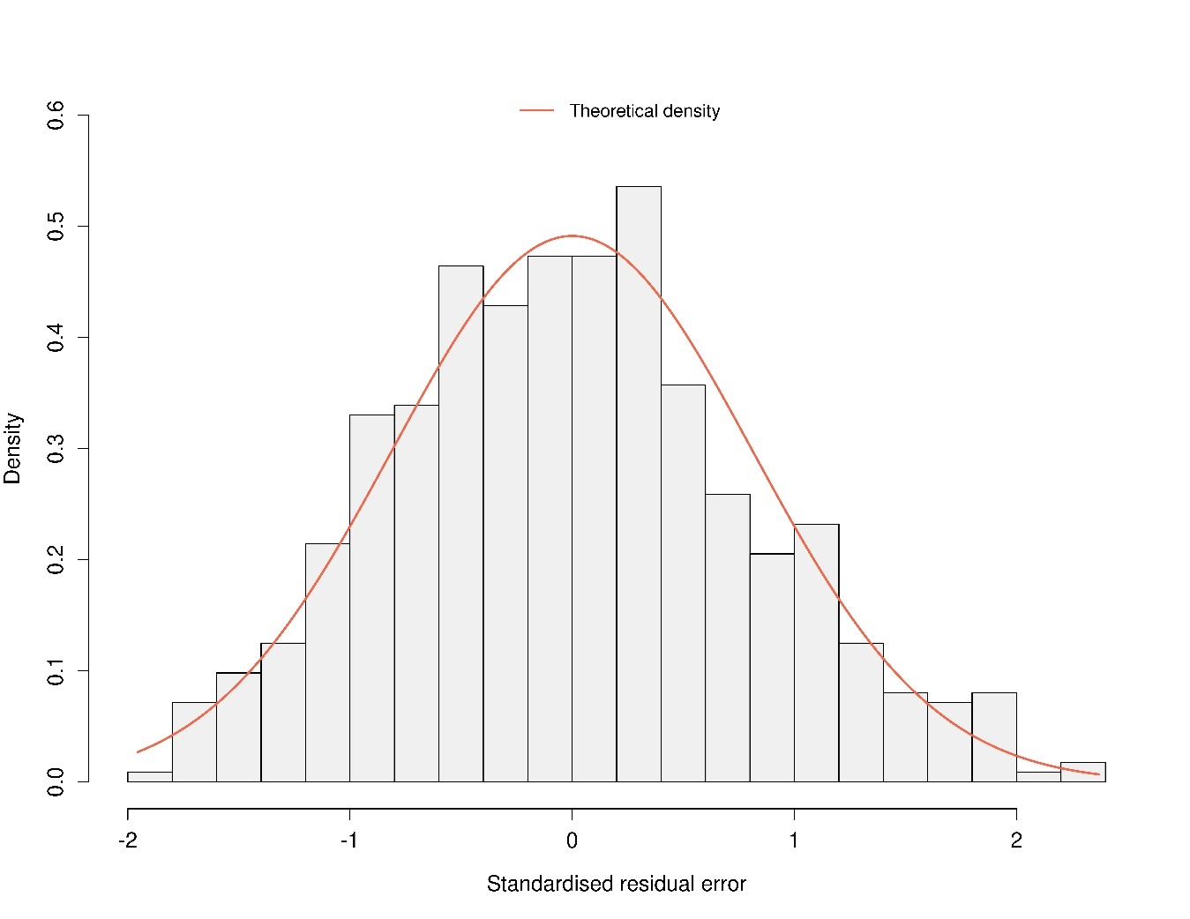
Figure S1: Histogram of the standardised residuals for milk protein concentration in 560 samples, including the theoretical density of the normal distribution.

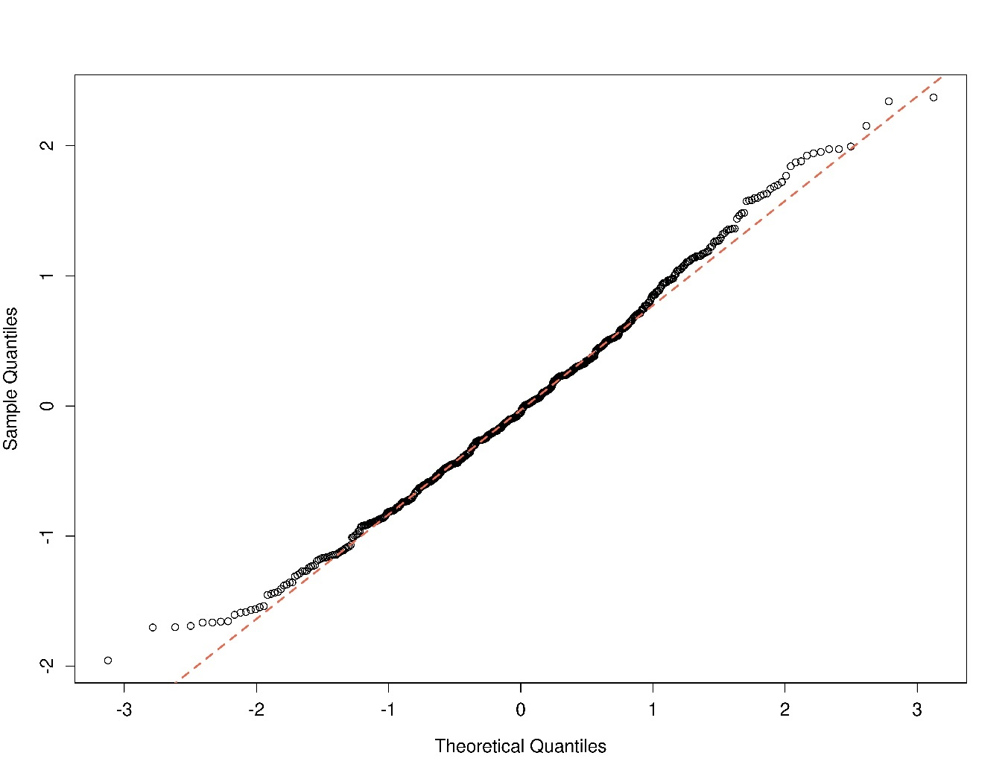
Figure S2: Normal distribution quantile-quantile (Q-Q)-plot of the standardised residuals for milk protein concentration in 560 samples.

References
Good, P. I. (2005). Permutation, Parametric and Bootstrap Tests of Hypotheses. In Good P (Ed.), Permutation, Parametric and Bootstrap Tests of Hypotheses (Third Edition). Springer Science. https://doi.org/10.1007/B138696
Madsen, H., & Thyregod, P. (2010). Introduction to General and Generalized Linear Models. CRC Press. https://doi.org/10.1201/9781439891148
Pinheiro, J., Bates, D., & R Core Team. (2022). nlme: Linear and Nonlinear Mixed Effects Models. R package version 3.1-160. https://CRAN.R-project.org/-package=nlme.
R Development Core Team. (2022). R: A Language and Environment for Statistical Computing. https://www.R-project.org/

