What is the battle of Actium?
It was a naval battle between the forces of Octavian and Marc Antony who both wanted to be the ruler of Rome after the previous ruler was assassinated.

Battle motivations
After the assassination of Julius Caeser, and the fall of the first triumvirate, Octavian wanted to control the Roman empire, Marc Antony, who was currently married to Octavian’s sister called Octavia Minor, also wanted to control it (these two were part of the second triumvirate, but that had been largely disbanded after the third member waged war on the other two and was promptly exiled). Marc started acting independent of the true heir, Octavian, and divorced Octavia and went to Egypt to try and get a boy who was the son of Julius Ceaser by Cleopatra, called Caesarion, to challenge Octavian's power. In Egypt, he was a lover of Cleopatra. Octavian, who was largely in charge of the Roman Senate, managed to convince the majority of the Senate to believe that Marc was a separatist threat to Roman civilization by reading out his “will” which said that he was planning to give his part of the Roman empire to Cleopatra, which was the entire east side of the Mediterranean, and sent a large amount of their naval fleets to destroy them.

Battle dates
2nd of September, 31 BC after a decade of rivalry between Octavian and Mark Antony.

Battle outcomes
Cleopatra killed herself.
Octavian became Augustus and converted the Roman republic into the Roman empire.
Octavian founded a city.
The Ptolemaic line died.

Battle people
Octavian who becomes Augustus
Marcus Agrippa, leader of Octavian’s naval fleet
Mark Antony and his fleets
Cleopatra and her fleets

Battle Map
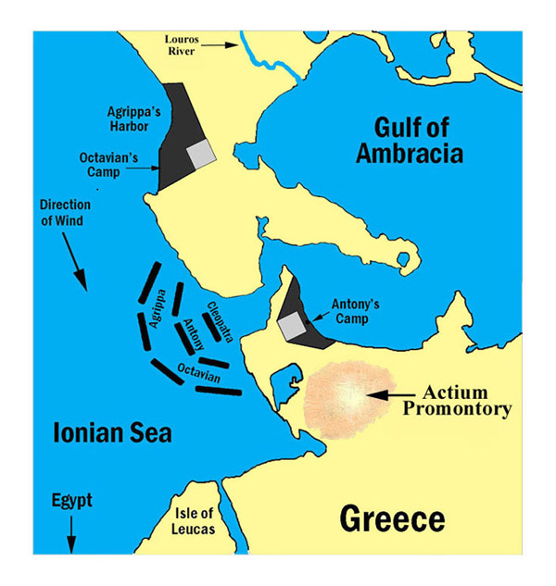

Cleopatra
Ptolemaic queen
Lover of Marc Antony
She had a son with Ceaser.
She married two of her brothers, and killed one of them so he wouldn’t get the crown.
She was descended from Ptolemy.
She had three children with Marc Antony, and Octavian killed all her male children, so there would no successors.
Caesarion was the son of Cleopatra by Ceaser, who was later killed so there would be no strong claim to the throne.

Marc Antony
Was a popular contester for the rule of Rome.
General for Ceaser’s army

Octavian --> Augustus
Was adopted by Ceaser, which is why he wasn’t a true heir to the throne, as Caesarion was. He was, however, the great nephew of Ceaser.

Military tactics
Octavian:
Octavian prepared for this war years in advance. His plans began to come into action when he (probably) forged a document showing that Marc Antony wanted to give Cleopatra VIII Philopator, his “Mistress” (Wife) Roman land, which is treason because she was Egyptian. Octavian sailed with 120,000 men to Dalmatia north of Marc’s camp and blocked him from entering Italy and secured a bridgehead at the Gulf of Ambracia. Meanwhile, he sent his trusty general, Marcus Agrippa, to create a blockade around Corinth and other places in southern Peloponnese. This starved out Antony’s men, forcing them to have a naval battle, where Octavian’s larger fleet of 400 ships had the advantage. In addition to having a larger fleet, Marcus Agrippa was an excellent naval commander, whereas Antony was not very capable of commanding battles at sea. On the morning of the actual battle, Octavian and Agrippa commanded their fleets to spread out and focus on strengthening the wings, so Antony and Cleopatra wouldn't out flank them, but it was the wrong choice as Antony went straight through the middle of their fleets. Only he and a few other of his ships escaped, and they fled, leaving the rest of their army fully exposed to attacks from Octavian’s fleet, which all came and brutally destroyed them with onboard catapults that launched flaming projectiles and absolutely decimated the majority of the fleet. After this, the rest of Marc Antony’s army essentially switched sides at some point in the next year. Octavian pursued Marc Antony and Cleopatria, and when he laid siege to Alexandria, they killed themselves.

Marc Antony + Cleopatra:

