Loan Default & Credit Risk Prediction
Analysing borrower behaviour and predicting default with SQL, Python and Tableau
Project report
Dataset: Give Me Some Credit (Kaggle), 150,000 borrowers
Tools: SQL (SQLite) · Python (pandas, scikit-learn) · Tableau

1. Executive summary
A lender wants to know which customers are likely to default and which characteristics are associated with repayment problems. Using 150,000 borrower records, this project cleans the data, answers seven business questions with SQL and Python, builds and compares three predictive models, and prepares the results for a Tableau dashboard.
Headline results
About 1 in 15 borrowers (6.68%) defaults. Payment history and credit utilization are the dominant risk signals. A gradient-boosting model separates risky from safe borrowers well (ROC AUC 0.87) and its probabilities are well calibrated. Reviewing the riskiest 10% of applicants finds 55% of all defaults.

- Default rate: 6.68% (10,026 of 149,999 borrowers).
- Strongest drivers: past-due history (2.8% default if never late vs 35% if 60+ days late) and revolving credit utilization (1.8% below 10% used vs 37% when over the limit).
- Income: moderate, steady effect (about 9% default below 4,000 a month vs 4% above 10,000).
- Highest-risk segments: borrowers with a 60+ day late record and utilization above 75% default 41-46% of the time. The top five segments hold 6% of borrowers but 37% of defaults.
- Prediction: ROC AUC 0.869, KS 0.58 on held-out data (5-fold CV 0.866). A cost-based decision rule cuts expected cost by about 36% versus approving everyone (under an illustrative 5:1 cost assumption).
- Data limitation: the dataset has no loan-amount field, so credit exposure is studied through proxies (utilization, debt ratio, number of credit lines).

2. Business problem and data

2.1 Questions addressed
# | Business question | Where answered
1 | What percentage of borrowers default? | Section 4.1; SQL 02
2 | Which customer characteristics are associated with default? | Section 4.2; SQL 03
3 | Does loan amount (credit exposure) affect default rates? | Section 4.3; SQL 04
4 | How does income relate to repayment? | Section 4.4; SQL 05
5 | Which customer segments have the highest risk? | Section 4.5; SQL 06
6 | Can we predict whether a borrower will default? | Section 5
7 | What factors are most important to the prediction? | Section 6

2.2 Dataset
The Kaggle Give Me Some Credit training file has 150,000 borrowers and 10 input variables. The target, SeriousDlqin2yrs (renamed default), is 1 if the borrower became 90 or more days past due within two years.
Variable (short name) | Meaning
default | 1 = 90+ days past due within 2 years (target)
utilization | Credit-card and personal-line balances divided by credit limits
age | Borrower age in years
late_30_59 / late_60_89 / late_90 | Times 30-59, 60-89 and 90+ days late
debt_ratio | Monthly debt payments divided by monthly gross income
income | Monthly income
open_lines | Number of open loans and credit lines
real_estate | Number of mortgage / real-estate loans
dependents | Number of dependents

3. Data quality and cleaning
Real credit data is rarely clean. The audit found the issues below. Where unsure, the approach was to flag and keep records rather than delete them, because removing the 20% of rows with missing income would bias the results. The same rules are implemented in Python (clean_data function) and SQL (credit_clean view), and both produce identical results.
Issue found | Records | Treatment
Missing monthly income | 29,731 (19.8%) | Flag income_missing; median fill inside the model pipeline
Missing dependents | 3,924 (2.6%) | Flag; median fill
Age of 0 | 1 | Dropped
Past-due counts of 96 or 98 (placeholder codes) | 269 | Reset to 0 and flagged; these rows default at 55% so the information is kept
Utilization up to 50,708x | 371 above 200% | Capped at 2.0
Debt ratio holds a raw amount when income is missing, or above 5 | 32,083 | Blanked out and flagged
Extreme incomes (to 3 million a month) | 301 above 50,000 | Capped at 50,000

4. Analysis findings

4.1 Q1: What percentage of borrowers default?
6.68% of borrowers (10,026 of 149,999) defaulted: about 1 in 15. The data is therefore imbalanced. A model that predicted that nobody defaults would be 93% accurate but useless, so models are judged with AUC, precision-recall and lift rather than accuracy.
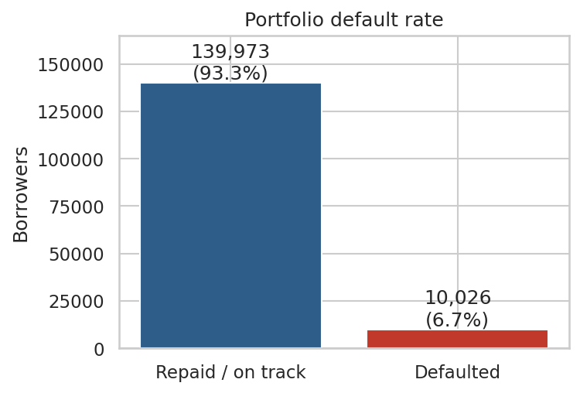
Figure 1: Portfolio default rate

4.2 Q2: Which characteristics are associated with default?
Payment history is the clearest signal. Borrowers who were never late default at 2.8%. Those who were 30-59 days late default at 12%, and those 60+ days late at 35%. Four or more 90-day lates push the rate to about 66%.
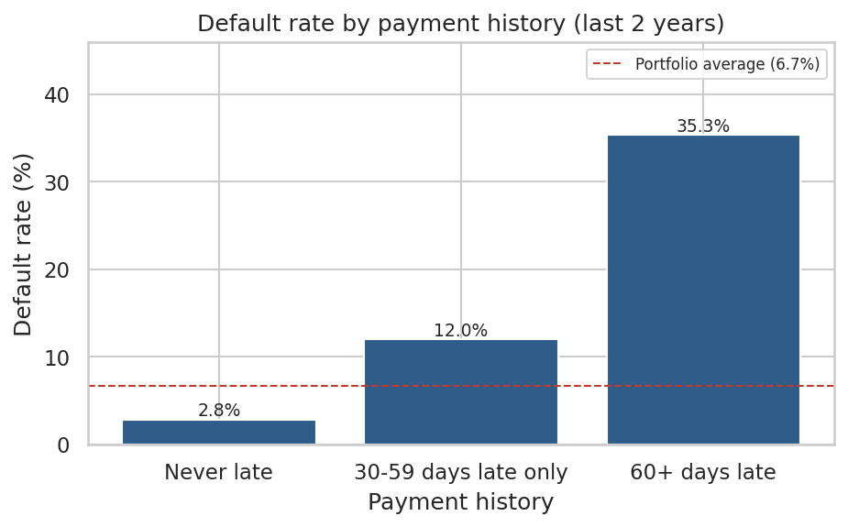
Figure 2: Default rate by payment history
Age shows a steady gradient: 11% default at ages 18-35, falling to 2.4% for borrowers over 65. Default also rises steadily with household size, from about 6% with no dependents to about 10% with four or more.
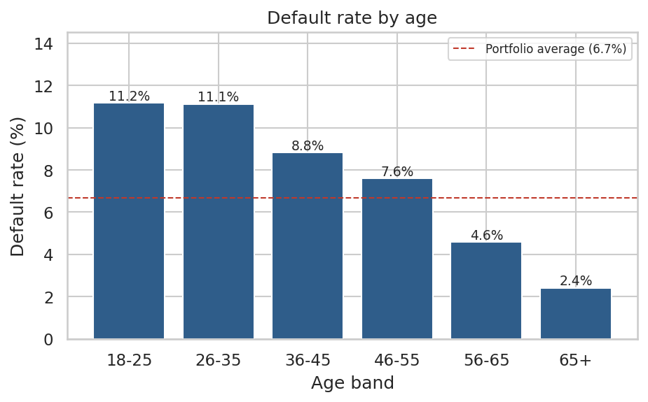
Figure 3: Default rate by age
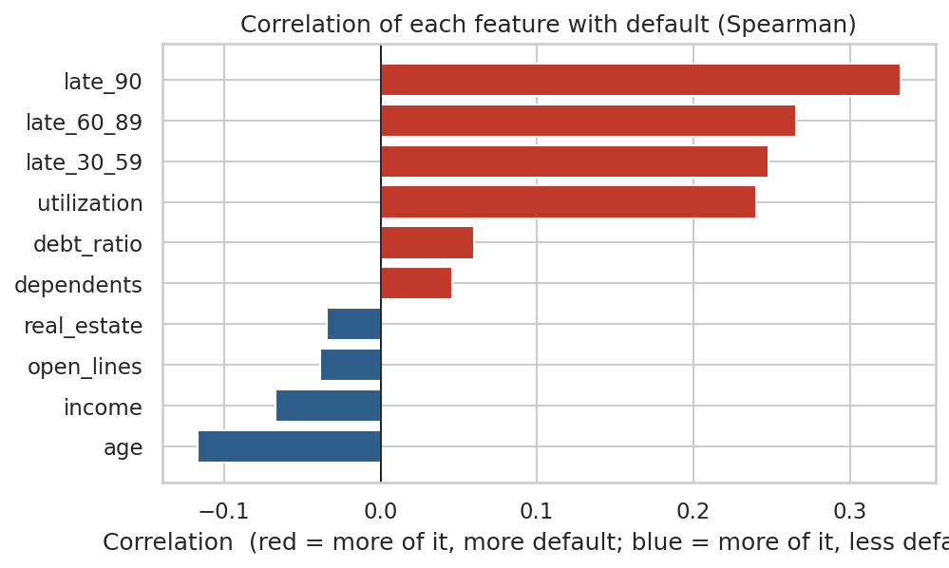
Figure 4: Spearman correlation of each feature with default

4.3 Q3: Does loan amount affect default? (credit-exposure view)
Data limitation
The dataset contains no loan-amount column, so this question cannot be answered literally. The analysis uses the closest available measures of how much credit a borrower carries.

- Utilization: the default rate rises from 1.8% (under 10% used) to 18% (75-100%) and 37% for borrowers over their limit.
- Debt ratio: risk is flat up to about 0.4, then rises to 10.6% at 0.6-1.0 and 13% above 1.0.
- Open credit lines: borrowers with 0-2 lines (a thin credit file) default at about 13%, roughly double the 5-7% seen elsewhere.
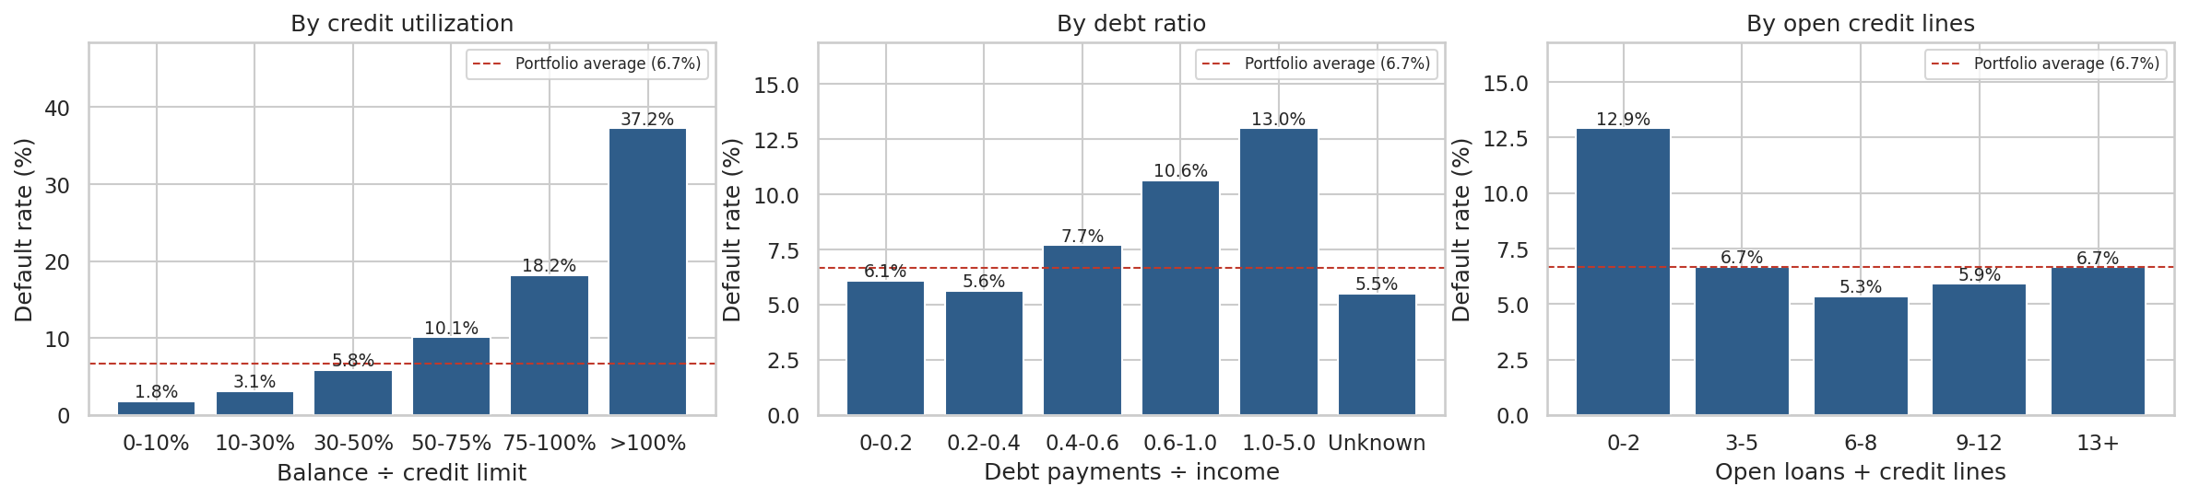
Figure 5: Default rate by utilization, debt ratio and open credit lines
The conclusion is that how much debt matters mainly relative to limits and income, not as an absolute amount.

4.4 Q4: How does income relate to repayment?
Default falls steadily as income rises: about 9% for borrowers earning under 4,000 a month, down to 4.3% above 10,000. Median income is also lower among defaulters (4,500 vs 5,466). The relationship is weaker than for payment history or utilization. Borrowers with unreported income are not riskier (5.6%, below the 6.7% average), so the missing flag is retained as a feature.
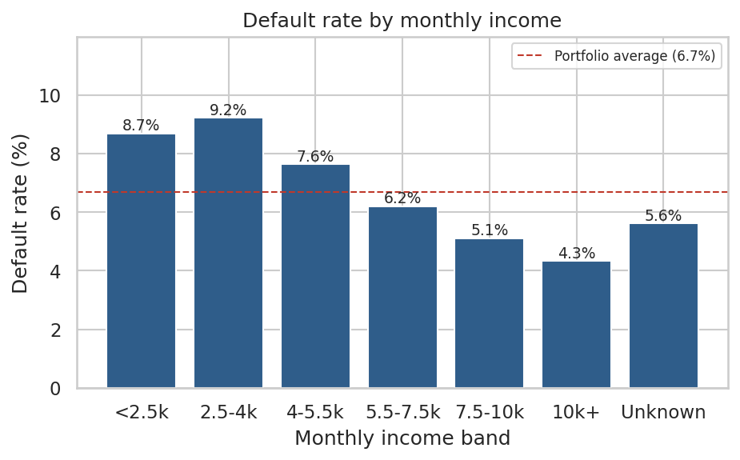
Figure 6: Default rate by monthly income

4.5 Q5: Which customer segments have the highest risk?
Segments were defined as payment history by utilization group by age group (27 combinations). The riskiest are borrowers with a 60+ day late record and utilization above 75%, defaulting 41-46% of the time, about 6-7 times the portfolio average, across all age groups. The five riskiest segments account for 6% of borrowers but 37% of all defaults. The safest segment (never late, utilization below 30%, age 55+) defaults at 0.8%.
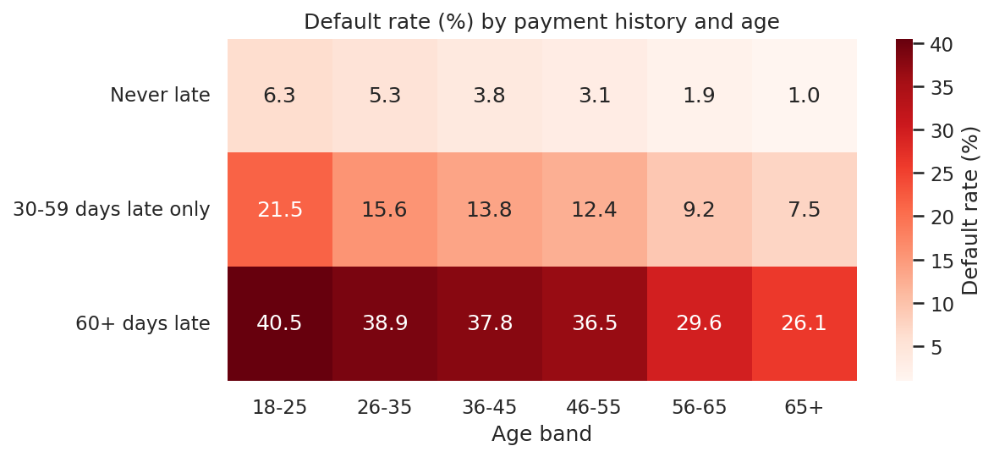
Figure 7: Default rate (%) by payment history and age band
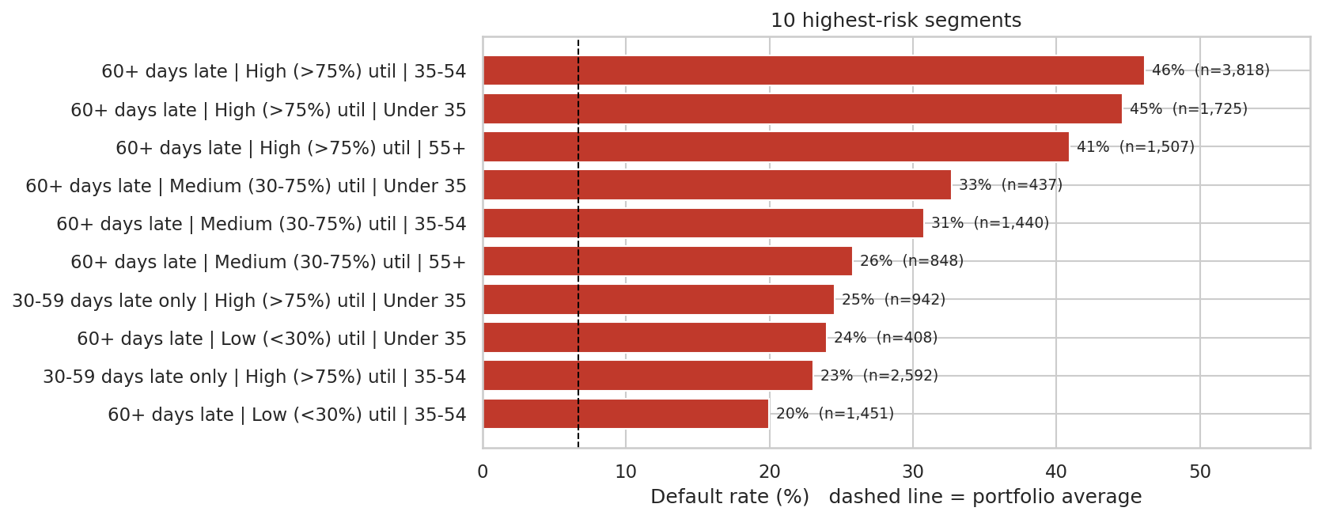
Figure 8: The ten highest-risk segments

5. Q6: Can we predict default?

5.1 Approach
- 80/20 stratified train/test split; the test set is untouched until evaluation.
- Median filling and scaling are learned from training data only, inside a pipeline, to avoid information leaking from the test set.
- Three models of increasing complexity: Logistic Regression (explainable benchmark), Random Forest, and Gradient Boosting (scikit-learn; the notebook switches to XGBoost automatically if installed).
- Class imbalance handled with class weights; evaluated with ROC AUC, PR AUC and the KS statistic.

5.2 Results
Model | ROC AUC | PR AUC | KS
Gradient Boosting | 0.869 | 0.403 | 0.582
Random Forest | 0.866 | 0.390 | 0.583
Logistic Regression | 0.861 | 0.382 | 0.565
Table: Hold-out test set (30,000 borrowers). PR AUC baseline is the default rate, 0.067.
All three models rank borrowers well above chance, and the simple Logistic Regression is only slightly behind the tree models, which indicates that most of the signal is simple and roughly monotonic. Gradient Boosting was used for scoring and decisions. A 5-fold cross-validated AUC of 0.866 agrees closely with the hold-out result, so the performance is not a lucky split.
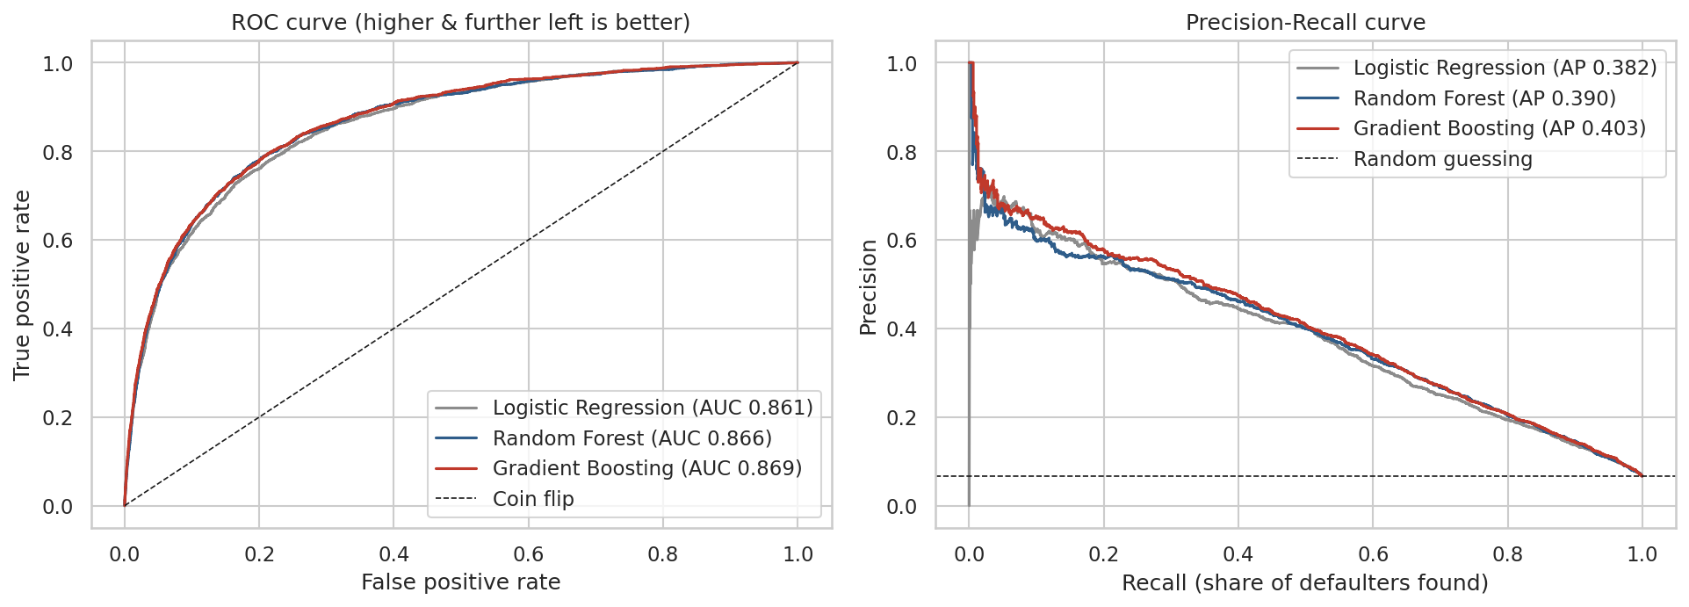
Figure 9: ROC and precision-recall curves on the hold-out set

5.3 Calibration
Predicted probabilities track actual default rates almost exactly, so they can be read at face value. This is what allows a cost-based decision rule to be applied directly.
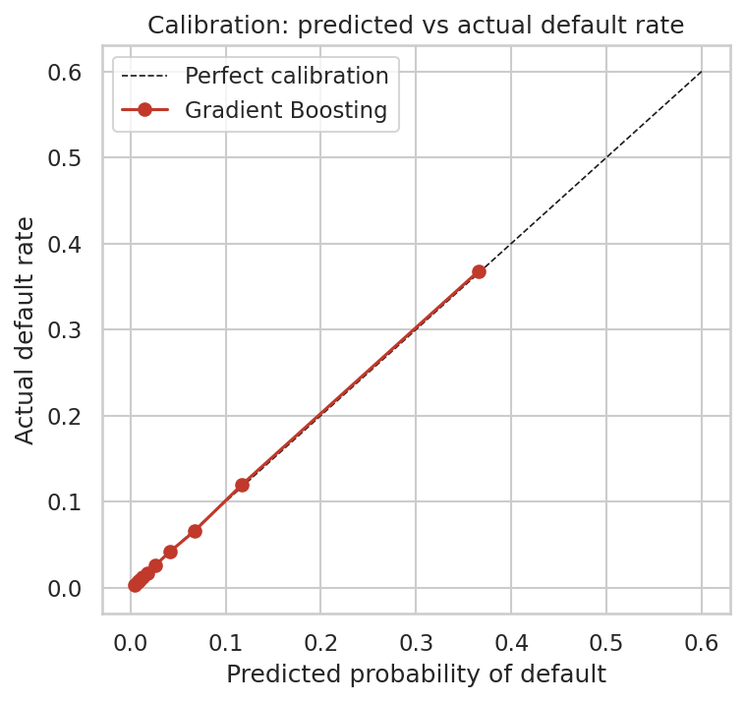
Figure 10: Calibration of predicted default probability

5.4 From probability to decision
The lender needs approve or decline decisions. Assuming a missed default costs five times as much as wrongly declining a good borrower (an illustrative assumption to be replaced with real finance figures), the cost-minimising cut-off is 1 / (1 + 5) = 16.7%.
Metric at 16.7% cut-off | Value
Borrowers declined / sent for review | 10.4%
Defaulters caught (recall) | 56.4%
Default rate among those declined (precision) | 36.1% (vs 6.7% baseline)
Cost of approving everyone | 50,130 units
Cost using the model | 31,870 units
Cost reduction | 36.4%

5.5 Lift
Ranking borrowers by predicted risk concentrates defaults heavily in the top deciles. The riskiest 10% contain 55% of all defaults (a 36.8% default rate, 5.5 times average) and the riskiest 30% contain 83%.
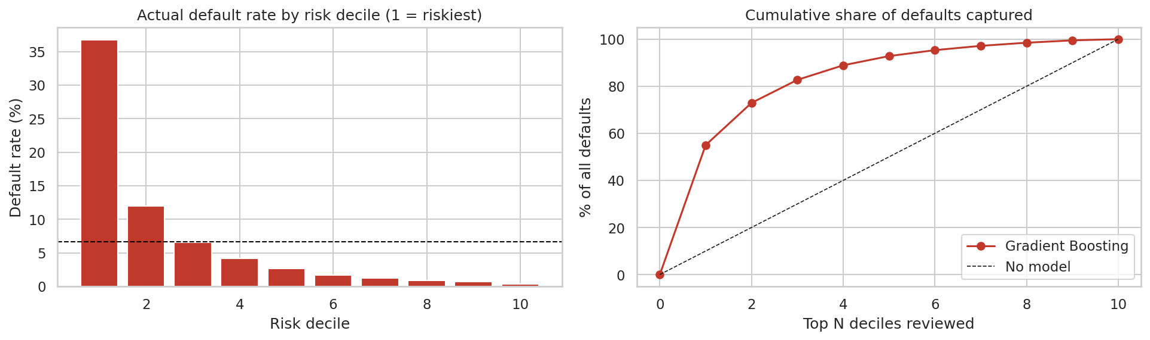
Figure 11: Default rate by risk decile and cumulative defaults captured
The predicted-risk bands used in the dashboard behave as intended: actual default rates climb steadily from 0.9% (Very Low, 73,011 borrowers) through 3.2%, 7.3% and 14.1% to 38.9% (Very High, 13,350 borrowers). These scores are out-of-fold, meaning each borrower was scored by a model that never saw them.

6. Q7: Which factors matter most?
Permutation importance (how much AUC falls when a feature is shuffled) shows that payment-history counts and utilization carry most of the predictive power, followed by age. Debt ratio, number of open lines and income add smaller increments. Because the three late-payment counts and their total share the same information, importance is spread between them and should be read as one group.
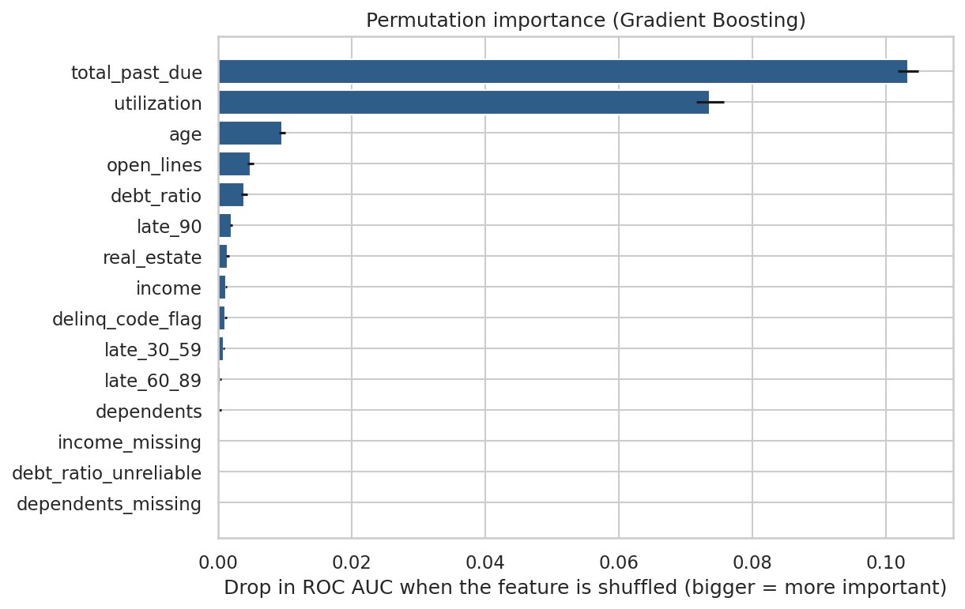
Figure 12: Permutation importance (Gradient Boosting)
In the Logistic Regression, one standard deviation more utilization roughly doubles the odds of default (odds ratio 2.0), each extra standard deviation of late-payment history raises the odds by 20-43%, and each standard deviation of age cuts the odds by about 25%.

7. Recommendations
- Underwriting: send Very High risk-band applicants (predicted default above 20%, actual 39%) to manual review or decline, and fast-track Very Low band applicants (below 2%, actual 0.9%), which is almost half of the portfolio.
- Early-warning monitoring: flag existing customers whose utilization crosses 75% or who record a first 30-59 day late payment. These are leading indicators of serious delinquency.
- Risk-based pricing: use the five risk bands to set pricing and limits instead of a single approve/decline cut-off.
- Collections focus: prioritise the small number of high-risk segments that hold a large share of defaults.
- Governance: keep Logistic Regression as the documented, explainable benchmark and use the boosted model for ranking.

8. Limitations and next steps
- No loan amount, interest rate, term or purpose in the data; exposure analysis relies on proxies.
- The 5:1 cost ratio is an assumption. Real loss-given-default and margin figures should replace it.
- Age is predictive but restricted or prohibited in credit decisions in many jurisdictions (for example under ECOA in the US). A production model should be tested without it and audited for fairness across groups.
- The data is a historical snapshot; models need monitoring and periodic retraining as conditions change.
- Findings are associations, not proof of cause.
- XGBoost was not installed in the environment used to produce these results, so scikit-learn gradient boosting was used. Installing xgboost and re-running the notebook switches automatically; very similar results are expected.
- Next steps: hyper-parameter tuning, SHAP explanations, weight-of-evidence scorecard, fairness audit, and a small Streamlit scoring app.

9. Project deliverables
Deliverable | Location | Purpose
Python notebook | notebooks/01_credit_risk_eda_and_modeling.ipynb | Cleaning, EDA, models, exports
SQL notebook | notebooks/02_sql_analysis.ipynb | All business questions answered in SQL
SQL scripts | sql/00 to 07 *.sql | Stand-alone versions of each query set
Tableau data | tableau/data/*.csv | Dashboard data sources
Tableau guide | tableau/TABLEAU_GUIDE.md | Fields, calculations and layout for two dashboards
README | README.md | Overview, results, how to run
This report | reports/Credit_Risk_Project_Report.docx | Written documentation

How to reproduce
Install the packages in requirements.txt, open the notebooks folder in Jupyter, and run notebook 01 and then notebook 02 using Restart and Run All. Notebook 01 takes about 2-3 minutes and regenerates all charts and Tableau CSVs; notebook 02 builds the SQLite database and runs the SQL.

