## Agricultural production challenges

Global agricultural production is at a crossroads. On the one side, the need to produce more food more cheaply is homogenising production systems with dramatic consequences for biodiversity, ecosystems and biomes. On the other, population growth, changing consumption patterns, rising incomes and globalisation are changing what, where and how much consumers consume. Global production of meat is projected to more than double from 258 million tonnes in 2006 to 455 million tonnes in 2050 whilst milk production is expected to grow from 664 to 1,077 million tonnes (Alexandratos and Bruinsma, 2012) to keep pace with rising demand. Meanwhile, the Food and Agriculture Organization (FAO) has estimated annual global production of crops will need to increase by 60% from 2006 levels to 2050 (FAO, 2016).

Potential yield gains for crops and livestock are hindered by widespread land degradation, land scarcity, and climate change that threaten where and how much food we can produce. A review conducted for the Intergovernmental Panel on Climate Change (IPCC) suggests climate change will adversely affect crop yields post 2030 (Porter et al., 2014) and these impacts will vary regionally in response to precipitation variation and temperature change (De Pinto et al., 2016). For livestock, climate change related impacts will likely decrease meat and milk production primarily due to changing quality of forage (Chapman et al., 2012), pest/disease extent and prevalence (Nardone et al., 2010; Bett et al., 2017) and water availability (Thornton et al., 2009; Havlík et al., 2015). Retaining ecosystem services in agriculture is paramount to meeting these (food security) challenges, it is argued (Bommarco et al., 2018).

Meanwhile farm systems worldwide are being homogenised in pursuit of productivity goals that are at the expense of local diversity and farm-systems resilience (Tscharntke et al., 2012). Yet, reduction in diversity increases vulnerability to climatic and other stresses, raises risks for individual farmers, and undermines the adaptability of agriculture to meet future drivers of change (Thrupp, 2000).

## Agrobiodiversity is undersupplied

Agrobiodiversity (see Figure 1 for definition) is declining primarily in response to farm intensification that has eroded natural capital in many agroecosystems (Chaplin-Kramer et al., 2015; Tsiafouli et al., 2015). Today, an increasingly constrained set of plant and animal diversity is relied upon for global agricultural production. Only 15 animal species worldwide account for 90% of livestock production (Villanueva et al., 2004). For crops, just 12 plant species worldwide provide more than 70% of all human calorific intake (Frison et al., 2012). Within these species, increasingly few breeds and varieties are responsible for the overwhelming majority of production (FAO, 2015a; Gruber, 2017). The ability to grow crops and graze pastures in challenging environments, particularly those most affected by climate change, will require adaptive genetic resources and work by Rojas-Downing et al., (2017) suggests crop and animal diversification are the most promising adaption measures.

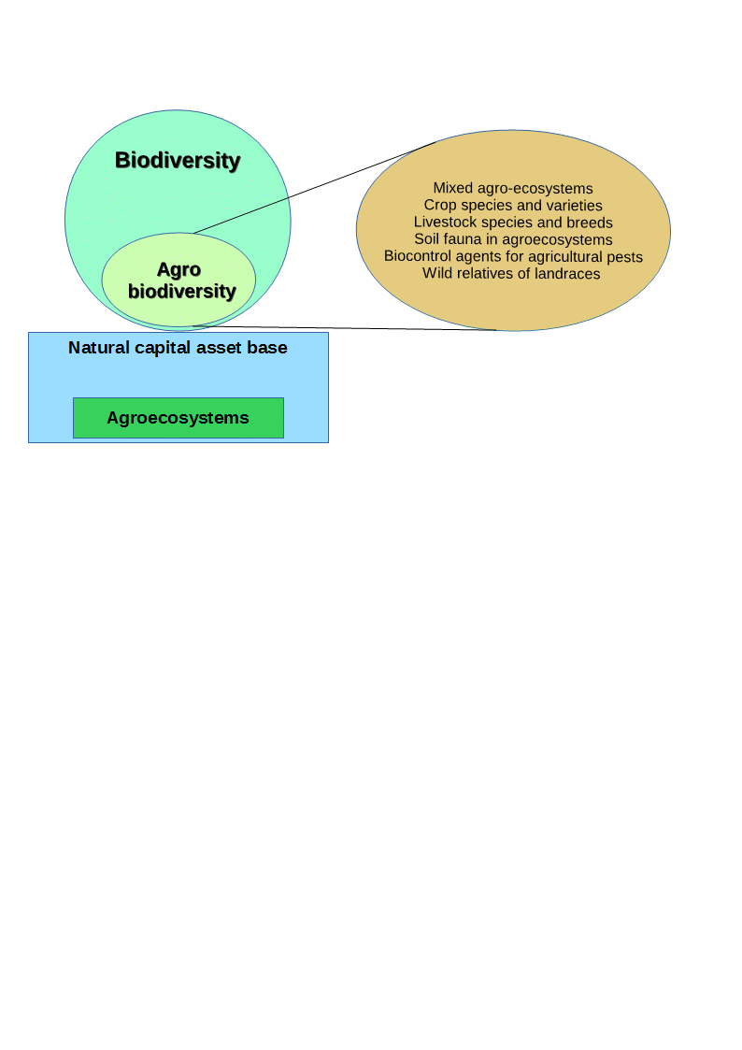

**Figure 1:** Biodiversity and agrobiodiversity are reliant on sustaining natural capital and agroecosystems. The various elements that comprise agrobiodiveristy (biodiversity of relevance to food and agriculture) are outlined. Adapted from FAO, (2004).

The thesis therefore brings this issue into focus by first acknowledging the undersupply of farm animal genetic resources (FAnGR) and plant genetic resources (PGR) globally and second; by exploring measures to increase their supply. FAnGR broadly includes avian and mammalian species for food production while PGR comprises cultivars and their wild relatives (FAO, 2015b). Both facets of diversity (collectively termed agrobiodiveristy herein) have been relatively understudied in the economic literature (though work by Bioversity International (2018) should be acknowledged[1]). The Intergovernmental Science-Policy Platform on Biodiversity and Ecosystem Services (IPBES, 2018) has outlined the need to invest in biodiversity and ecosystem services and suggests such investments make sound economic sense (i.e. the benefits generally far outweigh the costs). But while much work has explored the costs and benefits of preserving “naturally occurring” biodiversity, much less has focused on the supply and demand side aspects of agrobiodiveristy conservation.

Recent work by The Economics of Ecosystems and Biodiversity for Agriculture and Food (TEEBAgriFood) has stressed the importance of valuing natural capital in agroecosystems and the need to invest in agro-biodiversity for future food security (TEEB, 2018). Diversity is a public good not captured by markets because it lacks an explicit market value and is therefore not reflected in the true cost of food production. This means diversity is often undersupplied through conventional markets and institutions, resulting in a market failure since diversity is not supplied at socially optimal levels (Pearce and Moran, 1994); although what these levels are remains up for debate. This has resulted in the homogenisation of production landscapes worldwide (IPES-Food, 2016) and corrective measures are therefore necessary to supply more diversity through policies that govern food production and biological resource use.

## Economic incentives to supply more diversity

Economic incentives provide a means to address market failures through a range of policy tools including regulation, taxation, certification, and subsides. Incentives work by influencing the behaviours of actors and firms through the alteration market signals; thus correcting for market failure (Tietenberg and Lewis, 2018). Incentive schemes have become an increasingly popular way to address a range of environmental problems, including biodiversity loss. Incentives have been promoted because they offer more flexibility than traditional ‘command and control’ policies that require agents and firms to adhere to minimum standards or regulations.

This focus has been particularly evident in payments for ecosystem services (PES) schemes that reward landowners for supplying public goods. PES are voluntary incentive schemes where land managers can opt to supply a pre-defined service for a conservation payment, conditional on certain contractual obligations between the service provider and beneficiary (Farley and Costanza, 2010).

While economic incentives for conservation are proving more popular worldwide, a major constraint is funding limitations for conservation activities. Advancing our understanding of the cost effectiveness associated with different scheme designs is necessary and while this has been relatively well studied for some aspects of biodiversity conservation it remains comparatively underexplored in the context of agrobiodiveristy. Exploration of the latter may provide empirical basis to improve the design of schemes for better conservation outcomes. In this context, the technical design of schemes themselves may render them less effective at conserving certain value attributes of diversity (Börner et al., 2017) while approaches used to award contracts for supplying conservation services have also been shown to vary in efficiency (Windle and Rolfe, 2008; Duke et al., 2013).

PES type schemes have been formally adopted for plant and farm animal genetic resources conservation in Europe (Kompan et al., 2014; Poudel, 2015) but are relatively scarce on the global stage. Most schemes (though not all) provide payments to compensate yield gaps between traditional and improved varieties/breeds (Bojkovski et al., 2015). What most do not do is rationalise support based on different functions of cost and benefit (or endangerment). This shortfall is important since it means the selection of conservation agents (and ultimately the target of conservation effort) is not optimised for some objective, such as minimisation of cost or maximisation of diversity.

To improve conservation outcomes, it is necessary to incorporate such factors into the design of future incentive instruments. Additionally, the use of incentive schemes raises broader questions concerning fairness and distribution effects (Wunder, 2007; Jack et al., 2008; Narloch et al., 2013) as well as how conservation investments in agrobiodiveristy should be rationalised to reduce redundancy and maximise returns from investments.

## Aims and objectives

The contribution of this thesis lies in the development of policy-relevant interventions that could be used to better support PGR and FAnGR conservation, in response to key research challenges outlined by Cardellino and Boyazoglu, (2009). The thesis will provide a clearer picture of the private and public good values attached to rare breed conservation and how institutions may be working to ameliorate or exacerbate farm-diversity. Furthermore, this work improves our understanding of the likely costs of maintaining farm system diversity and the role of supply side instruments and incentives to affect (good) conservation outcomes, both in developed and developing countries.

The current supply of animal and, to a lesser extent plant diversity, is explored with a view to developing our understanding of the potential cost of supplying more diversity through incentive instruments. The former will broadly consider how contractual forms might be improved under existing agri environmental schemes (AES) or developed through stand-alone schemes (e.g. PES) where producers are rewarded for conservation effort. A mixture of diversity and endangerment metrics (e.g. numerical scarcity of breeding females and geographic concentration) are used to illustrate how interventions that target components of diversity can be more efficient than conventional conservation approaches.

The thesis is comprised of four studies. In Chapter 2, a review of public good characteristics associated with rare breeds is complimented by discourse surrounding how institutions are acting to exacerbate or ameliorate certain public good values embodied in rare breeds. Multiple proximate threats to diversity and issues pertaining to the use of incentive support schemes are discussed. Chapter 3 employs a choice experiment (CE) to determine farmer preferences for rare breed conservation contracts in Romania. Uptake in conservation programmes is modelled based on various payment scenarios related to farmer willingness to accept (WTA) conservation subsides. Barriers-to-entry that may preclude farmers from enrolling in incentive schemes are discussed, particularly in the context of small-scale producers where conservation arguably has a pivotal role to play.

In Chapter 4, a competitive tender survey is applied in Zambia to identify least cost conservation service providers for crop wild relatives (CWR) conservation. A linear programming (LP) model is used to demonstrate how selection of conservation sites and service providers can be optimised, subject to multiple diversity and social equity constraints. The appropriateness of selection under certain selection goals is discussed alongside resource needs and costs for national scale CWR conservation programmes. Chapter 5 provides an application of multi-criteria decision analysis (MCDA) to determine how livestock breeds (in the UK) could be prioritised to maximise returns on investments in diversity. Ethical arguments around prioritisation are provided alongside consideration of potential trade-offs between different conservation goals. Finally, Chapter 6 offers conclusions and recommendations from the thesis, plus suggestions for further work

1. Bioverstiy International has a research programme exploring Payment for Agrobiodiversity Conversation Services specifically (see <https://www.bioversityinternational.org/pacs/>).