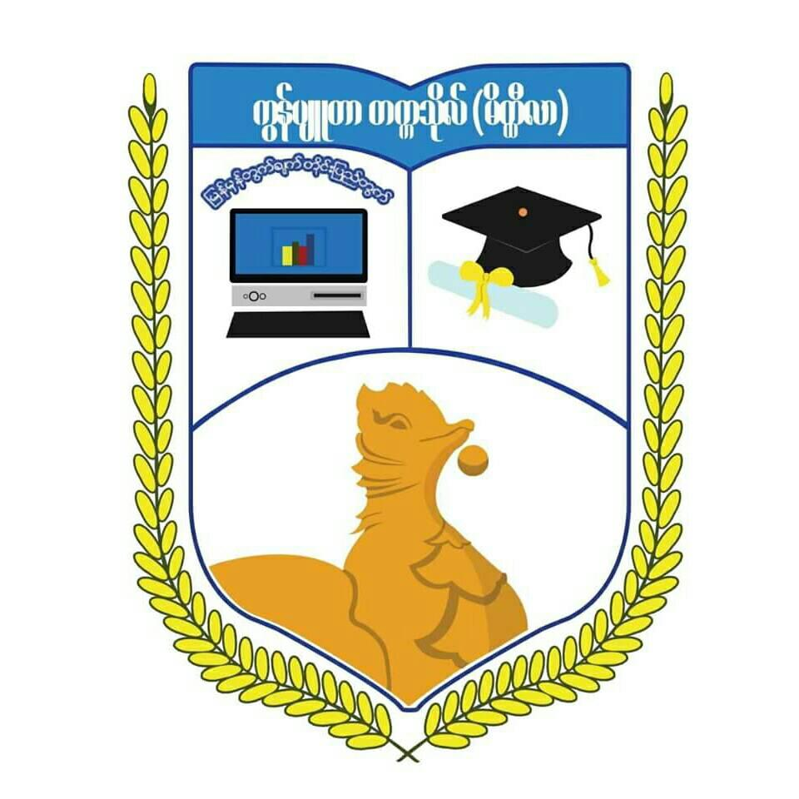

**UNIVERSITY OF COMPUTER STUDDIES (MEIKTILA)**

**INTERNSHIP REPORT**

In Partial Fulfillment of the Requirements for the Degree of Bachelor of

Computer Science

**Supervised By**

**Daw Thae Thae Han**

Lecturer

Information Technology Supporting and Maintenance

University of Computer Studies (Meiktila)

**Submitted By**

**5CS- 1: Ma Ei Ei Phyu**

**5CS-30: Mg Wai Phyoe Naing**

**August, 2019**

**PROJECT PLAN REPORT**

Project Title : Logistics Management System

Project Duration : May-July,2019

Student : 5CS-1 : Ma Ei Ei Phyu

5CS-30: Mg Wai Phyoe Naing

Organization : Global Connect Asia Co.,Ltd (Myanmar)