GOODTIP
Database Reference
Schema after the catalog refactor. PostgreSQL database goodtip, Django ORM, 11 application tables across 4 apps plus 9 Django plumbing tables. Total 20 tables.

1. Schema overview
The Goodtip database runs on PostgreSQL through Django, and its schema is split across five application areas — catalog, accounts, orgs, and tipping for our own code, plus Django's built-in plumbing — for a total of 20 tables. The design centres on a simple idea: a person joins one or more tipping groups, each group runs rounds of fixtures, each round contains matches between two teams, and each person submits one prediction (a "tip") per match. A recent refactor extracted three pieces of reference data — sport, competition, and season — out of the tables that used to store them as plain text and gave them their own lookup tables in a new "catalog" app, so those names are now stored once and referenced everywhere by id rather than copied around.

1.1 catalog app
The catalog app holds the three reference tables. catalog_sport is a top-level sport (AFL, NRL) with a unique name and slug. catalog_competition is a specific competition inside a sport (AFL, AFLW, NRL, NRLW), each row carrying a unique name and slug, an is_womens flag, and a foreign key to its parent sport — that sport foreign key is protected, so a sport cannot be deleted while competitions still reference it. catalog_season is a playing year, identified by a unique integer year plus an optional display label (for example 2026).

1.2 accounts app
The accounts app contains the login account in accounts_user. This is a custom user model extending Django's standard AbstractUser, configured so people sign in with their email address (unique) rather than a username, alongside a display_name and the usual permission and timestamp fields. One subtlety worth noting: because it extends AbstractUser, the username column still physically exists in the table — the system simply auto-fills it with the user's email behind the scenes. Two companion tables, accounts_user_groups and accounts_user_user_permissions, are Django's standard links tying users to permission groups and individual permissions.

1.3 orgs app
The orgs app models the groups and who belongs to them. orgs_organisation is a tipping group (such as an office footy comp), holding a name, the charity it raises for (charity_name and an optional charity_url), a creation timestamp, and a foreign key to the season it runs in — that season foreign key is protected, meaning a season can't be deleted while any organisation still points at it. An organisation's sports are modelled as a many-to-many relationship to catalog_sport, realised through the automatic join table orgs_organisation_sports; this is how a single group can cover both AFL and NRL as two ordinary rows, rather than needing a special "BOTH" value the way the old text field did. orgs_orgmember links a user to an organisation and records their role (admin or member) plus a join timestamp, with a uniqueness rule of one membership per person per group; deleting either the user or the organisation cascades and removes the membership.

1.4 tipping app
The tipping app holds the game itself across four tables. tipping_team is a club within a competition, carrying a name, a slug, an optional external API id, and a protected foreign key to its competition, with the slug required to be unique within that competition. tipping_round is a round of fixtures for one organisation in one competition, holding a round number, a lockout time, and a status of upcoming, open, locked, or complete; it has a protected foreign key to its competition and a cascading foreign key to its organisation, and it's unique on the combination of organisation, round number, and competition. Its status is partly time-derived rather than purely stored — the model computes an effective status and a locked flag based on the lockout time, so a round can read as "locked" once its lockout passes even if the stored column hasn't changed. tipping_match is a single game inside a round, with a cascading foreign key to that round, two protected foreign keys to teams (home and away), a kickoff time, an optional venue, a result (home, away, or draw, left empty until played), home and away scores, and an optional external API id. tipping_tip is the heart of the app: one person's prediction for one match, carrying a selection of home or away, a submission timestamp, and an is_correct flag that stays empty until the match has a result. A tip points at three things at once — a user, a match, and an organisation — and is unique on that combination, enforcing one tip per user per match per group; deleting any of those three parents cascades and removes the tip.

1.5 Django plumbing
Finally there are nine tables Django creates and manages itself, which round out the 20-table total and are rarely touched by hand: auth_group, auth_group_permissions, and auth_permission handle the permission system; django_admin_log records changes made through the admin site; django_content_type is an internal registry of every model; django_migrations tracks which schema migrations have run; and django_session stores logged-in session data.

1.6 How the connections fit together
Pulling the connections together: each competition belongs to one sport, and each organisation belongs to one season and is linked to many sports (and vice versa) through the join table. A user connects to an organisation through an org-member row that also stores their role. Each organisation owns many rounds, each round belongs to one competition and owns many matches, and each match references two teams (home and away), each of which belongs to a competition. Tips fan in from three directions — every tip ties back to a user, a match, and an organisation — making it the table where people, fixtures, and groups all meet.

2. Table inventory — all 20 tables
Every table in the database, grouped by app. The first 11 are our application tables; the last 9 are Django's built-in plumbing.
App | Table name | Purpose
catalog | catalog_sport | Top-level sport (AFL, NRL).
catalog | catalog_competition | Specific competition (AFL, AFLW, NRL, NRLW).
catalog | catalog_season | Playing year (2026).
accounts | accounts_user | Custom user model. Login by email.
orgs | orgs_organisation | Tipping group, e.g. an office footy comp.
orgs | orgs_organisation_sports | Auto-generated join table for Organisation ↔ Sport.
orgs | orgs_orgmember | Links a user to a group with a role.
tipping | tipping_team | A club within a competition.
tipping | tipping_round | A round of fixtures for one group, in one competition.
tipping | tipping_match | A single game between two teams inside a round.
tipping | tipping_tip | One person's prediction for one match — the heart of the app.
Django | auth_group | Permission groups.
Django | auth_group_permissions | Links groups to permissions.
Django | auth_permission | Every available permission.
Django | accounts_user_groups | Links users to groups.
Django | accounts_user_user_permissions | Links users to individual permissions.
Django | django_admin_log | History of changes via the Django admin.
Django | django_content_type | Internal registry of every model.
Django | django_migrations | Record of which migrations have run.
Django | django_session | Logged-in session data.
Verify against the live database: running \dt in psql should return exactly 20 rows.

3. What changed in this refactor
Previously, sport, competition, and season were plain text or integer fields stored directly on Organisation, Team, and Round. Every row repeated the same strings.
Now, those three concepts live in a dedicated catalog app as proper lookup tables. Every other table references them by foreign key, and a string like "AFL" is stored exactly once in the database.

Specific changes
- Organisation.sport (previously a text field with values AFL / NRL / BOTH) is now a many-to-many link to catalog.Sport. The special-case BOTH value is gone — an org covering both sports is now simply two rows in the M2M join table.
- Organisation.season (previously an integer like 2026) is now a foreign key to catalog.Season.
- Team.competition and Round.competition (previously text fields with values AFL, AFLW, NRL, NRLW) are now foreign keys to catalog.Competition.
Data migration: two data migrations — orgs/0002 and tipping/0002 — carry the old data forward. Both have working backwards() functions, so the refactor is fully reversible.

4. Entity-relationship diagram
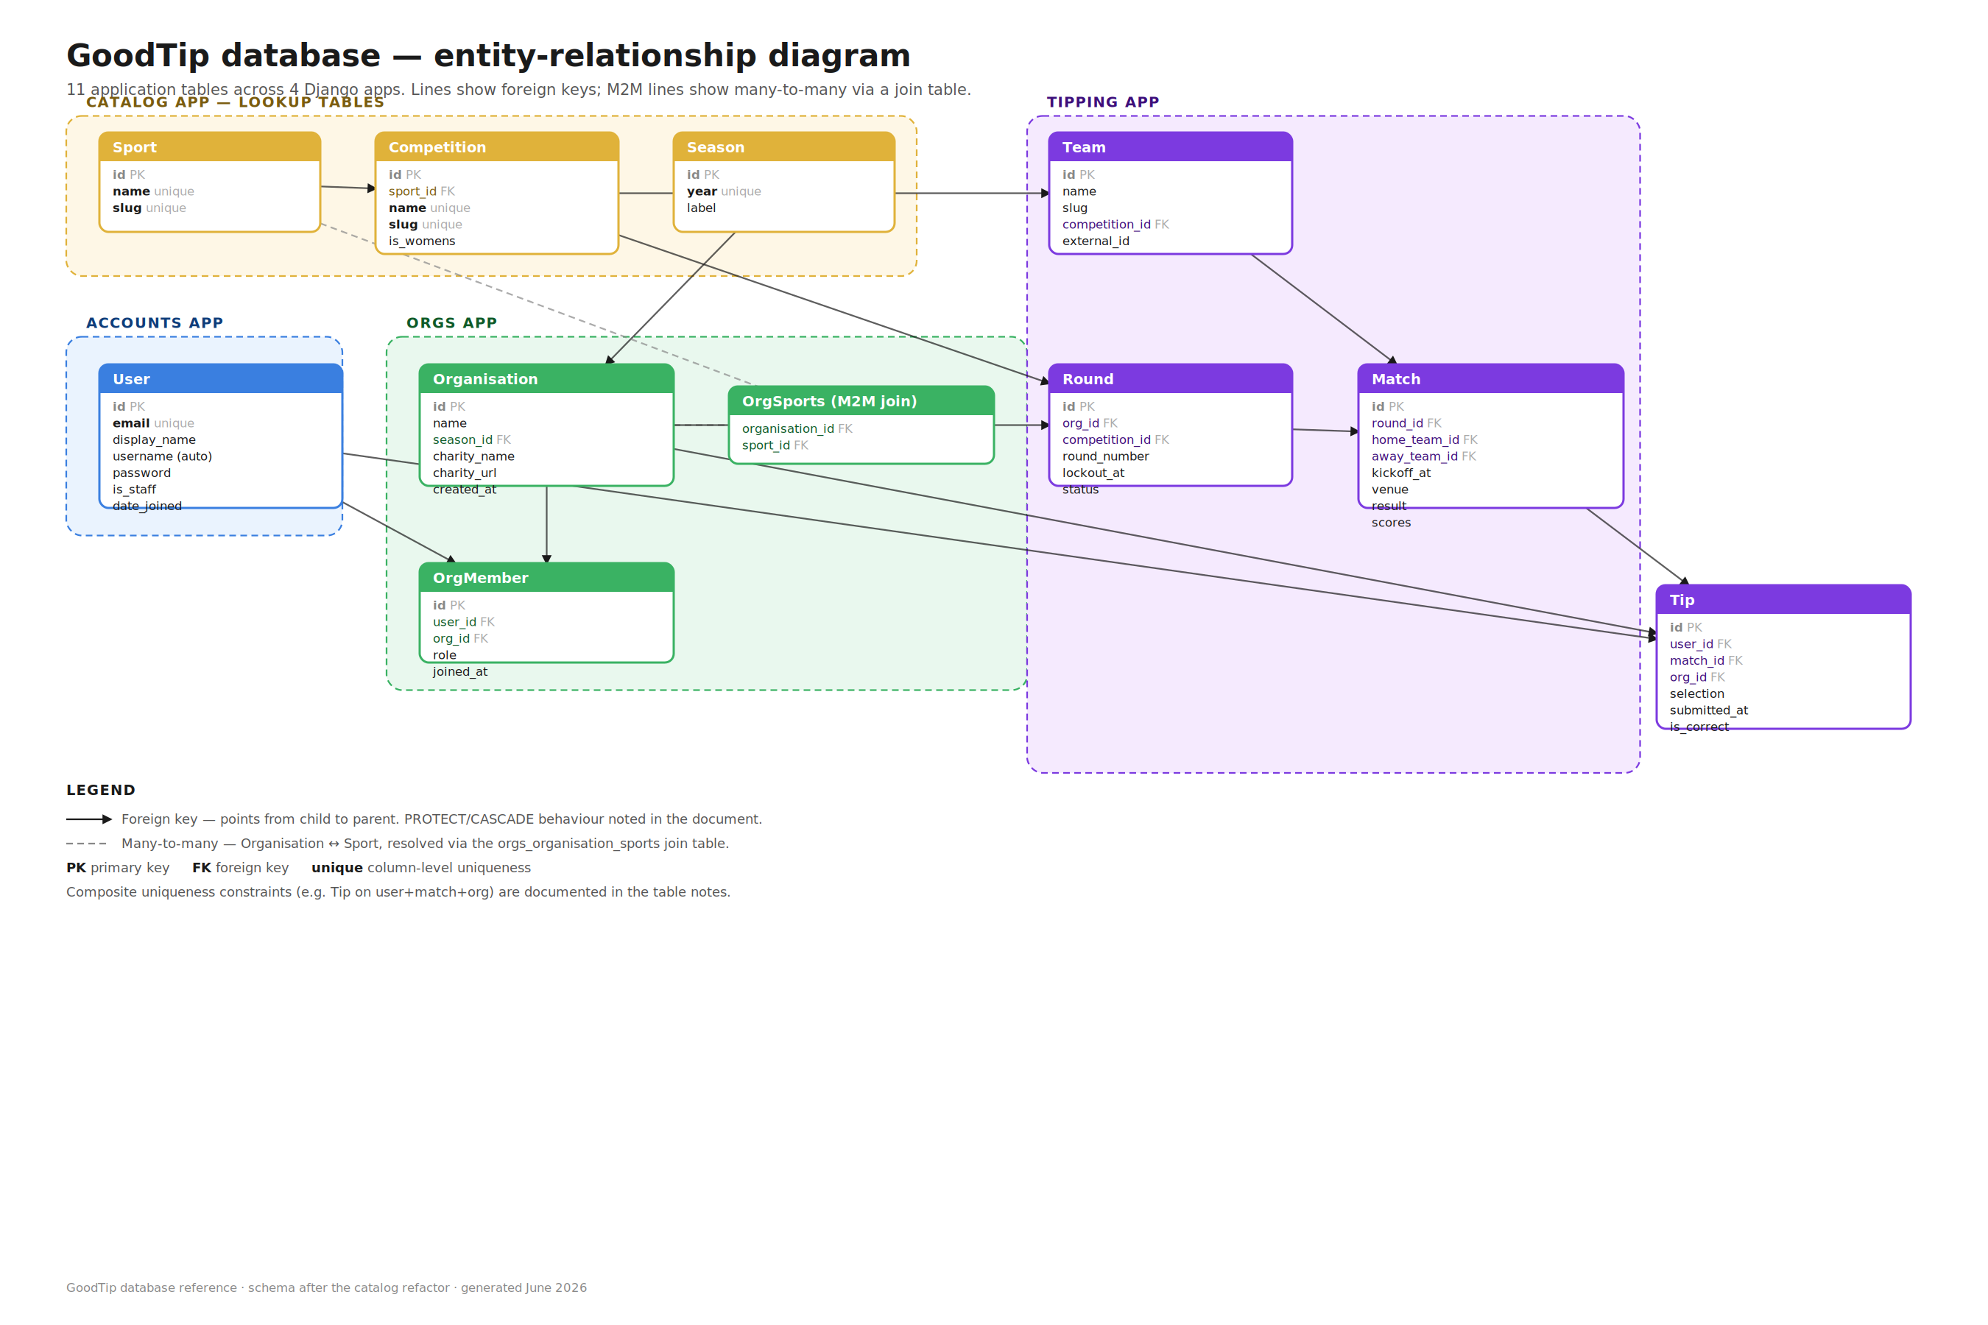
Figure 1 — 11 application tables grouped by Django app. Solid arrows are foreign keys, dashed lines are many-to-many.

5. catalog app — reference data
Three lookup tables. Every name lives here exactly once and is referenced by id everywhere else.

5.1 Sport
Table: catalog_sport. Current rows: 2 (AFL, NRL).
A top-level sport. AFL and NRL are the two we cover.
Column | Type | Notes
id | bigint | Primary key.
name | text | Unique. e.g. AFL, NRL.
slug | text | Unique URL-friendly form, e.g. afl, nrl.

5.2 Competition
Table: catalog_competition. Current rows: 4 (AFL, AFLW, NRL, NRLW).
A specific competition inside a sport. AFL and AFLW both belong to the AFL sport; NRL and NRLW both belong to the NRL sport.
Column | Type | Notes
id | bigint | Primary key.
sport_id | FK → catalog_sport | Which sport this competition belongs to. PROTECT — a Sport cannot be deleted while Competitions reference it.
name | text | Unique. e.g. AFL, AFLW, NRL, NRLW.
slug | text | Unique, e.g. aflw.
is_womens | boolean | True for AFLW and NRLW.

5.3 Season
Table: catalog_season. Current rows: 1 (2026).
A playing year.
Column | Type | Notes
id | bigint | Primary key.
year | integer | Unique. e.g. 2026.
label | text | Optional display label.

6. accounts app — people

6.1 User
Table: accounts_user. Current rows: 13.
Custom user model extending Django's AbstractUser. Login is by email — USERNAME_FIELD is set to "email", and email is the unique identifier.
Important — the username column still exists. Because we extend AbstractUser, the username column is still present in the table. Our user manager auto-fills it with the email on user creation. The old DATABASE.md said "sign in with email, not username" — that is correct for the login flow, but the schema still has the column.
Column | Type | Notes
id | bigint | Primary key.
email | text | Unique. The login identifier.
display_name | text | Shown around the app.
username | text | Inherited from AbstractUser. Auto-filled with the email by the user manager. Not used for login.
password | text | Hashed.
is_staff | boolean | Admin panel access flag.
is_superuser | boolean | Django superuser flag.
is_active | boolean | Whether the account is active.
last_login | datetime | Standard Django field.
date_joined | datetime | Set automatically on signup.
Helper tables: accounts_user_groups and accounts_user_user_permissions are Django's permission link tables — listed under section 8 (Django plumbing).

7. orgs app — groups and membership

7.1 Organisation
Table: orgs_organisation. Current rows: 2.
A tipping group — e.g. an office footy comp. Tied to a season, linked to one or more sports, raising for a charity.
Column | Type | Notes
id | bigint | Primary key.
name | text | The group's name.
season_id | FK → catalog_season | Which season the group runs in. PROTECT.
charity_name | text | Charity the group raises for. Phase 1 — single field, Phase 2 — proper Charity model.
charity_url | text | Optional link.
created_at | datetime | Set automatically.
Sports link: Organisation has a many-to-many relationship to Sport, resolved through the auto-generated join table orgs_organisation_sports. A group covering both AFL and NRL has two rows in that table.
Helper properties on the model:
- sport_label — returns a display string like "AFL" or "AFL + NRL".
- available_competitions — returns Competition objects filtered to the org's chosen sports.

7.2 OrgSports (join table)
Table: orgs_organisation_sports. Current rows: 3.
Auto-generated by Django to resolve the Organisation ↔ Sport many-to-many. You rarely query this directly — Django ORM handles it via .sports.all() on the Organisation model.
Column | Type | Notes
id | bigint | Primary key.
organisation_id | FK → orgs_organisation | CASCADE — deleting an Org removes its sport links.
sport_id | FK → catalog_sport | CASCADE.

7.3 OrgMember
Table: orgs_orgmember. Current rows: 19.
Links a User to an Organisation and records their role. One row per person per group.
Column | Type | Notes
id | bigint | Primary key.
user_id | FK → accounts_user | The member. CASCADE — deleting the User removes their memberships.
org_id | FK → orgs_organisation | The group. CASCADE — deleting the Org removes its members.
role | text | admin or member.
joined_at | datetime | Set automatically.
Composite uniqueness: unique_together = (user, org) — a user can only belong to a given group once.

8. tipping app — the tipping game

8.1 Team
Table: tipping_team. Current rows: 65 (18 AFL + 18 AFLW + 17 NRL + 12 NRLW).
A club within a competition. Carlton in AFL is a different row from Carlton in AFLW — competition is part of identity.
Column | Type | Notes
id | bigint | Primary key.
name | text | Display name, e.g. Carlton.
slug | text | URL-friendly, e.g. carlton.
competition_id | FK → catalog_competition | Which competition this club plays in. PROTECT — a Competition cannot be deleted while Teams reference it.
external_id | text | Optional — id from an external data API.
Composite uniqueness: unique_together = (slug, competition) — slug is unique within a competition, not globally.

8.2 Round
Table: tipping_round. Current rows: 5.
A round of fixtures for one organisation, in one competition. An org covering both AFL and NRL will have separate rounds per competition (e.g. AFL Round 1 and NRL Round 1 are two rows).
Column | Type | Notes
id | bigint | Primary key.
org_id | FK → orgs_organisation | Which group this round belongs to. CASCADE.
competition_id | FK → catalog_competition | Which competition. PROTECT.
round_number | integer | e.g. 1, 2, 3...
lockout_at | datetime | Tips lock at this time. Stored UTC, displayed Australia/Sydney.
status | text | upcoming, open, locked, or complete.
Composite uniqueness: unique_together = (org, round_number, competition) — no duplicate Round 1 for the same competition in the same group.
Helper properties on the model:
- is_locked — true if now() >= lockout_at, regardless of stored status.
- effective_status — time-aware status. Reads the stored status but escalates to locked once the lockout has passed, even if an admin has not updated the column.

8.3 Match
Table: tipping_match. Current rows: 27.
A single game between two teams inside a round.
Column | Type | Notes
id | bigint | Primary key.
round_id | FK → tipping_round | Which round. CASCADE.
home_team_id | FK → tipping_team | The home club. PROTECT.
away_team_id | FK → tipping_team | The away club. PROTECT.
kickoff_at | datetime | Match start. Stored UTC.
venue | text | Optional.
result | text | home, away, draw, or empty until played.
home_score | integer | Filled in after the game. Nullable.
away_score | integer | Filled in after the game. Nullable.
external_id | text | Optional — id from an external data API.

8.4 Tip
Table: tipping_tip. Current rows: 193. The heart of the app.
One person's prediction for one match within one group. A user belonging to two groups would have two Tip rows for the same Match — one per group.
Column | Type | Notes
id | bigint | Primary key.
user_id | FK → accounts_user | Who tipped. CASCADE.
match_id | FK → tipping_match | The game. CASCADE.
org_id | FK → orgs_organisation | The group it counts for. CASCADE.
selection | text | home or away. Draws are not tippable in Phase 1 — see note below.
submitted_at | datetime | Updated whenever the tip changes (auto_now).
is_correct | boolean | Nullable until the match result is entered, then set.
Composite uniqueness: unique_together = (user, match, org) — one tip per user per match per group.
Draw handling note: Match.result can be 'draw' but Tip.selection cannot. When a match draws, the points policy (everyone gets the point / nobody does) is applied during the result-entry routine — it does not require schema changes.

9. Migration history
Initial schemas plus the two data migrations that carried out the catalog refactor.
App | Migration | What it does
catalog | 0001_initial | Creates Sport, Competition, Season tables. Seeds initial reference data.
accounts | 0001_initial | Creates the custom User table with email as USERNAME_FIELD.
orgs | 0001_initial | Creates Organisation with the old text/integer sport+season fields, plus OrgMember.
orgs | 0002 (data migration) | Adds season FK and sports M2M to Organisation. Copies old text values forward — "BOTH" becomes two M2M rows. Removes the old fields. Reversible.
tipping | 0001_initial | Creates Team, Round, Match, Tip with the old text competition fields.
tipping | 0002 (data migration) | Replaces Team.competition and Round.competition text fields with FKs to catalog.Competition. Copies old text values forward. Removes the old fields. Reversible.
Rollback: either migration can be reversed with python manage.py migrate <app> 0001. This restores the old text fields with their original values.

10. Delete behaviour
Every foreign key in the schema declares an on_delete policy. The two used are PROTECT (you cannot delete a parent that has children) and CASCADE (deleting a parent deletes its children).

10.1 PROTECT — cannot be deleted while referenced
Parent | Blocking children
Sport | Competition — cannot delete a Sport while Competitions reference it.
Competition | Team and Round — cannot delete a Competition while either references it.
Season | Organisation — cannot delete a Season while Orgs run in it.
Team | Match (home_team / away_team) — cannot delete a Team while it has Matches.

10.2 CASCADE — deletes children
Parent | What cascades
Organisation | Round, Tip, OrgMember, and OrgSports rows are all deleted.
Round | Match rows in that round are deleted.
Match | Tip rows for that match are deleted.
User | Tip and OrgMember rows for that user are deleted.

11. Quick relationship reference
From | Kind | To | Meaning
Competition | → | Sport | Each competition belongs to one sport.
Organisation | → | Season | Each org runs in one season.
Organisation | ↔ | Sport | Many-to-many via orgs_organisation_sports.
OrgMember | → | User, Organisation | Links a person to a group with a role.
Team | → | Competition | Which competition the club plays in.
Round | → | Organisation, Competition | A round of fixtures for one group, in one competition.
Match | → | Round, Team×2 | home_team and away_team both point at Team.
Tip | → | User, Match, Organisation | Three FKs. A tip is identified by all three together.
One-line relationship map:
Sport ──< Competition ; Sport >── M2M ──< Organisation ; Season ──< Organisation ;
User ──< OrgMember >── Organisation ; Organisation ──< Round ──< Match ;
Competition ──< Team (home/away into Match) ; User ──< Tip , Match ──< Tip , Organisation ──< Tip

12. Django plumbing tables (9)
Created and managed by Django itself. Listed here for completeness — they make up 9 of the 20 total tables and you rarely touch them by hand.
Table | Purpose
auth_group | Permission groups.
auth_group_permissions | Links groups to permissions.
auth_permission | Every available permission.
accounts_user_groups | Links users to groups.
accounts_user_user_permissions | Links users to individual permissions.
django_admin_log | History of changes made via the Django admin.
django_content_type | Internal registry of every model.
django_migrations | Record of which migrations have run.
django_session | Logged-in session data.

13. How to inspect locally
All commands assume the local PostgreSQL setup.
List every table:
PGPASSWORD=masterclass psql -h localhost -U mbatha -d goodtip -c "\dt"
Inspect one table's columns and constraints:
PGPASSWORD=masterclass psql -h localhost -U mbatha -d goodtip -c "\d tipping_tip"
Open an interactive Django shell with the ORM:
python manage.py shell
>>> from tipping.models import Tip
>>> Tip.objects.filter(is_correct=True).count()
Generate raw SQL for the current schema (read-only):
python manage.py sqlmigrate <app> <migration_id>
Check pending migrations:
python manage.py showmigrations
GOOD TIP, MATE.
Database reference | Schema after the catalog refactor | June 2026

