ISSACK WAITHAKA
cs-sa07-24085

Tier 2
In this module I am going to learn about:
- How to exploit xxe, IDOR, and cookie manipulation
- Learn how to exploit binary path, hijacking and sudo permissions for privilege escalation
- The basics of brute forcing

Archetype
- The first thing to do was to connect to my openvpn and then spawn the machine
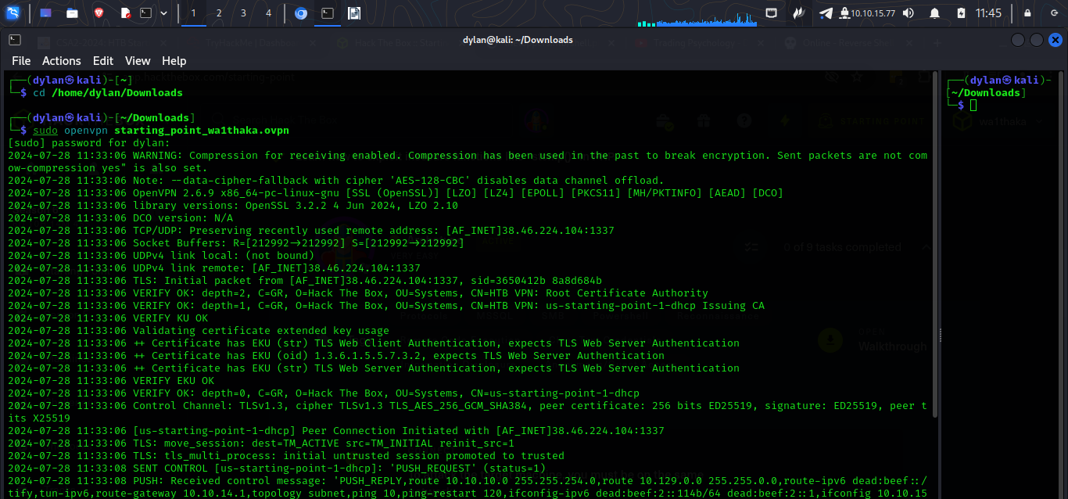



Questions
1.
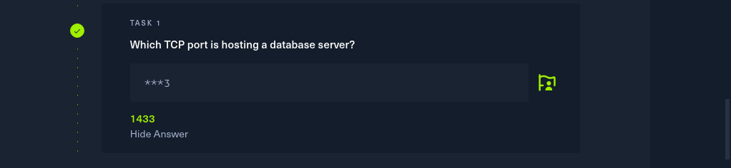
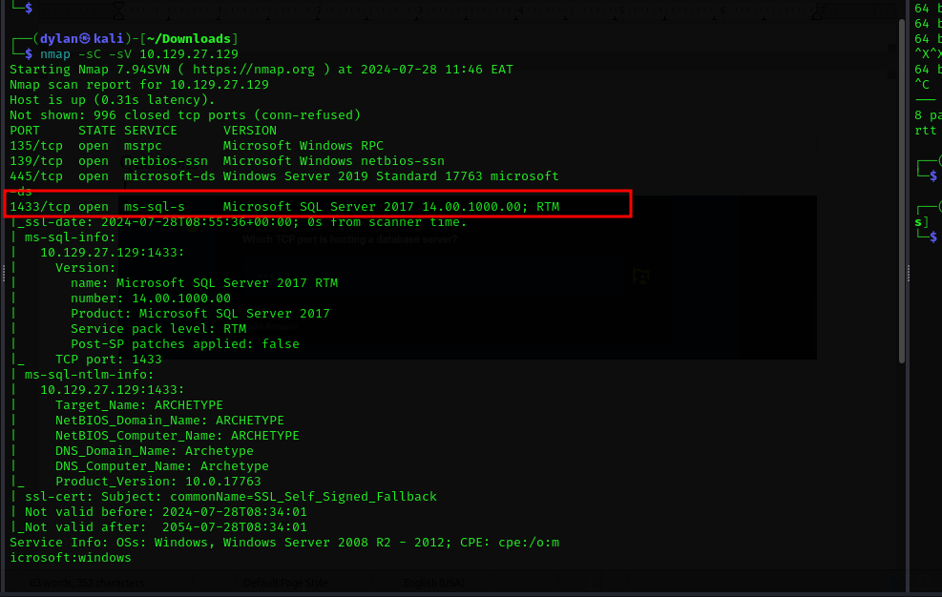

2.
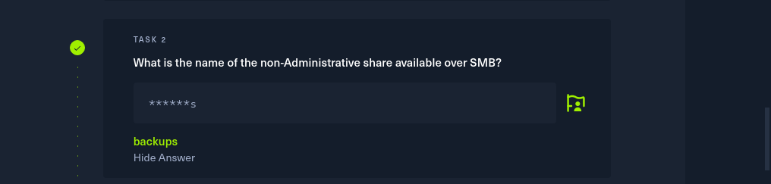
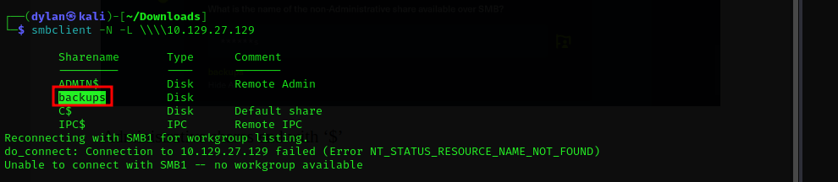
Administrative shares end with ‘$’

3.
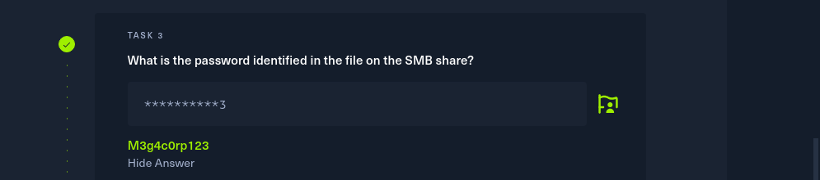
-For this I logged in the backups shares without a password and found a file which I downloaded into my local machine. The file had the password
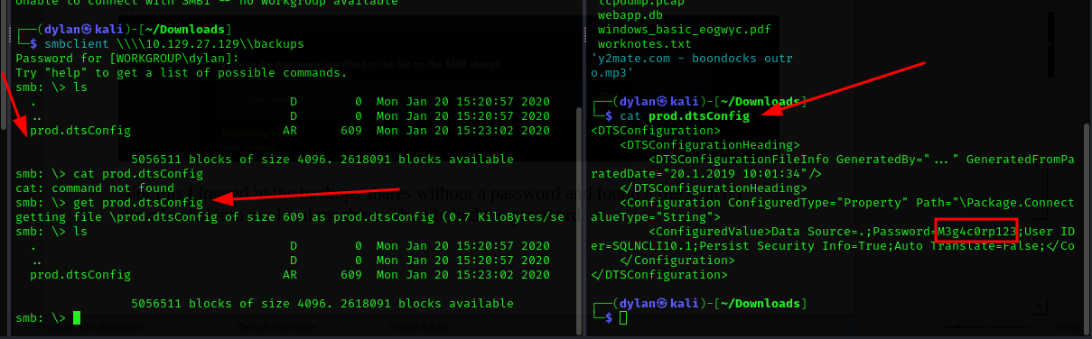

4.
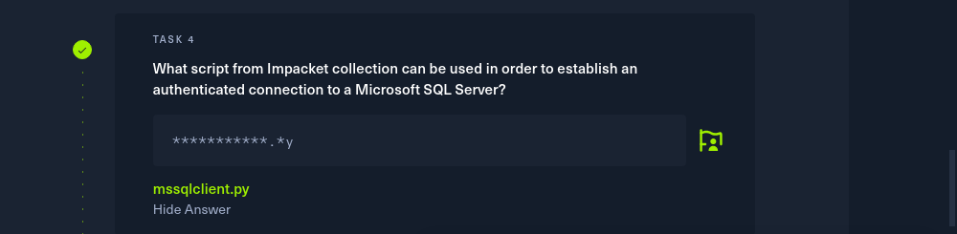
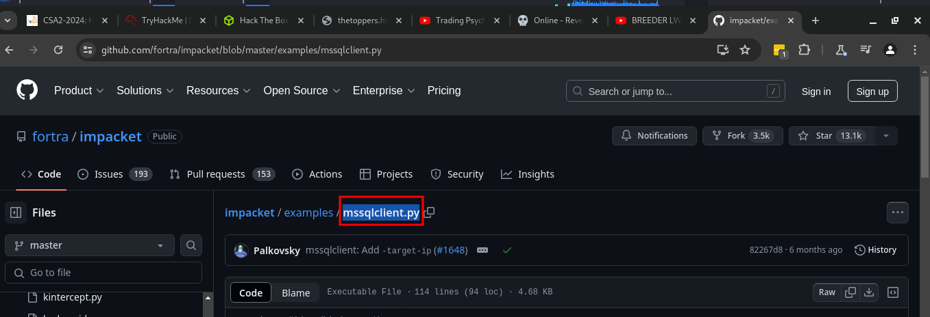
I did a little research for this

5.
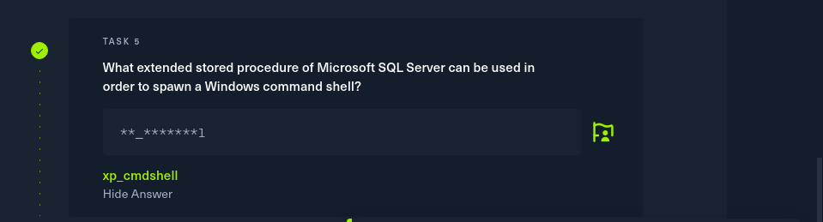
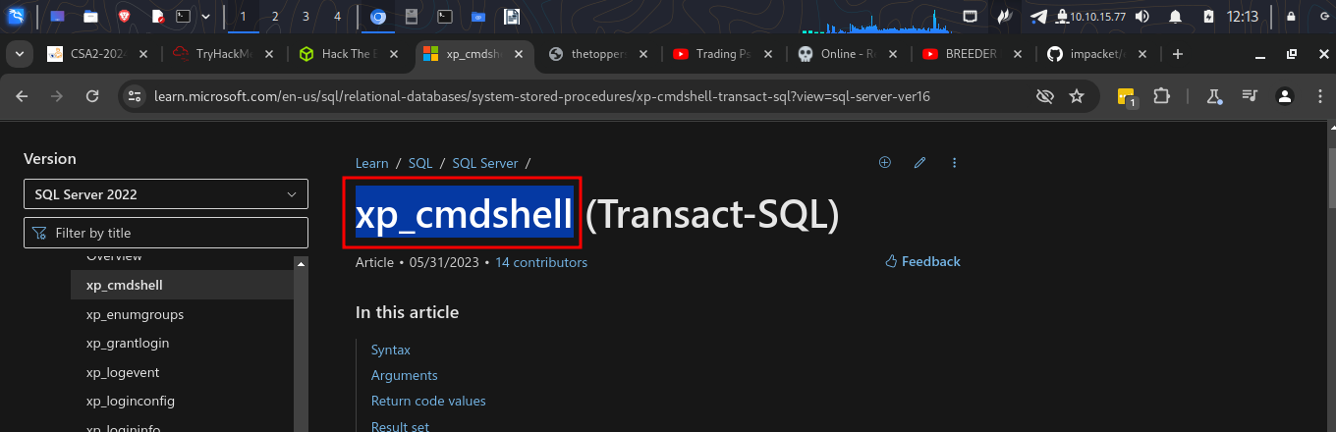
6.
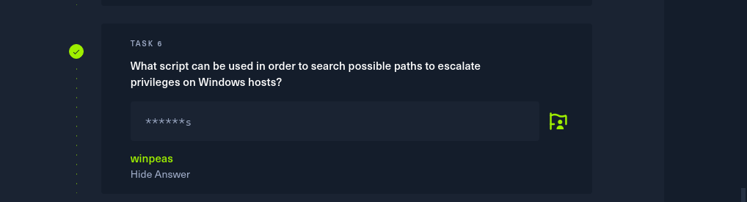

7.
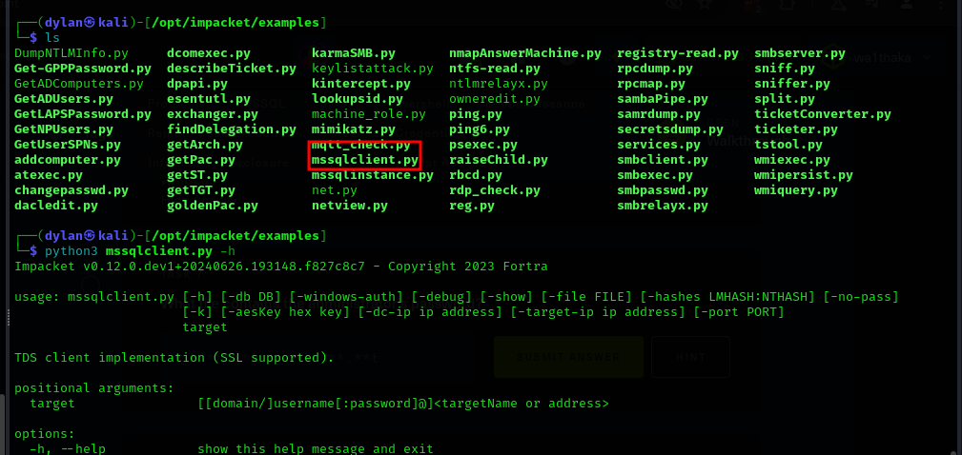
- Here is the script in my local machine. Now I can try to connect to mysql server

And I was logged in. I ‘-windows-auth’ to specify it was a windows authentication
I also used the password we git from the previous task
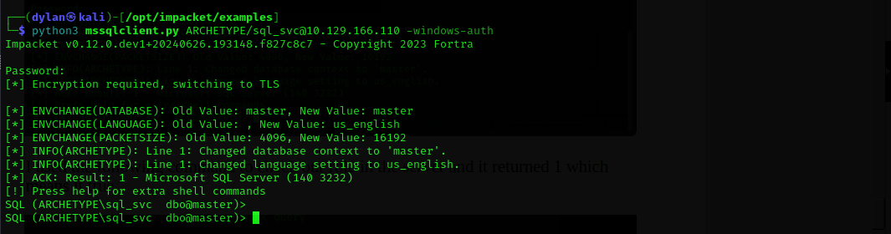
- The first thing was to enable the access procedure
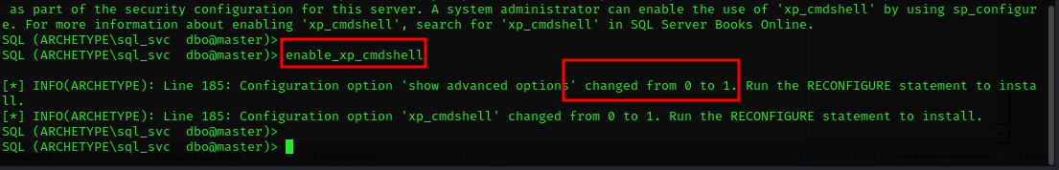
- Now we can try to generate a payload using msfvenom.
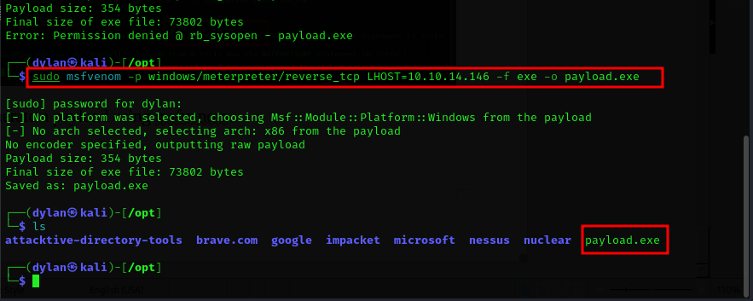
- Then we need to run metasploit which will try to use it to create a reverse shell
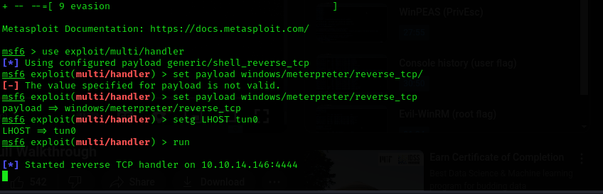
- This will set the listener up waiting for a meterpreter shell to connect back to the IP
- So to setup the paylpoad to the victim machine we set up the python http server

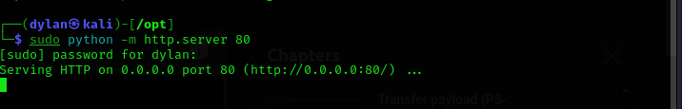
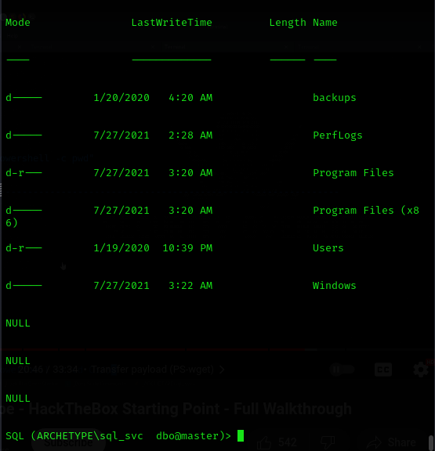
- used xp_cmdshell "powershell -c cd C:/; dir" to list different directories
-
- I downloaded the payload
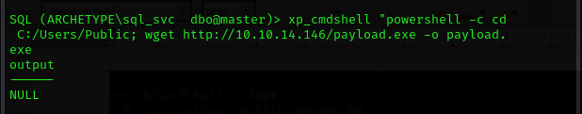
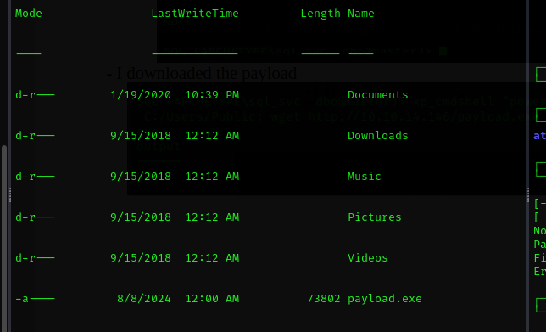
I ran it and it opened the meterpreter shell
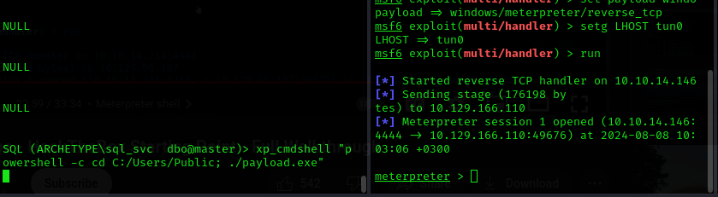
-I uploaded the Winpeas from my local machine to the metrepreter.
-Note that the file should be in the same directory with the metreprter shell
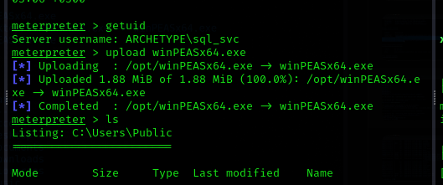
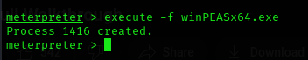
- I then executed it

- I then went to the shell and executed it
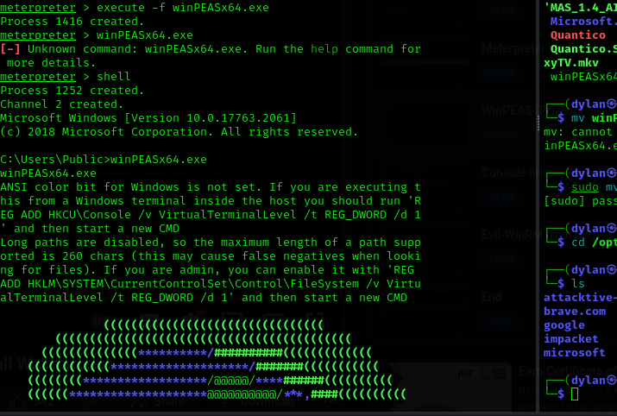
- I found this intersting file
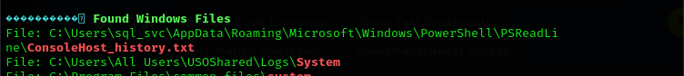
and used it to get answer
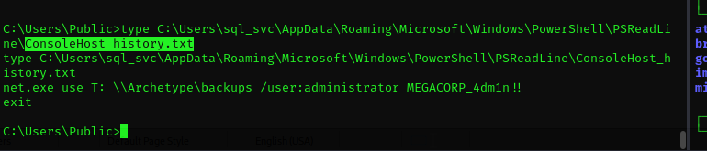

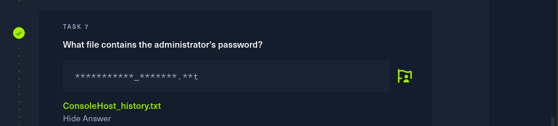

8.
To get the user file I had to navigate to sql_svc desktop and got the file user.txt
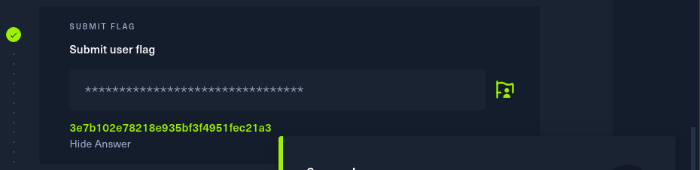

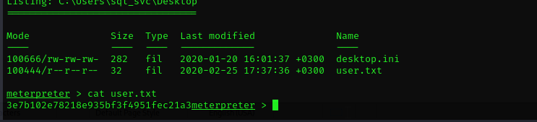
9.
To get the root flag I used evil-winrm tool together with the admin password we got earlier
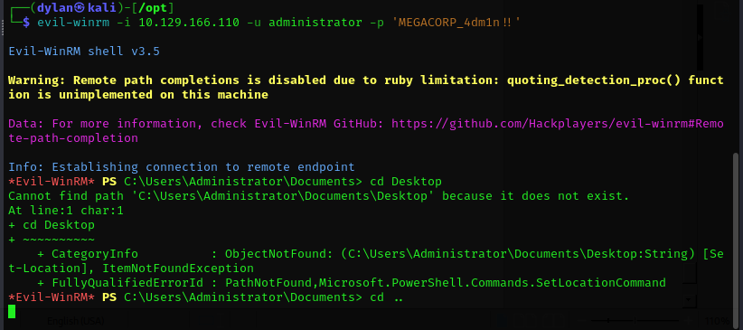
Now I navigated to the desktop directory where I got the flag
