ISSACK WAITHAKA
cs-sa07-24085

Introduction
- Mitre is known to be associated with CVE(Common Vulnerabilities and Exposure)
- Advanced Persistent Threat(APT) is a group or country that engages in long-term attacks against organizations or other countries

ATT&CK Framework
- In this section I learned about Mitre attack
- Is an accessible knowledge base of adversary tactics and techniques bases on real-world observation

Questions
1.
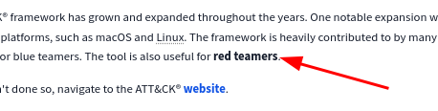

2.

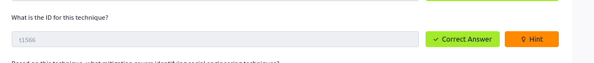

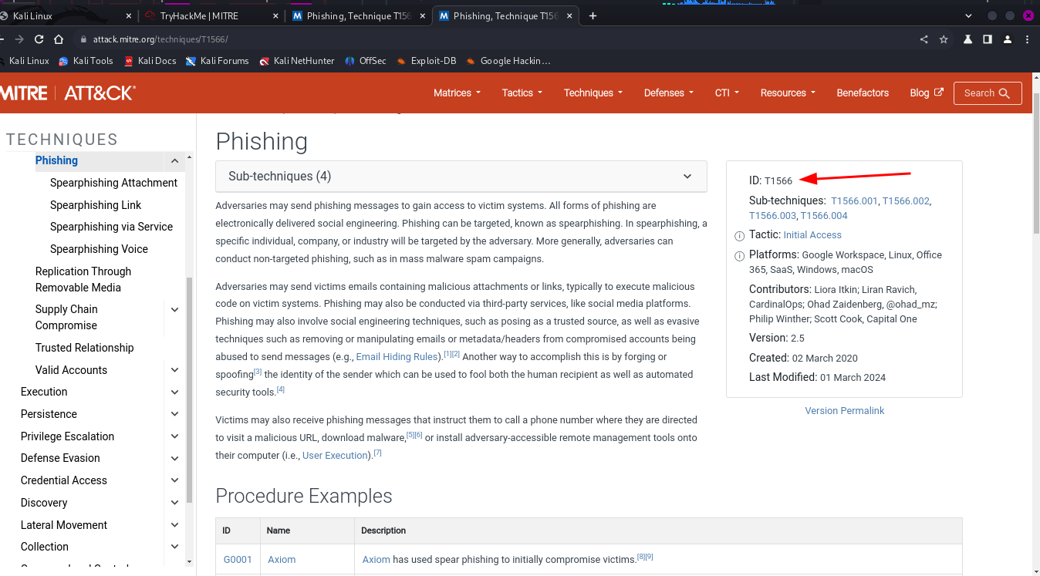
3.

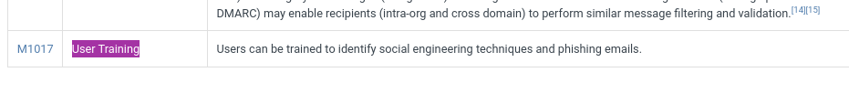
4.
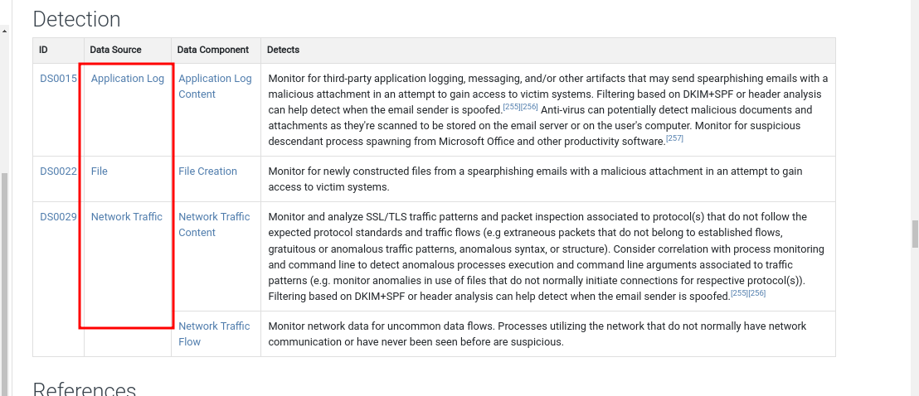
5.

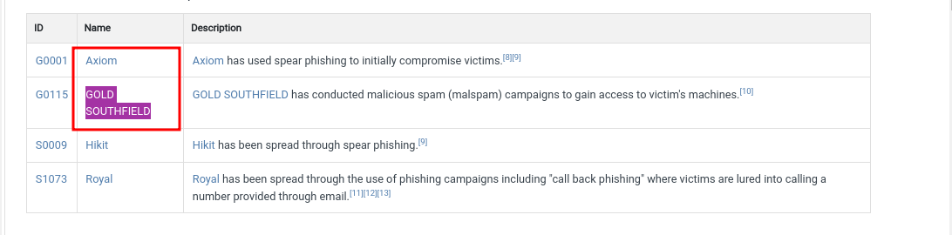
6.
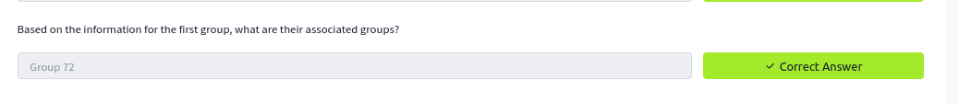
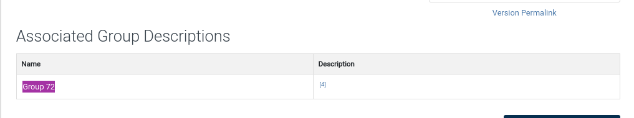

7.

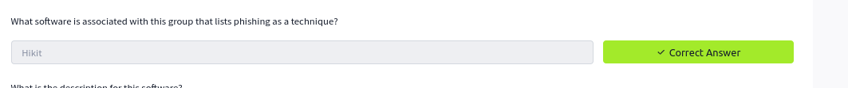
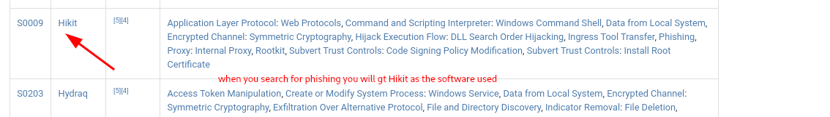
8.
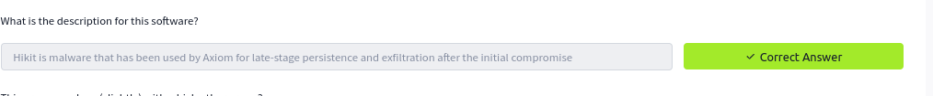
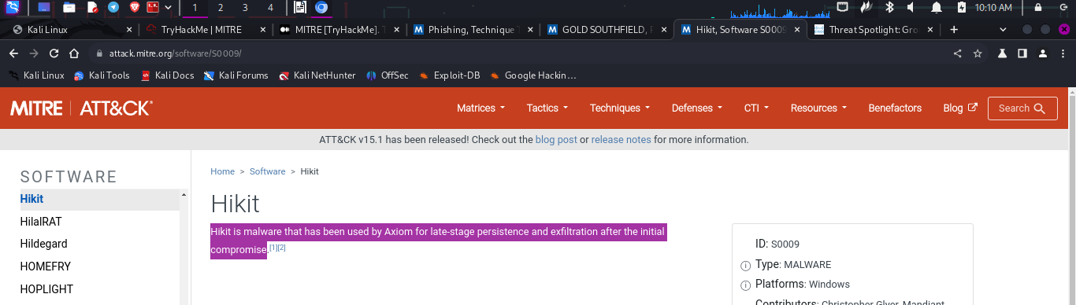
9.

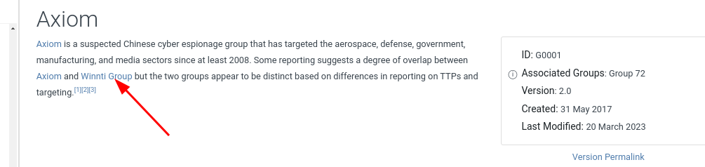

10.
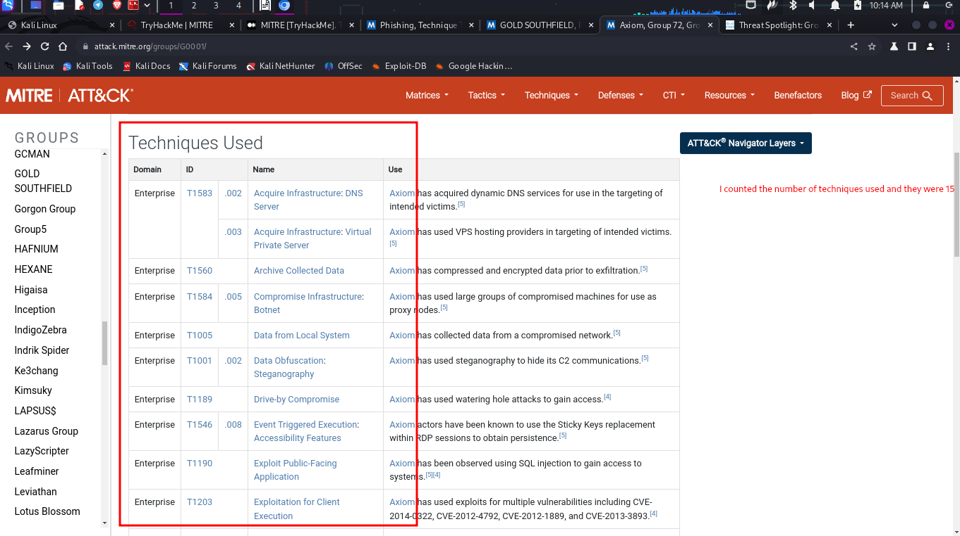

Cyber Analytics Repository
- It is a model base if analytics developed by MITRE based on the MITRE ATT&CK model

Questions
1.
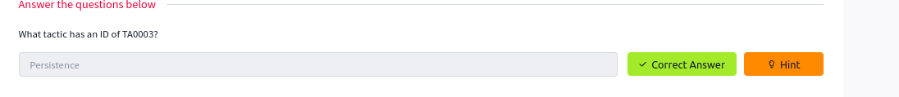
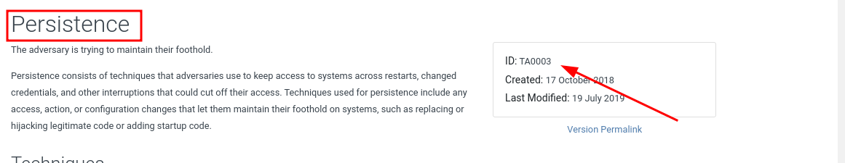
2.
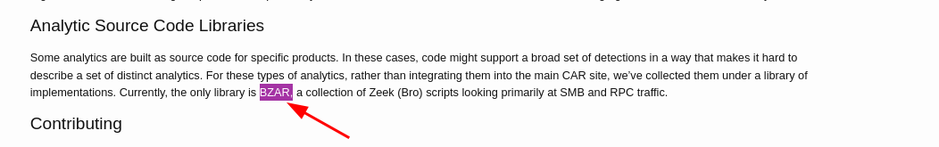
3.
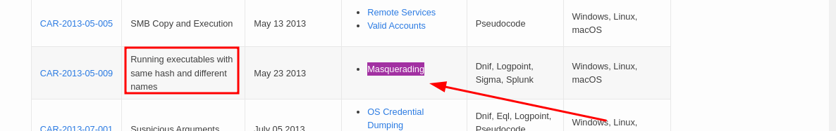
4.
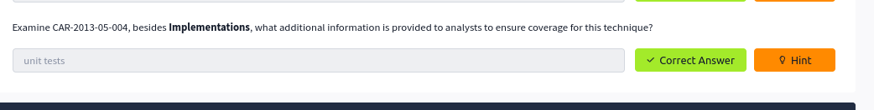
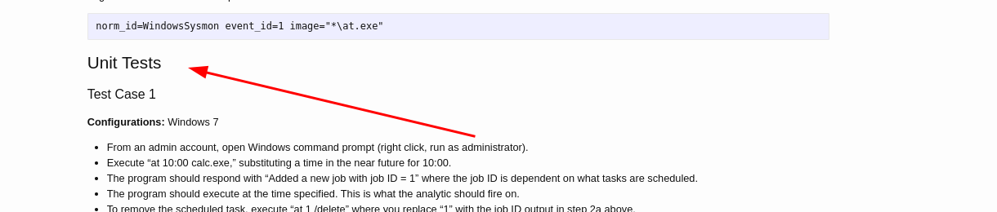

MITRE ENGAGE
- An Adversary Engagement Approach.

Questions
1.
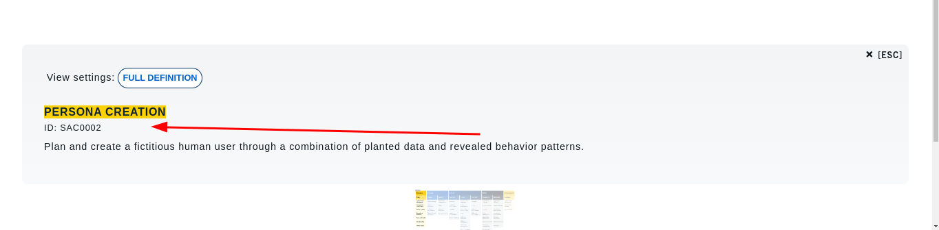
2

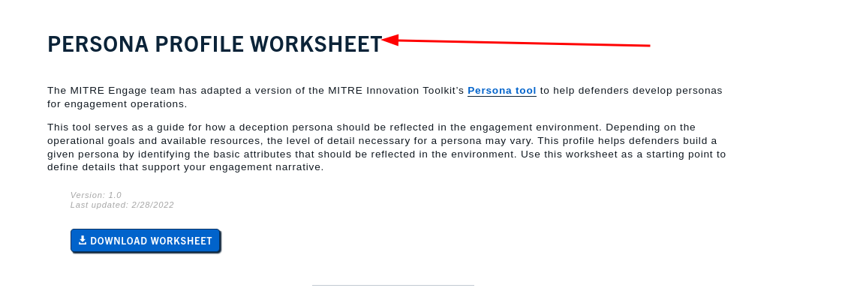
3.
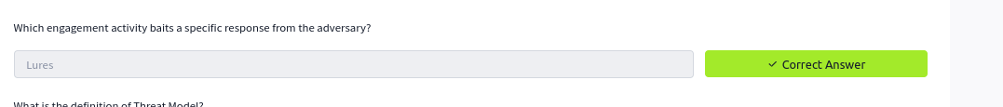
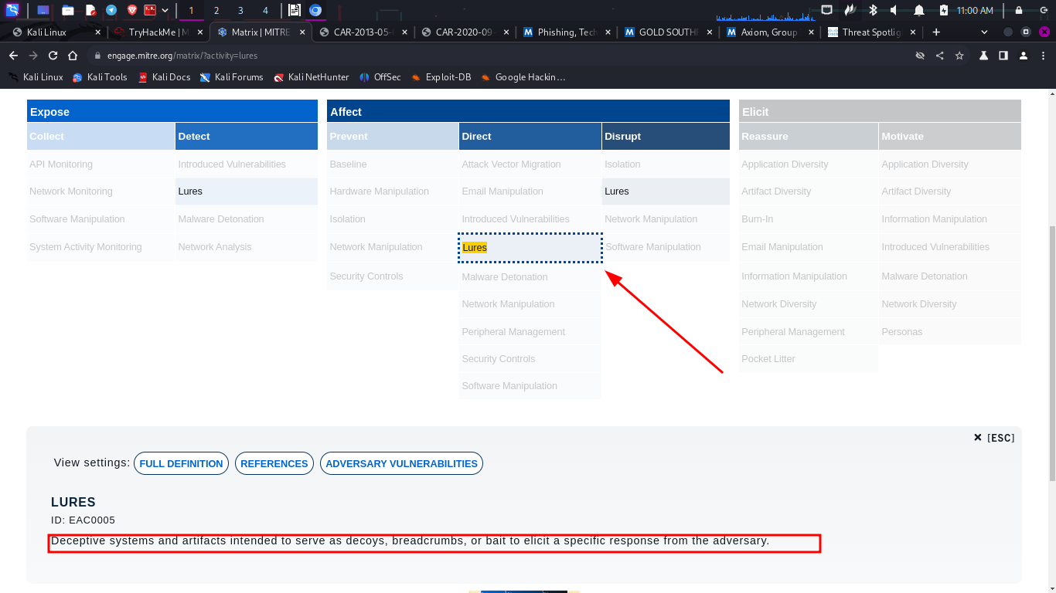
4.
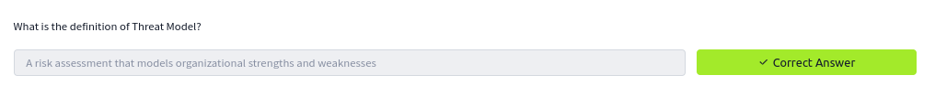
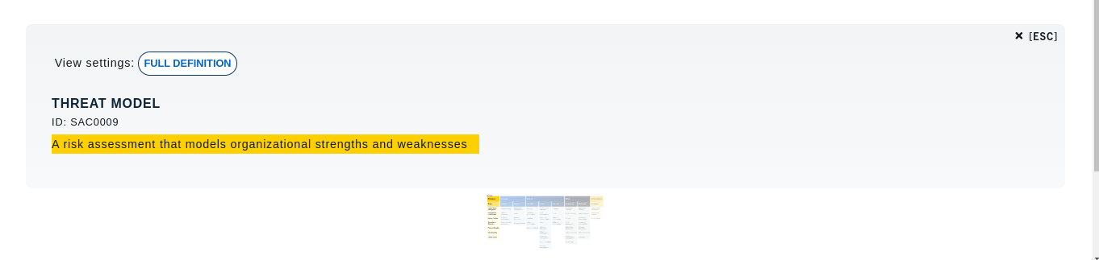

Defend
- Stands for Detection,Denial and Disruption Framework Empowering Network Defense

Questions
1.
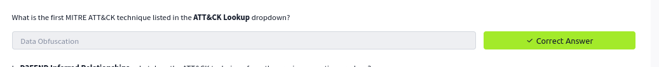
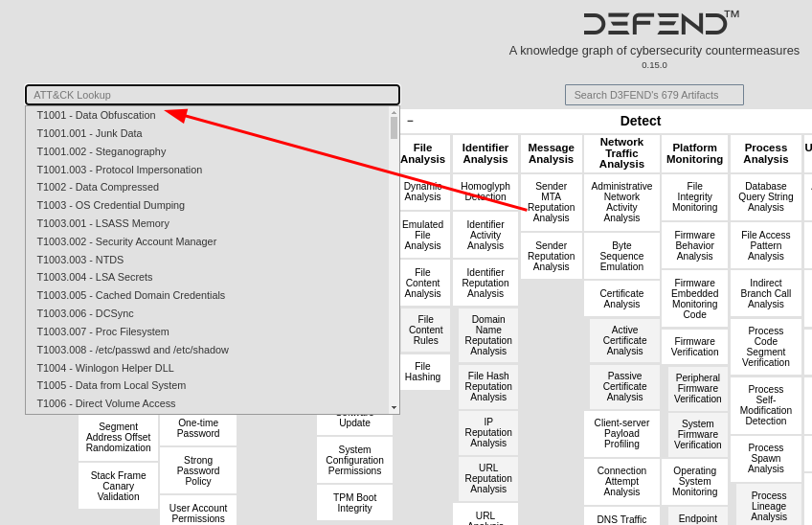
2.

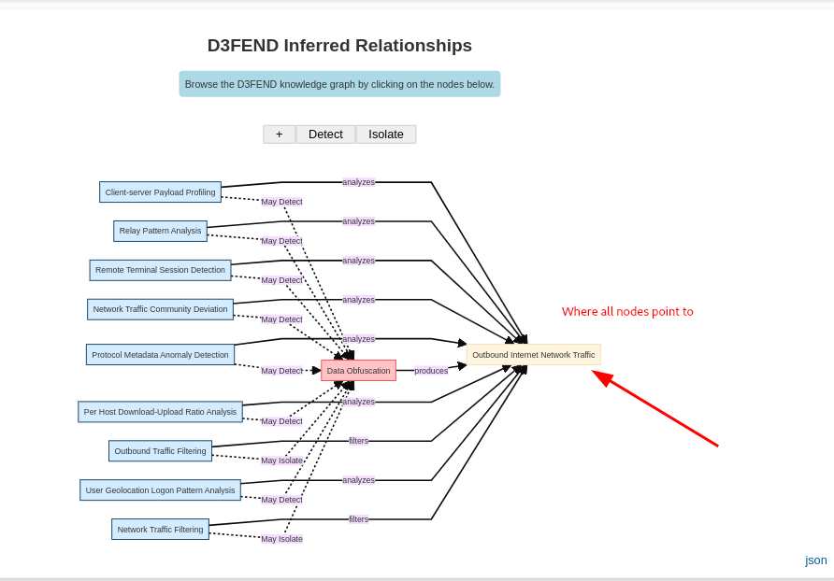
ATT&CK® Emulation Plans
- Center of threat-informed Defense (CTID)’s objective is to conduct research in cyber threats and share their research to improve defense

Questions
1.
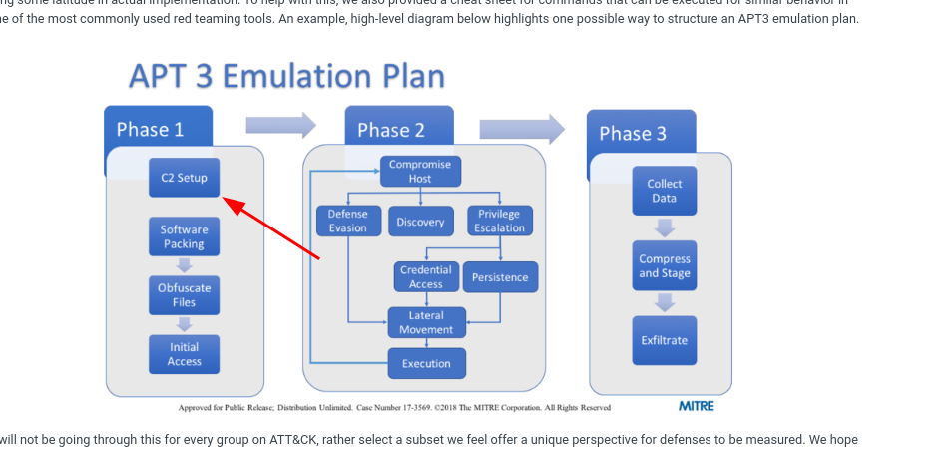

2.
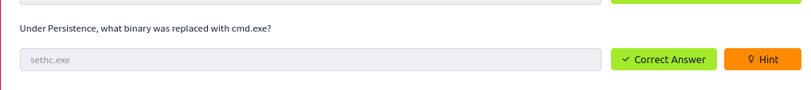
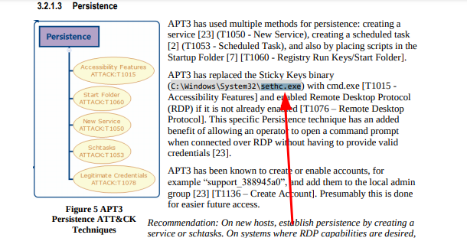

3.
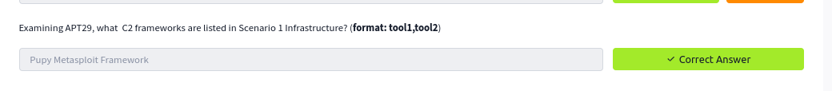
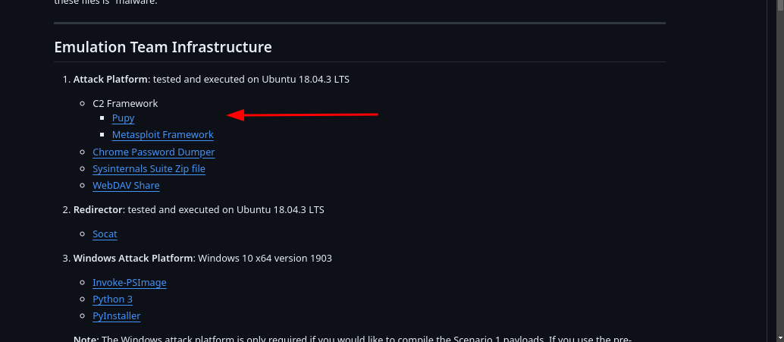
4.

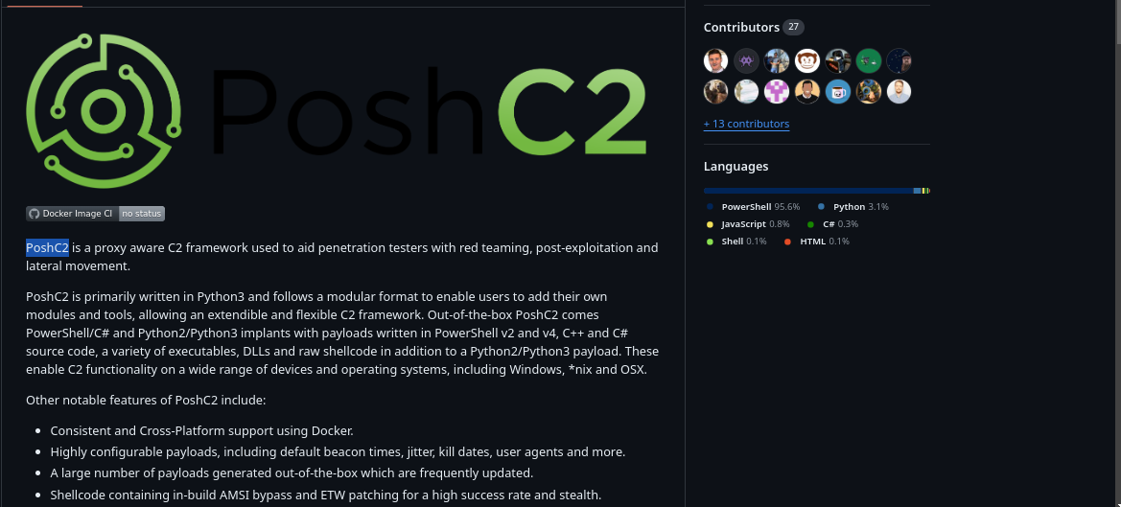
5.
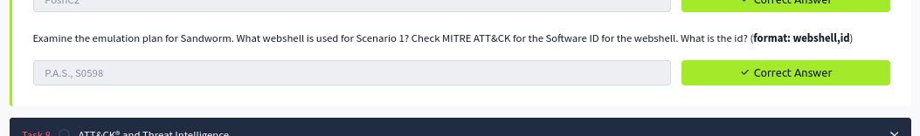

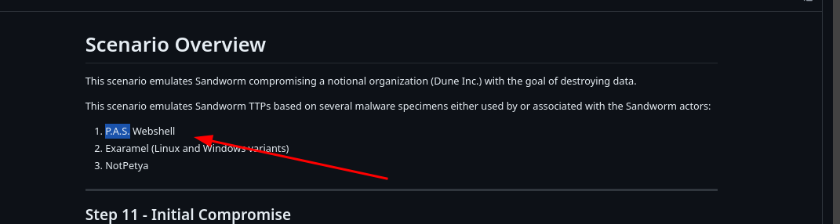
For the id I used browser extension ATT&CK
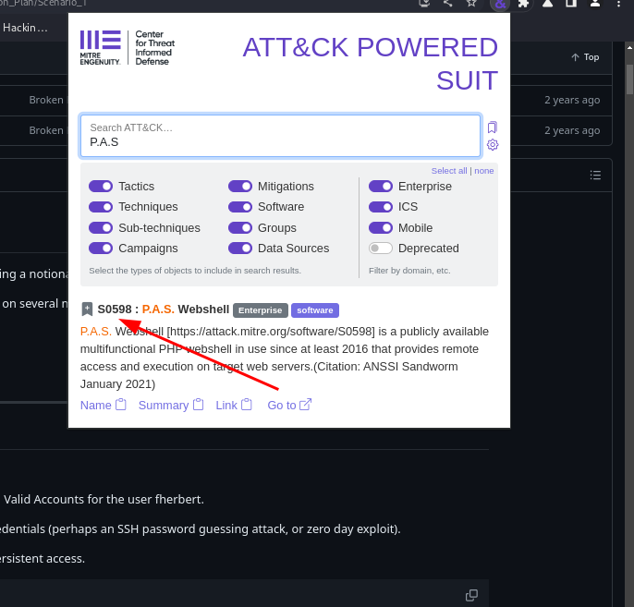

ATT&CK® and Threat Intelligence

Questions
1.

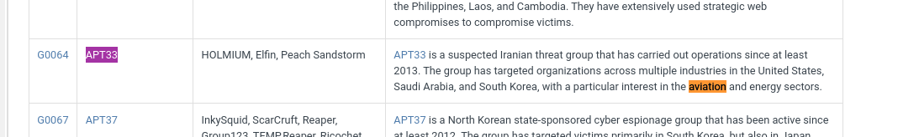
2.
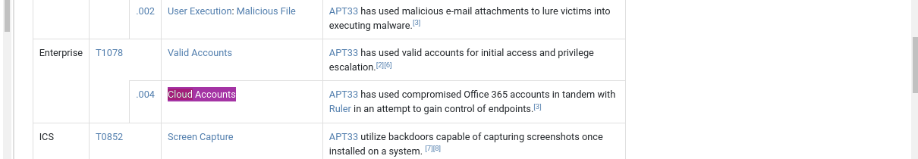

3.
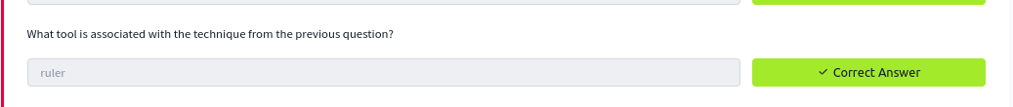
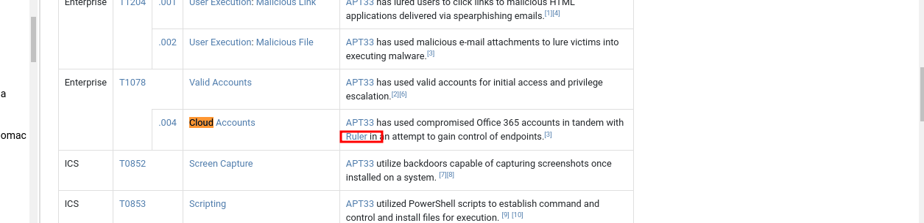
4
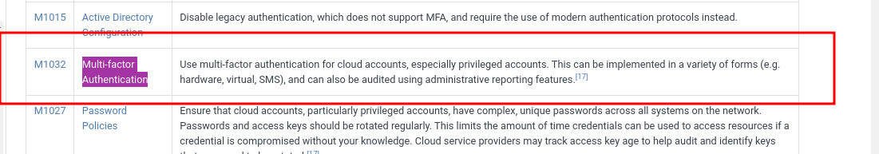
5

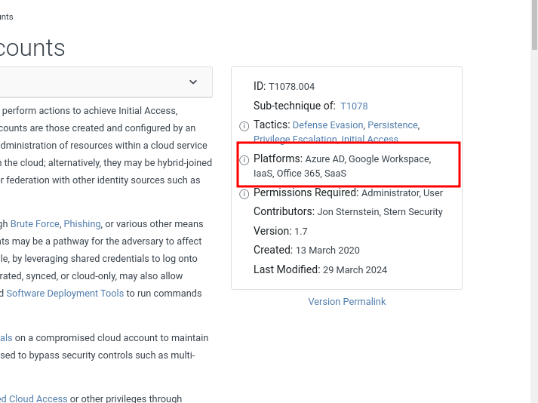
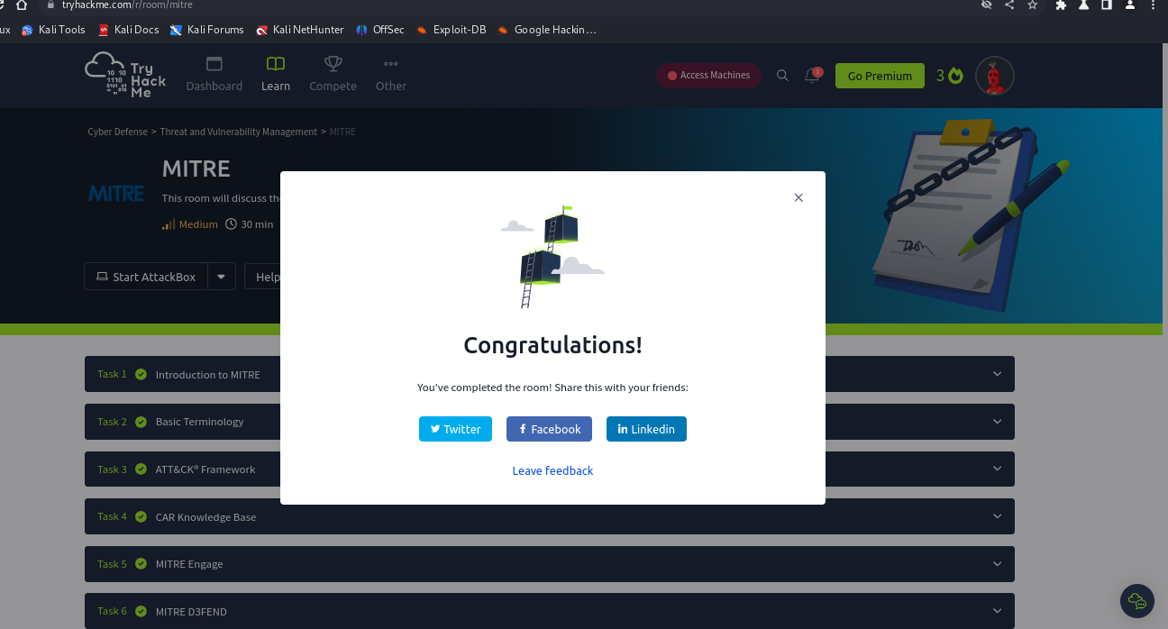

Conclusion
- I am now exposed to tools and resources that mitre has provided to the security community. I can say now that I have more information. For the SOC analyst or any other blue teamer, this information is very important. It also great for red teamers to know this information for the to try and bypass all the controls using knowledge acquired from this module.

