ISSACK WAITHAKA
cs-sa07-24085

Introduction
- Domain Name system (DNS) – offer a simple way for us to communicate with devices in the internet without remembering complex numbers

Question
1.
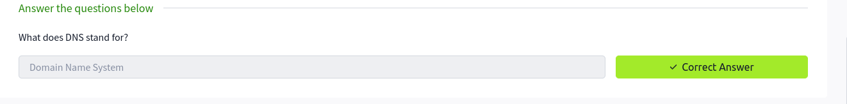

Domain Hierarchy
- Top-Level Domain(TLD) is the most right hand part of a domain name
- e.g for tryhackme.com the .com is the TLD
- is used to tell the purpose of a domain
- second-Level Domain is the tryhackme
- The subdomain is the left-hand side of the second-Level domain e.g blog.tryhackme.com

Questions

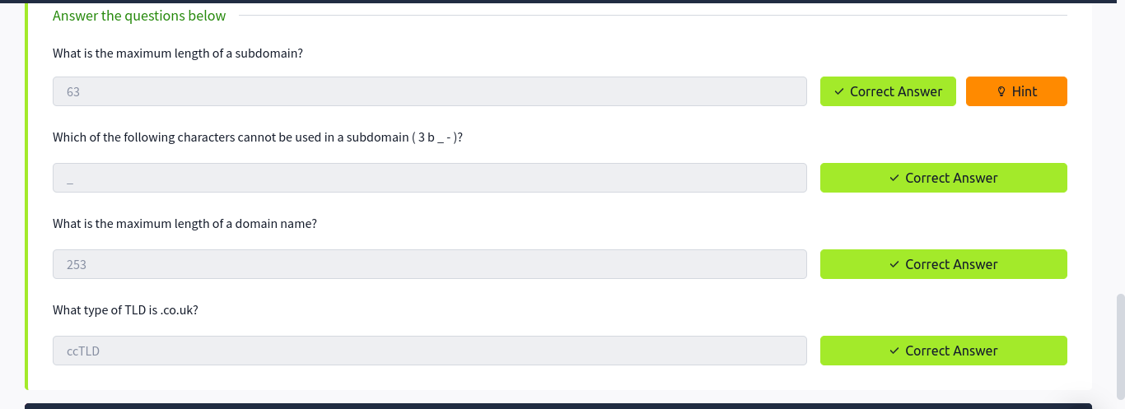

Record Types
- A record Resolve ipv4 addresses
- AAAA Record resolve ipv6 addresses
- CNAME Records used to resolve another domain name
- MX Record records to resolve the address of the server that handle the email for the domain
- TXT record are free text fields where text-based can be stored
Questions
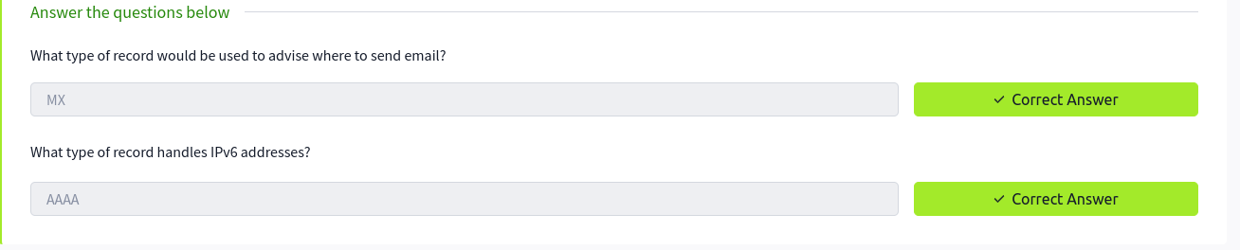

Making a request
- When a request is made, a computer looks for previously used addresses
- The root servers redirect you to Top Level domain depending on request
- The TLD hols records for where to find the nameserver
- the nameserver is used to store the DNS records for a particular name

Question
1.
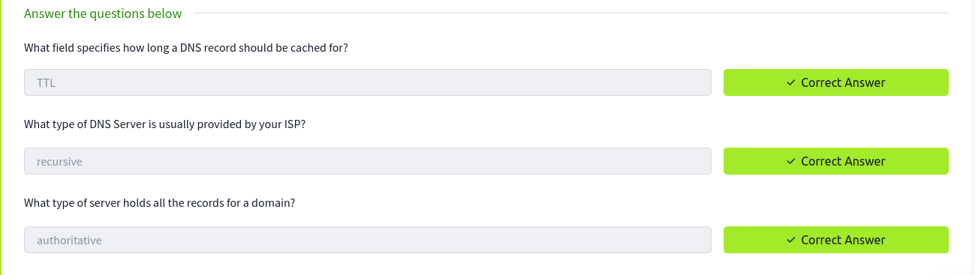

Practical
- I clicked the view site button to access the website.
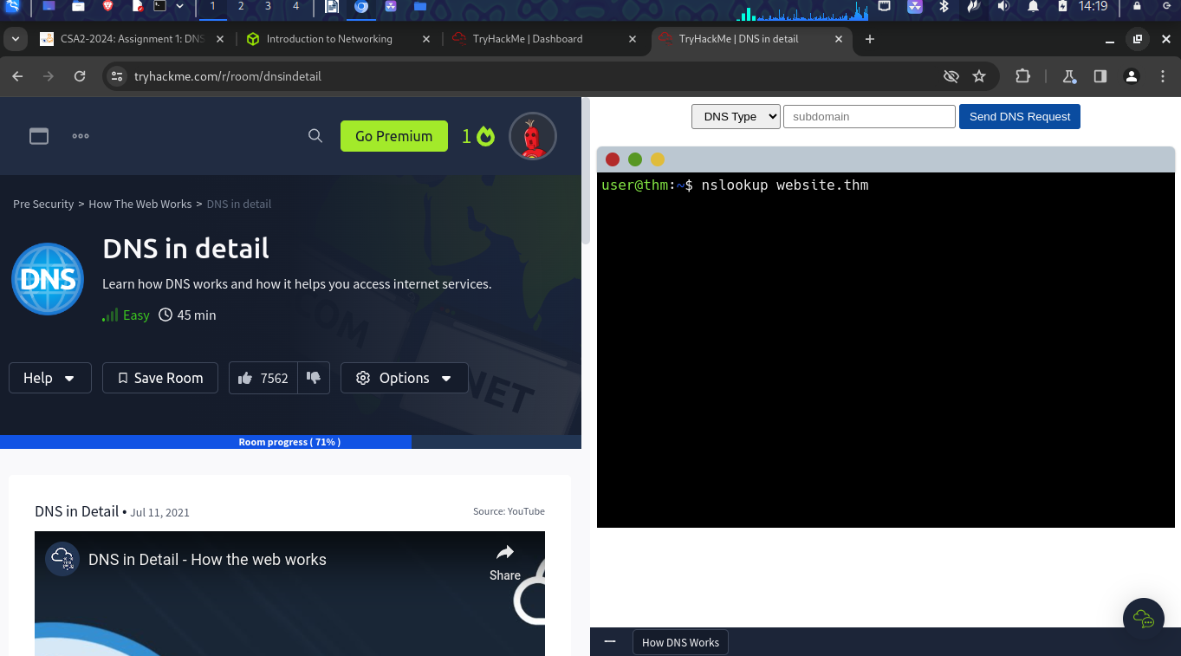

1.
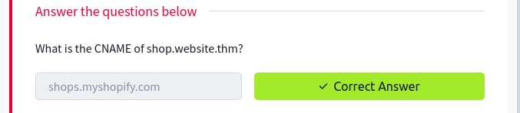
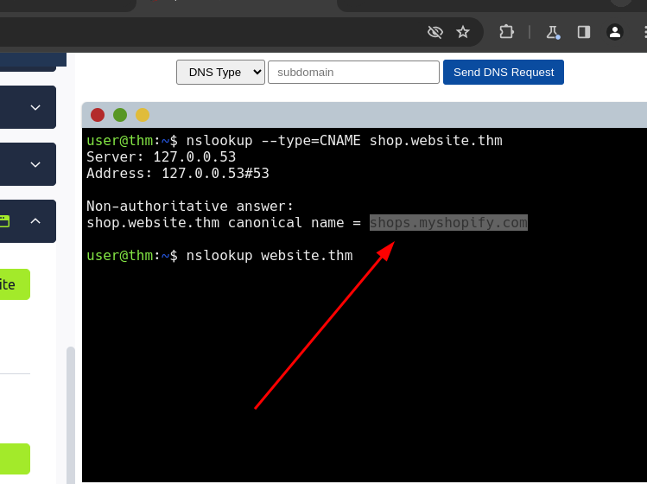

2.
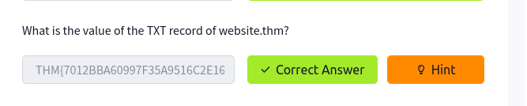
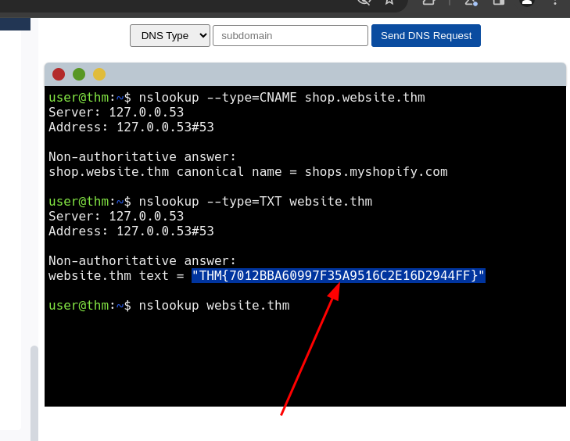

3.
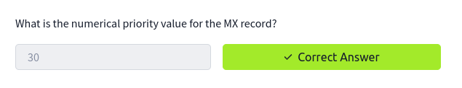
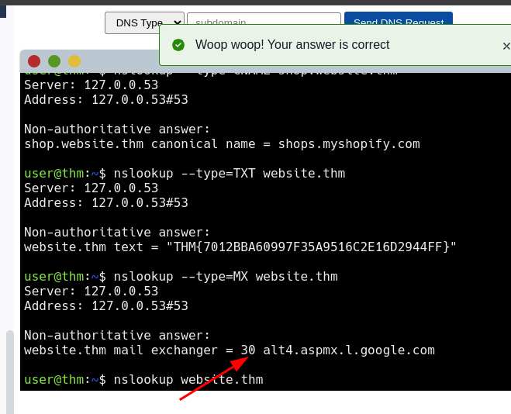

4.
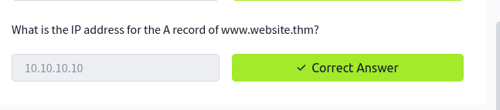
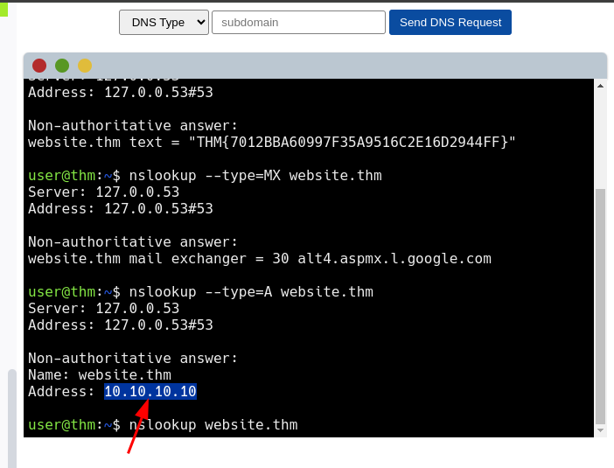

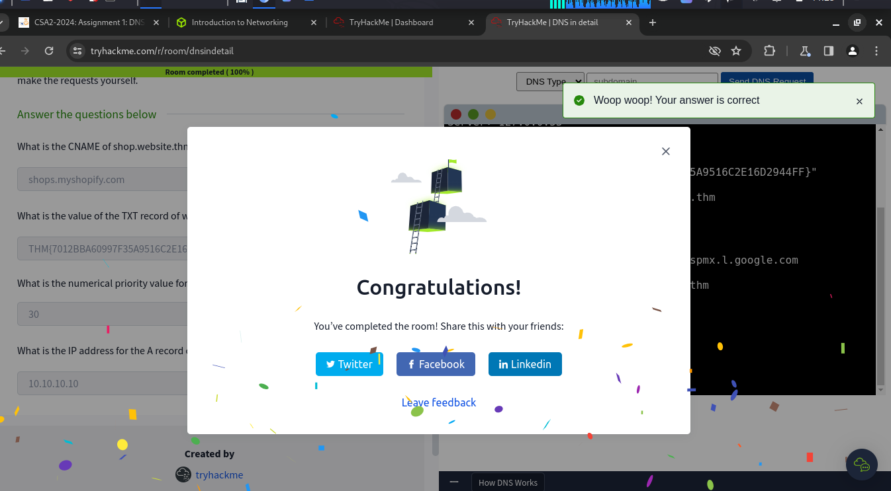

Conclusion
- In this room I learnt about about DNS(Domain Name System) Which is a protocol that allows devices to communicate without having to remember complex numbers
- It translates IP addresses to domain names
- I also did a practical at the end which helped me fully understand DNS

