**ANNUAL GENERAL MEETING**

**SOCIETY FOR GERMAN GENEALOG IN EASTERN EUROPE (SGGEE)**

**July 29, 2016**

**Radisson Hotel and Conference Centre Calgary Airport**

**6620 36th St. NE, Calgary, Alberta**

The meeting was called to order at 4:10 pm by Richard Benert, President, with 51 members in attendance.

1. The approval of the minutes of the 2015 Annual General Meeting held in Gatineau, Quebec, was the first item of business. These minutes had been posted on the website and copies were available at the meeting. David Neuman moved to approve the minutes as written. Erma Eggert seconded the motion; the motion carried.
2. There was no business arising from the 2015 minutes.

**Committee Reports, 2015-2016**

**Convention:** Bill Tucholke

Calgary, Alberta Canada is the place where SGGEE was initially founded and is the site of the 18th Convention and Annual General meeting. This marks the 5th time we have met in Calgary and the 8th time in the province of Alberta. Our convention theme “Pack Your Research Toolbox” was chosen by the convention committee.

This year a special emphasis is being placed on Volhynia with two of our speakers comjing from the Ukraine, Dr. Mykhailo Kostuik and Alex Brzyzenskyy. Professor Kostuik has extensively researched the history of our German ancestors who lived in Volhynia prior to the 1915 Russian deportations and Alex Brzyzenskyy has supervised the SGGEE Volhynian indexing project and for the past 12 years he has conducted “Volhynian AdventureTours” visiting numerous sites of former German villages throughout the Ukraine.

Special thanks go out to Mabel Kiessling who selected and made arrangements with the Radisson Hotel to host our convention; to Rita and Stephen Lyster for their generosity in sponsoring Dr. Kostiuk’s trip to Calgary and Peter Lipinski who donated handmade Kashubian bookmarks as door prizes.

We would like to take this opportunity to thank the many members and volunteers who have and are providing much needed assistance during the convention. Their willingness to volunteer creates a helpful and supportive atmosphere and the sharing of genealogical expertise among our members is often cited year after year as one of the highlights of our convention.

Special recognition goes out to Board Director Edie Adam for her creativeness and support in planning and developing our program guide and advertising materials; to Rose Ingram for her active involvement in assisting our speakers, overseeing the registration process and working our numerous details with the hotel that includes our banquet menu, equipment rentals etc., and to Publicity chair Helen Gillespie for her diligence in advertising our convention.

The convention committee is always in need of fresh ideas and input from our members. We encourage you to join the Convention committee if you would like to become more involved in the planning of our future conventions.

Next year, plans are to meet in the US. More specific information will be shared as it becomes available.

**Membership:** Ted Belke for Renate Dilk

This document provides the membership status as taken on June 30 2016 and reflects membership activities since last year’s convention report. Many previous members have returned over the past year. The intent is to start reporting on these situations for the upcoming year.

**Membership trend over the years**



**The categories of paid membership transactions for 2016 (Oct 1/2015 to June 30/2016) are:**



* Includes 10 honorary memberships

From this table we can see that the majority of memberships are renewals and they are received electronically.

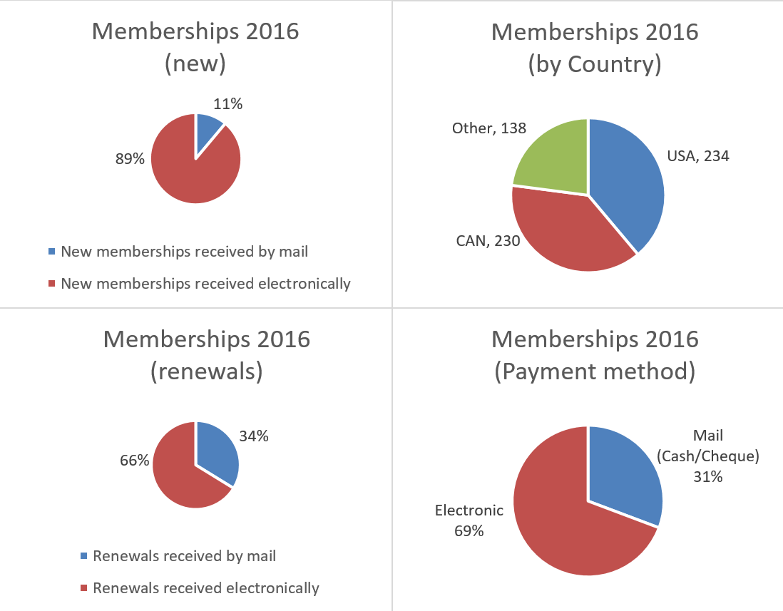

**The majority of members are located within the following countries:**

|  |  |  |
| --- | --- | --- |
|  | **# of Members** | **% of Total** |
| Canada | 230 | 38% |
| Germany | 105 | 17% |
| United States | 234 | 39% |

**Facebook Page Initiative:**

This page was created on May 8, 2015 to increase visibility and disseminate SGGEE related information.

**What works:** As was reported last year, the readership goes up when we post research related information.

Suggestions for improvements from 2015:

1. Change to a group format that requires users to join. This will allow for more privacy and information could then be exchanged between members and non-members. An option here could be to create a “group” page available to members-only? The con to this is that we will not have a visibility with non-members. No work has been done to close the group.

2. Post more research related information, this seems to be what our audience wants. More research related information was posted over the last year.

3. Add more photos. Photos have been added where available.

4. Post a link to the journal(s) As soon as journals are available a link is posted

5. Most important of all. If this is continued as a communication tool then some guidelines should be developed to outline what types of information should be shared/or not shared here. I always used my own judgement but this is SGGEE’s Facebook page so others should be involved in determining what we use Facebook for. In the next year I will work more closely with the publicity chair regarding messaging.

6. I recommend not duplicating any information from the web site, the web site should remain the “source” for information where possible. The Facebook page can “advertise” information that can be found on the web site and then links can be provided. This is what we have been doing over the past year.

7. Limit “small talk” type messages … these do not seem to be very popular with the audience. This is avoided where possible

8. Link to other genealogy Facebook pages and organizations Added where possible

For the upcoming year it would be helpful to have a few other volunteers assisting with the page, posting information. Below is some demographic information about the people that have “Liked” our page.

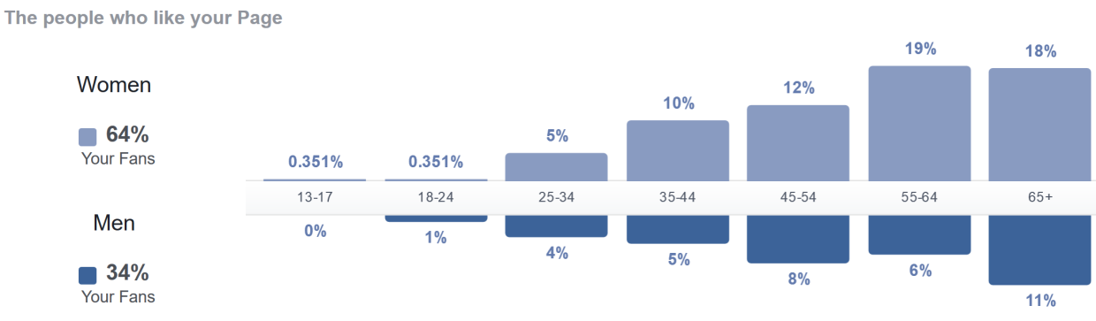

**Databases:** Dick Benert for Gary Warner

There are several existing databases that SGGEE maintains, and from time to time, some planned that have not yet been received or posted on the SGGEE website:

1. **Existing databases**

1. The Master Pedigree Database (MPD)

This database contains data from original Polish records, and also from the research of our members. It currently contains 522,828 (a net decrease of 511 below that at the last convention). The database is in a constant state of change because new data is always being added as well as merged (there were approximately 5,000 new records added this past year, so there were many records that were merged in order to show just the decrease in the number of records). The merge process establishes links between the various family files in the database and is the process by which we determine who among our members are cousins. This database now shows almost all given names as the most common German form as an aid to the merging process, which requires that the first 6 characters of the given name match for an automatic computer matchup. The exception to the most common German given name is for all SGGEE members and their spouses, which are maintained as submitted. The MPD currently contains the SGGEE001r10 update, the last one received before the death of its author, Al Muth. Gary Warner maintains this database.

See <https://www.sggee.org/members/genealogy.html>

2. The Parish Records Index (PRI)

This database is a listing of individual birth, marriage, death, and confirmation records extracted from original records in Poland. It currently contains 364,375 names (same as at last convention). The size of the database is increased by research supplied by volunteers, and is reduced as yet other volunteers transfer the portions of the database that have the most complete data to the Master Pedigree Database. Gary Warner maintains this database by updating it with new data provided by SGGEE volunteers.

See <https://www.sggee.org/members/pri_guide.html>

3. The Alternate Surnames List

This database is a listing of all of the alternate surnames used in the SGGEE Master Pedigree database. It is useful for members in determining what names their ancestors might have used in Poland or Russia as the result of their original surnames being corrupted to change to the Polish or Russian equivalent of the German name. For instance, the surname Schwarz (meaning the color black) has the Polish equivalent of Czarnecki. There are substantiated alternates- those confirmed by others who have not just submitted names to the Master Pedigree Database. This list is unchanged in the last year. There are also unsubstantiated alternates- those submitted by SGGEE members which may or may not be true alternates. This list also remains unchanged for the past year. The substantiated alternate names database is currently 7 pages of double column text. The unsubstantiated alternate names database is currently 218 pages of single column text that show the unsubstantiated alternates. Gary Warner maintains this database.

See <https://www.sggee.org/research/AlternateSurnamesDatabaseSubstantiated.pdf>

and also

<https://www.sggee.org/research/AlternateSurnamesDatabase.pdf>

4. The Alternate Christian Names List

This database is a listing of all of the various given names in the Master Pedigree Database, and their most common German equivalent, if any. The list was developed to assist in the merging of the records in the Master Pedigree Database, since the computer matchup of names to be compared requires that the first 6 letters of the given names be the same for a matchup. The list is currently 15 pages of double column German names with their more common English, and other language equivalents, and another 32 pages of double column English and other language names alongside their most common German name equivalent. Frank Stewner, Ed Koeppen and Gary Warner maintain this database. No significant changes in the last year, but a few corrections were made.

See <https://sggee.org/research/AlternateChristianNames.pdf>

5. The SGGEE001x database

This latest version of this database was provided by Al Muth in 2009. We have been unable to obtain any of the work he completed between 2009, and his death in 2013. The current version of that database is SGGEE001r10, and contains 194,000 names. The data is exclusively from Al’s extractions of Polish birth, marriage and death records. This data is incorporated into the Master Pedigree and mostly merged with it. Gary Warner is the keeper of this database

See <https://www.sggee.org/members/parallel.html>

6. The Lodz Trinity database

This is a database of original Polish records for the Lodz area, as input by John Marsch from transcriptions of the original Polish Lutheran records of the Lodz Trinity church. It is now complete and contains 34,492 names. This database is now a part of the Master Pedigree database, and is almost completely merged with the Master Pedigree Database. Gary Warner is the keeper of this database.

See <https://www.sggee.org/members/lodz.html>

7. The membership database

This is a database maintained by Renate Dilk that contains the contact data for all present and former members of SGGEE. It is updated every time a change or membership application is received and posted on the website usually the same day as a membership application is received. As of 31 May 2016, the database contained the names of 1986 present and past members of SGGEE. Renate Dilk is the keeper of this database.

See <https://www.sggee.org/members/member_data.html>

8. St. Petersburg birth, marriage and death indices (Volhynia, Kiev and Podolia)

This is a database that was extracted from the St. Petersburg records for Volhynia, Kiev and Podolia. It contains data on the births, marriages and deaths of Lutherans who lived in Volhynia, Kiev and Podolia between 1836 and 1885, and in addition was supplemented with data from later years for Rozyszcze and Wladimir-Wolynsk parishes and now contains approximately 422,000 names (same as last year). A cleanup of the marriage records to correct known errors occurred in 2006, and a similar cleanup of the birth and death records to remove known errors and to put data in an easier to use format was completed by Dick Stein in 2009. Confirmation data for Rozyszcze parish from 1862 to 1886 was added to the births index in 2010. Gary Warner is the keepr of this database and the supplemental data was provided by Dick Stein and his assistants.

See <https://www.sggee.org/research/StPeteBirth.html>

<https://www.sggee.org/research/StPeteMarriage.html>

<https://www.sggee.org/research/StPeteDeath.html>

9. Galicia Index of Individuals

This is a database of people who lived in various villages in Galicia. It contains birth, marriage and death data of the villagers and their ancestors. The database is very extensive and was prepared by Bill Fife, and has remained unchanged in the last year.

See <https://www.sggee.org/members/galicia/galicia_records.html> Bill Fife is the keeper of this database.

10. History Books Database

Many of the areas in which our ancestors settled in Canada and the USA have produced history books of the area, variously called Centennial books, Anniversary books, Jubilee books etc., which describe or tell about the original settlers in these areas. This database is a listing of the books (and the individuals in the books) held by either our members, or in the SGGEE Library. This database currently contains 26,000 names. Gary Warner is the keeper of this database.

See <https://www.sggee.org/members/localhistory.html>

11. Library materials database

Howard Krushel has made a listing of all of the materials in the SGGEE library. He was the custodian of that list until his retirement in the summer of 2014. All library material is now in storage.

See <https://www.sggee.org/members/library_contents.html>

12. Lublin Digital Archive Database  
  
See separate report from Karl Krueger and Sigrid Perry

13. The KGB file from Zhitomir Archives contains 4178 lines of data.  Names of people arrested about 1931 to 1945 and their fate. Also includes birth dates and names of family members.

See <https://sggee.org/members/MembersIndex.html#kgb>

14. Resettlement or Repatriation of 1930's file from the Zhitomir Archives contains 13,851 lines of data.  Gives place of resettlement plus former residence.

See [<https://sggee.org/members/MembersIndex.html#kgb>](http://sggee.org/members/MembersIndex#kgb)

15. Eastern Volhynia records for Zhitomir by Pastor Samuel Sigfried Lemke, recorded October 1941 to November 1943.  Baptism records contain 6977 names of those baptized, plus the names of the parents- most records are of people born in 1920's to 1943.  Also 502 lines of Marriage records contain marriages performed in 1942 and 1943.

See <https://www.sggee.org/members/MembersIndex.html#lemke> for access to these records. Additional information on these records is available, and was not shown on the website for privacy reasons (some persons would be less than 80 years old).

16. Gazetteers for Congress Poland, the old German, Russian and Austrian Empires, and also for Volhynia and Galicia. These have been created by Frank Stewner to show present-day and old names for each of these areas, and include coordinates for ease of locating on maps. Present villages identified in each area are:

Congress Poland- 6173 villages and towns (<https://sggee.org/research/Gazetteer_Poland.pdf>)

German Empire- 3941 villages and towns (<https://sggee.org/research/Gazetteer_German_Empire.pdf>)

Russian Empire- 1294 villages and towns (<https://sggee.org/research/Gazetteer_Russian_Empire.pdf>)

Austrian Empire- 211 villages and towns (<https://sggee.org/research/Gazetteer_Austrian_Empire.pdf>)

Galicia- 578 villages and towns (<https://sggee.org/research/Gazetteer_Galicia.pdf>)

Volhynia- 5545 villages and towns (<https://sggee.org/research/Gazetteer_Volhynia.pdf>)

1. **Databases planned**
2. BMD indexed data from the Lutheran Records in Zhitomir archives covering church books for time period 1900 to about 1915. Rough copies of this data is here at the convention, and we expect it to be on our website soon.
3. Dan Pratt and Horst Renz are extracting Russian-language marriage records from the AGAD online scans of Volhynia registers for Rozyszczce, Wladimir-Wolynsk and Lutzk Lutheran parishes.  These extractions include the **names of the parents of the groom and bride,** or in most cases the **name of the previous spouse for a widowed groom or bride,** and the **ages of the groom and bride** which were not included in the St. Petersburg records and the previous Rozyszcze project. These records will be added to the current VKP marriage database in phases.

**Finance:** Alan Pfahl

I am pleased to report on the financial results for *The Society for German Genealogy in Eastern Europe* for the 2015-2016 fiscal year.

Before looking at this year’s financial results, I wish to acknowledge the fine work of our previous treasurer **Ken Kufeldt**. As many of you will know, Ken is a retired financial professional from Calgary who volunteered as SGGEE treasurer many years ago. Over his tenure Ken became a “self-taught” accountant and ably fulfilled many of the financial functions of the society. On a personal note, I would particularly like to thank him for how generous he was with his time during my transition. He was of invaluable assistance helping me understand all the key financial aspects of the SGGEE treasurer position, such as the banking arrangements, the nature of regularly reoccurring transactions, the required reporting, etc. Although it is a great loss to the SGGEE to no longer be able to rely on Ken’s diligence and experience, we are happy to report he is continues to be active in the volunteer community with other organizations.

I also wish to acknowledge the efforts of **Virginia Braun**, who is here attending this year’s convention. While Virginia has been assisting the SGGEE for many years with a yearend review of our financials, this year her contribution was heroic. Because of my personal issues she received the 2015-2016 information much later than usual, and to make matters worse, due to different versions of the accounting software she was forced to essentially re-input all the various transactions. This was done at an extremely busy time for Virginia professionally. Needless to say, the society and especially I personally, owe Virginia an immense debt of gratitude.

SGGEE continues to benefit from a favourable financial position. On a year-over-year basis the assets of the SGGEE increased by 4.7% to $138,806. The composition of these assets changed somewhat as we shifted funds from our non-interest bearing chequing account into our savings account. This was done in recognition of the current low interest rate environment in an effort to earn a positive return on our funds on deposit. In addition, we augmented our US dollar holdings during the year from $8,474 at the end of 2014-2015 to $22,090 at the end of the current fiscal period. This diversifies our current assets somewhat better with respect to currency (see more comments on this below).

Our comparative income statement shows a slight decline in the society’s revenues. Our revenue is earned largely on convention registrations and memberships, both of which dropped during the 2015-2016 year. The 2015 convention was highly successful from the point of view of the various sessions, however Ottawa is a “non-traditional” market for German genealogy so it might have been expected that the convention fees didn’t quite approach the levels of the previous year. Regarding memberships, we are making it easier than ever before for individuals to become aware of, and to join, the SGGEE. This will need to be an area of clear focus for us all going forward. In order to continue the good work of the SGGEE we will need to devote more efforts to engage the next generation of genealogy-inclined individuals and spark their interest in German genealogy. This is especially critical as the current generations with strong personal links to Europe grow older.

The expenses to run our organization consist broadly of those related to holding our convention, conducting society research, publishing our journal, operating our website, and our general administrative expenses. It is heartening to see that the SGGEE operates in a prudent manner with due respect for the dollars contributed by our membership.

Of the many financial challenges facing the SGGEE, perhaps one of the thorniest is that of foreign exchange. Historically the society has held nearly all of its assets and reserve funds in Canadian dollars and over various time periods when the Canadian dollar was rising against the US dollar that has been beneficial. However, as many are aware we live in a period of rapid change and currency fluctuations have been extreme. Of note, the last couple of years witnessed the most rapid decline of the Canadian dollar (and, by the way, most other world currencies) against the US dollar. Fortunately there has been a bit of a rebound in 2016. This means that any of our expenses that are in US dollars (such as conventions held in the US, or international research dollars denominated in US dollars) are more affordable for us when converted from Canadian dollars.

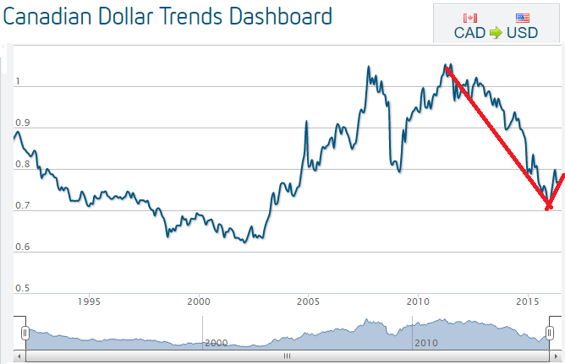

To better insulate us from positive or negative currency fluctuation we need to turn our attention to the appropriate level of assets the society holds in each currency. I intend to conduct further consultations on this issue in the coming weeks with a view to making a recommendation to the board, but my initial view is that transitioning to hold assets roughly 50/50 in Canadian and US dollar would offer better diversification for the SGGEE. This ratio also nicely corresponds to the approximate makeup of our membership. We also need to better leverage PayPal with respect to payments being remitted to us in US dollars, in order to avoid unnecessary currency exchanges. For instance, if we can retain US dollar PayPal membership fees in US dollars, instead of having forced conversions into Canadian dollars (as our accounts currently operate), this will go a long ways to solving our currency issues.

Other goals for the upcoming year will be to provide meaningful financial analysis of various board decisions affecting the direction of the SGGEE, to continue to conduct the day-to-day financial transactions of the SGGEE (i.e. deposits, bill payments, transfers, processing accounting entries, and financial statement preparation), to ensure good stewardship over SGGEE assets, as well as to engage the existing finance committee in a meaningful way in the finance function of the SGGEE.

**Research:** Rose Ingram

Lublin church books Indexing project. Team Leader Karl Krueger reported in the March Journal the 8 year effort to index the entire Lublin records from Digital records.

Indexing is still ongoing with a couple more disks to finish. Two disks were not received from the Lublin church and another disk is corrupted. Karl is attempting to index the records from these disks which area now online.

Lipno Area parishes: Team leader Earl Schultz reports the ongoing extraction of records from filmed records onto a spreadsheet. Names from this data is being transferred into the Legacy program and then eventually will be added to the Main Pedigree Database. Another time consuming project.

ROZYSZCZE PROJECT – PHASE TWO

Original Lutheran church register books of Rozyszcze, Wladimir-Wolynsk, and Lutzk parishes are held in the AGAD archive in Warsaw.  Initially, records to about 1895 were available on LDS microfilms 2380017 to 2380038.  In phase one of the Rozyszcze project, births, deaths, and marriages were extracted from these microfilms and added to our VKP database.

More recently, AGAD made available online digital scans of all the records up to just before WW I.  These records are being extracted in phase two which is just underway.  Marriages are being extracted first and will include the ages of the groom and bride and the names of their parents.  In addition, the ages of the groom and bride and the names of their parents are being added to all the marriages previously extracted for Rozyszcze parish 1862 to 1895 and Wladimir-Wolynsk parish 1891 to 1899.

It is expected that the first section of this new data will be added to the VKP marriages database later in 2016.

Volunteers are needed to do extractions from online scans.  Ability to read and translate the hand-written Russian-language records is essential and familiarity with the use of spreadsheets is desirable.  If you can help, please contact Dick Stein.

Lutheran records Indexing in Archives in Volhynia area – Years 1900 to 1915.

We have now received all indexes from the Zhitomir, Rowno and Lutzk archives of births, marriages and deaths records from 1900-1915.

These records are from eleven churches. It has been a big project with formatting the files, correcting name spellings and village spellings, typographical errors and other editing . We had hoped to have the indexed data on our website last year but ran into some roadblocks. We have more volunteers working on this project, so we anticipate having this data posted by end of this year.

We have the rough data available and some proofed data for searching in the Research room. DickStein, Ken Krell and myself will have this on our computers.

**Website:** Dick Benert for Karl Kreuger

Other than standard updates and providing new links to online records for different parishes in Volhynia and Russian Poland, little change has occurred on the web site. Matt Warner, however, has created an improved and safer mechanism for changing unwanted passwords and retrieving forgotten passwords. Matt Warner has suggested that SGGEE might want to host the site in the cloud rather than on a server he keeps in his house. Transparency to users will not be affected and changes to the site can continue to be made with our volunteer members. Another topic of consideration is whether to have an external person serve as a consultant to tweak the web site to make it more user friendly.

Frank Stewner continues to update the locations database and he is also providing us with a gazetteer of most regions of Europe that SGGEE is involved with. He has been providing us with annual updates to this gazetteer which is available on our website.

The membership of our listserv continues to increase slowly now just over 830 subscribers.

**Publicity:** Dick Benert for Helen Gillespie

Since the convention was to be held in a Western Canada venue, the direction for publicizing the event was refocused to those organizations more in the West and Central Canada and the US. Many of the eastern email contacts were removed and western contacts updated. A total of 112 genealogy and historical societies and cultural German organizations were contacted with a “save the date” in March, and again with a notice in May once the theme and venue were determined, and a reminder in June that included the link to the speaker list, and a reminder of the early registration discount. In Canada, GlobalGenealogy.com was included as this site keeps an online list of upcoming genealogy events from around the world. This week we were top of the list! An American site, <http://conferencekeeper.org/> which promotes all events genealogical also listed our event. It’s difficult to determine whether our event was cited in their newsletters as they are limited to members, but a brief search on the internet did churn up some listings on various genealogy sites.

SGGEE’s Facebbok page continued to attract new followers and is used in conjunction with our website and the mail list to inform people about our activities.

**Journal:** Dick Benert for Ray Block

On a quarterly basis, the SGGEE Journal is posted to the website following proofreading and editorial review by SGGEE directors and members. Karl Krueger, administrator of the SGGEE website, posts the latest version. Rose Ingram then sends an email to all current members informing them that the Journal is available for reading or downloading on-line. For those requesting a mailed version, we mail it within days of the posting of the electronic version. Our SGGEE Journal is required to be between twenty-four and forty pages, with articles pertinent to the stated goals of the organization, namely those areas inhabited by our ancestors in present day Poland and Ukraine. We presently have about fifty members receiving the printed version with about ten publications going to various societies and the Canadian National Archives.

We request that you send articles to the SGGEE Editor at [editor@sggee.org](mailto:editor@sggee.org). If you have any questions regarding your article including relevancy or interest on our part, we will gladly review the article and let you know if and when it will be published. Personal and family stories are of great interest to our membership. We can always use more articles and look forward to your contribution.

Submitted by Ray Block, SGGEE Journal Editor

**New Business**

1. A motion to accept the committee reports was made by David Neuman, seconded by Edie Adam. Motion carried.

2. Appointment of Auditor: Member Virginia Braun will continue to do the annual audit and report. This is a volunteer contribution. Rose Ingram moved, Edie Adam seconded, that Virginia Braun be approved as auditor. Motion carried.

3. Election of Directors to replace two retiring Directors ( Richard Benert and Elvin Meyers), each for a 3-year term. Richard will remain as Past-President, replacing Sigrid Pohl Perry in this capacity. Dick Stein nominated Dan Pratt, and Judy Hagen seconded the nomination. Dan was approved as Director. Rose Ingram nominated Marnie McCall, and Edie Adam seconded the nomination. Marnie was approved as Director. The position of Treasurer has been filled by the appointment of Alan Pfahl. This appointment was approved by the Board of Directors effective January 2016-August 2016 with the understanding that he or another member will be elected treasurer at the 2016 Annual General Meeting for a term beginning from that meeting through August 2018. Melonie Liening nominated Alan Pfahl to continue as treasurer, and Ted Belke seconded the nomination. Alan was approved as treasurer.

1. Dick Benert expressed gratefulness to the Lyster family for their generous donation of providing travel expenses in order for Professor Mykhailo Kostiuk from the Ukraine to speak at the convention this year. Also, to Don Miller and his willingness to help with travel expenses for Alex Brzhezytskyy, also from the Ukraine, who provided translation services and spoke.
2. Volunteers are always needed on the various committees.
3. Victor Gess suggested the possibility of having locality meetings for the membership to provide a venue for general discussions and increased education of the participants in regards to eastern European genealogy. The membership committee will review.
4. The motion to adjourn the 2016 Annual General Meeting was made by Marnie McCall, seconded by Rose Ingram. The motion carried, the meeting adjourned at 5:20 pm.

Respectfully submitted,

Melonie Liening, recording secretary