**Annual Meeting of the**

**Society for German Genealogy in Eastern Europe (SGGEE)**

Minneapolis Marriott Northwest

7025 Northland Drive North

Brooklyn Park, Minnesota, USA

The 2017 AGM of the Society of German Genealogy in Eastern Europe was held on 28 July 2917 at the Minneapolis Marriott Northwest Hotel. After a wonderful dinner with SGGEE members, the meeting was called to order by President Edie Adam at 7:15 pm. There were 32 members in attendance.

**Approval of minutes of the 2016 AGM**

A motion by Bill Tucholke was made to accept the 2016 AGM minutes as written. Ken Krell seconded. Motion approved.

**Old Business**

There was no business arising from the 2016 AGM minutes.

**Committee Reports**

The **RESEARCH** report was giving by Bill Tucholke for Rose Ingram.

ROZYSZCZE INDEXING PROJECT

The AGAD archive in Warsaw holds original register books of the Lutheran parishes Rozyszcze, Wladimir-Wolynsk, and Lutzk in western (Polish) Volhynia.  These were first made available on LDS microfilms and more recently AGAD made digital scans available on its website.  SGGEE previously indexed most of these records for the Volhynia-Kiev-Podolia (VKP) database.  The current project is to add links to the online scans for each entry in the VKP database and to continue indexing records for the later years (to 1914) which were not available when the original indexing was done.

As of June 2017, links to online scans have been added to the VKP database for:

  - marriages for Rozyszcze parish for the years 1862 to 1909 (the year 1902 is missing), a total of 11,924 marriages

- births for Rozyszcze parish for the years 1862 to 1899, a total of 47,101 births

In progress are the completion of births to 1913, the deaths from 1862 to 1911, and the confirmations for Rozyszcze parish.  Planned are the records of Wladimir-Wolynsk parish (1891 – 1914) and Lutzk parish (1899 – 1914).

The records are written in the Russian starting in 1892 and we need volunteers who are able to read and transcribe records written in Russian.  If you can help, please contact Dick Stein at [dababases@sggee.org](mailto:dababases@sggee.org)

Volhynian Archives Indexes – 1900-1918

To date we have indexes of the rough data from Zhitomir Archives which covers birth, marriage and death records from 5 churches; plus data from the Rowno archives from three churches posted on the SGGEE website in the members area.

The records for three churches in the Lutzk Archives are expected to be on the website by the end of the year after spelling and or typographical corrections are finished. We will inform the membership when these indexes are posted.

The original documents are in written Russian, and are not on-line, or are they yet filmed or digitized.

Data from these three Archives will available for viewing on some computers during Research Time.

The **CONVENTION** report was given by Bill Tucholke.

This is the 19th year since SGGEE was organized. In 2016, SGGEE joined the International German Genealogical Partnership, a newly formed organization uniting around 100 world-wide German genealogical societies. The common goal of IGGP is to research our German heritage by creating a network of people with expertise in the history, culture and genealogy of our ancestors.

On July 28, 29 and 30, the Minnesota German Genealogic Society is sponsoring the first IGGP convention titled “Connections: International, Cultural, Personal” being held at the Minnesota Northwest Hotel in Brooklyn Park, Minnesota. As one of the partner organizations, SGGEE is participating in this large convention. Due to the number of registrations and proposed presentations received, the convention has been expanded to 3 full days. More than 60 multiple track presentations are scheduled along with other activities.

SGGEE will have a vendor booth and resource room available on a limited basis. The Annual general meeting will be held during the convention where committee reports, election of new board members, and plans for the 2018 convention will be discussed.

The **MEMBERSHIP** report was given by Renate Dilk.

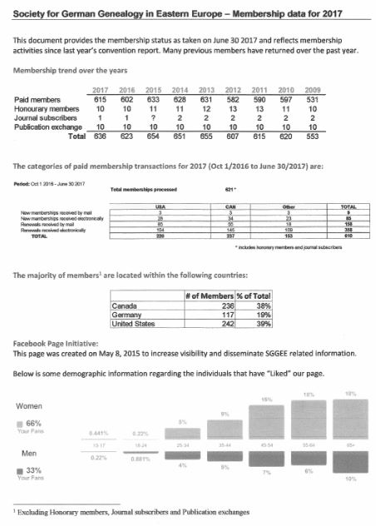 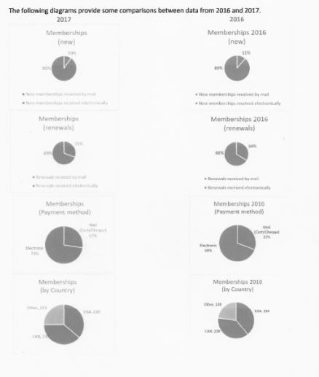

**COMMUNICATIONS** Report by Helen Gillespie  
  
SGGEE's open Facebook was created on April 15, 2015 by Renate Dilk Pilon and began with postings in May promoting the 2015 Convention in Gatineau/Ottawa.  
As recommended in 2015's report, more research-related info has been posted by the administrators - more than 250 to date - and viewed, "liked" (or not) and shared by many. The postings are an eclectic selection covering many aspects of research- for the beginner and the experienced:  resources and links, in several languages as some readers are multilingual. Occasional references to material on the SGGEE website are made but not duplicated and we note the Journal's publication. Information and links to other more specific Facebook pages or organizations in Prussian Genealogy are also shared. There are several specific Wolhynien Facebook pages and websites, in English and German.  
  
Currently there are more than 460 followers, but many more drop by to view, like and share the postings. Some, like Victor Gess's book have reached more than 800 contacts - a record. Membership is not required by this group so postings are limited to what the administrators can offer. Perhaps this could open up in future or more administrators added.  
  
The closed SGGEE group was created by Renate in August 2016 to permit members to post, exchange and seek information on a more private basis.  Currently there are about 50 members.  Membership is growing slowly with only a few seeking assistance regarding their "roadblocks".

The **JOURNAL** report was given by Edie Adam for Ray Bloch.

The publication of the quarterly SGGEE Journal is one of the charter requirements of the organization. We request articles from our membership that pertain to our primary genealogical areas of focus – namely those German regions in Eastern Europe that are now under the control of the governments of Poland and Ukraine. It is the intent of the Journal to memorialize the stories of those who lived there and those who have visited. We appreciate each and every submission from our members and hope that our readers can get a better understanding of the history our forefathers endured. For those of you who have articles, we request that you send articles to the SGGEE Editor at editor@sggee.org. If you have any questions regarding your article including relevancy or interest on our part, we will gladly review the article and let you know if and when it will be published. Personal and family stories are of great interest to our membership. We can always use more articles and look forward to your contribution. We post the Journal to our web site, www.sggee.org, followed by an email to our membership stating that the Journal is available for download. For those who request a printed copy, we mail it out within days of its posting.

The **WEBSITE** report was given by Edie Adam for Karl Krueger.

Other than standard updates and providing new links to online records for different parishes in Volhynia and Russian Poland, little change has occurred on the web site but this is about to change. Matt Warner has been working on revising the interface such that the pull down menu will be replaced with a navigation bar at the top of the page. This functionality will allow users accessing our web site on smartphones or pads to more easily navigate our site, however, other modifications will still be necessary as some links or pages do work on smartphones. Matt Warner has also suggested that SGGEE might want to host the site in the cloud rather than on a server he keeps in his house. Transparency to users will not be affected and changes to the site can continue to be made with our volunteer members.

Frank Stewner continues to update the locations database and he is also providing us with a gazetteer of most regions of Europe that SGGEE is involved with. He has been providing us with annual updates to this gazetteer which is available on our website.

The membership of our listserv continues to increase slowly now just over 850 subscribers.

The **LIBRARY** report was given by Edie Adam for Rose Ingram.

All the material in the Library is still in “storage”. In the past few years there has been some culling of obsolete books and material, so not everything you see on the Library List on our website exists anymore. We will be doing a further evaluation of what books need to be kept. We will also be checking to see what books may be online already.

There seems to be an abundance of maps of Poland and Volhyunia area which have been donated by some members in the past, and many seem to be duplicates or triplicates. An evaluation of these will also take place in the future. Any questions can be directed to [library@sggee.org](mailto:library@sggee.org).

The **DATABASE** report was given by Edie Adam for Gary Warner.

SGGEE Databases Report for 2017 convention- Summary

1. Master Pedigree Database (MPD)- a slight increase to 523,622 records. Many records were merged, and a significant number of locations were changed to conform to the location guidelines.
2. The Parish Records Index (PRI)- no change in 2017. It currently contains 364,375 names
3. The Alternate Surnames List- virtually no changes in 2017. The substantiated alternate names database is currently 7 pages of double column text. The unsubstantiated alternate names database is currently 218 pages of single column text that show the unsubstantiated alternates
4. The Alternate Christian Names List – virtually no changes in 2017. The list is currently 15 pages of double column German names with their more common English, and other language equivalents, and another 32 pages of double column English and other language names alongside their most common German name equivalent.
5. The SGGEE001x database- no changes in 2017. It contains 194,000 names, and is substantially merged into the MPD
6. The Lodz Trinity database- no changes in 2017. It contains 34, 492 names, and is substantially merged into the MPD
7. The membership database- As of 31 May 2016, the database contained the names of 2097 present and past members of SGGEE, an increase of 111 names since last year.
8. St. Petersburg birth, marriage and death indices (Volhynia, Kiev and Podolia)- major changes in 2017 with the addition of hot links for scans in Rozyszcze and Wladimir-Wolynsk parishes. Approximately 517,000 names in this database.
9. Galicia Index of Individuals- no change in 2017. Very extensive list, but number of names not determined.
10. History Books Database- no change in 2017. This database currently contains 26,000 names
11. Library materials database- no change in 2017
12. Lublin Digital Archive Database- This project of extraction of the Lublin, Poland parish records is complete and is in the process of being moved from the public area to the members only area. It contains 103, 340 records, of which 58,636 are baptisms, 31,499 are deaths, and 13,205 are marriages. Years covered are 1838-1940 with some big gaps.
13. The KGB file from Zhitomir Archives- no changes in 2017. The database contains 4178 lines of data
14. Resettlement or Repatriation of 1930's file from the Zhitomir Archives- no changes in 2017. The database contains 13,851 lines of data
15. Eastern Volhynia records for Zhitomir by Pastor Samuel Sigfried Lemke, recorded October 1941 to November 1943- no changes in 2017. The database contains 6977 names, plus the names of the parents.
16. Gazetteers for Congress Poland, the old German, Russian and Austrian Empires, and also for Volhynia and Galicia- major changes to most of the gazetteers in 2017. Congress Poland- 6288 villages and towns. German Empire- 4539 villages and towns. Russian Empire- 1315 villages and towns. Austrian Empire- 230 villages and towns. Galicia- 581 villages and towns. Volhynia- 5594 villages and towns.

Databases planned

1. BMD indexed data from the Lutheran Records in Zhitomir archives covering church books for time period 1900 to about 1915. Rough copies of this data is here at the convention, and also presently on our website.   Indexes from Rowno Archives are now on our website too.
2. ROZYSZCZE INDEXING PROJECT The AGAD archive in Warsaw holds original register books of the Lutheran parishes Rozyszcze, Wladimir-Wolynsk, and Lutzk in western (Polish) Volhynia.  These were first made available on LDS microfilms and more recently AGAD made digital scans available on its website.  SGGEE previously indexed most of these records for the Volhynia-Kiev-Podolia (VKP) database.  The current project is to add links to the online scans for each entry in the VKP database and to continue indexing records for the later years (to 1914) which were not available when the original indexing was done.

As of June 2017, links to online scans have been added to the VKP database for:

- marriages for Rozyszcze parish for the years 1862 to 1909 (the year 1902 is missing), a total of 11924 marriages

            - births for Rozyszcze parish for the years 1862 to 1899, a total of 47101 births

In progress are the completion of births to 1913, the deaths from 1862 to 1911, and the confirmations for Rozyszcze parish.  Planned are the records of Wladimir-Wolynsk parish (1891 – 1914) and Lutzk parish (1899 – 1914).

**Appointment of Auditors**

A motion was made to nominate Jurgen Kaut of Alberta, Canada to act as auditor by Marnie McCall. Bill Tucholke seconded the motion. Motion approved.

**Appointment of Directors**

The motion to affirm Virginia Braun of Winnipeg, Canada who has been appointed by the Board of Directors to act as director and treasurer to complete the remaining year of the vacated position of treasurer was made by Sigrid Pohl Perry and was seconded by Ken Krell. Motion approved.

The motion to affirm the appointment of Helen Gillespie of Ottawa, Canada by the Board of Directors to serve the remaining 2 years of a vacated 3 year term was made by Marnie McCall and seconded by Sigrid Pohl Perry. Motion approved.

**Election of Directors**

Arnold Badke of British Columbia, Canada was nominated to serve a 3 year term by Bill Toulke and seconded by Ralph Liening. Nomination approved.

John Abraham of Calgary, Canada was nominated to serve a 3 year term by Sigrid Pohl Perry, seconded by Bill O’Shea. Nomination approved.

**New Business**

It was announced that the 2018 convention, SGGEE’s 20th Anniversary, will be held the last weekend of July at the Coast Plaza Hotel in Calgary, Alberta. Planning has already begun and details will be announced via the website and Facebook.

There was discussion regarding a workshop in submitting data to the SGGEE database at next year’s convention which was met with great interest and enthusiasm by those who were present. There was also interest in the possibility in forming a “DNA group” within SGGEE members.

A raffle of three (3) one year SGGEE memberships was held with Ken Gregornik, Dennis Baehr and Tia Cobb being the lucky recipients.

The meeting was declared adjourned at 8:15 pm by President Edie Adam.

Respectfully Submitted,

Melonie Sackman Liening, Recording Secretary

|  |
| --- |
| **Minneapolis Marriott Northwest** |