1 - create a project folder

2 - go to the project from command line

3 - install virtual environment for python with
'python3 -m venv venv'

4 - activate the virtual environment
'pipenv shell'

5 - install django with
'pip install django'

6 - install django admin panel with
'django-admin startproject core .'

7 – Add new file ‘views.py’ to the ‘cofe’ project folder

from django.shortcuts import render

def home(request):
return render(request, 'index.html')

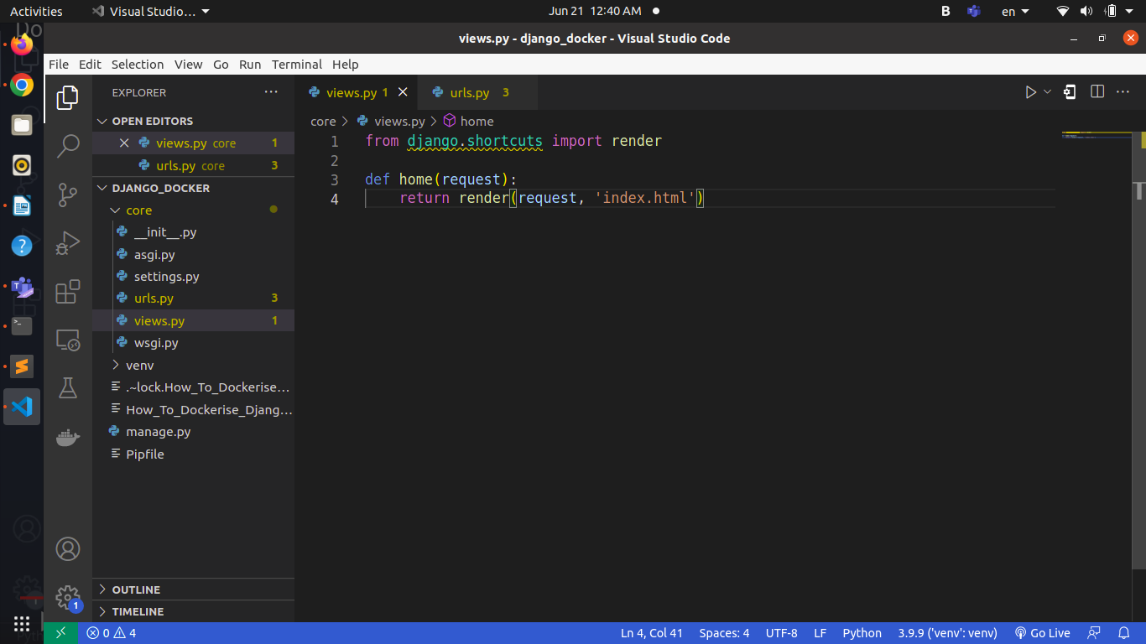

8 – Add new route to the ‘urls.py’

from django.contrib import admin
from django.urls import path

from . import views

urlpatterns = [
path('admin/', admin.site.urls),
path('', views.home),
]

9 – Add new folder ‘templates to the ‘core’ folder and add new file ‘index.html’

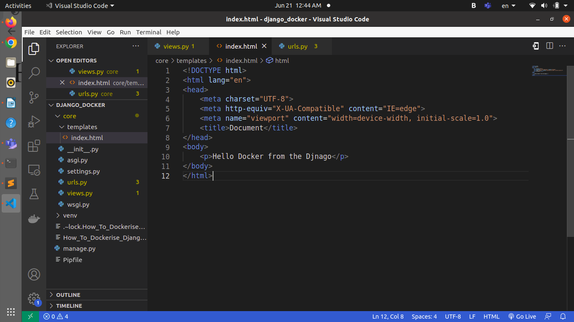

10 – Register the project folder ‘core’ to ‘settings.py’

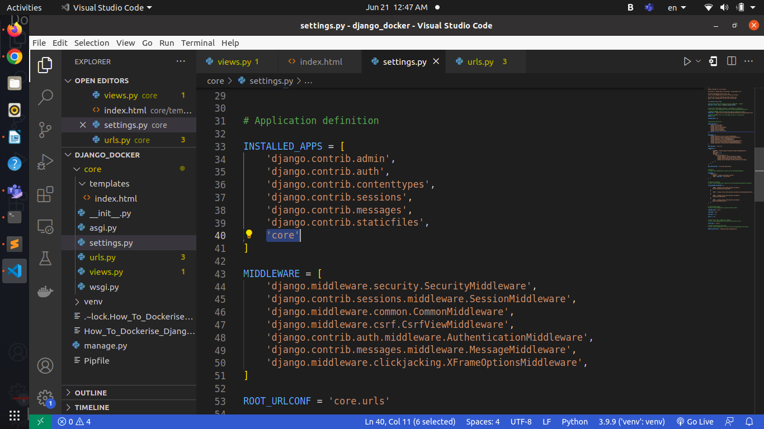

11 – Run the Project with
‘python3 manage.py runserver 127.0.0.1:8000’

12 – It will run at the command line like the following image

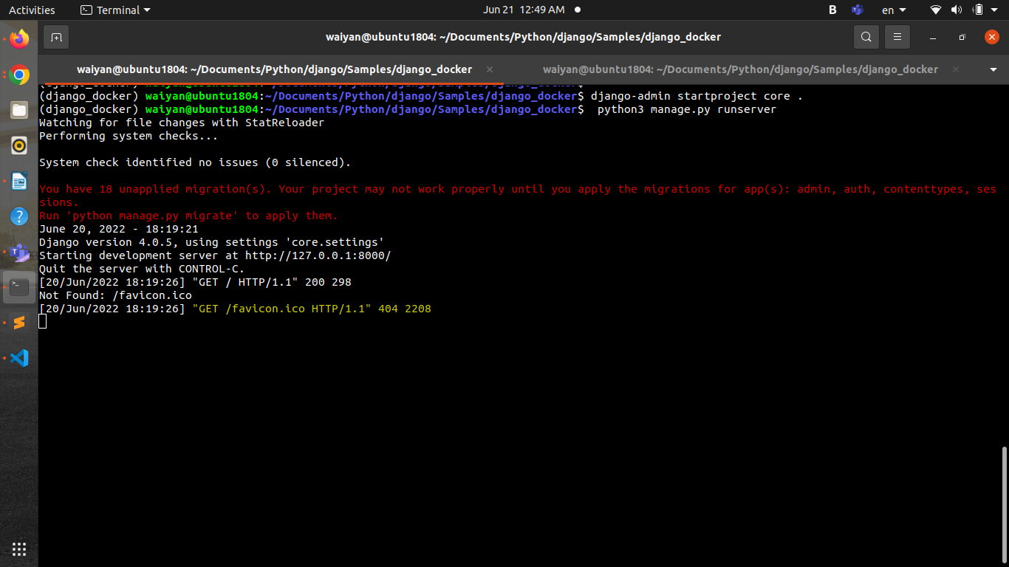

11 – Browse the project with ‘http://127.0.0.1:8000/ ‘and it will tun like the following image

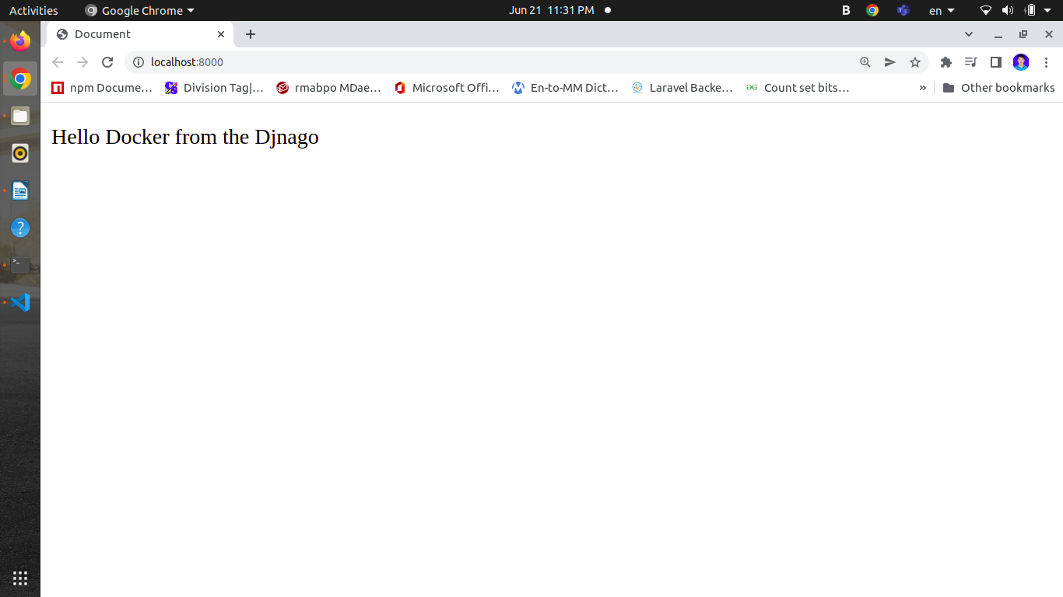

12 – Prepare Django Package list for the App. Go to the project folder and run the following
“pip freeze > requirements.txt” and it will generate “ requirements.txt”

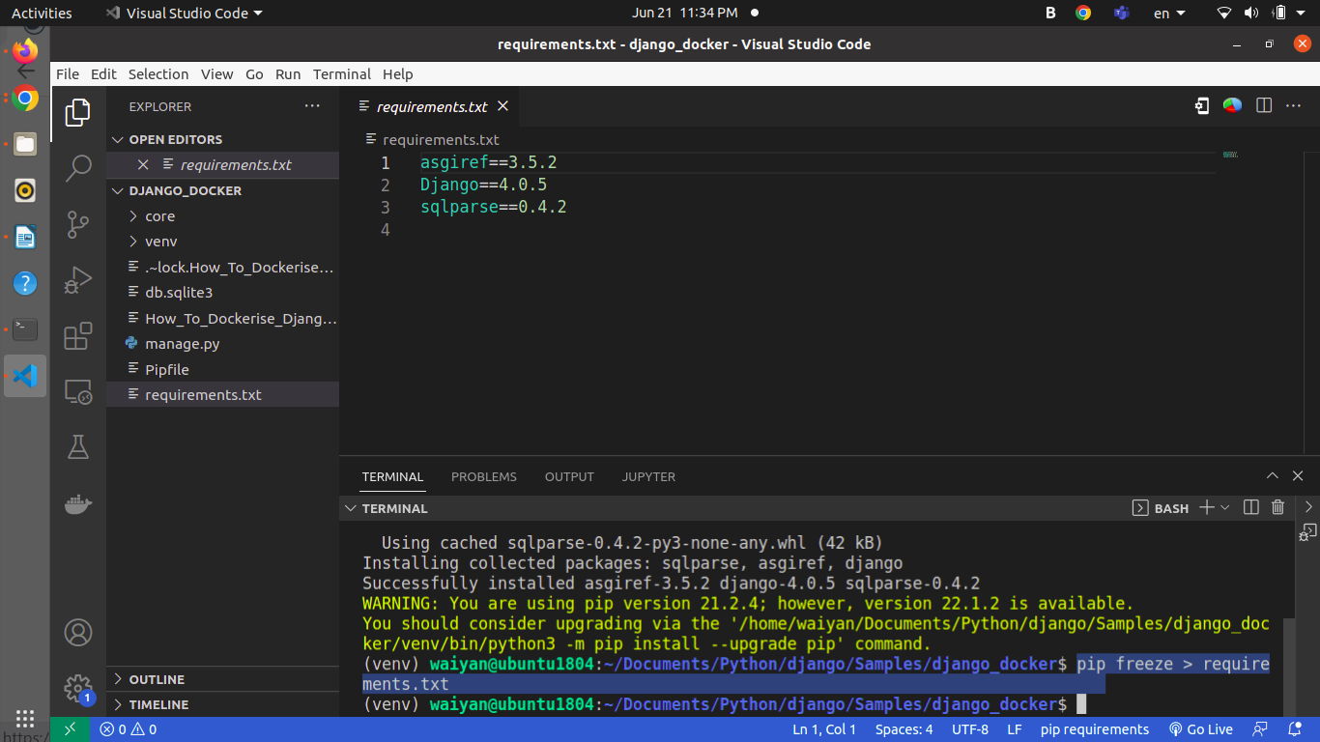
13 – Add docker file “Dockerfile” and docker ignore file “.dockerignore. to the project

FROM python:3.11-rc-bullseye

WORKDIR /app
COPY requirements.txt requirements.txt
RUN pip3 install -r requirements.txt

COPY . .

CMD [ "python3", "manage.py", "runserver", "0.0.0.0:8000" ]

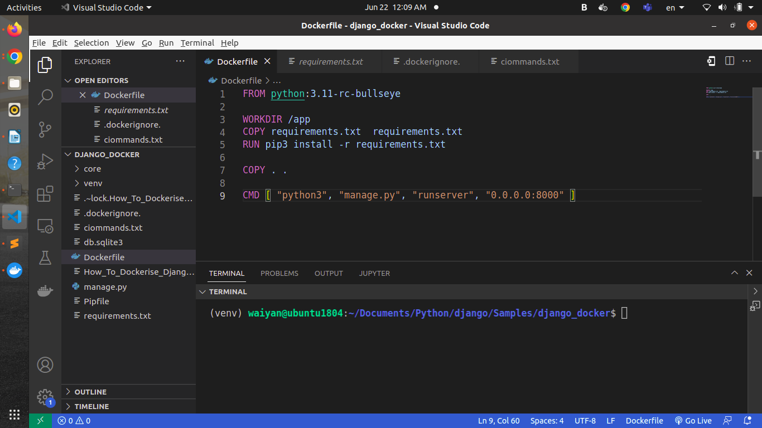

.dockerignore.
File name start with dot and end with dot
*/venv

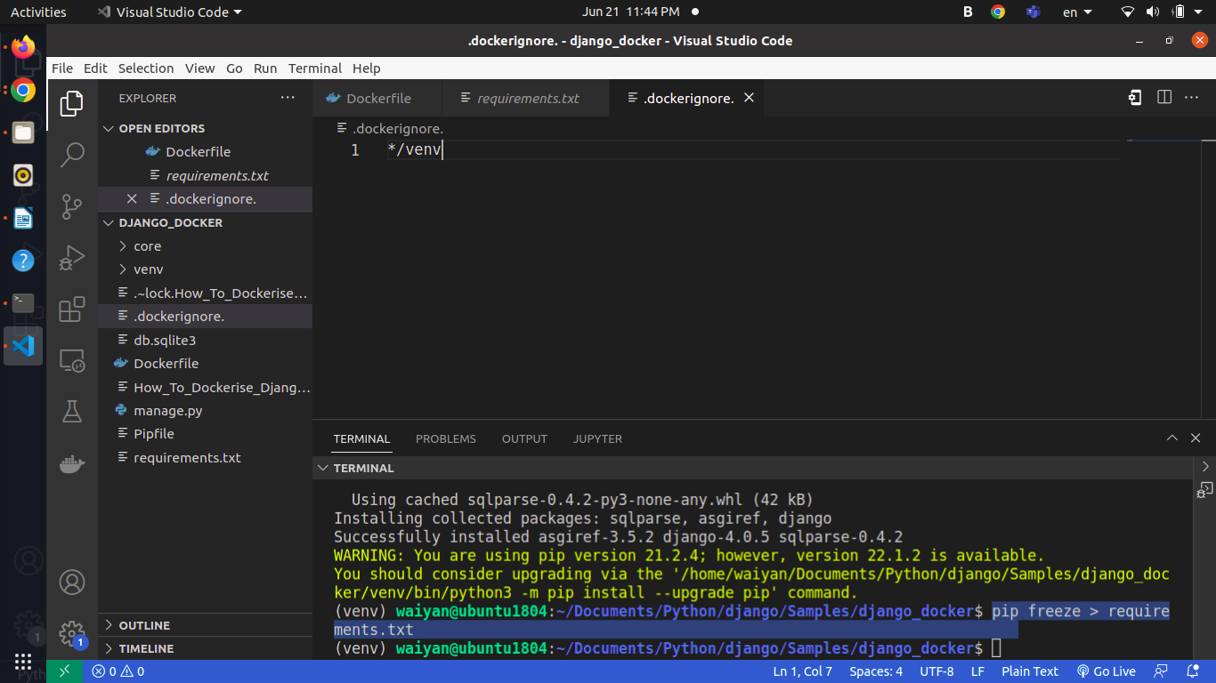
14 – Check the Docker Commands to run at the commmands.txt file at the project

docker build --tag python-dgango-william .
docker run --publish 8000:8000 python-dgango-william

15 – Create the Docker image with
“docker build --tag python-dgango-william . “

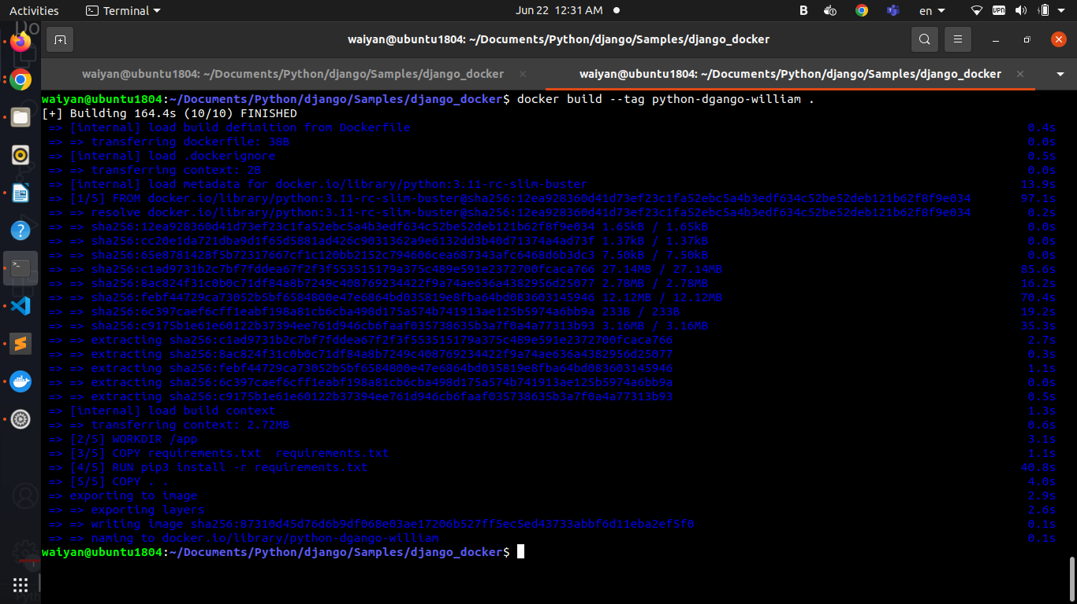

16 – Check the Docker image at Docker Desktop or at command line
“docker images “

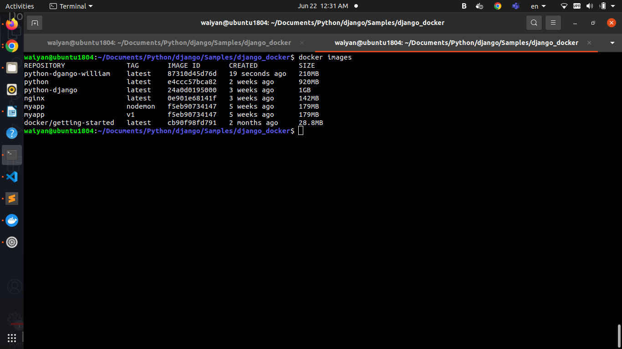

17 – run the docker image ( Create the docker container ) with
“docker run --publish 8000:8000 python-dgango-william“
and check the result at the browser with “http://localhost:8000/”

