Exploratory Data Analysis (EDA) Report
Titanic Dataset Analysis
CodeAlpha Data Analytics Internship - Task 2

1. Executive Summary
This report presents a comprehensive Exploratory Data Analysis (EDA) of the Titanic dataset from Kaggle. The analysis covers data structure exploration, statistical summaries, missing value assessment, and visualization of key patterns. The dataset contains 1,309 passenger records with 28 features, providing insights into passenger demographics, survival rates, and travel characteristics.

2. Objective
The primary objectives of this EDA are:
- Ask meaningful questions about the dataset before analysis
- Explore the data structure, including variables and data types
- Identify trends, patterns, and anomalies within the data
- Test hypotheses and validate assumptions using statistics and visualization
- Detect potential data issues or problems for further analysis

3. Dataset Information
Dataset Name: Titanic Dataset
Source: Kaggle
Number of Records: 1,309 passengers
Number of Features: 28 columns
The dataset contains comprehensive information about Titanic passengers, including demographic details (age, gender), travel information (passenger class, fare), and the target variable indicating whether passengers survived the disaster.

4. Tools & Libraries Used
- Python
- Pandas - Data manipulation and analysis
- Matplotlib - Data visualization
- Kaggle Notebook - Development environment

5. Data Exploration & Preview
Dataset Preview (First 5 Rows):

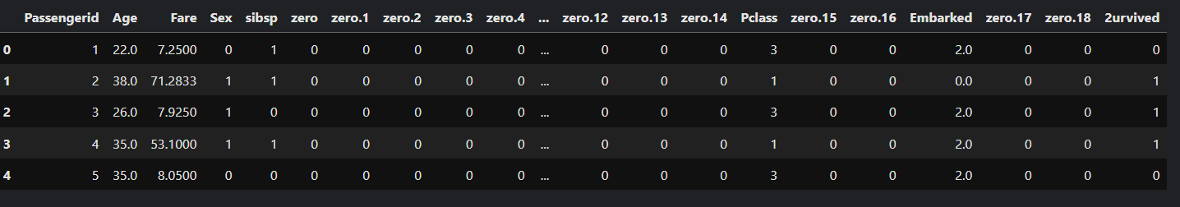
The dataset contains passenger information with numeric and categorical features. Key columns include passenger ID, age, fare, sex, number of siblings/spouses aboard, number of parents/children aboard, passenger class, embarkation port, and survival status.

6. Data Structure & Types
Dataset Information:

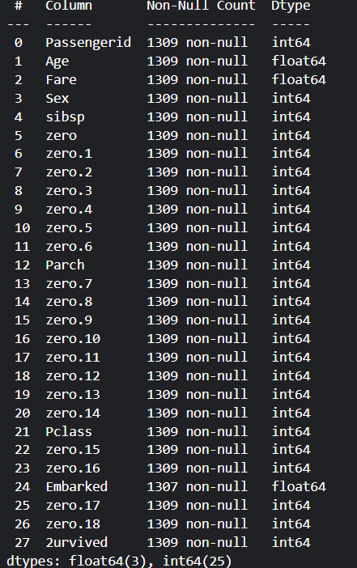
The dataset contains 1,309 records and 28 columns. Most columns have complete data with no missing values. The Embarked column has only 2 missing entries out of 1,309 records, making the dataset highly complete and suitable for analysis. Data types include both float64 (for continuous variables) and int64 (for discrete variables).

7. Statistical Summary
Descriptive Statistics:

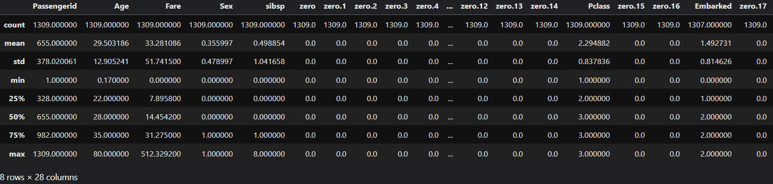
Key Statistical Insights:
- Average passenger age: 29.50 years (range: 0.17 to 80 years)
- Average ticket fare: 33.28 (range: 0 to 512.33)
- Passenger Class distribution: Classes 1, 2, and 3 with varying frequencies
- Survival rate: 26.13% (mean of survival column = 0.261)

8. Missing Values Analysis
Missing Values Summary:

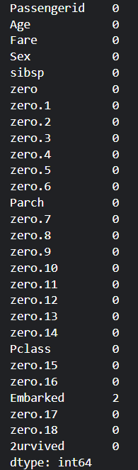
The dataset is exceptionally clean with minimal missing data. Only the Embarked column has 2 missing entries out of 1,309 records (0.15% missing rate). All other columns have complete data. This makes the dataset suitable for analysis with minimal data cleaning requirements.

9. Survival Analysis
Survival Distribution:
- Did Not Survive: 967 passengers (73.87%)
- Survived: 342 passengers (26.13%)
Key Observation: The majority of passengers (approximately 74%) did not survive the Titanic disaster, while only about 26% survived. This indicates a significant imbalance in the survival outcome variable.

10. Data Visualizations

10.1 Survival Count


Observation: The bar chart clearly shows the stark contrast between passengers who did not survive (0) and those who survived (1). The number of fatalities far exceeds the number of survivors.

10.2 Passenger Class Distribution

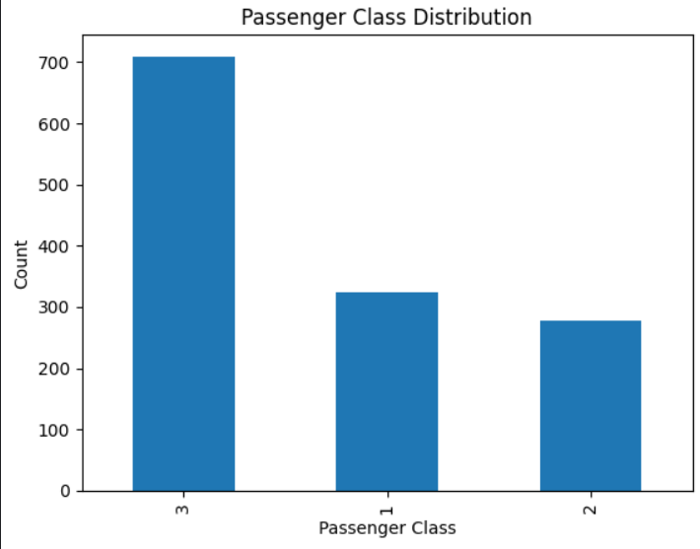
Observation: The majority of passengers traveled in Third Class (~700+), while significantly fewer passengers were in First Class and Second Class. This distribution reflects the economic demographics of the ship's passengers.

10.3 Age Distribution

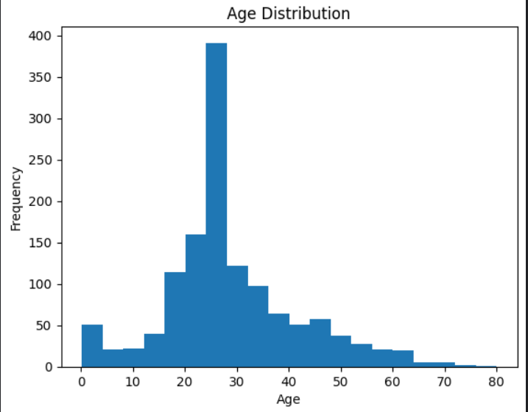
Observation: The age distribution shows a strong concentration of passengers between 20-35 years old. The histogram indicates a right-skewed distribution with fewer passengers in older age groups (above 60 years). This suggests the ship primarily carried working-age passengers and families.

11. Key Findings & Insights
Dataset Quality:
- 1,309 complete passenger records with minimal missing data (only 2 missing values in Embarked column)
- 28 features capturing demographic and travel information
Survival Patterns:
- Only 26.13% of passengers survived the disaster
- 73.87% of passengers did not survive
- Significant class imbalance in the target variable suggests that prediction models should account for this imbalance
Passenger Demographics:
- Average age: 29.5 years, with most passengers between 20-35 years old
- Majority of passengers (over 700) traveled in Third Class
- Ticket fares vary widely (0 to 512.33), indicating diverse socioeconomic backgrounds
Data Characteristics:
- Age distribution shows concentration in young to middle-aged groups
- Passenger class is a strong categorical variable with clear differentiation
- Very high data quality with minimal missing values

12. Conclusion
The Exploratory Data Analysis of the Titanic dataset reveals a well-structured and clean dataset suitable for advanced analytics and machine learning applications. The dataset contains 1,309 passenger records with 28 features, demonstrating high data quality with only two missing values.
Key observations indicate a strong imbalance in survival outcomes (26% survived vs. 74% did not), with most passengers concentrated in third class and aged between 20-35 years. The distribution patterns suggest potential correlations between passenger class, age, and survival outcomes.
This EDA provides a solid foundation for further analysis, including feature engineering, correlation studies, and predictive modeling. The dataset's quality and characteristics make it an excellent resource for understanding factors that influenced passenger survival during the Titanic disaster.

13. References
- Kaggle Titanic Dataset
- Python Documentation
- Pandas Documentation
- Matplotlib Documentation

