CODEALPHA DATA ANALYTICS INTERNSHIP
Task 3: Data Visualization using Netflix Dataset
Internship: CodeAlpha Data Analytics Internship

1. Introduction
Data visualization is the graphical representation of information and data using charts, graphs, and plots. It helps transform complex datasets into understandable visual formats, making it easier to identify trends, patterns, and relationships.
In this project, the Netflix Titles Dataset was analyzed using Python libraries such as Pandas and Matplotlib. Various visualizations were created to gain insights into Netflix content distribution, ratings, countries, release years, and genres.
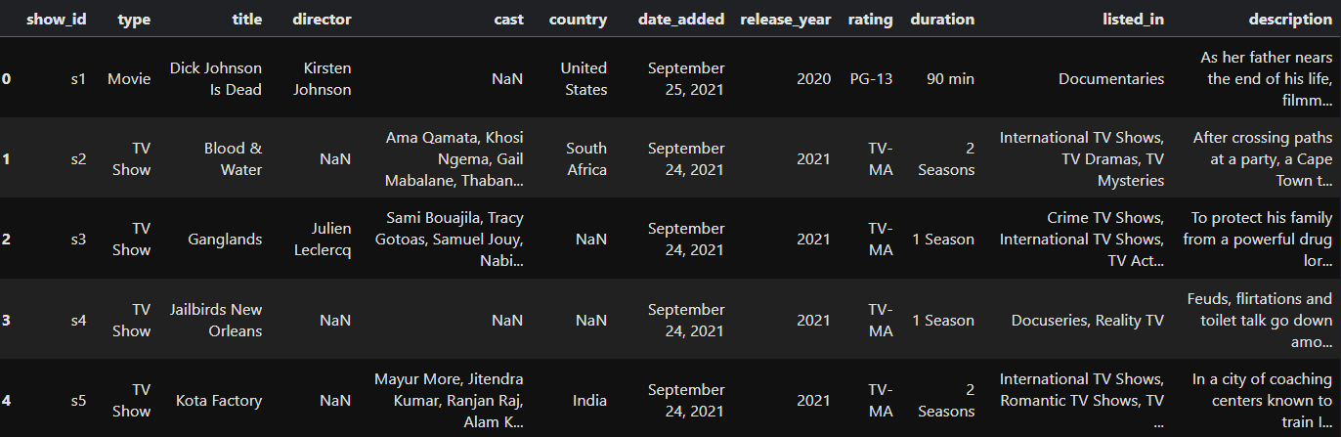
Dataset Preview (df.head())

2. Objective
The main objectives of this project are:
- To explore the Netflix Titles dataset.
- To identify trends in movies and TV shows.
- To visualize content ratings.
- To analyze content release patterns over time.
- To identify the countries producing the most Netflix content.
- To determine the most common genres available on Netflix.

3. Dataset Description
The Netflix dataset contains information about movies and TV shows available on Netflix.
Dataset Features:
- Show ID
- Type
- Title
- Director
- Cast
- Country
- Date Added
- Release Year
- Rating
- Duration
- Genre
- Description
Total Records: 8807
Total Columns: 12
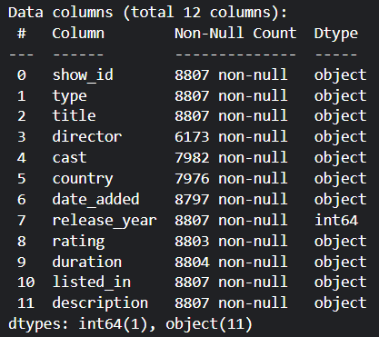
Dataset Information (df.info())

4. Data Cleaning
Data cleaning was performed to identify missing values and understand dataset quality.
Missing Values Found:
- Director: 2634 missing values
- Cast: 825 missing values
- Country: 831 missing values
- Date Added: 10 missing values
- Rating: 4 missing values
- Duration: 3 missing values
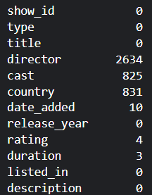
Missing Values Output

5. Data Visualization and Analysis

5.1 Movies vs TV Shows
A bar chart and pie chart were created to compare the number of movies and TV shows available on Netflix.
Observation: Movies account for approximately 69.6% of the total content while TV Shows account for 30.4%.
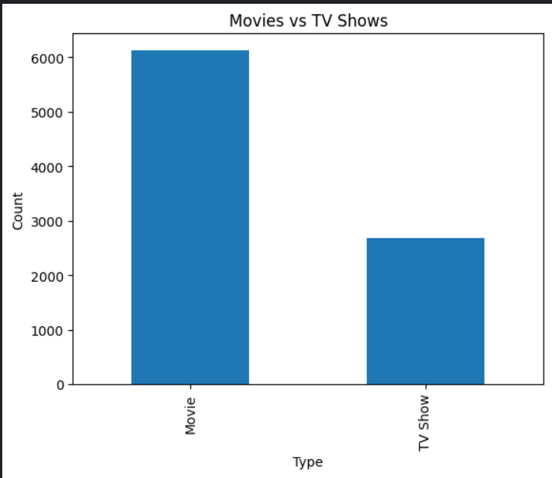
Movies vs TV Shows (Bar Chart)
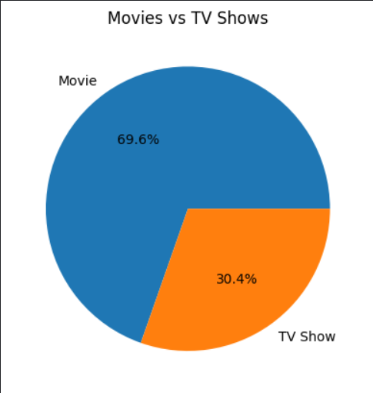
Movies vs TV Shows (Pie Chart)

5.2 Content Ratings Analysis
The content rating distribution was analyzed to understand audience targeting.
Observation: TV-MA is the most common rating category, indicating that Netflix contains a significant amount of mature audience content.
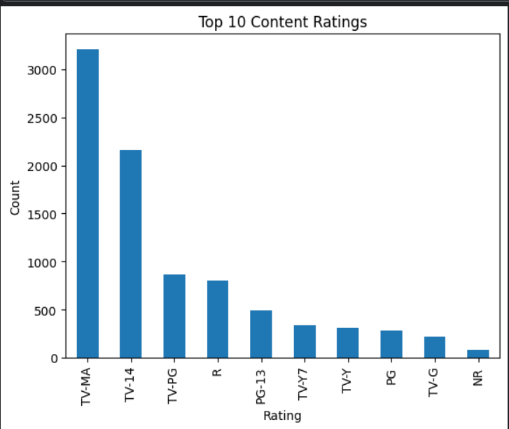
Content Ratings Chart

5.3 Release Year Analysis
A line chart was created to visualize the number of Netflix titles released each year.
Observation: Netflix content increased rapidly after 2015 and reached its highest level around 2019-2020.
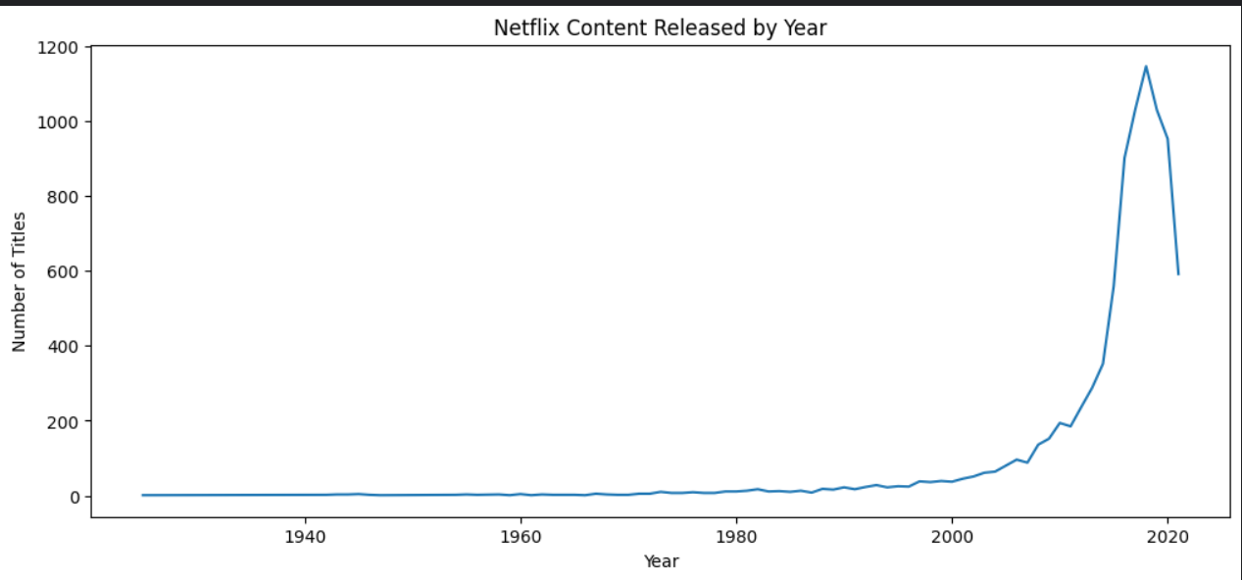
Release Year Distribution

5.4 Top Countries Analysis
The top countries contributing Netflix content were identified.
Observation:
- United States ranks first.
- India ranks second.
- United Kingdom ranks third.
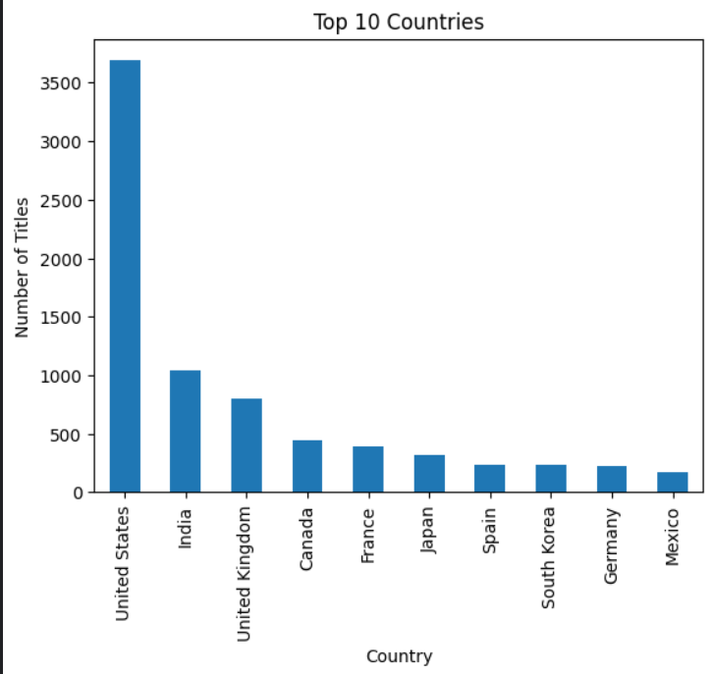
Top Countries Chart

5.5 Genre Analysis
Genre distribution was analyzed to determine the most common content categories.
Observation: The most popular genres are:
- International Movies
- Dramas
- Comedies
- International TV Shows
- Documentaries
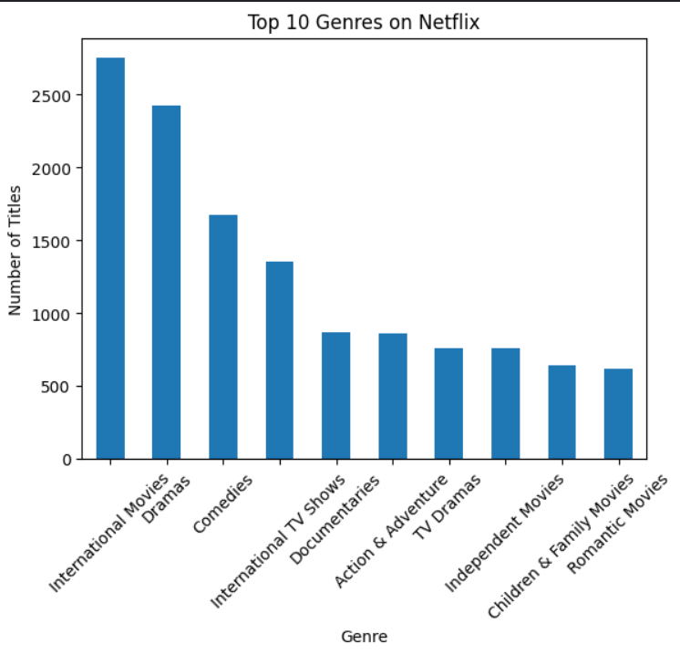
Top Genres Chart

6. Key Findings
- Netflix contains more Movies than TV Shows.
- TV-MA is the dominant content rating.
- The United States contributes the largest number of titles.
- Netflix experienced rapid content growth after 2015.
- International Movies and Dramas are the most popular genres.

7. Conclusion
This project successfully analyzed the Netflix Titles Dataset using Python and data visualization techniques. Multiple charts and graphs were created to understand content distribution, ratings, release trends, countries, and genres.
The analysis revealed that Netflix is primarily movie-focused, with strong contributions from the United States and a growing collection of international content. Data visualization proved effective in identifying patterns and communicating insights clearly.

