**Introduction:**

My website is actually a Gallery App and as you can see in first snapshot the score is 44. In below step I am going to improve the performance of a website from 44 to 90

**Step 1:**

Check the performance score of your website with help of lighthouse report in Chrome

So here the performance score of my website is **44** as it is seen below :

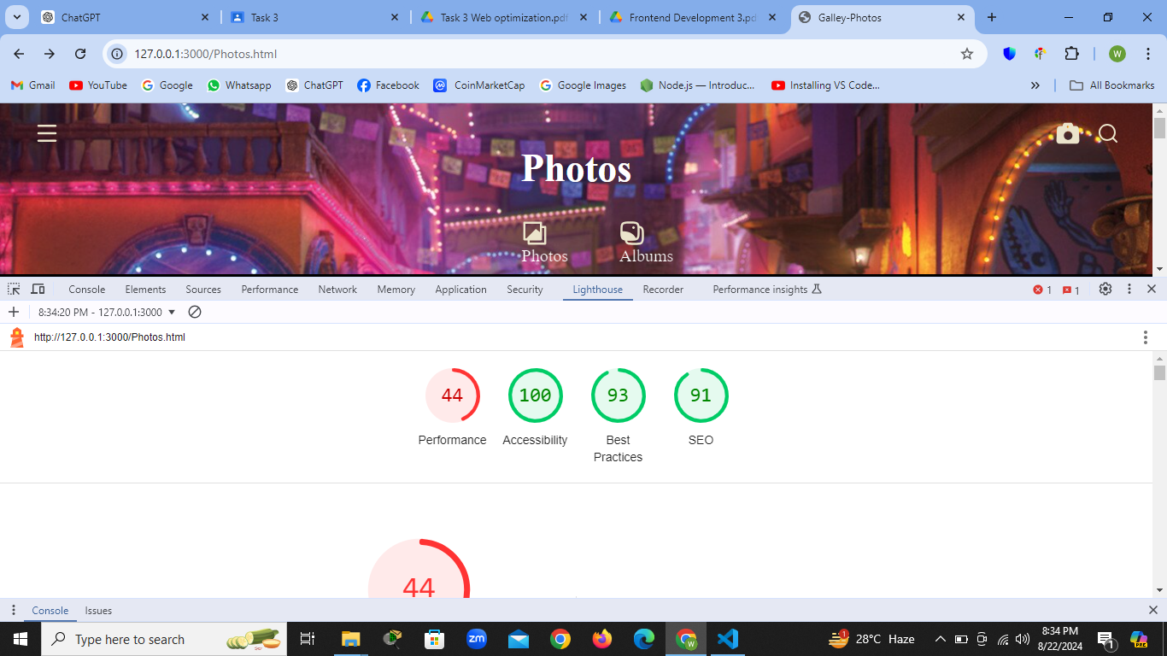

**Step 2:**

So First of all I used the **TINYPNG** web app to minimize the site of all the images present in my site

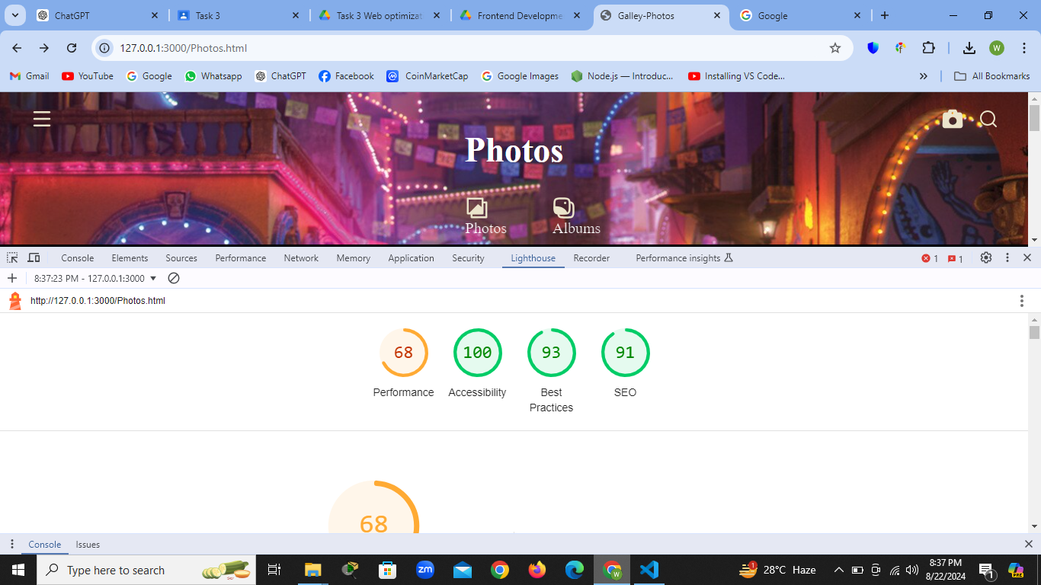

**Step 3:**

After Using TINYPG The performance score is still not very good

Then I used the web app named **SQUOOSH.APP/EDITOR** Now performance score is 87

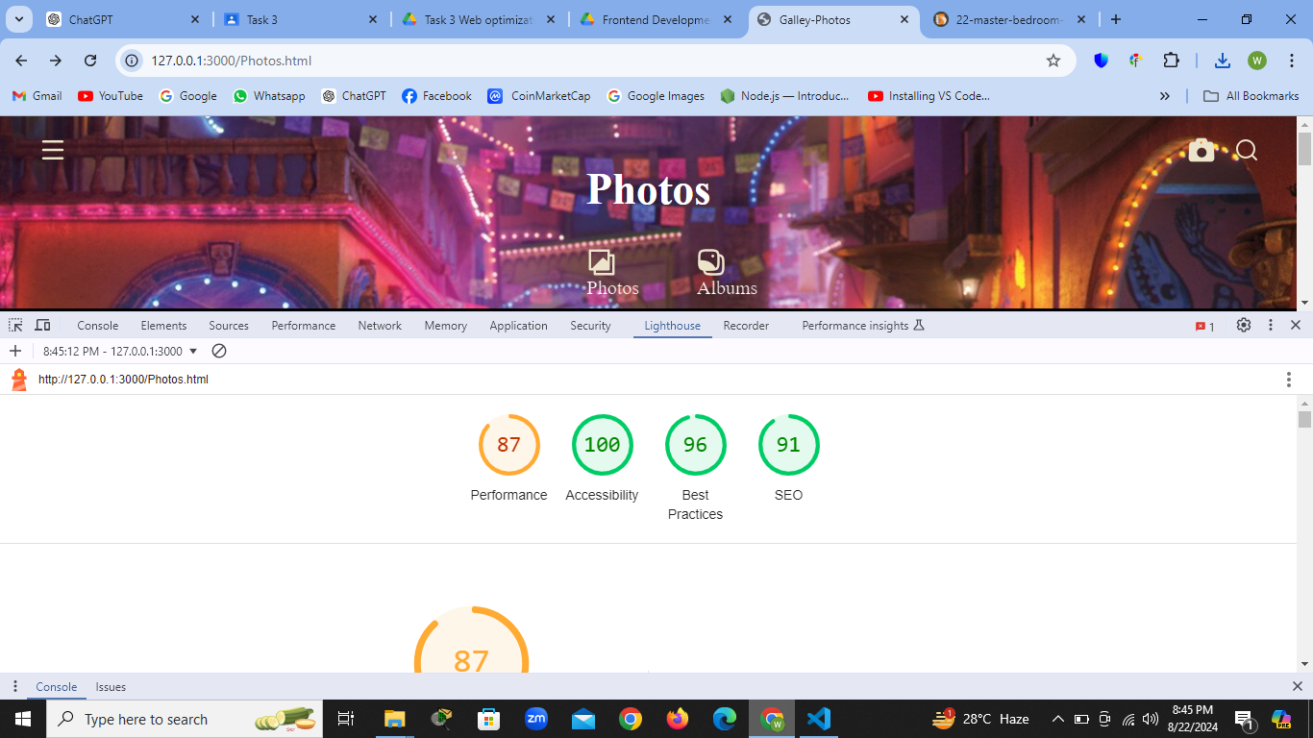

**Step 4:**

After Using **SQUOOSH.APP/EDITOR** The performance score is still not very Great

Then I Removed all the unnecessary code and along with that I added Preload attribute in my code Now performance score is 87

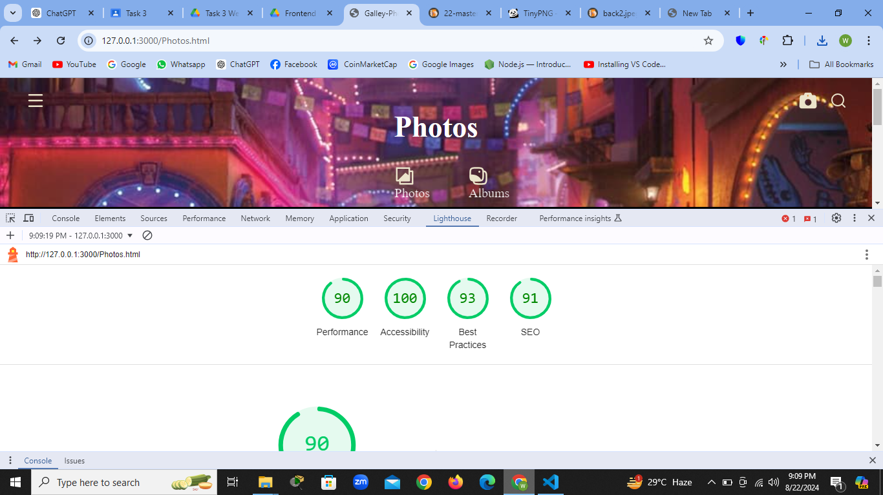

**Step 5:**

First The performance score is **44** and now it is improved to **90** which is quite good

