**Introduction:**

This is the task in which we have to check weather our website work perfectly or not on different versions of a browser so

**MY PROJECTS:**

**Music App:** I have built a music App that will fetch the music files dynamically as well as the Albums of a Music so I have checked my web app on different browser and it will run perfectly on all the browsers without any issue as that can be seen of the screenshots below:

**Chrome:**

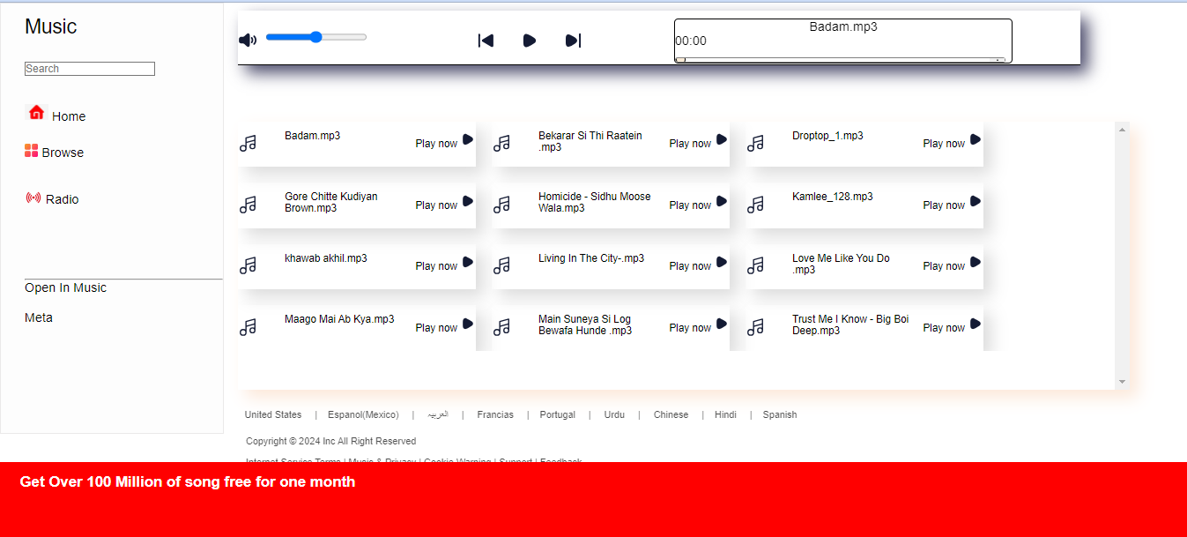

**Mozella Firefox**

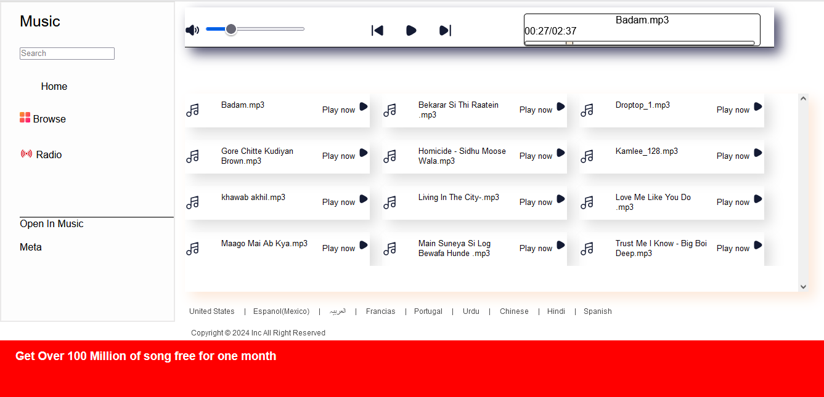

**Microsoft Edge**

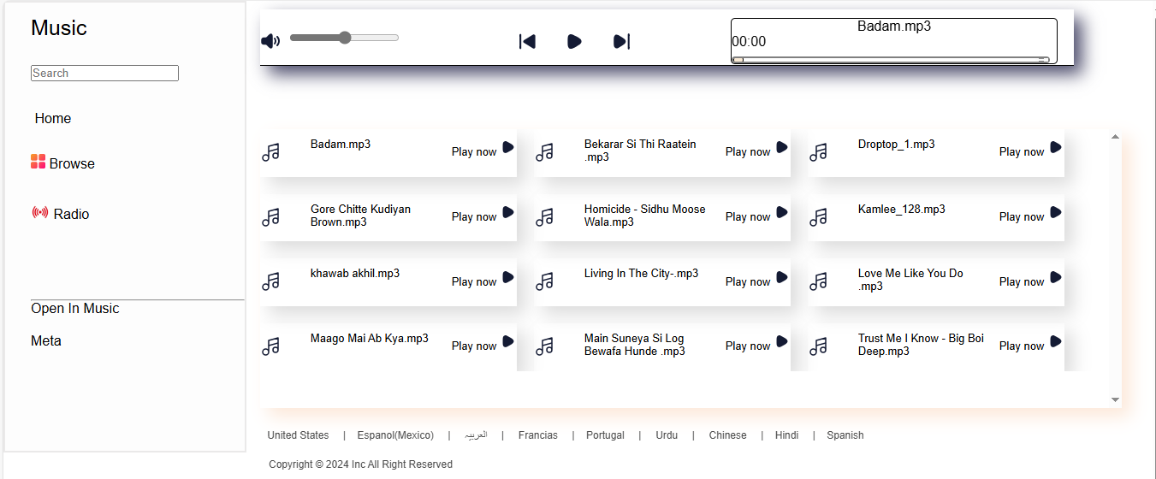

**Portfolio:** The Second app that I will check on all the browsers is My personal Portfolio and this will also run perfectly on all the browsers as that can be seen on the screenshots below:

**Chrome**



**Firefox**



**Microsoft Edge**



**Some Measures:**

These are some steps that a person should take if his/her website shows any error in different browsers:

1. Use tools like BrowserStack or CrossBrowserTesting to automate the process and cover more browsers and versions.
2. Use CSS vendor prefixes for properties that may not be fully standardized. For example:

-webkit- for Chrome, Safari, and newer Edge versions

-moz- for Firefox

-ms- for older versions of Internet Explorer

Tools like Autoprefixer can automatically add these prefixes to your CSS

3. Use **responsive web design techniques** to ensure that the website looks and works well on all screen sizes. This involves using fluid grids, flexible images, and CSS media queries.